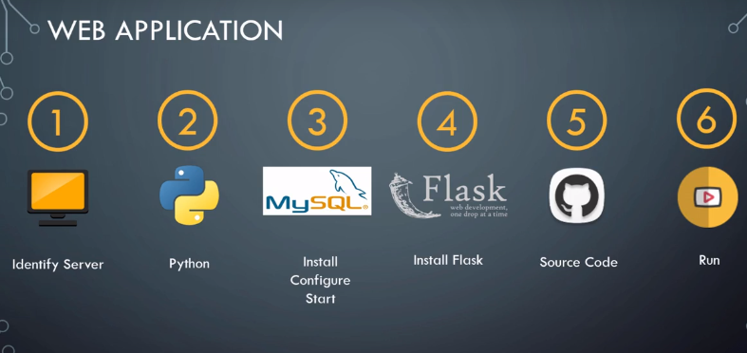

1.Identify

2.python based web application

3.install configure and start mysql

4.flask(web server): web application based on flask

5.push it to scm

6. Run web server

use case : standalone/distributed architecture