**Where python fits?**

it fits where quick development proto types.

**Notes:-**

python has library concept which can work across all the operating systems.

python can generate byte code like java.

python inputs can be from file/key board/command line/

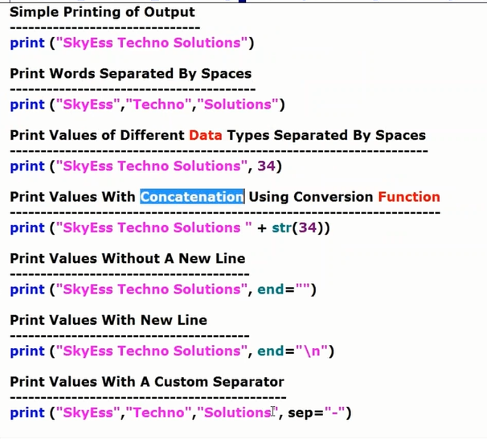

**conversion of function**

print "prashanth technologies" str(35)

**concatenation**

print "prashanth Technologies" +35

Error : cannot concate integer with string

print "prashanth Technologies" +str(35)

o/p: concatenation of number with string using function(str)

**python 3.6.4**

print "prashanth technologies" + str(35)

print ("prashanth technologies" , end="")

print ("prashanth technologies" , end="\n") ---new line (end is keyword)

print ("prashanth technologies" , sep="-") (sep is seperator ,is keyword)

print ("prashanth technologies" , sep=":")

print ("prashanth technologies" , sep="|")

**IQ :- what is default separator for string?**

**sol:- space**

**Python Identifier:-**

**identifier is a name given to identify**

* **Variable**
* **Function**
* **class**
* **Module**
* **object**

**Rules to be followed :-**

* Every identifier should start with A letter (A to Z or a to z)
* can also start underscore(_) followed by zero or more letters
* python identifier does not support @, $ and %.
* python is case sensitive programming language, Hence the Identifiers.

**Naming conversions for python identifiers:-**

* Class name start with an uppercase Letter.
* any other identifier start with A Lowercase letter
* an identifier started with A single leading underscore that identifier treated is private in nature
* an identifier started with two leading underscore that identifier treated is strongly private identifier in nature
* if the identifier ends with two trailing underscores, the identifier is a language defined special name

**Reserved words:-**

* reserved words cannot be used as constant or variable names or any other identifier names.
* all python keywords are represented by lowercase letter only.