1.Python

-----

# it is there is in market almost for 3 decades.

# python is open source(then it has got identity)

# it is object oriented approach.

# you can it as scripting language.

# python is not over rule other lanugage(it is false),

do u find c or java going out of the market.

Example:-

---------

# i want to show some specification results to my clients very quickly,

then i can catch my python impression from clients.

# it is economical language

2.Reason for python identity in recent times

------------------------------------------

# it is nearest human language readable.

# python has easy integration with other languages.

3.core-highlights of python

------------------------

# it is object oriented approach.

# it helps encapsulation standard like other languages.

# python can be used as a scripting language or can be compiled to byte code for large

application

# like other languages python garbage collection.

4.Main features of python

-------------------------

# standardard python common library(while you program you need cross verify based on os(android/windows/mac/linux applications) like

what kind of modules i have import along with parameters).

most famous programming languages that exists in the world

---------------------------------------------------------

# assembly based

# modular

# object oriented

# structured

# functional approach(big data/artificial intelligence)

python is combination of all of above.

Notes:-

-------

we generally say it is not compiled language.

sol :- dont think that is in-secured,you write python script embed that into any particular

language that can produce you a byte code.

this byte code run on any machine.

How to run python?

-----------------

# interactive interpreter

command line(windows/linux/or any other system)

how it is interactive?(one line statement)

>>> echo "This is my first python output"

This is my first python output

once you've asked, displaying immediately is called interactive.

# Script from command line(integrated collection of instruction)

we can execute a python script which is with .py extension at command

line.

--- control structure(if,loops)

--- functions

OLDER VERSION

-------------------

print "my first name is: prashanth"

new VERSION

-------------------

>>>print ("my first name is: prashanth)

>>>print ("my middle name is: kumar)

>>>print ("my last name is: pamula)

here you get traceback issue

# integrated development environment(larger development)

with editors/IDE(it provides facilities and features, we will develops.

print ("my first name is: prashanth)

print ("my middle name is: kumar)

print ("my last name is: pamula)

save this file with .py extension

execute this file as follows, python script01.py

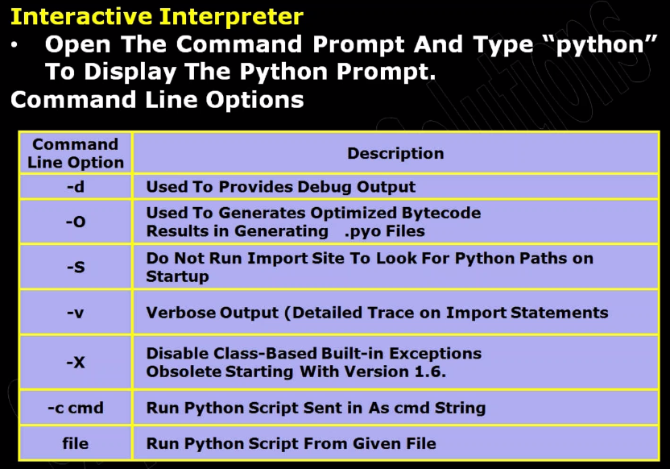

Note : while writing program ensure working with which version and follow the same version syntax

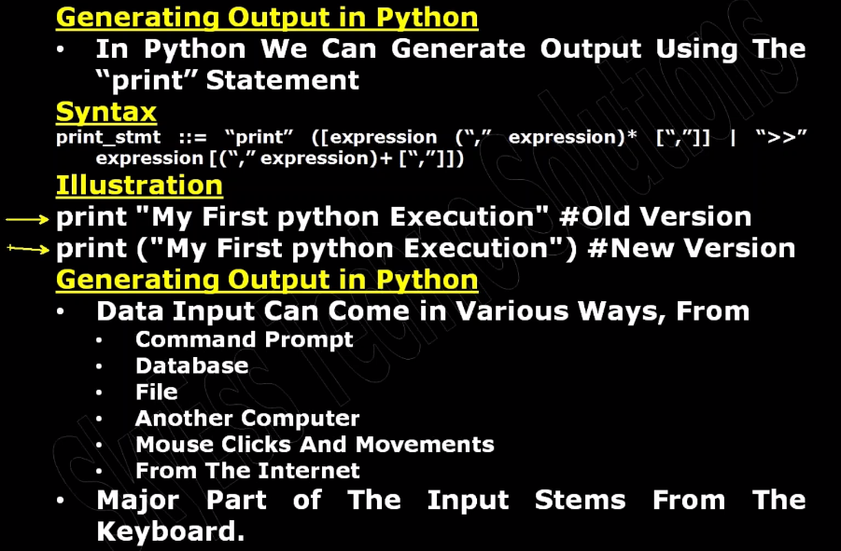

Example#1

--------------

start python environment

start as root like "python"

>>> print 4 + 5

missing parenthesis

>>> print (4 + 5)