https://linuxconfig.org/bash-scripting-tutorial

$ which bash

bash interpreter location: /bin/bash

Open up you favorite text editor and create file called hello_world.sh. Insert the following lines to a file:

NOTE:Every bash shell script in this tutorial starts with **shebang:"#!"**which is not read as a comment. First line is also a place where you put your interpreter which is in this case: /bin/bash.

Here is our first bash shell script example:

#!/bin/bash  
# declare STRING variable  
STRING="Hello World"  
#print variable on a screen  
echo $STRING

Navigate to a directory where your hello_world.sh is located and make the file executable:

$ chmod +x hello_world.sh

Make bash shell script executable

Now you are ready to execute your first bash script:

./hello_world.sh

Example of simple bash shell script

**Simple Backup bash shell script**

#!/bin/bash  
tar -czf myhome_directory.tar.gz /home/linuxconfig

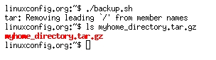

**Variables**

In this example we declare simple bash variable and print it on the screen ( stdout ) with echo command.

#!/bin/bash  
 STRING="HELLO WORLD!!!"  
 echo $STRING

Bash string Variables in bash script

Your backup script and variables:

#!/bin/bash  
 OF=myhome_directory_$(date +%Y%m%d).tar.gz  
 tar -czf $OF /home/linuxconfig



**Global vs. Local variables**

#!/bin/bash  
#Define bash global variable  
#This variable is global and can be used anywhere in this bash script  
VAR="global variable"  
function bash {  
#Define bash local variable  
#This variable is local to bash function only  
local VAR="local variable"  
echo $VAR  
}  
echo $VAR  
bash  
# Note the bash global variable did not change  
# "local" is bash reserved word  
echo $VAR

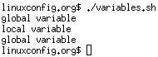

**Passing arguments to the bash script**

#!/bin/bash  
# use predefined variables to access passed arguments  
#echo arguments to the shell  
echo $1 $2 $3 ' -> echo $1 $2 $3'  
  
# We can also store arguments from bash command line in special array  
args=("$@")  
#echo arguments to the shell  
echo ${args[0]} ${args[1]} ${args[2]} ' -> args=("$@"); echo ${args[0]} ${args[1]} ${args[2]}'  
  
#use $@ to print out all arguments at once  
echo $@ ' -> echo $@'  
  
# use $# variable to print out  
# number of arguments passed to the bash script  
echo Number of arguments passed: $# ' -> echo Number of arguments passed: $#'

/arguments.sh Bash Scripting Tutorial

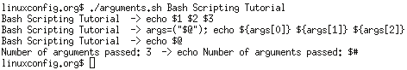

**Executing shell commands with bash**

#!/bin/bash  
# use backticks " ` ` " to execute shell command  
echo `uname -o`  
# executing bash command without backticks  
echo uname -o

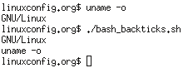

**Reading User Input**

#!/bin/bash  
   
echo -e "Hi, please type the word: \c "  
read word  
echo "The word you entered is: $word"  
echo -e "Can you please enter two words? "  
read word1 word2  
echo "Here is your input: \"$word1\" \"$word2\""  
echo -e "How do you feel about bash scripting? "  
# read command now stores a reply into the default build-in variable $REPLY  
read  
echo "You said $REPLY, I'm glad to hear that! "  
echo -e "What are your favorite colours ? "  
# -a makes read command to read into an array  
read -a colours  
echo "My favorite colours are also ${colours[0]}, ${colours[1]} and ${colours[2]}:-)"

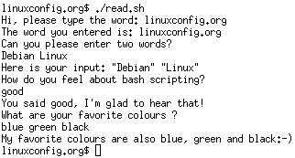

**Bash Trap Command**

|  |  |
| --- | --- |
| #!/bin/bash # bash trap command trap bashtrap INT # bash clear screen command clear; # bash trap function is executed when CTRL-C is pressed: # bash prints message => Executing bash trap subrutine ! bashtrap() {  echo "CTRL+C Detected !...executing bash trap !" } # for loop from 1/10 to 10/10 for a in `seq 1 10`; do  echo "$a/10 to Exit."   sleep 1; done echo "Exit Bash Trap Example!!!" |  |

**Arrays**

**Declare simple bash array**

#!/bin/bash  
#Declare array with 4 elements  
ARRAY=( 'Debian Linux' 'Redhat Linux' Ubuntu Linux )  
# get number of elements in the array  
ELEMENTS=${#ARRAY[@]}  
  
# echo each element in array   
# for loop  
for (( i=0;i<$ELEMENTS;i++)); do  
 echo ${ARRAY[${i}]}  
done

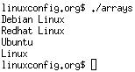

**Read file into bash array**

#!/bin/bash  
# Declare array  
declare -a ARRAY  
# Link filedescriptor 10 with stdin  
exec 10<&0  
# stdin replaced with a file supplied as a first argument  
exec < $1  
let count=0  
  
while read LINE; do  
  
 ARRAY[$count]=$LINE  
 ((count++))  
done  
  
echo Number of elements: ${#ARRAY[@]}  
# echo array's content  
echo ${ARRAY[@]}  
# restore stdin from filedescriptor 10  
# and close filedescriptor 10  
exec 0<&10 10<&-

**Bash script execution with an output:**

linuxconfig.org $ cat bash.txt   
Bash  
Scripting  
Tutorial  
Guide  
linuxconfig.org $ ./bash-script.sh bash.txt   
Number of elements: 4  
Bash Scripting Tutorial Guide  
linuxconfig.org $

**Bash if / else / fi statements**

**Simple Bash if/else statement**

Please note the spacing inside the [ and ] brackets! Without the spaces, it won't work!

#!/bin/bash  
directory="./BashScripting"  
  
# bash check if directory exists  
if [ -d $directory ]; then  
 echo "Directory exists"  
else   
 echo "Directory does not exists"  
fi

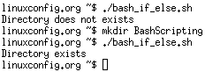

**Nested if/else**

#!/bin/bash  
   
# Declare variable choice and assign value 4  
choice=4  
# Print to stdout  
 echo "1. Bash"  
 echo "2. Scripting"  
 echo "3. Tutorial"  
 echo -n "Please choose a word [1,2 or 3]? "  
# Loop while the variable choice is equal 4  
# bash while loop  
while [ $choice -eq 4 ]; do  
   
# read user input  
read choice  
# bash nested if/else  
if [ $choice -eq 1 ] ; then  
   
 echo "You have chosen word: Bash"  
  
else   
  
 if [ $choice -eq 2 ] ; then  
 echo "You have chosen word: Scripting"  
 else  
   
 if [ $choice -eq 3 ] ; then  
 echo "You have chosen word: Tutorial"  
 else  
 echo "Please make a choice between 1-3 !"  
 echo "1. Bash"  
 echo "2. Scripting"  
 echo "3. Tutorial"  
 echo -n "Please choose a word [1,2 or 3]? "  
 choice=4  
 fi   
 fi  
fi  
done

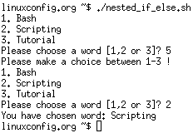

**Bash Comparisons**

**Arithmetic Comparisons**

|  |  |
| --- | --- |
| -lt | < |
| -gt | > |
| -le | <= |
| -ge | >= |
| -eq | == |
| -ne | != |

#!/bin/bash  
# declare integers  
NUM1=2  
NUM2=2  
if [ $NUM1 -eq $NUM2 ]; then  
 echo "Both Values are equal"  
else   
 echo "Values are NOT equal"  
fi

Bash Arithmetic Comparisons

#!/bin/bash  
# declare integers  
NUM1=2  
NUM2=1  
if [ $NUM1 -eq $NUM2 ]; then  
 echo "Both Values are equal"  
else   
 echo "Values are NOT equal"  
fi

Bash Arithmetic Comparisons - values are NOT equal

#!/bin/bash  
# declare integers  
NUM1=2  
NUM2=1  
if [ $NUM1 -eq $NUM2 ]; then  
 echo "Both Values are equal"  
elif [ $NUM1 -gt $NUM2 ]; then  
 echo "NUM1 is greater then NUM2"  
else   
 echo "NUM2 is greater then NUM1"  
fi

Bash Arithmetic Comparisons - greater then

**String Comparisons**

|  |  |
| --- | --- |
| = | equal |
| != | not equal |
| < | less then |
| > | greater then |
| -n s1 | string s1 is not empty |
| -z s1 | string s1 is empty |

#!/bin/bash  
#Declare string S1  
S1="Bash"  
#Declare string S2  
S2="Scripting"  
if [ $S1 = $S2 ]; then  
 echo "Both Strings are equal"  
else   
 echo "Strings are NOT equal"  
fi

Bash String Comparisons - values are NOT equal

#!/bin/bash  
#Declare string S1  
S1="Bash"  
#Declare string S2  
S2="Bash"  
if [ $S1 = $S2 ]; then  
 echo "Both Strings are equal"  
else   
 echo "Strings are NOT equal"  
fi

bash interpreter location: /bin/bash

**Bash File Testing**

|  |  |
| --- | --- |
| -b filename | Block special file |
| -c filename | Special character file |
| -d directoryname | Check for directory existence |
| -e filename | Check for file existence |
| -f filename | Check for regular file existence not a directory |
| -G filename | Check if file exists and is owned by effective group ID. |
| -g filename | true if file exists and is set-group-id. |
| -k filename | Sticky bit |
| -L filename | Symbolic link |
| -O filename | True if file exists and is owned by the effective user id. |
| -r filename | Check if file is a readable |
| -S filename | Check if file is socket |
| -s filename | Check if file is nonzero size |
| -u filename | Check if file set-ser-id bit is set |
| -w filename | Check if file is writable |
| -x filename | Check if file is executable |

#!/bin/bash  
file="./file"  
if [ -e $file ]; then  
 echo "File exists"  
else   
 echo "File does not exists"  
fi

Bash File Testing - File does not exist 

Similarly for example we can use while loop to check if file does not exists. This script will sleep until file does exists. Note bash negator "!" which negates the -e option.

#!/bin/bash  
   
while [ ! -e myfile ]; do  
# Sleep until file does exists/is created  
sleep 1  
done

**Loops**

**Bash for loop**

#!/bin/bash  
  
# bash for loop  
for f in $( ls /var/ ); do  
 echo $f  
done

Running for loop from bash shell command line:

$ for f in $( ls /var/ ); do echo $f; done

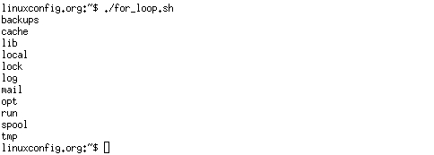

**Bash while loop**

#!/bin/bash  
COUNT=6  
# bash while loop  
while [ $COUNT -gt 0 ]; do  
 echo Value of count is: $COUNT  
 let COUNT=COUNT-1  
done

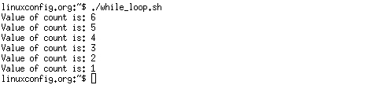

**Bash until loop**

#!/bin/bash  
COUNT=0  
# bash until loop  
until [ $COUNT -gt 5 ]; do  
 echo Value of count is: $COUNT  
 let COUNT=COUNT+1  
done

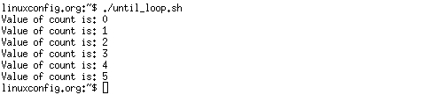

**Control bash loop with**

Here is a example of while loop controlled by standard input. Until the redirection chain from STDOUT to STDIN to the read command exists the while loop continues.

#!/bin/bash  
# This bash script will locate and replace spaces  
# in the filenames  
DIR="."  
# Controlling a loop with bash read command by redirecting STDOUT as  
# a STDIN to while loop  
# find will not truncate filenames containing spaces  
find $DIR -type f | while read file; do  
# using POSIX class [:space:] to find space in the filename  
if [[ "$file" = *[[:space:]]* ]]; then  
# substitute space with "_" character and consequently rename the file  
mv "$file" `echo $file | tr ' ' '_'`  
fi;  
# end of while loop  
done

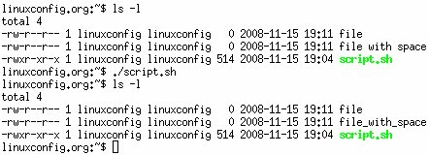

**Bash Functions**

!/bin/bash  
# BASH FUNCTIONS CAN BE DECLARED IN ANY ORDER  
function function_B {  
 echo Function B.  
}  
function function_A {  
 echo $1  
}  
function function_D {  
 echo Function D.  
}  
function function_C {  
 echo $1  
}  
# FUNCTION CALLS  
# Pass parameter to function A  
function_A "Function A."  
function_B  
# Pass parameter to function C  
function_C "Function C."  
function_D

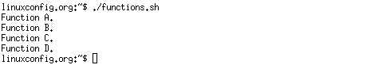

**Bash Select**

#!/bin/bash  
   
PS3='Choose one word: '   
  
# bash select  
select word in "linux" "bash" "scripting" "tutorial"   
do  
 echo "The word you have selected is: $word"  
# Break, otherwise endless loop  
 break   
done  
  
exit 0

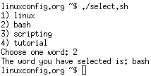

**Case statement conditional**

#!/bin/bash  
echo "What is your preferred programming / scripting language"  
echo "1) bash"  
echo "2) perl"  
echo "3) phyton"  
echo "4) c++"  
echo "5) I do not know !"  
read case;  
#simple case bash structure  
# note in this case $case is variable and does not have to  
# be named case this is just an example  
case $case in  
 1) echo "You selected bash";;  
 2) echo "You selected perl";;  
 3) echo "You selected phyton";;  
 4) echo "You selected c++";;  
 5) exit  
esac

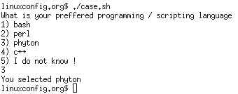

**Bash quotes and quotations**

Quotations and quotes are important part of bash and bash scripting. Here are some bash quotes and quotations basics.

**Escaping Meta characters**

Before we start with quotes and quotations we should know something about escaping meta characters. Escaping will suppress a special meaning of meta characters and therefore meta characters will be read by bash literally. To do this we need to use backslash "\" character. Example:

#!/bin/bash  
   
#Declare bash string variable  
BASH_VAR="Bash Script"  
  
# echo variable BASH_VAR  
echo $BASH_VAR  
  
#when meta character such us "$" is escaped with "\" it will be read literally  
echo $BASH_VAR   
  
# backslash has also special meaning and it can be suppressed with yet another "\"  
echo "\"

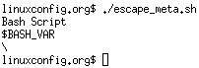

**Single quotes**

Single quotes in bash will suppress special meaning of every meta characters. Therefore meta characters will be read literally. It is not possible to use another single quote within two single quotes not even if the single quote is escaped by backslash.

#!/bin/bash  
   
 #Declare bash string variable  
 BASH_VAR="Bash Script"  
   
 # echo variable BASH_VAR  
 echo $BASH_VAR  
   
 # meta characters special meaning in bash is suppressed when using single quotes   
 echo '$BASH_VAR "$BASH_VAR"'

Using single quotes in bash

**Double Quotes**

Double quotes in bash will suppress special meaning of every meta characters except "$", "\" and "`". Any other meta characters will be read literally. It is also possible to use single quote within double quotes. If we need to use double quotes within double quotes bash can read them literally when escaping them with "\". Example:

#!/bin/bash  
   
#Declare bash string variable  
BASH_VAR="Bash Script"  
  
# echo variable BASH_VAR  
echo $BASH_VAR  
  
# meta characters and its special meaning in bash is   
# suppressed when using double quotes except "$", "\" and "`"  
  
echo "It's $BASH_VAR and \"$BASH_VAR\" using backticks: `date`"

Using double quotes in bash

**Bash quoting with ANSI-C style**

There is also another type of quoting and that is ANSI-C. In this type of quoting characters escaped with "\" will gain special meaning according to the ANSI-C standard.

|  |  |  |  |
| --- | --- | --- | --- |
| \a | alert (bell) | \b | backspace |
| \e | an escape character | \f | form feed |
| \n | newline | \r | carriage return |
| \t | horizontal tab | \v | vertical tab |
| \\ | backslash | \` | single quote |
| \nnn | octal value of characters ( see [http://www.asciitable.com/ ASCII table] ) | \xnn | hexadecimal value of characters ( see [http://www.asciitable.com/ ASCII table] ) |

The syntax fo ansi-c bash quoting is: $'' . Here is an example:

#!/bin/bash  
   
# as a example we have used \n as a new line, \x40 is hex value for @  
# and is octal value for .  
echo $'web: www.linuxconfig.org\nemail: web\x40linuxconfigorg'

quoting in bash with ansi-c stype

**Arithmetic Operations**

**Bash Addition Calculator Example**

#!/bin/bash  
   
let RESULT1=$1+$2  
echo $1+$2=$RESULT1 ' -> # let RESULT1=$1+$2'  
declare -i RESULT2  
RESULT2=$1+$2  
echo $1+$2=$RESULT2 ' -> # declare -i RESULT2; RESULT2=$1+$2'  
echo $1+$2=$(($1 + $2)) ' -> # $(($1 + $2))'

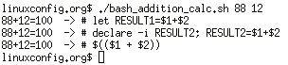

**Bash Arithmetics**

#!/bin/bash  
   
echo '### let ###'  
# bash addition  
let ADDITION=3+5  
echo "3 + 5 =" $ADDITION  
  
# bash subtraction  
let SUBTRACTION=7-8  
echo "7 - 8 =" $SUBTRACTION   
  
# bash multiplication  
let MULTIPLICATION=5*8  
echo "5 * 8 =" $MULTIPLICATION  
  
# bash division  
let DIVISION=4/2  
echo "4 / 2 =" $DIVISION  
  
# bash modulus  
let MODULUS=9%4  
echo "9 % 4 =" $MODULUS  
  
# bash power of two  
let POWEROFTWO=2**2  
echo "2 ^ 2 =" $POWEROFTWO  
  
  
echo '### Bash Arithmetic Expansion ###'  
# There are two formats for arithmetic expansion: $[ expression ]   
# and $(( expression #)) its your choice which you use  
  
echo 4 + 5 = $((4 + 5))  
echo 7 - 7 = $[ 7 - 7 ]  
echo 4 x 6 = $((3 * 2))  
echo 6 / 3 = $((6 / 3))  
echo 8 % 7 = $((8 % 7))  
echo 2 ^ 8 = $[ 2 ** 8 ]  
  
  
echo '### Declare ###'  
  
echo -e "Please enter two numbers \c"  
# read user input  
read num1 num2  
declare -i result  
result=$num1+$num2  
echo "Result is:$result "  
  
# bash convert binary number 10001  
result=2#10001  
echo $result  
  
# bash convert octal number 16  
result=8#16  
echo $result  
  
# bash convert hex number 0xE6A  
result=16#E6A  
echo $result

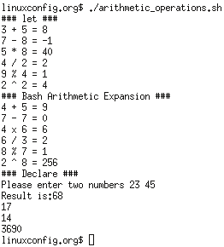

**Round floating point number**

#!/bin/bash  
# get floating point number  
floating_point_number=3.3446  
echo $floating_point_number  
# round floating point number with bash  
for bash_rounded_number in $(printf %.0f $floating_point_number); do  
echo "Rounded number with bash:" $bash_rounded_number  
done

Round floating point number with bash

**Bash floating point calculations**

#!/bin/bash  
# Simple linux bash calculator   
echo "Enter input:"   
read userinput  
echo "Result with 2 digits after decimal point:"  
echo "scale=2; ${userinput}" | bc   
echo "Result with 10 digits after decimal point:"  
echo "scale=10; ${userinput}" | bc   
echo "Result as rounded integer:"  
echo $userinput | bc

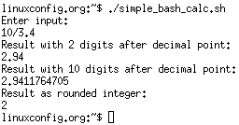

**Redirections**

**STDOUT from bash script to STDERR**

#!/bin/bash  
   
 echo "Redirect this STDOUT to STDERR" 1>&2

To prove that STDOUT is redirected to STDERR we can redirect script's output to file:  
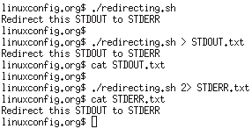

**STDERR from bash script to STDOUT**

#!/bin/bash  
   
 cat $1 2>&1

To prove that STDERR is redirected to STDOUT we can redirect script's output to file:  
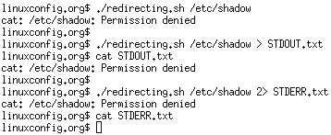

**stdout to screen**

The simple way to redirect a standard output ( stdout ) is to simply use any command, because by default stdout is automatically redirected to screen. First create a file "file1":

$ touch file1

$ ls file1

file1

As you can see from the example above execution of ls command produces STDOUT which by default is redirected to screen.

**stdout to file**

The override the default behavior of STDOUT we can use ">" to redirect this output to file:

$ ls file1 > STDOUT

$ cat STDOUT

file1

**stderr to file**

By default STDERR is displayed on the screen:

$ ls

file1 STDOUT

$ ls file2

ls: cannot access file2: No such file or directory

In the following example we will redirect the standard error ( stderr ) to a file and stdout to a screen as default. Please note that STDOUT is displayed on the screen, however STDERR is redirected to a file called STDERR:

$ ls

file1 STDOUT

$ ls file1 file2 2> STDERR

file1

$ cat STDERR

ls: cannot access file2: No such file or directory

**stdout to stderr**

It is also possible to redirect STDOUT and STDERR to the same file. In the next example we will redirect STDOUT to the same descriptor as STDERR. Both STDOUT and STDERR will be redirected to file "STDERR_STDOUT".

$ ls

file1 STDERR STDOUT

$ ls file1 file2 2> STDERR_STDOUT 1>&2

$ cat STDERR_STDOUT

ls: cannot access file2: No such file or directory

file1

File STDERR_STDOUT now contains STDOUT and STDERR.

**stderr to stdout**

The above example can be reversed by redirecting STDERR to the same descriptor as SDTOUT:

$ ls

file1 STDERR STDOUT

$ ls file1 file2 > STDERR_STDOUT 2>&1

$ cat STDERR_STDOUT

ls: cannot access file2: No such file or directory

file1

**stderr and stdout to file**

Previous two examples redirected both STDOUT and STDERR to a file. Another way to achieve the same effect is illustrated below:

$ ls

file1 STDERR STDOUT

$ ls file1 file2 &> STDERR_STDOUT

$ cat STDERR_STDOUT

ls: cannot access file2: No such file or directory

file1

or

ls file1 file2 >& STDERR_STDOUT

$ cat STDERR_STDOUT

ls: cannot access file2: No such file or directory

file1