- Database is a place where we store Data.
- Amazon has 2 offering ( 1. RDS (for SQL Database(rows n columns) 2.DynamoDB(structure less Db) )
- There is also Red shift ( is for Data warehouse)

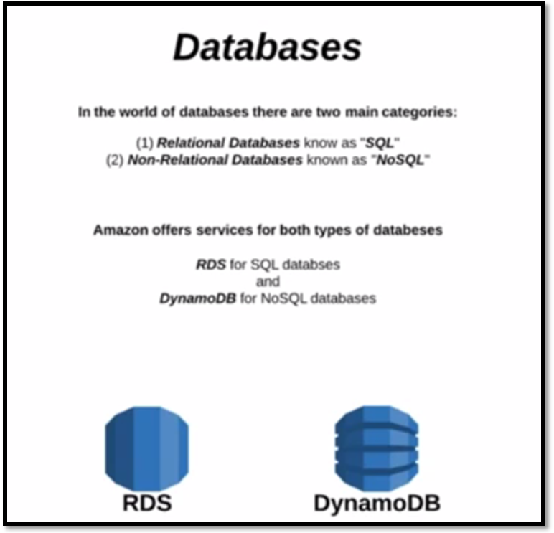
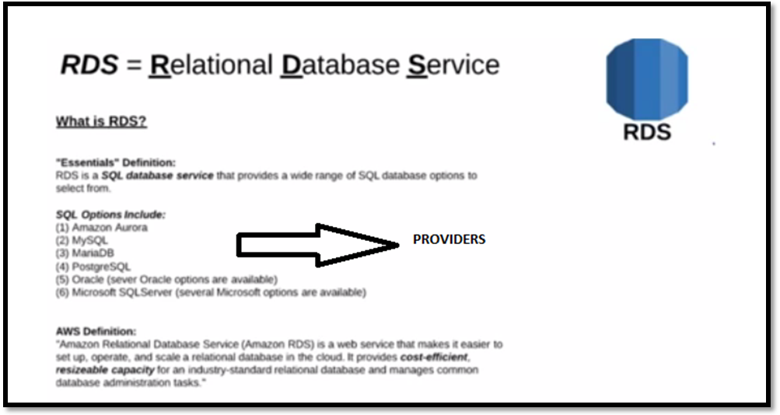

Popular:- Oracle, mysql, postgres sql
- Amazon aurora : is forked from mysql and Amazon made some customization. it is not free.

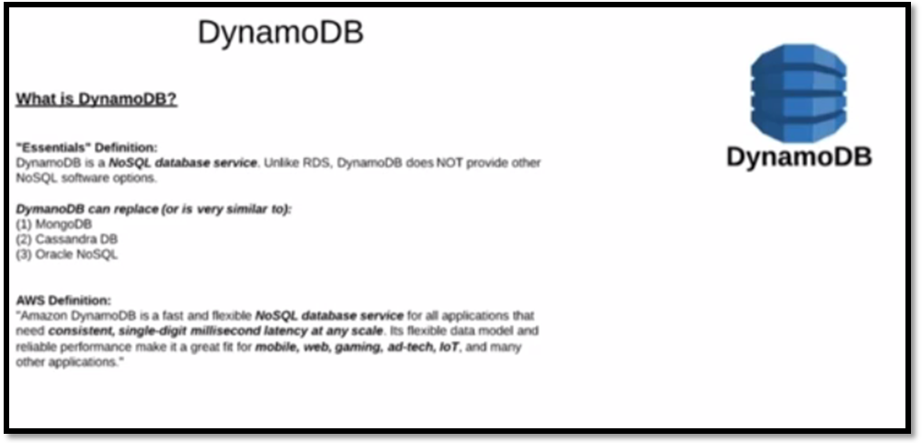

- It is No-Sql database custom designed by Amazon
- if your application is using mongo db or cassandra DB or oracle no sql we can replace with Dynamo DB in aws , & not using same db u have used in.
- we use no sql where we don't predict structure (
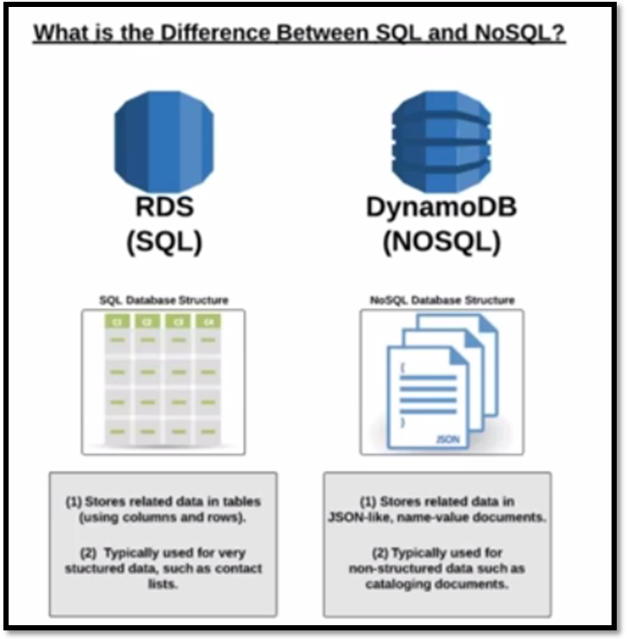
RDS : Query to retrieve
No SQL : API to retrieve data
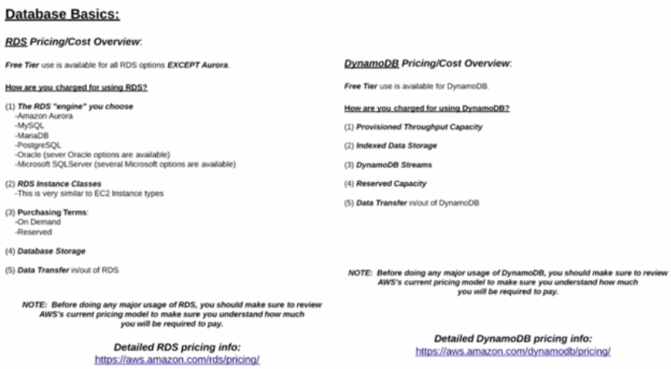
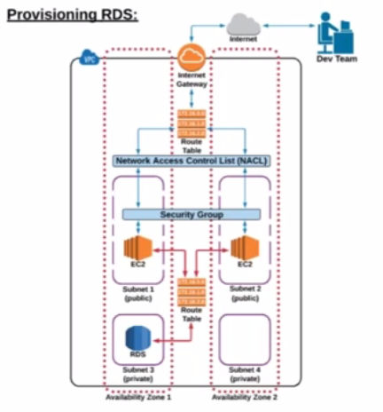

IQ: your admin wants to see how machine is accessible which is here(public) , u should not login into machine n see?
sol: using SSH tunneling( is not a new concept)

Public : If a subnet has route to igw is called public subnet
Private : If a subnet doesn't have route to igw is called private subnet
Q. How do you know whether subnet has internet?
sol: subnet should have route to igw.
Note: web servers alone will be public network, rest all will be in private.

How Aws Works?
Region : Geographical location, every region has AZ and every AZ has data centers.
Asia pacific (region) --- Mumbai (Az) --- (chennai Dc1,bangalore Dc2 etc)
why DC: if one DC goes down, other will be available.
- VPC is a region concept

what is the max retention period in RDS?
35days, retention : backup ,from today how many days we want.
here we have to select /choose window.
what is MySQL port?
3306
where db data stores?
it stores in EC2 ,manages by AWS.

