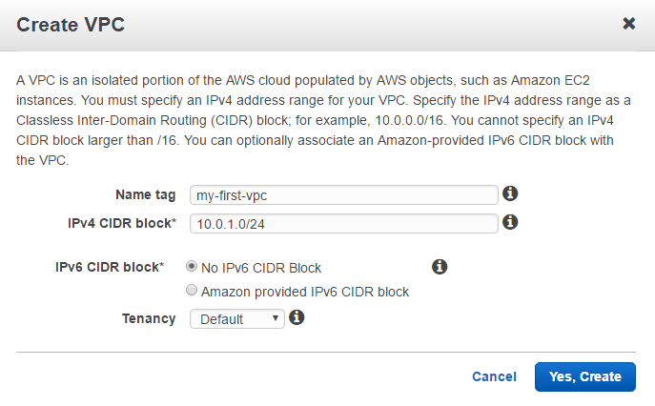
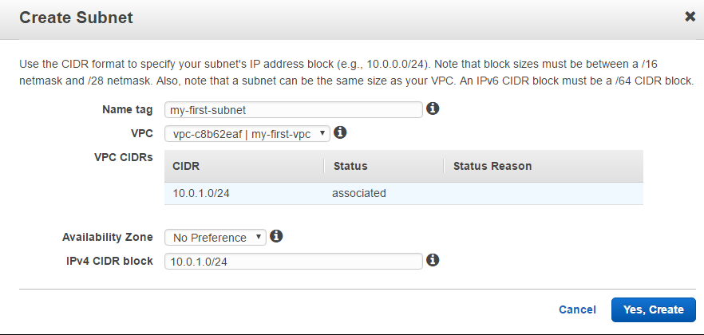

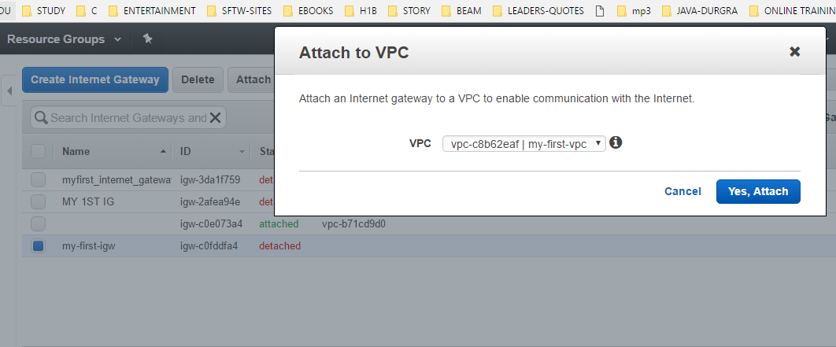

To create a custom route table
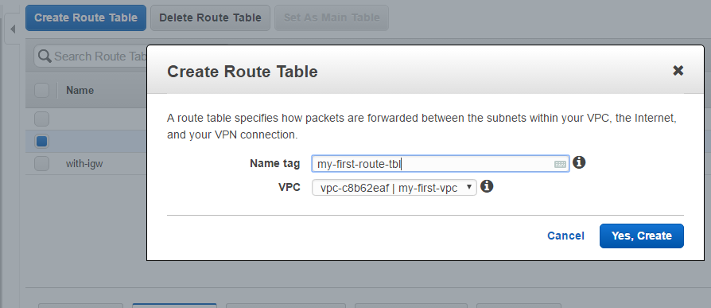

On the Routes tab, choose Edit, Add another route, and add the following routes as necessary. Choose Save when you're done.

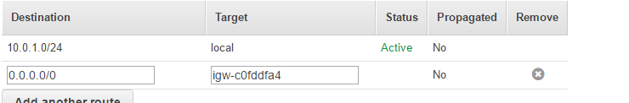

To create a new security group and associate it with your instances

In the Create Security Group dialog box, specify a name for the security group and a description. Select the ID of your VPC from the VPC list, and then choose Yes, Create.
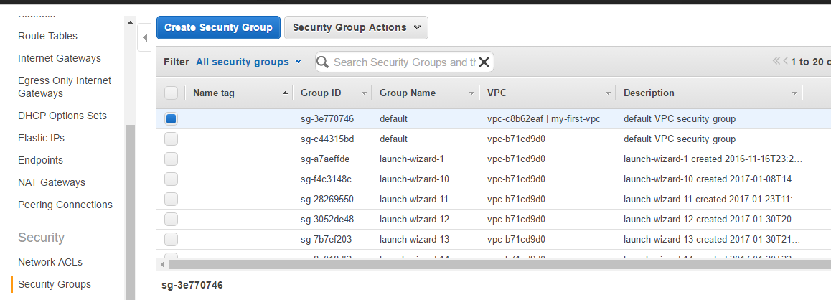

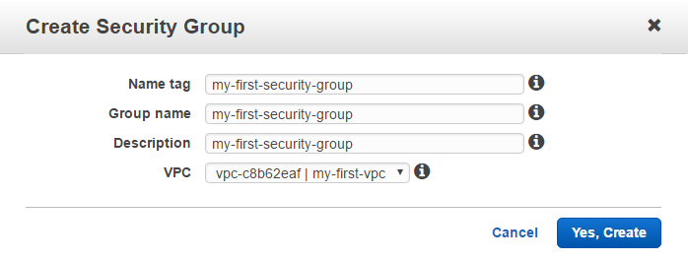
- Select the security group. The details pane displays the details for the security group, plus tabs for working with its inbound rules and outbound rules.
- On the Inbound Rules tab, choose Edit. Choose Add Rule, and complete the required information. For example, select HTTP or HTTPS from the Type list, and enter the Source as 0.0.0.0/0 for IPv4 traffic, or ::/0 for IPv6 traffic. Choose Save when you're done.
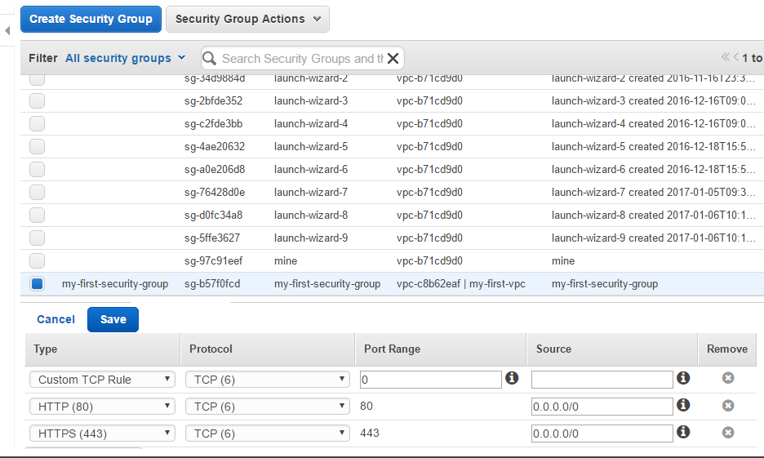
Or
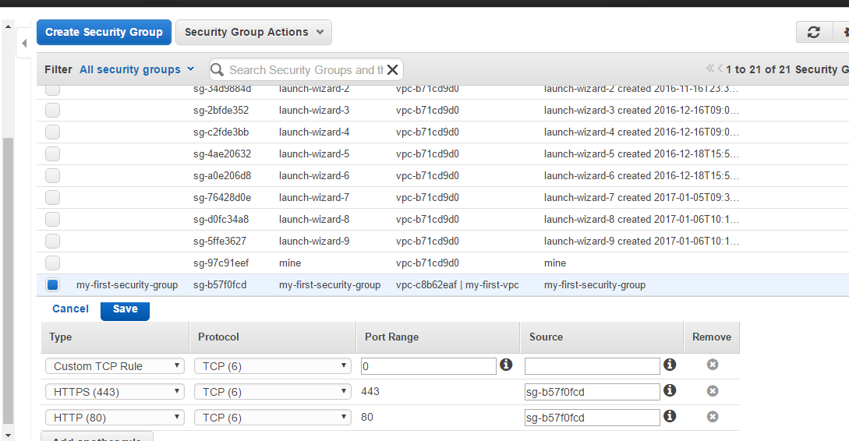

Open the Amazon EC2 console at https://console.aws.amazon.com/ec2/.

In the navigation pane, choose Instances .

