**What is S3?**

* simple object based storage
* File can be 0byes- to-5 tb
* Files are stored in bucket(similar to folder)
* S3 is a universal namespace, that is name must be unique globally.
* when you a file to s3, you will receive a HTTP 200 code if the upload was successful.
* Built for 99.99% availability( Amazon guarantees )

**Notes:**

S3 is a Simple Key-value store

Object consists of following

**- Key** (This is simply the name of the object)

**- value**(This is simply the data, which is made up of sequence of bytes)

**- Versioning**( Important for versioning)

- Metadata(data about file(which holds and etc)

**- Bucket Polices, Access control list**

**- Cross origin resource sharing**

**- transfer acceleration**

**Storage Tiers/Classes:-**

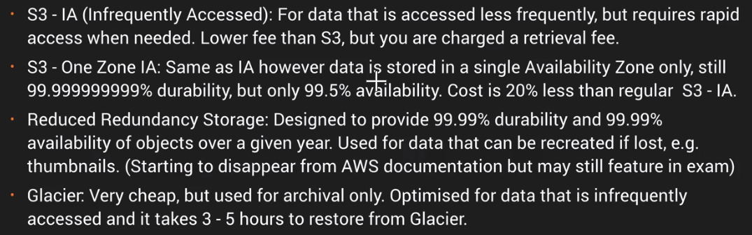

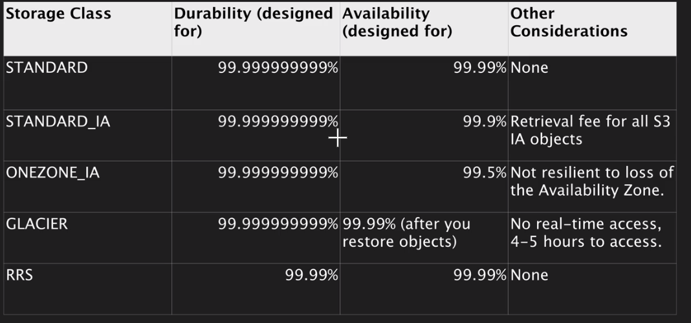

Announcing S3 Intelligent-Tiering — a New Amazon S3 Storage Class

S3 Intelligent-Tiering is a new Amazon S3 storage class designed for customers who want to optimize storage costs automatically when data access patterns change, without performance impact or operational overhead. S3 Intelligent-Tiering is the first cloud object storage class that delivers automatic cost savings by moving data between two access tiers — frequent access and infrequent access — when access patterns change, and is ideal for data with unknown or changing access patterns.

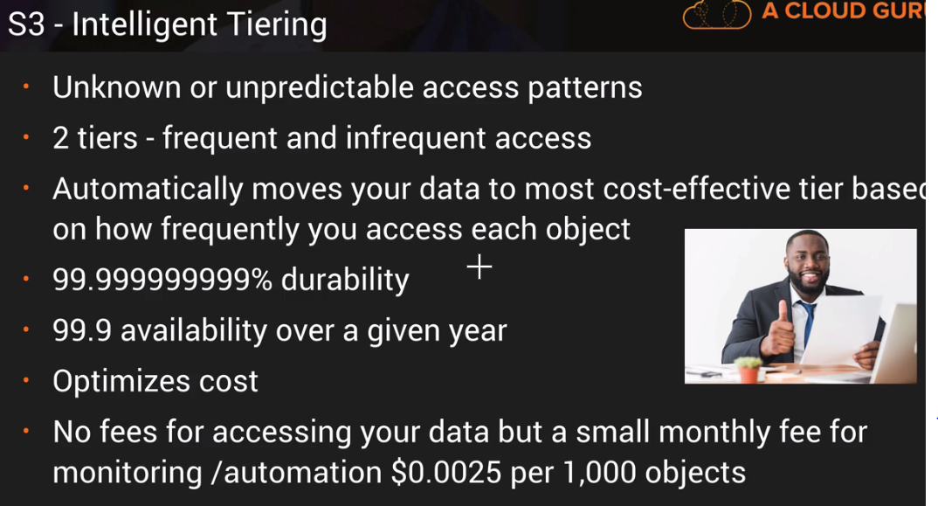

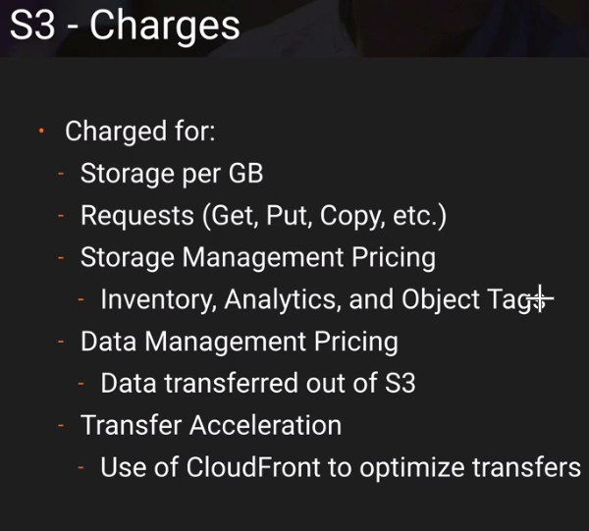

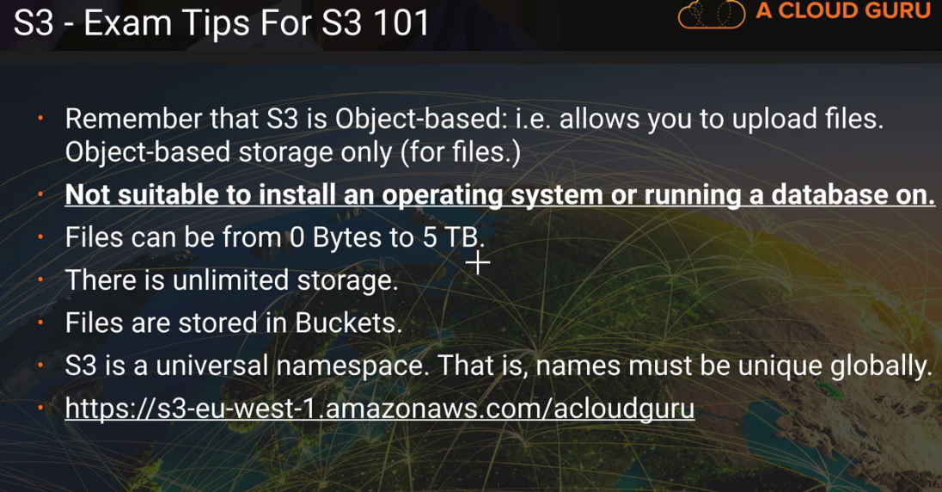

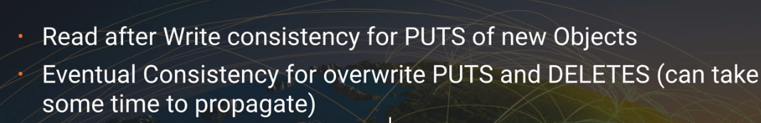

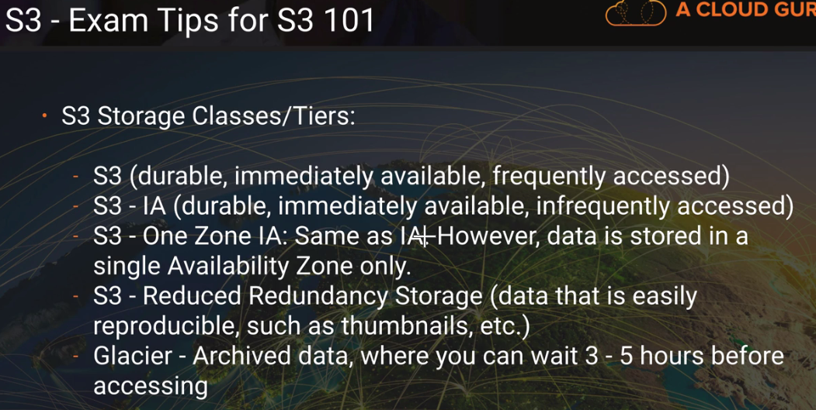

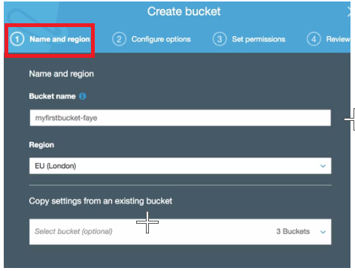

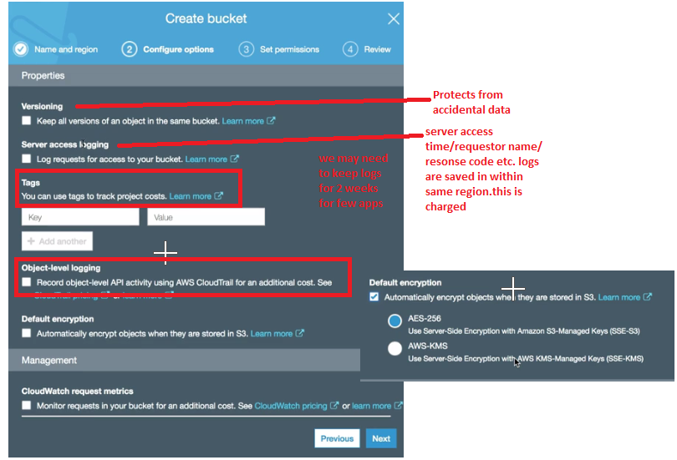 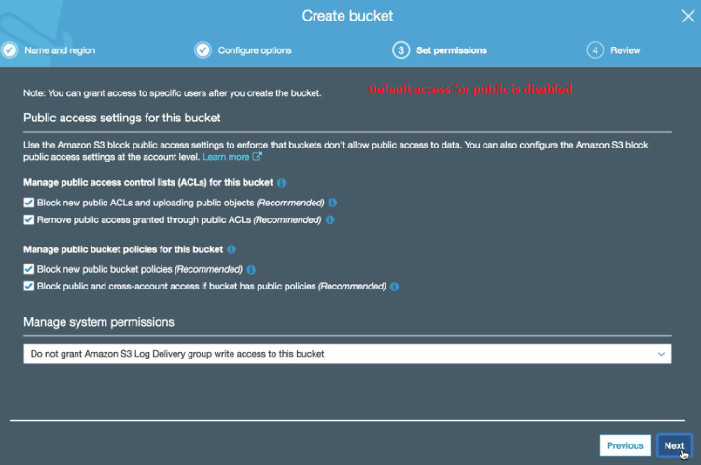

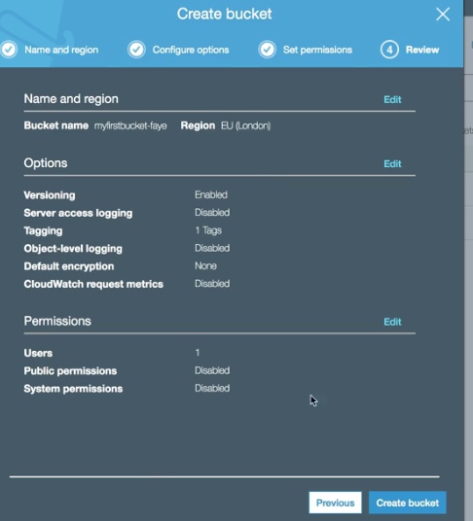

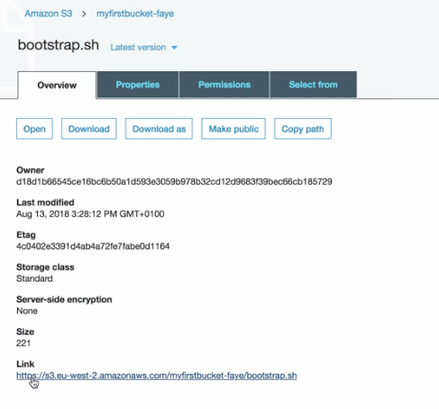

IQ:- will it be possible to revert it, Once we make bucket level objects as public?

Sol: No

