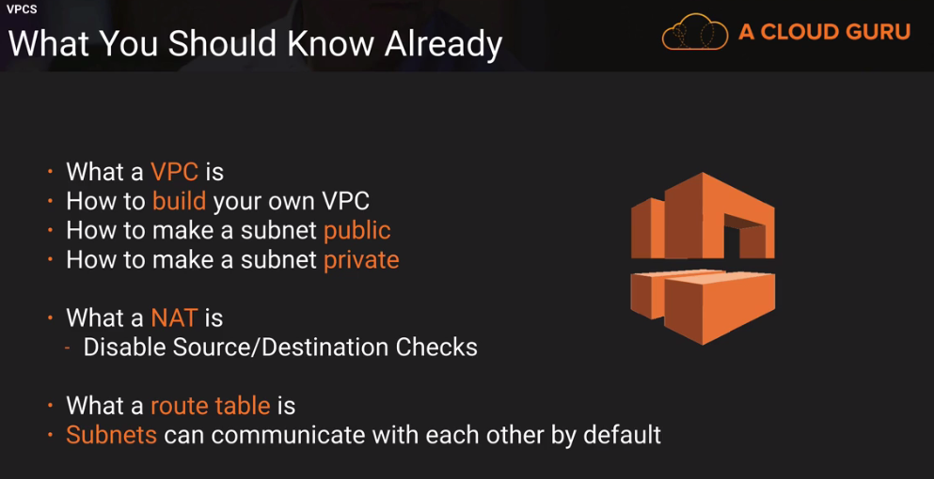

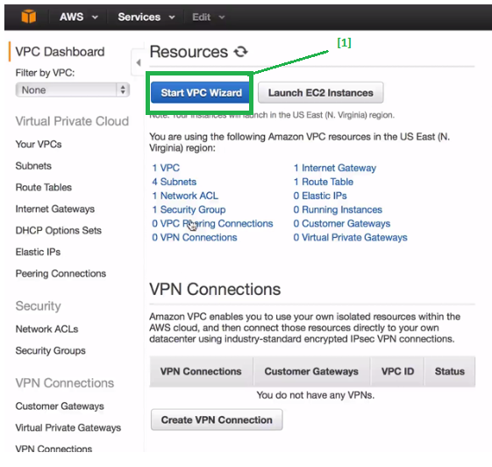

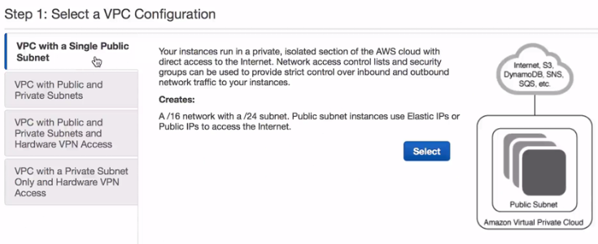

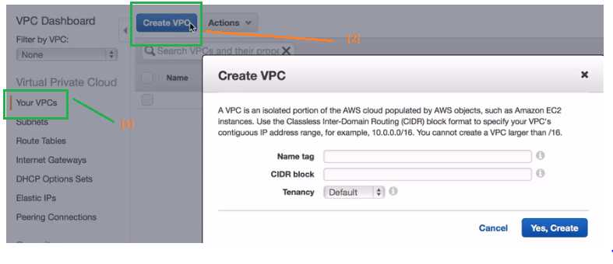

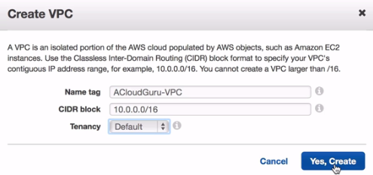

**CIDR** : class less inter domain routing, it is basically subnetting

**[ most common : 10.0.0.0/16 ]**

**Route Table?**

**Note:**

**1. Route table automatically gets created once we created vpc.**

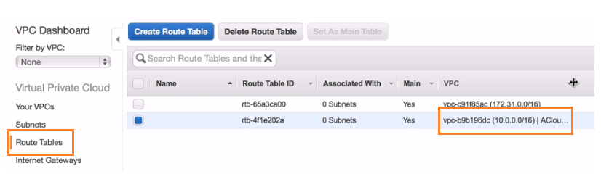

**Subnet**

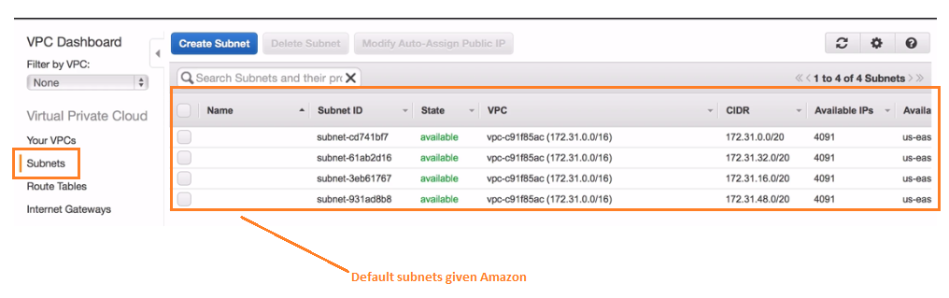

**IQ: subnets are mapped to how many az's?**

**sol: 1**

**Why do we need 3 subnets?**

we would have 3tier architecture,want to have 3 different subnets,

we select one subnets for internet facing application.

**web-dmc--->application---->Database**

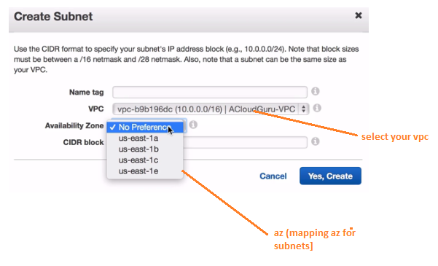

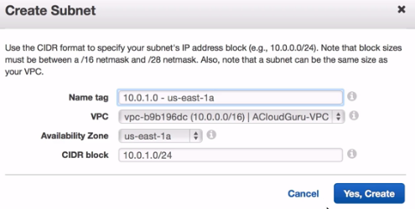

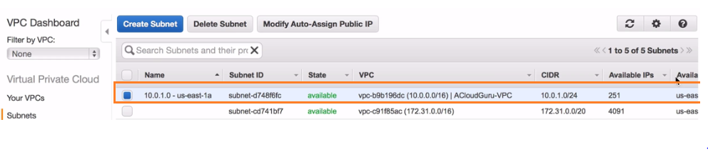

**Second subnet**

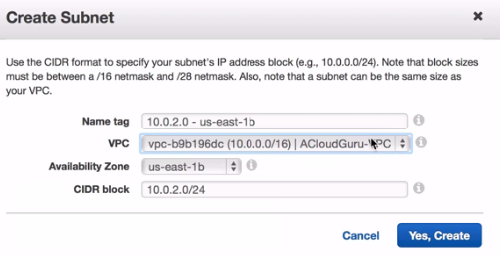

**3rd subnet**

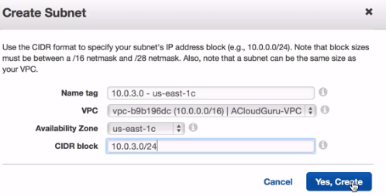

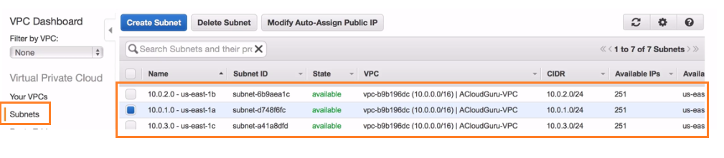

**Internet gateway**

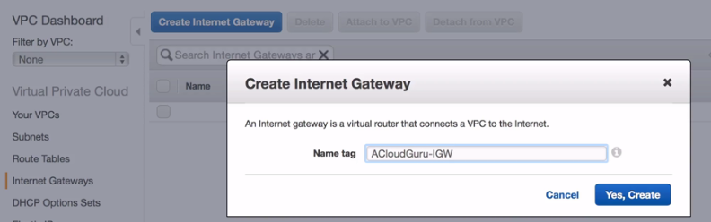

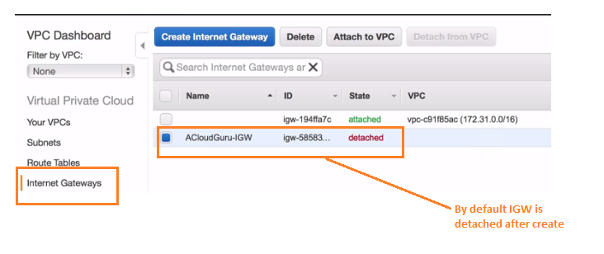

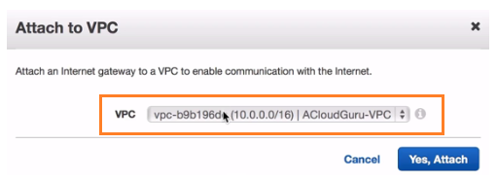

**Summary**

**1.vpc**

**2.subnets with multiple az**

**3.we have route table**

**4.we have internet gateway**

**Create Route table for our Ec2 machines to communicate**

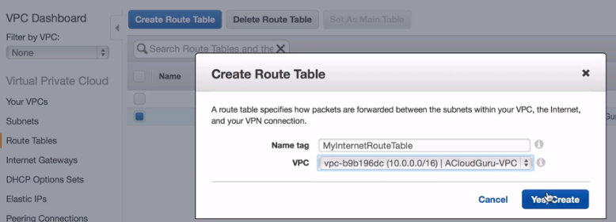

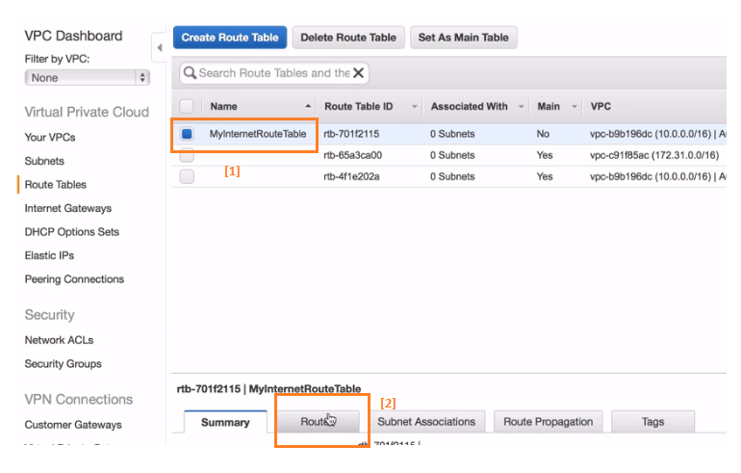

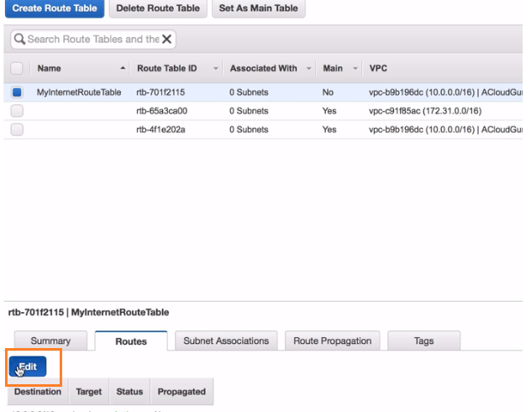

**Add rule below rule for route table with igw (meaning route table has internet access (0.0.0.0)**

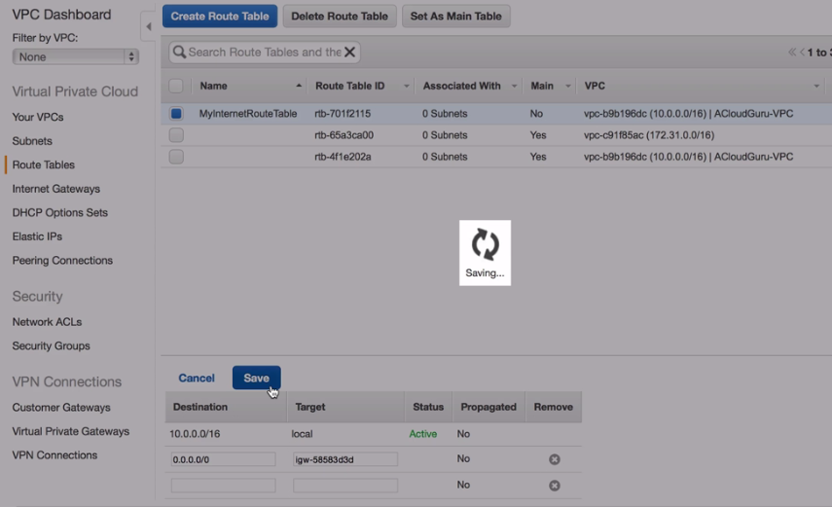

**Choosing which subnet want to have internet**

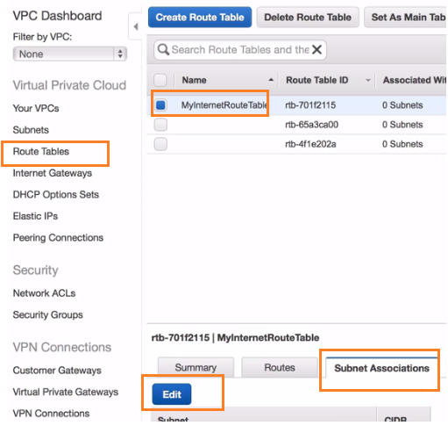

**selecting vpc to have internet facing access and save**

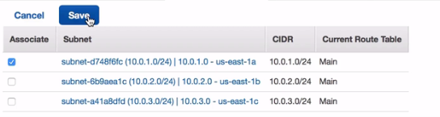

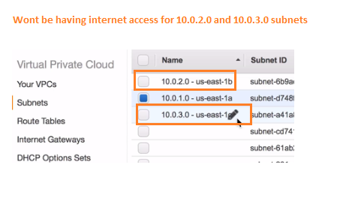

**Task: Deploy an instances with 10.0.1.0 and 10.0.2.0 subnets**

**10.0.1.0**

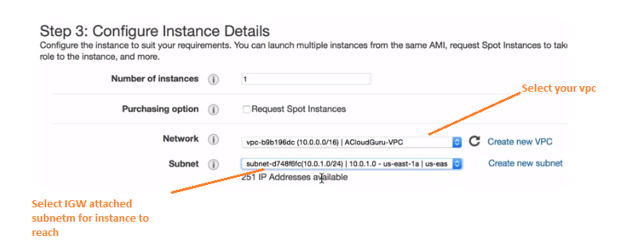

**10.0.2.0 [ No internet access ]**

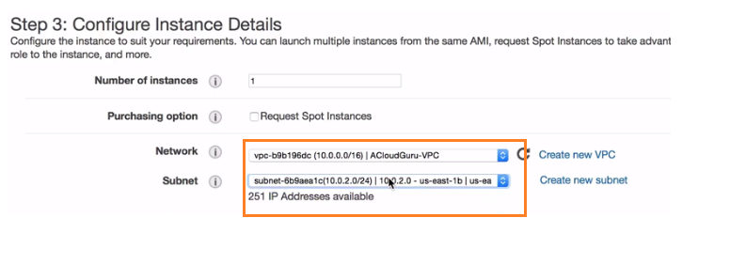

**INSTANCE NAMES FOR 3 SUBNETS**

**1. WEBSERVER 2.APP SERVER 3. DATABASE SERVER**

**SCENARIO:** giving internet access for DB server(run yum update & install mysql)

1. go to security group, create new SG for NAT instance

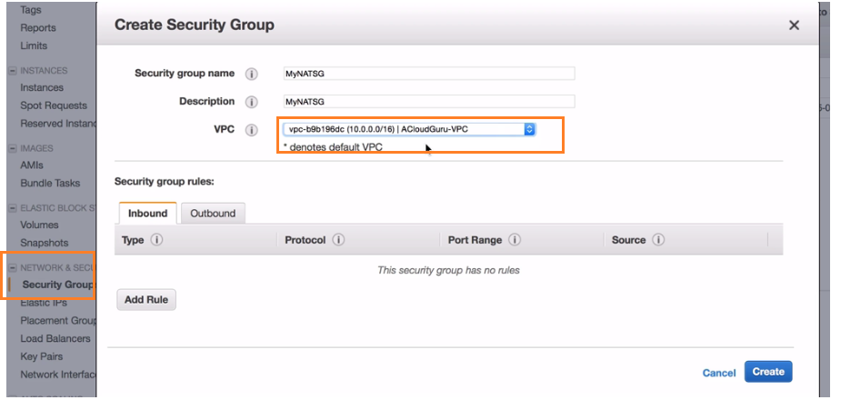

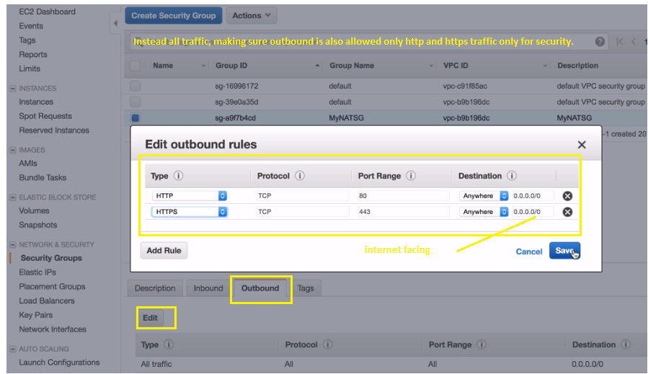

successfully our private subnet allows http and https traffic.

Creating NAT

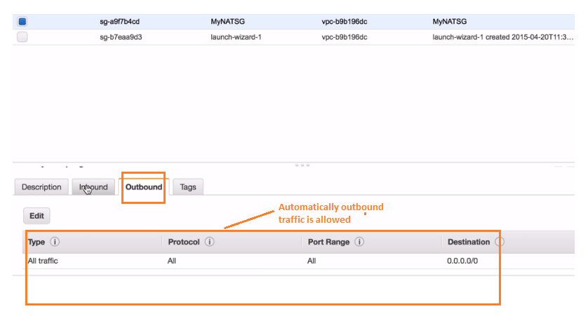

Scenario: NAT is going to communicate with Ec2 instance in our private subnets and its going to allow

http and https traffic to flow from public subnet to priate subnet.

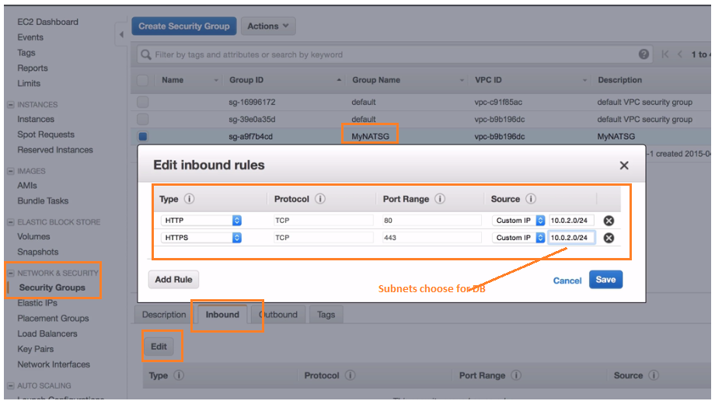

IQ. Network Bottlenecks, nat is not performing well what should you do?

**sol:**

* + use larger instance type becoz we get more "network throughput".
  + if i use t2.micro i will get less "network throughput"
  + m3.xlarge give good 'network throughput'.

**What is Network Throughput?**

Network throughput is usually represented as an average and measured in bits per second (bps), or in some cases as [data packets](http://blog.datapath.io/what-is-a-data-packet) per second. Throughput is an important indicator of the performance and quality of a network connection. A high ratio of unsuccessful message delivery will ultimately lead to lower throughput and degraded performance.

**Creating NAT instance**

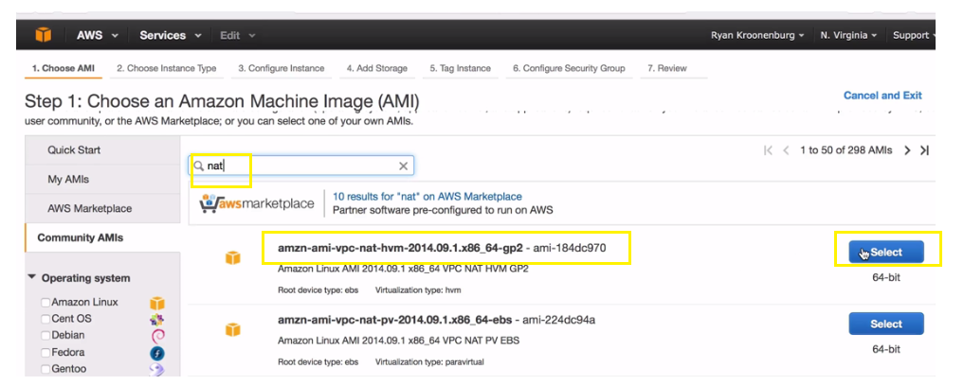

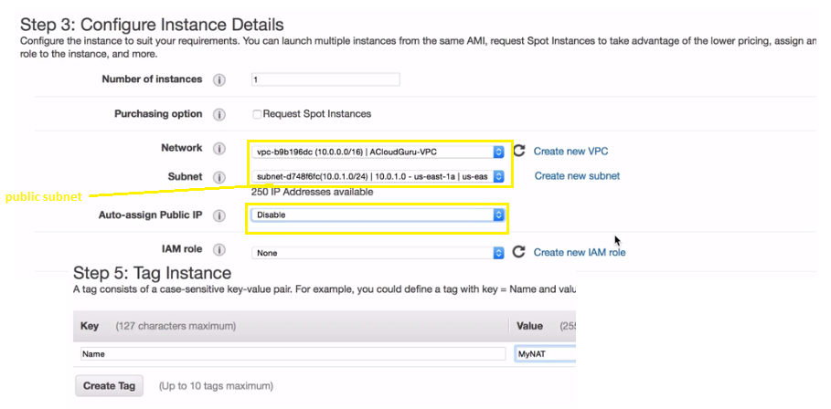

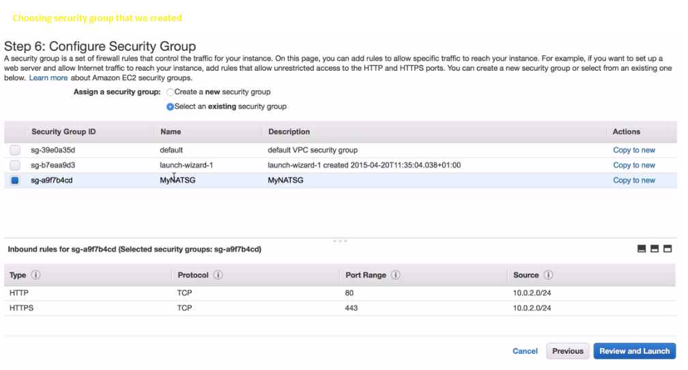

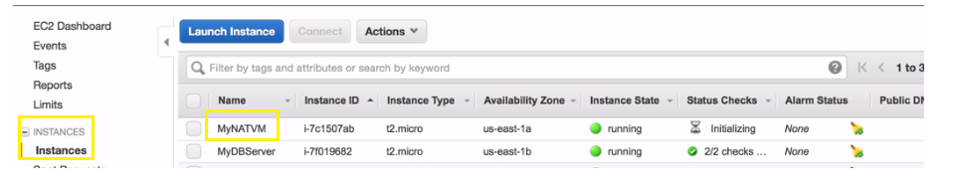

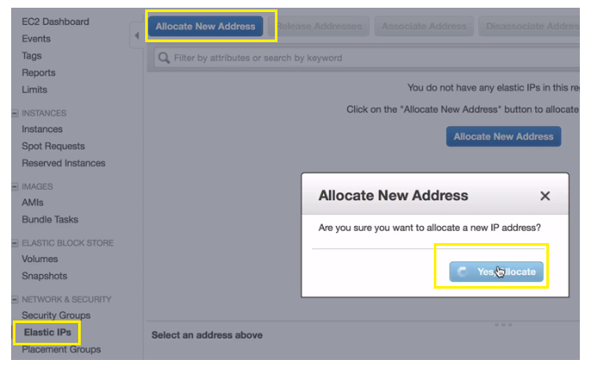

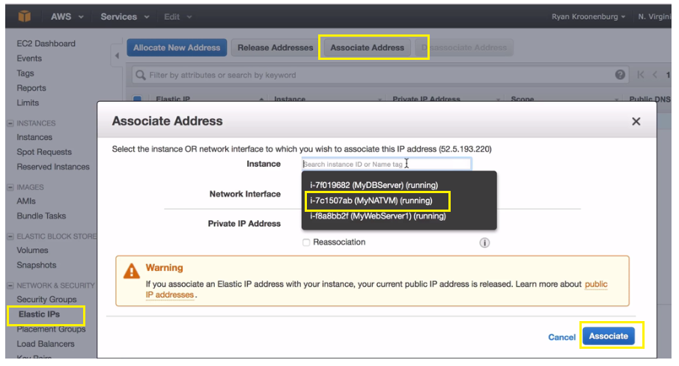

**IQ. you got nat instance,you services u got in private subnets and you cannot communicate to the ec2's,what should u do?**

**sol: disable source and destination checks**

**choose ---natinstance(instance)---actions---network--enable/disable source and destination checks**

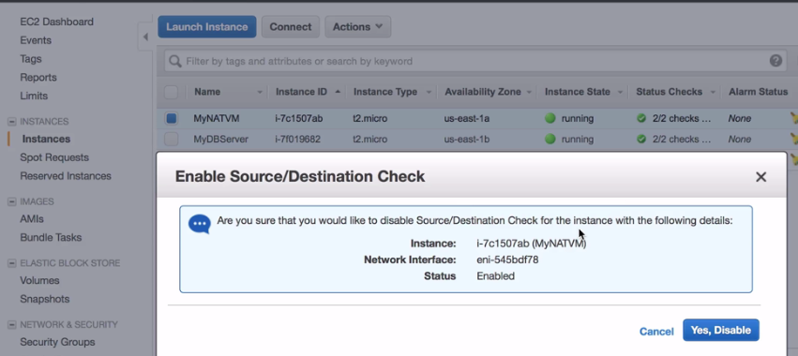

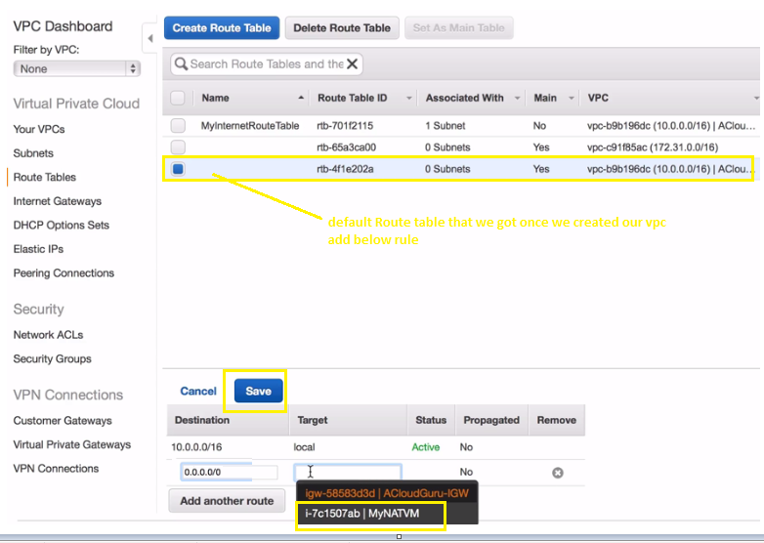

**login to DB server ( run yum update)- u can say u have internet access.**

