**Problem 1 : Experiment with Gaussian discriminators**

In this problem, we implemented Linear Discriminant Analysis (LDA) and Quadratic Discriminant Analysis (QDA).

The accuracy reported for LDA is 97.0%

The accuracy reported for QDA is 96.0%

The plot for discriminating boundary for both linear and quadratic discriminators is as shown below

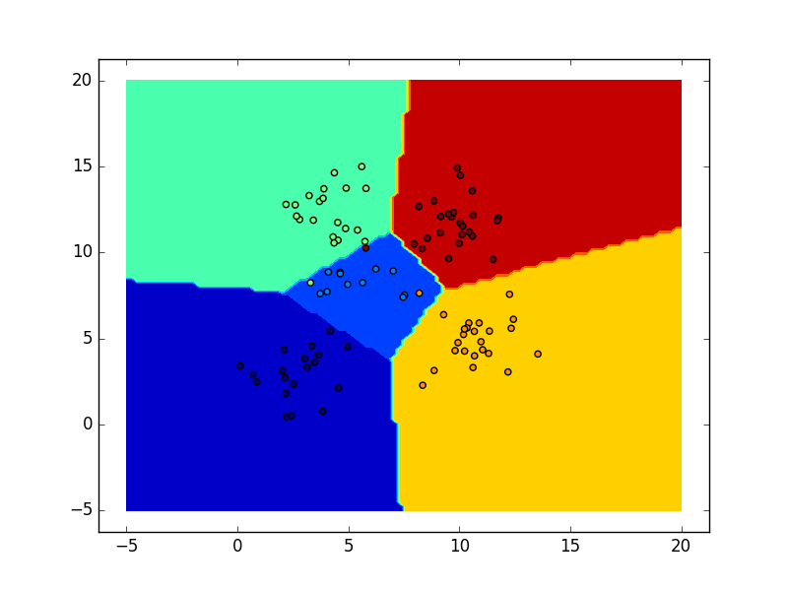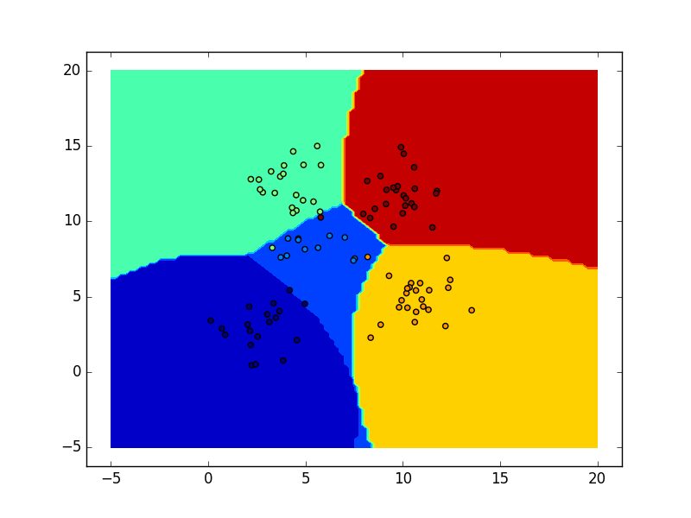

LDA QDA

LDA and QDA are two classic classifiers. They have closed-form solutions that can be easily computed, are inherently multiclass, have proven to work well in practice and have no hyper parameters to tune. As can be seen from the plot above, LDA has a decision boundary which is linear and QDA has decision boundary which is quadratic. QDA fits the data better than LDA, but has more parameters to estimate.

In the case of LDA, the Gaussians for each class are assumed to share the same covariance matrix: Sigma_k = \Sigma for all http://scikit-learn.org/stable/_images/math/e9203da50e1059455123460d4e716c9c7f440cc3.png. This leads to linear decision surfaces between the data. In the case of QDA, there are no assumptions on the covariance matrices Sigma_k of the Gaussians, leading to quadratic decision surfaces. Thus there are differences between the two boundaries.