Ansible Day -1 Task’s

1)Watch ansible-01 video and write down notes.

Completed watching video and making notes.

2) Setup one master and two worker nodes in ansible.

Step-1: Launch 3 Ec2 intances (Ubuntu)

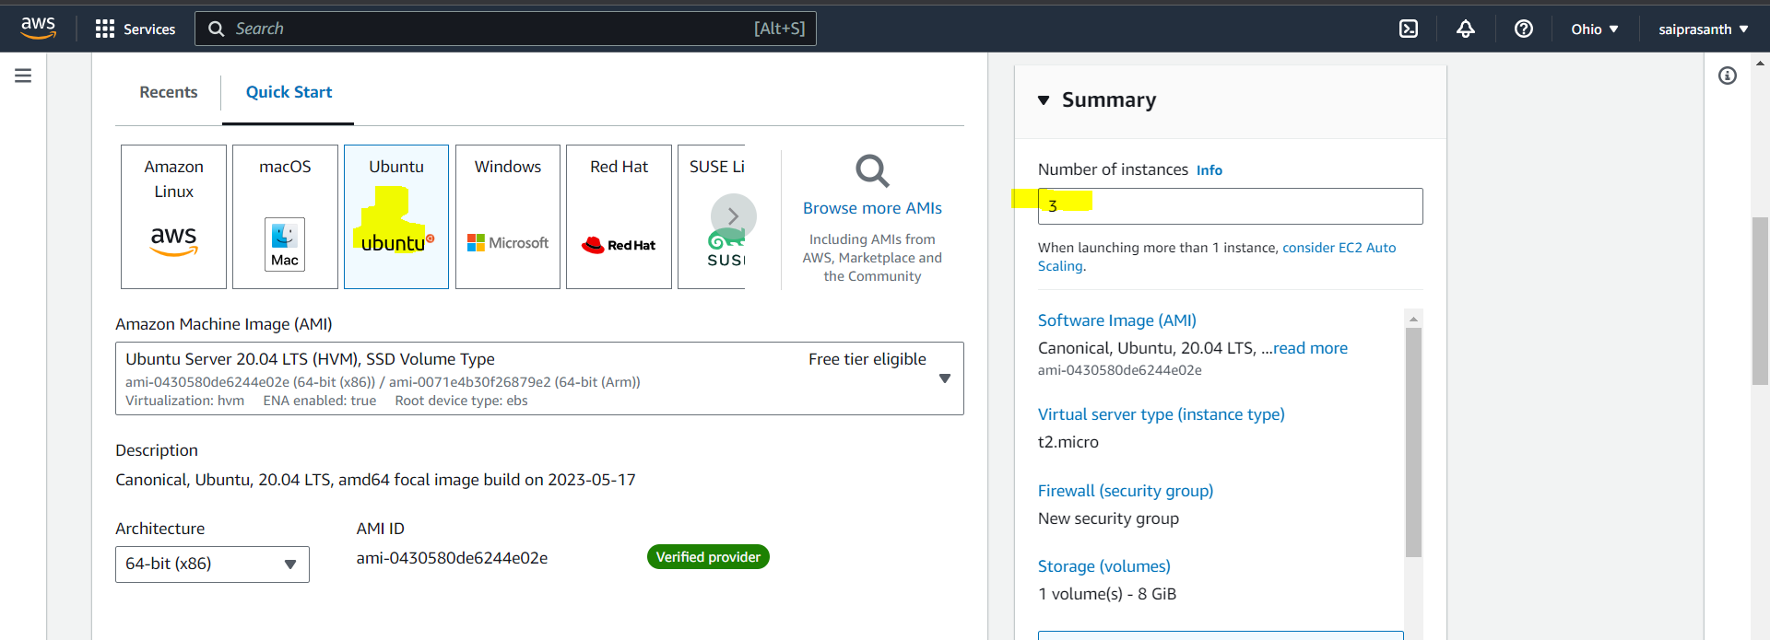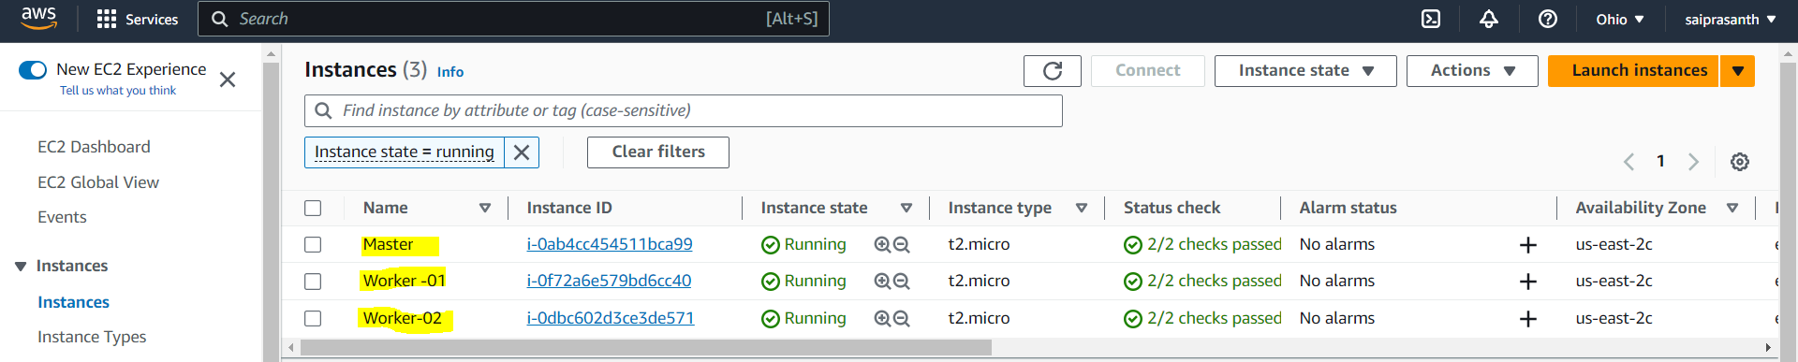

# connet to master server swich to root user

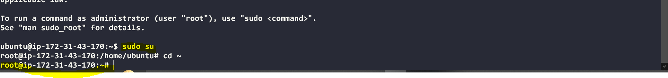

Step -2 :create a key in master server by using ssh –keygen command

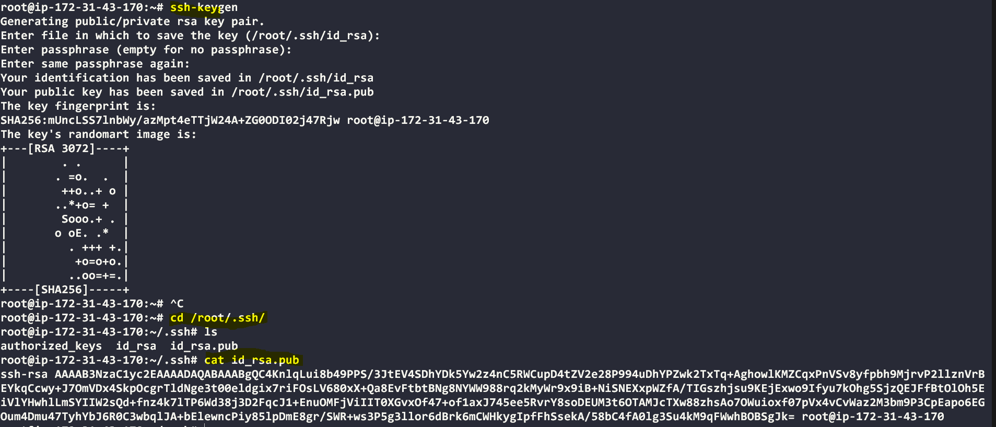

Step -3 :connet to worker- 01 server and copy the generated key in Master and save the key in Worker -01 at authorized keys under.ssh folder.

 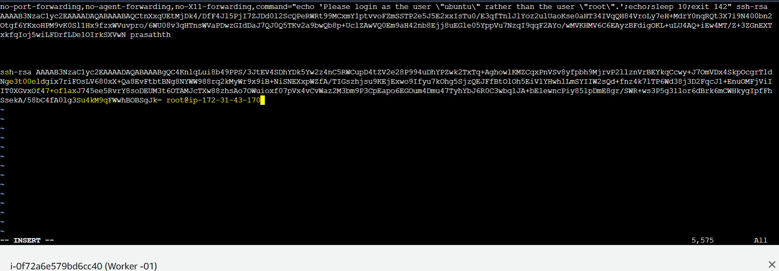 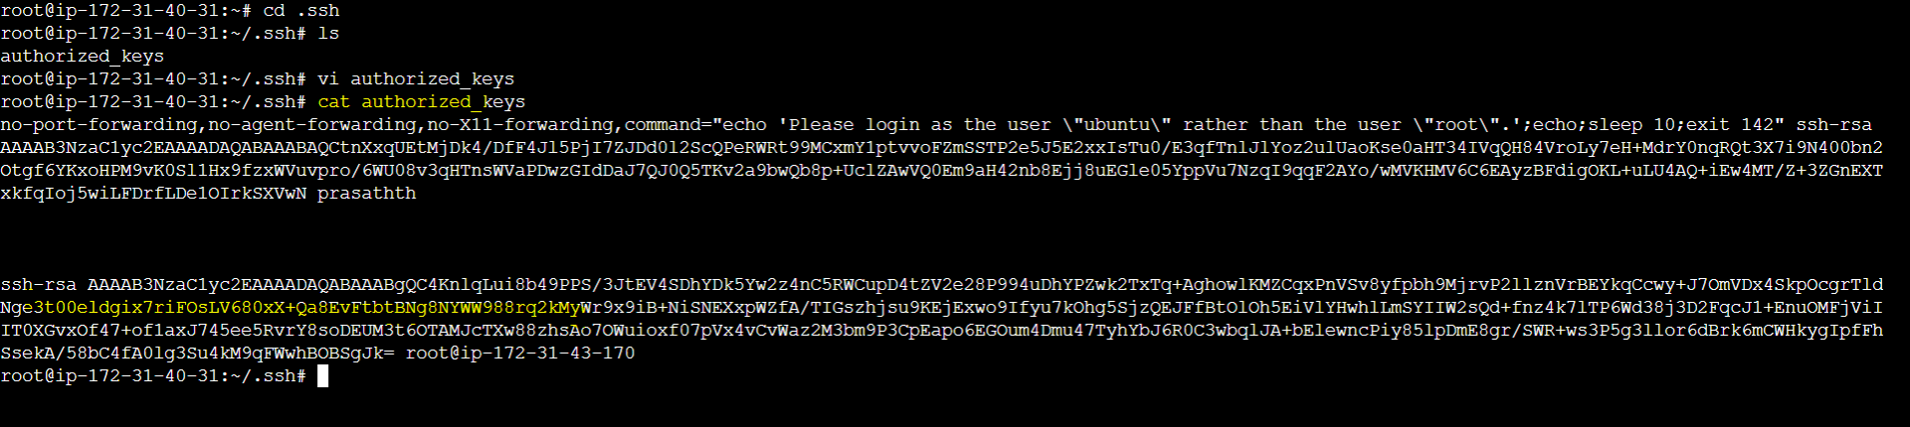

#Check the connection between master and worker

Ssh root@worker-01 public ip

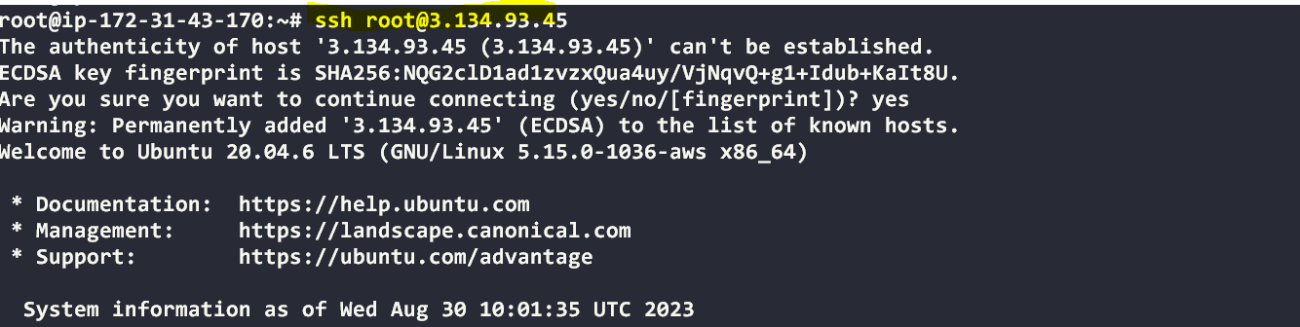 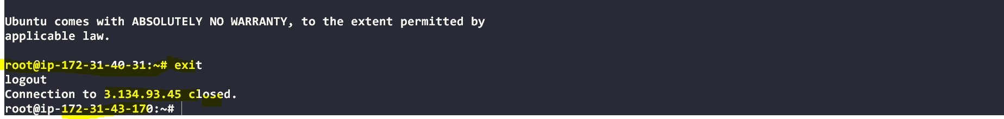

Step -4:connet to worker- 02 server and copy the generated key in Master and save the key in Worker -02 at authorized keys under.ssh folder.

 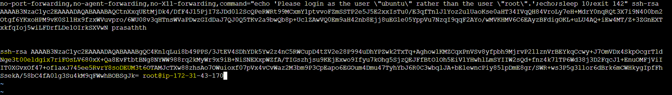

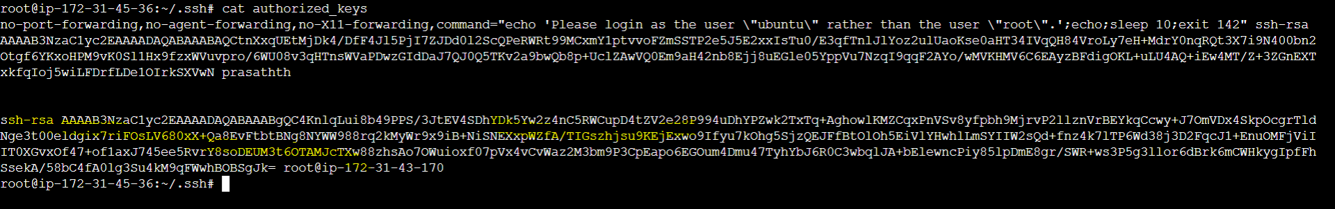

#Check the connection between master and worker

Ssh root@worker-02 public ip

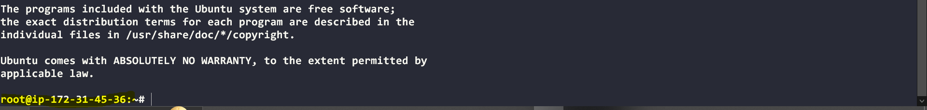

Step-5 install Ansible in master server

Upadte Ubuntu server

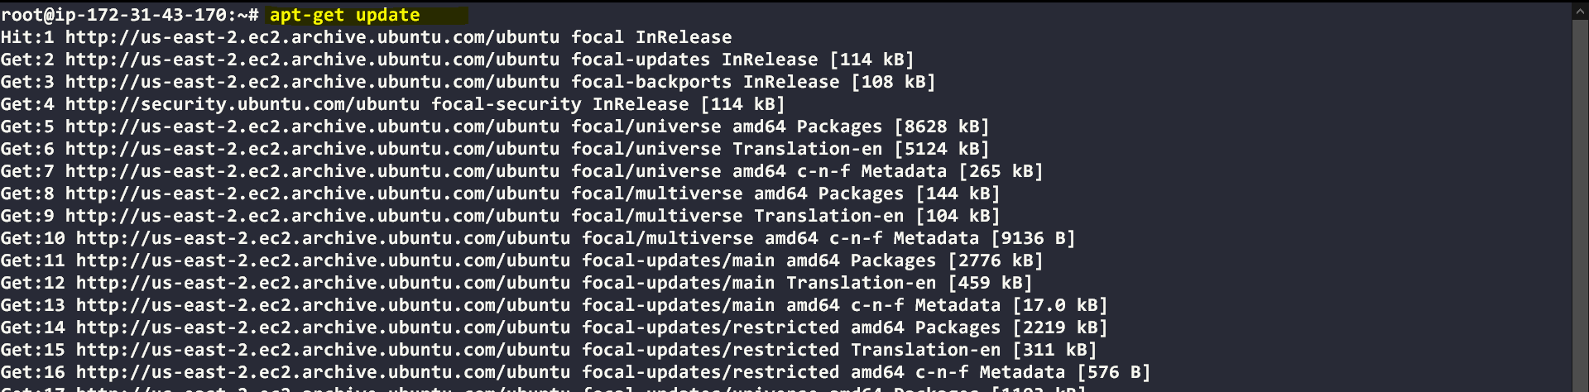

#sudo apt-add-repository ppa:ansible/ansible

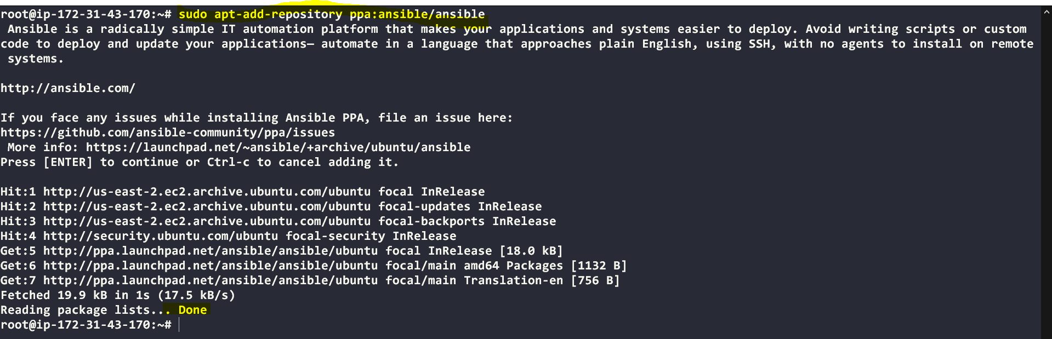

#sudo apt update



#sudo apt install ansible

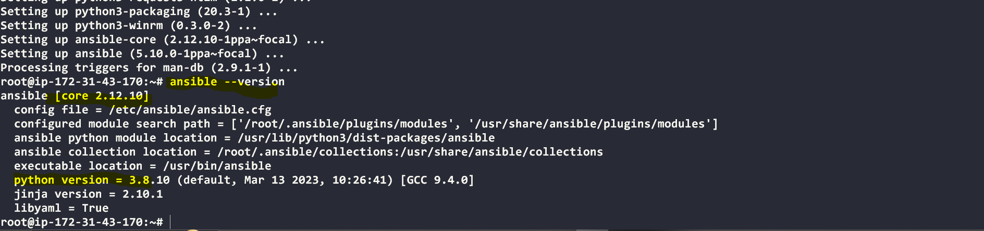

#setting up inverntory file 🡪 cd /etc/ansible

Add the ip address of worker 01,02



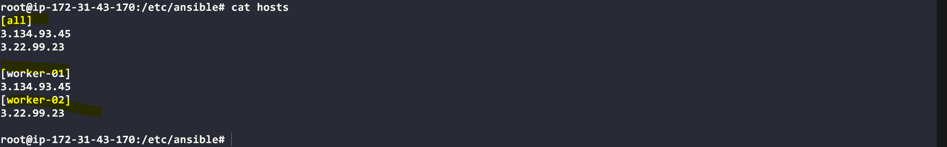

# To check complete details use –vvv

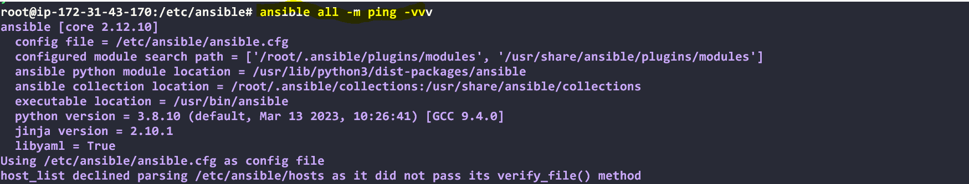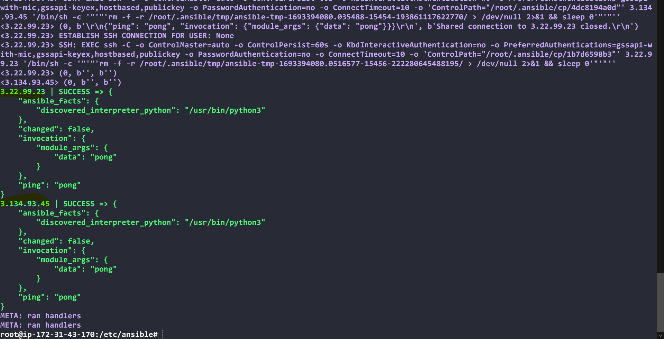

# using customized inventory

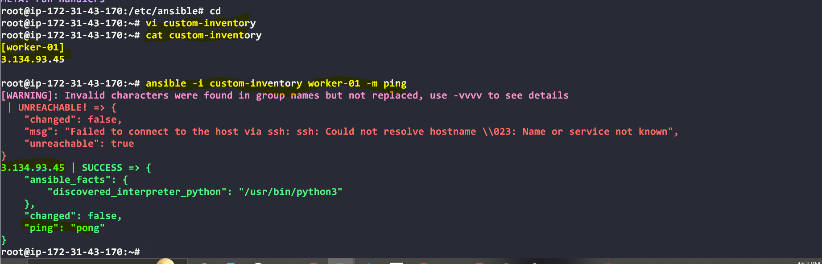

3) Execute the adhoc command shared in #dvps-cloud-documents Channel.

# To check the connetivity between slaves

#ansible all –m ping

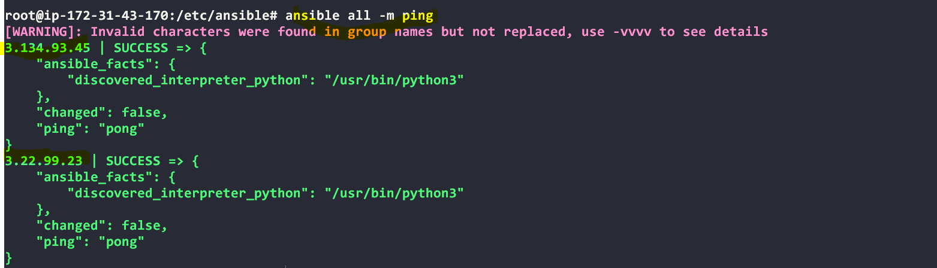

#ansible worker-01 –m ping

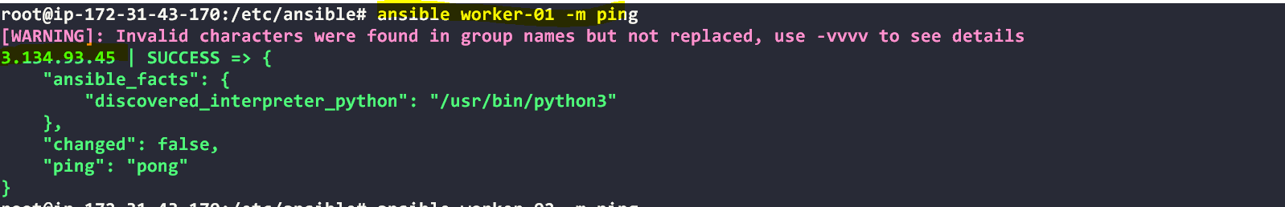

#ansible worker-02 –m ping

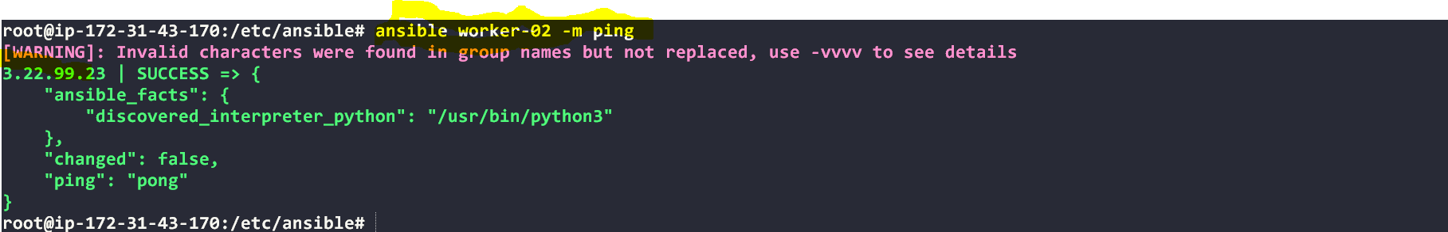

#ansible all -m ping -i ansible_hosts

Tips: -i is used if we are using more than one invertory file

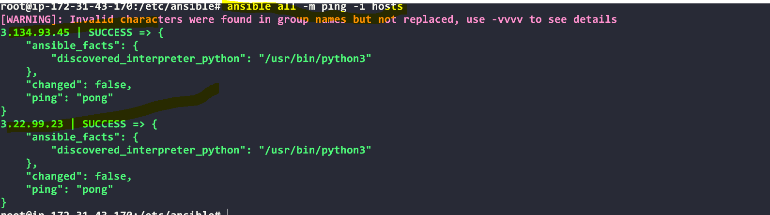# How to gather facts of slave machine

#ansible all -m setup  

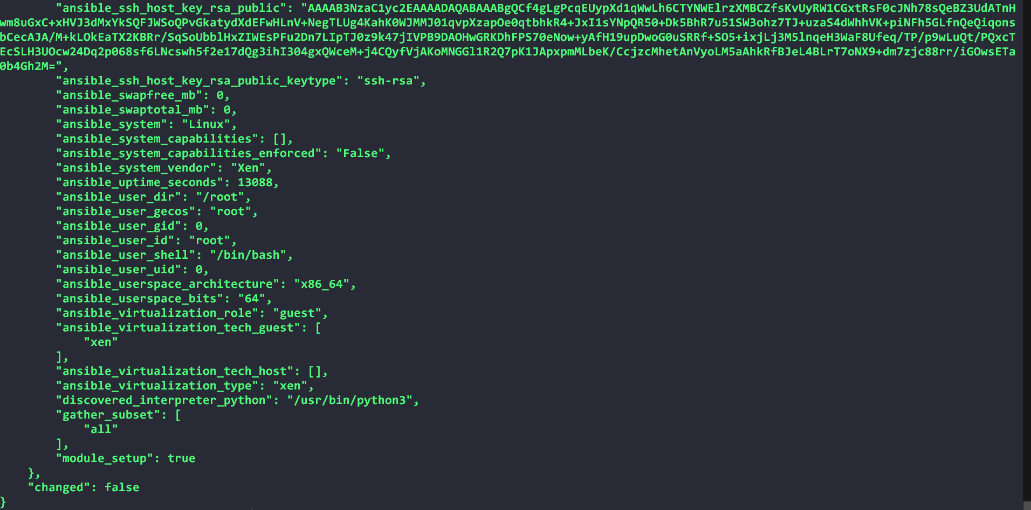# TO checkthe uptime of a slave machine

#ansible all -a uptime

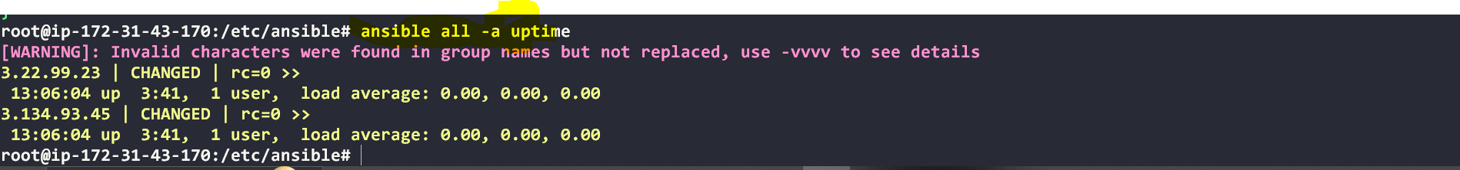

Tips: -m is the module and -a should contain the command it should run which goes as an argument to command and shell.

# check the free memory or memory usage of host

#ansible all -a "free -m"

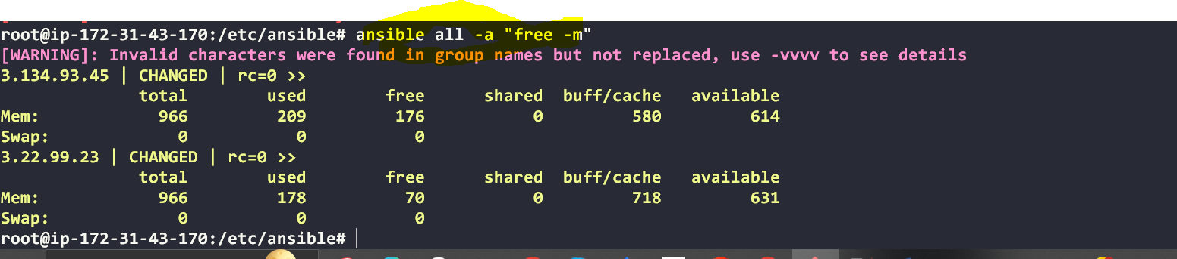

# What if you do not have SSH key-based? How to pass username and password?

**Create user:**



**Ansible all –m usr –a ‘name=prasanth password=7885’**

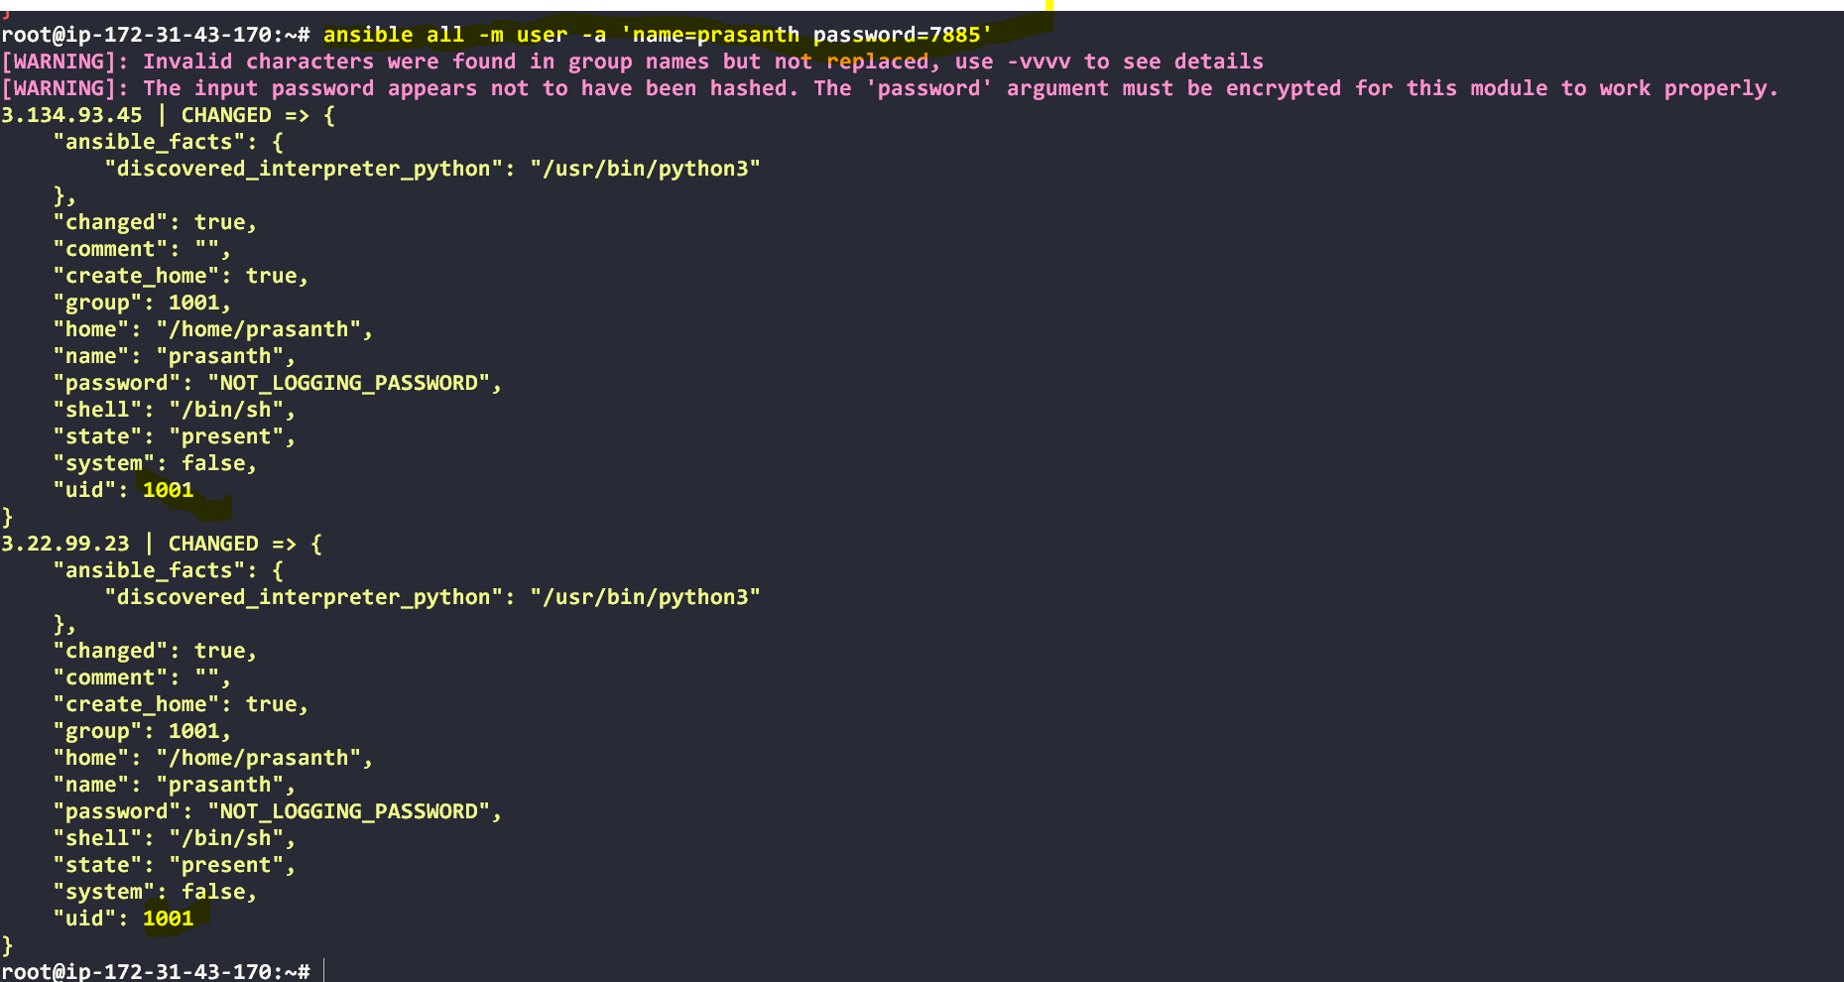

ansible all -m ping --user=ansadm --ask-pass

# Execute a command as root user (sudo) on host

ansible all -m shell -a "cat /etc/passwd|grep -i ansadm" -s --ask-sudo-pass

# Execute a command using become module

ansible all -m shell -a "cat /etc/passwd|grep -i ansadm" -b –K

Tips: -b is the option for become and by default it will become root user –K is to tell ansible to ask for SUDO password

#Execute a command as a different user (sudo su)

ansible all -m file -a "path=/home/ansadm/test state=directory mode=0755" -b --become-user=ansadm

# Create a Linux user group

ansible all -m group -a "weblogic-devops state=present"

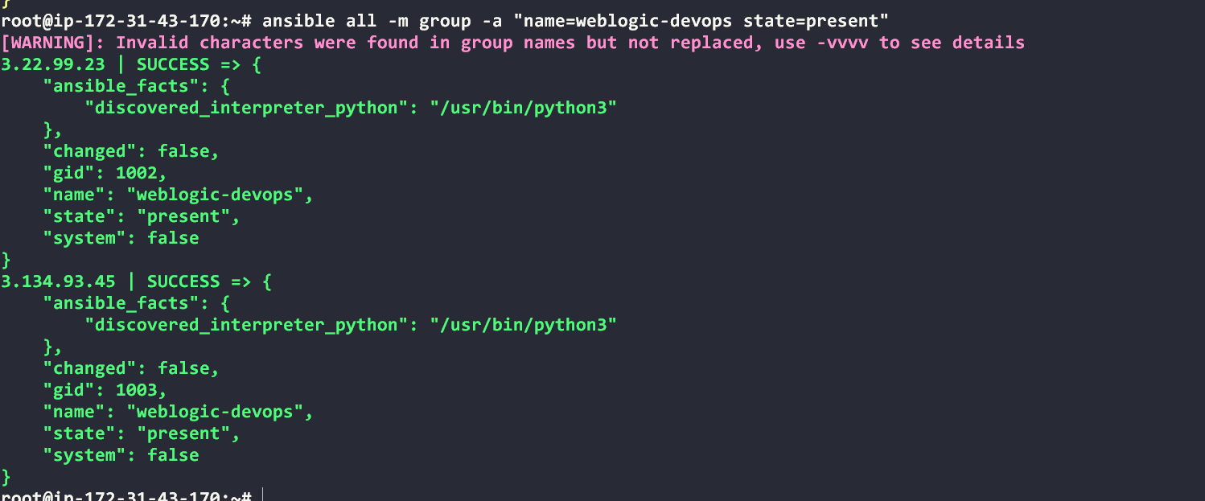



# Create a file with 755 permission

ansible all -m file -a "path=/home/asnadm/testfile state=touch mode=0755"

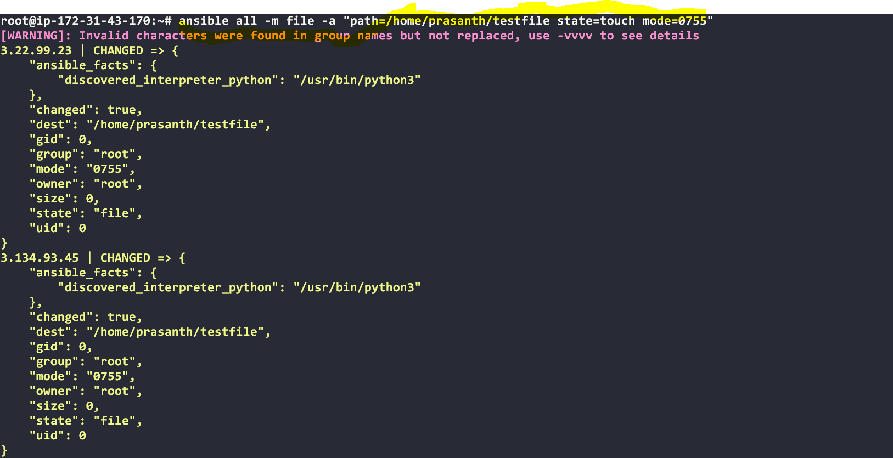 

# Change ownership of a file

ansible all -m file -a "path=/home/ansadm group=weblogic-Devops owner=weblogic-Devops" -b

# update mster

ansible all –m shell –a “apt-get –y update”

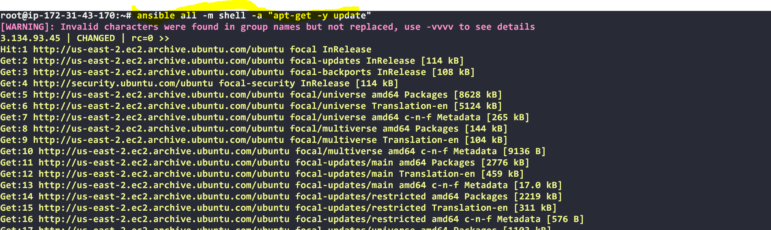

#install apache2

ansibe all –m apt –a “name=apache2 state=latest”

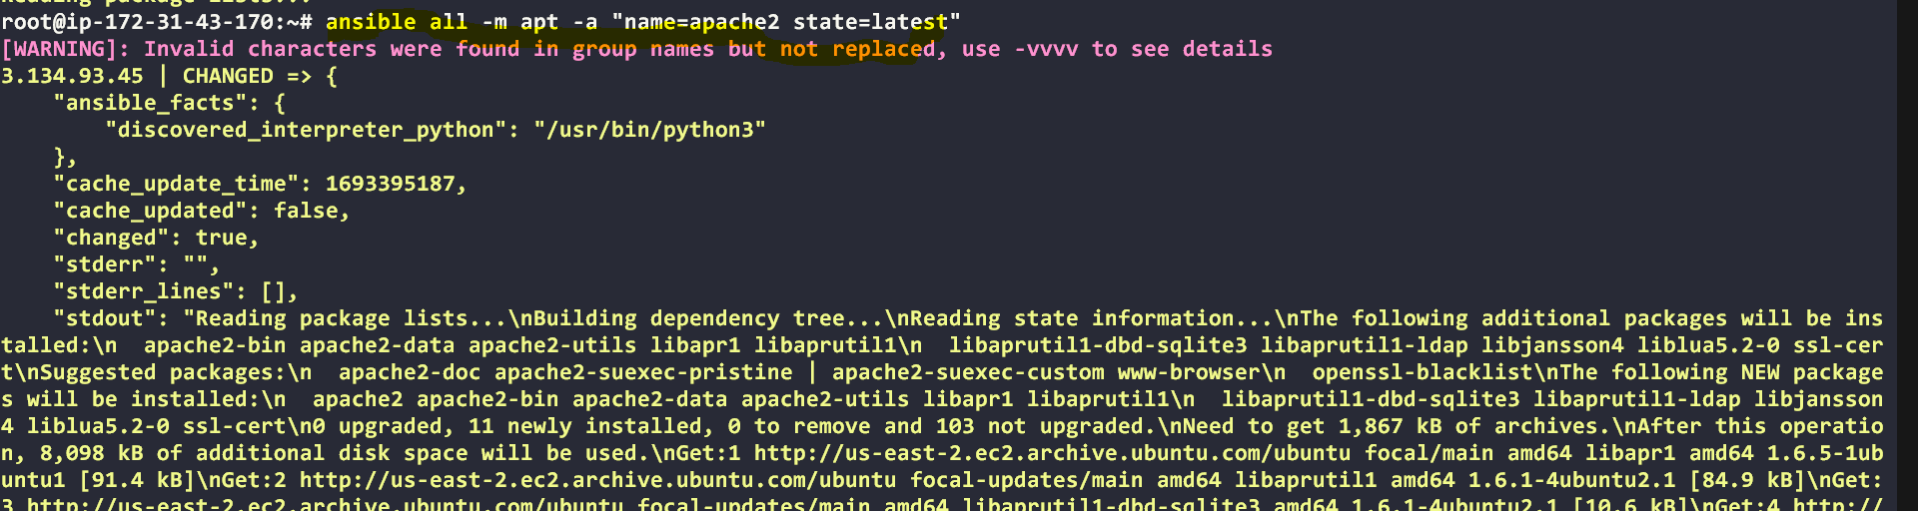

#start apache2

ansible all –m service –a “name=apache2 state=started”

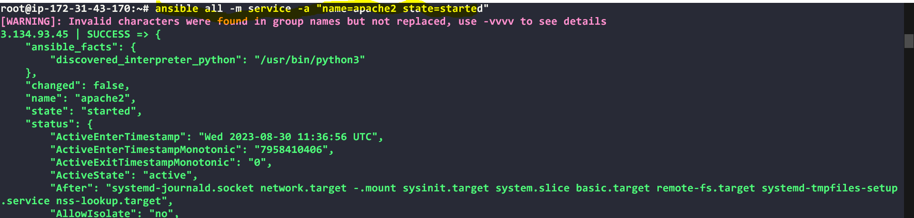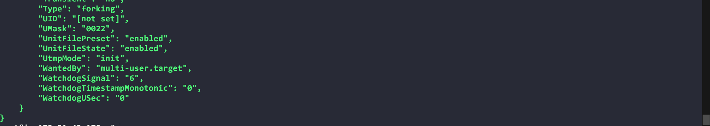

#Output: copy the public ip of worker-01 in browser

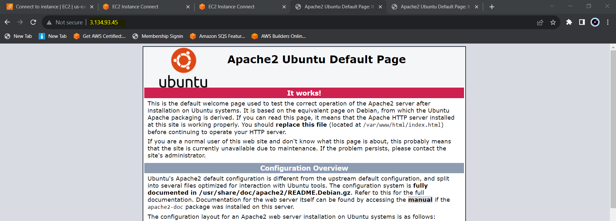

#Output: copy the public ip of worker-02 in browser

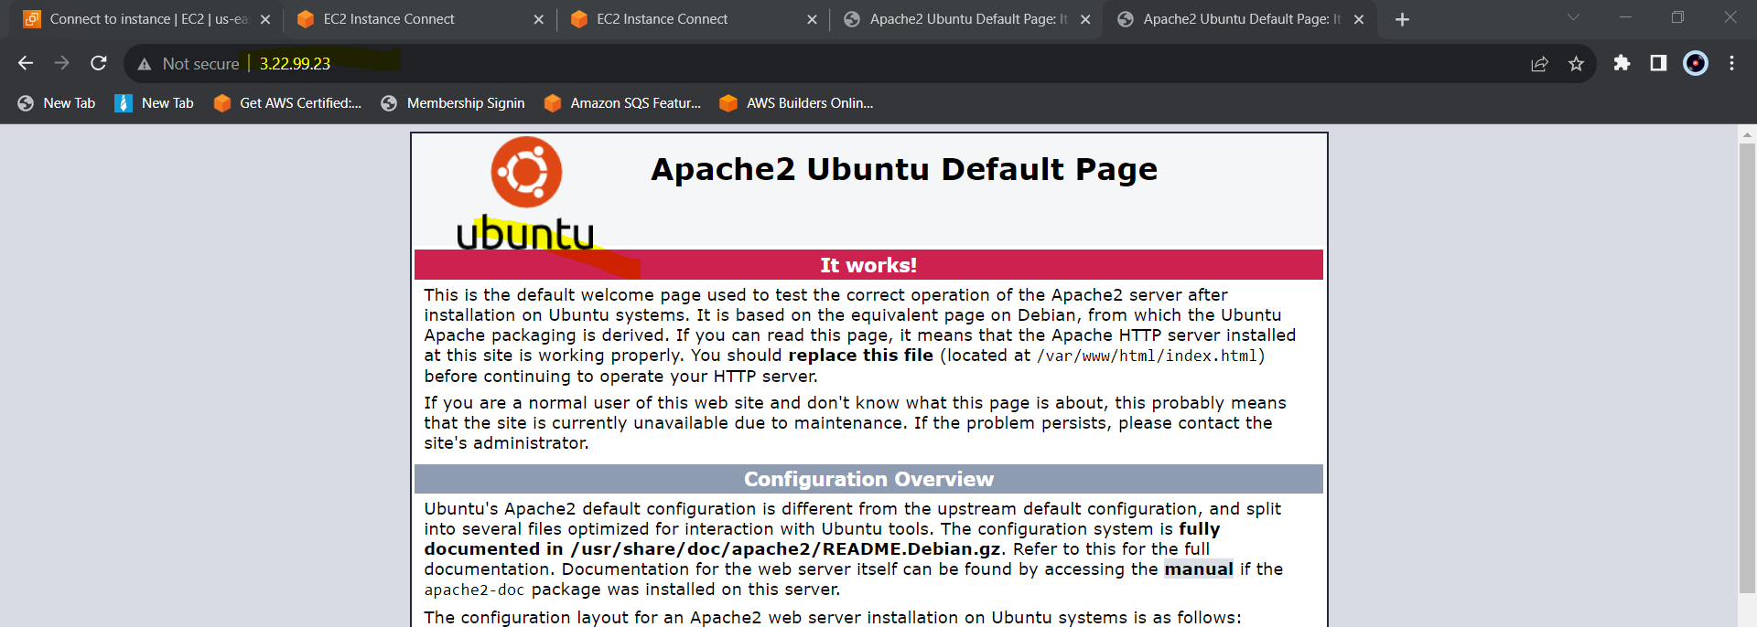

#stop apache2

ansible all –m service –a “name=apache2 state=stopped”

