Ansible -03

1. Create ansible playbook to create ansible vault.

Encrypt:

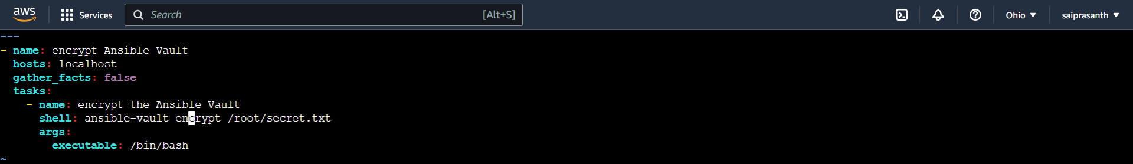



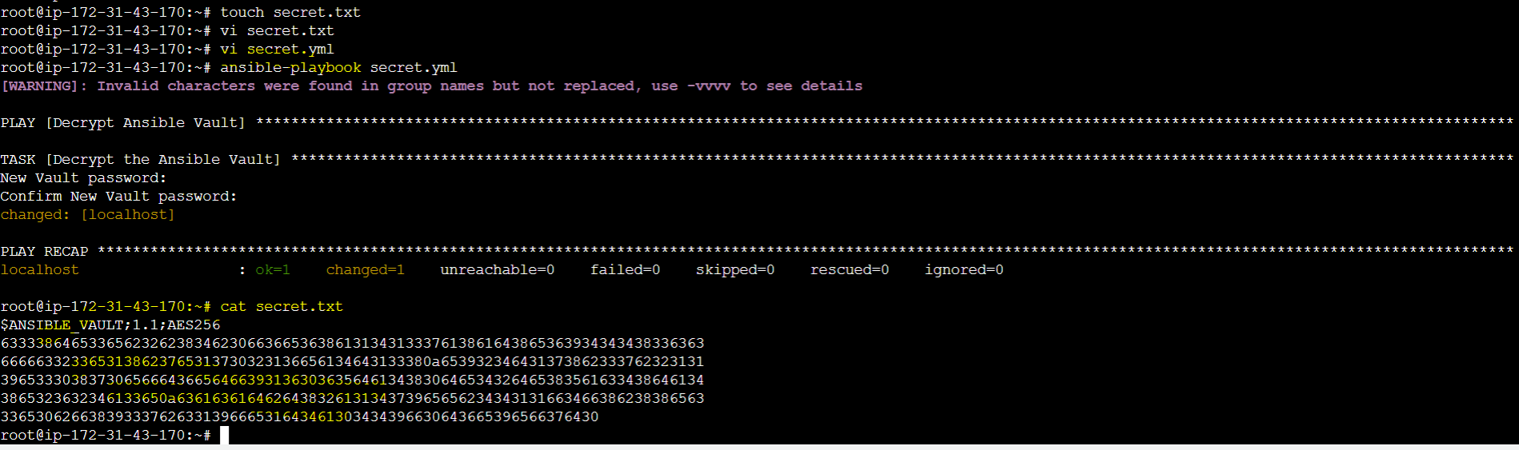

Decrypypt:

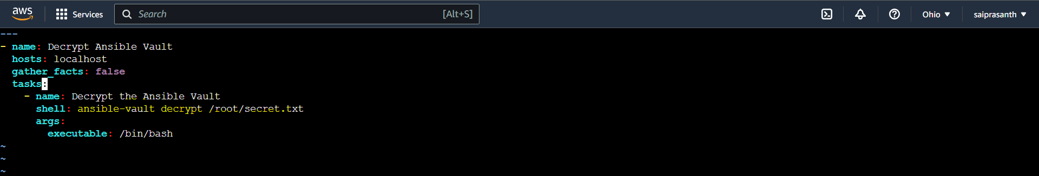

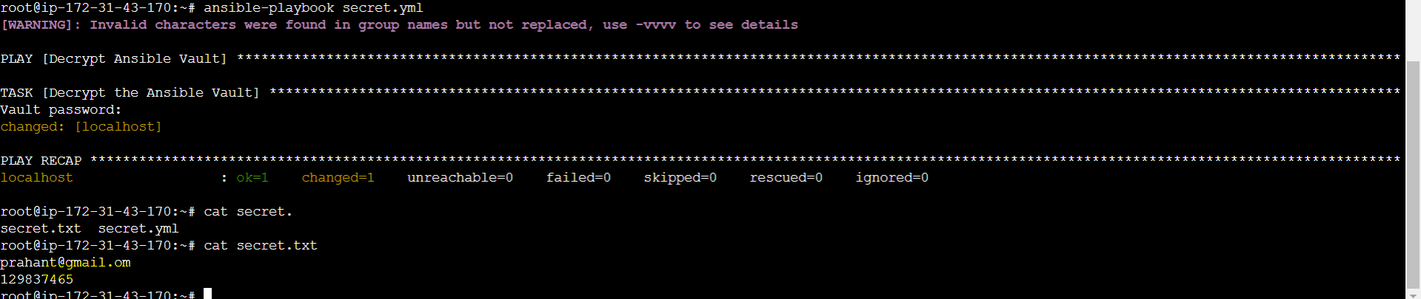

2) Create ansible playbook using roles to configure LAMP stack

3) Setup ansible AWX and explore the options