Tasks 19-07-2023

1. Bash script to provision AWS ec2.

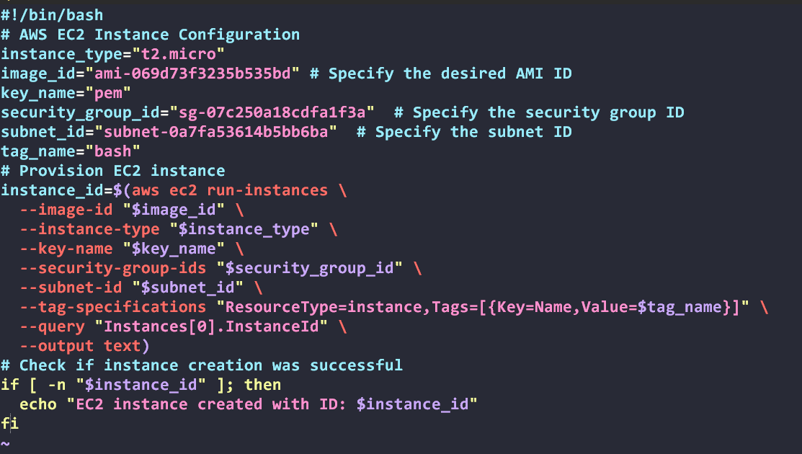

Output:

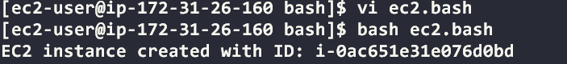

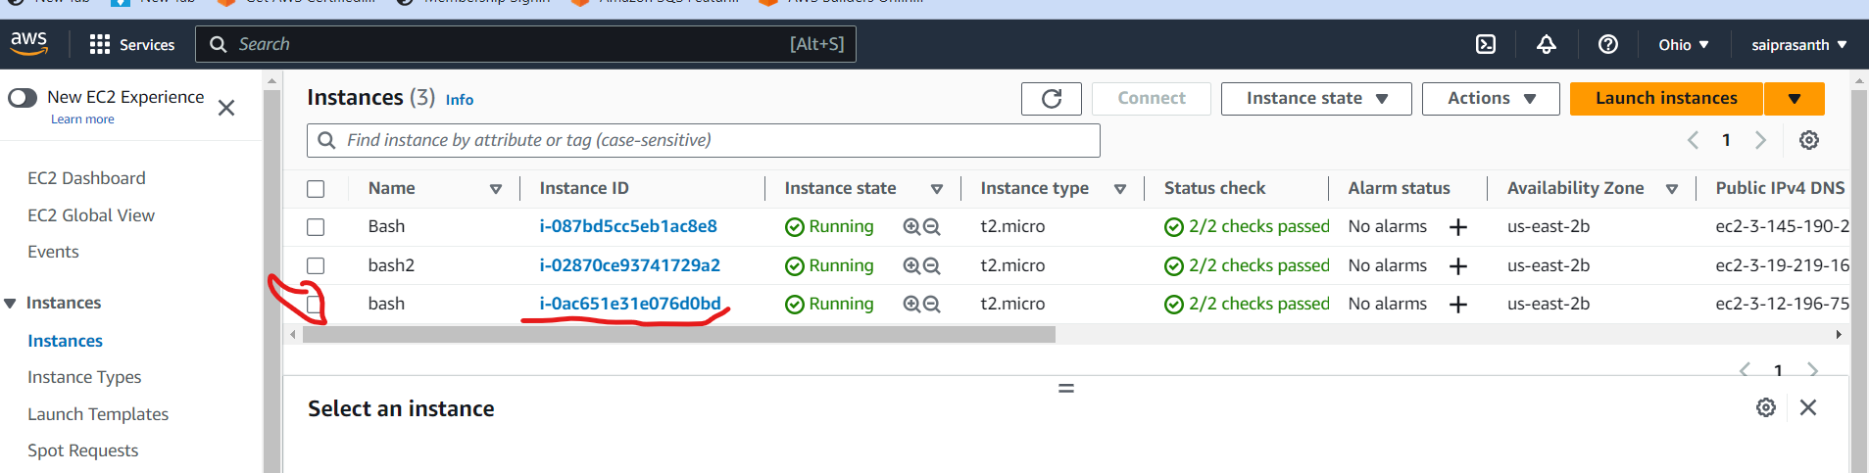

1. Bash script to find the files with the extension .txt and delete the files.

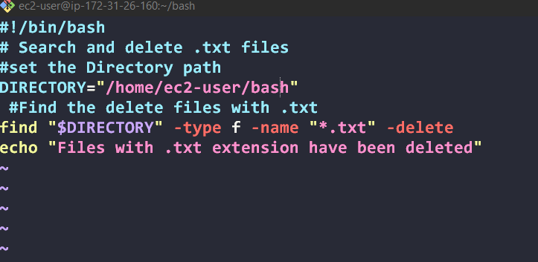

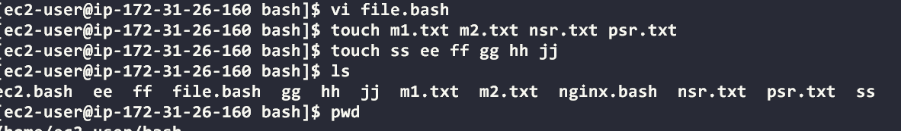

Output:

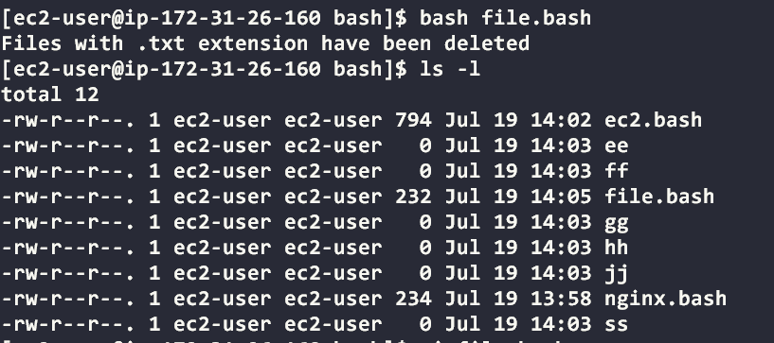

1. Bash script to install nginx and run on port number 80.

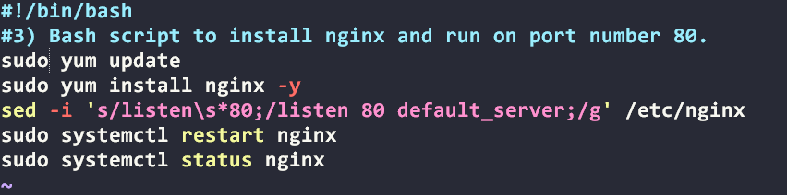

Output:

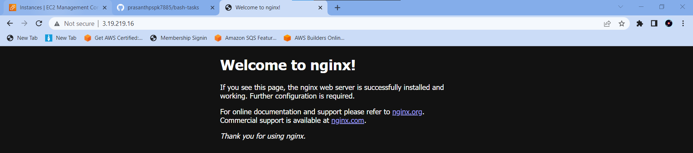

1. Bash script to install httpd and run on port number 81.

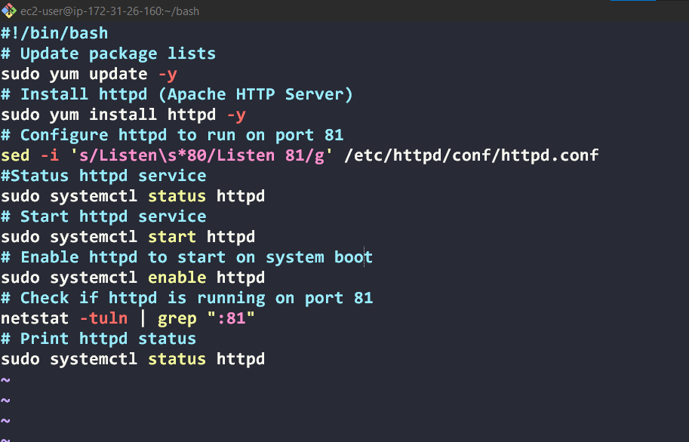

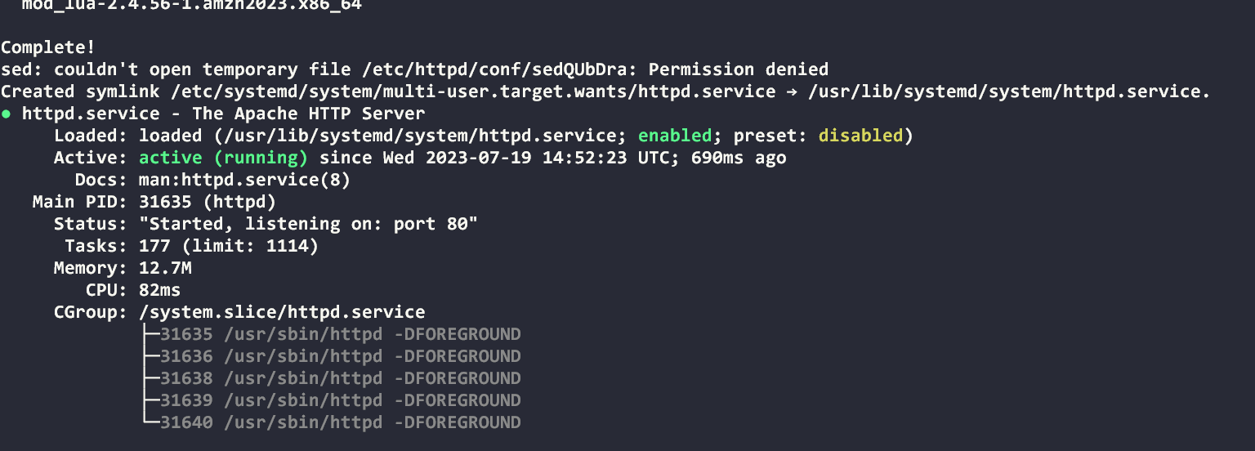

Output:

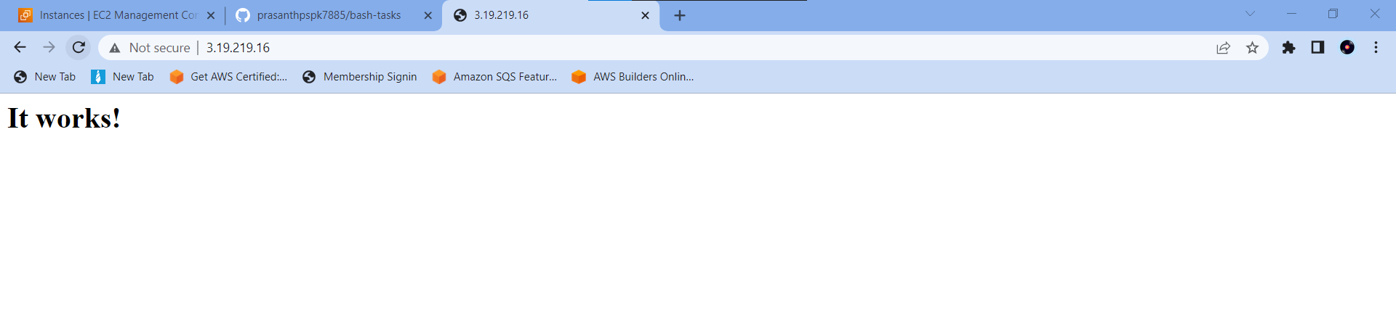

1. Bash script to install Apache Tomcat and Deploy a sample war application.

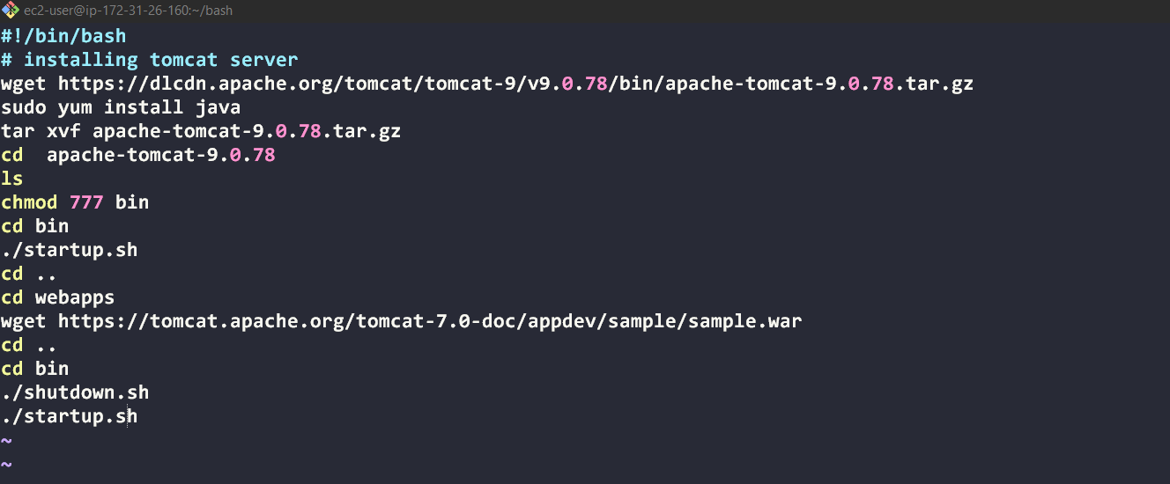

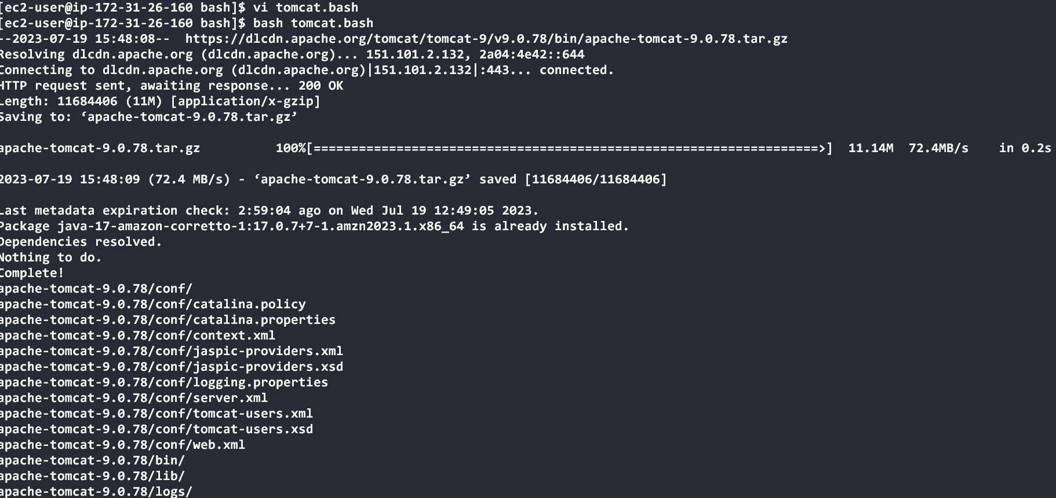

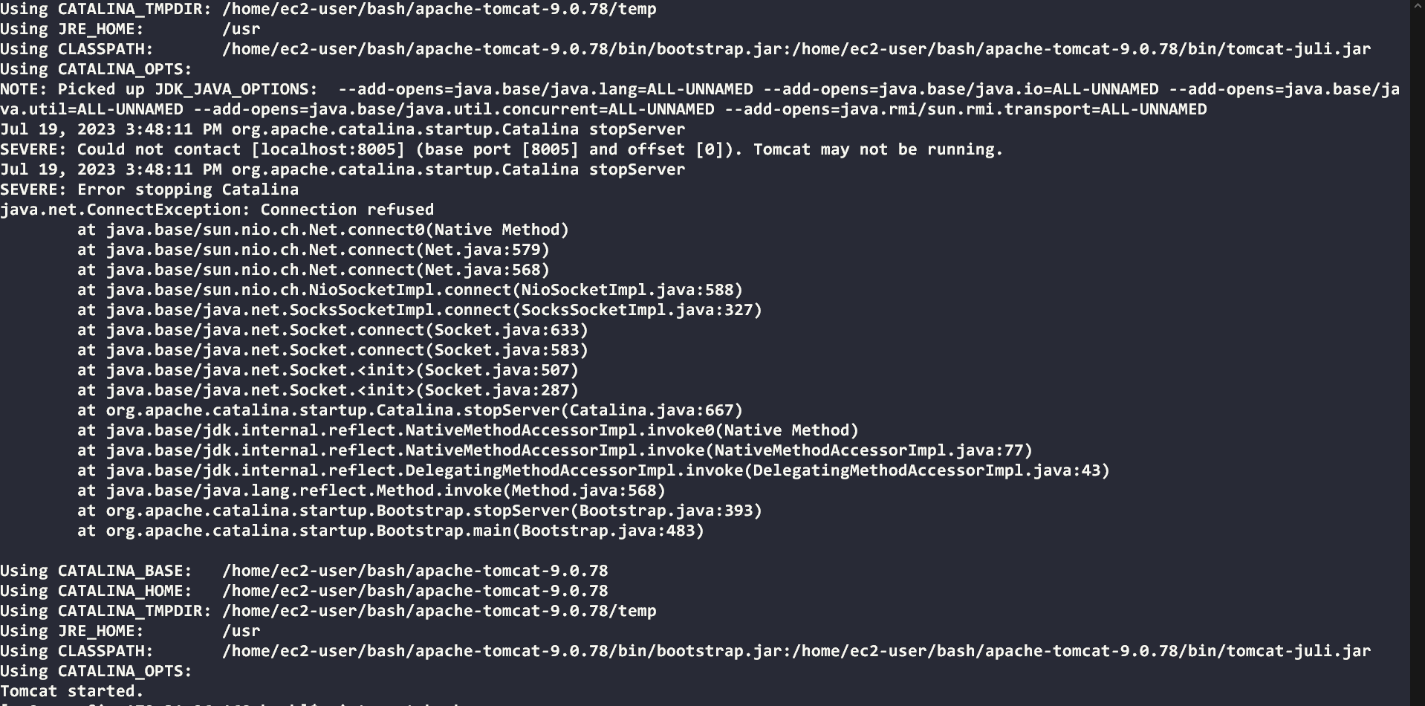

Output:

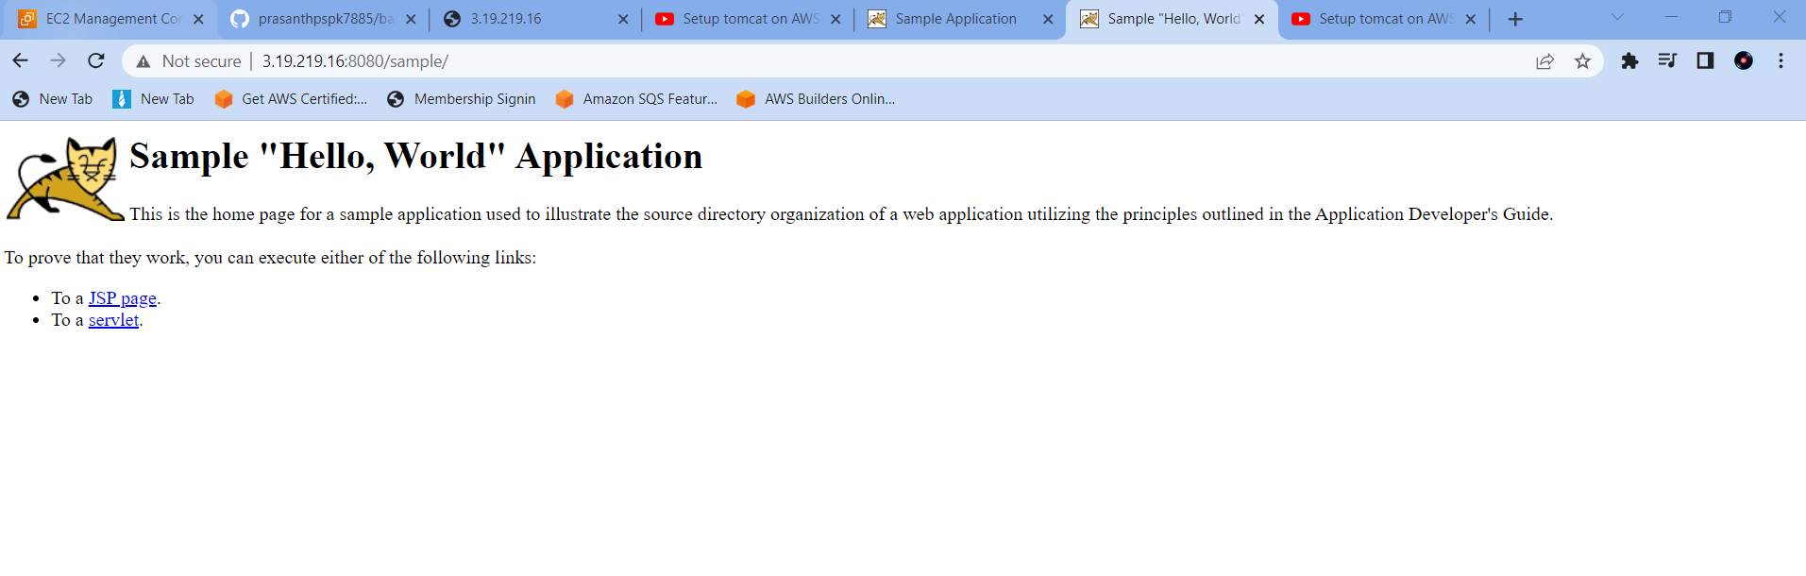

<<<<<…. **End** ….>>>>>