COLLEGE CODE : 5113

COLLEGE NAME : Kingston Engineering College

DOMAIN : Internet of Things

PROJECT TITLE : Smart Traffic Management System

PROJECT MEMBERS:

D Thukkaram(Leader) 511321104104

S Prasanth 511321104069

R Pravin Kumar 511321104073

S Sujith 511321104097

R Sriram 511321104098

Smart Traffic Management system using the Wokwi Simulator involves simulating sensors, traffic lights, and vehicles using the Arduino platform. In this example, we'll create a basic setup to get you started. Please note that this is a simplified simulation; real-world traffic management systems are much more complex.

Step 1: Setting up the Wokwi Simulator

1. Go to the Wokwi website: [https://wokwi.com/](https://wokwi.com/).

2. Create an account if you don't have one.

3. Once you're logged in, click on "Create a New Project."

Step 2: Create the Traffic Light System

In this example, we'll simulate two traffic lights: one for the main road and one for the side road.

1. On the Wokwi platform, add an Arduino board to your project. You can search for "Arduino" in the components library and drag it to your project.

2. Add two LEDs (representing the red and green lights for each traffic light). Search for "LED" in the components library and add two LEDs to the project.

3. Connect one LED to digital pins 2 and 3, which will represent the traffic light for the main road.

4. Connect the other LED to digital pins 4 and 5, representing the traffic light for the side road.

Step 3: Simulate the Sensors

In a real smart traffic management system, sensors (e.g., motion sensors, cameras) detect the presence of vehicles and control the traffic lights. In the simulation, you can simulate vehicle presence with buttons.

1. Add two buttons from the components library to the project. These will act as vehicle presence sensors for the main road and side road.

2. Connect one button to a digital pin (e.g., pin 6) to simulate the presence of vehicles on the main road.

3. Connect the other button to a different digital pin (e.g., pin 7) to simulate the presence of vehicles on the side road.

Step 4: Arduino Code

Circuit Diagram :

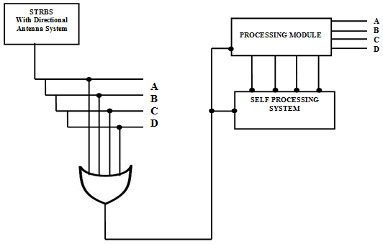

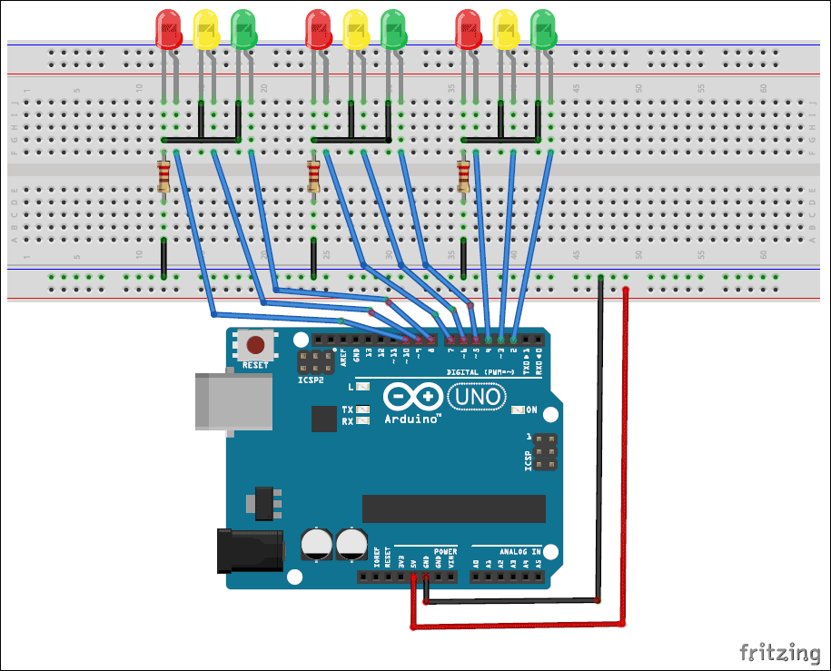

Now, you need to write the Arduino code that will control the traffic lights based on the sensor inputs. Here's a simple example sketch to get you started:

```Python code

import RPi.GPIO as GPIO

import time

mainRoadRedPin = 2

mainRoadGreenPin = 3

sideRoadRedPin = 4

sideRoadGreenPin = 5

mainRoadSensorPin = 6

sideRoadSensorPin = 7

GPIO.setmode(GPIO.BCM)

GPIO.setup(mainRoadRedPin, GPIO.OUT)

GPIO.setup(mainRoadGreenPin, GPIO.OUT)

GPIO.setup(sideRoadRedPin, GPIO.OUT)

GPIO.setup(sideRoadGreenPin, GPIO.OUT)

GPIO.setup(mainRoadSensorPin, [GPIO.IN](http://gpio.in/), pull_up_down=GPIO.PUD_UP)

GPIO.setup(sideRoadSensorPin, [GPIO.IN](http://gpio.in/), pull_up_down=GPIO.PUD_UP)

def main():

while True:

if GPIO.input(mainRoadSensorPin) == GPIO.LOW:

*# Main road has vehicles, so stop side road traffic*

GPIO.output(mainRoadRedPin, GPIO.LOW)

GPIO.output(mainRoadGreenPin, GPIO.HIGH)

GPIO.output(sideRoadRedPin, GPIO.HIGH)

GPIO.output(sideRoadGreenPin, GPIO.LOW)

elif GPIO.input(sideRoadSensorPin) == GPIO.LOW:

*# Side road has vehicles, so stop main road traffic*

GPIO.output(mainRoadRedPin, GPIO.HIGH)

GPIO.output(mainRoadGreenPin, GPIO.LOW)

GPIO.output(sideRoadRedPin, GPIO.LOW)

GPIO.output(sideRoadGreenPin, GPIO.HIGH)

else:

*# No vehicles, all lights are red (4-way stop)*

GPIO.output(mainRoadRedPin, GPIO.LOW)

GPIO.output(mainRoadGreenPin, GPIO.HIGH)

GPIO.output(sideRoadRedPin, GPIO.LOW)

GPIO.output(sideRoadGreenPin, GPIO.HIGH)

time.sleep(0.1)

try:

main()

finally:

```

Step 5: Simulation and Testing

1. Save the code in your project and click the "Start Simulation" button in Wokwi.

2. You can now click the buttons representing vehicle presence to simulate traffic on the main and side roads.

3. Observe how the traffic lights change based on vehicle presence.

This is a basic example to get you started with simulating a Smart Traffic Management system using the Wokwi Simulator. In a real-world scenario, you would use more advanced sensors and control logic.