COLLEGE CODE : 5113

COLLEGE NAME : Kingston Engineering College

DOMAIN : Internet of Things

PROJECT TITLE : Smart Traffic Management System

PROJECT MEMBERS:

D Thukkaram(Leader) 511321104104

R Sriram 511321104098

S Prasanth 511321104069

R Pravin Kumar 511321104073

S Sujith 511321104097

Introduction :

Traffic management is an integral part of modern urban living, impacting the daily lives of countless individuals and the overall efficiency of cities. A traffic management app built with HTML, CSS, and JavaScript can provide a practical and accessible solution to address the challenges associated with traffic control, incident management, and route optimization. This introduction outlines the process of creating a traffic management app using these fundamental web technologies.

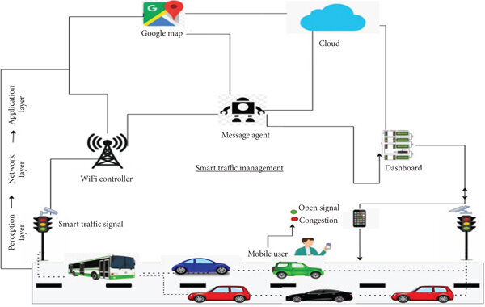

Key Components of a Traffic Management App:

Real-Time Traffic Information: HTML, CSS, and JavaScript are used to present real-time data, such as traffic flow, congestion, and incidents, in an easily digestible format. This information empowers users to make informed decisions about their routes.

Interactive Maps: JavaScript libraries and APIs enable the integration of interactive maps, allowing users to visualize traffic conditions, identify incidents, and plan alternative routes.

Incident Reporting: HTML forms can be used to facilitate incident reporting, allowing users to submit information about accidents, roadwork, or other road-related issues.

User Alerts and Notifications: JavaScript can be employed to create dynamic notifications that keep users informed about traffic incidents, road closures, or alternative routes.

User Authentication: For a personalized experience, user authentication mechanisms are implemented, enabling users to save preferences and receive customized updates.

User Interface (UI): CSS is utilized to design an intuitive and visually appealing user interface. Effective UI design plays a significant role in ensuring the user-friendliness of the app.

CODE :

Creating a complete traffic management app using HTML, CSS, and JavaScript is a significant project that requires careful planning, and this response can only provide an outline.

HTML CODE :

<!DOCTYPE html>

<html>

<head>

<title>Traffic Management App</title>

<link rel="stylesheet" type="text/css" href="styles.css">

</head>

<body>

<header>

<h1>Traffic Management App</h1>

</header>

<nav>

<!-- Navigation links -->

</nav>

<main>

<section id="map">

<!-- Display a map for traffic visualization -->

</section>

<section id="incidents">

<!-- Display a list of traffic incidents -->

</section>

</main>

<footer>

<p>&copy; 2023 Traffic Management App</p>

</footer>

<script src="script.js"></script>

</body>

</html>

CSS CODE :

/\* Basic styles for the app \*/

body {

font-family: Arial, sans-serif;

margin: 0;

padding: 0;

}

header {

background-color: #333;

color: white;

text-align: center;

padding: 10px;

}

nav {

background-color: #444;

color: white;

padding: 10px;

}

main {

display: flex;

justify-content: space-between;

padding: 20px;

}

section {

flex: 1;

padding: 10px;

}

footer {

background-color: #333;

color: white;

text-align: center;

padding: 10px;

}

JavaScript CODE :

// Simulated data for traffic incidents

const trafficIncidents = [

{ location: "Main Street", type: "Accident" },

{ location: "Highway 101", type: "Roadwork" },

// Add more incidents

];

// Function to display traffic incidents

function displayIncidents() {

const incidentsSection = document.getElementById("incidents");

incidentsSection.innerHTML = "<h2>Current Incidents</h2>";

trafficIncidents.forEach(incident => {

incidentsSection.innerHTML += `<p>${incident.location} - ${incident.type}</p>`;

});

}

// Simulated map display using an API (e.g., Google Maps API)

// Fetch and display traffic incidents

displayIncidents();

Challenges and Considerations:

Developing a traffic management app with HTML, CSS, and JavaScript involves addressing specific challenges:

Real-Time Data: Integrating real-time traffic data into the app may require using external APIs or developing custom solutions to collect and display this information.

User Experience: Designing a user-friendly and responsive interface is crucial to ensure that users can easily access and interact with the app, especially on various devices and screen sizes.

Scalability: As the app gains users, scalability becomes an essential consideration to maintain performance and responsiveness.

Security: Safeguarding user data and the app against potential threats is critical, especially if user accounts and personal information are involved.

Cross-Browser Compatibility: Ensuring that the app functions consistently across different web browsers is vital for providing a seamless user experience.