**DE-STRESS**

* **A BATTLE AGAINST DEPRESSION**

by

**ABHISHEK R 2015103579**

**PRASANTH P 2015103601**

A project report submitted to the

**FACULTY OF COMPUTER SCIENCE**

**AND ENGINEERING**

*in partial fulfillment of the requirement for*

*the award of the degree of*

**BACHELOR OF ENGINEERING**

*in*

**COMPUTER SCIENCE AND ENGINEERING**



**DEPARTMENT OF COMPUTER SCIENCE AND**

**ENGINEERING**

**ANNA UNIVERSITY, CHENNAI-25**

**NOVEMBER 2018**

**BONAFIDE CERTIFICATE**

Certified that this project report titled **DE-STRESS - A BATTLE AGAINST DEPRESSION** is the bonafide work of **ABHISHEK R (2015103579)** and **PRASANTH P** **(2015103601)** who carried out the project work for **Creative and Innovative Lab** under my supervision, for the fulfillment of the requirements for the award of the degree of Bachelor of Engineering in Computer Science and Engineering. Certified further that to the best of my knowledge, the work reported herein does not form part of any other thesis on the basis of which a degree or an award was conferred on an earlier occasion on these or any other candidates.

|  |  |
| --- | --- |
| Place: Chennai | Bhuvaneshwari R |
| Date: | Teaching Fellow |
|  | Department of Computer Science and Engineering |
|  | Anna University, Chennai - 25 |

**ABSTRACT**

The purpose of this project is to develop an application capable of detecting depression among people. Large amount of data is generated due to increase in social networking sites usage in recent years. This data can be analyzed to detect emotions of people, thereby detecting depression, a state of mental illness.

The data generated is pre-processed using natural language processing techniques. The processed data is then fed into a machine learning classifier and the trained classifier is generated. This trained classifier is stored for faster access. A website is developed as the front-end for the user. A module for detection of extreme depression i.e.) suicidal thoughts is also added.

Apart from these the application is designed to perform real time evaluation of twitter users by streaming user tweets, performing evaluation and thereby predicting depression.

**TABLE OF CONTENTS**

|  |  |
| --- | --- |
| **ABSTRACT** | iii |
| **LIST OF FIGURES** | vii |
| **LIST OF TABLES** | viii |
| **LIST OF ABBREVIATIONS** | ix |
| **1. INTRODUCTION** | 1 |
| 1.1 Problem Domain | 1 |
| 1.2 Problem Description | 2 |
| 1.3 Scope | 2 |
| 1.4 Contribution | 2 |
| 1.5 SWOT Analysis | 3 |
| 1.6 PESTLE Analysis | 4 |
| 1.7 Organization of Thesis | 5 |
| **2. RELATED WORK** | 6 |
| 2.1 Models | 6 |
| 2.2 Drawbacks and Inferences | 7 |
| **3. REQUIREMENT ANALYSIS** | 8 |
| 3.1 Functional Requirements | 8 |
| 3.2 Non Functional Requirements | 8 |
| 3.3 Constraints and Assumptions | 9 |
| **4. SYSTEM DESIGN** | 10 |
| 4.1 System Architecture | 10 |
| 4.2 UI Design | 11 |
| 4.3 Class Diagram | 13 |
| 4.4 Module Design | 13 |
| 4.5 Complexity Analysis | 15 |
| **5. SYSTEM DEVELOPMENT** | 16 |
| 5.1 Prototype Across the Modules | 16 |
| 5.2 Algorithm | 17 |
| 5.3 Deployment Details | 17 |
| **6. RESULTS AND DISCUSSION** | 18 |
| 6.1 Dataset for Testing | 18 |
| 6.2 Output Obtained in Various Stages | 18 |
| 6.3 Sample Screenshots of Input and Output while Testing | 20 |
| 6.4 Performance evaluation | 21 |
| **7. CONCLUSION** | 22 |
| 7.1 Summary | 22 |
| 7.2 Criticism | 22 |
| 7.3 Future work | 22 |
| **TEST CASES FOR EACH MODULE** | 23 |
| A.1 Preprocessing | 23 |
| A.2 MNB Classifier | 24 |
| A.3 Extreme Depression Detector | 24 |
| **REFERENCES** | 25 |

**LIST OF FIGURES**

|  |  |  |
| --- | --- | --- |
| 4.1 | System Architecture | 10 |
| 4.2 | UI design (Home page) | 11 |
| 4.3 | UI design (User) | 12 |
| 4.4 | UI design (Analyzer) | 12 |
| 4.5 | Class Diagram | 13 |
| 5.1 | Code Overview | 16 |
| 6.1 | Preprocessing | 18 |
| 6.2 | Bag-Of-Words | 19 |
| 6.3 | Classifier | 19 |
| 6.4 | Output | 19 |
| 6.5 | Output (User Page) | 20 |
| 6.6 | Output (Analyzer Page) | 20 |

**LIST OF TABLES**

|  |  |  |
| --- | --- | --- |
| 1.1 | SWOT Analysis | 3 |
| 1.2 | PESTLE Analysis | 4 |
| 6.1 | F1 Score | 21 |

**LIST OF ABBREVIATIONS**

|  |  |
| --- | --- |
| MNB | Multinomial Naive Bayes |
| SWOT | Strength Weakness Opportunity Threat |
| PESTLE | Political Economical Social Technological Legal Environmental |
| SVM | Support Vector Machine |
| IDE | Integrated Development Environment |
| UI | User Interface |
| BOW | Bag-of-words |
| REST | Representational State Transfer |
| GUI | Graphical User Interface |
| CDN | Content Delivery Network |

**CHAPTER 1**

**INTRODUCTION**

Depression (major depressive disorder) is a common and serious medical illness that negatively affects how you feel, the way you think and how you act. Fortunately, it is treatable. Depression causes feeling of sadness and/or a loss of interest in activities once enjoyed. It can lead to a variety of emotional and physical problems and can also decrease a person’s ability to function at work and at home.

Social Computing is an innovative and growing computing exemplar for the analysis and modelling of social activities taking place on various platforms. It is used to produce intellectual and interactive applications to derive efficient results. The wide availability of social media sites provides individuals to share their sentiments or opinions about a particular event, product or issue. Social media has recently emerged as a premier method to disseminate information online. Through these online networks, tens of millions of individuals communicate their thoughts, personal experiences, and social ideals. Thus we can analyze data from these and thereby predict depression.

**1.1 PROBLEM DOMAIN**

Natural Language Processing is a field of computer science which deals with interactions between the computer and human languages. It deals with making the computer to understand and interpret human language. Machine learning is a field of computer science that uses statistical techniques to give computer systems the ability to "learn" with data, without being explicitly programmed.

It is quite natural for everyone to be sad once in a while. But if this feeling prolongs over a long period of time it leads to depression. Some symptoms of depression which may go unnoticed are sadness, feeling of loneliness, changes in

sleep cycle, loss of interest, feeling tired all the time etc… We live in a world where people share their thoughts and views over social media constantly.

In this project we have developed a Machine Learning system which can detect depression from users’ posts. People use twitter to share their views or feelings more often when compared to other social networking sites. Taking this into consideration we have developed a system which can detect depression from tweets.

**1.2 PROBLEM DESCRIPTION**

Given a sentence as input the system analyses it for signs of depression and accordingly suggests ideas to the user. The output would be motivational quotes or links to community groups or helplines that offers support.

**1.3 SCOPE**

Depression is a leading cause of mental ill health, which has been found to increase risk of early death. More than 300 million people suffer from depression worldwide. At its worst, depression can even lead to suicide. Close to 800,000 people die due to suicide every year. In recent years there has been a considerable increase in depression among teenagers. Being able to identify depression in early stages could make a big difference to those who are suffering from it. Hence this system could be of use in the field of medicine/health and in social networks.

**1.4 CONTRIBUTION**

This system suggests various methods that could help the users to identify and fight depression right from the beginning stages. This system demonstrates the efficiency of machine learning techniques to predict/detect disorders with high accuracy. This could be implemented on by social networking sites so that they can detect and help the individuals who are feeling depressed fight it.

**1.5 SWOT ANALYSIS**

|  |  |
| --- | --- |
| **Strengths:**   1. Real time information 2. Powerful brand image 3. Helps monitor and follow up campaigns 4. Has 300M + active users 5. Web application access. 6. Easy to collect data and analyse. 7. Highly engaged users. 8. Free to use. | **Weakness:**   1. Low retention rate. 2. Too much reliability on dataset. 3. Inconsistency in dataset. 4. Limit in maximum allowed characters (280 characters) 5. Unequal distribution of tweets. 6. Data safety issues. |
| **Opportunities:**   1. Easy to access. 2. Integration with other platforms. | **Threats:**   1. Data might get lost. 2. Accounts might get hacked. 3. Presence of bots/fake profiles. |

**Table 1.1 SWOT Analysis**

**1.6 PESTLE ANALYSIS**

|  |  |
| --- | --- |
| **Political:**     1. Capable of changing the political landscape | **Economical:**     1. Increase in e-commerce industry which needs advertising. |
| **Social:**     1. Identify social behaviour. 2. identify trending content. 3. Wide reach. | **Technological:**   1. Everything is accessible using mobile phones. 2. Technology keeps improving day to day. |
| **Legal:**   1. Risk of cyber-stalking and other cyber security issues. 2. Free speech dilemma 3. Defamation and malicious tweets | **Environmental:**   1. Promotion of environment campaigns. 2. Promoting campaigns for a cause. 3. Comfortable environment. |

**Table 1.2 PESTLE Analysis**

## 

## 

## **1.7 ORGANISATION OF THESIS**

Chapter 2 discusses the existing approaches to depression detection in greater detail. Chapter 3 gives the requirements analysis of the system. It explains the functional and nonfunctional requirements, constraints and assumptions made in the implementation of the system. Chapter 4 explains the overall system architecture and the design of various modules along with their complexity. Chapter 5 gives the implementation details of each module, describing the algorithms used. Chapter 6 elaborates on the results of the implemented system and gives an idea of its efficiency. It also contains information about the dataset used for testing and other the observations made during testing. Chapter 7 concludes the thesis and gives an overview of its criticisms. It also states the various extensions that can be made to the system to make it function more effectively.

**CHAPTER 2**

**RELATED WORK**

This gives a survey of various machine learning models that can be designed for depression detection. The models include the likes of Multinomial Naïve Bayes Classifier, Support Vector Machine, Decision tree and Random Forest. This helped us to study in detail the various methods and choose the best which suits our needs.

**2.1 MODELS**

**2.1.1 NAIVE BAYES CLASSIFIER**

Naïve Bayes classifier is a simple probabilistic classifier that uses the concept of mixture models to perform classification. Naïve Bayes remains a popular method for text categorization, the problem of judging documents as belonging to one category or the other (such as [spam or legitimate](https://en.wikipedia.org/wiki/Spam_filtering), sports or politics, etc.) with [word frequencies](https://en.wikipedia.org/wiki/Bag_of_words) as the features. With appropriate pre-processing, it is competitive in this domain with more advanced methods including [support vector machines](https://en.wikipedia.org/wiki/Support_vector_machine). It also finds application in automatic [medical diagnosis](https://en.wikipedia.org/wiki/Medical_diagnosis).

Given a problem instance to be classified, represented by a vector representing some *n* features (independent variables), it assigns to this instance probability for each of *K* possible outcomes or *classes.*

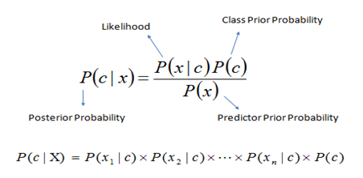

**2.1.2 SUPPORT VECTOR MACHINE**

Support vector machine (SVM) solves the traditional text categorization problem effectively; generally outperforming Naïve Bayes as it supports the concept of maximum margin. The main principle of SVMs is to determine a linear separator that separates different classes in the search space with maximum distance i.e. with maximum margin The idea of SVM is to determine a boundary or boundaries that separate distinct clusters or groups of data. SVM performs this task constructing a set of points and separating those points using mathematical formulas.

**2.1.3 DECISION TREE**

Random Forest classifier is a tree-based classifier. It consists of numerous classification trees that can be used to predict the class label for a given data point based on the categorical dependent variable. In the classifier tree, the internal nodes are represented as the features, the edges leaving a node are represented as tests on the feature’s weight, and the leaves are represented as class categories. It performs classification preliminary from the root node and moves incrementally downward until a leaf node is detected. The document is then classified in the category that labels the leaf node.

**2.1.4 RANDOM FORESTS**

Random forests or random decision forests are an [ensemble learning](https://en.wikipedia.org/wiki/Ensemble_learning) method for [classification](https://en.wikipedia.org/wiki/Statistical_classification), [regression](https://en.wikipedia.org/wiki/Regression_analysis) and other tasks, that operate by constructing a multitude of [decision trees](https://en.wikipedia.org/wiki/Decision_tree_learning) at training time and outputting the class that is the [mode](https://en.wikipedia.org/wiki/Mode_(statistics)) of the classes (classification) or mean prediction (regression) of the individual trees. Random decision forests correct for decision trees' habit of [overfitting](https://en.wikipedia.org/wiki/Overfitting) to their [training set](https://en.wikipedia.org/wiki/Test_set).

**2.2 DRAWBACKS AND INFERENCES**

A linear SVM would be preferred when we wish to emphasize the ability to identifying most depressed individuals at the risk of identifying a few false positives. A Naive Bayes method is preferred when accuracy is given priority.All the above mentioned models are language dependent. A language independent model should be designed.

**CHAPTER 3**

**REQUIREMENT ANALYSIS**

**3.1 FUNCTIONAL REQUIREMENTS**

* Based on the intensity of depression, the system outputs either a helpline or community group or motivational quotes.
* The system must be optimized for space complexities.
* The system must be able to make prediction based on the entered text input.
* Server response time must be optimal.
* Content of website must be motivating and helpful.

**3.2 NON FUNCTIONAL REQUIREMENTS**

**3.2.1 USER INTERFACE**

There must be a simple to use and attractive UI where the user can enter the input (tweets).

**3.2.2 HARDWARE REQUIREMENTS**

The client side requirement is only a browser with good internet connection The server side must be able to handle multiple requests & tools to run machine learning python scripts. Server must be able to run JavaScript runtime environment (NodeJs)

**3.2.3 SOFTWARE REQUIREMENTS**

OS - Windows or Linux

Programming Language - JavaScript, Python.

Frameworks - JQuery, Bootstrap.

Libraries - Pandas, Scikit-learn, Numpy, NLTK, Tweepy.

Tools - Visual Studio Code

**3.2.4 PERFORMANCE**

The system should provide consistent, reliable with low false positives.

**3.3 CONSTRAINTS AND ASSUMPTIONS**

**3.3.1 CONSTRAINTS**

* The system can’t differentiate between sarcasm and seriousness.
* System can’t identify internet lingos like rofl, lol, bff.
* There could be false positives.

**3.3.2 ASSUMPTIONS**

* The text is in English and is void of foreign letters/characters.
* The user input is genuine.

**CHAPTER 4**

**SYSTEM DESIGN**

**4.1 SYSTEM ARCHITECTURE** The block diagram of the entire system is shown in figure 4.1.

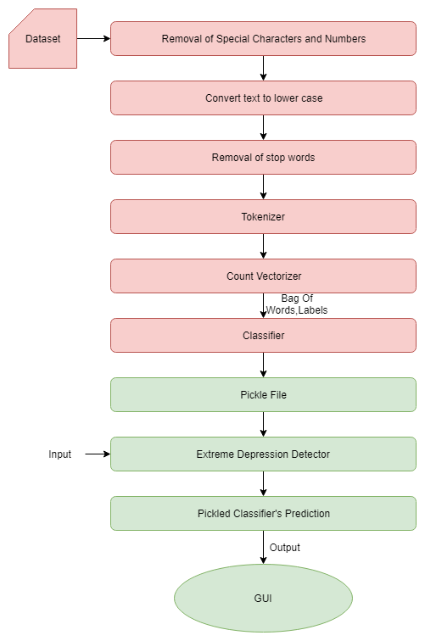

**Figure 4.1 System Architecture**

The system aims at validating the user input for possibility of depression. The depression dataset and user’s input are initially subjected to preprocessing. The preprocessor takes the English text/tweet, removes the special characters and converts the text to lowercase. This is followed by tokenizing the text and removal of stop words. This preprocessed dataset is then sent to the count vectorizer which in turn produces a bag of words along. The bag of words and labels is sent to the Multinomial Naive Bayes classifier and a trained classifier is generated which is in turn stored in a pickle file. The preprocessed input is fed to the extreme depression detector and pickled classifier where the intensity of depression is determined. The output is displayed in the UI.

## **4.2 UI DESIGN**

## A simple and easy to use User Interface (UI) has been designed for the system using Visual Studio IDE. The home screen of the UI contains two buttons which enables the user to switch between user mode and analyst mode. Each button takes you to the respective screen which has a text box and a button. The input sentences/paragraph is typed in the textbox. On clicking the Check/Analyze button, the appropriate output will be displayed.

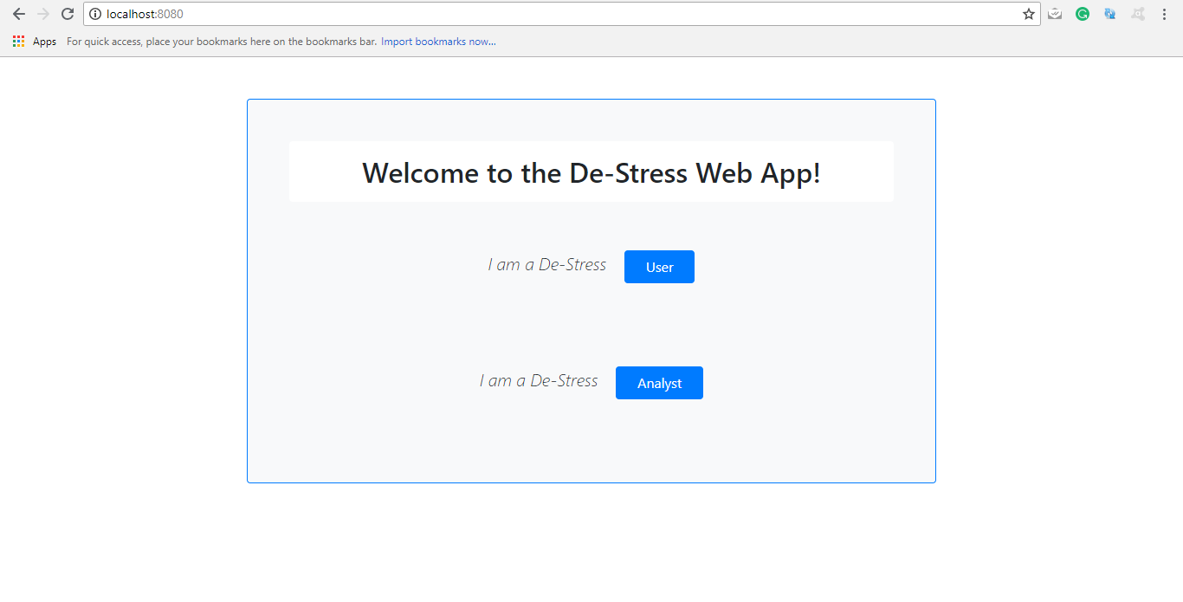

**Figure 4.2 UI design (Home page)**

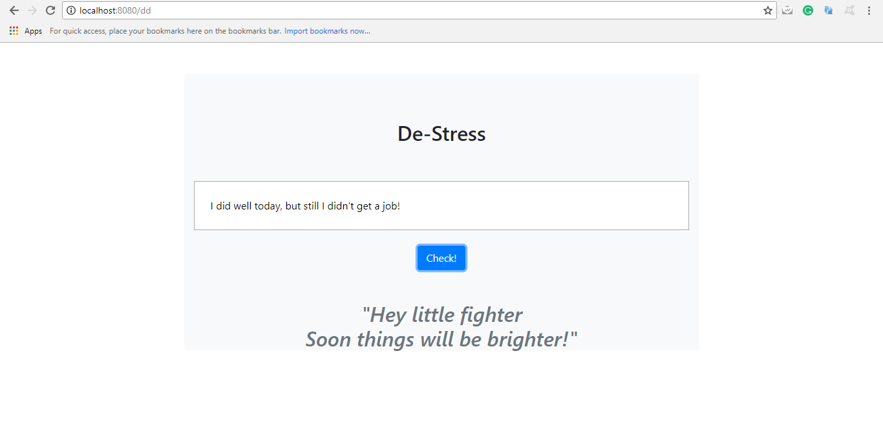

**Figure 4.3 UI design(user)**

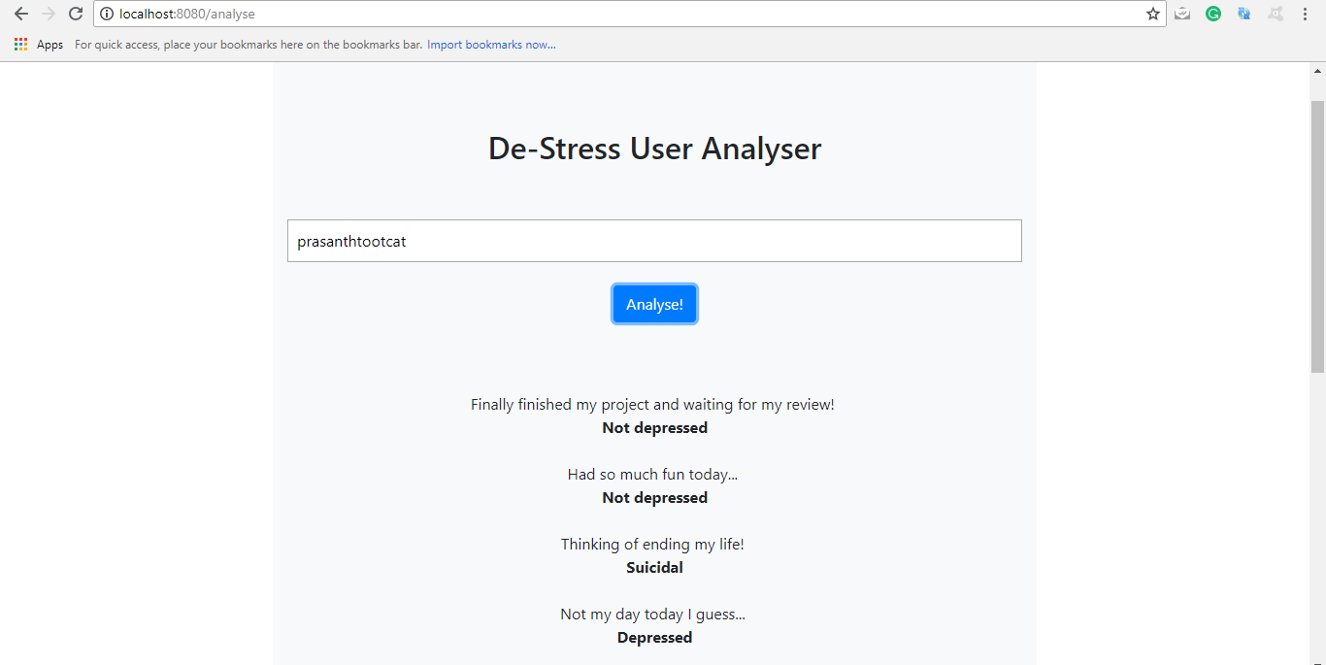

## 

## **Figure 4.4 UI design(Analyzer)**

## **4.3 CLASS DIAGRAM**

The class diagram of the entire system is shown in figure 4.5. This diagram depicts the functions of various modules in the system clearly. It also shows the interaction between the modules of the system thereby providing a clear idea for implementation.

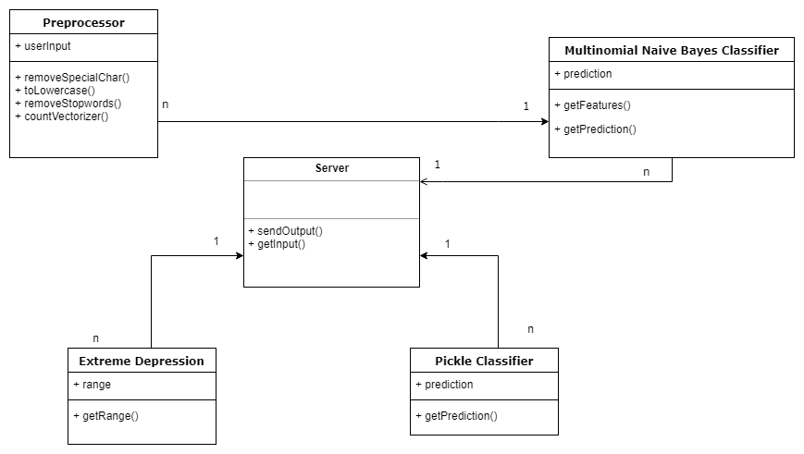

**Figure 4.5 Class Diagram**

## **4.4 MODULE DESIGN**

## **4.4.1 PRE-PROCESSING**

Data preprocessing is a data mining technique that involves transforming raw data into an understandable format. Real-world data is often incomplete, inconsistent, and/or lacking in certain behaviors or trends, and is likely to contain many errors. Data preprocessing is a proven method of resolving such issues.

* Data cleaning: fill in missing values, smooth noisy data and resolve inconsistencies.
* Data transformation: normalization and aggregation.
* Data reduction: reducing the volume but producing the same or similar analytical results.
* Data discretization: part of data reduction, removing numerical attributes and special characters.

The text must be parsed to remove words, called tokenization. Then the words need to be encoded as integers or floating point values for use as input to a machine learning algorithm, called feature extraction (or vectorization). CountVectorizer builds a count matrix where rows are occurrences counts of different words taking into account the high-dimensional sparsity. The scikit-learn library is used to perform both tokenization and feature extraction of the input text data.

**BAG OF WORDS**

We cannot work with text directly when using machine learning algorithms. Each tweet is an “*input*” and a class label is the “*output*” for our predictive algorithm. Algorithms take vectors of numbers as input, therefore we need to convert documents to fixed-length vectors of numbers. A simple and effective model for thinking about text documents in machine learning is called the Bag-of-Words Model, or BoW. The bag-of-words and labels is fed to the Multinomial Naive Bayes Classifier.

**4.4.2 MULTINOMIAL NAIVE BAYES CLASSIFIER**

Naive Bayes is a family of algorithms based on applying Bayes theorem with a strong(naive) assumption, that every feature is independent of the others, in order to predict the category of a given sample. They are probabilistic classifiers, therefore will calculate the probability of each category using Bayes theorem, and the category with the highest probability will be output. Naive Bayes classifier is a general term which refers to conditional independence of each of the features in the model, while Multinomial Naive Bayes classifier is a specific instance of a Naive Bayes classifier which uses a multinomial distribution for each of the features. Multinomial Naive Bayes simply assumes multinomial distribution for all the pairs, which seem to be a reasonable assumption in some cases, i.e. for word counts in documents.

**4.4.3 PICKLE FILE**

Pickle is used for serializing and de-serializing Python object structures, also called marshalling or flattening. Serialization refers to the process of converting an object in memory to a byte stream that can be stored on disk or sent over a network. Later on, this character stream can then be retrieved and de-serialized back to a Python object. Pickling is the conversion of an object from one representation (data in Random Access Memory (RAM)) to another (text on disk). Pickle is very useful for when you're working with machine learning algorithms, where you want to save them to be able to make new predictions at a later time, without having to rewrite everything or train the model all over again. It can also be used to send data over a Transmission Control Protocol (TCP) or socket connection, or to store python objects in a database.

**4.4.4 SERVER**

The server side scripting language is NodeJs. It uses an event-driven, non-blocking I/O model that makes it lightweight and efficient. NodeJs represents a "JavaScript everywhere" paradigm, unifying [web application](https://en.wikipedia.org/wiki/Web_application) development around a single programming language, rather than different languages for server side and client side scripts. The user is redirected to the page according to the url and the input is transferred as a query through REST calls. The query is processed and the output is displayed in the GUI.

**4.4.5 GUI**

HTML and Bootstrap are used to develop the front end. The graphical user interface, is a type of user interface that allows users to interact with electronic devices through graphical icons and visual indicators such as secondary notation, instead of text-based user interfaces, typed command labels or text navigation. Nearly all [digital](https://techterms.com/definition/digital) interfaces are GUIs.

## **4.5 COMPLEXITY ANALYSIS**

### **4.5.1 TIME COMPLEXITY**

The time complexity of all preprocessing steps is O(N).

In case of Multinomial naive bayes classifier the

Training Time: O(|D|Ld + |C||V|)) where Ld is the average length of a document in D. Assumes V and all Di , ni , and nij pre-computed in O(|D|Ld ) time during one pass through all of the data.

Test Time: O(|C| Lt ) where Lt is the average length of a test document. Very efficient overall, linearly proportional to the time needed to just read in all the data.

### **4.5.2 COMPLEXITY OF THE PROJECT**

The complexity of the project depends to a great extent upon the time taken to train the classifier and size of the data set. The efficiency depends upon the accuracy of the data set used. To improve access speed, the trained classifier is dumped into a pickle file. Response time depends on the latency of the server.

**CHAPTER 5**

**SYSTEM DEVELOPMENT**

# The system described consists of various packages like pandas, numpy, regex, sklearn etc… The overall code overview showing the organization of these various packages of the Machine Translation system can be seen in figure 5.1.

**Figure 5.1 Code Overview**

## **5.1 PROTOTYPE ACROSS THE MODULES**

The input and output to each module of the system is described in this section.

**PREPROCESSOR**

This module takes the English text/tweet as input and produces as intermediary output the text without special characters and numbers. This is followed by tokenizing the text and removing stop words (am,is,are,..). A bag of words approach is used. The countvectorizer produces the bag of words. The bag of words and the labels are fed to the Multinomial Naive Bayes Classifier.

**MULTINOMIAL NAIVE BAYES CLASSIFIER**

This module take the bag of words and the labels as its input. The classifier classifies the tweets as depressed or not depressed. The model is trained with 80% of dataset and tested with 20%.

**PICKLE FILE**

The trained classifier is pickled so that access time is reduced. This ensures that output is determined faster that under normal circumstances.

**SERVER**

The text entered by the user/fetched from the user’s account is subjected to the extreme depression detection sub-module which checks for high intensity of depression and the text is validated for depression against the pickle file.

## **5.2 ALGORITHM**

The Multinomial Naive Bayes algorithm used for prediction of depression is as show below

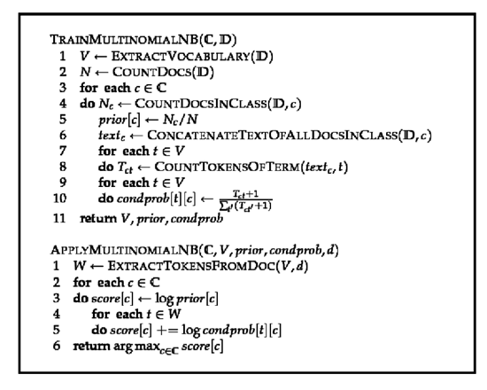

## **5.3 DEPLOYMENT DETAILS**

Python libraries such as pandas, numpy, sklearn, tweepy etc… must be available in the deployment environment with support to deploy NodeJs application. Apart from these front end libraries such as bootstrap and jQuery must be made available either locally in server or through CDN.

**CHAPTER 6**

# **RESULTS AND DISCUSSION**

## **6.1 DATASET FOR TESTING**

The dataset has around 35,000 tweets. It training dataset consists of tweets with depressed/not depressed labels. Each module of the system was also tested separately. The results of this module testing as well as the testing of the entire system are summarized below.

## **6.2 OUTPUT OBTAINED IN VARIOUS STAGES**

This section shows the results obtained during module testing

**6.2.1 INPUT**

The input is a tweet in case of a user or twitter username in case of an analyst.

**6.2.2 PRE-PROCESSING**

The output obtained from the pre-processing module is as show in the figure 6.1 and figure 6.2

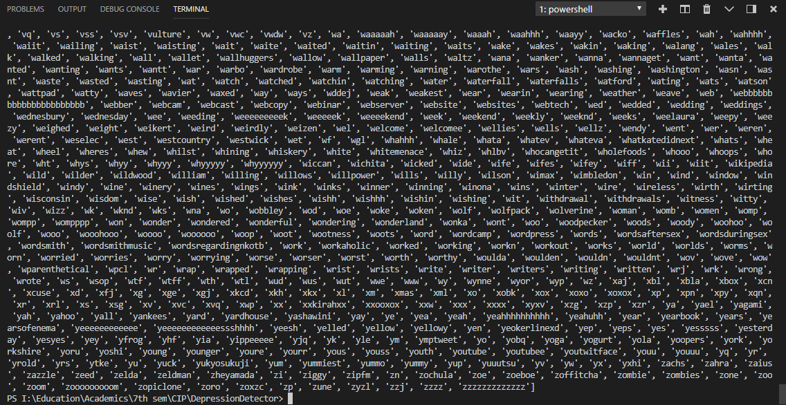

**Figure 6.1 Preprocessing**

**BAG OF WORDS**

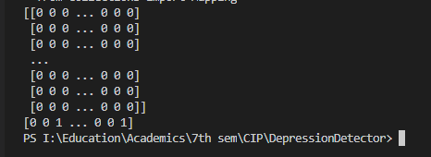

**Figure 6.2 Bag-of-Words**

**6.2.3 CLASSIFIER**

The classifier is trained and is dumped into a pickle file as show in the figure 6.3



**Figure 6.3 Classifier**

**6.2.4 SERVER**

The server runs the algorithm and sends the prediction to the GUI as output.

The output is rendered as motivational quote, helpline or as an analysis depending on the user profile.

**6.2.5 OUTPUT**

The sample output obtained is of various forms depending on the user profile as shown in figure 6.4



**Figure 6.4 Output**

**6.3 SAMPLE SCREENSHOTS OF INPUT AND OUTPUT WHILE TESTING**

Figure 6.5 and 6.6 shows the different outputs obtained during testing.

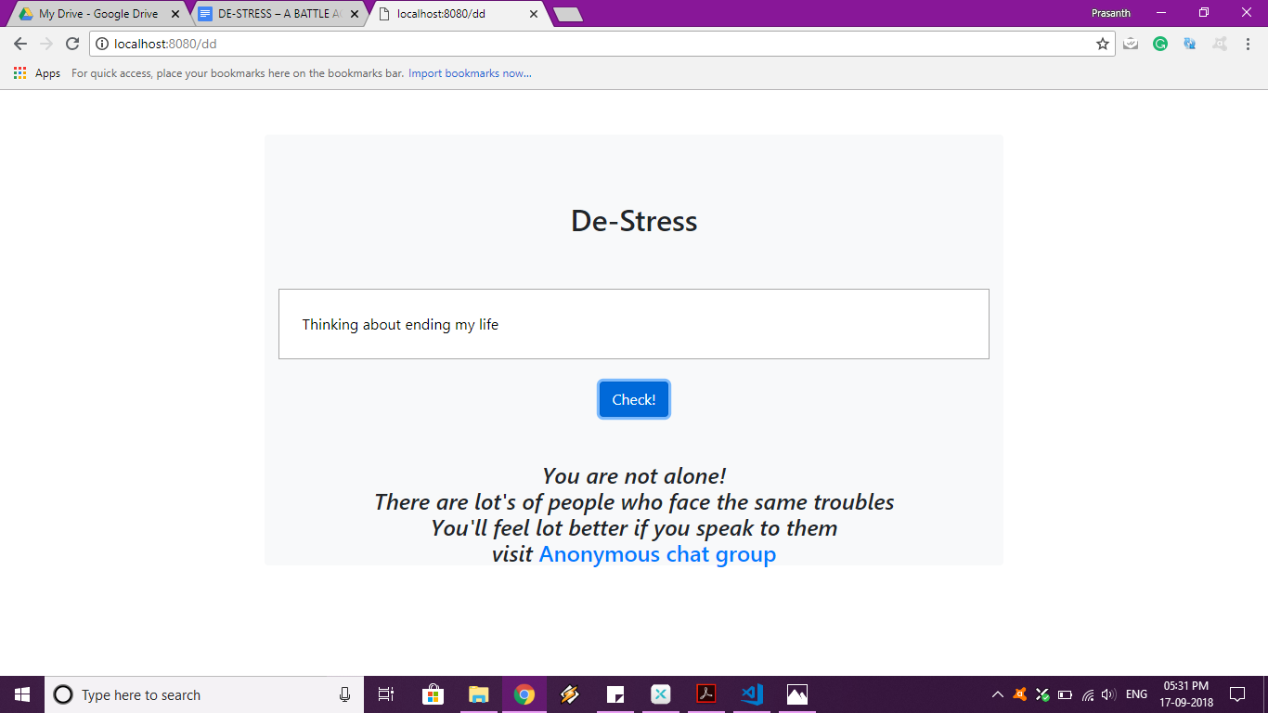

**Figure 6.5 Output(User page)**



**Figure 6.6 Output (Analyzer page)**

## **6.4 PERFORMANCE EVALUATION**

**6.4.1 F1 score**

The results are evaluated on the basis of F1 score and accuracy. The F1 score is the primary performance measure and accuracy is the secondary measure. F1 score is calculated based on the precision and recall.

*F*1 *score* = (2 *∗ P ∗ R)/P* + *R*

Here, P stands for Precision and R is the Recall.

Precision = [True Positive]/[True Positive + False Positive]

Recall = [True Positive]/[True Positive + False Negative]

It can be noticed from the results that Multinomial Naive Bayes has performed with the F1 score of 80.39.

The accuracy of the Multinomial Naive Bayes is 76%.. The accuracy obtained is shown in

Table 6.1

|  |  |  |  |  |
| --- | --- | --- | --- | --- |
|  | Precision | Recall | F1-score | Accuracy |
| Multinomial Naive Bayes Classifier | 0.7513 | 0.8640 | 0.8039 | 76% |

**Table 6.1 F1 score**

**CHAPTER 7**

**CONCLUSION**

**7.1 SUMMARY**

This is a machine learning system which can detect depression in users based on their tweets. The tweets are analyzed to detect emotions of people and thereby depression is detected. Data preprocessing involves converting the text to lowercase, removal of stop words, removal of special characters. The preprocessed data and is subjected to the countvectorizer which produces a bag-of-words as its output. This is fed to the classifier along with the labels and the classifier checks for depression. The results of the classifier are pickled in order to minimize the access time. The preprocessed input is passed through the extreme depression detector to check for suicide ideation. After validation, the accuracy of the classifier is measured. The system has been designed to include user mode and analyst mode. In analyst mode one can fetch tweets from a particular user’s account and analyze the last ‘n’ tweets for signs of depression. Based on the intensity of depression, methods to fight against depression are suggested.

**7.2 CRITICISM**

The accuracy of the classifier can be increased by increasing the number of tuples used from the dataset which requires computational power. Improved methods could be implemented to increase accuracy. Inconsistency in the dataset might cause error to propagate to all modules of the system. The system should be properly trained to handle sarcasm.

**7.3 FUTURE WORK**

Methods to reduce number of false positives should be implemented. This would help in increasing the precision of the analysis. The method is language specific. The system could be modified to work on many languages. Determining techniques that can be used in medical context to detect clinical depression from social media user’s behavior. The system could be implemented on other social media sites.

**APPENDIX A**

**Test Cases For Each Module**

This section provides the test cases for each of the modules of the system developed.

**A.1 PREPROCESSING**

**A.1.1 Test Prerequisite**

The input text should be in English

**A.1.2 Description**

The set of test cases to this module covers different types of tweets involving numbers, special characters, emoticons etc...

**A.1.3 Test Cases**

**TC ID : 01**Input: Sentences with uppercase, lowercase and mixed case characters.

Expected Output: The entire input is converted to lowercase.

**TC ID : 02**Input: Sentences with numbers.

Expected Output: The numbers are removed.

**TC ID : 03**Input: Sentences with emoticons or special characters.

Expected Output: The special characters and emoticons are removed.

**TC ID : 04**Input: Sentences containing stop words such as is, are, the etc...

Expected Output: Stop words, special characters are removed from the text and it is converted to lowercase.

**A.2 MNB Classifier**

**A.2.1 Test Prerequisite**

A bag of words and labels should be generated.

**A.2.2 Description**

Bag-of-words should have the number of occurrences of each word. Appropriate labels are to be fed to the classifier.

**A.2.3 Test Cases**

**TC ID : 01**Input: Bag of words from countvectorizer.

Expected Output: Pickle file generated from the trained classifier. **A.3 Extreme Depression Detector**

**A.2.1 Test Prerequisite**

The classifier should be trained and pickled.

**A.2.2 Description**

The pickled classifier reduces access time.

**A.2.3 Test Cases**

**TC ID : 01**Input: Input from user

Expected Output: Detects whether the text is suicidal or not.

**REFERENCES**

[1] Mandar Deshpande and Vignesh Rao,*”Depression Detection using Emotion Artificial Intelligence”* in Proceedings of the International Conference on Intelligent Sustainable Systems,2017.

[2] Huma Parveen and Prof. Shikha Pandey,*”Sentiment Analysis on Twitter Data-set using Naive Bayes Algorithm”* in 2nd International Conference on Applied and Theoretical Computing and Communication Technology,2016*.*

[3] Mitali Desai and Mayuri A. Mehta,*”Techniques for Sentiment Analysis of Twitter Data:A Comprehensive Survey”* in International Conference on Computing, Communication and Automation,2016.

[4] Benjamin L. Cook,Ana M. Progovac, Pei Chen, Brian Mullin, Sherry Hou and Enrique Baca-Garcia, *”Novel Use of Natural Language Processing (NLP) to Predict Suicidal Ideation and Psychiatric Symptoms in a Text-Based Mental Health Intervention in Madrid”*, Computational and Mathematical Methods in Medicine Volume,2016.

[5] M.S.Neethu and R.Rajsree, *”Sentiment analysis in twitter using machine learning techniques”*,Fourth International Conference on Computing, Communications and Networking Technologies (ICCCNT), 2013.

[6] N. Kasture and P. Bhilare, *“An Approach for Sentiment analysis on social networking sites”*, Computing Communication Control and Automation (ICCUBEA)*,* 2015, pp. 390-395.

[7] S. Bhuta, A. Doshi, U. Doshi and M. Narvekar, *“A review of techniques*

*for sentiment analysis Of Twitter data”*, Issues and Challenges in Intelligent Computing Techniques (ICICT), 2014, pp. 583-591.

[8] G. Gautam and D. Yadav, *“Sentiment analysis of twitter data using machine learning approaches and semantic analysis”*, in 7th Int. Conf. on Contemporary Computing, 2014, pp. 437-442.

[9] A. Sarlan, C. Nadam and S. Basri, *“Twitter Sentiment Analysis”*, in International Conference on Information Technology and Multimedia, 2014, pp. 213-216.

[10] A. Celikyilmaz, D. Hakkani-Tur and Junlan Feng, *“Probabilistic model based sentiment analysis of twitter messages”*, IEEE Spoken Language Technology Workshop (SLT)*,* 2010, pp. 79-84.