

De-Stress

Abhishek R(2015103579)

Prasanth P(2015103601)

# Abstract System Architecture

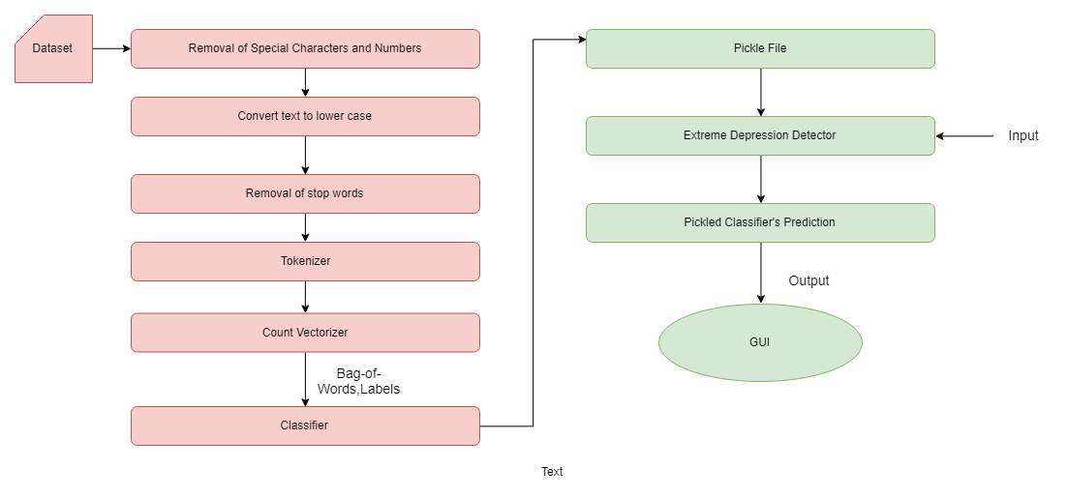

Depression is a state of mental illness that affects a large number of people worldwide. It affects the people negatively in their career, health, social life and other aspects of their life. Severe depression can also lead to suicide. Fortunately, depression is curable, provided it is detected at an earlier stage. Social network is a good platform as people tend to share their emotions through tweets.

Machine learning techniques can be employed to process these tweets by comparing them with existing data available to predict whether a person is depressed or not and thereby provide methods to assist them. Even suicide attempts can be prevented. Assistance can be provided by motivating them in case of minor depression and suggestion of anonymous psychiatrist’s help in case of severe depression.

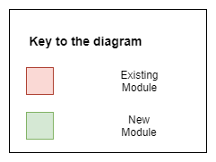

The depression detection model was implemented in python and GUI is provided for easier access with standard web development technologies. This project can create a serious impact if it is implemented as an add on / plugin in social networking sites. The advantage of this project is that as more and more data is analyzed the better will be the project’s accuracy. We achieved an accuracy of 76%. Thus this project will help in making a positive impact in many aspects of a person’s life.

Objectives

Result Analysis Conclusion

The objective of this project is to

* Detect depression based on their social networking activities
* Providing assistance to recover from depression
* Detect depression at an early stage
* Motivating people to get ahead of depression
* Suggesting anonymous psychiatrist’s help
* Providing a platform to analyze depression

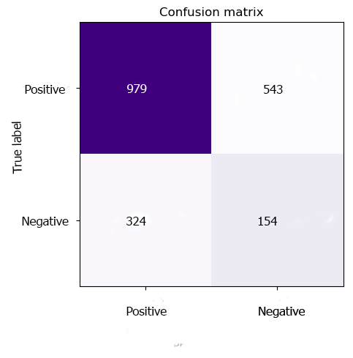

The module has :

* Precision : 75%
* Recall : 86.4%
* F1 score: 80%

Major References

Mitali Desai, Mayuri A. Mehta*,”Techniques for sentiment analysis of Twitter data: A comprehensive survey”*, International Conference on Computing, Communication and Automation (ICCCA), 2016

M.S.Neethu, Rajsree, *”Sentiment analysis in twitter using machine learning techniques”*,Fourth International Conference on Computing, Communications and Networking Technologies (ICCCNT), 2013

Precision = TP*1.0/(TP+FP)

Recall = TP*1.0/(TP+FN) F1 score: (2*P*R)/(P+R)

Submitted for CS7711 – Creative & Innovative Project Laboratory (Group3) Course Instructor: R.Bhuvaneshwari