**Customer Marketing Analitics**

**1. Getting to know the data**

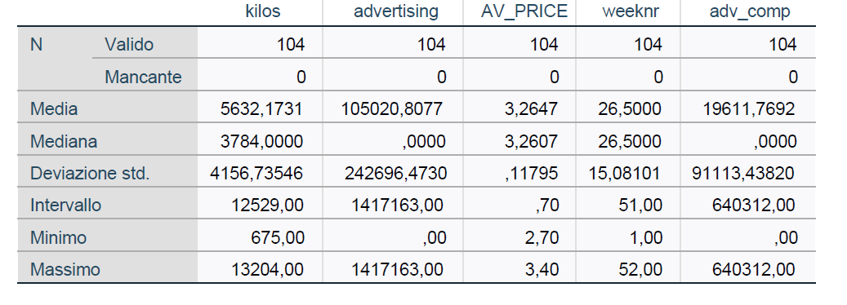

1. We have total 104 data points in the given Wool Worth Dataset (one year data) and there are no missing values.
2. The Average Kilos of products (Eta and Kraft) sold per year X
3. Minimum Kilos of products (Eta and Kraft) sold
4. Maximum Kilos of products (Eta and Kraft) sold
5. The Average Advertising Price of Wool Worth brands
6. The Minimum Advertising Price of Wool Worth brands
7. The Maximum Advertising Price of Wool Worth brands
8. The Average Advertising Price of Wool Worth competitor
9. The Minimum Advertising Price of Wool Worth competitor
10. The Maximum Advertising Price of Wool Worth competitor

**b.**

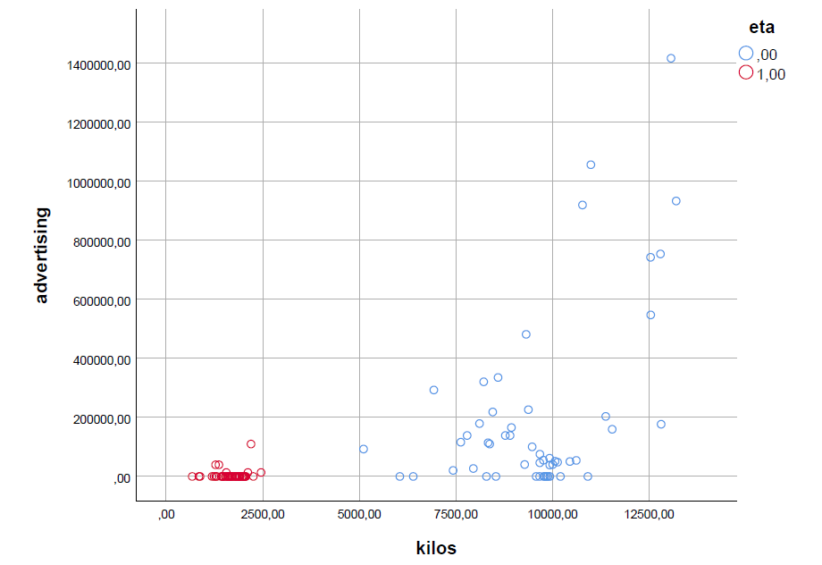

1. The relation between advertising price and number if items sold is quite look like linearly classified on the overall products (Krafts and Eta)
2. But If we separately for Kraft sold and Eta Sold with their corresponding advertising prices is different. (Kraft – Linear, Eta – Non Linear)

**2.Advertising elasticities**

1. The output is the natural logarithm of the total volume sold in kilos (kilosln) and the input it’s the natural logarithm of total advertising spending of the affected brand in AU$ (advertisingln). That because we want to know the percentage of variation in kilos sold deriving from a percentage of variation in advertising.
2. We added a small amount ( AU$) to advertising in order to avoid to many missing value.

If we consider both products the equation of the linear regrassion is:

$kilosln=\left(0.12±0.01\right)advertising+\left(7.6±0.1\right)$

The kilos sold for both product increase linearly with the money invest in advertising of both product.

The p-value of this regression is less than 0.05 therefore the linear regression is valid.

For an increase in advertisingln of 1% the kilosln increase of 0.119%.

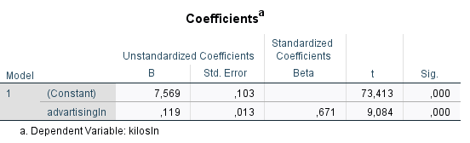

c. The equation for Eta is:

$kilosln=\left(0.009±0.012\right)advertising+\left(7.38±0.05\right)$

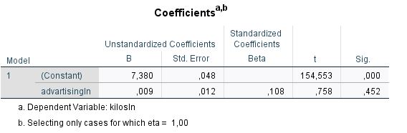

The equation for Kraft is

$kilosln=\left(0.008±0.006\right)advertising+\left(9.07±0.06\right)$

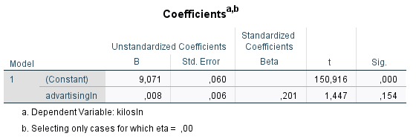

For an increase in advertisingln of 1% the kilosln of Eta increase of 0.009%. and for Kraft an increase of 0.008%

d.

The Results the linear regression for Eta and Kraft separately are not statistically valid (Sig <0.05). Moreover the coefficient B is nearly 0 for both products.

For these reasons only the simultaneously advertising of both product have a positive feedback in the kilos of Eta’s and Kraft’s products sold. The strategy of invest in the advertising of just one product is not effective.

**3. Adding control variables**

We do a multiple linear reggression with new parameters in attition at advertisingln: long-term trend, season of the year and average price level. The dipend variable is kilosln.

a.

1)For both product the equation is:

$\begin{aligned}kilosln=\left(8±2\right)advertisingln+\left(0.2±0.2\right)summer \\ +\left(0.2±0.2\right)fall−\left(0.4±0.7\right)AVPrice+\left(0.015±0.007\right)weeknr+\left(0.1±0.2\right)winter+\left(1.2±1\right)\end{aligned}$

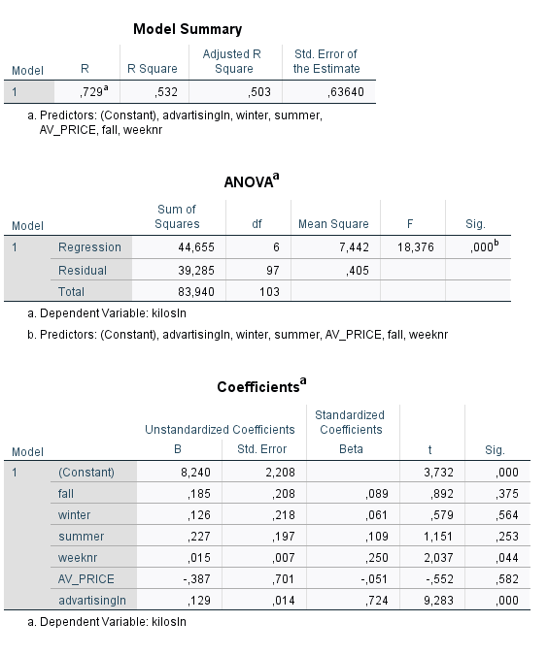

2)For Kraft the equation is:

$\begin{aligned}kilosln=\left(0.01±0.05\right)advertisingln−\left(0.03±0.09\right)summer \\ −\left(0.1±0.1\right)fall−\left(0.3±0.2\right)AVPrice+\left(0.010±0.002\right)weeknr−\left(0.1±0.7\right)spring+\left(9.9±0.7\right)\end{aligned}$

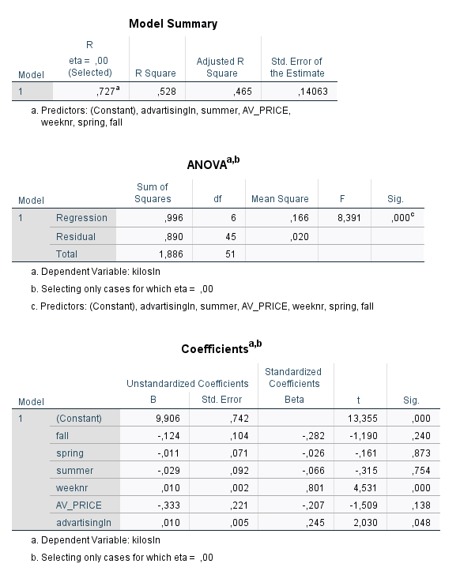

3)For Eta the equation is

$\begin{aligned}kilosln=\left(0.006±0.008\right)advertisingln−\left(0.18±0.06\right)summer \\ −\left(0.42±0.06\right)fall−\left(0.6±0.3\right)AVPrice+\left(0.019±0.003\right)weeknr−\left(0.06±0.07\right)winter+\left(9±1\right)\end{aligned}$

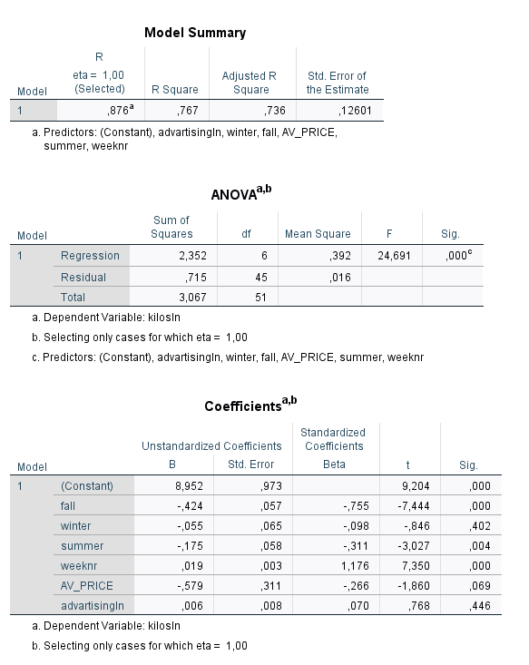

**b,c)**

In the model 1 (both products), the kilosln sold is affected by advertising (like the previosly analisis) and by the parameter weeknr. The kilosln grow with the weeks go by after the crisis.

In the model 2 (Kraft) the kilosln sold is affected by advertising and by the parameter weeknr. In this model adding a long-term trend show that the company strategy of advertising work (In contrast without long-term trend)

In the model 3 (Eta) the kilosln sold is affected by the variable fall weeknr Summer. The parameter AVPrice have a Sig slightly higher than 0.05 and for a complete analisis we also take account of this indipendent variable.

The kilosln decrease with AV_PRICE , in the fall season and during summer time. In this case advertisingln don’t play a role in the kilosln sold(Sig is too high)

To conclude adding a long-term trend and average price to the analisis show that the major Kraft advertising campaign leads to sales growth. However The sales increase faster if the company had done a major advertising campaign for both products (the coefficient of advertisingln is higher and the sig is lower in model 1)

d)

We are considering mass media as another environmental factor which is talking about the spread of the infection of salmonella due to Eta and Kraft products.

**4.Adding the competition**

**a,b)** In this model we add the competitor advertising in order to understand the impact to the kilosln

1)For both product the coefficients are:

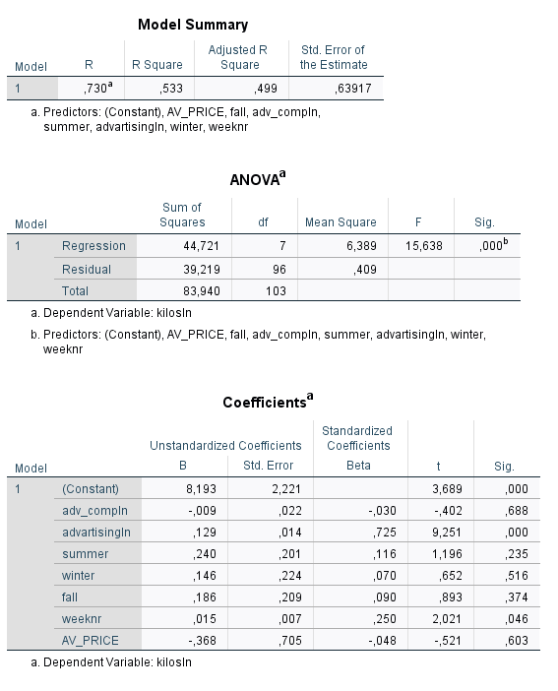

**2)**For Eta the coefficients are:

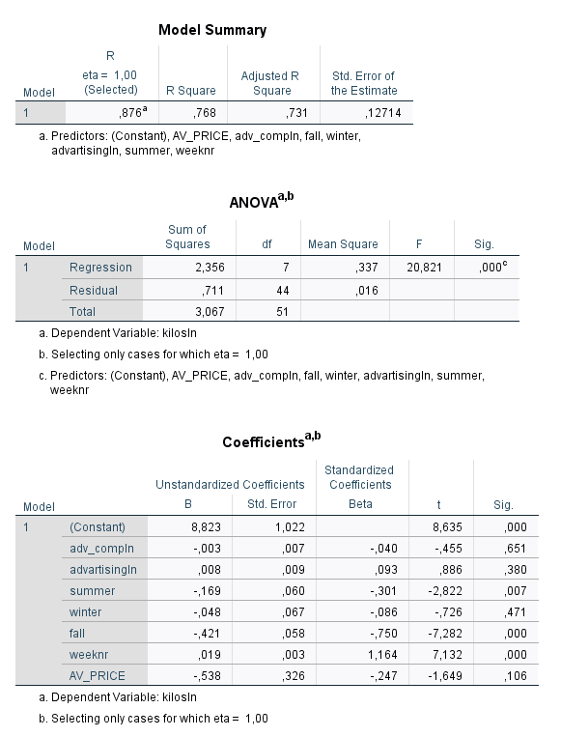

**3)**For Kraft the coefficients are :

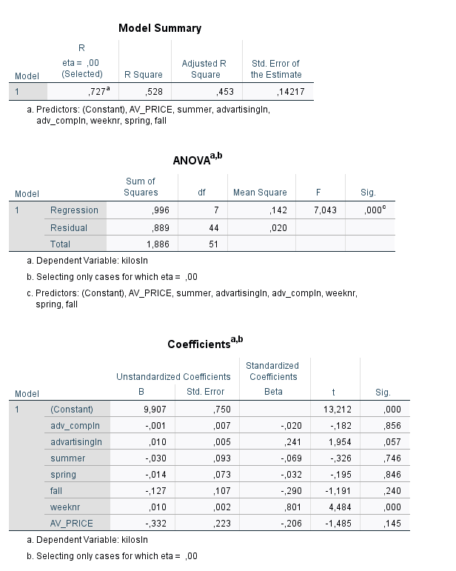

The adv_competitor don’t have a fundamental role in the kilosln because the p value is higer than 0.05 in all models. The coefficient is negative in all cases, that means its have a negative feedback on the kilosln (though is not significant ).

**c** We calculate a new parameter (shareofvoice)

1)For both product the coefficients are:

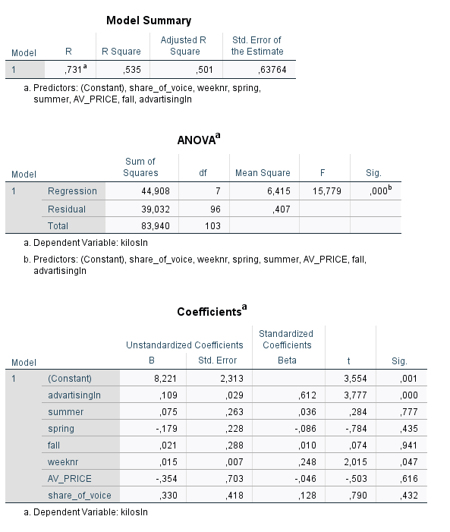

2)For Eta the coefficients are:

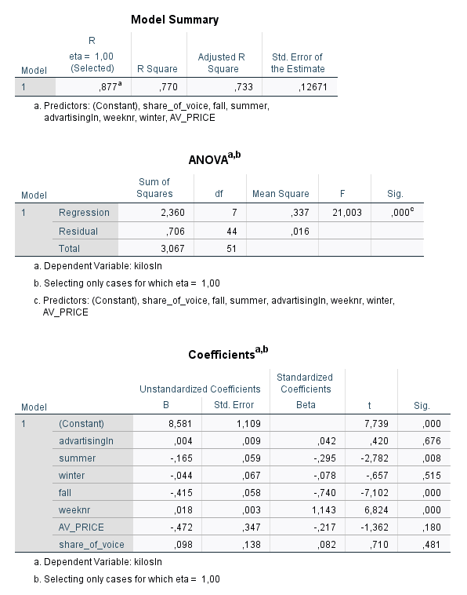

3)For Kraft the coefficients are :

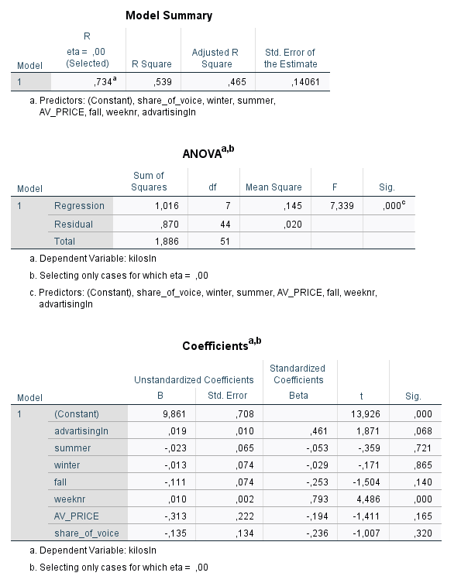

In all three models the p value is above 0.05 so we can says this variable don’t significantlyaffect the kilosln. However the B coefficient of shareofvoice in the models 1 and 2 is positive, that means that an increase in shareofvoice of 1% the kilosln increase of 0.330 % and 0.098% respectively.

On the other side in the model 3 the variable share of voice has a negative feedback on the kilosln variable. An increase in shareofvoice of 1% the kilosln deacrease og 0.135%.

One possible explanation for the negative coefficients is that an aggressive advertising campaign can cause decline of sales.

d)

We think that the share of voice it's statistically more interesting considering the elements we saw in the points b/c

**5 Adding dynamics**

a)

Adding lags can be absolutely interesting to understand if starting later to do advertising can be useful in order to have a stronger response from the market. Maybe, in the next weeks after the crisis costumer are more sensitive about the link between the salmonella desease and Eta and Kraft so a delay in advertising can be effective

**b)**

1)For both product the coefficients are:

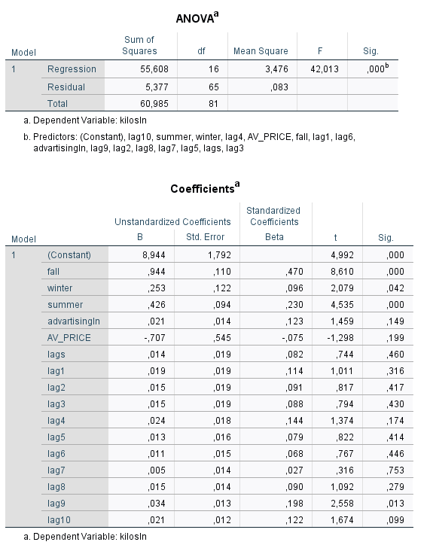

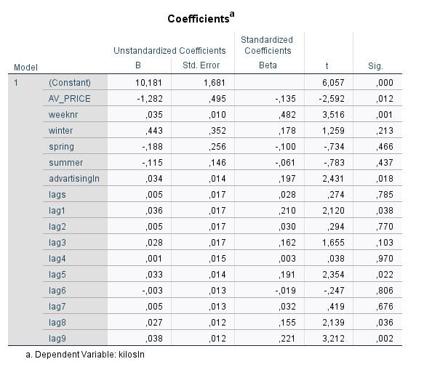

2)For Eta the coefficients are:

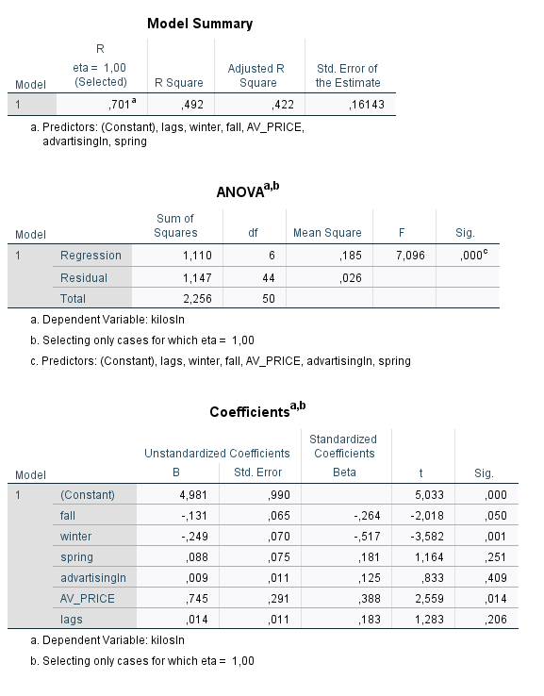

3)For Kraft the coefficients are :

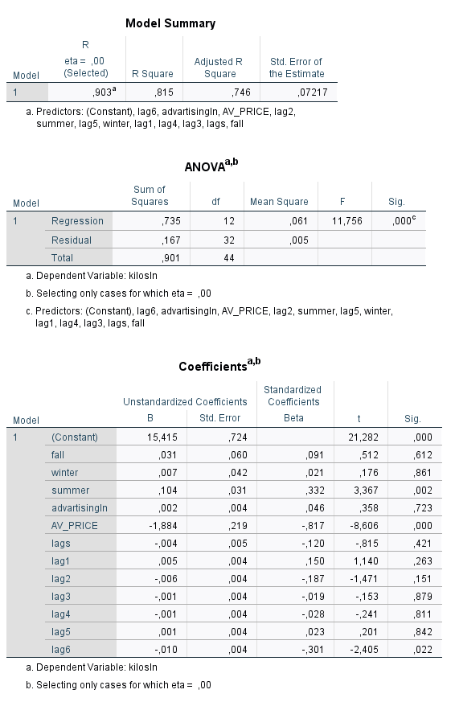

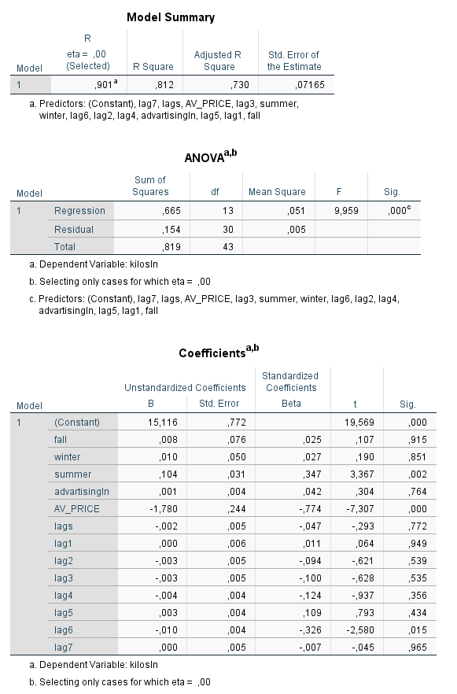

c)

In the model 1 and 3 the strategy of delay advertising have a positive feedback on the kilosln. In the model 1 if you add the lag beyond 10 , the model is becoming insignificant where model is not so responsive with the given input variables which is describing , the effect of advertising campaign is negligable on the Kilos of products sold. This is happened even for the model 3 at lag6. In contrast for the model 2 adding a lag does’t affect the kilosln.

d)

The Adtock variable is the weighted average between previous advertising and current advertising. The parameter α is the weight; if α is equal to zero the Adstock variable is affected only by the previous advertising, if α is equal to 1 the Adstock variable is affected only by the current advertising. The dinamic is given by α infact (1- α) is the carryover of the stock .

6)

a) Adding variables it’s not generating always a better model. We saw that adding a quite large number of variables have an impact on the significance. On the other side we have to say that obviously reality it’s difficult to represent but we need to consider all the variables that can have an impact on the model to give the right response to the question we have.

b) Concerning the validation and model testing we can say that we can use a cross validation. The goal of this model is to test the model's ability to predict new data that was not used in estimating it, in order to flag problems like overfitting or selection bias and to give an insight on how the model will generalize to an independent dataset

c) As we saw spending more money in advertising can generate better sales. But even if advertising can be really effective on people we think that an admission to be in fault can improve the fidelity and the sells too.

d) We think that this type of model it’s not usable due to the presence of only few significant variables. An explorative analysis in order to understand the behavior of variables can surely help in improve our model.