**AIM**: -Design a basic website pages and posts with AI generated Content and AI generated images.

**About WordPress.org**

### WordPress.org is a free and open-source content management system (CMS) that powers a significant portion of the websites on the internet. It provides a user-friendly interface, robust features, and a large community of developers and users. Here's an overview of WordPress.org and its features:



**Open-Source Platform:** WordPress.org is open-source, meaning the source code is freely available to the public. Users can modify and distribute the software, fostering a collaborative community.

## User-Friendly Interface:

The platform is known for its intuitive and user-friendly interface, making it accessible to beginners and non-technical users.

## Themes:

Users can choose from a vast collection of themes to change the look and feel of their websites. Themes are customizable, and users can modify them to suit their specific needs.

## Plugins:

Plugins extend the functionality of WordPress. There are thousands of plugins available for various purposes, including SEO optimization, security, e-commerce, and more.

## Content Management:

WordPress excels as a content management system, allowing users to easily create, edit, and manage different types of content, including text, images, videos, and more.

## Blogging Platform:

Originally designed as a blogging platform, WordPress remains a popular choice for bloggers. It offers features like categories, tags, and scheduled publishing.

## Customization Options:

Users can customize their websites extensively using widgets, menus, and the WordPress Customizer. Customization options include header and footer settings, color schemes, and more.

## Responsive Design:

WordPress themes are designed to be responsive, ensuring that websites look and function well on a variety of devices, including desktops, tablets, and smartphones.

## Search Engine Friendly:

WordPress is inherently SEO-friendly. It allows users to optimize their content for search engines, and there are several SEO plugins available for additional functionality.

## Multi-Language Support:

WordPress supports multiple languages, allowing users to create websites in their preferred language.

## Media Management:

Users can easily upload and manage media files, including images, videos, and audio. The platform also provides options for image resizing and cropping.

## Community Support:

WordPress has a large and active community of developers, designers, and users. This community support is invaluable for troubleshooting issues, sharing knowledge, and collaborating on projects.

## Regular Updates and Security:

WordPress releases regular updates to enhance features, improve security, and fix bugs. Users are encouraged to keep their installations up to date for optimal performance and security.

## E-commerce Capabilities:

With the help of e-commerce plugins like WooCommerce, WordPress can be transformed into a powerful platform for online stores.

## Membership and Subscription Sites:

WordPress allows the creation of membership sites and subscription-based content, making it suitable for various business models.

.

# Steps by Steps for website in WordPress

Here's a step-by-step guide to help you create a website using WordPress.org:

**Step 1: Domain and Hosting**

1. Choose and register a domain name for your website.
2. Select a reliable web hosting provider. Common choices include Bluehost, SiteGround, or HostGator.

## Step 2: Install WordPress

1. Log in to your hosting account.
2. Look for an option to install WordPress. Many hosting providers offer a one-click WordPress installation.
3. Follow the on-screen instructions to complete the installation.

## Step 3: Accessing the WordPress Dashboard

1. After installation, access your WordPress dashboard by visiting your domain followed by "/wp-admin" (e.g., [www.yourdomain.com/wp-admin).](http://www.yourdomain.com/wp-admin))
2. Log in with the credentials you created during the installation process.

## Step 4: Choose a Theme

1. Navigate to "Appearance" > "Themes" in the dashboard.
2. Click on "Add New" and browse through the available themes.
3. Click "Install" on the theme you like and then activate it.

## Step 5: Customize Your Site

1. Go to "Appearance" > "Customize" to access the WordPress Customizer.
2. Here, you can modify your site title, tagline, colors, fonts, and other appearance settings.
3. Preview your changes before saving.

## Step 6: Install Essential Plugins

1. Navigate to "Plugins" > "Add New."
2. Search for and install essential plugins like Yoast SEO for SEO optimization, Contact Form 7 for forms, and Akismet for spam protection.
3. Activate the installed plugins.

## Step 7: Create Pages and Posts

1. Start creating your main pages like Home, About Us, Contact, etc., under "Pages."
2. Write and publish blog posts under "Posts."

## Step 8: Set Up Navigation Menu

1. Go to "Appearance" > "Menus" to create and customize your navigation menu.
2. Add your created pages to the menu structure.

## Step 9: Configure Permalinks

1. Go to "Settings" > "Permalinks."
2. Choose a permalink structure that is SEO-friendly, like "Post name."

## Step 10: Configure Settings

1. Review and adjust general settings under "Settings" > "General."
2. Configure reading and discussion settings based on your preferences.

## Step 11: Secure Your Website

1. Ensure your website's security by using strong passwords.
2. Install a security plugin like Wordfence or Sucuri.

## Step 12: Back Up Your Website

1. Regularly back up your website using a plugin like UpdraftPlus.
2. Store backups in a secure location.

## Step 13: Launch Your Website

1. Once satisfied with the appearance and content, officially launch your website.
2. Share it with your audience and start promoting your content.

# CYBER SECURITY

A successful cybersecurity approach has multiple layers of protection spread across the computers, networks, programs, or data that one intends to keep safe. In an organization, the people, processes, and technology must all complement one another to create an effective defense from cyber attacks..

**Mobile Device Security**: Mobile Device Security helps in protecting sensitive data stored in the mobile and transmitted through portable devices like laptops, tablets & wearables. The potential threats to mobile devices mainly comprise phishing scams, malicious mobile apps, spyware, unsecure Wi-Fi networks & data leakage. To avoid safety violate, every company must take preventative & clear steps to decrease the risk.

**Remote Working**: Remote working is very helpful for organizations because it increases productivity, better work-life balance, and flexibility but it also increases cyber security problems. So, the devices which are used for work purposes like laptops, computers, and smartphones must stay locked once anti-virus software is installed

**The Future of AI in Cybersecurity**: Artificial intelligence within Cyber security simply helps organizations in observation, reporting, detecting, and cyber threats countering to maintain data confidentiality. The growing awareness among individuals, progression in information technology, intelligence up-gradation, police work solutions & growing volume of information collected from various sources have demanded the use of improved & reliable cyber security .

**Cybersecurity with IoT:** IoT-based cyber security is a technology used to protect connected devices & networks within the Internet of things, So internet of things involves connecting computing devices, digital & mechanical machinery, animals, items, etc. every object is specified with a unique identifier & the capability to transfer data separately across a network..

**Ethical Hacking:** Ethical hacking is an authorized attempt to get illegal access to a computer system, data, application, or infrastructure of the organization. This hacking simply targets to check the system otherwise network that malicious hackers can destroy or exploit. The company hires Cyber Security engineers to perform different activities to test the defenses of the system.

**Password-based Authentication**: The password-based authentication is a very simple cybersecurity concept used in different companies. When this data is stolen then it can be made sold or public to get revenue. So, randomized password implementation can make it much more difficult for cybercriminals to get access to different accounts. In addition, two-factor authentication can also provide addition.

**Cyber Insurance:** Cyber insurance is one type of insurance that can be insured to defend businesses from cyber attacks & more commonly from risks relating to IT infrastructure & activities. The coverage of cyber-insurance policy provides first-party coverage from different losses like data destruction, hacking, theft, extortion, rejection of service attacks, failure to defend data, etc.

**Dashboard:**

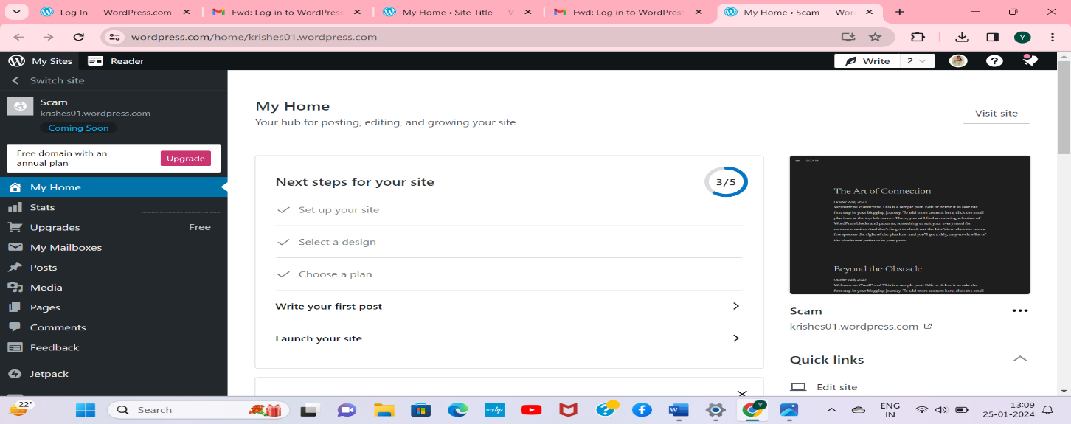

The WordPress dashboard is the central hub where website administrators manage and control various aspects of their WordPress-powered site. It serves as the main control panel, providing access to key features and settings. Here's an overview of the different sections and functionalities found in the WordPress dashboard:

## Admin Bar:

* + Located at the top of the screen, the admin bar provides quick access to various actions and shortcuts. It includes links to create new posts or pages, view your site, access the customizer, and more.

## Toolbar Menu:

* + The toolbar menu on the left side of the screen is the primary navigation menu. It contains several sections, including:
    - Dashboard: The main overview page with at-a-glance information about your site.
    - Posts: Create, edit, and manage blog posts.
    - Media: Upload and manage images, videos, and other media files.
    - Pages: Create, edit, and manage static pages.
    - Comments: Monitor and moderate comments on your site.
    - Appearance: Customize the site's theme, widgets, menus, and the site's overall look.
    - Plugins: Install, activate, deactivate, and manage plugins.
    - Users: Manage user accounts and roles.
    - Tools: Access various tools for importing and exporting content.
    - Settings: Configure general, writing, reading, discussion, media, and other site settings.

## At a Glance:

* + This section on the dashboard provides a quick overview of key information about your site, such as the number of published posts and pages, comments, and the currently active theme.

## Quick Draft:

* + A feature that allows you to quickly draft new blog posts directly from the dashboard without entering the full editor.

## Activity:

* + Displays a chronological list of recently published posts and comments on your site.

## Site Health:

* + Introduced in later WordPress versions, this section provides insights into the health of your site, highlighting any issues that may need attention.

## Recent Comments:

* + A section displaying the most recent comments made on your site, allowing you to moderate and respond to them quickly.

## WordPress News:

* + Provides the latest news and updates from the official WordPress blog, keeping you informed about software updates, security announcements, and more.

## Screen Options and Help:

* + Located at the top-right corner of the screen, these dropdown menus allow you to customize the elements displayed on the dashboard and access contextual help for specific pages.

## Widgets:

* + In the "Appearance" section, you can add, remove, and customize widgets in the dashboard. These widgets can provide additional information or functionality based on your preferences.

## Customizer:

* + Accessible through the "Appearance" section, the Customizer allows you to preview and make changes to your site's appearance in real-time. It includes options for themes, colors, fonts, and more.

## Editor:

* + In the "Appearance" section, you can access the theme editor to modify your theme's code (use caution and backup before making changes).

## Theme :Spiel

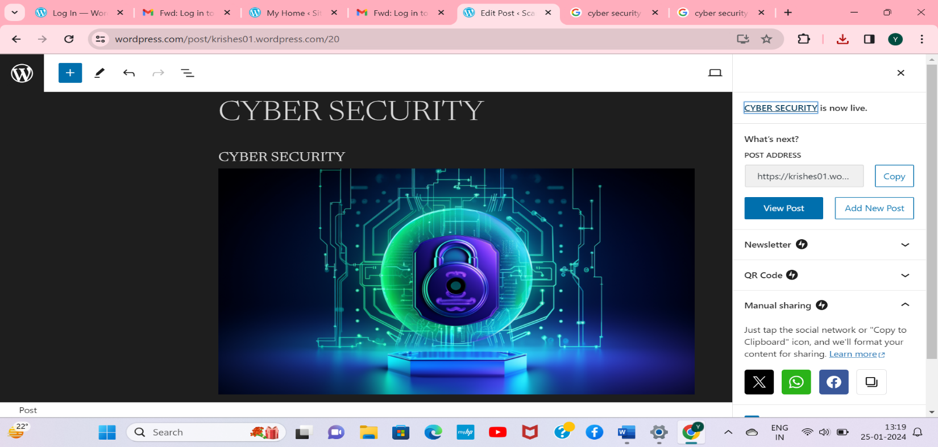

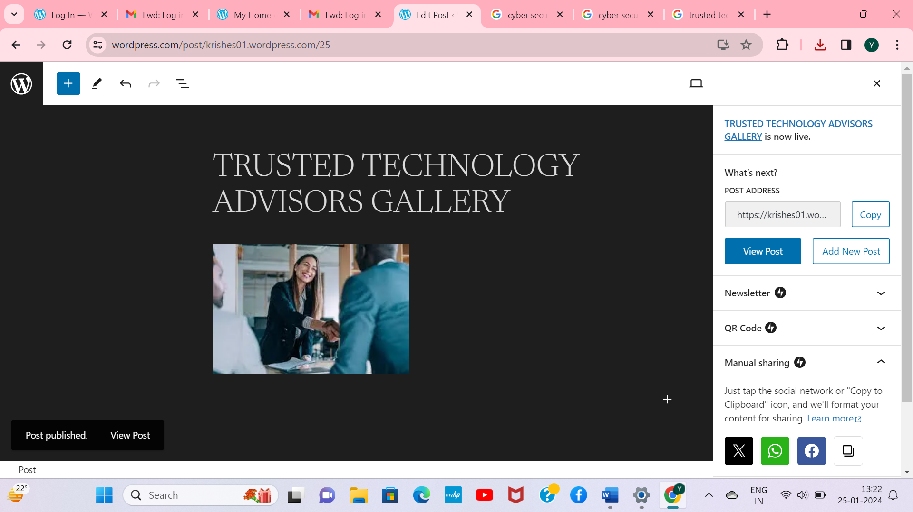

**Posts :**

## No of posts :-8 Posts list in Cars

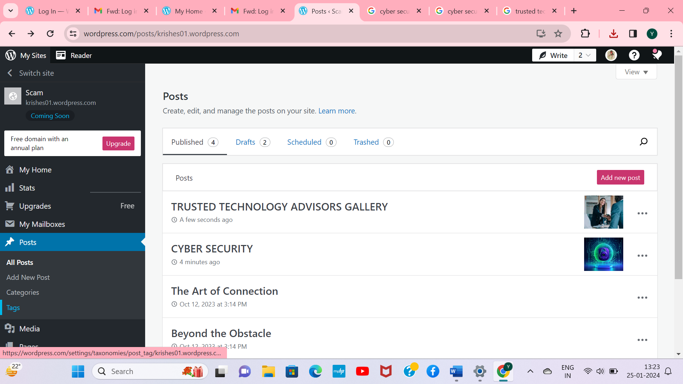

**Plugins Plugins list in Cars website**

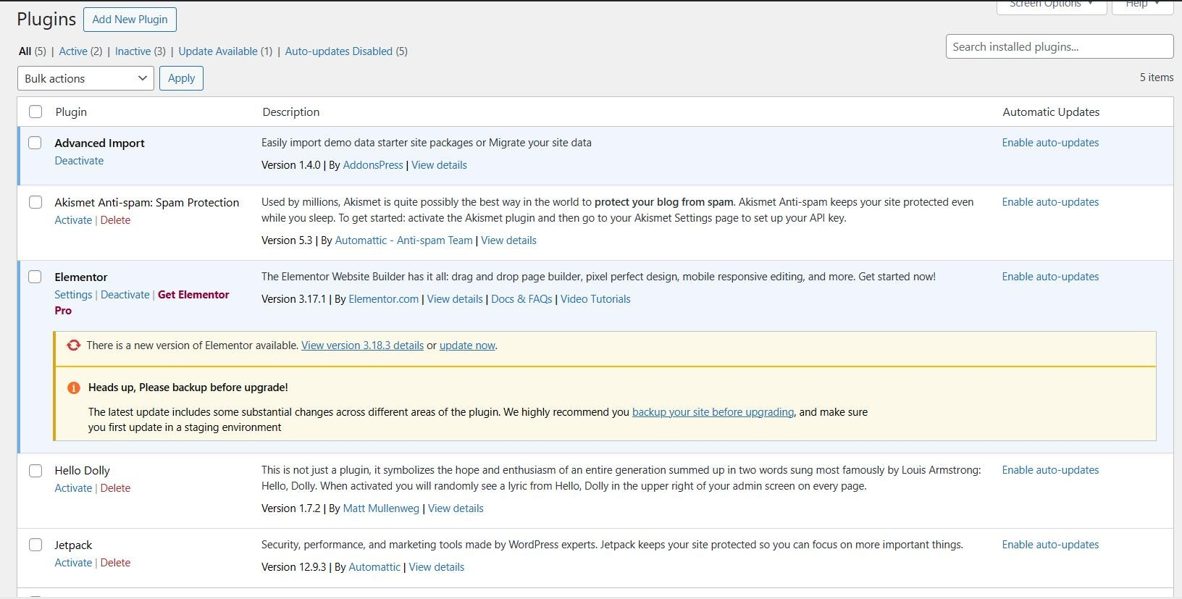

**Users Users list in Cars website**

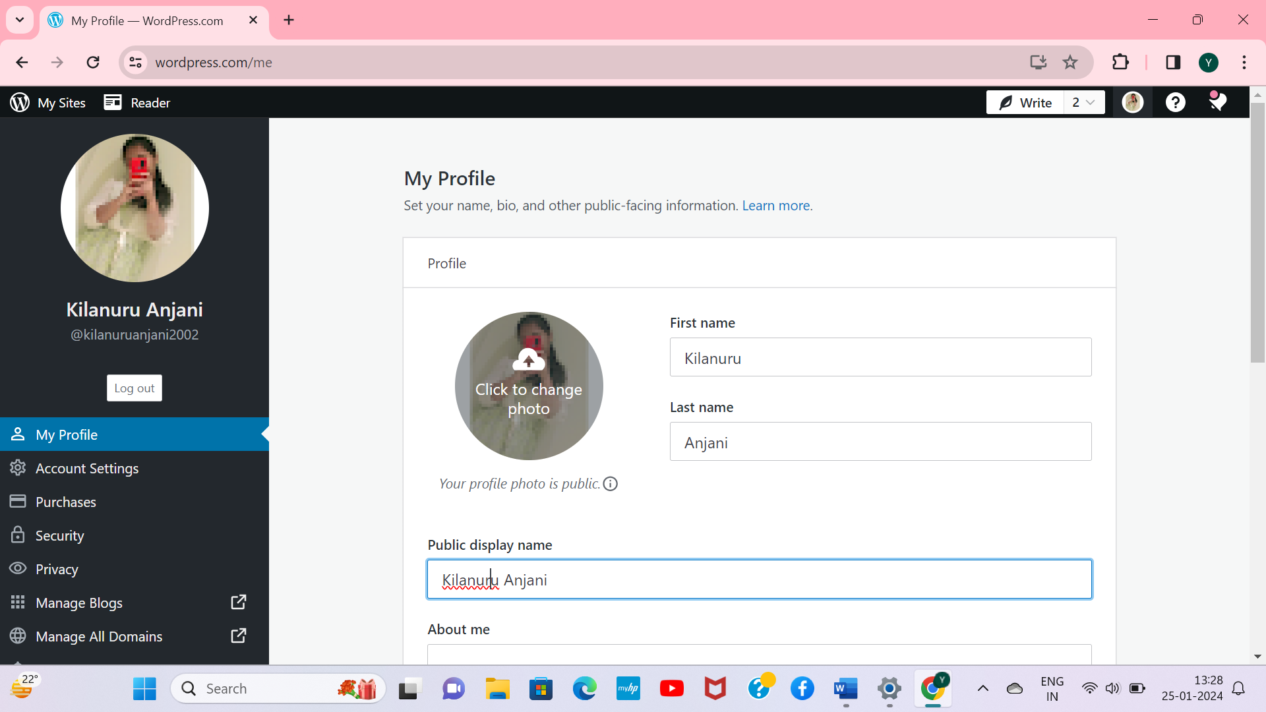

# Conclusion

In conclusion, the WordPress dashboard serves as the nerve center for website administrators, offering a user- friendly and comprehensive interface to manage and control various aspects of a WordPress-powered site. With its intuitive design, the dashboard allows users to navigate through key features seamlessly, empowering them to create, customize, and maintain their websites without the need for extensive technical knowledge.

From the admin bar and toolbar menu to specialized sections like At a Glance, Quick Draft, and Site Health, the dashboard provides a wealth of information and tools at a glance. Users can easily access essential functionalities such as creating and managing posts, pages, media, comments, and more. The inclusion of the Customizer and Widgets allows for real-time customization of the site's appearance and functionality.

Moreover, the WordPress dashboard fosters a sense of community and keeps administrators informed through features like Recent Comments and WordPress News, ensuring that users stay connected with their audience and are aware of the latest developments in the WordPress ecosystem.

As a central hub for website management, the dashboard streamlines the process of running a WordPress site, whether it's a personal blog, business website, or an intricate online platform. Its accessibility and flexibility make it an invaluable tool for users of varying experience levels, allowing them to focus on creating engaging content and building a vibrant online presence.