Minibatch Optimal Transport Invalidates Standard DP-SGD Accounting in Private Flow Matching for Tabular Data
[Author Name]¹, [Author Name]², [Author Name]³, [Author Name]¹*
¹ [Department, Institution, City, Country]
² [Department, Institution, City, Country]
³ [Department, Institution, City, Country]
* Correspondence: [Corresponding author name] ([email address])
Keywords: differential privacy | DP-SGD | flow matching | optimal transport | privacy auditing | synthetic tabular data | negative results
ABSTRACT
Differentially private (DP) synthetic tabular data is often proposed as a safe way to share sensitive records, and flow matching is an attractive generator for it. We report three findings. First, minibatch optimal-transport (OT) coupling, a common way to straighten flows, makes the loss of each example depend on the rest of its batch. This breaks the per-example sensitivity bound on which standard DP-SGD accounting relies, while the reported budget stays the same. We prove that independent coupling (I-CFM) keeps the bound and OT coupling does not, and we find violating neighbouring batches on two datasets. On a 20,000-record cardiovascular cohort, 69% of audited batches violated the bound, and a finite-sample white-box audit certified the violation at 95% confidence: within standard accounting, no valid certificate for that run can be below ε = 1.47, whereas 0.84 was reported. Second, we prove an end-to-end guarantee for a public-schema pipeline built on I-CFM; checking the proof against the code exposed five further leak classes, each reproduced on real data. Third, we trace where utility comes from. Jointly accounted class-conditional marginals raise the downstream AUC on UCI Adult from 0.49 to 0.906 at ε = 0.741, above target-aware AIM (0.872), and a randomly initialised flow adds no practically relevant utility to them. A flow warm-started on records drawn from the noisy marginals and then fine-tuned with DP-SGD does learn cross-column dependence from the private data (pre-registered, 10 seeds, significant in all six settings). An ε-adaptive budget split, also pre-registered, gave no benefit.

1 Introduction
Sensitive tabular records, such as hospital admissions, insurance claims and census responses, are among the most useful and least shareable data that institutions hold. Synthetic data offers a way around this tension: a generator learns the distribution of the private table and releases new records that have no direct link to real individuals [1]. Recent generators for mixed-type tables have narrowed the gap to real data considerably [2–4], and the clinical community has started to validate them on large cohorts, where models trained on synthetic records approach the predictive performance of models trained on the originals [1]. A synthetic record, however, is not private by default. Generators can memorise rare records, and only a formal guarantee such as differential privacy (DP) [5] bounds what an adversary can learn about any single person.
The standard way to obtain that guarantee for a neural generator is to train it with differentially private stochastic gradient descent (DP-SGD) [6]. DP-SGD has been used to train GANs [7], diffusion models [8] and, more recently, rectified flows [9]. Its standard privacy analysis rests on a single invariant: each training example influences the noisy update only through its own clipped per-example gradient. Libraries enforce this invariant for known offenders; Opacus, for instance, refuses batch normalisation layers because they mix statistics across examples [10]. The accountant computes a guarantee from the noise multiplier, the sampling rate and the number of steps under the assumptions supplied to it; it does not verify that the implemented mechanism satisfies them. A training loss that silently couples examples therefore leaves the reported ε unchanged even though the conditions of the analysis no longer hold. For contrastive losses this problem is known, and dedicated mechanisms have been proposed for it [11].
Flow matching [12, 13] learns a velocity field that transports a Gaussian prior to the data along straight paths between paired samples. How the samples are paired matters for sample quality. Pairing each record with an independent noise draw (independent coupling, I-CFM) is simple but produces curved flows; solving an assignment problem over the whole minibatch (OT-CFM) straightens the flows and allows fewer integration steps [14, 15]. The OT plan, however, is a function of every record in the batch. To our knowledge, no prior work has asked what this does to DP-SGD. The question is practical, because OT coupling is offered as a drop-in option in widely used flow-matching code, and a practitioner who adds DP-SGD to such code obtains a certificate that looks correct.
A second question concerns utility. Deep DP generators are usually compared with each other, yet benchmarks of DP synthesis consistently find that simple marginal-based methods such as MST and AIM perform best on tabular data [16–18]. When a pipeline combines a deep generator with a marginal-based component, the credit for good results is easily assigned to the deep model. We therefore designed our evaluation around the ablation that separates the two.
In this study, we built and audited a complete DP synthesis pipeline for tabular data based on flow matching. More specifically, we aimed to: (i) determine whether minibatch OT coupling is compatible with the standard DP-SGD analysis, in theory and on real data, (ii) certify any violation with an audit whose conclusion holds at a stated confidence level, (iii) prove an end-to-end guarantee for the full pipeline and check it against the implementation, and (iv) measure how much of the downstream utility is due to the flow itself, and whether the flow can add to the marginals once it starts from what they already provide. We keep three kinds of evidence apart throughout: the theorem states what can happen in general, the adversarial search finds concrete counterexamples, and the conditional white-box audit certifies a sensitivity violation for a specific neighbouring pair. The paper makes the following contributions, in order of importance.
- An accounting pitfall. We prove that batch-OT coupling does not guarantee the sensitivity bound assumed by standard DP-SGD accounting, under both add/remove and replace-one adjacency, while I-CFM satisfies it by construction. Replacement records found by our search re-pair up to 26 of 64 batch members.
- A certified audit on two datasets. Finite-sample white-box audits of the conditional Gaussian step certify, at 95% confidence, that the audited neighbouring batches violate the sensitivity bound. Within the standard accounting framework this forces certificates at least 22% (UCI Adult: 0.898 against 0.735 reported) and 76% (cardiovascular cohort: 1.474 against 0.839) above the reported values. We do not present these as lower bounds on the privacy loss itself, which would require auditing the subsampled mechanism.
- A taxonomy of implementation defects with reproductions. Checking an end-to-end proof against the code exposed five classes of defects that leak private information without changing the reported ε. We reproduce each on real data; for example, a private 78 × 78 feature-similarity matrix is recovered from released weights with a maximum error of 1.1 × 10⁻⁷.
- Where the utility comes from. A jointly accounted, target-aware marginal stage lifts utility above AIM and MST, and a randomly initialised flow adds no practically relevant utility to it. A flow warm-started from the noisy marginals and fine-tuned with DP-SGD does learn cross-column dependence from the private records, which a pre-registered 10-seed test confirmed in every setting we evaluated. A pre-registered ε-adaptive budget split failed, and we report it as a negative result.

2 Methods

2.1 Differential Privacy, Adjacency and Threat Model
A randomised mechanism M is (ε, δ)-differentially private if Pr[M(D) ∈ S] ≤ e^{ε} Pr[M(D′) ∈ S] + δ for every pair of neighbouring datasets D ≃ D′ and every set of outputs S [5]. Our guarantees use add/remove adjacency (D and D′ differ by the presence of one record), the relation assumed by the Opacus accountants [10]. Because a replacement is a removal followed by an addition, an add/remove guarantee converts to replace-one adjacency as
$(ε, δ) add/remove ⟹ (2ε, (1 + e^{ε})δ) replace-one$ (1)
by sequential composition of the two steps. The sensitivity audits in Section 2.7 are stated for replace-one neighbours, for which the per-step bound assumed by the accountant is 2C.
DP-SGD samples a batch B by including each record independently with probability q, clips every per-example gradient g_{i} to norm C, and adds Gaussian noise to the clipped sum:
$S̃(B) = ∑_{i∈B}ḡ_{i} + 𝒩(0, σ^{2}C^{2}I), ḡ_{i} = g_{i} · min(1, \frac{C}{‖g_{i}‖_{2}})$ (2)
Accountants based on Rényi DP [19] or on privacy random variables (PRV) [20] compose T such steps into one (ε, δ) guarantee, assuming that S(B) = Σ ḡ_{i} changes by at most C in L2 norm when one record is added or removed. We also use Gaussian differential privacy (GDP) [21]: a Gaussian step with sensitivity Δ and noise scale σC is (Δ/σC)-GDP, and for any test with false-positive rate α and false-negative rate β against a μ-GDP mechanism, μ ≥ Φ⁻¹(1 − α) − Φ⁻¹(β).
Implementation of the DP-SGD step. We use Opacus 1.6 only for Poisson sampling (DPDataLoader) and for accounting (PRV, with RDP reported alongside); we do not use the Opacus optimizer. Per-example gradients are computed by microbatched autograd. The per-example loss is the mean squared error over the d encoded coordinates. Clipped per-example gradients are summed, N(0, σ²C²I) is added to the sum, and the noisy sum is divided by the fixed public constant B = 512, the expected batch size qN, before the AdamW update. Batches are drawn by the Opacus DPDataLoader.from_data_loader, which includes each record independently with probability q_{L} = 1/⌈N/B⌉ (0.0417 for Adult and 0.0313 for Cardio), so the realised batch size varies around q_{L} N. The accountant is given q = B/N (0.0427 and 0.0320). Since q_{L} ≤ q for every N and B, and the PRV bound is non-decreasing in the sampling rate, the accounting is conservative; a regression test checks q_{L} ≤ q. An empty batch is stepped with noise only and counted as a step. Dividing by qN is post-processing only when N is public, which is exactly the situation analysed by Wang et al. [22]; we therefore state that assumption explicitly below.
Threat model. The adversary knows the code, every hyper-parameter, the public schema and every record except the target, and may choose the neighbouring dataset. It observes the synthetic dataset, the released weights of the velocity network and the privacy summary (ε, δ, σ, q, T). Training telemetry, such as loss curves and gradient norms, is computed without noise and is not released. We assume that (A1) column types, bounds and category lists are declared independently of the data; (A2) the cohort size N is public, as in every DP-SGD deployment that sets q = B/N; (A3) column and target names are public; and (A4) noise is unpredictable, with floating-point attacks [23] out of scope.

2.2 Flow Matching and Couplings
Conditional flow matching trains a velocity network v_{θ}(z_{t}, t) to regress the displacement z₁ − z₀ along z_{t} = (1 − t)z₀ + t z₁, where z₀ ~ N(0, I) is a prior draw and z₁ is an encoded record [12]. The per-example loss is ℓ_{i}(θ) = ‖v_{θ}(z_{t,i}, t_{i}) − (z_{1,i} − z_{0,i})‖² / d. Under I-CFM, record i is paired with its own prior draw z_{0,i}, and t_{i} ~ U(0, 1) is drawn independently for each record. Under OT-CFM, the batch is re-paired by the assignment π∗ = argmin_{π} Σ_{i} ‖z_{0,i} − z_{1,π(i)}‖², solved exactly with the Hungarian algorithm [24] (SciPy linear_sum_assignment), and record π∗(i) is matched with prior draw i [14, 15]. Algorithm 1 shows one DP-SGD step for both couplings and marks the single line at which batch dependence enters. Figure 1 illustrates the effect on a small two-dimensional example.
Algorithm 1. One DP-SGD step of conditional flow matching. The two couplings differ only in line 3.
Input: Poisson batch B (rate q), parameters θ, clip norm C, noise multiplier σ, public divisor qN
1 for each record i ∈ B: draw z0_i ~ N(0, I), t_i ~ U(0, 1) (independent per record)
2 z1_i ← φ(x_i) (row-local public-schema encoding)
3 I-CFM : pair (z0_i, z1_i) -> ℓ_i depends on record i only
OT-CFM: π* ← Hungarian(‖z0_a − z1_b‖², a, b ∈ B); pair (z0_i, z1_π*(i)) -> ℓ_i depends on all of B
4 zt_{i} ← (1 − t_i) z0_i + t_i z1_i ; ℓ_i ← ‖v_θ(zt_{i}, t_i) − (z1_i − z0_i)‖² / d
5 g_i ← ∇θ ℓ_i ; ḡ_i ← g_i · min(1, C / ‖g_i‖₂) (per-example clipping)
6 G ← ( Σ_{i∈B} ḡ_i + N(0, σ²C² I) ) / (qN) (noise on the sum, public divisor)
7 θ ← AdamW(θ, G); EMA update of the released copy (post-processing)
Accountant: records (σ, q) for this step; it never inspects line 3.

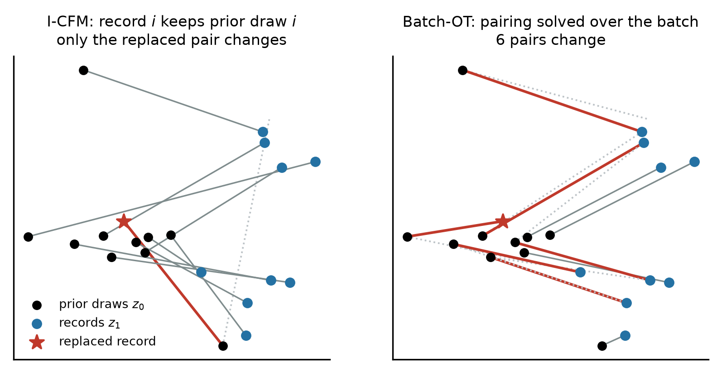
Figure 1. Where batch dependence enters (two-dimensional illustration with ten records and the exact Hungarian solver). Replacing one record (star) changes only its own pair under I-CFM, but under batch-OT it changes the pairs of six records, so their clipped gradients change as well. Dotted lines show the pairs before the replacement.

2.3 Sensitivity of the Clipped-Gradient Sum
Proposition 1 (I-CFM respects the bound). Under I-CFM, ℓ_{i} depends only on (z_{0,i}, z_{1,i}, t_{i}, θ). Adding or removing record j therefore changes S(B) by exactly ḡ_{j}, so ‖S(B) − S(B′)‖₂ ≤ C. The standard accountant applies without modification.
Theorem 1 (batch-OT does not guarantee the bound). Under OT-CFM, changing record j alters column j of the cost matrix, which may re-pair a set R of other records, with |R| = k ≤ |B| − 1. Then
$‖S(B) − S(B′)‖_{2} = ‖∑_{i∈\{j\}∪R}(ḡ_{i}(B) − ḡ_{i}(B′))‖_{2} ≤ 2C(k + 1)$ (3)
Standard DP-SGD accounting requires Δ₂(S) = sup ‖S(B) − S(B′)‖₂ ≤ C over add/remove neighbours and over all values of the per-example randomness (z₀, t). Under OT-CFM this condition is not guaranteed. Whenever Δ₂(S) > C, the conditions of the standard accountant's proof are not satisfied, and its reported ε is no longer established by that analysis. The accountant cannot detect this, because it computes a guarantee from (σ, q, T) under the assumptions supplied to it. A replace-one violation also implies an add/remove violation: by the triangle inequality through B \ {j}, if ‖S(B) − S(B′)‖ > 2C then one of the two add/remove neighbours differs by more than C. The theorem does not claim that an OT-trained model has no DP guarantee at all. A mechanism-specific analysis with a larger sensitivity bound, up to 2C(k + 1), would give a valid but much weaker certificate. The problem belongs to the family of non-decomposable objectives studied by Kong et al. [11], with one difference that makes it easy to miss: here the coupling creates the dependence, and the loss written for a single example looks per-example.

2.4 Synthesis Pipeline
The pipeline (Figure 2) turns a private table and a public schema into a synthetic table. Records are first encoded by a row-local map φ: numeric columns are scaled to [−1, 1] using the declared bounds, categorical columns are one-hot encoded over the declared categories, and missing values are filled with the midpoint of the public bounds. Because every constant used by φ comes from the schema, D ≃ D′ implies φ(D) ≃ φ(D′), and any mechanism that is DP on encoded records is DP on the raw ones. The velocity network and all training settings are listed in Table 1. The released model is an exponential moving average (EMA) of the DP-SGD iterates, which is post-processing. Sampled records are clamped to the public domain and decoded; one-hot blocks are decoded by argmax.
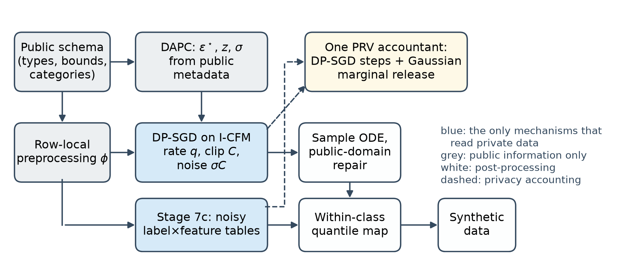
Figure 2. Synthesis pipeline. Blue boxes are the only mechanisms that read private data; both are Gaussian mechanisms and are composed in a single PRV accountant (dashed lines). Grey boxes depend on public information only, and white boxes are post-processing of the two private releases.
Table 1. Implementation and configuration. Complete settings, including the baseline environment, are listed in Supplementary Table S5.
Item | Setting
Software | Python 3.12.10; PyTorch 2.6.0 (CUDA 12.4, cuDNN 9.1); Opacus 1.6.0 (sampling and accounting only); NumPy 2.5.1; SciPy 1.18.0; scikit-learn 1.9.0
Hardware and precision | NVIDIA RTX 4060 Ti, 8 GB, driver 610.88; FP32 with TF32 matrix multiplication enabled
Velocity network | Sinusoidal time embedding (64) → Linear–SiLU–Linear; input Linear–LayerNorm–SiLU (128 units); 2 residual blocks of [Linear–LayerNorm–SiLU]×2; zero-initialised linear output; learnable input affine; PyTorch default initialisation otherwise
Optimisation | AdamW, learning rate 10⁻³, weight decay 10⁻⁵, cosine annealing to 10⁻⁵ per epoch; 5 epochs (Adult, Cardio), 10 epochs (small cohorts); no early stopping
DP-SGD | Poisson sampling, expected batch 512, clip norm C = 1.25, noise multiplier σ from bisection on the PRV accountant, δ_{SGD} = 8 × 10⁻⁶ (release δ = 10⁻⁵)
Flow matching | t ~ U(0, 1), z₀ ~ N(0, I); OT via exact Hungarian assignment (ablation only); EMA decay min(0.999, (1 + s)/(10 + s)) at step s
Warm start (Section 2.6) | Optional: 20 epochs of non-private AdamW (learning rate 10⁻³, batch 512) on N records drawn from the Stage 7c tables; the DP-SGD schedule is unchanged
Sampling | RK4, 30 steps; clamp to [−1, 1]; argmax on one-hot blocks
Seeds | Experiments seed the PyTorch and NumPy generators with the run index (0–9) for reproducibility, which also fixes the DP-SGD noise; a release must not do this (Section 3.3). Stage 7c noise is drawn from an unseeded generator

2.5 Choice of the Privacy Budget
The released budget ε∗ of each dataset was fixed before any private computation by a public-metadata policy, the dataset-adaptive privacy budget controller (DAPC). For a requested budget of ε = 1, it selects ε∗ = 0.741 (Adult), 0.849 (Cardio) and 0.753 (Pima) from the rounded cohort size, the encoded dimension and name-based column sensitivities. Because it reads only public quantities, it consumes no privacy budget. Its complete specification, a robustness analysis and a pre-registered test of an adaptive budget split (Section 3.7) are given in Supplementary Section S1. The results of the main text use fixed budget splits and do not depend on those details.

2.6 Class-Conditional Marginal Stage and Joint Accounting
The optional Stage 7c measures one table of counts per non-target column, cross-classified with the target, on public bins (32 bins, logarithmically spaced for heavy-tailed columns) and public categories, following the measurement step of MST and AIM [16, 17]. One record changes exactly one cell in each of the M tables, so the concatenated count vector has L2 sensitivity √M under add/remove adjacency. Adding N(0, z²M) to every cell is a Gaussian mechanism with noise multiplier z. We record it in the same PRV accountant as the DP-SGD steps, as a single step with sampling rate 1, and calibrate σ so that the joint composition equals ε∗. A fixed split spends a share ρ of ε∗ on the marginals, measured as the ε that the marginal release alone would cost; ρ = 0.9 is our primary configuration. After sampling, the synthetic table is post-processed in the spirit of Sklar's theorem [25]: class sizes are taken from the noisy tables, and within each class every column is quantile-mapped onto its noisy conditional marginal while the within-class ranks produced by the flow are kept. The flow thus supplies the dependence structure and the noisy tables supply the label–feature marginals. Replacing the flow's ranks with random ranks gives the marginals-only ablation, which uses no information from the flow.
Warm start. In the default configuration the flow starts from a random initialisation, so DP-SGD has to learn everything, including the label–feature structure that Stage 7c already releases. In the warm-start configuration we run Stage 7c first, draw N records from the noisy tables with independent within-class ranks, and pretrain the velocity network on them for 20 epochs without noise. The term refers to the initial network weights; it is unrelated to warm-start flow matching [26], which moves the starting point of sampling. DP-SGD then fine-tunes this network on the private records with the same σ, q and T. The pretraining reads only the output of the marginal mechanism and therefore costs no privacy. StraightDP [9] proposed the same two-stage pattern for image rectified flows: release class-conditional moments once, then spend the rest of the budget on DP-SGD. We apply it to tabular data with count marginals. To isolate what DP fine-tuning learns from the private records, the warm-only ablation runs and accounts every DP-SGD step with a learning rate of zero, so that its released weights equal the warm start and its ε is identical.
Theorem 2 (end-to-end guarantee). Let M₁ be T steps of Algorithm 1 with I-CFM, Poisson rate q = B/N, clip norm C and noise multiplier σ, and let M₂ be the Gaussian release of the M count tables with noise multiplier z. Under A1–A4, the release (synthetic data, EMA weights, privacy summary) is (ε∗, δ_{SGD})-DP with respect to add/remove adjacency, where ε∗ is the PRV composition of M₁ and M₂ at δ_{SGD} = 8 × 10⁻⁶ ≤ δ.
Proof outline. (a) Preprocessing is row-local under A1, so adjacency is preserved. (b) The budget policy, the split (z, σ), the number of steps T (fixed epochs, no data-dependent stopping) and all hyper-parameters are functions of public inputs and constants. The initialisation is data-independent or, with the warm start, a post-processing of the output of M₂. In the latter case M₁ is chosen adaptively after M₂, which PRV composition covers. (c) By Proposition 1 each step of M₁ has add/remove sensitivity C; with Poisson sampling it is a subsampled Gaussian mechanism, including empty batches. The accountant's rate B/N is not smaller than the loader's actual rate, and dividing by the public constant qN is post-processing under A2. (d) The optimizer state, the AdamW update and the EMA are functions of the noisy gradients only. (e) M₂ is a Gaussian mechanism with L2 sensitivity √M and noise z√M, drawn independently of M₁. (f) PRV composition of the recorded history gives ε∗; the run asserts that the accountant stays within the target before any output is released. (g) Sampling, repair, decoding and the within-class quantile map read only the released model, fresh prior noise and the noisy tables, and are post-processing. Supplementary Section S2 gives the formal mechanism specification and the full proof, with every code path that reads private data classified.

2.7 Privacy Audits
Sensitivity search. We measured ‖S(B) − S(B′)‖₂/2C for replace-one neighbours in batches of 64 records, over 10 network initialisations with 10 batches each, and set C so that every per-example gradient was clipped, as it is in all our training runs. The random search replaces a record with another real record. The screened search picks the best of 313 candidates (200 real records, 63 records placed on other examples' prior draws and 50 domain points) by how many other records they re-pair, and evaluates the exact sensitivity for the top five. The hill-climbed search starts from the three best screened candidates, restricted to valid encoded records, and runs 150 steps of local search on the exact objective. These are heuristic searches: they find counterexamples, and the true worst case may be larger.
Conditional white-box step audit. For the worst pair found, we fix the two batches together with their prior draws and times, and test the conditional Gaussian mechanism S(B) + N(0, σ²C²I) against S(B′) + N(0, σ²C²I) with the training noise multiplier. The Neyman–Pearson test projects the output onto S(B′) − S(B). We estimate its false-positive and false-negative rates from 10⁶ independent noise draws per hypothesis and bound both with Clopper–Pearson intervals [27] (Bonferroni-corrected, 95% overall). This finite-sample test yields a 95% lower bound μ_{lb} on the GDP parameter of the conditional step, and therefore on its sensitivity, Δ ≥ μ_{lb} σC [28, 29]. Standard accounting assumes μ ≤ 2/σ for a replace-one step, so μ_{lb} > 2/σ certifies that the sensitivity assumption fails for this pair.
What the audit does and does not establish. The audit conditions on a fixed pair of batches, whereas the trained mechanism samples each record with probability q, which amplifies privacy. It is therefore not a lower bound on the privacy loss of the subsampled mechanism, and we do not report it as one. It does constrain the standard accounting framework, which certifies a Poisson-subsampled Gaussian mechanism from a single worst-case sensitivity bound: any valid bound must be at least the certified sensitivity of the audited pair. Re-running the accountant with the correspondingly larger bound, equivalently with the noise multiplier 2/μ_{lb}, gives the smallest ε this framework can certify for the run, which we call the *accounting-consistent ε∗. Estimating the privacy loss of the full subsampled mechanism would require auditing the sampling event as well, which we leave to future work.
Black-box audit. We also ran a one-run canary audit [30] on the synthetic output: 1000 random valid-domain canaries were each included in training with probability 1/2, scored by their distance to the nearest synthetic record, and the 100 highest and 100 lowest scores were guessed as members and non-members. The number of correct guesses yields a lower bound on ε at 95% confidence.

2.8 Datasets
The sensitivity study and the main utility study used two datasets. UCI Adult [31] has 48,842 records in the combined UCI release, 23.9% of them with income above 50K (the target). We drew a uniform random sample of 15,000 records without replacement with a fixed seed (not stratified) and split it into 12,000 training and 3,000 test records; its 15 columns encode to 78 dimensions. The Kaggle cardiovascular disease dataset [32] has 70,000 records from medical examinations, with 11 features and a binary disease target. We drew a uniform random sample of 20,000 records in the same way (16,000 training and 4,000 test records; 12 encoded dimensions). We could not identify a peer-reviewed data descriptor for this dataset, so Supplementary Table S5 reports the SHA-256 digests of both source files to make the exact versions verifiable. For Cardio we declared bounds from clinical plausibility rather than from the data, for example systolic blood pressure in [60, 250] mmHg. An exploratory small-cohort stress test used Pima Indians Diabetes [33] (768 records; 614 training and 154 test) together with Breast Cancer Wisconsin, a bank churn table and an insurance-cost table (455 to 1600 training records). All train/test splits were 80/20, unstratified, with a fixed random seed. Every schema used in the paper was checked for completeness, since the pipeline would otherwise fall back to private statistics.

2.9 Evaluation Metrics
Train on synthetic, test on real (TSTR): a random forest is trained on the synthetic table and evaluated by AUC on the real held-out split; the same classifier trained on the real training split gives the reference (TRTR). An AUC of 0.5 corresponds to chance.
Marginal total variation distance (TVD): for every column (1-way) or pair of columns (2-way), the real and synthetic tables are discretised on the public bins, and half the L1 distance between the two frequency tables is averaged over all columns or pairs. This is the workload error used to evaluate MST and AIM. Lower is better.
All-column accuracy: for every column in turn, a random forest trained on the synthetic table, discretised on the public bins, predicts that column from all the others; its accuracy on the real test split is averaged over columns. Unlike TSTR AUC, which only concerns the label, this metric responds to dependence among the features. The same procedure applied to the real training split gives the reference, which is 0.712 on Adult and 0.603 on Cardio.
3-way label TVD: the TVD averaged over all (target, feature, feature) marginals, that is, over feature pairs within each class.
Sensitivity ratio Δ/2C: the clipped-sum sensitivity of a replace-one pair divided by the bound assumed by standard accounting. Values above 1 are violations.
Accounting-consistent ε: the smallest ε, at the training δ, that the standard subsampled-Gaussian accountant can certify when its sensitivity bound covers the audited pair (noise multiplier 2/μ_{lb}). It is not a lower bound on the privacy loss of the trained mechanism.

2.10 Baselines and Statistical Analysis
AIM, MST, DP-CTGAN and PATE-CTGAN were run with smartnoise-synth 1.0.8 [34, 35] at the same ε and δ, with the same public schema, numeric columns discretised on public bounds, and no budget spent on preprocessing. Because Stage 7c knows the target column, we also ran AIM restricted to the label × feature workload, which gives AIM the same task information; this is the comparison we regard as fair. Configuration sweeps used 3 seeds per cell. The coupling comparison and the flow ablation used 10 paired seeds. Paired differences were tested with the Wilcoxon signed-rank test [36], and equivalence with two one-sided t-tests (TOST) [37]. The equivalence margins, ±0.01 AUC and ±0.005 TVD, were fixed before the 10-seed confirmation runs and after the 3-seed exploratory sweep. They correspond to roughly a quarter of the seed-to-seed standard deviation of the deep baselines in AUC (0.036–0.054) and to about 5% of the 2-way TVD achieved on Adult, and we regard smaller differences as practically irrelevant for data release. The warm-start study was pre-registered: the objective, the grid, the fitting procedure of the adaptive rule and the success criterion were written down before the runs, and a confirmatory addendum was registered after the 3-seed grid and before the 10-seed runs (PREREGISTRATION.md in the artifact). Its hypotheses were tested with one-sided Welch t-tests [38] and Holm-corrected over the six dataset–budget cells [39].

3 Results

3.1 The Search Finds Neighbours That Re-pair Much of the Batch
On Adult, the screened search found replacement records that re-paired 13.9 other records on average and up to 26 of 64. The consequence for the clipped-gradient sum is shown in Figure 3 and Table 2. Random neighbours stayed within the bound, which explains why the problem is invisible in ordinary training, but the searched neighbours did not. The hill-climbed search exceeded the bound in 17% of Adult batches, by up to 1.182 times. The effect was larger on Cardio, where the bound was exceeded in 69% of batches and the worst batch reached 1.484 times the bound. As predicted by Proposition 1, I-CFM remained below the bound in all audited batches; its largest value was 0.975 on Cardio.
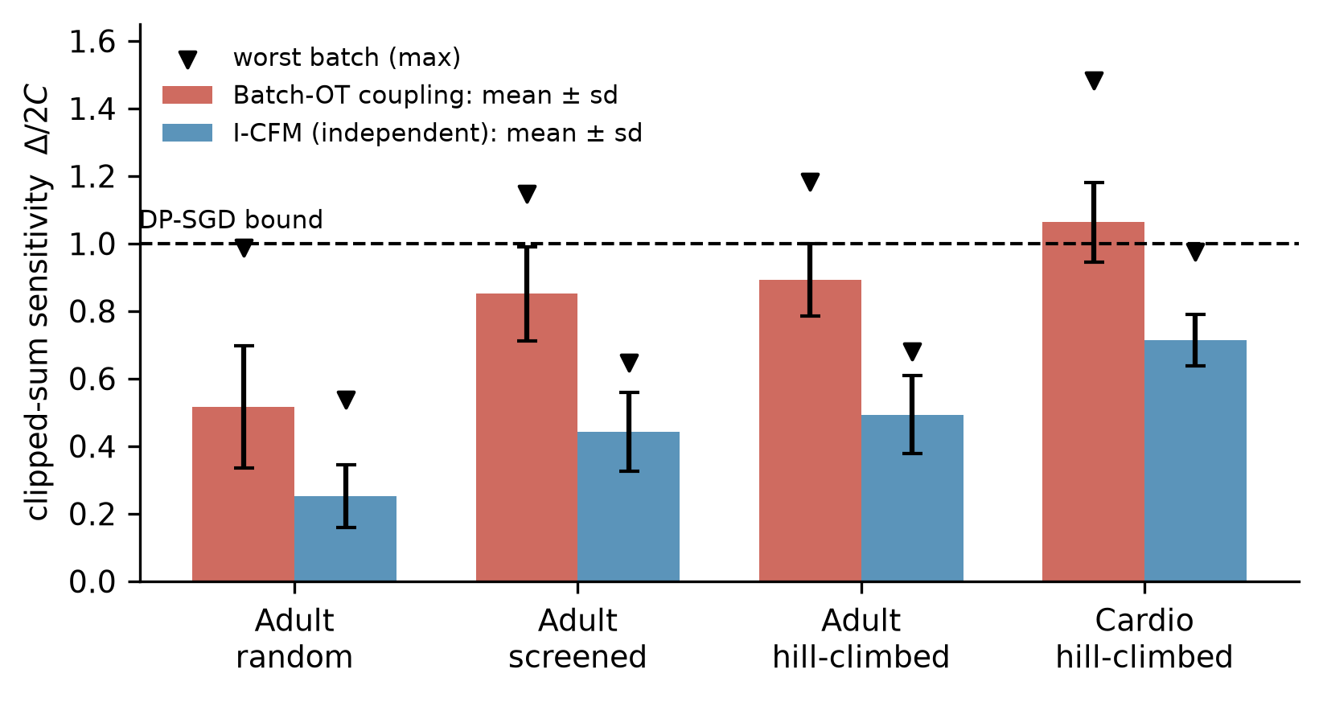
Figure 3. Clipped-gradient-sum sensitivity relative to the bound assumed by standard DP-SGD accounting, for replace-one neighbours in batches of 64 records (100 batches per setting). Bars show mean ± standard deviation; triangles mark the worst batch found. The dashed line is the bound.
Table 2. Clipped-sum sensitivity Δ/2C found by the searches (100 batches per row). Values above 1 violate the bound assumed by standard DP-SGD accounting.
Dataset, search | OT max | OT > 1 | I-CFM max | I-CFM > 1
Adult, random | 0.99 | 0% | 0.54 | 0%
Adult, screened | 1.147 | 15% | 0.648 | 0%
Adult, hill-climbed | 1.182 | 17% | 0.681 | 0%
Cardio, hill-climbed | 1.484 | 69% | 0.975 | 0%

3.2 Conditional Audits Certify the Sensitivity Violation
Sensitivity values found by a search could be attributed to numerical artefacts of that search. The conditional white-box audit removes this objection for the audited pairs, because its conclusion is a finite-sample bound that holds with 95% confidence. On Adult, the audit of the worst OT pair gave μ ≥ 0.896 against the 0.764 assumed by standard accounting (Table 3, Figure 4), so the sensitivity of that step exceeds the assumed bound. Within the standard accounting framework, a certificate that covers this pair cannot be smaller than ε = 0.898, whereas 0.735 was reported. On Cardio, the audit gave μ ≥ 1.427 against an assumed 0.966, and the accounting-consistent ε is 1.474 against a reported 0.839, 76% higher. These numbers describe what the standard accounting can certify; they are not measured privacy losses (Section 2.7). The same audit applied to the worst I-CFM pairs gave μ ≥ 0.518 on Adult and μ ≥ 0.936 on Cardio, both below the assumed values, as Proposition 1 predicts.
Table 3. Conditional white-box audits of one DP-SGD step for the worst pair found (finite-sample test, 95% confidence). The last row is the smallest ε that the standard accounting framework can certify; it is not a privacy-loss lower bound.
 | Adult OT | Adult I-CFM | Cardio OT | Cardio I-CFM
Noise multiplier σ | 2.617 | 2.617 | 2.070 | 2.070
Empirical FPR / FNR | 0.326 / 0.327 | 0.397 / 0.397 | 0.237 / 0.237 | 0.319 / 0.320
μ lower bound (95%) | 0.896 | 0.518 | 1.427 | 0.936
μ assumed (2/σ) | 0.764 | 0.764 | 0.966 | 0.966
Violation certified | yes | no | yes | no
Reported ε | 0.735 | 0.735 | 0.839 | 0.839
Accounting-consistent ε | ≥ 0.898 | 0.735 | ≥ 1.474 | 0.839

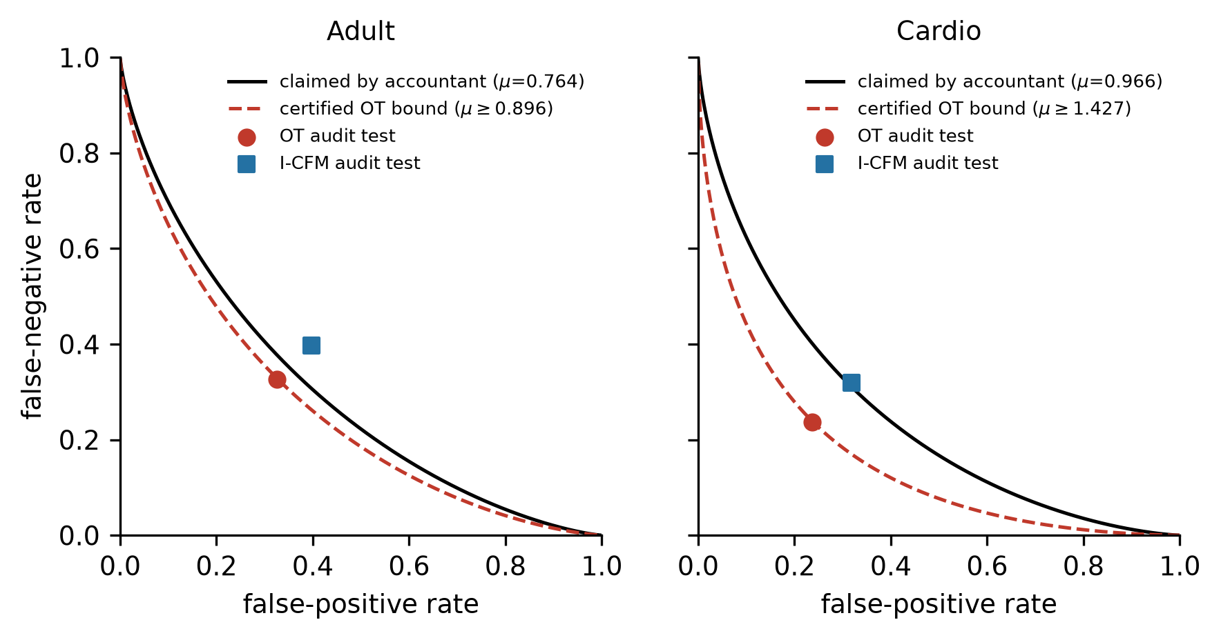
Figure 4. Hypothesis-testing view of the conditional audits. Black curves show the trade-off between false-positive and false-negative rates that standard accounting assumes for one step; red dashed curves show the certified lower bound for the worst OT pair. The OT test points lie below the assumed curve, which is impossible if the assumed sensitivity bound held; the I-CFM points lie on or above it.
The black-box canary audit found nothing. It gave ε_{lb} = 0 for three seeds of each coupling and also for a near-non-private control trained at ε = 28.6 for 30 epochs. This audit therefore has no power against this generator: the synthetic data does not reproduce individual canaries even when almost no noise is added. Implementation-level violations of the kind studied here are visible only to white-box audits, which agrees with earlier work on debugging DP implementations [40, 41].

3.3 Checking the Proof Against the Code Exposed Five Leak Classes
While writing the proof of Theorem 2, we checked every code path that reads private data. This exposed five leaks, none of which changed the reported ε. Table 4 lists them together with a reproduction on UCI Adult (script and output in the released artifact; minimal code patterns in Supplementary Section S3). The clearest case is the model buffer. A graph-refinement step stored the absolute cosine similarity between feature columns, computed over all private rows without noise, as the normalised adjacency buffer D^{−1/2}(A + I)D^{−1/2} of the velocity network. Since each diagonal entry of that buffer equals 1/deg_{i}, the normalisation can be inverted exactly, and an adversary holding the released weights recovers the full private 78 × 78 similarity matrix with a maximum absolute error of 1.1 × 10⁻⁷. All five implementation defects were fixed in the audited implementation and covered by regression tests, and all pipeline experiments reported here were run after the fixes, with the exception of the training-length probe noted in Section 3.4.
Table 4. Leak classes found by checking the proof against the implementation, with reproductions on UCI Adult (pre-fix behaviour).
Leak class | Where | Reproduction (what an adversary recovers) | Fix and regression test
Fixed random seed on a noise path | Histograms, dependency matrix, budget controller | Regenerating the seed-42 Laplace noise recovers all 6 noisy race counts exactly | Unseeded generator; test that repeated releases differ
Clipping the noise instead of the query | Early budget controller | Output ranges of neighbours become disjoint once the query gap exceeds twice the clip, so ε is unbounded | Clip the query, never the noise
Un-noised statistic in a model buffer | Graph refinement → velocity network | Private 78 × 78 cosine matrix recovered from the weights, max error 1.1 × 10⁻⁷ | Strict mode uses public W₀ only; test that refinement ignores data
Data-dependent bin edge | Zero-inflated histogram | Published edge 594 equals the smallest positive capital-gain value | Edge from public bound; test that edges do not depend on data
Silent schema fallback | Encoder, undeclared bounds or categories | Private age minimum (17) and maximum (90) enter the encoder | Runtime warning listing uncovered columns; completeness check

3.4 The Sound Coupling Costs No Detectable Utility
With the flow alone and 10 paired seeds on Adult, I-CFM reached a TSTR AUC of 0.533 ± 0.049 and OT-CFM 0.526 ± 0.091 (Wilcoxon p = 0.49). Differences in correlation error (0.01086 against 0.01089) and in distance to the closest real record (5.20 against 5.16) were statistically significant but below 1% in size. An earlier run, made before the leaks of Section 3.3 were fixed, suggested a 0.05 AUC advantage for OT; it did not replicate. Both couplings, however, were close to chance, while the real-data reference was 0.917. A training-length probe, run before the fixes and therefore indicative only, showed that the same generator reached 0.861 when trained almost without noise for 60 epochs, so capacity is not the limiting factor. At ε ≈ 0.74 more training did not help in that probe, because the accountant raised the noise multiplier from 2.6 to 8.2 when the number of epochs went from 5 to 60.

3.5 With a Randomly Initialised Flow, Utility Comes from the Marginals
Spending part of the budget on Stage 7c changed the picture completely (Figure 5, Table 5). On Adult, TSTR AUC rose from 0.49 with the flow alone to 0.879 with a 0.2 share and 0.906 with a 0.9 share, close to the real-data reference of 0.917. On Cardio, the 0.9 share reached 0.779, the same as the real-data reference. The 2-way TVD fell steadily as the share increased, and on Adult it reached 0.096. The decisive comparison is between the full pipeline and the marginals-only ablation at the same split (Table 6). With 10 paired seeds they were statistically equivalent on every metric at the prespecified margins; no practically relevant utility contribution from the randomly initialised flow was detected. On Adult, the TSTR AUC was 0.9060 against 0.9061 (difference −0.0001, 95% CI [−0.0023, 0.0021]); on Cardio, 0.7785 against 0.7789 (−0.0004, 95% CI [−0.0038, 0.0030]). The resulting confidence intervals were substantially narrower than the prespecified margins. The only detectable contribution of the flow was a reduction of 0.0011 in the 2-way TVD on Cardio (Wilcoxon p = 0.01), about 2% of the error and inside the equivalence margin. Per-seed values are listed in Supplementary Table S4.
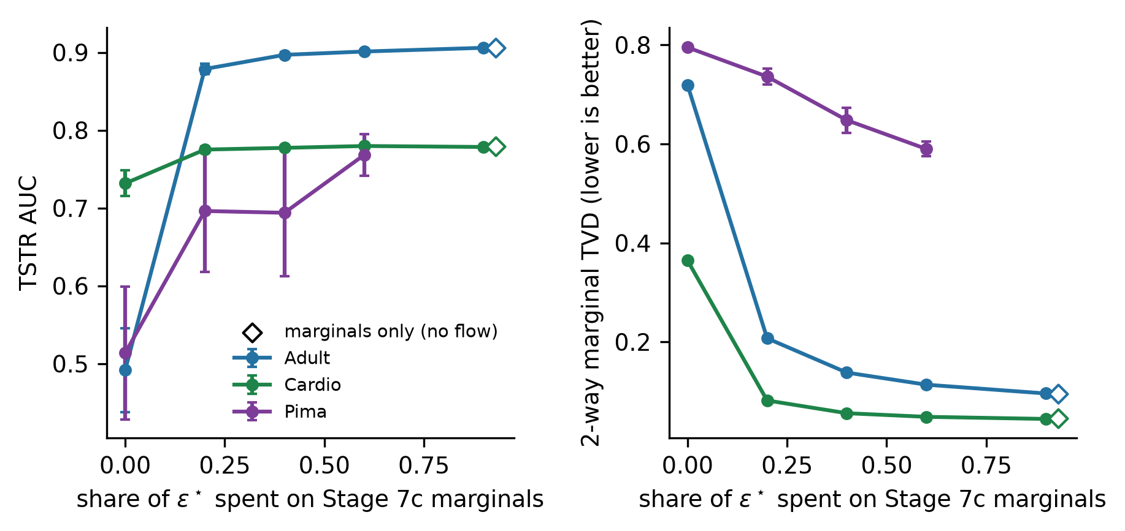
Figure 5. Downstream utility (left) and 2-way marginal error (right) as a function of the share of ε∗ spent on the class-conditional marginals; a share of 0 is the flow alone. Open diamonds show the marginals-only ablation at a share of 0.9, which uses no information from the flow. Points are means over 3 seeds, and over 10 seeds at a share of 0.9 for Adult and Cardio.
Table 5. Budget split and flow ablation. Entries are TSTR AUC / 2-way TVD. DAPC-selected ε∗: Adult 0.741, Cardio 0.849, Pima 0.753.
Configuration | Adult | Cardio | Pima
Flow only | 0.492 / 0.719 | 0.732 / 0.365 | 0.514 / 0.795
Flow + 1-way marginals | 0.497 / 0.271 | 0.710 / 0.227 | 0.477 / 0.773
Share 0.2 | 0.879 / 0.207 | 0.775 / 0.082 | 0.696 / 0.736
Share 0.6 | 0.901 / 0.114 | 0.780 / 0.049 | 0.768 / 0.590
Share 0.9 (10 seeds) | 0.906 / 0.096 | 0.779 / 0.044 | –
Share 0.9, marginals only (10 seeds) | 0.906 / 0.095 | 0.779 / 0.046 | –

Table 6. Equivalence tests, full pipeline minus marginals-only ablation at a 0.9 share (10 paired seeds, df = 9). Both one-sided tests must reject for equivalence.
Dataset, metric | Full (mean ± sd) | Marginals only | Difference [95% CI] | Margin | TOST t (lower, upper) | TOST p | Wilcoxon p
Adult, AUC | 0.9060 ± 0.0018 | 0.9061 ± 0.0016 | −0.0001 [−0.0023, 0.0021] | ±0.01 | 10.13, −10.35 | 1.6 × 10⁻⁶ | 0.73
Adult, 2-way TVD | 0.0959 ± 0.0013 | 0.0953 ± 0.0016 | +0.0006 [−0.0011, 0.0022] | ±0.005 | 7.64, −6.06 | 9.4 × 10⁻⁵ | 0.49
Cardio, AUC | 0.7785 ± 0.0027 | 0.7789 ± 0.0029 | −0.0004 [−0.0038, 0.0030] | ±0.01 | 6.36, −6.89 | 6.5 × 10⁻⁵ | 0.67
Cardio, 2-way TVD | 0.0444 ± 0.0008 | 0.0455 ± 0.0010 | −0.0011 [−0.0018, −0.0004] | ±0.005 | 12.91, −20.19 | 2.1 × 10⁻⁷ | 0.01

The result did not depend on the privacy level within the range we tested. At ε∗ = 2.45 and 4.72 on Adult, the full pipeline (with the adaptive split of Supplementary S1) reached 0.905 and 0.906, the marginals-only ablation 0.906 and 0.907, and the flow alone 0.526 and 0.581 (Figure 6). Averaging each record's loss over four noise draws, the noise multiplicity technique of DPDM [8], and halving the hidden width did not change the outcome either (Adult 0.900, Cardio 0.778, Pima 0.748).
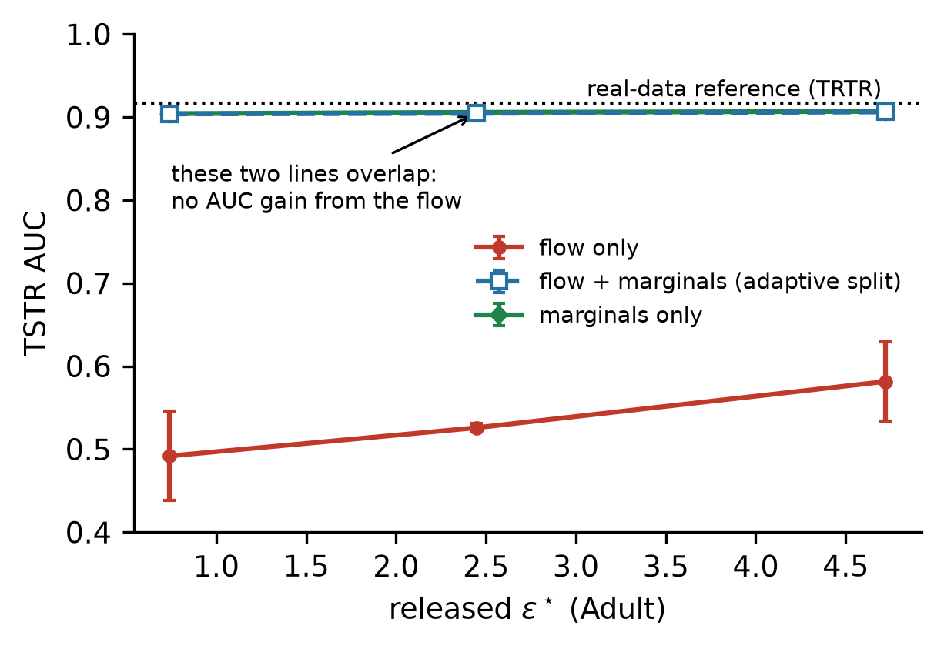
Figure 6. Utility on Adult across privacy levels. The full pipeline and the marginals-only ablation overlap at every ε∗, and the flow alone stays far below the real-data reference. Means ± standard deviation over 3 seeds.

3.6 Comparison with Published DP Synthesizers in a Target-Aware Setting
The comparison in this section concerns target-aware synthesis, in which the downstream prediction target is known when the budget is spent. At ε = 0.741 on Adult, AIM with the same label × feature workload as Stage 7c reached a TSTR AUC of 0.872, against 0.906 for our pipeline, and its 2-way TVD degraded to 0.267 against 0.096 (Table 7, Figure 7). With their default, target-agnostic workloads, AIM and MST reached 0.790 and 0.713 and kept low 2-way TVD (0.112 and 0.128); these numbers answer a different question, general-purpose synthesis, and should not be read as a like-for-like comparison. The deep baselines, DP-CTGAN and PATE-CTGAN, performed at chance, as did our flow without marginals, in line with published benchmarks in which marginal-based methods dominate DP synthesis of tabular data [18].
Table 7. Comparison on Adult at ε = 0.741 and δ = 10⁻⁵. Mean ± standard deviation over 3 seeds (10 seeds for our main configuration). The first two rows are the target-aware comparison.
Method | Workload | TSTR AUC | 1-way TVD | 2-way TVD
Ours, flow + Stage 7c (share 0.9) | label × feature | 0.906 ± 0.002 | 0.028 | 0.096
AIM | label × feature | 0.872 ± 0.002 | 0.015 | 0.267
AIM | all 2-way (default) | 0.790 ± 0.011 | 0.018 | 0.112
MST | default | 0.713 ± 0.031 | 0.014 | 0.128
PATE-CTGAN | – | 0.534 ± 0.043 | 0.506 | 0.705
Ours, flow only | – | 0.492 ± 0.054 | 0.510 | 0.719
DP-CTGAN | – | 0.484 ± 0.036 | 0.298 | 0.468

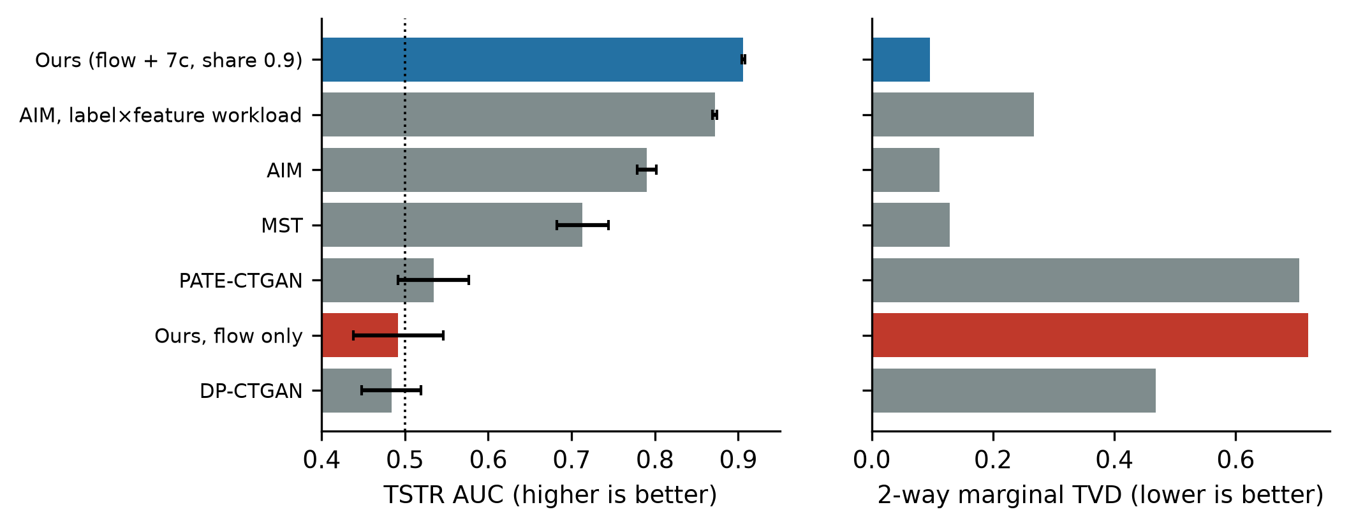
Figure 7. Matched-ε comparison on Adult. Left: downstream utility (the dotted line marks chance). Right: 2-way marginal error. Blue: our pipeline with Stage 7c; red: our flow alone; grey: published DP synthesizers.

3.7 A Warm-Started Flow Learns Dependence That the Marginals Cannot Carry
The flow in Section 3.5 had to learn from noise-dominated gradients, starting from a random network. The warm start removes that handicap by giving the flow what the marginals already say before it sees any private record. Table 8 and Figure 8 report the pre-registered 10-seed confirmation. Downstream AUC did not change: the warm-started flow was equivalent to the marginals-only ablation at the ±0.01 margin in all six cells. All-column accuracy, which responds to dependence among features, was higher with the warm-started, fine-tuned flow in all six cells (H1, Holm-corrected p < 0.05), by 1.0 to 2.1 percentage points. On Adult, part of that gain did not come from the private data: the warm start alone, whose weights are a post-processing of the marginals, already scored 0.8 to 1.0 points above marginals-only, presumably because the network maps nearby prior draws to nearby records and so induces some dependence of its own. On Cardio the warm start alone was level with marginals-only. The comparison that isolates learning from private records is H2, DP fine-tuning against the warm start alone. It held in all six cells, with gains of up to 1.5 percentage points. The pre-registered decision rule allowed the claim only if H1 and H2 both held in at least five of six cells; this criterion was met. The effect is modest. Of the gap in all-column accuracy between marginals-only and real data, the warm-started, fine-tuned flow closes between 7% and 25%.
Table 8. Pre-registered 10-seed confirmation at a 0.9 marginal share: all-column accuracy (mean ± sd) and the gain from DP fine-tuning over the warm start alone (H2, one-sided Welch test, Holm-corrected over six cells). The last column is TSTR AUC for marginals only and for the warm-started, fine-tuned flow.
Dataset (ε∗) | Marginals only | Warm start only | Warm start + DP fine-tuning | DP fine-tuning gain [Holm p] | TSTR AUC
Adult (0.74) | 0.5459 ± 0.0025 | 0.5540 ± 0.0043 | 0.5581 ± 0.0019 | +0.0041 [7.9 × 10⁻³] | 0.905 / 0.906
Adult (2.45) | 0.5457 ± 0.0038 | 0.5535 ± 0.0024 | 0.5640 ± 0.0027 | +0.0105 [1.1 × 10⁻⁷] | 0.909 / 0.910
Adult (4.72) | 0.5448 ± 0.0030 | 0.5551 ± 0.0031 | 0.5660 ± 0.0022 | +0.0108 [1.7 × 10⁻⁷] | 0.910 / 0.911
Cardio (0.85) | 0.5461 ± 0.0020 | 0.5472 ± 0.0034 | 0.5564 ± 0.0017 | +0.0091 [3.8 × 10⁻⁶] | 0.779 / 0.779
Cardio (3.10) | 0.5471 ± 0.0019 | 0.5450 ± 0.0016 | 0.5599 ± 0.0023 | +0.0149 [5.5 × 10⁻¹¹] | 0.778 / 0.782
Cardio (6.09) | 0.5471 ± 0.0020 | 0.5473 ± 0.0039 | 0.5614 ± 0.0020 | +0.0141 [1.7 × 10⁻⁷] | 0.781 / 0.782

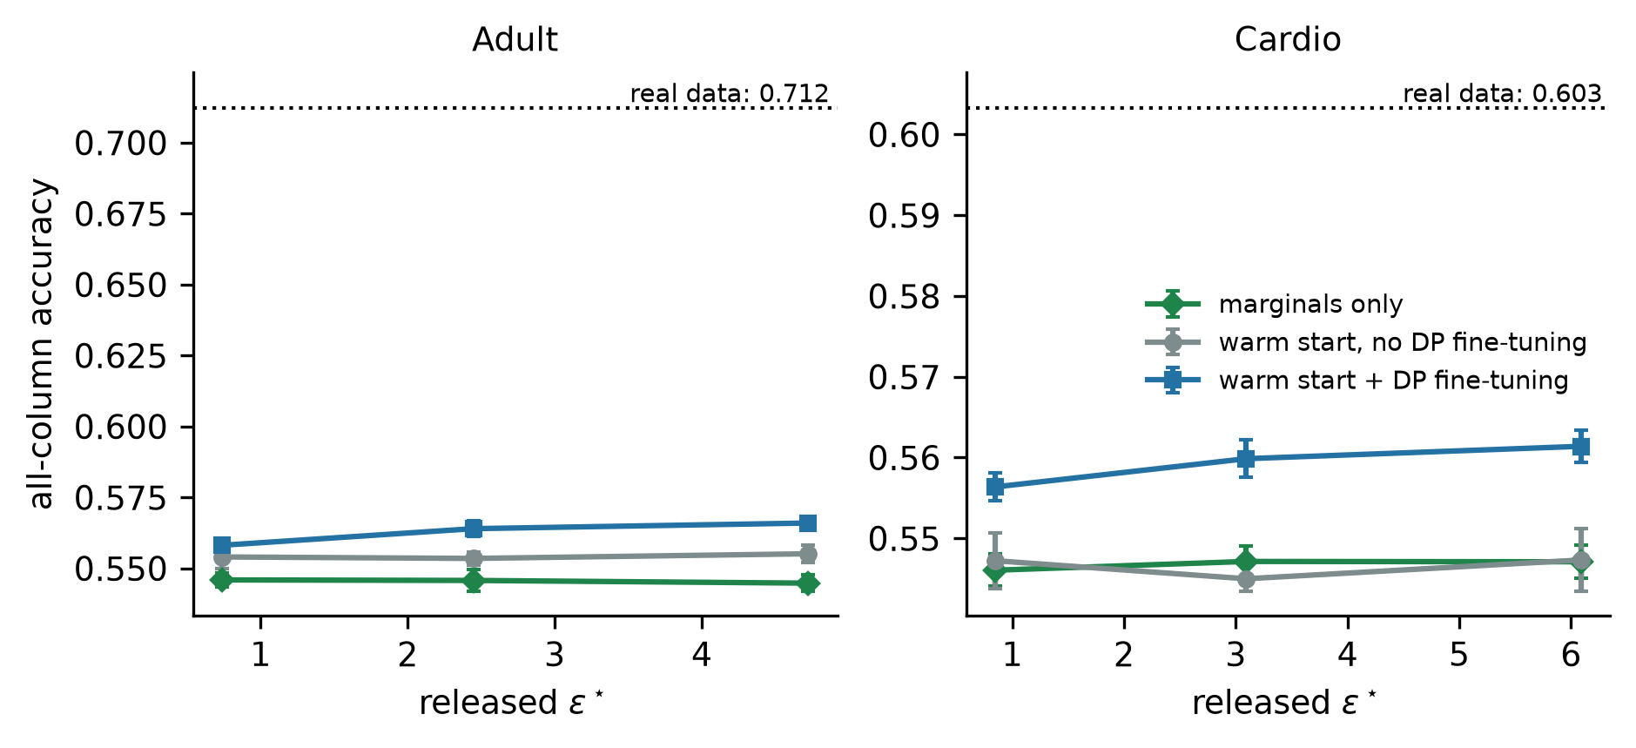
Figure 8. All-column accuracy against the released budget. The warm-started flow is pretrained on records drawn from the noisy marginals (post-processing) and then either fine-tuned with DP-SGD (blue) or left unchanged (grey). The dotted line is the same measure on real data. Means ± standard deviation over 10 seeds.
The same study tested the original motivation of DAPC, namely that the split of ε∗ between the marginals and the flow should adapt to the budget. As pre-registered, we fitted the simplest monotone rule in ε∗ on Adult and evaluated it on Cardio (Supplementary Section S1.3). On Adult, a 0.9 share was best at every budget, so the fitted rule never adapts. On Cardio, a fixed 0.5 share scored higher than the rule (composite 0.909 against 0.876). The criterion failed, and we make no claim for an adaptive split.

3.8 Exploratory Stress Test on Small Cohorts
This section is exploratory (5 seeds per dataset) and is not used as evidence for the main claims. Without Stage 7c, the flow was at chance on all four small datasets: Pima AUC 0.472 ± 0.065, bank churn 0.486 ± 0.052, Breast Cancer Wisconsin 0.309 ± 0.152, and an insurance regression task with R² = −4.1 ± 2.5. Changing the schedule did not help. On Pima, batch sizes from 32 to 512 and between 20 and 800 DP steps all gave AUC between 0.48 and 0.55, because the accountant raised the noise multiplier from 5.4 to 18.6 to pay for the additional steps. The below-chance mean on Wisconsin is not a signal. With so few steps the network stays close to its random initialisation, and the output correlations of that initialisation have a seed-specific sign: the same seed gave an AUC of about 0.1 even at ε = 50.

4 Discussion
In this work, we have shown that a design choice made for sample quality, minibatch OT coupling, invalidates the standard accounting of DP-SGD when the two are combined, and that independent coupling restores a provable guarantee without a detectable loss of utility. The finding rests on a theorem, on counterexamples found by search on two datasets, and on audits whose conclusions hold at 95% confidence for the audited pairs. The size of the effect depended on the data: within the standard accounting framework, the audited pairs force certificates 22% above the reported budget on Adult and 76% above it on Cardio. We did not characterise which data properties drive this difference. A plausible explanation is that Cardio has few, mostly numeric dimensions, so that one replaced record can move the OT assignment of many neighbours at once, but this remains to be tested.
What matters most for practitioners is that the failure cannot be seen from the outside. The accountant reports the same ε for both couplings, and a black-box membership audit on the synthetic data, the check most often applied to released data, found no leakage even in a run that was almost non-private. This agrees with the view that implementation errors in DP training are best found by white-box auditing of the mechanism itself [29, 41]. The five leak classes of Section 3.3 share this property. Each left the privacy summary unchanged, each was found only by tracing the code paths that read private data, and each could be exploited on real data. Fixed seeds on noise paths, clipped noise, un-noised statistics stored in model buffers, data-dependent bin edges and silent schema fallbacks are generic mistakes, not properties of our system.
The utility results need to be stated precisely. With a randomly initialised flow, the noisy marginal stage accounted for essentially all measured downstream utility, and no practically relevant contribution from the flow was detected under the prespecified equivalence margins. Two readings of this result are possible. On the one hand, it is consistent with the benchmark literature, in which marginal-based methods outperform deep generators under DP on tabular data [18]; under DP-SGD, the noise added to a network with many parameters overwhelms the signal from a few thousand records, whereas a table of counts carries the same label information with far less noise. On the other hand, it is a warning about attribution. A pipeline that combines a deep generator with a strong DP measurement will often look good, and without the ablation the credit naturally goes to the deep model. We recommend that DP generative papers report this ablation routinely.
The warm-start result qualifies this negative finding without reversing it. The flow did not improve the label-related utility that the marginals already provide, but once it started from them it learned dependence among features from the private records, which a set of label × feature count tables cannot represent. This agrees with the design argument of StraightDP [9]: whatever a cheap one-shot measurement can carry should not be relearned through noisy gradients, and the gradient budget is better spent on what remains. The design of the ablation mattered here as well. Had we compared the fine-tuned flow only with marginals-only, we would have credited DP-SGD on Adult with part of a gain that the warm start obtains without seeing any private record. The gains from fine-tuning are modest and are smallest at the lowest budget, where the fine-tuning noise is largest.
The comparison with AIM needs one further qualification. Our marginal stage is target-aware. Given the same target-aware workload, AIM narrowed the gap in downstream AUC from 0.12 to 0.034, while our pipeline kept a lower 2-way TVD (0.096 against 0.267), so the advantage does not come from the workload alone. A user with several downstream targets would need a workload that covers all of them, and we did not evaluate that setting. Finally, a pre-registered test of an ε-adaptive budget split found that a fixed share was at least as good. We see no reason to adapt the split while the flow contributes only second-order structure.

4.1 Threats to Validity
Theoretical validity. Our violation results concern the standard DP-SGD accounting, which assumes per-example sensitivity C under add/remove adjacency; they do not exclude a weaker but valid mechanism-specific analysis of OT-CFM. The white-box audits condition on fixed batches and do not include privacy amplification by subsampling; they bound what the standard accounting can certify, not the privacy loss of the subsampled mechanism. Theorem 2 relies on assumptions A1–A4, in particular on a public cohort size (A2), which also makes the normalisation by the expected batch size post-processing [22]. The conversion to replace-one adjacency costs a factor of two in ε and (1 + e^{ε}) in δ (Equation 1).
Empirical validity. The sensitivity searches are heuristics and may understate the worst case, which would only strengthen the conclusion. The audits certify violations for the audited pairs only. The main utility results rest on two datasets with 10 paired seeds; configuration sweeps used 3 seeds, and the small-cohort study is exploratory. The confirmatory warm-start addendum was written after the 3-seed grid had been seen, as the pre-registration states.
External validity. We did not test cohorts larger than 20,000 records, pretraining on public data from a related population, or larger architectures such as transformers; these are the settings in which the flow is most likely to contribute more. The marginal stage is target-aware, and the utility comparison applies to that setting.
Implementation validity. Results depend on the software versions and hardware listed in Table 1 and Supplementary Table S5, including TF32 arithmetic. Experiments seed the random generators for reproducibility, and the noise is drawn from non-cryptographic generators; a production release must use unseeded, cryptographically secure noise, as provided by the secure mode of Opacus [10].

5 Conclusions
Minibatch optimal-transport coupling makes the gradient of each training example depend on its batch-mates, which invalidates the standard privacy accounting of DP-SGD without any visible sign in the reported budget. On two datasets, certified conditional audits of the worst neighbouring pairs found by search showed that certificates within the standard accounting framework must be at least 22% and 76% larger than the reported ones. Independent coupling restores the standard guarantee at no detectable cost, and we proved an end-to-end guarantee for a complete synthesis pipeline built on it. Checking that proof against the code exposed five classes of implementation defects that no privacy summary could reveal, each reproducible on real data. A jointly accounted, target-aware marginal stage accounted for essentially all measured downstream utility, and a randomly initialised flow added no practically relevant utility to it. Warm-starting the flow from the noisy marginals, at no privacy cost, let DP fine-tuning add cross-column dependence learned from the private records, whereas an ε-adaptive budget split brought no benefit. These findings argue for white-box auditing of DP training code and for routine ablations that separate a deep generator from the simpler DP measurements it is combined with.

Data and Code Availability
All code, the formal privacy proof, the raw results of every experiment (including the 10⁶-trial audit outputs, per-seed utility results and leak reproductions), configuration files, random seeds and the scripts that regenerate every table and figure are archived at [repository URL and DOI to be inserted before submission]. Supplementary Section S6 maps each table and figure to the script and raw file that produce it. UCI Adult, the Kaggle cardiovascular disease dataset and the other benchmark datasets are publicly available from their original sources and are not redistributed.

Supplementary Material
Supplementary Material is available with this article: S1, the budget policy (DAPC): complete specification, robustness analysis and the pre-registered test of an adaptive split; S2, formal mechanism specification and full proof of Theorem 2; S3, leak reproductions and minimal code patterns; S4, per-seed results and statistical tests; S5, full configuration and software environment; S6, artifact manifest.

Acknowledgements
[To be completed by the authors.]

Author Contributions
[To be completed by the authors.]

Conflicts of Interest
[To be completed by the authors.]

References
[1] F. Ortuño, V. M. de la Oliva Roque, J.-I. Ramirez-Lopez, D. P. Kreil, J. Dopazo, and C. Loucera, "High-fidelity synthetic data replicates clinical prediction performance in a million-patient diabetes cohort," Adv. Sci., vol. 13, e16196, 2026, doi:10.1002/advs.202516196.
[2] L. Xu, M. Skoularidou, A. Cuesta-Infante, and K. Veeramachaneni, "Modeling tabular data using conditional GAN," in Advances in Neural Information Processing Systems (NeurIPS), 2019.
[3] A. Kotelnikov, D. Baranchuk, I. Rubachev, and A. Babenko, "TabDDPM: Modelling tabular data with diffusion models," in Proc. Int. Conf. Machine Learning (ICML), 2023.
[4] H. Zhang, J. Zhang, B. Srinivasan, Z. Shen, X. Qin, C. Faloutsos, H. Rangwala, and G. Karypis, "Mixed-type tabular data synthesis with score-based diffusion in latent space," in Proc. Int. Conf. Learning Representations (ICLR), 2024.
[5] C. Dwork, F. McSherry, K. Nissim, and A. Smith, "Calibrating noise to sensitivity in private data analysis," in Proc. Theory of Cryptography Conf. (TCC), 2006, pp. 265–284.
[6] M. Abadi, A. Chu, I. Goodfellow, H. B. McMahan, I. Mironov, K. Talwar, and L. Zhang, "Deep learning with differential privacy," in Proc. ACM SIGSAC Conf. Computer and Communications Security (CCS), 2016, pp. 308–318.
[7] J. Jordon, J. Yoon, and M. van der Schaar, "PATE-GAN: Generating synthetic data with differential privacy guarantees," in Proc. Int. Conf. Learning Representations (ICLR), 2019.
[8] T. Dockhorn, T. Cao, A. Vahdat, and K. Kreis, "Differentially private diffusion models," Trans. Machine Learning Research, 2023.
[9] X. Che, D. Xu, and X. Wu, "StraightDP: Geometry-aware differential privacy for rectified-flow transformers," arXiv:2607.29100, 2026.
[10] A. Yousefpour, I. Shilov, A. Sablayrolles, D. Testuggine, K. Prasad, M. Malek, J. Nguyen, S. Ghosh, A. Bharadwaj, J. Zhao, G. Cormode, and I. Mironov, "Opacus: User-friendly differential privacy library in PyTorch," arXiv:2109.12298, 2021.
[11] W. Kong, A. Muñoz Medina, and M. Ribero, "Differentially private optimization for non-decomposable objective functions," in Proc. Int. Conf. Learning Representations (ICLR), 2025.
[12] Y. Lipman, R. T. Q. Chen, H. Ben-Hamu, M. Nickel, and M. Le, "Flow matching for generative modeling," in Proc. Int. Conf. Learning Representations (ICLR), 2023.
[13] X. Liu, C. Gong, and Q. Liu, "Flow straight and fast: Learning to generate and transfer data with rectified flow," in Proc. Int. Conf. Learning Representations (ICLR), 2023.
[14] A. Tong, K. Fatras, N. Malkin, G. Huguet, Y. Zhang, J. Rector-Brooks, G. Wolf, and Y. Bengio, "Improving and generalizing flow-based generative models with minibatch optimal transport," Trans. Machine Learning Research, 2024.
[15] A.-A. Pooladian, H. Ben-Hamu, C. Domingo-Enrich, B. Amos, Y. Lipman, and R. T. Q. Chen, "Multisample flow matching: Straightening flows with minibatch couplings," in Proc. Int. Conf. Machine Learning (ICML), 2023.
[16] R. McKenna, G. Miklau, and D. Sheldon, "Winning the NIST contest: A scalable and general approach to differentially private synthetic data," J. Privacy and Confidentiality, vol. 11, no. 3, 2021.
[17] R. McKenna, B. Mullins, D. Sheldon, and G. Miklau, "AIM: An adaptive and iterative mechanism for differentially private synthetic data," Proc. VLDB Endowment, vol. 15, no. 11, pp. 2599–2612, 2022.
[18] Y. Tao, R. McKenna, M. Hay, A. Machanavajjhala, and G. Miklau, "Benchmarking differentially private synthetic data generation algorithms," arXiv:2112.09238, 2021.
[19] I. Mironov, "Rényi differential privacy," in Proc. IEEE Computer Security Foundations Symp. (CSF), 2017, pp. 263–275.
[20] S. Gopi, Y. T. Lee, and L. Wutschitz, "Numerical composition of differential privacy," in Advances in Neural Information Processing Systems (NeurIPS), 2021.
[21] J. Dong, A. Roth, and W. J. Su, "Gaussian differential privacy," J. Royal Statistical Society Series B, vol. 84, no. 1, pp. 3–37, 2022.
[22] W. Wang, S. Cui, H. Cui, and X. Yuan, "Rethinking the security of DP-SGD: A corrected analysis of differentially private machine learning," arXiv:2605.15648, 2026.
[23] I. Mironov, "On significance of the least significant bits for differential privacy," in Proc. ACM Conf. Computer and Communications Security (CCS), 2012, pp. 650–661.
[24] H. W. Kuhn, "The Hungarian method for the assignment problem," Naval Research Logistics Quarterly, vol. 2, no. 1–2, pp. 83–97, 1955.
[25] A. Sklar, "Fonctions de répartition à n dimensions et leurs marges," Publ. Inst. Statist. Univ. Paris, vol. 8, pp. 229–231, 1959.
[26] M. Kim, "Warm-start flow matching for guaranteed fast text/image generation," arXiv:2603.19360, 2026.
[27] C. J. Clopper and E. S. Pearson, "The use of confidence or fiducial limits illustrated in the case of the binomial," Biometrika, vol. 26, no. 4, pp. 404–413, 1934.
[28] M. Nasr, S. Song, A. Thakurta, N. Papernot, and N. Carlini, "Adversary instantiation: Lower bounds for differentially private machine learning," in Proc. IEEE Symp. Security and Privacy (S&P), 2021, pp. 866–882.
[29] M. Nasr, J. Hayes, T. Steinke, B. Balle, F. Tramèr, M. Jagielski, N. Carlini, and A. Terzis, "Tight auditing of differentially private machine learning," in Proc. USENIX Security Symp., 2023.
[30] T. Steinke, M. Nasr, and M. Jagielski, "Privacy auditing with one (1) training run," in Advances in Neural Information Processing Systems (NeurIPS), 2023.
[31] B. Becker and R. Kohavi, "Adult," UCI Machine Learning Repository, 1996, doi:10.24432/C5XW20.
[32] S. Ulianova, "Cardiovascular disease dataset," Kaggle, 2019. [Online]. Available: https://www.kaggle.com/datasets/sulianova/cardiovascular-disease-dataset
[33] J. W. Smith, J. E. Everhart, W. C. Dickson, W. C. Knowler, and R. S. Johannes, "Using the ADAP learning algorithm to forecast the onset of diabetes mellitus," in Proc. Annu. Symp. Computer Applications in Medical Care, 1988, pp. 261–265.
[34] OpenDP, "SmartNoise synthesizers (smartnoise-synth), version 1.0.8," 2024. [Online]. Available: https://github.com/opendp/smartnoise-sdk
[35] L. Rosenblatt, X. Liu, S. Pouyanfar, E. de Leon, A. Desai, and J. Allen, "Differentially private synthetic data: Applied evaluations and enhancements," arXiv:2011.05537, 2020.
[36] F. Wilcoxon, "Individual comparisons by ranking methods," Biometrics Bulletin, vol. 1, no. 6, pp. 80–83, 1945.
[37] D. J. Schuirmann, "A comparison of the two one-sided tests procedure and the power approach for assessing the equivalence of average bioavailability," J. Pharmacokinetics and Biopharmaceutics, vol. 15, no. 6, pp. 657–680, 1987.
[38] B. L. Welch, "The generalization of ‘Student’s’ problem when several different population variances are involved," Biometrika, vol. 34, no. 1–2, pp. 28–35, 1947.
[39] S. Holm, "A simple sequentially rejective multiple test procedure," Scand. J. Statist., vol. 6, no. 2, pp. 65–70, 1979.
[40] M. Jagielski, J. Ullman, and A. Oprea, "Auditing differentially private machine learning: How private is private SGD?" in Advances in Neural Information Processing Systems (NeurIPS), 2020.
[41] F. Tramèr, A. Terzis, T. Steinke, S. Song, M. Jagielski, and N. Carlini, "Debugging differential privacy: A case study for privacy auditing," arXiv:2202.12219, 2022.

Supplementary Material

S1 Dataset-Adaptive Privacy Budget Controller (DAPC)

S1.1 Complete Specification
DAPC maps a requested budget ε_{max} to the released budget
$ε^{∗} = ε_{max} − (ε_{max} − ε_{min}) · \frac{1 − e^{−βR}}{1 − e^{−β}}$ (S1)
where R is a public risk score. DAPC reads only public inputs: column names, the target-column name, the cohort size N (assumption A2) and the encoded dimension d, which is fixed by the declared schema. Table S1 lists every rule and constant. Column sensitivity is assigned by case-insensitive substring matching of the column name against three keyword lists, checked in the order shown; the first list that matches determines the score.
Table S1. Complete DAPC specification. All inputs are public.
Quantity | Definition | Value or rule
Column score s_{i} (high) | name contains any of | ssn, social_security, name, mrn, address, zip, phone, email, ip_address, biometric → s_{i} = 0.95
Column score s_{i} (medium) | else, name contains any of | age, gender, sex, race, ethnicity, dob, birth, income, marital, insurance → s_{i} = 0.65
Column score s_{i} (clinical) | else, name contains any of | diagnosis, disease, icd, cancer, hiv, mental_health, substance, mortality → s_{i} = 0.50
Column score s_{i} (default) | otherwise | s_{i} = 0.10
r_{sens} | mean of s_{i²} over all columns | in [0.01, 0.9025]
r_{scale} | exp(−n/600), n = N rounded to the nearest 50 | in (0, 1]
r_{dim} | 1 − exp(−d/100), d = encoded dimension | in [0, 1)
r_{task} | 0.85 if the target name contains mortality, death, cancer or icu; otherwise 0.30 | public flag
Aggregation | R = max(r_{sens}, 1 − Π_{k} (1 − w_{k} r_{k})^{γk}) | w = (0.35, 0.30, 0.20, 0.15), γ = (1.5, 1, 1, 1)
Budget map | Equation S1 | ε_{min} = 0.4, β = 2.5, ε_{max} = requested budget (1.0; 4 or 8 in the sweep)
Abstention | raw N < 100 | no release
Rejection | d > 500 | no release
Stage 7c split (fixed) | z such that the marginal release alone costs ρ ε∗ | ρ ∈ {0.2, 0.4, 0.6, 0.9}
Stage 7c split (adaptive) | z = max(0.25 n / (K √M), z_{cap}) | K = largest table size, M = number of tables, z_{cap} gives a 0.6 share
Flow noise σ | bisection on the PRV accountant | joint composition with Stage 7c equals ε∗ at δ_{SGD} = 8 × 10⁻⁶

S1.2 Robustness to the Hand-Set Constants
Across ten datasets, DAPC selected ε∗ between 0.655 and 0.905 and abstained below 100 records. We perturbed all constants jointly over 2000 draws: weights from Dirichlet(50 w), exponents scaled by U(0.8, 1.2), and β from U(2, 3). The 5–95% range of ε∗ per dataset had a width between 0.06 and 0.15. The dataset ranking was stable, with a median Kendall τ of 0.96 and a 5th percentile of 0.82. A 10% change to any single weight moved ε∗ by at most 0.011. The adaptive split rule gave TSTR AUC / 2-way TVD of 0.904 / 0.116 on Adult, 0.780 / 0.070 on Cardio and 0.729 / 0.601 on Pima (3 seeds). It matched the best fixed split on Adult (0.906 / 0.096 at a 0.9 share) but not on Cardio, where the 0.9 share reached a 2-way TVD of 0.044. It is therefore not used in the main results.

S1.3 Pre-Registered Test of an ε-Adaptive Split
Because the ad hoc rule above was fitted by hand, we also ran a pre-registered test (runs/flow_value/PREREGISTRATION.md, written before the grid was run). Configurations used the warm-started flow of main-text Section 2.6 with marginal shares ρ ∈ {0.2, 0.5, 0.9}, on Adult and Cardio at requested budgets of 1, 4 and 8, with 3 seeds each. Each configuration received a composite score, the mean of the min–max-normalised TSTR AUC, all-column accuracy, −(2-way TVD) and −(3-way label TVD) within its (dataset, ε) cell. The rule was fitted on Adult only, as the simplest monotone function of the released ε∗ that reproduces the best ρ at each budget, and was evaluated on Cardio. The claim required the rule to beat every fixed ρ on Cardio when averaged over the three budgets. On Adult, ρ = 0.9 was best at every budget, so the fitted rule is the constant ρ = 0.9 and adapts to nothing. On Cardio, its mean composite was 0.876, against 0.909 for a fixed ρ = 0.5 (Table S1b). The pre-registered criterion therefore failed, and we make no claim that an ε-adaptive budget split improves utility.
Table S1b. Pre-registered adaptive-split test: composite score per (dataset, requested ε) cell, 3 seeds (higher is better; the scores are normalised within each cell).
Cell (ε∗) | ρ = 0.2 | ρ = 0.5 | ρ = 0.9 | Marginals only (ρ = 0.9) | Rule choice
Adult, 1 (0.74) | 0.268 | 0.817 | 0.933 | 0.750 | (fitted)
Adult, 4 (2.45) | 0.374 | 0.784 | 0.960 | 0.656 | (fitted)
Adult, 8 (4.72) | 0.443 | 0.810 | 0.938 | 0.669 | (fitted)
Cardio, 1 (0.85) | 0.378 | 0.934 | 0.891 | 0.768 | ρ = 0.9
Cardio, 4 (3.10) | 0.457 | 0.823 | 0.967 | 0.397 | ρ = 0.9
Cardio, 8 (6.09) | 0.575 | 0.970 | 0.771 | 0.352 | ρ = 0.9

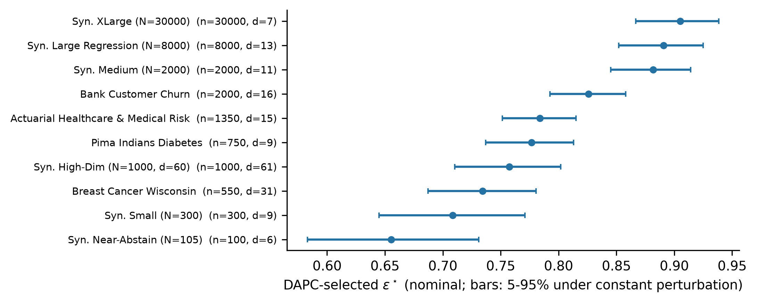
Figure S1. Budget selected by DAPC for ten datasets, with 5–95% ranges under joint perturbation of its constants (2000 draws). n: rounded cohort size; d: encoded dimension.

S2 Formal Mechanism Specification and Proof of Theorem 2

S2.1 Setting
Adjacency. D ≃ D′ if one is obtained from the other by adding or removing one record (add/remove). Replace-one guarantees follow from Equation 1 of the main text.
Released outputs. (i) the synthetic table; (ii) the EMA weights of the velocity network; (iii) the privacy summary (ε∗, δ_{SGD}, σ, z, q, T). Everything else computed by the pipeline, including loss curves, gradient norms, clip fractions, row and missing-cell counts and a dataset hash used as an internal audit handle, is operator telemetry that is computed without noise and is never released.
Assumptions. A1 public schema (types, bounds, category lists, kinds); A2 public cohort size N; A3 public column and target names; A4 unpredictable noise. The pipeline warns at run time and lists every column for which A1 is not met, because the encoder would otherwise fall back to private statistics.

S2.2 Mechanisms
M₁ (DP-SGD on I-CFM). For t = 1, …, T with T = epochs × ⌈N/B⌉ fixed in advance: sample B_{t} by including each encoded record independently with probability 1/⌈N/B⌉; for each included record draw z₀ ~ N(0, I) and t ~ U(0, 1) independently; compute the per-example loss and gradient, clip to norm C = 1.25, sum, add N(0, σ²C²I), divide by the public constant qN = B, and apply AdamW; update the EMA copy. Initialisation uses PyTorch defaults with a zero-initialised output layer and does not depend on data; with the warm start, it is instead the result of non-private pretraining on records sampled from the output of M₂ (Lemma S5). Empty batches are processed with the noise term only and counted.
M₂ (Stage 7c). For each non-target column c, compute the count table n_{c}(y, b) over public target levels y and public bins or categories b, and release n_{c} + N(0, z²M) independently per cell, where M is the number of tables.
Accounting. The PRV accountant receives the history {(σ, q = B/N) × T, (z, 1) × 1} and σ is found by bisection so that the composed ε at δ_{SGD} = 8 × 10⁻⁶ equals ε∗. The run asserts the accountant value before any output is released. RDP is reported alongside as a second bound.

S2.3 Lemmas
Lemma S1 (row-local preprocessing). Under A1, imputation uses the midpoint of public bounds, encoding uses public categories and bounds, and scaling is an affine map fixed by public bounds. Hence the encoded versions of D ≃ D′ are again add/remove neighbours.
Lemma S2 (DP-SGD). By Proposition 1 of the main text, the clipped sum of each step has add/remove L2 sensitivity at most C. Each step is therefore a Poisson-subsampled Gaussian mechanism with noise multiplier σ. The accountant uses q = B/N ≥ 1/⌈N/B⌉, and since ε is non-decreasing in q, the accounting is conservative. Division by the public constant B and the AdamW and EMA updates are post-processing of the noisy sums under A2.
Lemma S3 (Stage 7c). One record contributes exactly one count to each of the M tables, so the concatenated vector has L2 sensitivity √M, and adding N(0, z²M) per cell is a Gaussian mechanism with noise multiplier z. Its noise is drawn from an unseeded generator, independently of M₁.
Lemma S4 (public controller). ε∗, z, σ and T are deterministic functions of public inputs (Table S1) and are fixed before M₁ or M₂ is run, so they are constants of the composed mechanism.
Lemma S5 (warm start). When the warm start is enabled, M₂ is run first. N records are drawn from its noisy tables, independently within each class, and encoded with the public schema. The velocity network is then trained on them without noise, starting from the data-independent initialisation. The only inputs of this step are the output of M₂, the public schema, the public N (A2) and fresh randomness, so the starting point of M₁ is a post-processing of M₂. M₁ is thus chosen adaptively after M₂. PRV composition bounds adaptive compositions of Gaussian mechanisms exactly as it bounds non-adaptive ones, and σ, q and T are still fixed in advance (Lemma S4), so the accounting history is unchanged. In the ablation without DP fine-tuning, every step of M₁ is still executed and accounted, with the learning rate set to zero.
Proof of Theorem 2. By Lemma S1 we may work on encoded records. By Lemma S4 the mechanism parameters are constants, and by Lemma S5 a warm start makes M₁ an adaptive choice after M₂. M₁ and M₂ are Gaussian mechanisms with the stated sensitivities (Lemmas S2 and S3), and their PRV composition at δ_{SGD} yields ε∗. Sampling from the released EMA model with fresh prior noise, clamping, decoding, and the within-class quantile map read only the released model, fresh randomness and the noisy tables, and are therefore post-processing. The released outputs are thus (ε∗, δ_{SGD})-DP, and δ_{SGD} ≤ δ. ∎

S2.4 Scope of the White-Box Audits
The audits in the main text condition on a fixed pair of batches with fixed prior draws and times. They certify, with 95% confidence, a lower bound on the sensitivity of that conditional Gaussian step, and hence that the sensitivity assumption of the standard accountant fails. They do not include the Poisson sampling of the trained mechanism, which amplifies privacy, so they are not lower bounds on its privacy loss. The accounting-consistent ε is the smallest ε that the standard subsampled-Gaussian accountant can certify with a sensitivity bound large enough to cover the audited pair: since that pair has replace-one sensitivity at least μ_{lb} σC, one of its add/remove neighbours has sensitivity at least μ_{lb} σC/2, and the accountant with noise σC and this bound is equivalent to noise multiplier 2/μ_{lb}. A lower bound on the privacy loss of the full mechanism would require auditing the sampling event, for example with many training runs or a one-run audit of the subsampled step, which we leave to future work.
Table S2. Every code path that reads private data, with its classification.
Stage | What reads private data | Classification
0 De-identification | Column selection by name; dataset hash for an internal audit handle | Public function; hash is telemetry, not released
1 Dataset intelligence | Column-name sensitivity rules; missingness, outlier and dependency analyses disabled in strict mode | Public
2 Preprocessing | Imputation, encoding and scaling from the public schema | Row-local map (Lemma S1)
3 Constraint graph | Graph from column names and ontology; dependency matrix set to the identity | Public
3b Graph refinement | Strict mode passes no data (leak fixed, Section S3) | Public
5 DAPC | Rounded N, d, names | Public (Lemma S4)
6 Warm start (optional) | Reads only the noisy Stage 7c tables, the public schema and N | Post-processing of M₂ (Lemma S5)
6/8 Flow training | Algorithm 1 with I-CFM | M₁ (Lemma S2)
7c Marginals | Label × feature count tables | M₂ (Lemma S3)
7 Repair and decoding | Released model, fresh prior noise, public domain | Post-processing

S3 Leak Reproductions
The reproductions run on UCI Adult with the pre-fix behaviour (script leak_demos.py, output leak_demos.json in the artifact). Where the fixed code no longer exposes the old path, the pre-fix line is re-implemented verbatim in the script.
Listing S1. Minimal pre-fix code patterns of the five leak classes (simplified).
# 1 fixed seed on a noise path
rng = np.random.default_rng(42); noisy = counts + rng.laplace(0, M / eps, K)
# 2 clipping the noise instead of the query
release = f(D) + np.clip(rng.laplace(0, b), -c, c)
# 3 un-noised statistic stored in a model buffer
cos = abs(cosine_between_columns(X_private)); model.register_buffer('adj_matrix', normalise(a*W0 + (1-a)*cos))
# 4 data-dependent bin edge
lo = max(1.0, X_private[X_private > 0].min()); bins = np.geomspace(lo, hi, K)
# 5 silent schema fallback
lo, hi = schema.get('bounds', [col.min(), col.max()]) # private min/max when bounds are missing

Table S3. Reproduction results (from leak_demos.json).
Leak class | Reproduction | Result
Fixed seed | Laplace histogram of race at ε = 0.1 with seed 42; regenerate and subtract the noise | 6 of 6 counts recovered exactly
Clipped noise | Noise clipped to ±1, query gap 3 | Output ranges disjoint, ε unbounded
Model buffer | Read adj_matrix from the state_dict; deg_{i} = 1/N_{ii}; A = N ⊙ √(deg degᵀ) − I; |cos| = (A − αW₀)/(1 − α) | 78 × 78 matrix, max error 1.1 × 10⁻⁷
Bin edge | Pre-fix lower log-bin edge for capital-gain | Published 594 = private minimum 594
Schema fallback | Encode age without declared bounds | Private min 17 and max 90 stored by the encoder

Regression tests in the artifact: test_leak_regressions.py (graph refinement ignores data in strict mode; histogram bin edges do not depend on private values), test_conditional_marginals.py (Stage 7c noise differs across releases; joint calibration never exceeds the budget), test_phase1_privacy.py (DAPC is invariant to shuffling private values; I-CFM per-example gradient independence), and a run-time warning that lists columns not covered by the schema.

S4 Per-Seed Results and Statistical Tests
Table S4a. Adult, share 0.9: full pipeline vs marginals only, per seed.
Seed | AUC full | AUC marginals only | Difference
0 | 0.9032 | 0.9076 | -0.0044
1 | 0.9053 | 0.9058 | -0.0005
2 | 0.9081 | 0.9021 | +0.0060
3 | 0.9063 | 0.9069 | -0.0006
4 | 0.9077 | 0.9068 | +0.0009
5 | 0.9055 | 0.9072 | -0.0017
6 | 0.9066 | 0.9066 | +0.0000
7 | 0.9087 | 0.9048 | +0.0039
8 | 0.9047 | 0.9069 | -0.0022
9 | 0.9037 | 0.9062 | -0.0025

Table S4b. Cardio, share 0.9: full pipeline vs marginals only, per seed.
Seed | AUC full | AUC marginals only | Difference
0 | 0.7743 | 0.7818 | -0.0075
1 | 0.7779 | 0.7762 | +0.0017
2 | 0.7829 | 0.7782 | +0.0047
3 | 0.7784 | 0.7797 | -0.0013
4 | 0.7787 | 0.7789 | -0.0002
5 | 0.7785 | 0.7737 | +0.0048
6 | 0.7765 | 0.7816 | -0.0051
7 | 0.7829 | 0.7764 | +0.0065
8 | 0.7783 | 0.7834 | -0.0051
9 | 0.7768 | 0.7793 | -0.0025

Table S4c. 2-way TVD per seed: full pipeline vs marginals only.
Seed | Adult full | Adult marginals only | Cardio full | Cardio marginals only
0 | 0.0960 | 0.0923 | 0.0446 | 0.0448
1 | 0.0978 | 0.0952 | 0.0448 | 0.0457
2 | 0.0958 | 0.0963 | 0.0426 | 0.0445
3 | 0.0958 | 0.0961 | 0.0442 | 0.0464
4 | 0.0968 | 0.0958 | 0.0438 | 0.0441
5 | 0.0946 | 0.0941 | 0.0449 | 0.0471
6 | 0.0958 | 0.0960 | 0.0450 | 0.0466
7 | 0.0947 | 0.0978 | 0.0444 | 0.0459
8 | 0.0936 | 0.0957 | 0.0442 | 0.0451
9 | 0.0977 | 0.0938 | 0.0457 | 0.0449

Table S4d. I-CFM vs batch-OT (flow only), Adult, per seed (TSTR AUC).
Seed | I-CFM | Batch-OT | Difference
0 | 0.531 | 0.533 | -0.002
1 | 0.430 | 0.437 | -0.006
2 | 0.513 | 0.675 | -0.161
3 | 0.539 | 0.528 | +0.011
4 | 0.567 | 0.553 | +0.015
5 | 0.544 | 0.457 | +0.087
6 | 0.537 | 0.482 | +0.056
7 | 0.616 | 0.613 | +0.003
8 | 0.560 | 0.610 | -0.050
9 | 0.493 | 0.378 | +0.115

Table S4e. Pre-registered 10-seed confirmation (Addendum A), all-column accuracy, mean ± sd. H1: warm start + DP fine-tuning > marginals only; H2: warm start + DP fine-tuning > warm start without fine-tuning. One-sided Welch tests, Holm-corrected over the six cells.
Cell (ε∗) | Marginals only | Warm, no fine-tuning | Warm + DP fine-tuning | H1 diff (p Holm) | H2 diff (p Holm)
Adult (0.74) | 0.5459 ± 0.0025 | 0.5540 ± 0.0043 | 0.5581 ± 0.0019 | +0.0122 (7.6 × 10⁻¹⁰) | +0.0041 (7.9 × 10⁻³)
Adult (2.45) | 0.5457 ± 0.0038 | 0.5535 ± 0.0024 | 0.5640 ± 0.0027 | +0.0182 (7.6 × 10⁻¹⁰) | +0.0105 (1.1 × 10⁻⁷)
Adult (4.72) | 0.5448 ± 0.0030 | 0.5551 ± 0.0031 | 0.5660 ± 0.0022 | +0.0212 (7.5 × 10⁻¹²) | +0.0108 (1.7 × 10⁻⁷)
Cardio (0.85) | 0.5461 ± 0.0020 | 0.5472 ± 0.0034 | 0.5564 ± 0.0017 | +0.0103 (5.4 × 10⁻¹⁰) | +0.0091 (3.8 × 10⁻⁶)
Cardio (3.10) | 0.5471 ± 0.0019 | 0.5450 ± 0.0016 | 0.5599 ± 0.0023 | +0.0127 (2.8 × 10⁻¹⁰) | +0.0149 (5.5 × 10⁻¹¹)
Cardio (6.09) | 0.5471 ± 0.0020 | 0.5473 ± 0.0039 | 0.5614 ± 0.0020 | +0.0143 (1.4 × 10⁻¹¹) | +0.0141 (1.7 × 10⁻⁷)

Table S4f. The same runs, other metrics (mean over 10 seeds). AUC equivalence: TOST at ±0.01 (Welch).
Cell | AUC marginals only | AUC warm + DP | TOST p | 3-way TVD marginals only | 3-way TVD warm + DP
Adult 1 | 0.9054 | 0.9060 | 8.4 × 10⁻⁹ | 0.1166 | 0.1149
Adult 4 | 0.9091 | 0.9100 | 1.7 × 10⁻⁸ | 0.0888 | 0.0865
Adult 8 | 0.9104 | 0.9109 | 1.0 × 10⁻⁷ | 0.0831 | 0.0807
Cardio 1 | 0.7791 | 0.7786 | 1.2 × 10⁻⁵ | 0.0577 | 0.0532
Cardio 4 | 0.7782 | 0.7818 | 1.4 × 10⁻³ | 0.0503 | 0.0438
Cardio 8 | 0.7809 | 0.7815 | 1.8 × 10⁻⁵ | 0.0491 | 0.0418

Equivalence was tested with paired two one-sided t-tests at margins of ±0.01 AUC and ±0.005 TVD, fixed before the 10-seed confirmation runs. For each metric, the lower statistic is t_{L} = (d̄ + m)/(s_{d}/√n) and the upper is t_{U} = (d̄ − m)/(s_{d}/√n), with n − 1 = 9 degrees of freedom; equivalence is declared when both one-sided p-values are below 0.05. The resulting statistics are reported in Table 6 of the main text.

S5 Full Configuration and Software Environment
Table S5. Complete configuration.
Component | Setting
Main environment | Python 3.12.10; PyTorch 2.6.0+cu124 (CUDA 12.4, cuDNN 9.1); Opacus 1.6.0; NumPy 2.5.1; SciPy 1.18.0; scikit-learn 1.9.0; pandas 2.3.3; exact versions pinned in requirements-lock.txt
Baseline environment | Separate virtual environment: smartnoise-synth 1.0.8, mbi 1.1.0, PyTorch 2.14, Opacus 0.14; pinned in requirements-baselines-lock.txt
Hardware | NVIDIA GeForce RTX 4060 Ti (8 GB), driver 610.88; FP32 with TF32 matrix multiplication
Encoding | Public-schema min–max scaling to [−1, 1]; one-hot for categories (≤ 20 levels), ordinal otherwise; missing indicators from the schema
Velocity network | Time embedding: sinusoidal (64) → Linear(64) → SiLU → Linear(64). Input: learnable elementwise affine plus 0.1 × public-graph propagation, concatenated with the time embedding → Linear(128) → LayerNorm → SiLU. Two residual blocks h + [Linear–LayerNorm–SiLU]×2. Output Linear, zero-initialised
Training | AdamW (lr 10⁻³, weight decay 10⁻⁵), cosine annealing to 10⁻⁵ stepped per epoch; per-example loss = MSE averaged over d coordinates; t ~ U(0, 1); z₀ ~ N(0, I); no gradient accumulation; no early stopping
DP-SGD | Microbatched per-example autograd (chunks of 128); clip C = 1.25; noise N(0, σ²C²I) on the clipped sum; divide by B = 512; Poisson sampling via Opacus DPDataLoader; empty batches stepped with noise
Accounting | Opacus PRV accountant at δ_{SGD} = 8 × 10⁻⁶ (release δ = 10⁻⁵), RDP reported alongside; σ by 48-step bisection
Stage 7c | 32 public bins (log-spaced when the upper-to-lower bound ratio exceeds 1000), public categories; Gaussian noise z√M per cell; unseeded generator
Warm start | Stage 7c released first; N records drawn from the noisy tables with independent within-class ranks and encoded with the public schema; 20 epochs of AdamW (lr 10⁻³, weight decay 10⁻⁵, batch 512) without noise; I-CFM loss; the EMA starts after the warm start. Ablation: DP-SGD steps run and accounted with learning rate 0
Sampling | Fourth-order Runge–Kutta, 30 steps; clamp to [−1, 1]; argmax decoding of one-hot blocks
Sensitivity search | Batch 64; 10 initialisations × 10 batches; C = 0.5 × minimum per-example gradient norm (all clipped); screened: 200 real + 63 prior-anchored + 50 random valid candidates, exact sensitivity for the top 5; hill-climb: 150 steps from the top 3, 1–3 block mutations per step
White-box audit | 10⁶ trials per hypothesis in chunks of 4000 on GPU; threshold Δ/2 on the projection; Clopper–Pearson at 97.5% per rate (Bonferroni); implied ε from the PRV accountant at q = 512/N, T = 5⌈N/512⌉
Canary audit | 1000 canaries, inclusion probability 1/2, k = 100 guesses per side fixed in advance, 95% confidence (pure-DP form of the one-run bound)
Baselines | Numeric columns discretised into 32 public bins; preprocessor ε = 0; DP-CTGAN 50 epochs; δ = 10⁻⁵; 3 seeds
Data provenance | adult.csv: 48,842 records, SHA-256 d273d956c28eba72241f69dcbb78e37e93862248503a1873fb44b9fc2a6ae00b; cardio_train.csv: 70,000 records, SHA-256 2423cc5534fdc70887471778fc92b673ebb53d0d5188537b9029643b8a10e275; pima_diabetes.csv: 768 records, SHA-256 123ce738f394095a201da0f65c5e174cdcb19cdf5ec1535aee65e2b0e1e2aae2. Samples: uniform without replacement, pandas sample(n, random_state=42); splits: scikit-learn train_test_split(test_size=0.2, random_state=42), unstratified
Loader and accountant rates | Opacus DPDataLoader.from_data_loader samples at q_{L} = 1/⌈N/B⌉ (Adult 0.0417, Cardio 0.0313); the accountant uses q = B/N (0.0427, 0.0320) ≥ q_{L}; regression test test_loader_sampling_rate_never_exceeds_accountant_rate
Seeds | PyTorch and NumPy generators seeded with the run index for experiments (fixes DP-SGD noise for reproducibility only); Stage 7c noise unseeded; data splits use seed 42

S6 Artifact Manifest
Table S6. Where each result comes from. Paths are relative to the repository root.
Result | Script | Raw output
Table 2 (random, screened) | lumisyn/backend/verify_icfm_sensitivity.py --worst-case-only | runs/icfm_worst_case_sensitivity.json
Table 2 (hill-climbed), Table 3, Fig. 4 | lumisyn/backend/audit_privacy.py [--dataset cardio --part A] | runs/privacy_audit.json
Section 3.4, Table S4d | lumisyn/backend/verify_icfm_sensitivity.py --utility-only | runs/icfm_sensitivity_verification.json
Table 4, Table S3 | lumisyn/backend/leak_demos.py | runs/leak_demos.json
Tables 5–6, Figs. 5–6, Tables S4a–c | lumisyn/backend/dapc_split_eval.py; flow_ablation_stats.py | runs/dapc_split/results.jsonl; flow_ablation_stats.json
Table 7, Fig. 7 | baselines_eval.py --prepare; baselines_gen.py (baseline environment); baselines_eval.py | runs/baselines/results.json
Section 3.8 | lumisyn/backend/run_hard_stress_test.py --seeds 5 | runs/hard_stress_test_results.json
Section 3.7, Table 8, Fig. 8, Tables S1b, S4e–f | lumisyn/backend/flow_value_eval.py; flow_value_analysis.py | runs/flow_value/results.jsonl; analysis.json; PREREGISTRATION.md
Section S1, Fig. S1 | lumisyn/backend/dapc_sensitivity.py | runs/dapc_sensitivity.json
All figures | paper/docx_build/make_figures.py | paper/docx_build/fig/
Long-form proof | – | report/PRIVACY_PROOF.md
Tests (90) | python -m pytest lumisyn/backend/tests | –

