**EX.NO :**

**DATE :**

**CREATE AND USE REPOSITORY IN GIT HUB**

**AIM:** To create and use a repository using github.

**ALGORITHM :**

**STEP 1:** Open browser and search Github.com

**STEP 2:**Sign-in to the website, then the github homepage will be displayed.

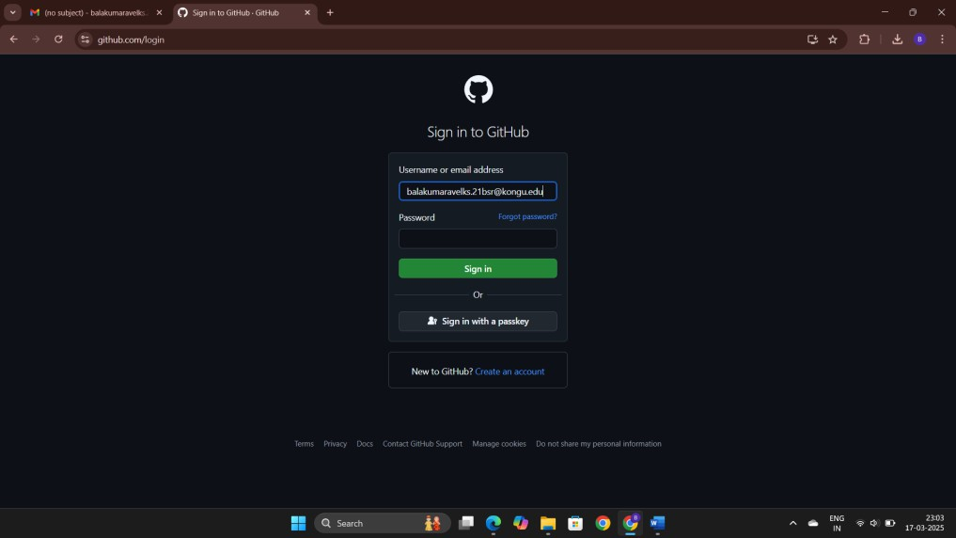

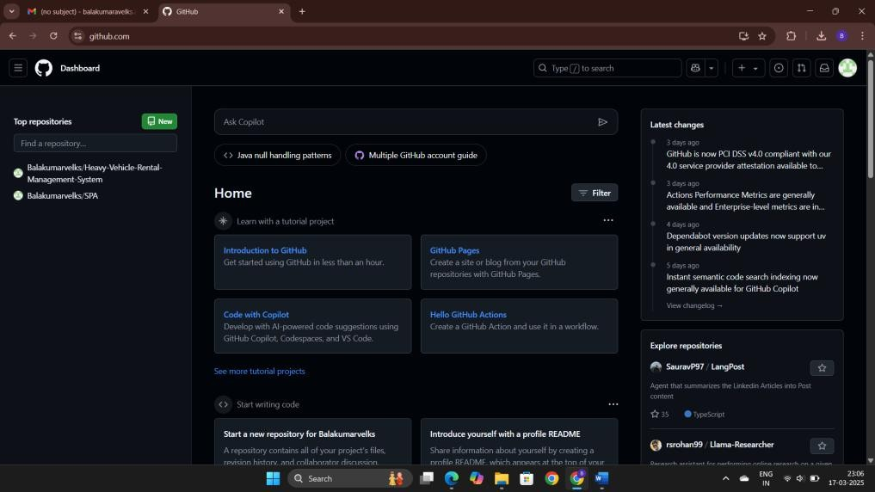

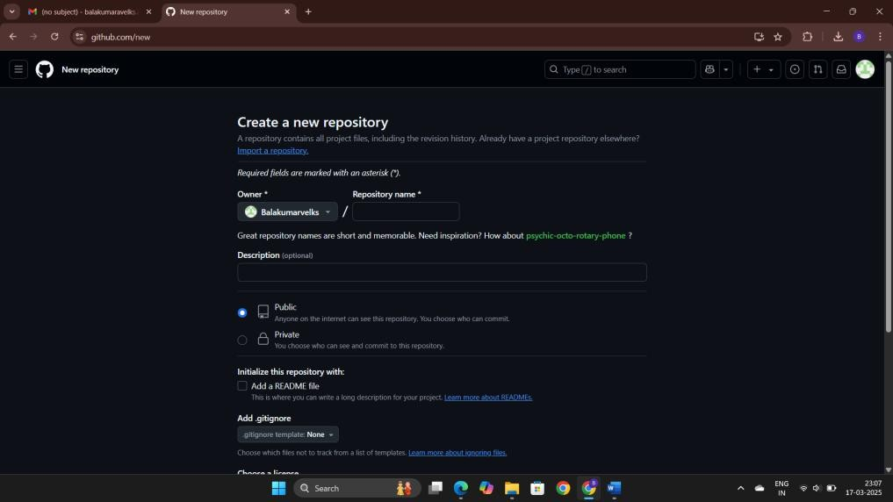**STEP 4:** Give the repository name and makes as public.



**STEP 6:** Click add file button click create file or upload file. **7:** Choose thefile and upload in github.

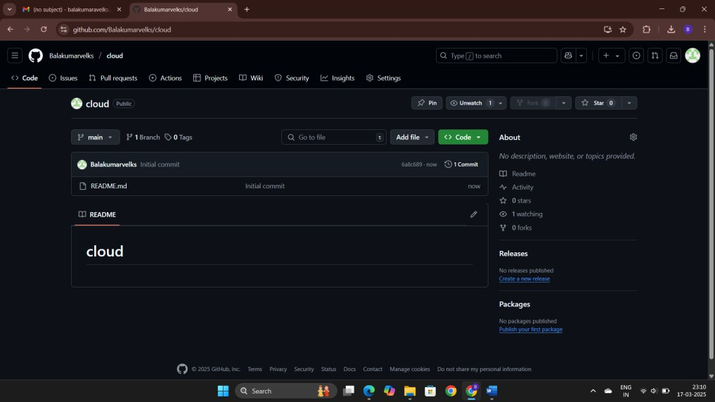

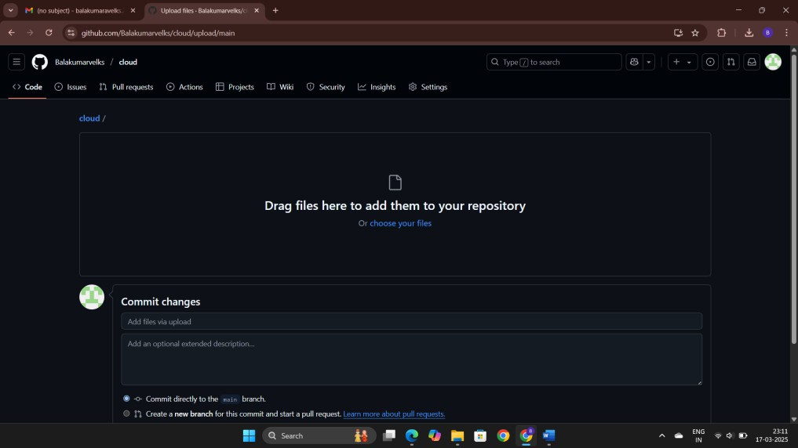

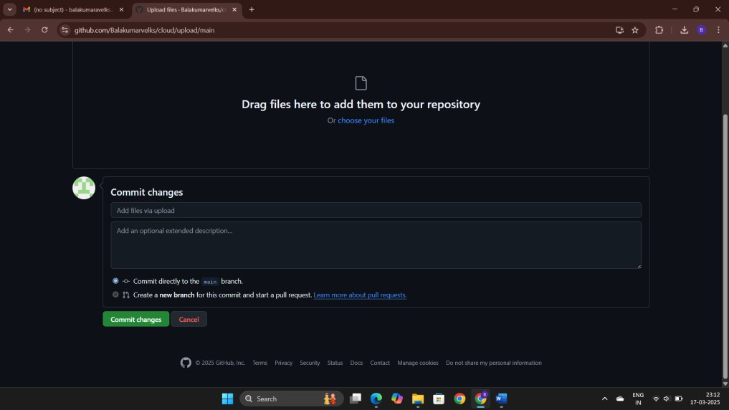**STEP 8:** Click the button commit changes.

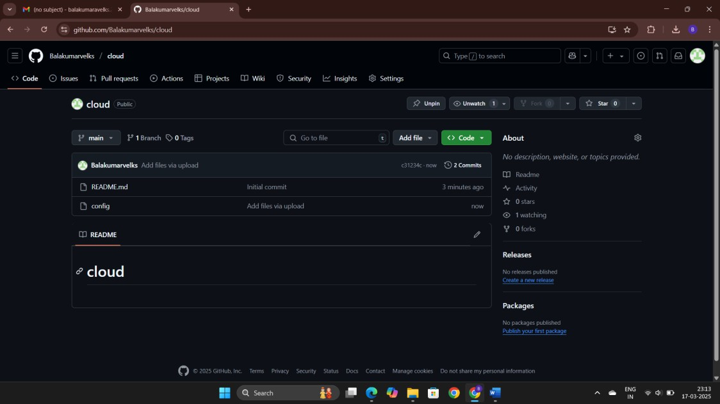

|  |  |
| --- | --- |
| COE(30) |  |
| RECORD(20) |  |
| VIVA(10) |  |
| TOTAL(60) |  |

**RESULT :**

In Github, Repository has been created and program uploaded successfully.