ANU simple click flowcharts
  - User actions and cloud cost touchpoints
30 October 2026
Use this guide to follow the application one task at a time. Each numbered box shows what to click and what appears next. Alternative choices explain errors, cancellation and ways to go back. Cloud notes explain where storing, downloading or sending information can add cost.
Available screens and buttons depend on your role. Incomplete features and headset steps that require confirmation are marked in the relevant tasks.

Find a section
Login Tasks 1 to 3
Common controls Tasks 4 to 7
Dashboards Tasks 8 to 8
Trainees and instructors Tasks 9 to 14
Batches and schedules Tasks 15 to 19
Courses and learning content Tasks 20 to 28
Course access Tasks 29 to 31
Volumes and recordings Tasks 32 to 40
Mapping and reattempts Tasks 41 to 43
Trainee learning Tasks 44 to 47
Headset and live view Tasks 48 to 50
Device sessions Tasks 51 to 51
Institutions and reports Tasks 52 to 54
Cloud costs are usage based. A click does not have a single fixed price. Charges depend on file size, retention, downloads, server work, live connection time and the provider plan.

Login

1 Sign in
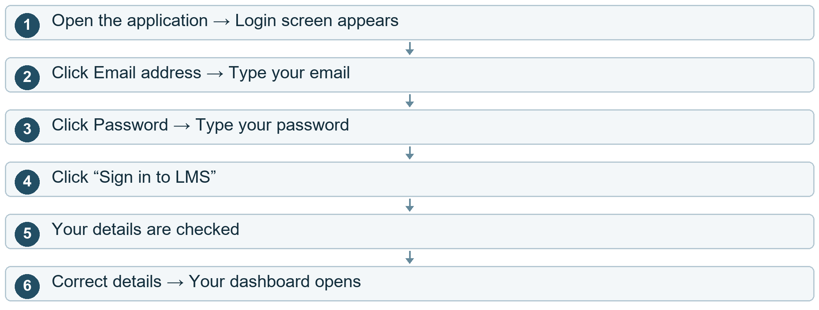

Other choices
After step 3 Click the eye icon. Password becomes visible. Click it again to hide it.
After step 5 A field is empty. “Please fill all the fields” appears. Fill the missing field and click Sign in again.
After step 5 Email or password is wrong. “Invalid credentials” appears. Correct your details and click Sign in again.
Cloud cost here. At Sign in: the cloud checks your account and saves the login session. Cost comes from the number of checks and the time the server runs.

Login

2 Forgot password
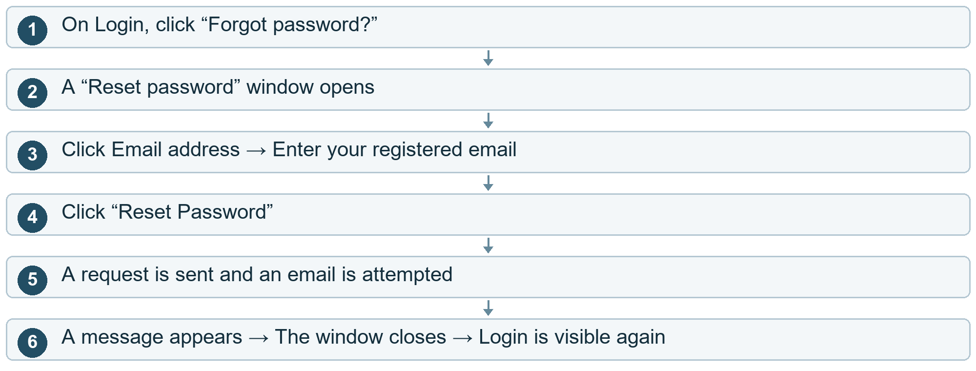

Other choices
After step 2 Click Cancel, X, or outside the window. The window closes. You return to Login.
After step 4 Email field is empty. An error appears. Enter your email and try again.
Cloud cost here. At Reset Password: the cloud records the request and sends an email. Charges depend on server usage and the email provider.
Current project note. Needs completion: the current email contains placeholder text. A working reset link, new-password screen and phone-based password recovery are not completed in this flow.

Login

3 Verify an account resend OTP
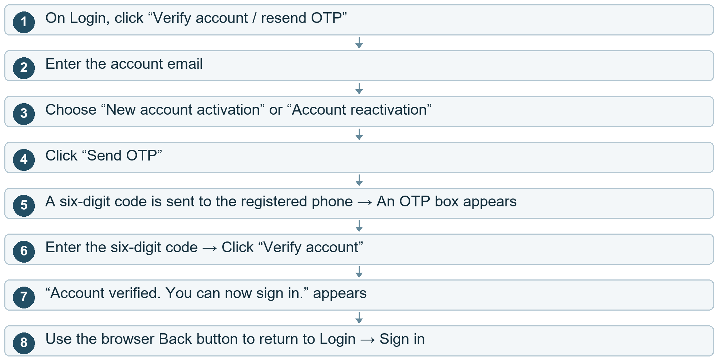

Other choices
After step 5 Did not receive the code?. Click Resend OTP. A new sending attempt is made.
After step 6 Code is wrong or expired. An error appears. Enter a valid code or request another one.
Cloud cost here. At Send / Resend OTP: notification-provider charges may apply. At Verify account: the saved account is checked and updated.
Current project note. This verifies account activation/reactivation. It is separate from resetting a forgotten password.

Common controls

4 Open another screen
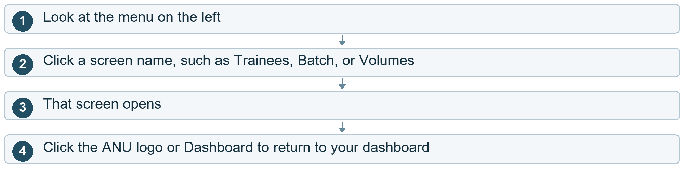

Other choices
After step 1 Menu is collapsed. Click the chevron arrow to expand it. Click again to collapse it.
Cloud cost here. Changing the menu itself is local. Opening a screen may read saved cloud data.
Current project note. The visible menu depends on whether you are a trainee, instructor, institution admin or super admin.

Common controls

5 Notifications
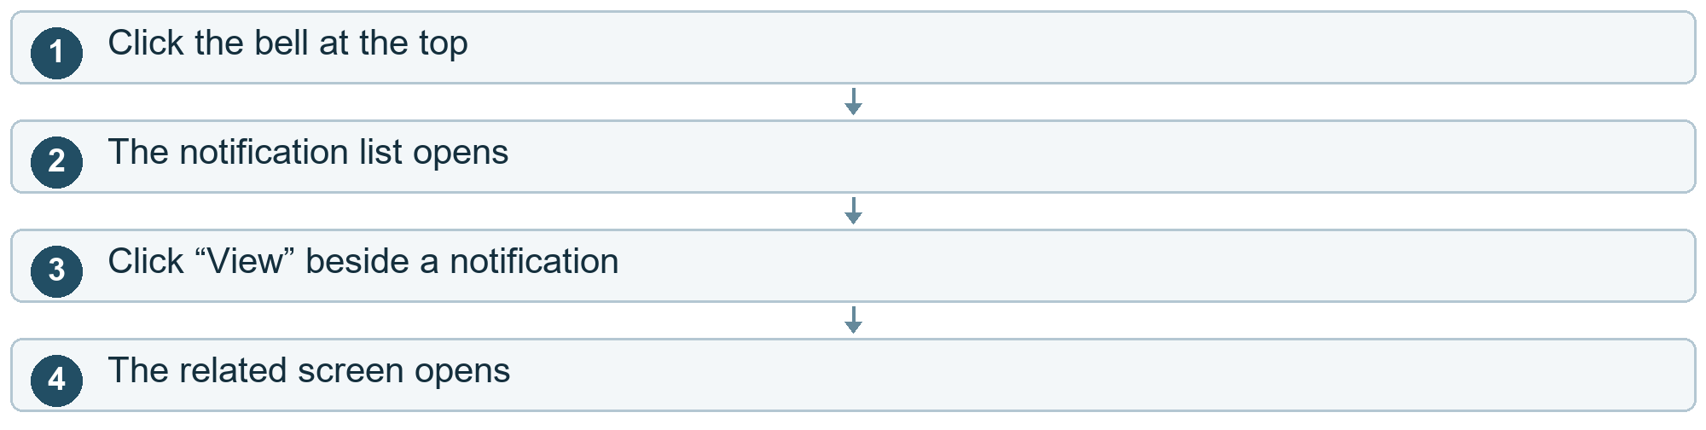

Other choices
After step 2 Click Mark as read. That notification becomes read.
After step 2 Click Mark all read. All listed unread notifications become read.
After step 2 Click the bell again / outside the menu. The notification menu closes.
Cloud cost here. Reading or updating saved notifications uses cloud data. It does not upload headset video.

Common controls

6 View profile manage sessions log out
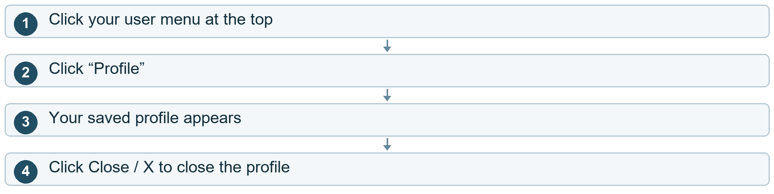

Other choices
After step 1 Click Sessions instead. The device-session screen opens. See “Log out a device”.
After step 1 Click Logout instead. Your current session ends. The Login screen opens.
Cloud cost here. Opening a profile may read saved cloud data. Logout updates your saved session.

Common controls

7 Fullscreen table pages and search
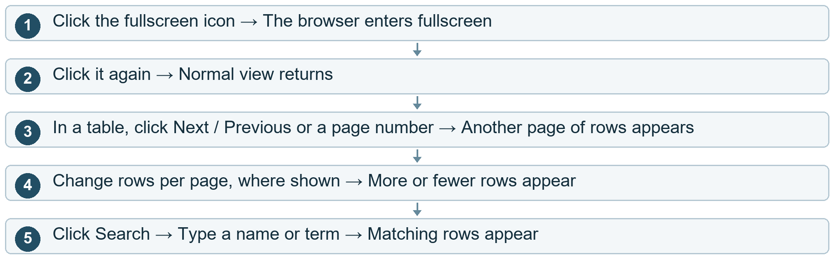
Cloud cost here. Fullscreen is local. Table/search controls may work on already-loaded rows or request another set of cloud data, depending on the screen.

Dashboards

8 Use your dashboard
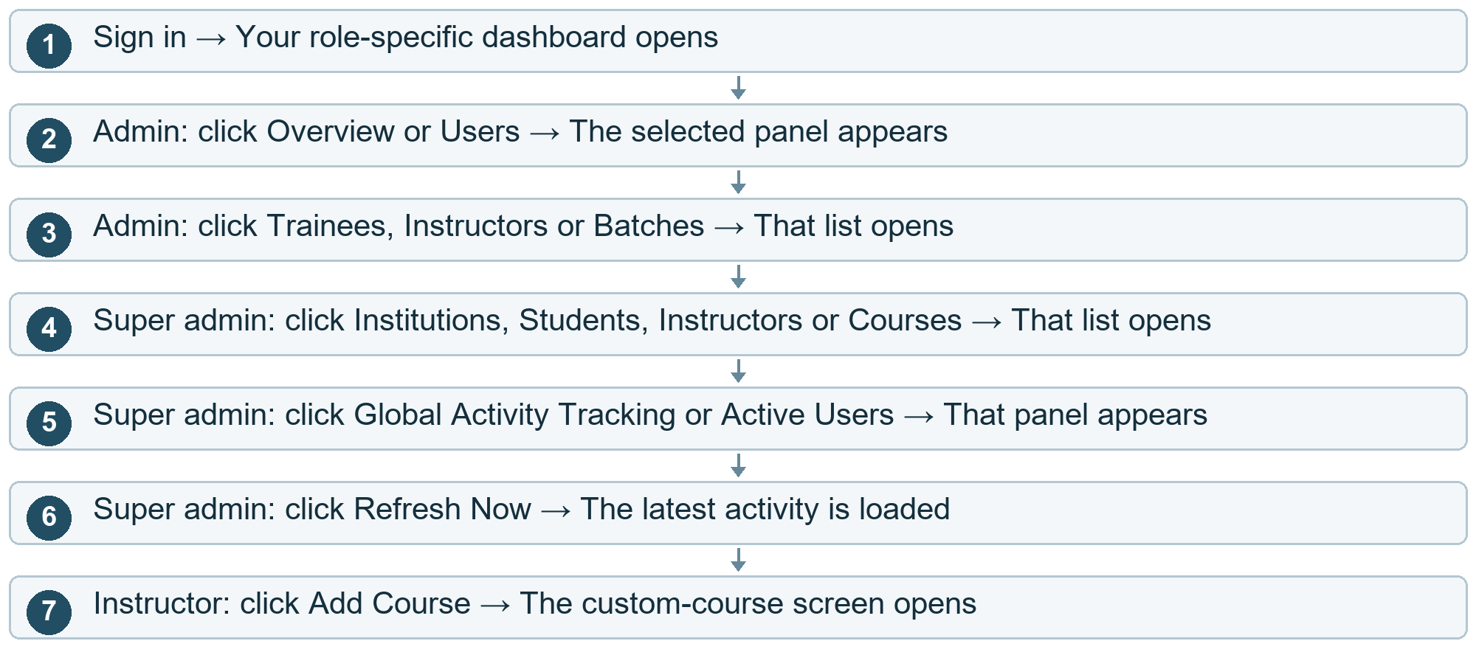
Cloud cost here. Dashboard data and refreshes read saved cloud information. Switching a panel may use information already loaded.
Current project note. These are separate role-specific choices. One person will not see all of them.

Trainees and instructors

9 Add a trainee personal details
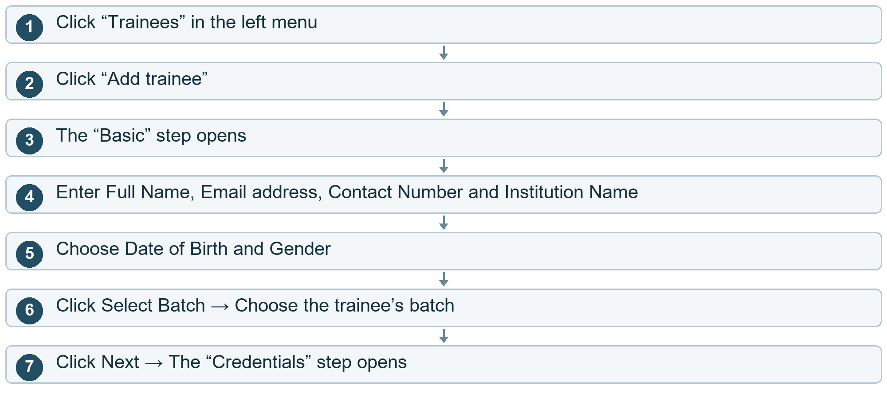
Cloud cost here. The batch choices are read from saved data. Typing these details does not save the trainee yet.

Trainees and instructors

10 Add a trainee password photo and save
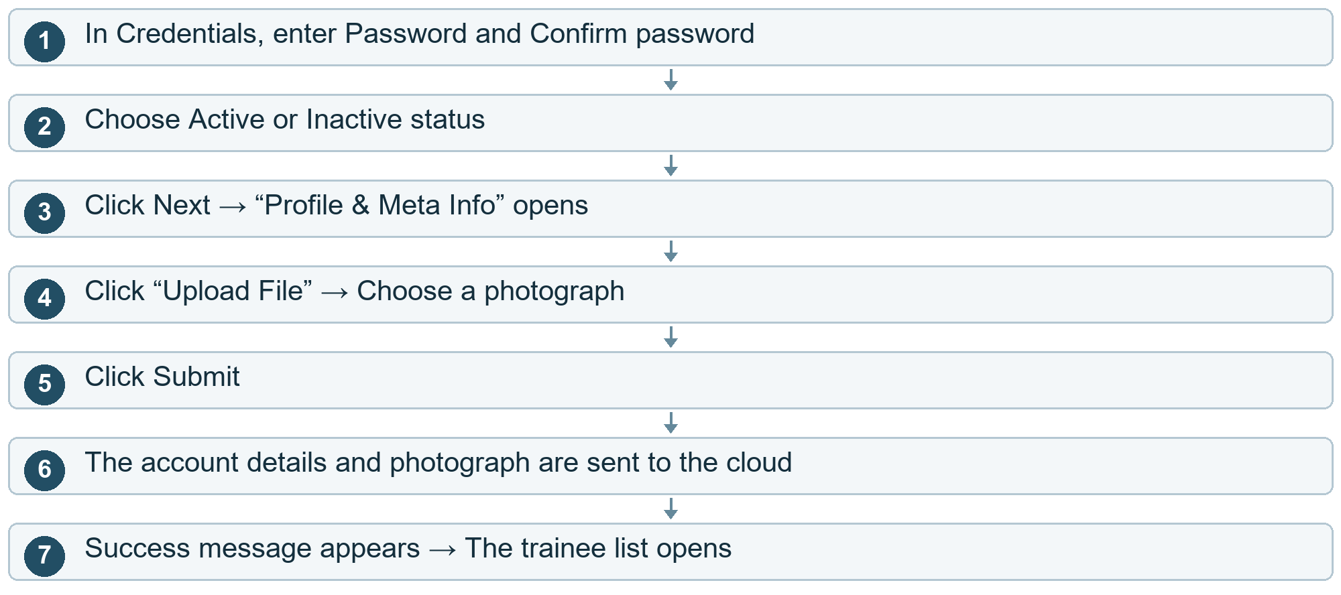

Other choices
After step 2 Need to change personal details?. Click Prev to return to Basic.
After step 4 Need to change credentials?. Click Prev to return to Credentials.
After step 5 Passwords do not match. An error appears. Return to Credentials and correct them.
After step 6 Email already exists / required information is missing. An error appears. Correct the information before submitting again.
Cloud cost here. At Submit: account details are stored in the database; the photo is sent with the form. File storage and verification-message costs depend on the server path used.

Trainees and instructors

11 Add an instructor
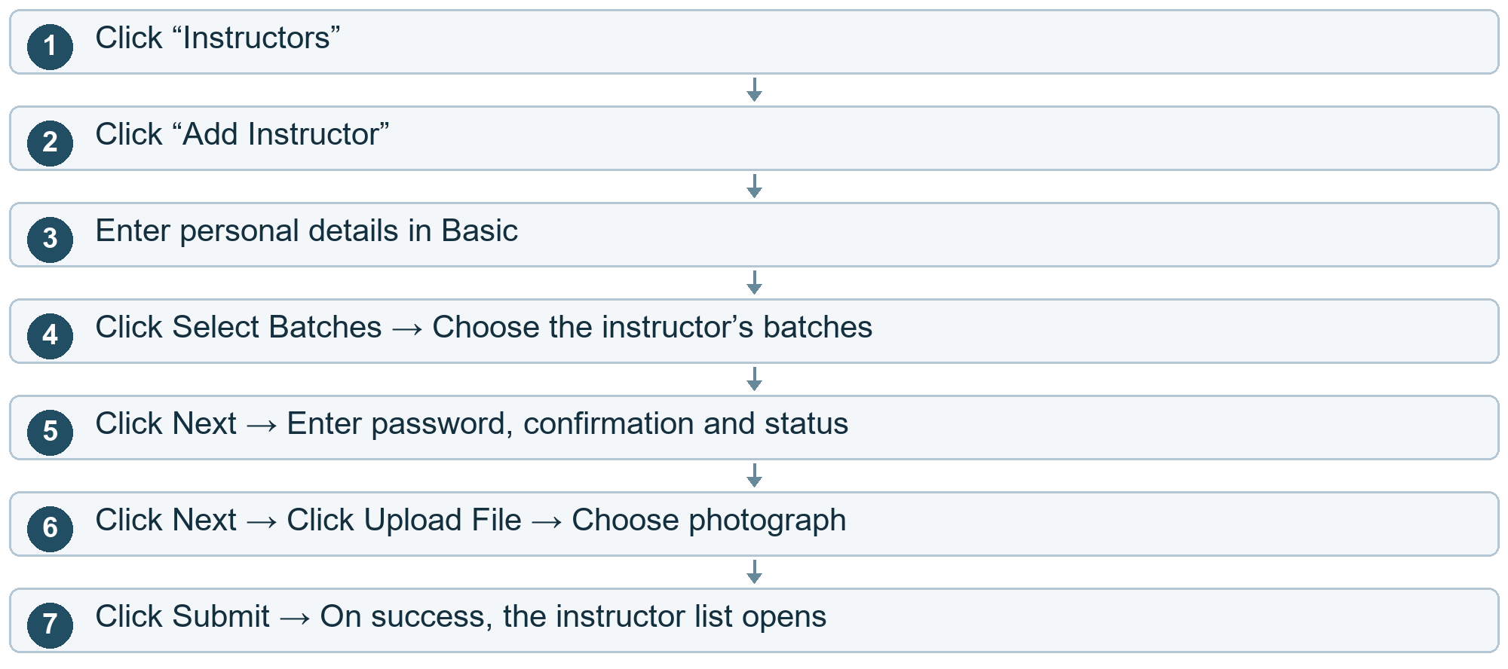

Other choices
After step 5 Need to go back?. Click Prev to return to the earlier step.
After step 7 The form is rejected. Read the error, correct the details and submit again.
Cloud cost here. At Submit: cloud account creation, submitted photo handling and any verification message may incur usage.

Trainees and instructors

12 View or edit a trainee
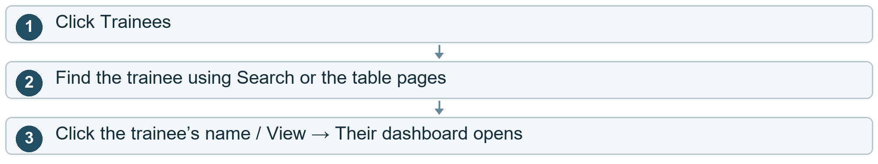

Other choices
After step 2 To edit instead. Click Edit → Change the displayed fields / batch → Click Submit → On success, the list refreshes.
After step 2 Close the edit window without saving. Click X or close the dialog. You return to the list.
Cloud cost here. View reads saved results. Submit saves account changes in the cloud.

Trainees and instructors

13 Enable disable or delete a trainee
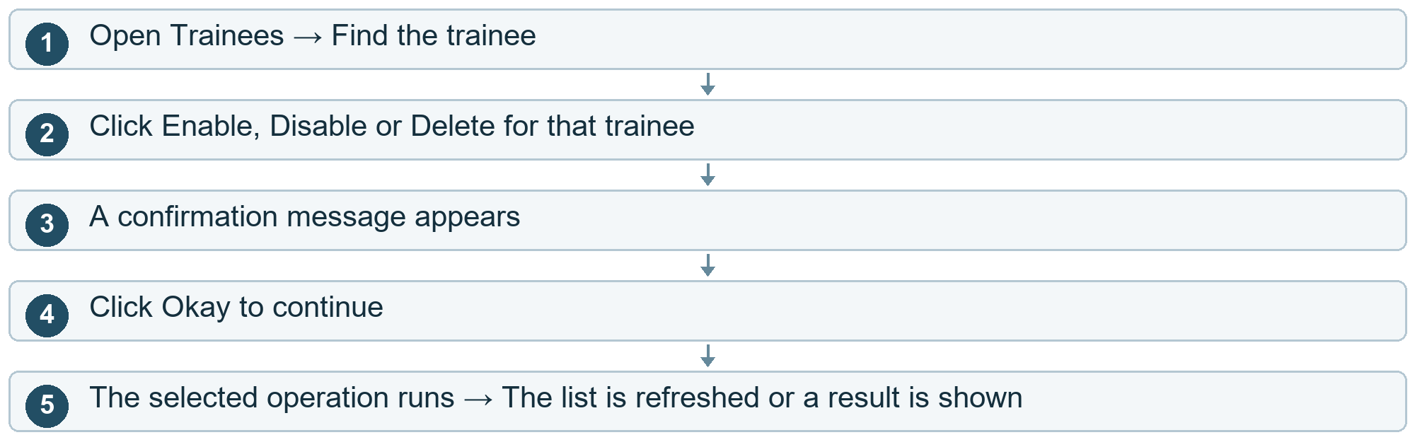

Other choices
After step 3 Click Cancel. The operation is cancelled. The account stays as it was.
After step 4 You selected Enable. A verification OTP is sent. The trainee must verify the account to complete activation.
After step 5 The request fails. An error appears. Check the result before trying again.
Cloud cost here. At Okay: the saved account is updated or deleted. Enable may also send a paid verification message.

Trainees and instructors

14 View edit or delete an instructor
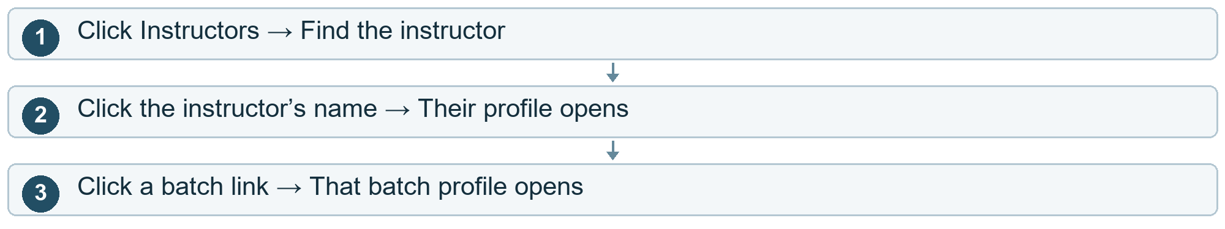

Other choices
After step 1 See assigned batch names in the list. Click the batch expander. Click it again to collapse the names.
After step 1 Edit the instructor. Click Edit → Change the form → Click Submit → The list refreshes on success.
After step 1 Delete the instructor. Click Delete → Click Okay in the confirmation. Click Cancel to keep the account.
Cloud cost here. Viewing reads cloud information. Saving or confirming deletion changes saved account data.

Batches and schedules

15 Create a batch
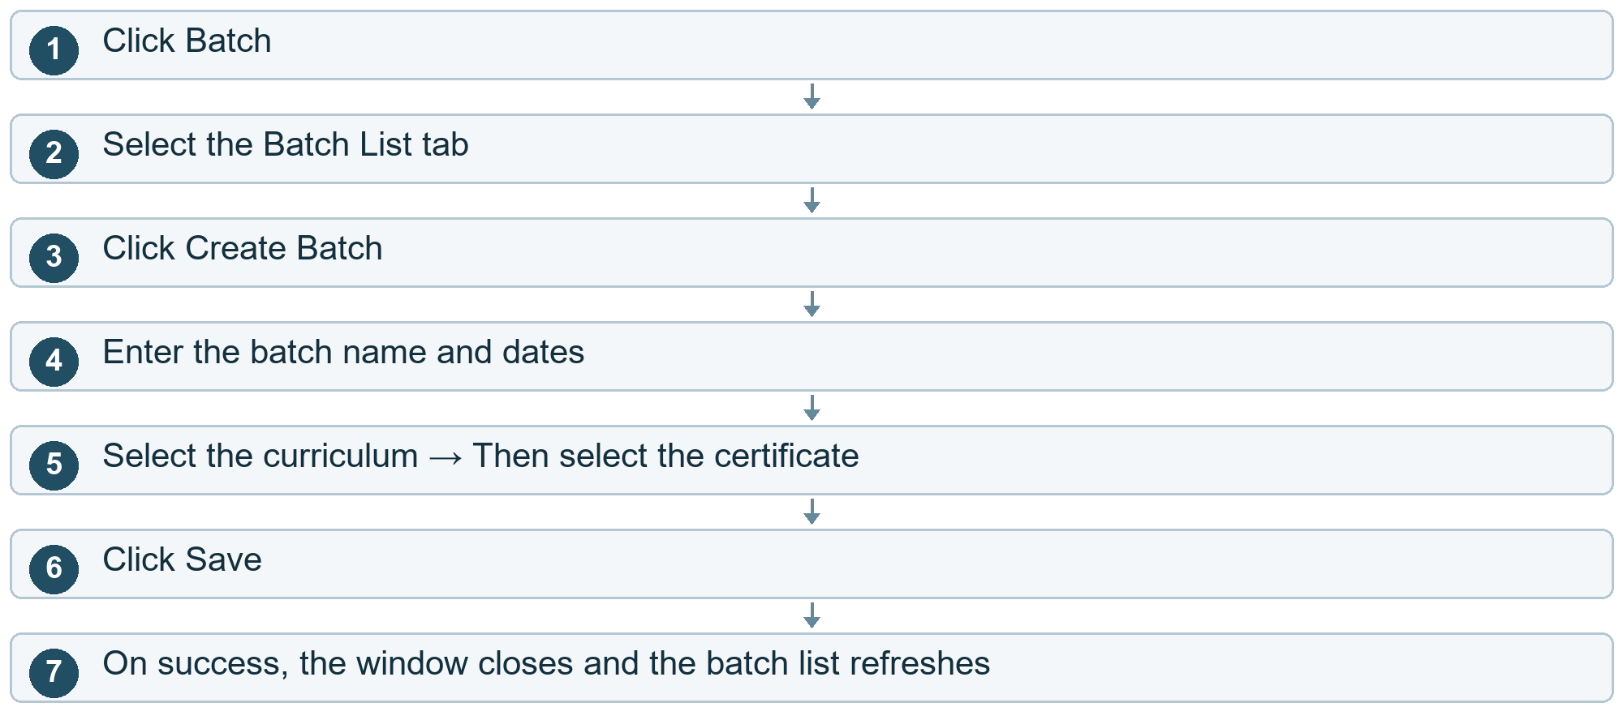

Other choices
After step 6 Required details are missing / the batch already exists. An error appears. Correct the form and click Save again.
After step 3 Decide not to create it. Click X or outside the window.
Cloud cost here. At Save: batch information is stored in the cloud. Curriculum and certificate choices also read saved data.

Batches and schedules

16 Find open edit or delete a batch
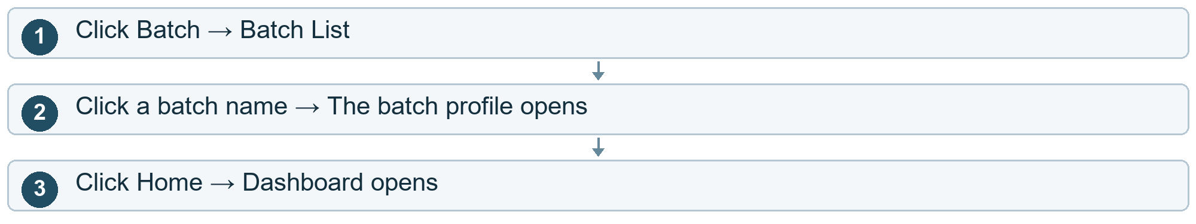

Other choices
After step 1 Filter batches. Click the filter icon → Choose at least one filter → Click Apply → Matching batches appear.
After step 1 Edit a batch. Open its row menu → Click Edit → Change name / dates → Click Update.
After step 1 Cancel an edit. Click Close.
After step 1 Delete a batch. Open its row menu → Click Delete → Click Okay to delete or Cancel to keep it.
Cloud cost here. Opening/filtering reads cloud data. Update and confirmed deletion change saved batch data.
Current project note. Some sort icons in the batch profile have no sorting action connected.

Batches and schedules

17 Create targeted learning
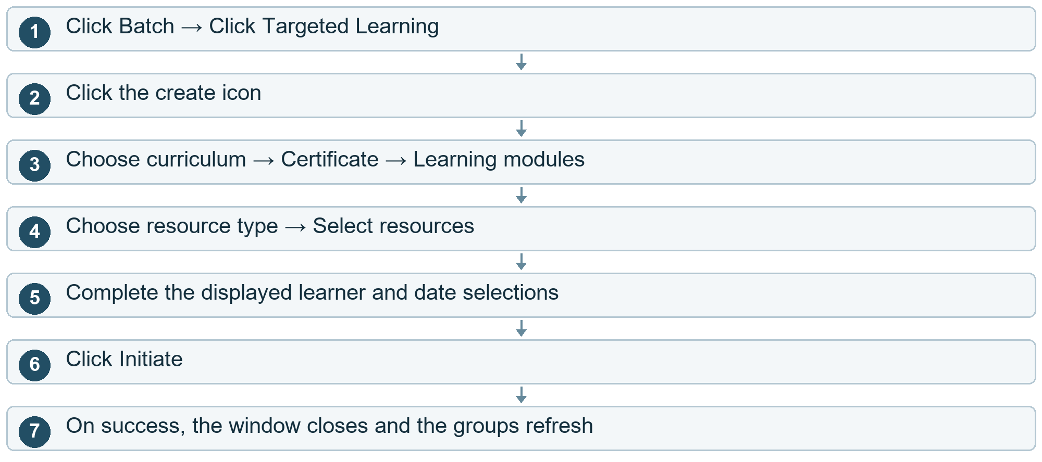

Other choices
After step 6 Information is missing. An error appears. Complete the form and click Initiate again.
After step 2 Cancel creation. Click X or outside the window.
Cloud cost here. Choices read saved cloud data. Initiate stores the targeted learning assignment.

Batches and schedules

18 Open or delete targeted learning
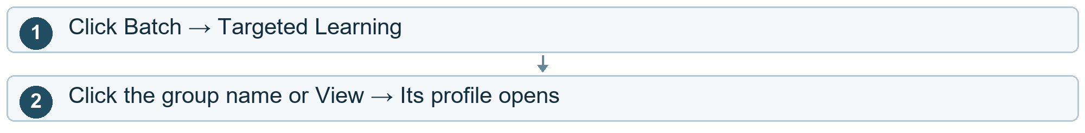

Other choices
After step 1 Delete a group. Open its row menu → Delete → Okay. Choose Cancel to keep it.
Cloud cost here. Opening reads saved group information. Confirmed deletion removes the saved assignment.

Batches and schedules

19 Use the schedule
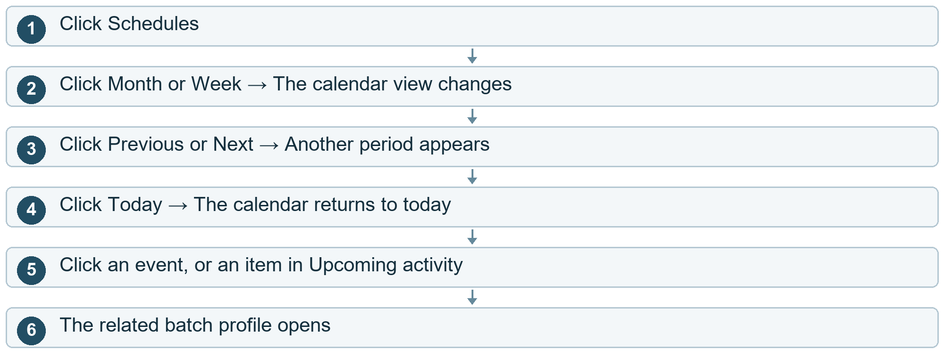
Cloud cost here. Loading schedules and opening the batch read saved cloud data. Moving the displayed calendar period is a view action.

Courses and learning content

20 Create a curriculum
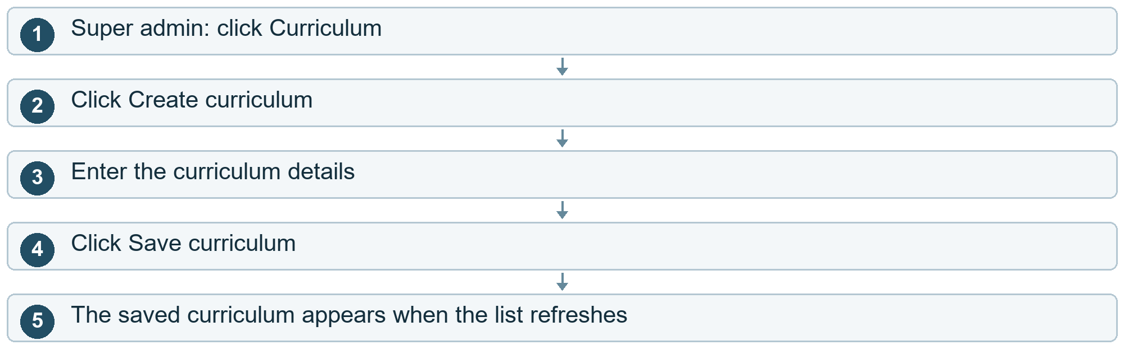

Other choices
After step 2 Cancel. Click Close / X or outside the window.
After step 4 Saving fails. Correct the information and try again.
Cloud cost here. At Save curriculum: the new curriculum is written to cloud data.

Courses and learning content

21 Use a curriculum s menu
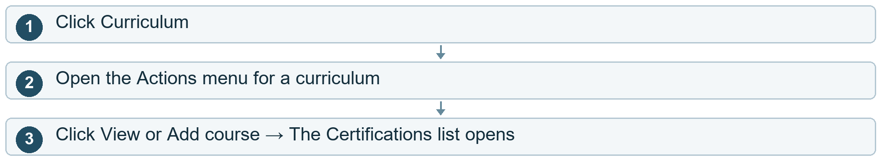

Other choices
After step 2 Click Tag trainees. The Trainees list opens.
After step 2 Click Tag instructors. The Instructors list opens.
After step 2 Click Delete. A confirmation appears. Okay deletes it; Cancel keeps it.
Cloud cost here. Opening lists reads saved data. Confirming Delete changes cloud data.

Courses and learning content

22 Create open or delete a certification
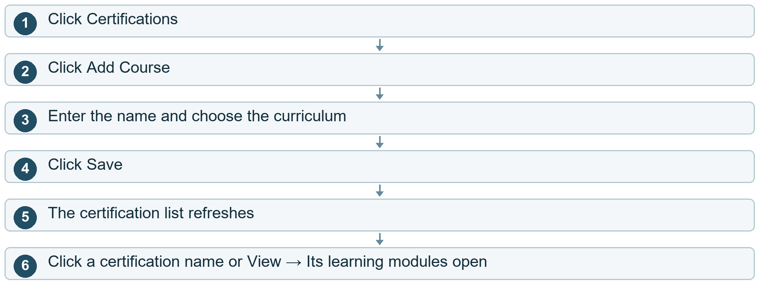

Other choices
After step 2 Cancel creation. Click X / outside the window.
After step 1 Expand a list row. Click its arrow / expandable label; click again to collapse it.
After step 1 Delete a certification. Open the row menu → Delete → Okay. Choose Cancel to keep it.
After step 1 Tag a course. Open the row menu → Tag Course → Choose associations → Save.
Cloud cost here. Save, Tag Course and confirmed Delete change saved cloud data. Opening a certification reads its content.

Courses and learning content

23 Open modules topics and resources
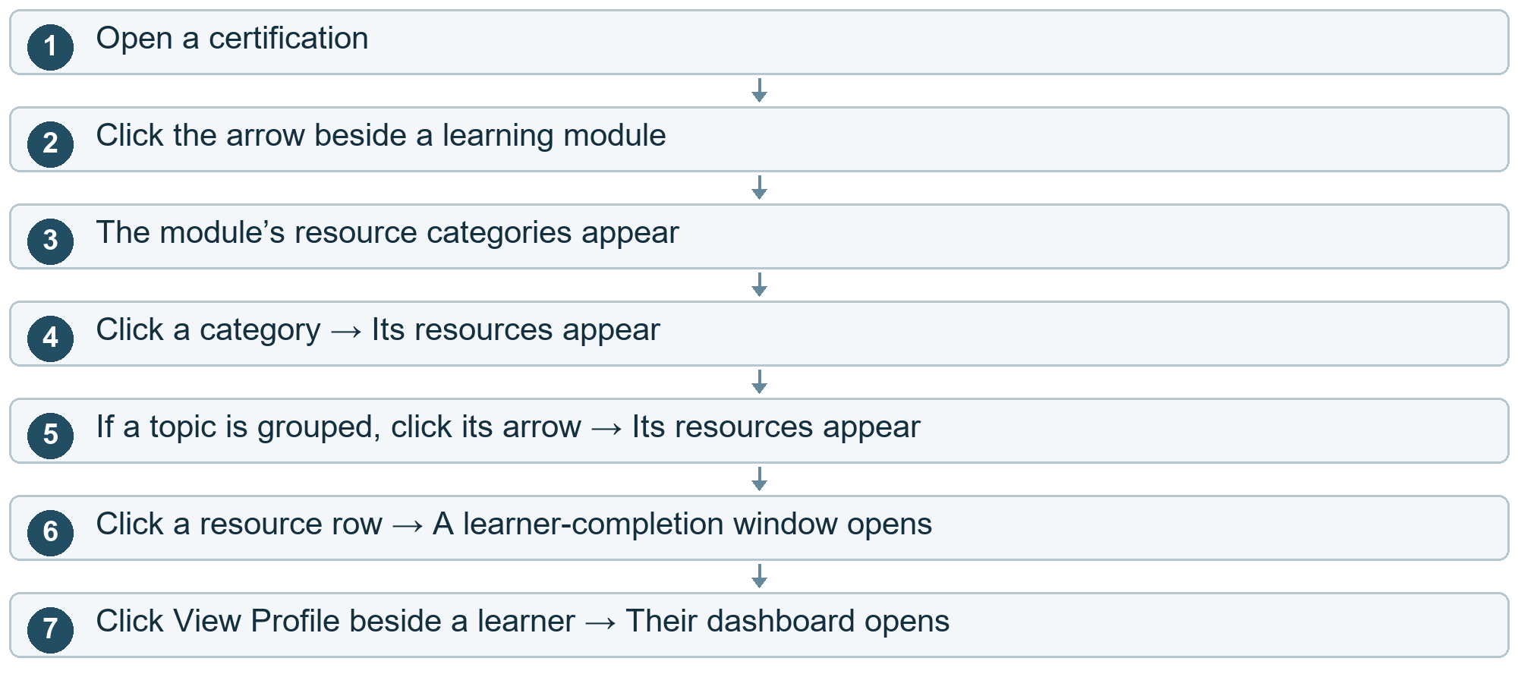

Other choices
After step 2 Hide the module again. Click the same arrow.
After step 4 Hide a category / topic. Click its arrow again.
After step 6 Return to the resources. Click X or outside the completion window.
Cloud cost here. Opening content or learner-completion details reads saved cloud data. Expand / collapse actions themselves are local.

Courses and learning content

24 Create a learning module
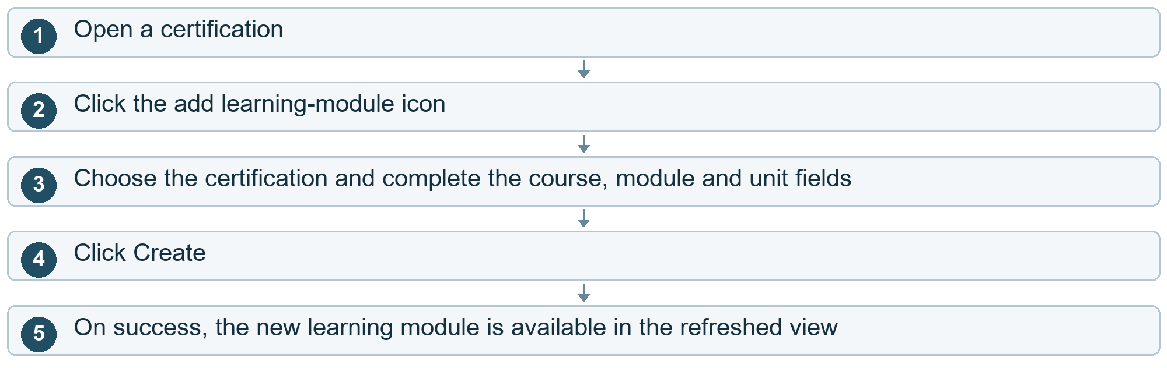

Other choices
After step 2 Cancel. Click X / outside the window.
After step 4 Creation fails. Correct the form and try again.
Cloud cost here. At Create: learning-module information is stored in the cloud.

Courses and learning content

25 Create a resource
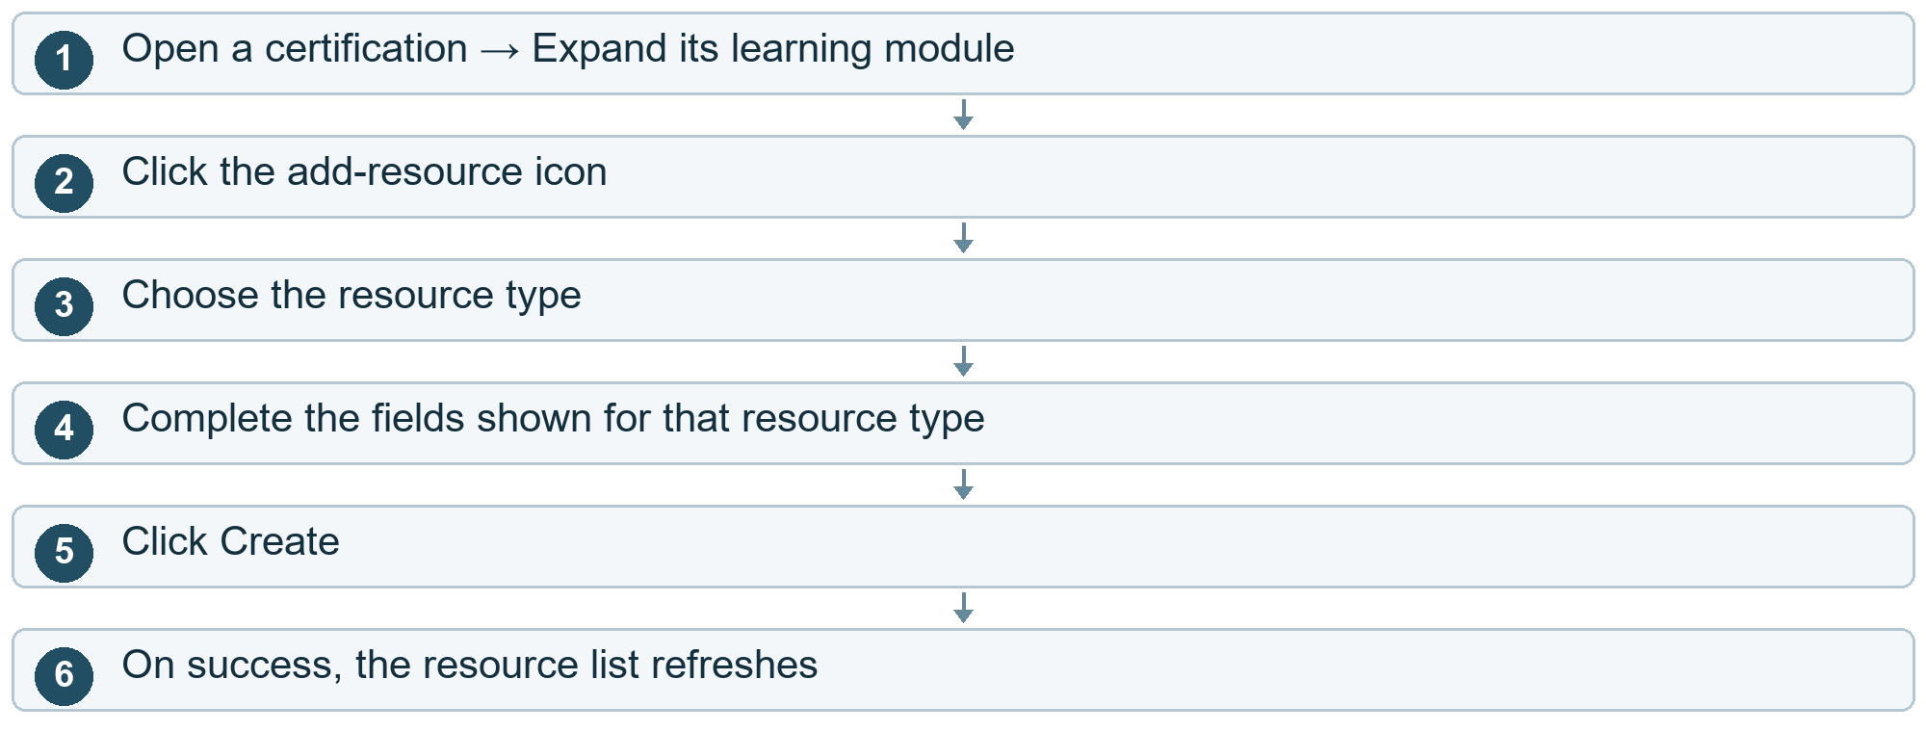

Other choices
After step 2 Cancel. Click X / outside the window.
After step 5 Creation fails. Correct the information and click Create again.
Cloud cost here. At Create: the resource details are stored in the cloud.

Courses and learning content

26 Attach a volume to a resource
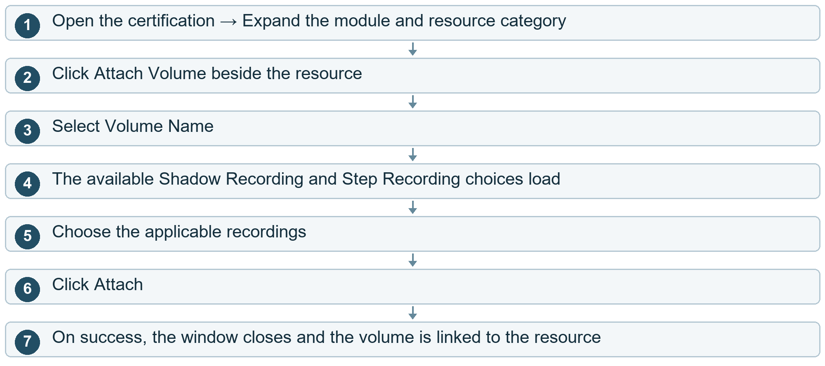

Other choices
After step 2 Cancel. Click Cancel / X or outside the window.
After step 6 Attachment fails. An error appears. Correct the selections and try again.
Cloud cost here. Selecting a volume reads recording information. Attach saves the link. It does not upload the whole volume again.

Courses and learning content

27 Add or edit questions
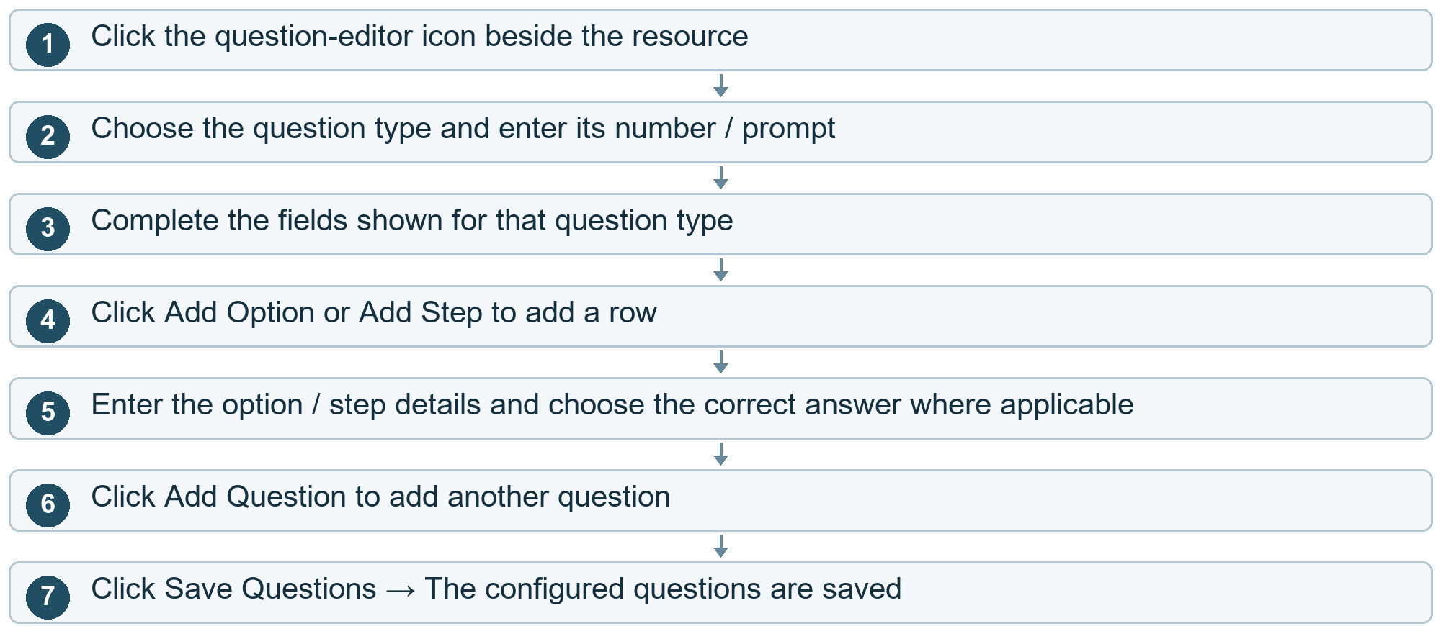

Other choices
After step 3 Add an image. Use the image file selector, where shown, or enter its image address.
After step 4 Remove an option / step. Click its remove icon.
After step 6 Remove a question. Click that question’s delete icon.
After step 1 Close the editor. Click X / close the dialog.
After step 7 Validation or saving fails. Read the error, correct the fields and save again.
Cloud cost here. Save Questions stores question data. Uploading an image adds file-storage usage. Merely adding/removing an unsaved form row is local.

Courses and learning content

28 Alternate Chapter Module Resource screens
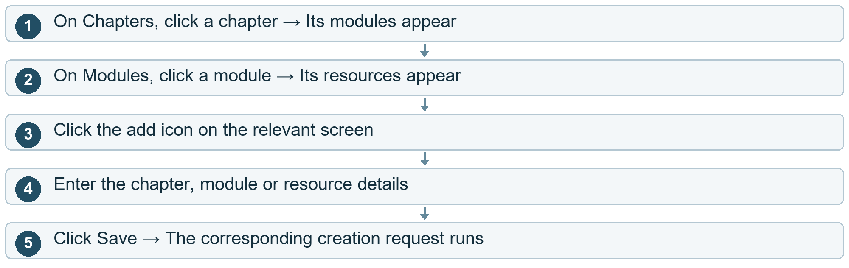

Other choices
After step 3 Cancel. Click X / close.
After step 2 Edit resource questions. Click the question icon beside the resource.
Cloud cost here. Save stores the corresponding content record.
Current project note. The old Course breadcrumb points to an unregistered destination. The current source can send the user back to Login through that link.

Course access

29 Create and publish an accessible course
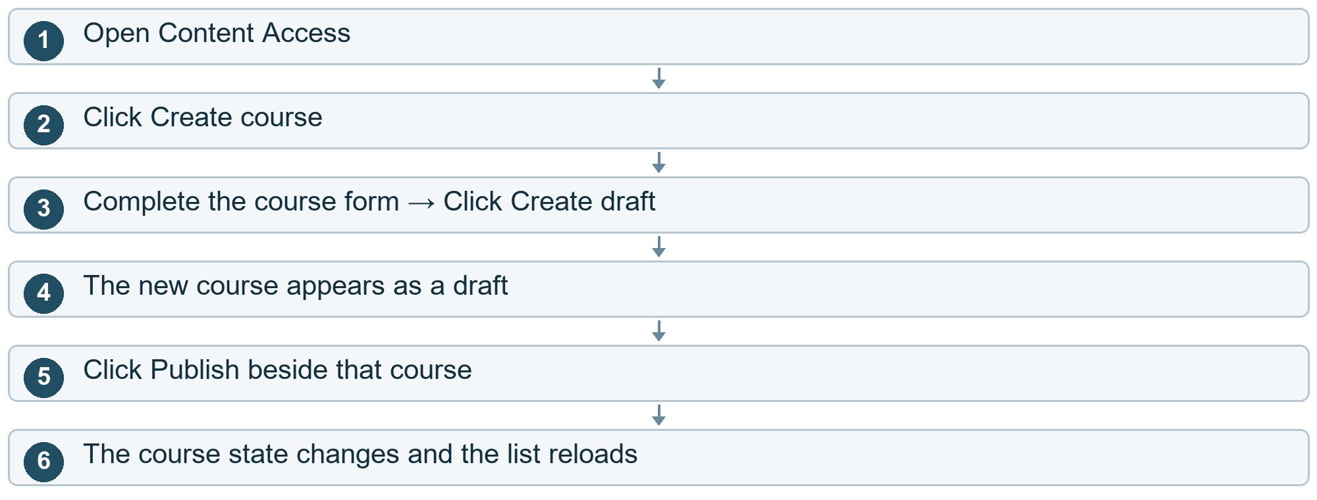

Other choices
After step 2 Cancel creation. Click the close control.
After step 4 Unpublish an existing course. Click Unpublish. The course returns to draft.
After step 4 Archive an existing course. Click Archive.
Cloud cost here. Create draft and changing the publication state update cloud data.
Current project note. Only users with the relevant permissions see these controls.

Course access

30 Choose who can see or use a course
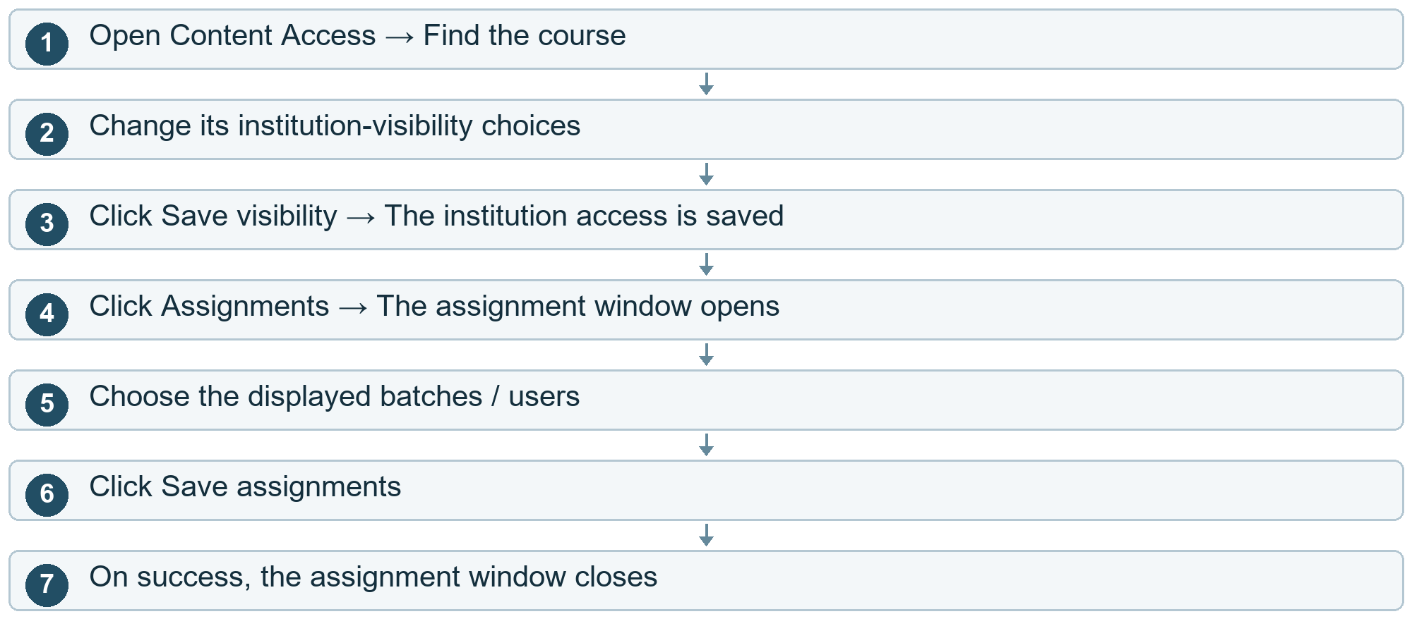

Other choices
After step 4 Cancel assignments. Click the close control.
After step 1 Open the course instead. Click Open → Its certification details appear.
Cloud cost here. Save visibility and Save assignments store access rules in the cloud.

Course access

31 Add administrators and review older content
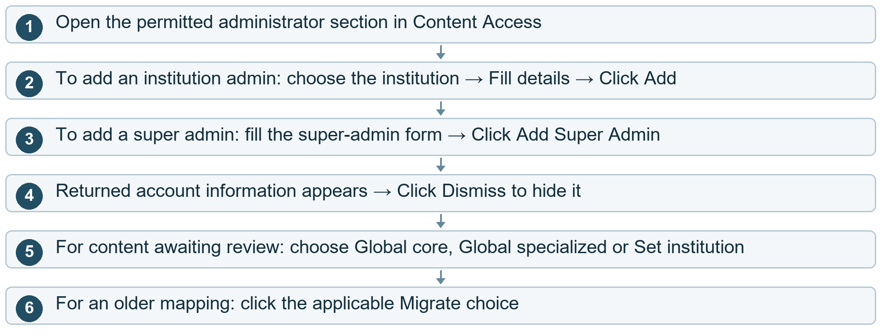
Cloud cost here. Creating accounts and assigning ownership update cloud data. A verification message may add notification charges.
Current project note. These controls are restricted by role. Ownership/migration actions apply to existing content requiring review, not to an ordinary learner.

Volumes and recordings

32 Upload a volume enter details
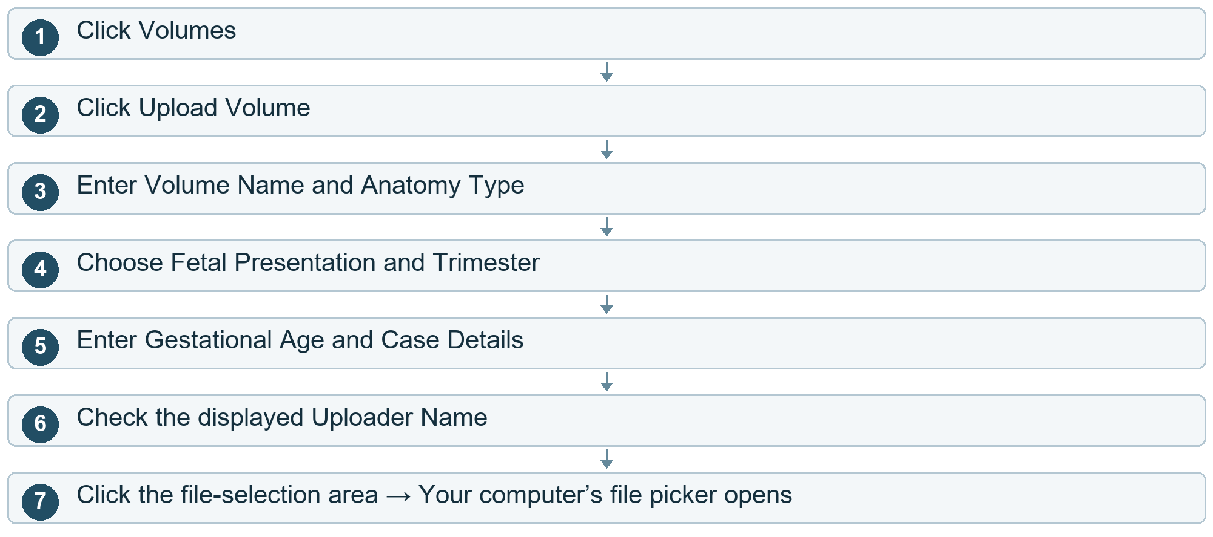

Other choices
After step 2 Cancel. Click X / outside the upload window.
Cloud cost here. No volume file is sent merely by opening this window or typing metadata.

Volumes and recordings

33 Upload a volume choose files and send
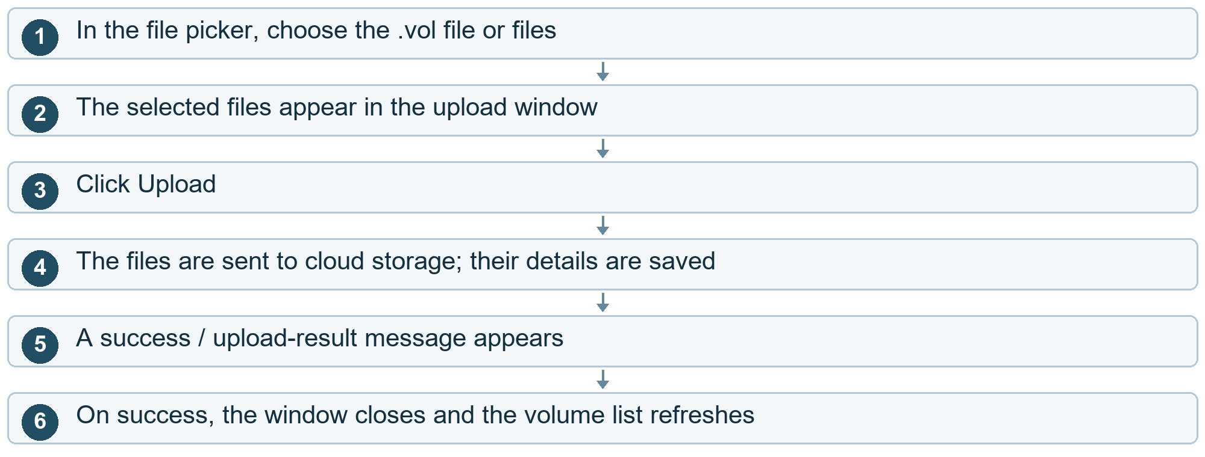

Other choices
After step 2 Wrong file selected. Click Remove file beside it → Select the correct file.
After step 3 Required details or files are missing. An error appears. Complete the form and click Upload again.
After step 4 A file fails to upload. Inspect the upload result before retrying, so already-uploaded files are not blindly sent again.
Cloud cost here. At Upload: file capacity, upload requests and server processing are chargeable dimensions. Keeping the file in storage adds a monthly storage charge.
Current project note. The file picker allows up to ten .vol files. The backend also applies its configured file-size limit.

Volumes and recordings

34 Filter edit or convert a volume
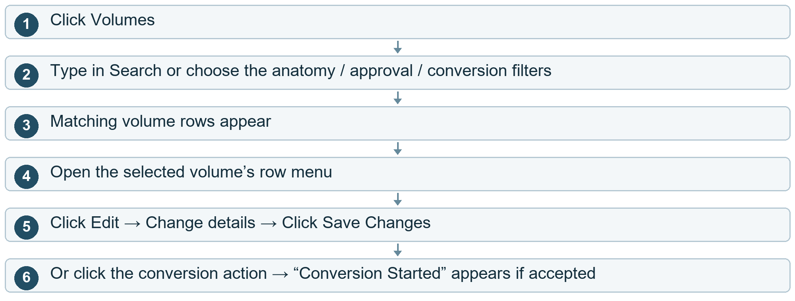

Other choices
After step 5 Cancel editing. Click Cancel / X.
After step 5 Saving fails. Read the error, correct the form and save again.
After step 6 Conversion request fails. An error appears. Check the volume state before retrying.
Cloud cost here. Save Changes updates saved metadata. Starting conversion runs a cloud computer and creates a converted file, so compute time and new file storage are charged.

Volumes and recordings

35 Download a volume or placement file
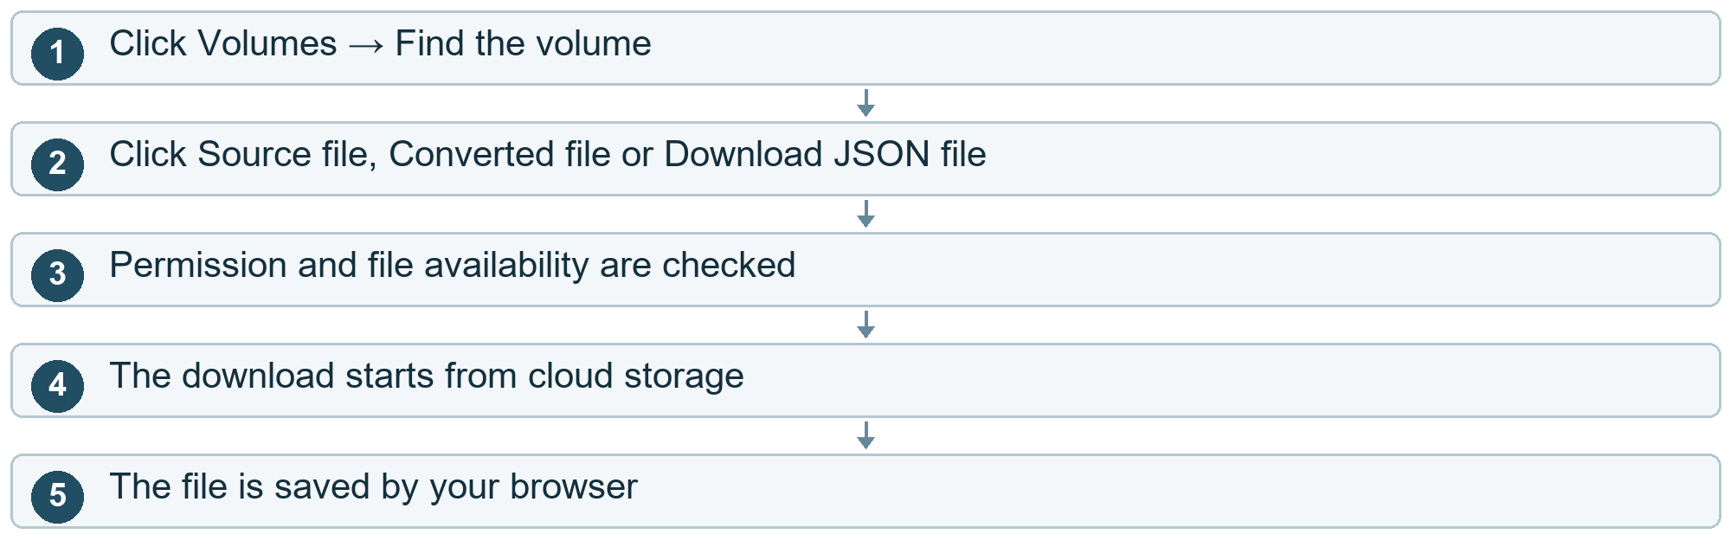

Other choices
After step 3 File is unavailable / access is denied. An error appears. The download does not complete.
Cloud cost here. At download: file-read requests and data sent from the cloud may be billed. More downloads mean more delivered data.

Volumes and recordings

36 Upload placement information
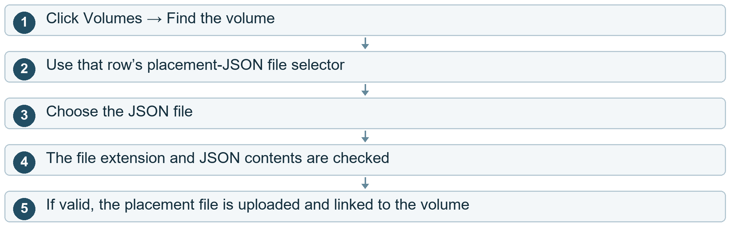

Other choices
After step 4 The file is not valid JSON. An error appears. Choose a corrected JSON file.
Cloud cost here. At upload: the placement file is stored in the cloud and its saved volume link is updated.

Volumes and recordings

37 Download reference recordings
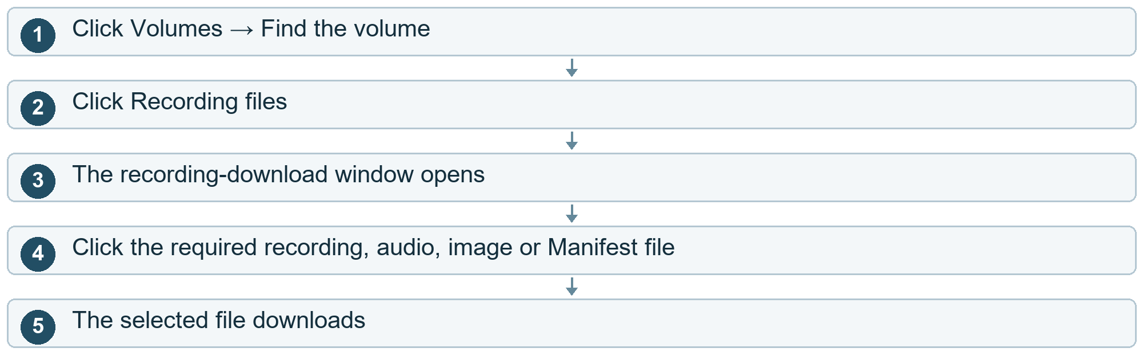

Other choices
After step 3 Return without downloading. Click X / outside the window.
After step 4 File preparation fails. An error appears. Check file availability and retry.
Cloud cost here. Opening the list reads saved recording information. Each file download adds file requests and possible outbound-data charges.

Volumes and recordings

38 Approve or reject an uploaded volume
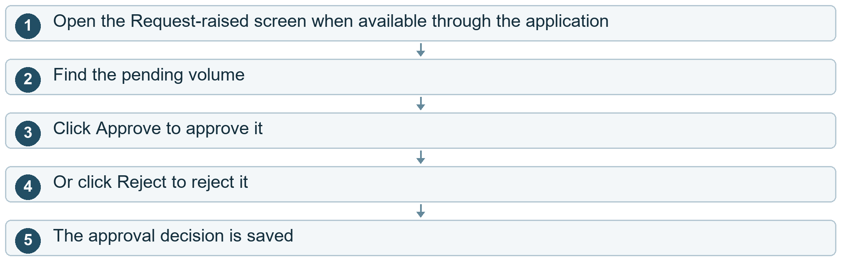
Cloud cost here. Approve / Reject updates the saved approval status. It does not itself run conversion or transfer the full file.

Volumes and recordings

39 Manage a cluster
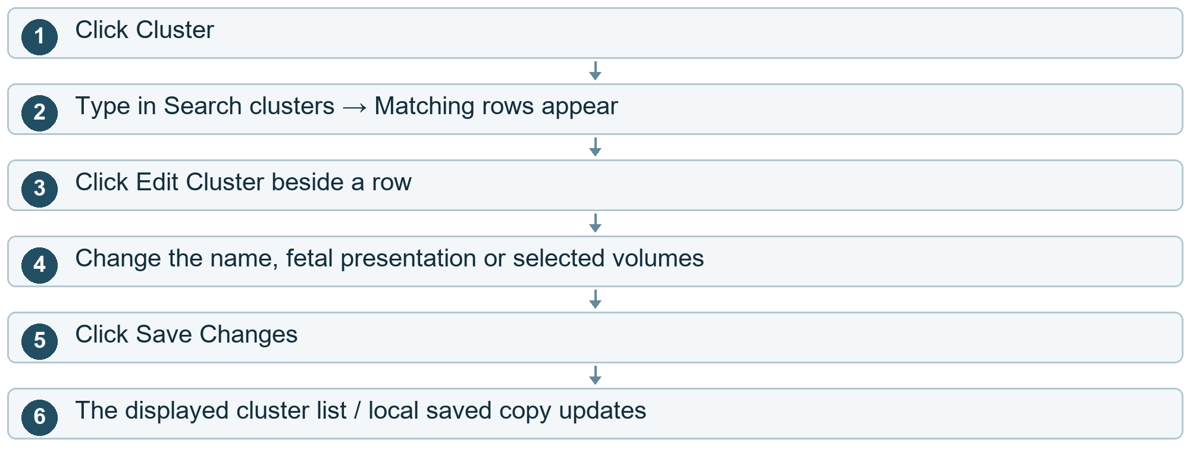

Other choices
After step 3 Cancel editing. Click Cancel / X.
After step 2 Delete a cluster. Click Delete Cluster → The deletion path runs and the displayed list updates.
Cloud cost here. A successful cloud update uses database requests. The current page also has a local fallback, so a changed list does not always prove the cloud save succeeded.
Current project note. Add-cluster and recording-upload windows exist in the source, but their opening buttons are absent from the currently reviewed table/header. They should not be shown as available clicks.

Volumes and recordings

40 Recording upload window if made accessible
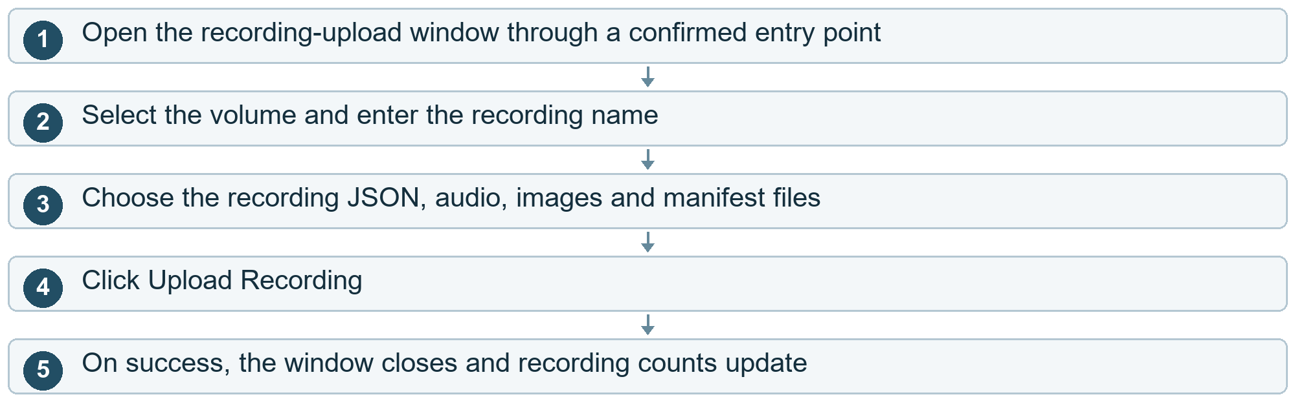

Other choices
After step 2 Replace an existing recording instead. Click Replace Existing Recording → Choose the existing recording → Choose replacement files → Click Replace Recording Files.
After step 3 Cancel. Click Cancel / X while no upload is running.
After step 4 Files are missing or rejected. Read the error and correct the selected files.
Cloud cost here. Upload / Replace sends file data to cloud storage and updates recording records.
Current project note. This is a defined window with an unconfirmed opening click, not a complete reachable user journey in the reviewed screen.

Mapping and reattempts

41 Create a course mapping
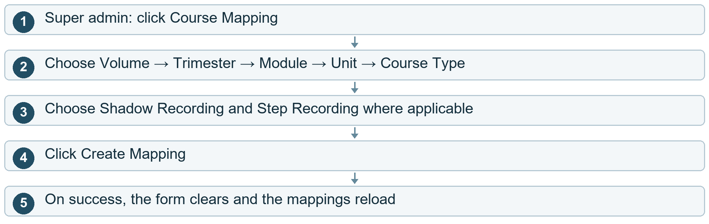

Other choices
After step 2 Start the form again. Click the form’s Clear button.
After step 4 A required choice is missing / saving fails. Read the error and correct the form.
After step 5 Find existing mappings. Set list filters → Click Apply or Refresh. Click the filter Clear to reset them.
Cloud cost here. Create Mapping stores links between existing content. It does not resend the whole volume file.

Mapping and reattempts

42 Create a custom course
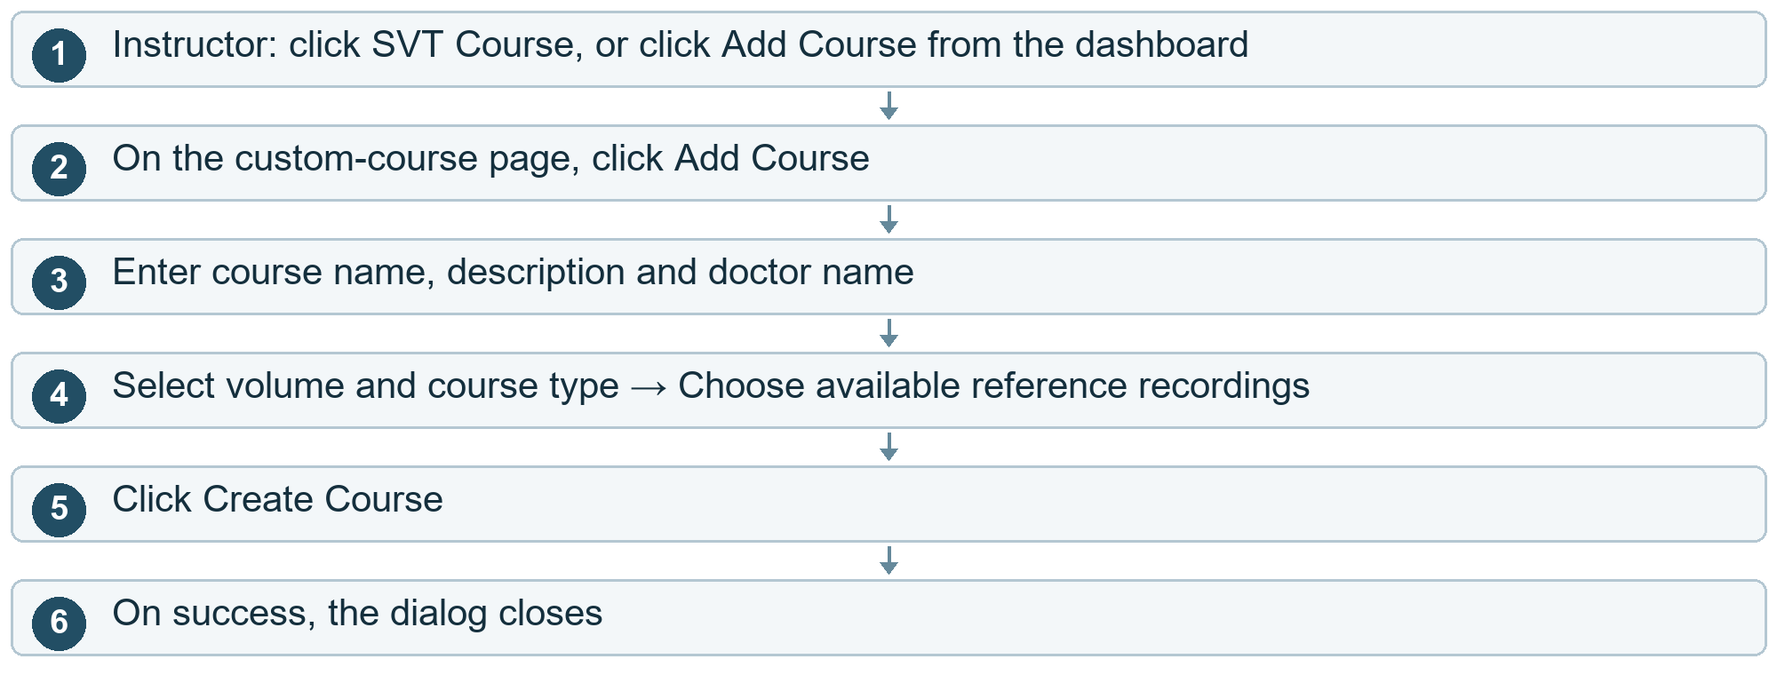

Other choices
After step 3 Start the form again. Click Clear.
After step 2 Cancel. Click X / outside the window.
After step 1 Return to dashboard. Click Back.
After step 5 Required details or volume trimester are missing. An error appears. Correct the form and retry.
Cloud cost here. Create Course stores the course mapping and metadata; existing volume files are reused.

Mapping and reattempts

43 Set reattempt options
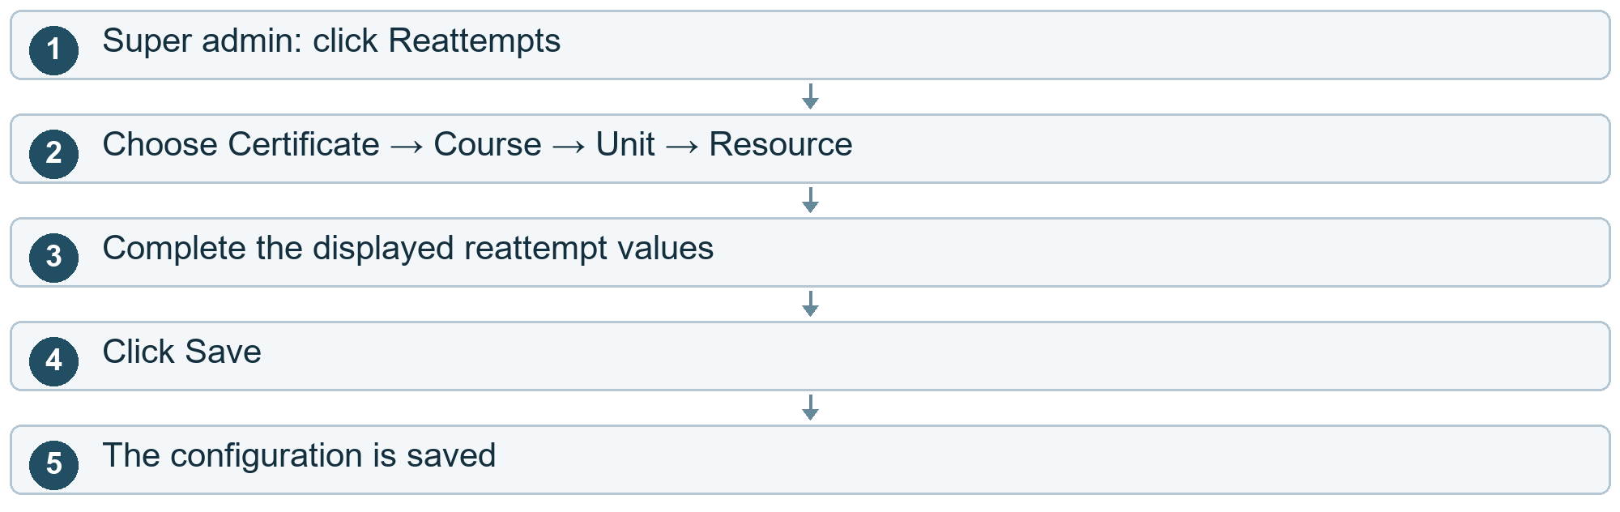

Other choices
After step 2 Reset the form. Click Clear.
After step 5 Find saved settings. Choose list filters → Apply or Refresh. Click Clear Filters to reset the list.
Cloud cost here. Save updates cloud configuration. Apply / Refresh reads existing configuration.

Trainee learning

44 Choose what to view in My Learning
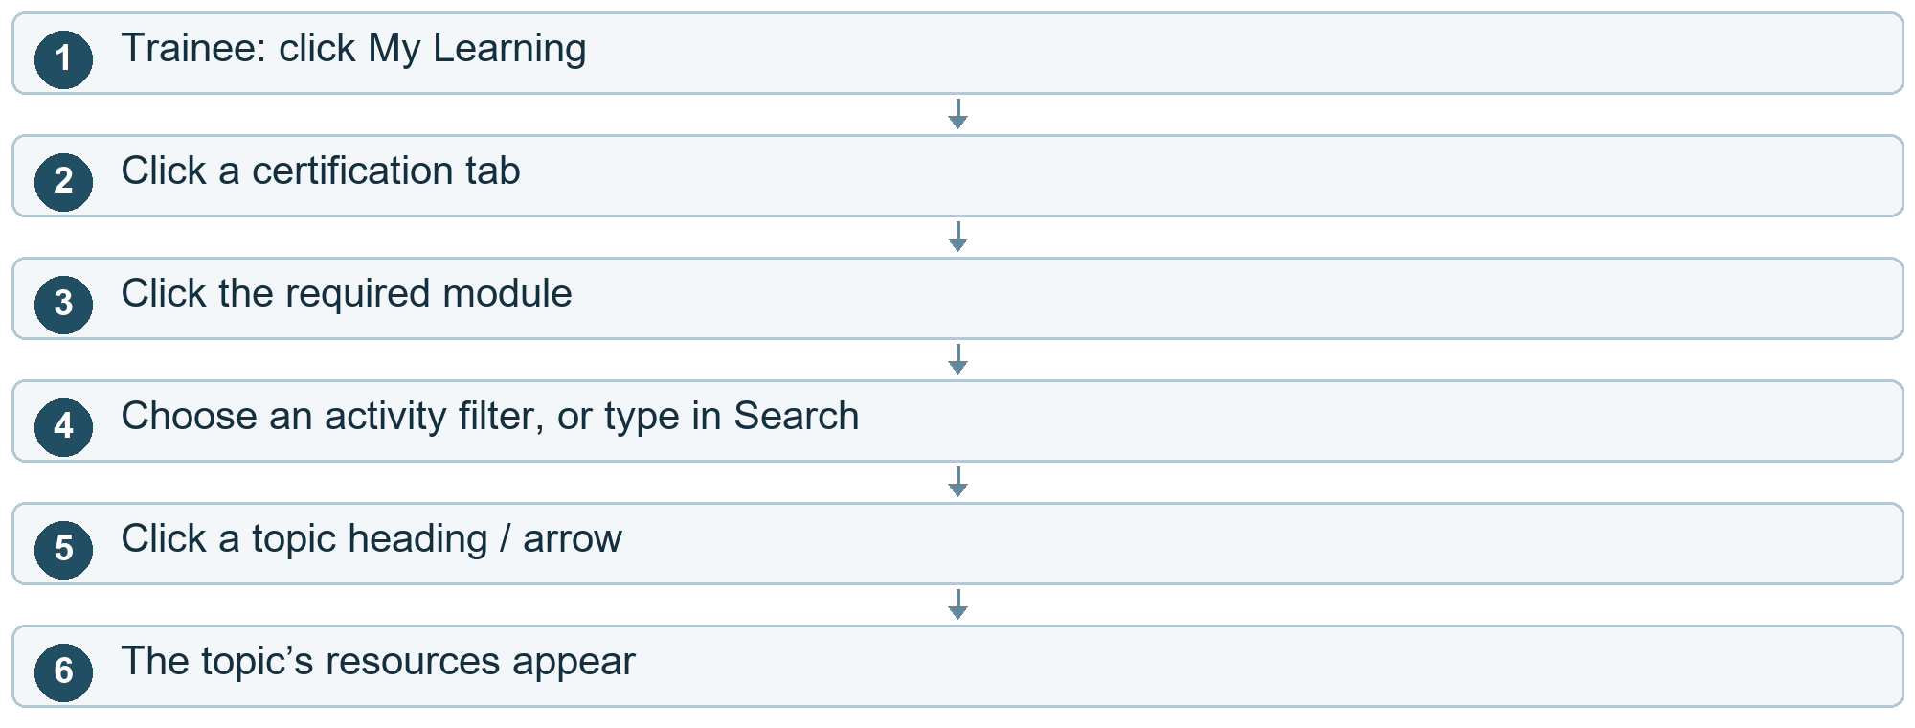

Other choices
After step 3 The module is locked. The current module stays selected.
After step 5 Hide the topic. Click the topic heading / arrow again.
Cloud cost here. The screen reads saved learning information. Most tab, filter and expand controls update the local view.

Trainee learning

45 View questions scores and attempt details
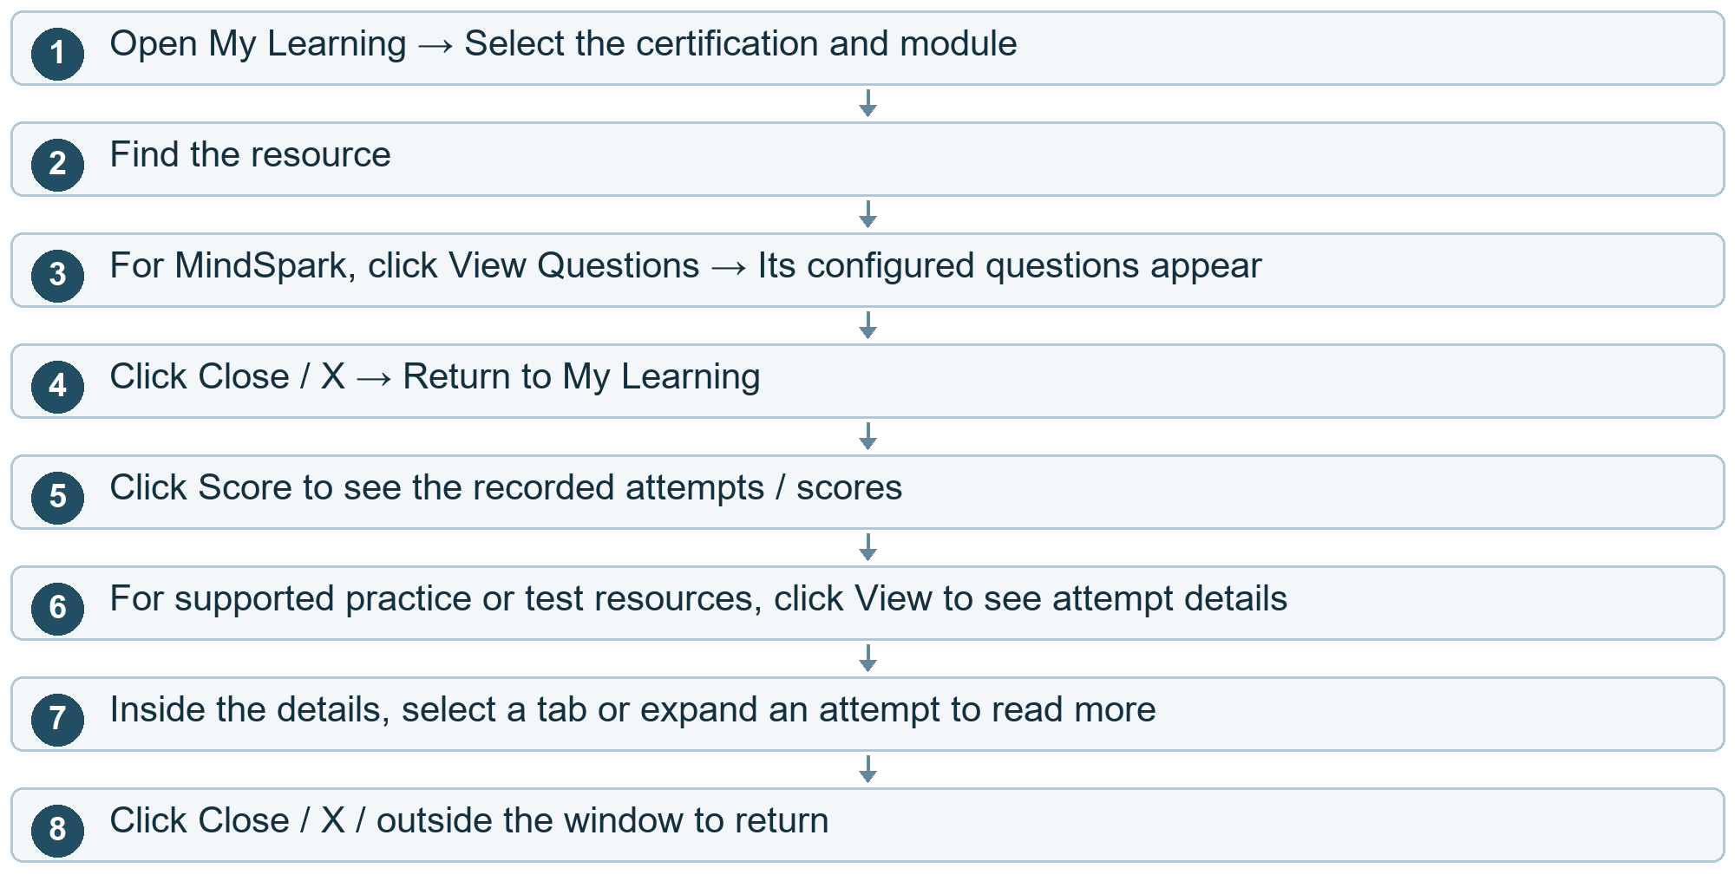

Other choices
After step 2 Image interpretation. Click the interpretation resource row → Its interpretation details appear.
After step 6 Open a submitted or reference image. Click View submitted image, User image or Expert image where shown.
Cloud cost here. Viewing attempts reads stored results. Opening an image can deliver a file from cloud storage, adding read / outbound-data usage.
Current project note. These controls display existing questions and results. They are not a web button to start the headset simulation.

Trainee learning

46 View progress
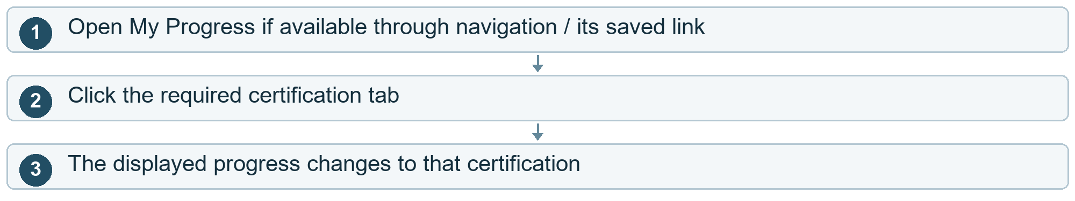
Cloud cost here. Progress data is read from the cloud. Tab selection may reuse information already loaded.
Current project note. My Progress has a registered screen, but is not shown in the current trainee sidebar.

Trainee learning

47 Send and manage a query
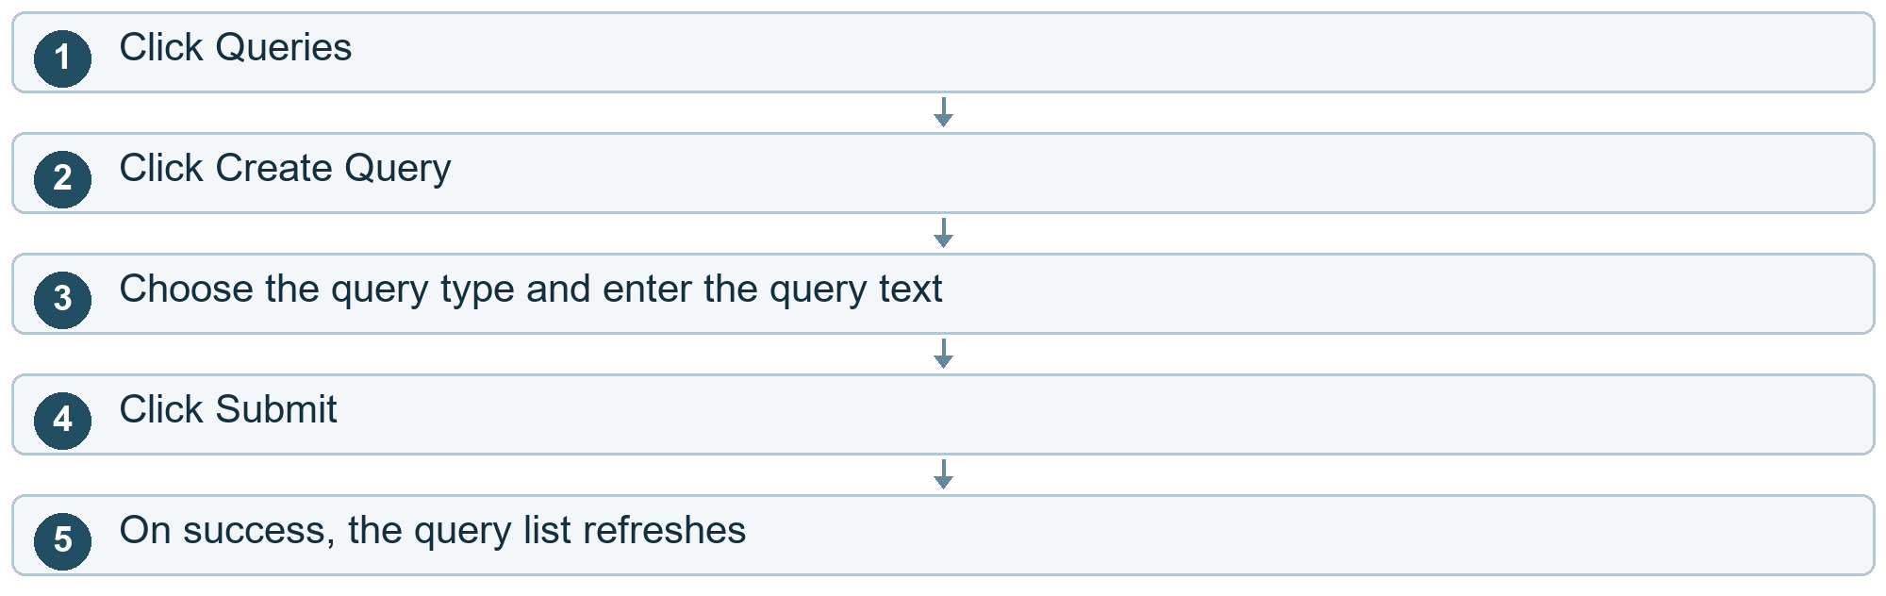

Other choices
After step 2 Cancel. Click X / outside the dialog.
After step 5 Mark a query resolved, where permitted. Open its row menu → Click Mark as Resolved.
After step 5 Delete a query, where permitted. Open its row menu → Click Delete.
After step 5 Click View in the current query menu. Only the menu closes; a query-detail screen is not opened by this handler.
Cloud cost here. Submit, Resolve and Delete change saved query information.

Headset and live view

48 Watch your own headset stream
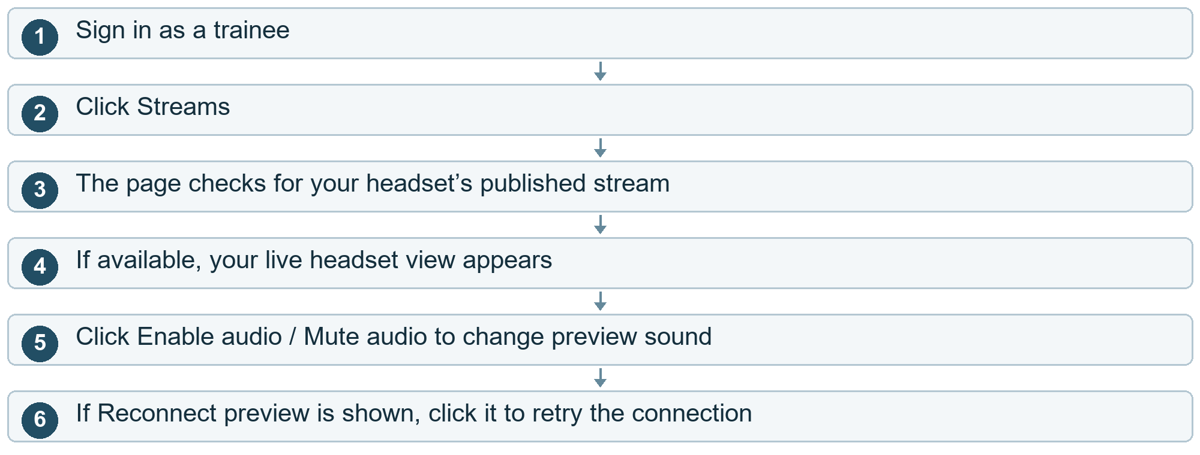

Other choices
After step 3 Headset is not publishing. A waiting / unavailable message appears. Start publishing on the headset using its own controls.
Cloud cost here. While connected: live-video participant time is billed. India’s first-tier video rate is $0.092 per connected participant-hour. The headset publisher and browser viewer each add connection time.
Current project note. The exact headset clicks to start publishing cannot be confirmed without the Unity/headset project.

Headset and live view

49 Admin watches a trainee s headset
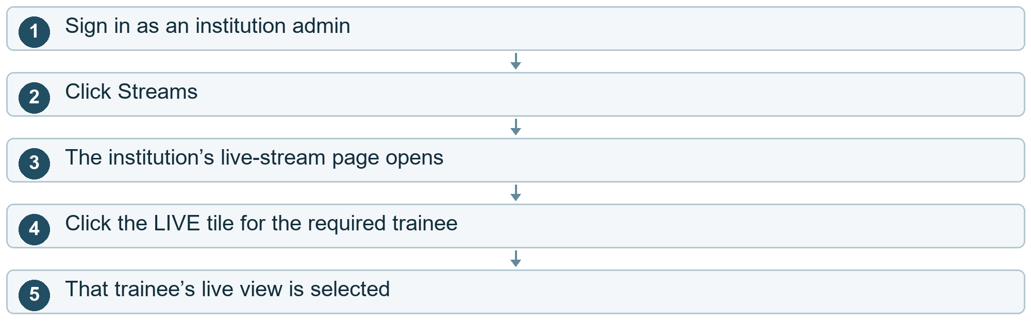
Cloud cost here. While viewing: live participant time is billed. The trainee’s stream is also copied to the institution’s live stage; that usage must be included when calculating the full cloud bill.
Current project note. Live viewing does not automatically mean the video is saved as a recording.

Headset and live view

50 Where headset files and results travel
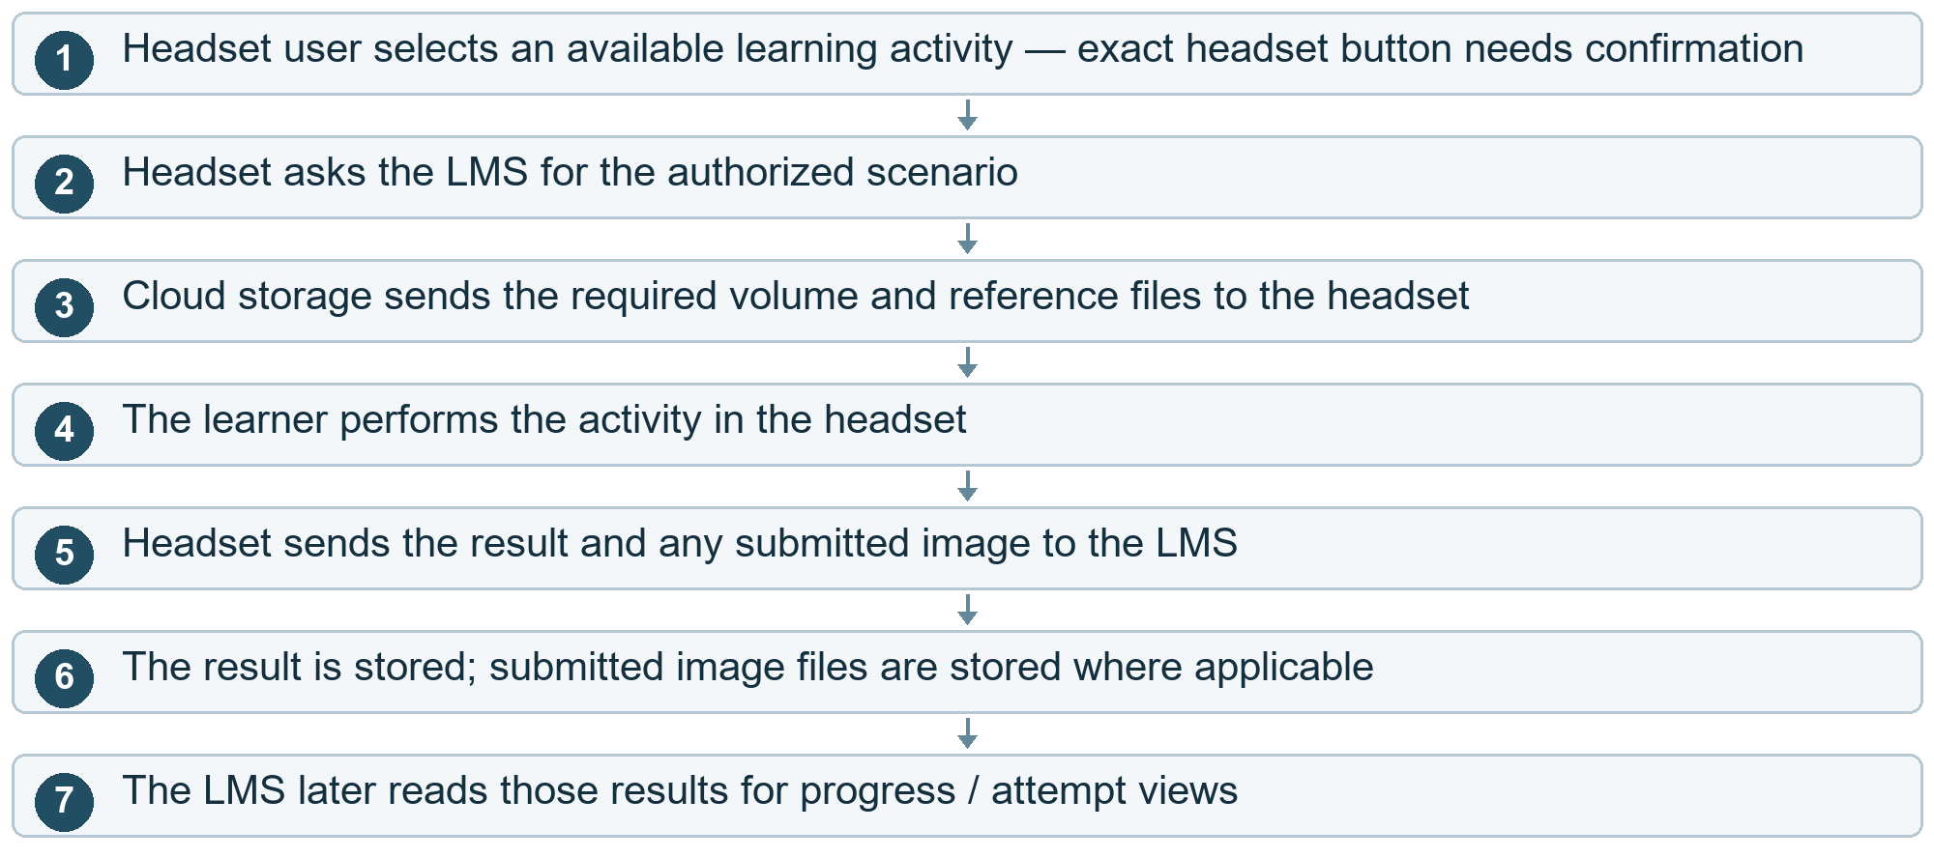
Cloud cost here. At download: file reads and delivered data. At submission: server/database usage and image storage. During live viewing: separate live-participant charges.
Current project note. This shows the data journey. The local project does not establish every screen or button inside the headset.

Device sessions

51 Log out a device
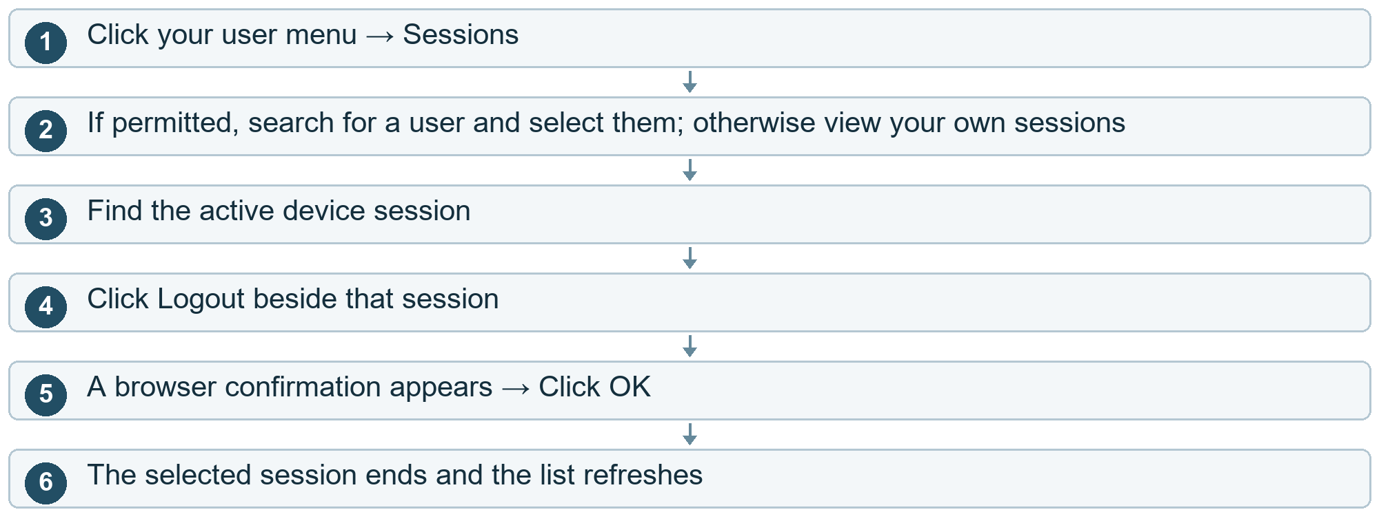

Other choices
After step 5 Click Cancel. The session stays active.
After step 6 You ended your current session. The Login screen opens.
After step 3 Log out every session instead. Click Logout all sessions → Confirm OK. Click Cancel to keep them.
Cloud cost here. Confirmation updates saved login sessions. A background session check also runs regularly while the app is open.

Institutions and reports

52 Onboard a scan center
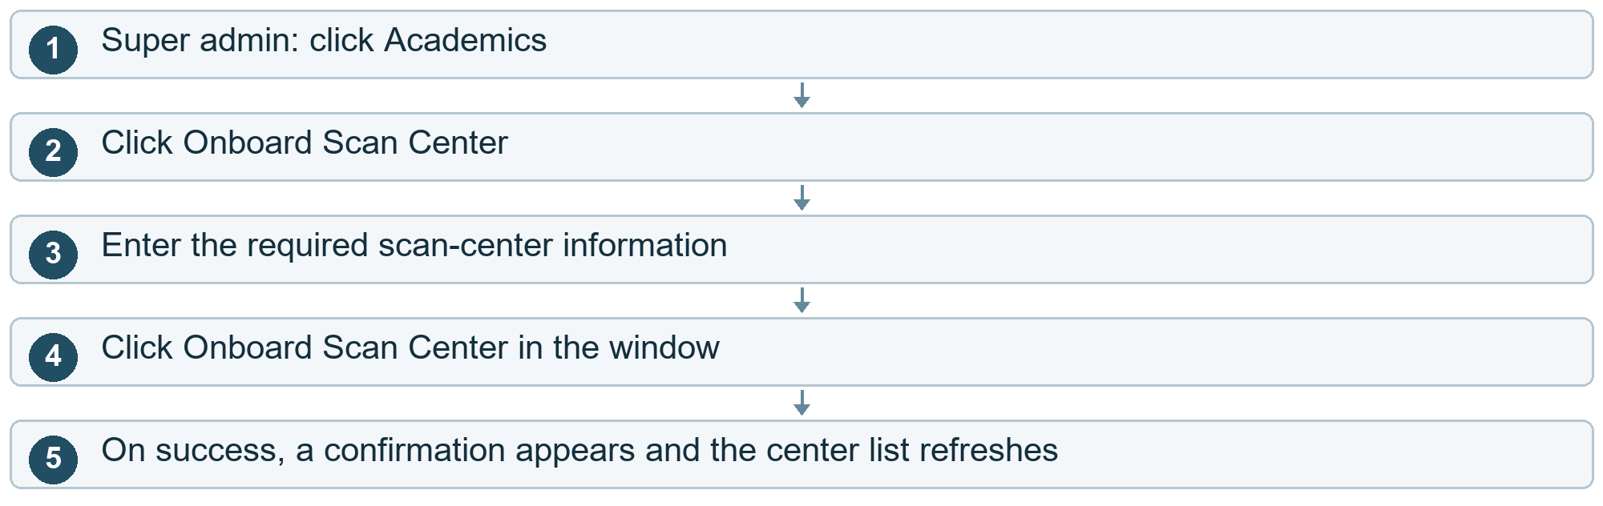

Other choices
After step 2 Cancel. Click Cancel / X.
After step 4 Information is missing / the request fails. An error appears. Correct the form and try again.
Cloud cost here. At Onboard: institution/account data is saved. Configured account notifications can add delivery costs.

Institutions and reports

53 Filter or inspect scan center actions
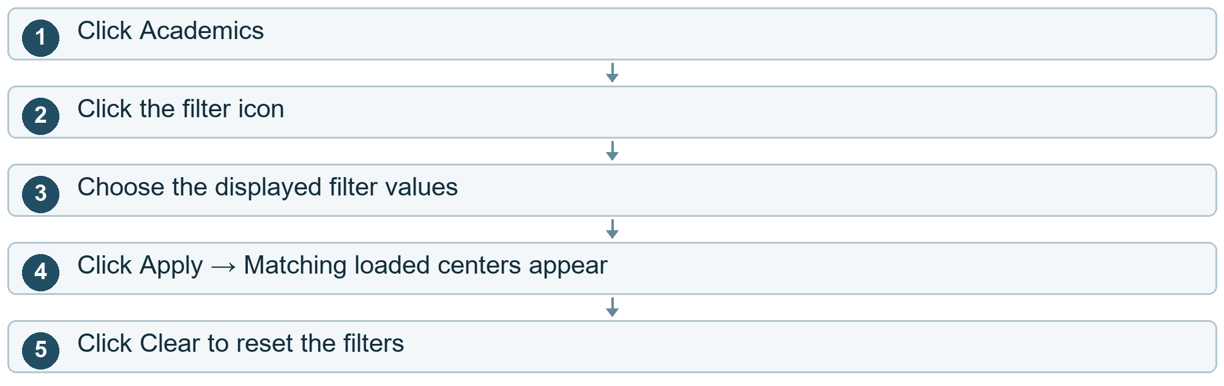

Other choices
After step 2 Close the filter. Click X / close.
After step 1 Row menu → View Details. Current action does not open a detail page.
After step 1 Row menu → Edit. An edit window opens. Update currently lacks an active cloud-saving call.
After step 1 Row menu → Delete. A confirmation appears. The current delete action lacks an active cloud-delete call.
Cloud cost here. Filtering the already-loaded centers is local. The unfinished edit/delete controls do not establish a saved cloud change.
Current project note. A success message from the unfinished controls should not be treated as proof that a center was changed or deleted.

Institutions and reports

54 Reports screen
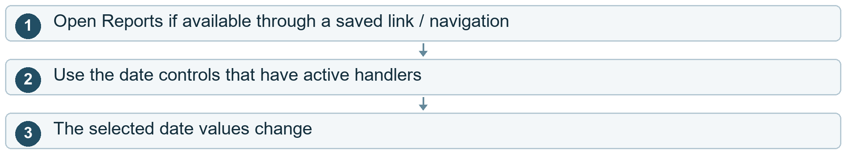
Cloud cost here. Opening reports may read saved information.
Current project note. Some visible report/filter buttons have no connected action. A working report-generation flow cannot be claimed from those buttons.

Cloud pricing reference
Amazon IVS pricing: https://aws.amazon.com/ivs/pricing/
The live-video example uses the India first-tier rate of USD 0.092 per connected participant-hour. The full bill also depends on replication, other cloud resources, applicable tiers, allowances, discounts and taxes.
Storage charges depend on average retained file size and storage duration. Download charges depend on file requests and delivered data. Conversion charges depend on computer resources and running time. Database, server and notification charges depend on the selected provider plans and actual usage.

