COSC2006 – Final Exam Study Guide – F20

The following is a list of possible short-answer questions for the upcoming Final Exam. Some of these will appear on the Final Exam – although slight changes may be made to the final question.

Chapter 1:

This chapter covered the fundamentals of the Java programming language. It should mostly be a review of material from COSC1046 and COSC1047. The fundamental principles of the Java language along with a good understanding of inheritance, polymorphism, interfaces, abstract classes, super/this, and access modifiers are required.

https://quizlet.com/344748707/carrano-chapter-2-flash-cards/

https://quizlet.com/344658539/carrano-chapter-1-flash-cards/

Chapter 2:

- What are the nine phases of the software life cycle? Briefly describe each.
  - Phase 1: Specification: specified the problems and prototype program.
  - Phase 2: Design: select the optimum modules, interface, method
  - Phase 3: Risk Analysis: to identify risk and then manage them.
  - Phase 4: Verification: to prove the algorithm with formal methods.
  - Phase 5: Coding: %10 part. Create the program with programing language.
  - Phase 6: Testing: testing the program with valid, invalid, random data etc.
  - Phase 7: Refining the Solution: to improve the program
  - Phase 8: Production: use by user.
  - Phase 9: Maintenance: getting better program for users. Avoid the extra problems and expenses.

- What is a loop invariant?
- a condition that is true for every iteration of a loop

- What is the benefit of procedural abstraction?
- Separate what the procedure does from implementation of the procedure so it is easier to use

- What is meant by information hiding?
- Making data private so that other modules can only access data using specified methods (getters/setters)

- What are the three principles of object-oriented programming?
Encapsulation, inheritance, polymorphism

- What are some ways of finding logic errors?
With Debugging. Debugging tools ‘watches, break points, System.out.print, and Dump method.’

- What is meant by procedural abstraction?
Separates the purpose of a method from its implementation

- What are the four parts necessary to proving that a loop is correctly implemented?
before the loop starts
Before every iteration
After every iteration
After the loop

- In a UML diagram, what does it mean if there is an arrow pointing from class A to class B?
Inheritance

- There are two important features of fail-safe programming. Name one of these features.
- A program that will perform reasonably no matter what the user inputs

Chapter 3:

- What is a base case?
- special case in a recursive function that will stop the function when satisfied

- What are the four questions that must be considered when constructing a recursive solution?
  - How can you define in smaller problem?
  - How does each recursive call make the problem smaller?
  - What is the base case?
  - Will you reach the base case?

- What is a recurrence relation?
- A reoccurring relation that can be solved when given one or more initial terms

- What is an activation record?
- A stack frame that contains: the methods local variables, method arguments, return address of method call, current value of method

- What elements are included in a method’s local environment?
- the methods local variables, method arguments, return address of method call, current value of method

- What are the two factors which contribute to the inefficiency of some recursive solutions?
- Overhead associated with method calls
- Inherent efficiency of recursive algorithms

- What is a tail-recursive method?
- the recursive method where the last step of method call is a call to itself

- Why do some compilers automatically replace tail recursion with iteration?
- b/c they can make recusive method calls more efficient by not creating a new stack frame for each call

- Suppose a program contains a recursive method findFibonacci(int n), which computes the n-th Fibonacci number. Even if we know that a client method will never call findFibonacci( ) with the values 1 or 2 as arguments, why does the implementation of findFibonacci( ) still need to have base cases?
- Because the first couple terms of the Fibonacci series do not follow the pattern of the rest. 0 is not the sum of the two previous values and neither is 1. That is why the base cases need to be hardcoded.

The recursive method needs a base case otherwise it calls itself to forever with an incorrect answer. These fib(0) and fib (1) are base case for the Fibonacci recursive method.

https://quizlet.com/344790742/carrano-chapter-3-flash-cards/

COSC2006 – Final Exam Study Guide – F20

Chapter 4:
Procedural abstraction make all happen inside module
Information hiding make data private only module can access it.

- What are some of the benefits of modularity?
  - Easier to write read and modify

- What are the three types of operations on data?
  - To add data
  - To remove data
  - Ask questions about data

- What is data abstraction?
- Only care about what not how, in other words, don’t worry about implementation details

- What is an abstract data type (ADT)?
- collection of data with operations on the data

- What is a data structure?
- A construct used to store data (queues, stacks, trees, linked list), each one has unique advantages and disadvantages

- What is an axiom?
- A mathematical proposition that should be true if the method is implemented properly

- When is a compiler-generated default constructor created?
- When you don’t specify a constructor yourself

- What are exceptions used for?
- Used to indicate that an error has occurred

- How do checked exceptions and runtime exceptions differ in the way that they are handled?
- Checked exceptions are serious and must be handled, runtime exceptions are more like warnings and don’t need to be handled

- What is the difference between the physical size and the logical size of an array?
- Physical size = capacity
- Logical size = current size

- What feature of Java allows you to enforce information hiding when you define a class such as an ADT?
- Private data members
- Public getters and setters

https://quizlet.com/344802192/carrano-chapter-4-flash-cards/#:~:text=What%20feature%20of%20Java%20allows,as%20private%20instead%20of%20public

Chapter 5

- What is the difference between a linked list and an array in terms of their capacity to store data?
- Arrays have a fixed maximum size
- A reference based linked list will have unlimited storage (or as much as computer will allow)

- What information is stored in a reference to an object?
- Location of object

- What does a node of a linear linked list contain?
- Item (or a value) and reference to next node

- What does a traversal operation do?
- It iterates through every item in a list

- When can a special case occur when inserting a new node into a linear linked list?
- A special case can occur when the list is full or empty

- When can a special case occur when deleting a node from a linear linked list?
- A special case can occur when the list is empty, or when deleting head/tail

- When can a special case occur when using the get() method to retrieve an item from a linear linked list?
- When the item you are searching for is not in the list

- What impact does using a dummy node have in terms of special cases?
- The use of a dummy node will remove all special cases

- What are the three high-level steps to insert a new node into a linear linked list?
- newNode = new Node(item);
- newNode.next = curr;
- prev.next = newNode;

- What are the three high-level steps to delete a node from a linear linked list?
- Prev.next = curr.next;

- What are two advantages of using a reference-based implementation of the ADT list instead of an array-based implementation?

- No need to shift after every insertion/deletion
- Unlimited capacity

- What are the advantages of using an array-based implementation instead of a reference-based implementation of the ADT list?
- Don’t need to traverse through every node to find a specific node
- Don’t need to carry the extra information of reference of next node

- What is the difference between a linear linked list and a circular linked list?
- The last node in a circular linked list will reference the first node, unlike in a linear linked list

- What is a dummy head node?
- A node that is always present in a linked list even if the list is empty

- Why is a loop necessary to find an arbitrary node in a linked list?
- Because the only way to find the item of every node is to traverse through the list

Arbitrary = random

Why do you need to loop through a linkedlist to find a random node, b/c you can’t see whats in the linkedlist unless you loop through it

Copyright © 2020 by Michael Lajoie, Sault Ste Marie, Ontario

All rights reserved. No part of this work may be reproduced or used in any form or by any means – graphic, electronic, or mechanical – without the

prior written permission of the author.
COSC2006 – Final Exam Study Guide – F20

Chapter 7

- What is meant by the last-in, first-out (LIFO) property as it relates to a stack?
- Similar to a pile of books, you can only access the last element on the stack

- What is meant by the first in, first out (FIFO) property as it relates to a queue?
- Similar to a line up at the bank, the first item placed in the queue will be the first item dequeued.

- What is the difference between the stack pop and peek operations?
- Pop removes the item, peek just shows you it.

- When does the push, pop and peek operations throw a StackException?
- When the stack is empty

- What is the advantage of an implementation of a stack that uses the ADT list over an implementation that uses a linked list?
- Simpler to write

- When implementing a stack using an array, where should you push and pop items? Why?
- You should push and pop from the end of the array. You can always pop at size-1, which is constant time. You can push at size which is constant.

- What are the three facts about converting from infix expressions to postfix expressions?

- Operands stay in same order
- Operator moves to right
- Brackets removed

- What are the factors which determine the placement of operators when an infix expression is converted to a postfix expression?
- Parentheses
- operator precedence
- left-to-right association.

- What is an exhaustive search?
- Brute force method of searching, search every possible combination.

- Stack question like: Suppose we begin with an empty stack, and perform the following operations: push 7, push 2, push 9, push 6, pop, pop, peek, push 1, push 3, peek, push 8, pop, peek, pop, pop, push 5, push 4, pop, pop, pop, push 8. What is contained on the stack when we are done? Write out the contents from top to bottom.

- 7 8 (so from top to bottom is 8 7)

- Why does the ADT stack not define a get( ) method?
- Because you can only access items from the top of the stack aka by using the pop method

Aka = also known as
Via = through
Kk = okay
Brb = be right back
G2g = got to go
Wsup = whats up

https://quizlet.com/345369428/carrano-chapter-7-flash-cards/#:~:text=1)%20What%20is%20meant%20by,first%20item%20removed%20from%20it.&text=Answer%3A%20The%20pop%20operation%20retrieves,the%20top%20of%20the%20stack.

https://quizlet.com/304036263/data-structure-ch-7-flash-cards/

Chapter 8

- What is the main difference between a stack and a queue?
- Stack = Lifo
- Queue = Fifo

- What is the action performed by the enqueue operation?
- Adds item to back of queue, throws exception if queue is full

- What is the action performed by the dequeue operation?
- Removes and returns item from front of queue, throws exception if queue is empty

- Define the problem of rightward drift in an array-based implementation of a queue.
- In a queue, if you don’t shift the items left after dequeuing, they will continuously approach the right towards the max-length of the array.
- Once they read the max-length of the array, the queue will appear full even though there are empty spaces towards the left.

- What is the advantage an implementation of a queue that uses the ADT list over an implementation that uses a linked list?
- Linkedlist = more efficient
- List = easier to write

- What are three examples of position-oriented ADT?
- List
- Stack
- Queue

- What is a deque?
- Subtype of a queue that allows for insertions and deletions at both ends.

- Give two examples of run-time errors or exceptions that may occur when we enqueue or dequeue.
- An exception can occur when enqueuing to a full queue or dequeuing from an empty queue.

-

- If an object is inserted into a queue, how soon can it be removed?
- It can be removed once any item in front of it is removed.

COSC2006 – Final Exam Study Guide – F20

Chapter 10

1) What two measurements are parts of a program’s efficiency?
- Time complexity and space complexity

- List the three factors which can cloud the comparison of algorithms performed by implementing the algorithms in Java (or some other high-level language) and running the programs.
- How the algorithm is coded
- What computer is being used
- The data given to the program

- What is measured by an algorithm’s growth rate?
- How much slower it gets as input increases
- How much more space it requires as input increases

- What is a growth-rate function?
- A function that specifies an algorithms order of magnitude as input grows

- What is determined by worst-case analysis?
- The cost of the algorithm in the worst-case scenario

- What is determined by average-case analysis?
- The cost of the algorithm in the average case senario

- When choosing between two algorithms, under what conditions can the efficiencies of the algorithms be ignored?
- When the space is irrelevant or when the input size is really small

- What is the sort key of a record?
- Sort key specifies the criteria used to perform the sort

- What is the drawback of the mergesort with respect to storage?
- Requires a temporary array that is equal in size with the input array

- How does the quicksort partition an array?
- Selects a pivot element
- Partitions array into two sub arrays, according to whether they are greater or less than pivot
- Recursively sorts the two sub arrays

- Questions about time Complexity Like: If an algorithm requires 2n³ + 17n² + 54n + 512 operations to perform, where n is the size of the input data, then we say the order of the algorithm is O(_____).
- BigO(n³)

- Suppose we wish to sort an array of 4-digit integers using radix sort. We will make four passes over the elements of the array. What occurs during the first pass?
- Start by organizing items from the last digit by placing them into buckets
- Use sorted items and compare from (last digit -1) then place into buckets
- Use sorted items and compare from (last digit – 2) then place into buckets
- Until you compare by (first digit) then you will have fully sorted array

Say you have some blocks. You know what it means to sort the blocks from smallest to biggest; just line them up in order.
Well, let's consider a different thing, which I'll call kinda sorting the blocks. I point out a specific block to you, and you have to put all the smaller blocks to its left and all the larger blocks to its right. Doesn't matter what the order is among those smaller/larger blocks, just that they're all on the correct side of the block I pointed out.
Quicksort works by kinda sorting, and then kinda sorting the left and right sides of that kinda sorted lineup, and so on and so forth. When you finish, the blocks will be actually sorted.
Why is this useful? Well, you can easily see how kinda sorting is easier than actual sorting. It turns out that for really big groups of blocks, kinda sorting is so much easier than actual sorting, even doing all those kinda sorts is easier than doing an actual sort in the way you'd think to do it.
From our pool of blocks, you pick an average block, not too big and not too small. Quicksort works best when you always pick the most average block. Picking is the key to the quicksort algorithm. You should always have the same number of blocks that are smaller and large than the middle block. It won’t always be perfect but the closer you get, the faster the algorithm.
When you are done sorting all the blocks to the left or to the right, you start again. You pick the most average block from the left side and you start to order the left half of the blocks again, you now now have two quarters and the right half, you then proceed to do the same on the right side.
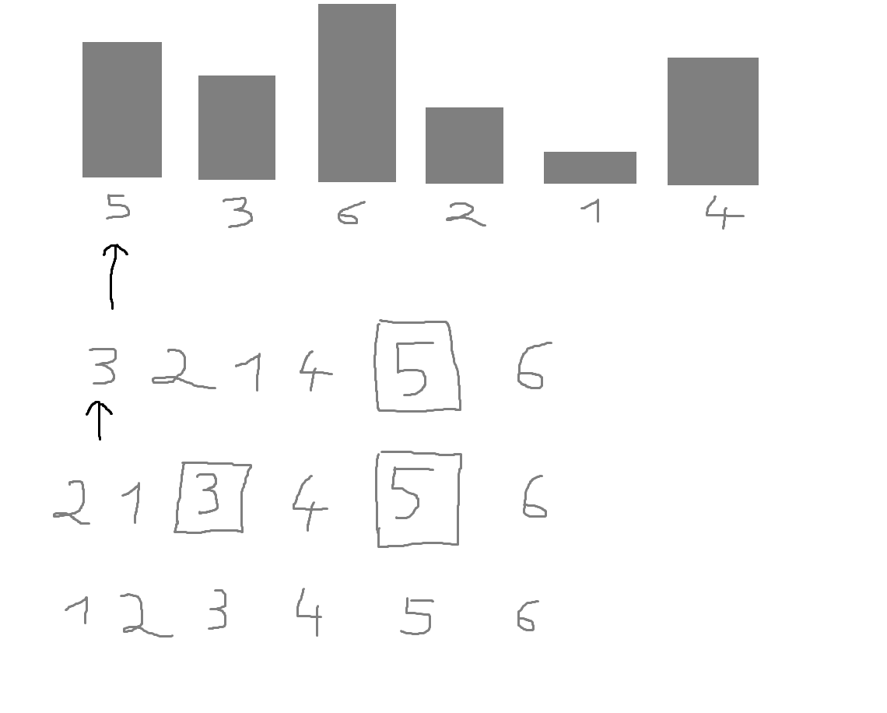
We have these 6 blocks. We don’t know the most average block for sure, so we just guess and pick the block with the size 5. This is now our pivot element. We put every blocks maller than 5 on the left side, and every block bigger on the right side. (We are now in the second row).
Then we take another guess for the left half of our blocks (3, 2, 1, 4). We guess it’s 3. We then again do the thing we are already good at, comparing and sorting. We take all the smaller elements than 3 and put them on the left, and every block bigger than three on the right side. (2, 1 is smaller) and (4, 5, 6 is larger).
We then have the order 2, 1, 3, 4, 5, 6. The right half only consists of one element: 6. Well I guess that half is already sorted then we go on to the next level: picking another “average” element and sorting. Since there is only (2, 1) are unsorted, it does not take very long.
Now simply by always divindg our lists and just sorting elements into the bigger and the smaller subtree, we achieve a much finer granularity with every level. When we are at the bottom (when you can’t divide anymore) we are at our goal, we sorted our list already.
lets take the set:
[5, 3, 4, 9, 1, 7]
First pick a random element of the set to be the pivot. Let's just pick the first one, 5. So now we have:
Pivot - 5, remaining set [3, 4, 9, 1, 7]
Now iterate through the set and compare them to the pivot. If they are "less than" the pivot, place them in one set, if they are "greater than" the pivot, place them in the other set. We should end up with this:
Less than [3, 4, 1], pivot - 5, greater than [9, 7].
From here we can see that all the elements are in place with respect to the pivot, 5. If we somehow sorted the "less than" and "greater than" sets, we could just merge all the sets together and the whole thing would be sorted. The trick is to sort those "less than" and "greater than" sets, and the way to do that is, of course, using quicksort! Let's sort the "less than" set first. So we have:
[3, 4, 1]
Let's pick the first element to be the pivot again, so we end up with:
pivot - 3, remaining set [4, 1]
repeating the comparison step from before we get:
less than [1], pivot - 3, greater than [4]
Now, we're in the same situation as before only one thing is different; the "less than" and "greater than" sets only have one element, and a one element set is automatically sorted! This is the base case of quicksort: performing quick sort on a one element set (or an empty set) just returns the set. So now all we have to do is merge the three sets together and it's sorted. We end up with:
[1, 3, 4]
Now we go back to where we were before, only now we have the "less than" set already sorted. So we're here:
Less than [1, 3, 4], pivot - 5, greater than [9, 7]
Now we just have to sort that greater than set, once again using quicksort and selecting the first element as the pivot we get:
less than [7], pivot - 9, greater than []
The less than set and greater than set each have 1 or less elements so they're already sorted and we can just merge them together! We get:
[7, 9]
Bringing this sorted set back to where we started we get
less than [1, 3, 4], pivot - 5, greater than [7, 9]
Now the less than and greater than sets are sorted and we can just merge the whole thing together! We get:
[1, 3, 4, 5, 7, 9]
and we're done.
__________________
MergeSort
Mergesort is the "general case" sorting method that provides a guaranteed (deterministic) performance bound that is theoretically optimal. It's also very easy to implement.
mergesort(list):
is list.length == 1?
return list
return combine(mergesort(lefthalf(list)), mergesort(righthalf(list)))
Basically split a list of objects in two. Mergesort those two lists. Combine the two lists in sorted order. To do the combine, you just keep looking at the first element of each list and taking out the "lowest" one and putting onto the end of your combine result.
The strength of mergesort is how general it is, and how deterministic it is. It does not assume anything about the elements in the list, except that they can be compared to each other, and it ALWAYS takes O(N logN) time to execute, no matter the list.
You can compare it to Radixsort, which is much faster than mergesort, but only works on integers, because the optimization in performance comes at the cost of generality. It has to assume the elements are integers.

