TABLE OF CONTENTS

- INTRODUCTION
  - Scope
  - Objective
  - Project Overview
  - Existing Systems
1.4.1 Disadvantages
  - Proposed Systems Confidentiality
    - Authentication
    - Integrity
    - Non-Repudiation

- APPROACH
  - DSS Approach
  - RSA Approach
  - Disadvantages Of RSA Over DSA
  - Secure Hash Algorithm (SHA-1)

- SYSTEM REQUIREMENTS
  - Hardware Requirements
  - Software Requirements

- PROJECT DESIGN
  - Description About Data flow Diagrams
  - Analysis Of Data Flow Diagrams
  - Data Flow Diagrams

5. 0 CODE AND IMPLEMENTATION
  - Java API Used For Connectivity
    - Packages Used In Connectivity
    - Classes Used In Connectivity
    - Interfaces
    - About Java
    - Features of Java
    - About JDBC
    - Java Database connectivity
    - About Oracle
    - About Structured Query language

6.0 SCREEN SHOTS
  - Home page
    - Introduction
    - login
    - Registration

6.2 Login page as administrator
6.2.1 Login as administrator
6.2.2 Delete or Create
6.2.3 Register New User
6.2.4 Delete Existing User’s
6.2.5 Username Deleted

  - Login as sender
    - If Write
    - Message
    - Signing
    - Encrypt Message

6.4 Login as receiver
6.4.1 If Read
6.4.2 Decryption
6.4.3 Verifying
6.4.4 Original message

- SYSTEM TESTING
  - Compilation Test
  - Execution Test
  - Output Test

- FUTURE ENHANCEMENTS

- CONCLUSION

10.0 BIBLIOGRAPHY

1. INTRODUCTION
Scope
The project is confined to the intranet in an organization. This application makes sure that security services such as secrecy, authentication, integrity and non-repudiation are provided to the communicating parties.
Objective
This project has been developed keeping in view the security features that need to be implemented in the networks following the fulfillment of these objectives:

- To develop an application that deals with the security threats that arise in the network.
- To enable the end-users as well as the organizations come out with a safe messaging communication without any threats from intruders or unauthorized people.
- To deal with the four inter-related areas of network security namely Secrecy, Authentication, Non-repudiation and Integrity.
Project Overview
This application makes use of Digital Signature Algorithm (DSA) along with a hash function. The hash code is provided as input to a signature function along with a random number generated for this particular signature. The signature function also depends on the sender’s private key and a set of parameters known to a group of communicating principals. This set constitutes a global public key. The result is a signature consisting of two components.

At the receiving end, verification is performed. The receiver generates a quantity that is a function of the public-key components, the sender’s public key, and the hash code of the incoming message. If this quantity matches with one of the components of the signature, then the signature is validated.
This application makes sure that the security services Authentication, Secrecy, Integrity, and Non-repudiation are provided to the user.
- This application allows to keep the information out of the hands of unauthorized persons. This is called Secrecy.
- It also deals with determining whom a person is communicating with before revealing sensitive information or entering a business deal. This is called Authentication.
- Non-repudiation deals with proving that a particular message was sent by a particular person in case he denies it later.
- Integrity makes sure whether a particular message has been modified or something has been added to it. He project mainly deals with maintenance of the above mentioned security services thereby allowing the users as well as the network organizations to keep track of intrusions and thus enhancing the security services.

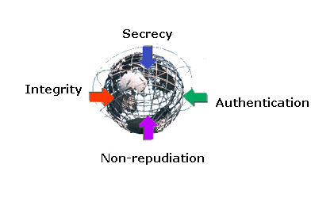

Existing system
These days almost all organizations around the globe use a messaging system to transfer data among their employees through their exclusive intranet. But the security provided is not of high standards. More and more unauthorized people are gaining access to confidential data.

Disadvantages:
- The validity of sender is not known.
- The sender may deny sending a message that he/she has actually sent and similarly the receiver may deny the receipt that he/she has actually received.
- Unauthorized people can gain access to classified data.
- Intruders can modify the messages or the receiver himself may modify the message and claim that the sender has sent it.
Proposed system
The system will provide the following security services:
Confidentiality:
Confidentiality is the protection of transmitted data from passive attacks. With respect to the release of message contents, several levels of protection can be identified. The broadest service protects all user data transmitted between two users over a period of time. For example, if a virtual circuit is set up between two systems, this broad protection would prevent the release of any user data transmitted over the virtual circuit. Narrower forms of this service can also be defined, including the protection of a single message or even specific fields within a message. These refinements are less useful than the broad approach and may even be more complex and expensive to implement. The other aspect of confidentiality is the protection of traffic flow from analysis. This requires that an attacker not be able to observe the source and destination, frequency, length, or other characteristics of the traffic on a communications facility.

Authentication:
The authentication service is concerned with assuring that a communication is authentic. In the case of a single message, such as a warning or alarm signal, the function of the authentication service is to assure the recipient that the message is from the source that it claims to be from. In the case of an ongoing interaction, such as the connection of a terminal to a host, two aspects are involved. First, at the time of connection initiation, the service assures that the two entities are authentic (i.e. that each is the entity that it claims to be). Second, the service must assure that the connection is not interfered with in such a way that a third party can masquerade as one of the two legitimate parties for the purposes of unauthorized transmission or reception.
Integrity:
Integrity basically means ensuring that the data messages are not modified. An integrity service that deals with a stream of messages assures that messages are received as sent, with no duplication, insertion, modification, reordering or replays. The destruction of data is also covered under this service. Thus the integrity service addresses both message modification and denial of service.
Non-repudiation:
Non-repudiation prevents either sender or receiver from denying a transmitted message. Thus, when a message is sent, the receiver can prove that the message was in fact sent by the alleged sender. Similarly, when a message is received, the sender can prove that the message was in fact received by the alleged receiver.

DIGITAL SIGNATURES

Message authentication protects two parties who exchange messages from any third party. However, it does not protect the two parties against each other. Several forms of disputes between the two parties are possible.

For example, suppose that A sends an authenticated message to B. Consider the following disputes that could arise:
- B may forge a different message and claim that it came from A. B would simply have to create a message and append an authentication code using the key that A and B share.
- A may deny sending the message. Because it is possible for B to forge a message, there is no way to prove that A did in fact send the message.

The most attractive solution to this problem is the Digital Signature. The Digital Signature is analogous to the handwritten signature. It must have the following properties:

  - It must be able to verify the author and the date and time of the signature.
  - It must be able to authenticate the contents at the time of the signature.
  - The signature must be verified by third parties, to resolve disputes.

Thus, the digital signature function includes the authentication function.
Based on the above properties, the following requirements can be formulated for the digital signatures:
- The signature must be a bit pattern that depends on the message being signed.
- The signature must use some information unique to the
sender, to prevent both forgery and denial.
- It must be relatively easy to produce the digital signature.
- It must be relatively easy to recognize and verify the digital signature.
- It must be computationally infeasible to forge a digital signature, either by constructing a new message for an existing digital signature or by constructing a fraudulent digital signature for a given message.
- It must be practical to retain a copy of the digital signature in storage.
A secure hash function, embedded properly in a scheme satisfies these requirements.

2.0 APPROACH
There are two approaches to implement digital signatures:
- DSS approach
- RSA approach

The Digital Signature Standard (DSS) makes use of the Secure Hash Algorithm (SHA) to present a new digital signature technique, the Digital Signature Algorithm (DSA).It uses an algorithm that is designed to provide only the digital signature function. Unlike RSA, it cannot be used for encryption or Key exchange. Nevertheless, it is a public-key technique.

RSA Approach

In the RSA approach, the message to be signed is input to a hash function that produces a secure hash code of fixed length. This hash code is then encrypted using the sender’s private key to form the signature. Both the message and the signature are then transmitted. The recipient takes the message and produces a hash code. The recipient also decrypts the signature using the sender’s public key. If the calculated hash code matches the decrypted signature, the signature is accepted as valid. Because only the sender knows the private key, only the sender could have produced a valid signature.

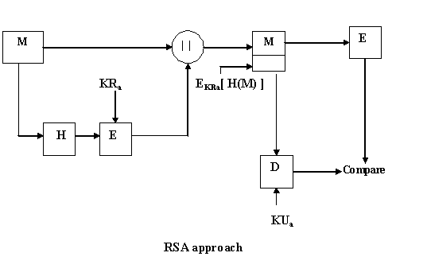

Where

M = Message
H = Hash Function
E = Message Digest at the Sender’s side
D = Message Digest at the Receiver’s side
KR_{a} = Sender’s Private Key
KU_{a} = Sender’s Public Key

DSS Approach

The Digital Signature Standard approach also makes use of a hash function. The hash code is provided as input to a signature function along with a random number generated for this particular signature. The signature function also depends on the sender’s private key and a set of parameters known to a group of communicating principals. This set constitutes a global public key. The result is a signature consisting of two components.

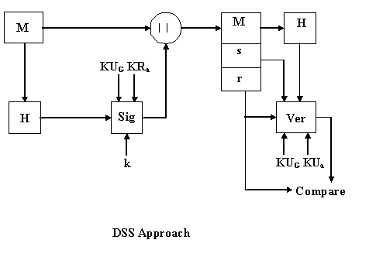

Where

M = Message
H = Hash Function

SYSTEM REQUIREMENTS

  - Hardware Requirements
      - Hard disk: - 40GB
      - RAM: - 512MB
      - Processor: - p4
      - Multimedia Key Board
      - LG Monitor

  - Software Requirements
      - Operating Systems: WINDOWS NT 4 / 2000 / XP
      - Technologies Used: Java, jdbc, jsp
      - Application Server: Apache Tomcat
      - Front End: html,jsp
      - Back End: Oracle 9.i

DATA FLOW DIAGRAMS

-

The DFD is a simple graphical notation that can be used to represent a system in terms of the input data to the system, various processing carried out on these data, and the output data generated by the system.

PRIMITIVE SYMBOLS FOR CONSTRUCTING DFD’S:-

There are essentially five different types of symbols used to construct DFD’s.
- Function Symbol
- External Entity
- Dataflow Symbol
- Data Store Symbol
- Output

Function Symbol:-

A function is represented using a CIRCLE. This symbol is called a PROCESS or a BUBBLE. Bubbles are annotated with the names of the corresponding function

Process
External Entity:-

A RECTANGLE represents an external entity. External entities are those physical entities which are external to the software system and interact with the system by inputting data to the system or by consuming the data produced by the system.

External Entity
Dataflow Symbol:-

A directed ARC or an ARROW is used as a dataflow symbol. A dataflow symbol represents the data flow occurring between two Processes or between an External Entity and a Process in the direction of the data flow arrow.

Dataflow

Data Store Symbol:-

OPEN BOXES are used to represent data stores. A data store represents a logical file, a data structure or a physical file on disk. Each data store is connected to a process by means of a data flow symbol. The direction of the data flow arrow shows whether data is being read from or written into a data store.

Data store

Output:-

This BOX represents data production during human computer interaction.

Output

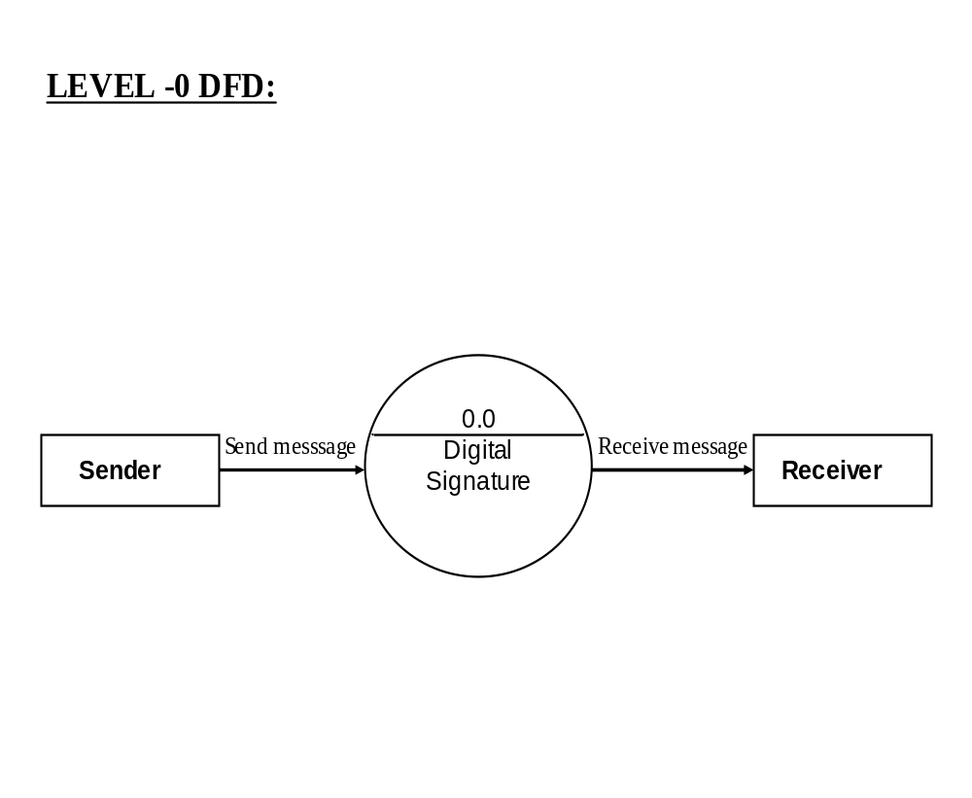

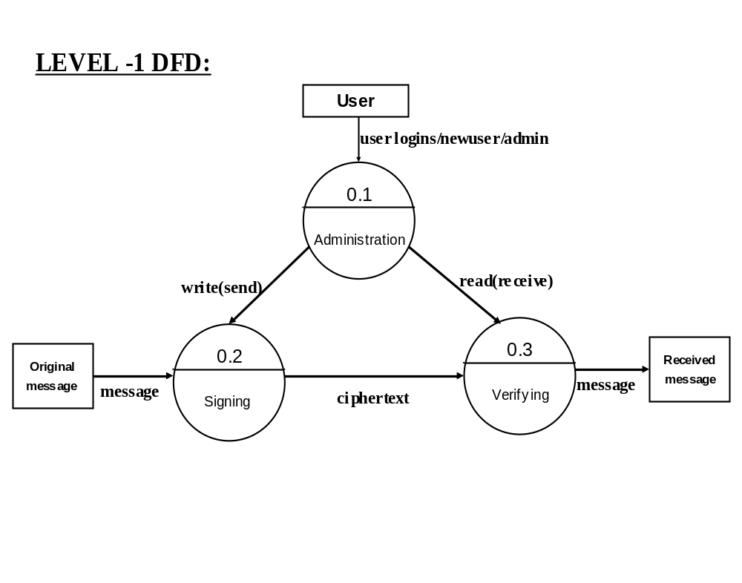

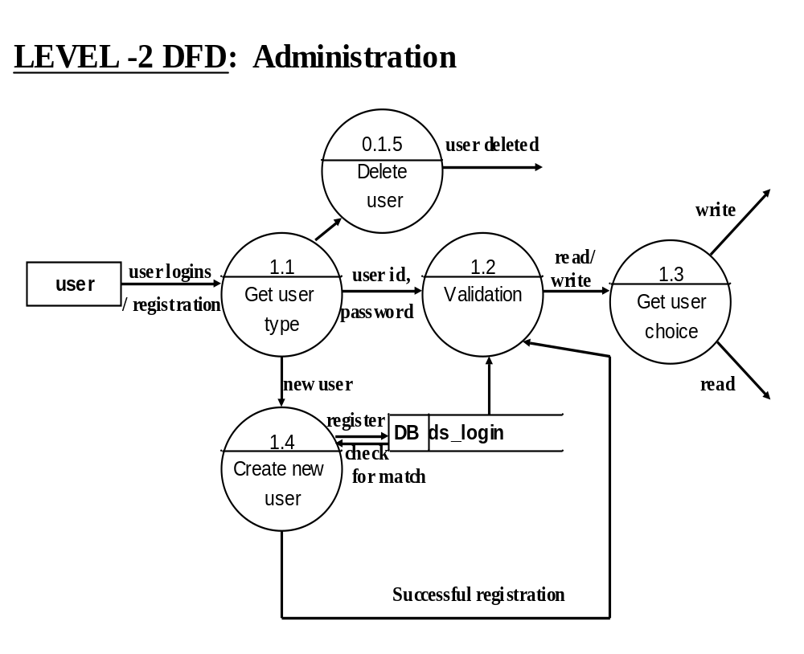

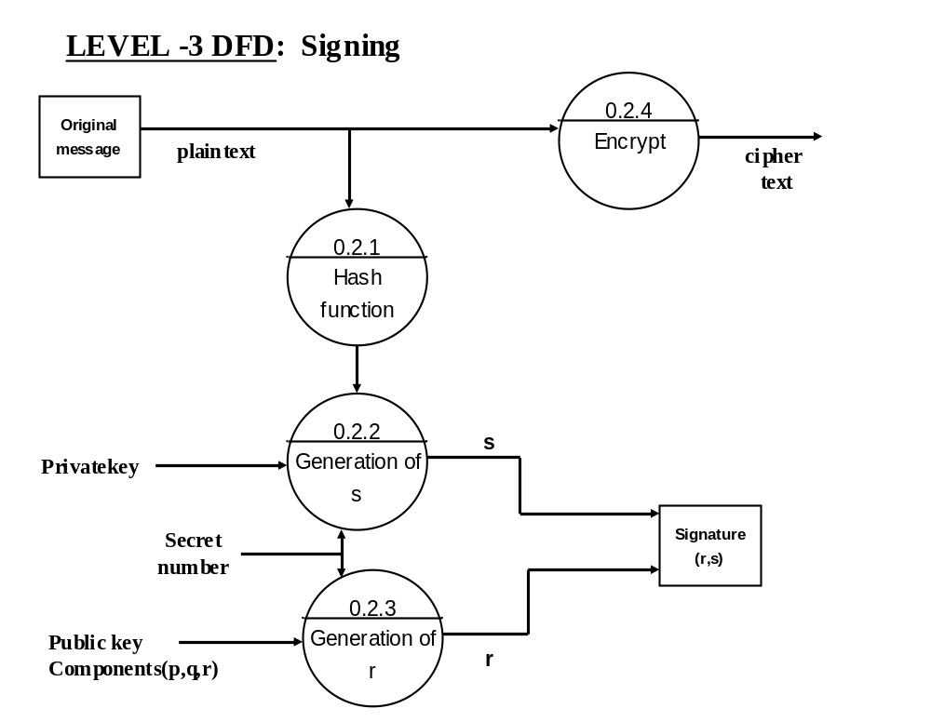
\

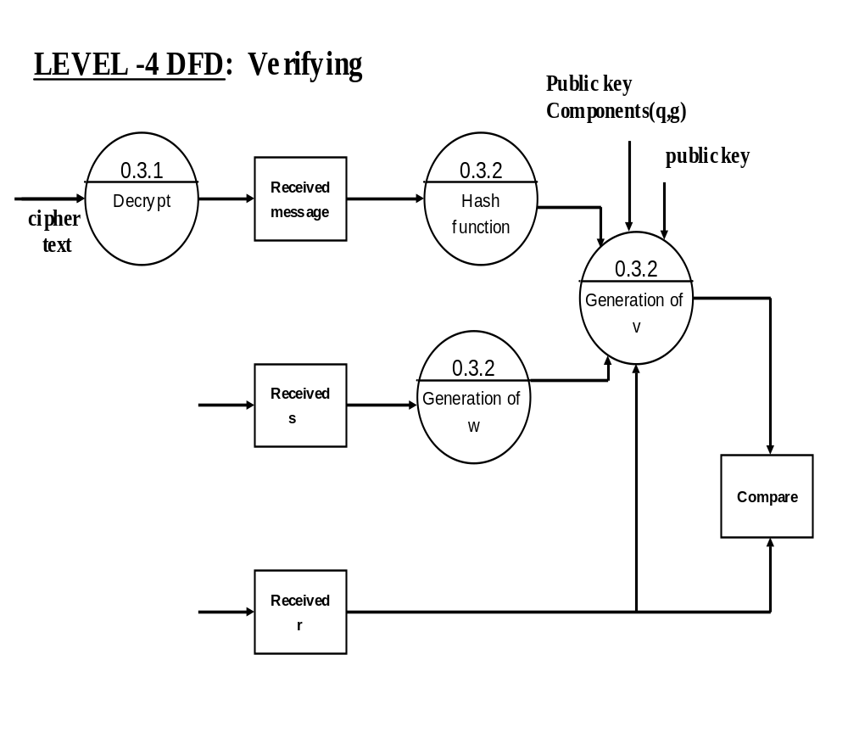

- CODE AND IMPLEMENTATION

  - Java API Used For JDBC Connectivity

    - Packages Used In Connectivity

java.io.*
java.security.*
javax.crypto.*
javax.crypto.spec.*

    - Interfaces

Statement
Prepared Statement
Connection
Result Set

ABOUT JAVA

Now-a-days all are familiar with Internet, the worldwide network

Computers, connects together thousand of computer all over the world. These

Network connections are increasing day by day in a rapid rate, so the Network

traffic is increasing at a pulse rate. Computers connected to the net are from

many different manufactures, running on different operating systems and them

differ in architecture, computing power and capacity. By considering this Point

“SUN MICROSYSTEMS” corporation felt the need for a new

Programming language suitable for this heterogeneous Environment and java

was the solution. This breaks barriers between different computers, chips and

operation systems. Using java your application becomes compatible with all

Operating systems.

FEATURES FO JAVA
- Simple
- Secure
- Portable
- Object oriented
- Robust
- Multithreaded

Simple: - It is simple for professional programming to learn and they can use
it effectively .If we already know object oriented programming then learning
Java is very easy. It inherits syntax from c and object oriented features from
C++, so if the user knows c and c++ then it will be a easy way to do effective
Java programming

Secure: - As we know many people are affected by viral infection when they download an executable file or program. Rather then, virus programs we have malicious programs that can gather private information, such as credit card number, bank account balances and passwords by searching the contents of your computer local file system. Java has a better answer for this effect i.e., “FIREWALL” between networked application and your computer

Portable:-As already we have discussed about compatibility of operating
System, Computers, chips. In internet the programs have to be dynamically
Downloaded to all the various types of platforms. For this purpose java
Program will generate a byte code (which is not an executable code).
Byte code is a highly optimized set of instructions designed to be executed by java run system, which is called as JVM (Java Virtual Machine)

Object-Oriented:-Java is purely object oriented. The object model in java
is simply and easy to extend, while simple types, such as integers, are kept as
High-performance non-objects.

Robust: - The ability to create robust programs was given a high priority in
the design of java. To gain reliability, java restricts you in a few key areas, to
force you to find your mistakes early in program development.

At the same time, java frees you from having to worry about many of the most
Common causes of programming errors. Because java is a strictly typed
Language, it checks your code at compile time. Java is robust for two reasons,
they are

- MEMORY MANAGEMENT
- MISHANDLED TASK IN TRADITIONAL

WHAT IS JDBC?

JDBC is a Java API for executing SQL statements. (JDBC is often thought of as “Java Database Connectivity”). It consists of a set of classes and interfaces written in the java programming language.

Using JDBC, it is easy to send SQL statements to virtually any relational database. In the other words, with the JDBC API, it is not necessary to write to one program to access a Sybase database, another program will be able to send SQL statements it the appropriate database . The combinations of JAVA and JDBC lets a programmer write if once and run it any where.

Java, being robust, secures, easy to use, easy to understand, and automatically downloadable on a network, is an excellent language basis for database applications.

JDBC extends what can be done in Java. For example, with Java and the JDBC API, it is possible to publish a web page, which contains an applet that uses information obtained from a remote database with more and more programmers using the Java Programming language, the need for days database access from java is continuing to grow. MIS managers like the combination of Java and JDBC because it makes disseminating

Information easy and economical, Businesses can continue to use their installed database and access information even if it is stored on different database management systems. Development time for new application is short. A programmer can write an application or an update once, put it on the server, and everybody has access to the latest version. A Low Level API and a base for higher-level API

JDBC is a “Low level” interface that means that it is used to invoked SQL commands

directly, it works very well in this capacity and is easier it use than other database connectivity APIs, but it was designed to be a base upon which to build higher level interfaces and tools. A high level interface is “user-friendly”, using a more understandable.
API that is translated behind the scenes into a low level interface such as JDBC. At the time of writing, two kinds of higher level APIs are under development of top of JDBC

1) An embedded SQL for Java. At least one vendor plan to build this DBMS implement SQL, a language designed specifically for use with databases.

JDBC requires that the SQL statements be passed as Strings to Java method. The embedded SQL preprocessor then translates this JAVA/SQL mix onto Java with JDBC calls.

A direct mapping of relation database tables to Java classes. In this “object/relational” mapping, each row of the table becomes an instance of that class, and each column value corresponds to an attribute of that instance. Programmers can then operate.

ODBC is hard to learn. It mixes simple and advanced features together, and it has complex options even for simple queries.JDBC on the other hand, was designed to keep simple things simple while allowing more advanced capabilities where required.

A Java API like JDBC is needed in order it enable a “pure Java” solution. when ODBC is used, the ODBC Driver Manager and drivers must be manually installed an every client machine. When the JDBC driver is written completely in Java, however, JDBC code is automatically installable, portable, and secure on all platforms from network computers to mainframes.

1.1) TWO-TIERS AND THREE-TIER MODELS

The JDBC API supports both two-tier and three-tier models for database access.

In the two-tiers models, a Java applet or application talks directly to

Database. This requirement a JDBC driver that communicates with the particular database management system being accessed. A user’s SQL statements are delivered to the database and results of those statements are sent back to the user.

The database may be located on another machine to which the user is connected through a network. This is referred to as a client/server configuration, with the user’s machine as client and the machine housing the database as server. The network cans Intranet or it can be Internet

JAVA APPLICATION Client Machine
JDBC

DBMS-Proprietary
Protocol

Database Server

JDBC Two-Tier Modes

In the three-tier modes, commands are sent to a “middle-tier” of services, which then sends SQL statements to the database. The database processes the SQL statements and sends the results back to the middle-tier, which then sends them to the users. Another advantage is that when there is a middle-tier, the user can employ an easy-to-use higher level API, which is translated by the middle tier into the appropriate low-level calls. Finally in many cases the three-tier architecture can provide performance advantages.

JDBC DRIVER TYPES
The JDBC drivers that we are aware of this time generally fit into one of four categories:
JDBC-ODBC Bridge plus ODBC Driver: The Java Soft bridge product provides JDBC access through ODBC drivers. As a result, this kind of drivers is most appropriate on a corporate network where client installations are not a major problem, or for application server code written in Java in three-tier architecture.
Native-API partly Java driver: This kind of driver converts JDBC calls into calls on the Client API for Oracle, Sybase, Informix and DB2.
JDBC-NET pure Java driver: This kind of driver converts JDBC calls directly into the network protocols used by DBMS. Since many of this protocol are proprietary, the database vendors themselves will be the primary source.

JAVA DATABASE CONNECTION
Java is an ideal language for persistent data storage. By using class inheritance and data encapsulation, a Java application developed to work with one type of data storage can be ported or extended to work with another. An example is an application currently working with an RDBMS (Relational
Database Management System) that is extended to use RIM (Remote Method Invocation) to store data in a file.
A common misconception with Java is that database access can occur only with JDBC (Java Database Connectivity) API. Although, the JDBC provides a handy set of lower level classes to manager database connections and transactions it is not a mandatory component’s/Java uses the Socket classes included in the Java.io package .If you wanted to, you could as easily connect to an mSql database using MSql java instead of the JDBC driver.
A common misconnection with java is that database access can occur only
With JDBC provides a handy set of lower level classes to manage database
Connections and transactions; it is not a mandatory component. MSql/Java uses the Socket classes included in the Java.net package and the data input and output stream classes included in the Java.io package. If you want to you can easily connect to an MSql database instead of JDBC driver.

Additional efforts are underway to establish a standard Java class Companies are also creating their own optimized data access classes, such as Microsoft’s DAO (Data Access Object) classes. As an alternative to persistent storage of data in database management systems, Java can also be used to store data to files using object serialization. The JDK contained core classes grouped together into packages, two of these (Java.net and Java) provide the classes’ necessary to connect to a database and send and receive data. However, most of us do not want to create a socket and a stream data to and it to implement a simple transaction .The JDBC consists of a basic of interfaces and a Driver Manager class used as the basis for several drivers. Drivers provide the functionality specific to a database or database middleware layer. Certain limitations became immediately
Apparent when using the JDBC.First; the JDBC-ODBC Bridge used native method calls and a DLL (Dynamic link library) to connect to a database, prohibiting its use in applets accessible through the internet. Because of applet security issues, the JDBC limits network connectivity to the same host from which the applet was downloaded. For use with an applet, databases must be installed on the same server as the HTTP server- potential security risks. A workaround is to have the driver access a middleware layer, which in turn accesses a database which located else where. Several companies have produced this type of drivers.
Object Serialization simply means to store an object from the store. Objects can be retrieving as an object from the store. Object can be manipulated in memory and can reference their members and any associations. With serialization, you can also do the same objects in a persistent format (such as a system file) for later retrieval.
As a handy way to explain the usefulness of the database Metadata interface and to provide a good first step for beginning to work with data access in Java, the Java
Dbutil application was created to work with the JDBC-ODBC Bridge. This tool takes five parameters: The ODBC database name as defined with the ODBC Administrator, the username, the password (sorry the password is not encrypted) the information category and the information category option. Among the option the existing tool can provide is information about the database, it procedures, tables columns and transactions. The JDK 1.5 documentation contains a list of the methods and variables for use with the Database Metadata interface, which are too numerous to list here. Use the JDK
documentation to modify the tool to suit your needs or to have a little fun with
some very simple coding that provides The Java Database connectivity (JDBC)
API includes classes that can handle most database access needs. For simple
select statements to processing the results of a complex stored procedure to
access more then one database at a time, the JDBC provided the functionality
most applications needs.
Connecting to a database and making simple queries one very important aspect
Of the JDBC is how easy so to use to connect to a database, make a query, and
Process the result rakes not more then a few lines of code as the following sections demonstrate.
ABOUT ORACLE
Introduction to Database Management System (DBMS)
Database is an integrated collection of user related data stored with minimum redundancy, serves many users/applications quickly and efficiently. A database system is basically a computerized record keeping system, it is a computerized system whose overall purpose is to maintain information and make them information available on demand
DBMS is a collection of inter-related data and set of programs that allow several users to access and manipulate data. Its mains purpose so to provide users with an abstract view of the data, the systems hides certain details of how the data is stored and maintained
Database Management System is divided into four main components
- Database
- Hardware
- Software
- User
Database: It consist of collection of persistent data that is used by the application System
Hardware: The processors and associated main memory that are used to support the execution of database software.
Software: The layer between the physical database and the users that handles all requests from the user for access to the database
Users: There are three type of users
- Application programmers
- End user
- Database Administrator( DAB)
TYPE OF DBMS
  - Hierarchical
  - Network
  - Inverted
  - Relational
RELATIONAL DATABASE MANAGEMENT SYSTEM
Database Management System has evolved from hierarchical to network to relational model; the most widely accepted database model is the relational model. The relational database management system uses only its relational capabilities to manage the information sorted in the database. The relational model has three different aspects.
- Structure
- operation
- Integrity rules
Structures:
They are well defined objects that store the data of a database structure and the data contained within them can be manipulated by operations.
Operations:
They are clearly defined actions that allow users to manipulate the data and structures of a database. The operations on a database must adhere to a predefined set of integrity rules.
Integrity rules:
They are laws that govern which operations are allowed on the data and structured of a database. Integrity rules protect the data and the structures of a database.
A DBMS can be regarded as relational only if it obeys a set of 12 rules formulated by Dr,E.F.Codd These rules defined the scope and functionality of a relational database.
There is a single overall rule called “Zero Rules” which foundation rule that covers all other rules. It states that “Any Truly Relational Database must be manageable entirely through its relational capabilities”.
The twelve rules are as follows
- The Information Rule
- The Guaranteed Rule
- The Systematic Treatment of null values
- The Database Description Rule
- The comprehensive sub language Rule
- The view update rule
- The insert, update and delete rule
- The physical data independence rule
- The logical data independence rule
- The integrity independence rule
- The distribution independency rule.
- The no subversion rule.
ADVANTAGES OF RDBMS
  - Data redundancy can be reduced
  - Data independence
  - Ensure access and integrity
  - Sharing data
  - Recovery from failure
  - Uniform security and privacy through password through automatic backup
DISADVANTAGES OF RDBMS
- Cost of software and hardware
- problems associated with centralization
- complexity of backup and recovery

STRUCTURED QUERY LANGUAGE:
SQL stands for Structural Query Language which is used to communicate with relational database, which are in turn a set of related information stored in the form of tables.
SQL is a non procedural language because it processes sets of records rather then just one data at a time and also provides automatic navigation to the data. Here one can manipulate a ser or rows rather then one at t time. SQL commands accept a sets or rows as input and return sets as outputs. The set property of SQL allows the results of one SQL statements to be used as input to another. Here one need not specify the access method of the data.
SQL is utilized as the communication language with the database among the database users like database administrators, system administrators, security administrators and application programmers.
SQL provides commands for a variety of tasks including:
Querying data
- Inserting, updating and deleting the rows in an object.
- Creating, replacing, altering and dropping objects.
- Controlling access to the database and its objects.
- Guaranteeing database consistency and integrity.

The SQL is subdivided according to their functions as follows
Data Definition Language (DDL)
(Or)
Schema Definition Language
Data Manipulation Language (DML)
Data Control Language (DCL)
SQL*PLUS is a program or a tool available for working with an ORACLE database. It allows the user to:
- Create tables in a database
- Stores information in the tables
- Changes information in the tables.
- Retrieve the information in the form we choose, performing calculations on it and combining it in new ways.
- maintain the database itself

Homepage of the Digital Signature.

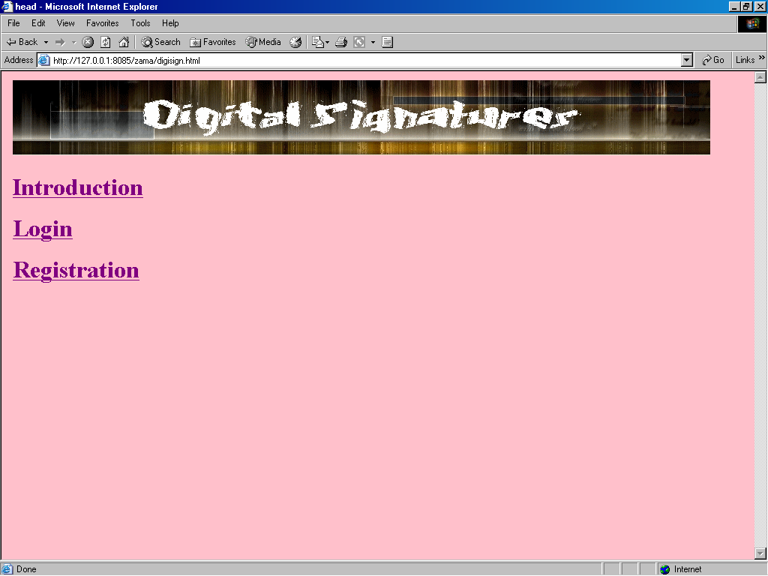

Introduction page

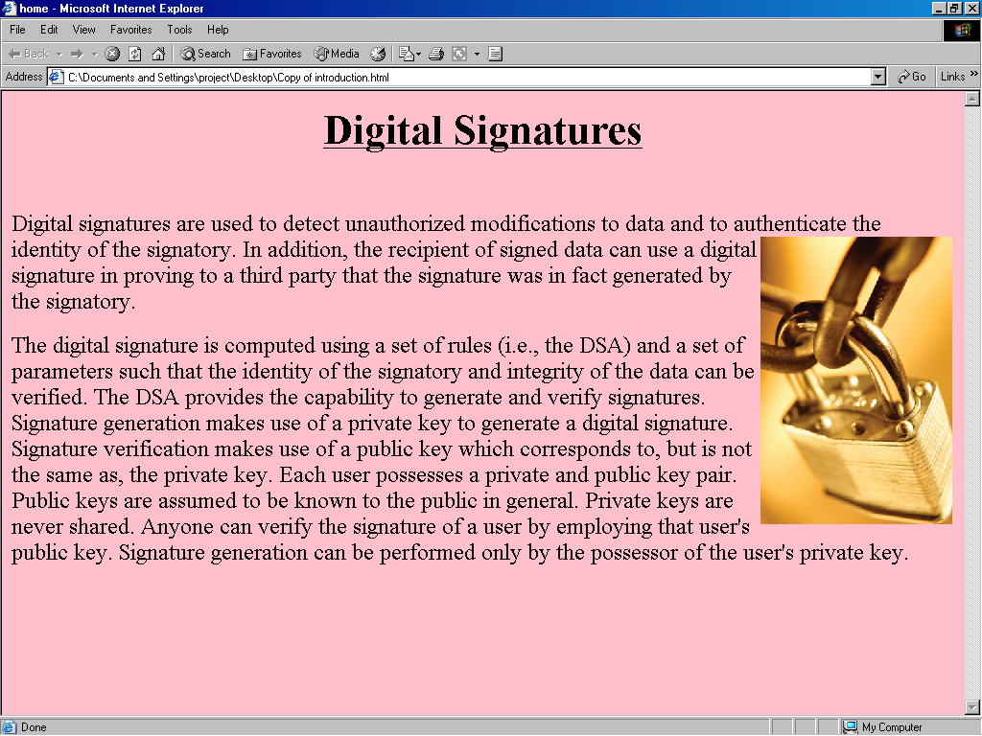

Login page as user:

User can write (send) and read (receive) messages.

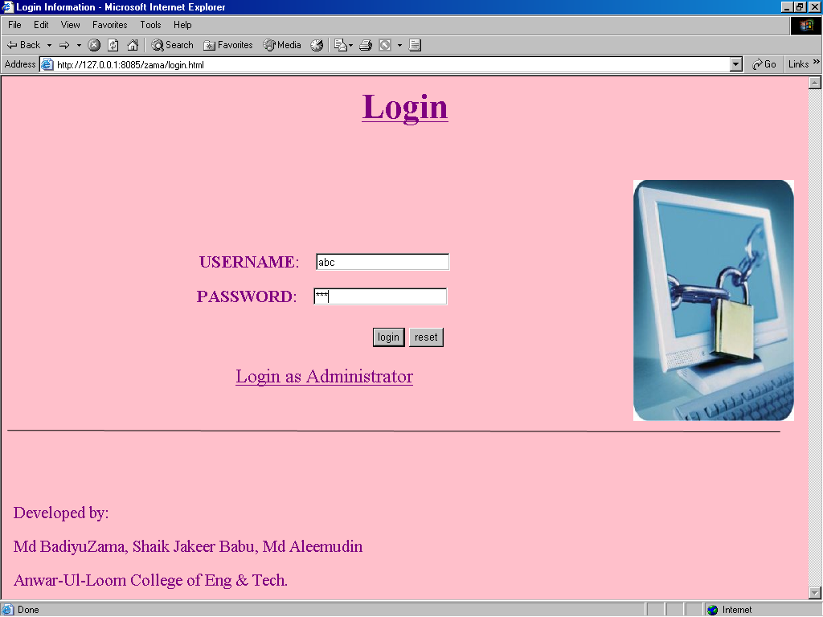

Invalid user page

If user enters either the name or password incorrect..

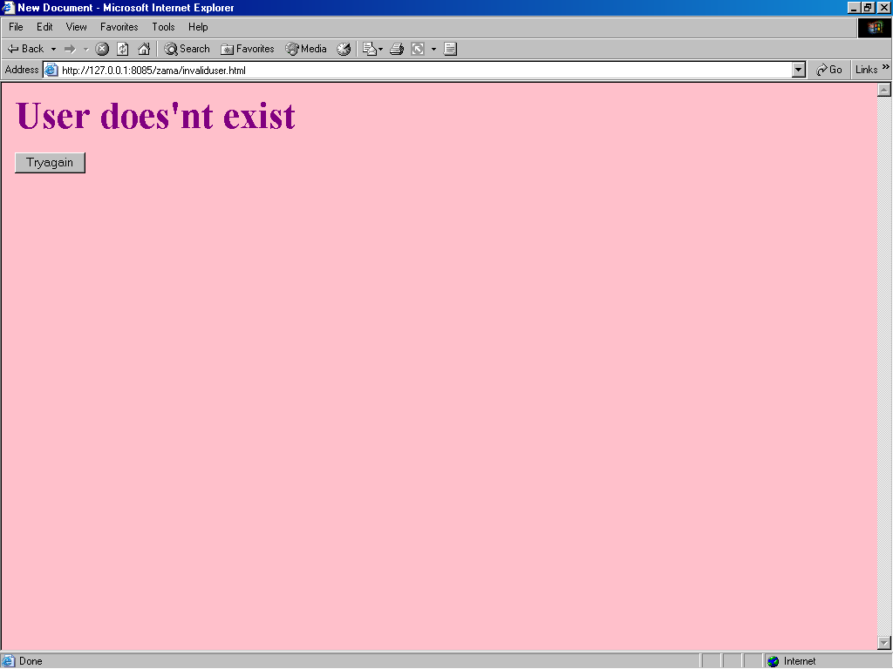

Choice1 page:
User selects Write option to send a message.

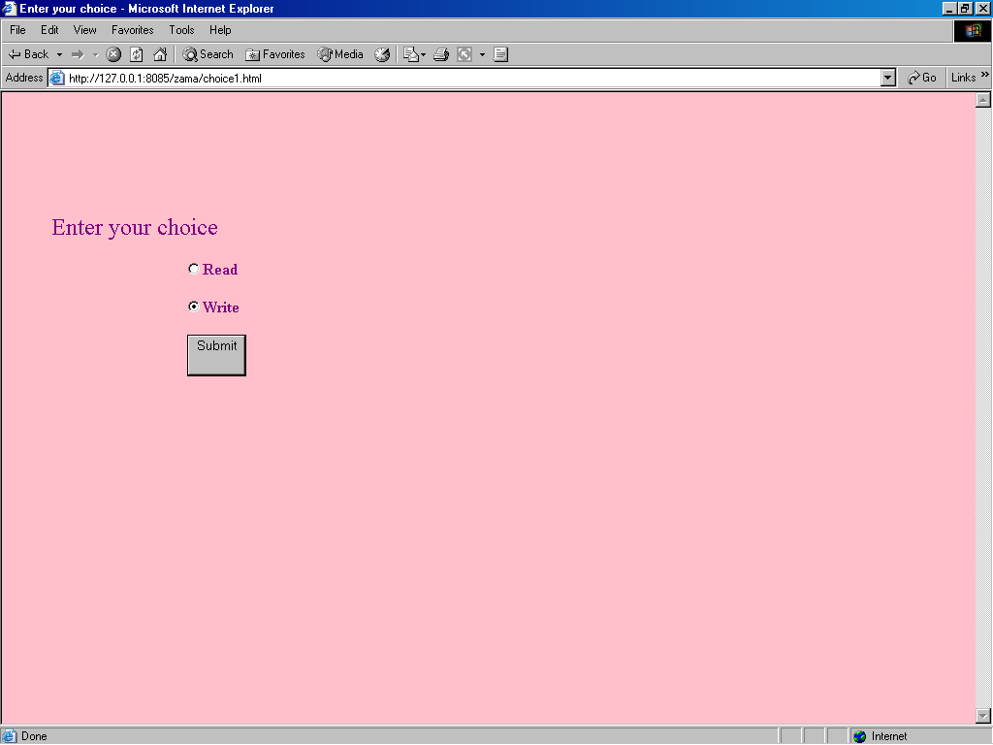

Sender enters the message.

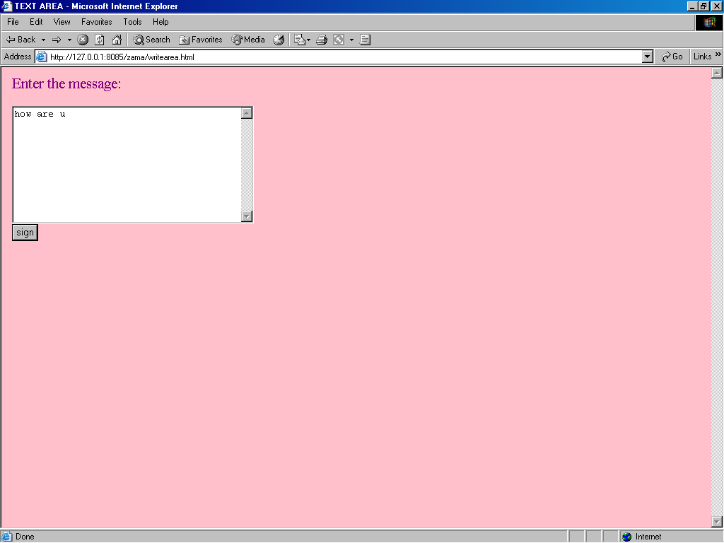

The message is signed using private key of the sender.

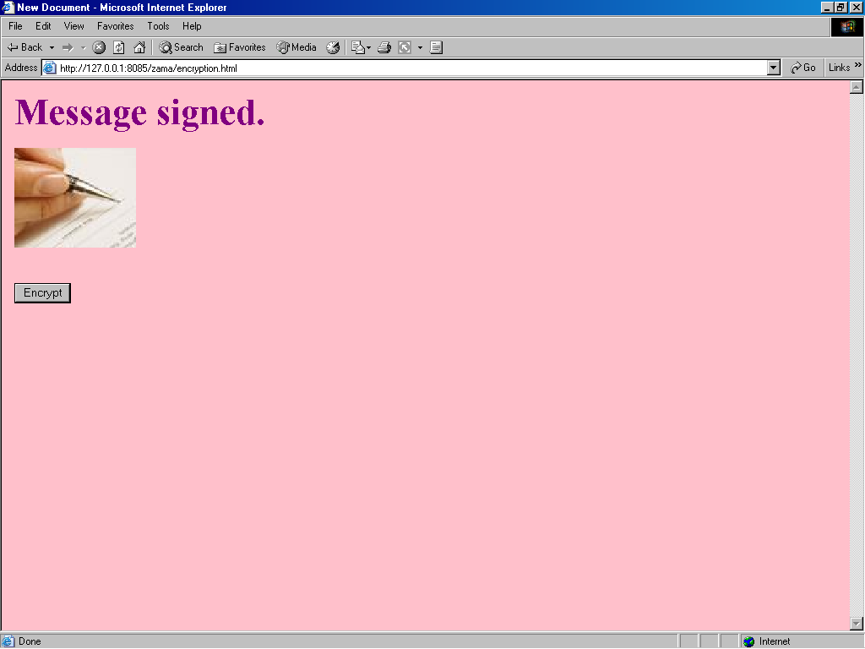

The cipher text is sent to the receiver xyz.

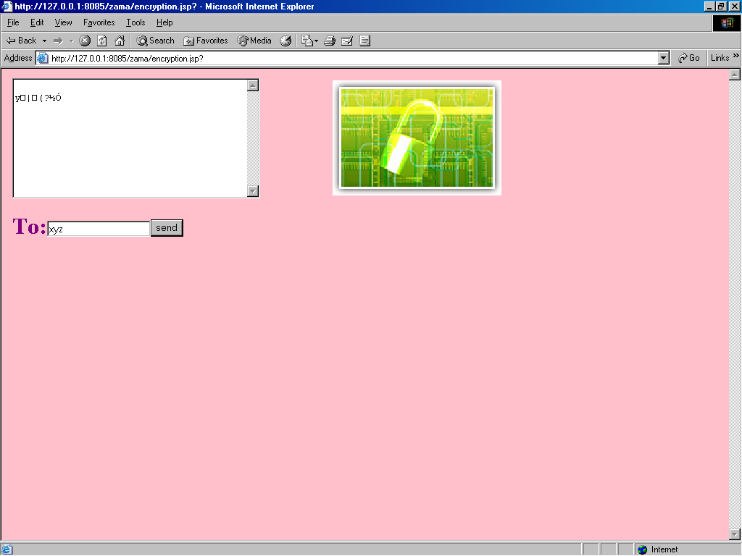

The message has been sent successfully.

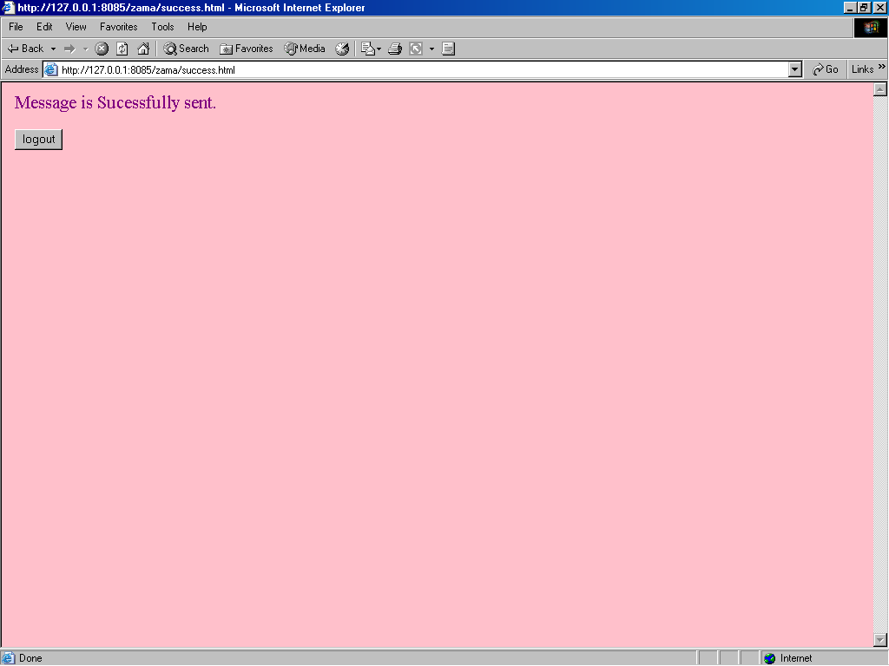

The receiver doesn’t exist

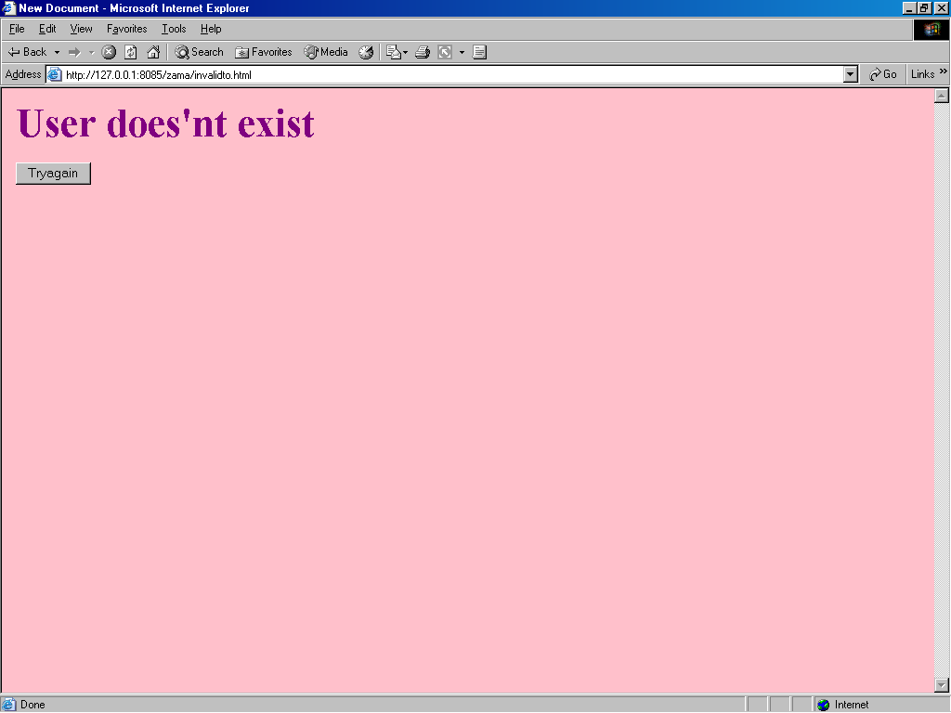

The receiver enters his login name and password.

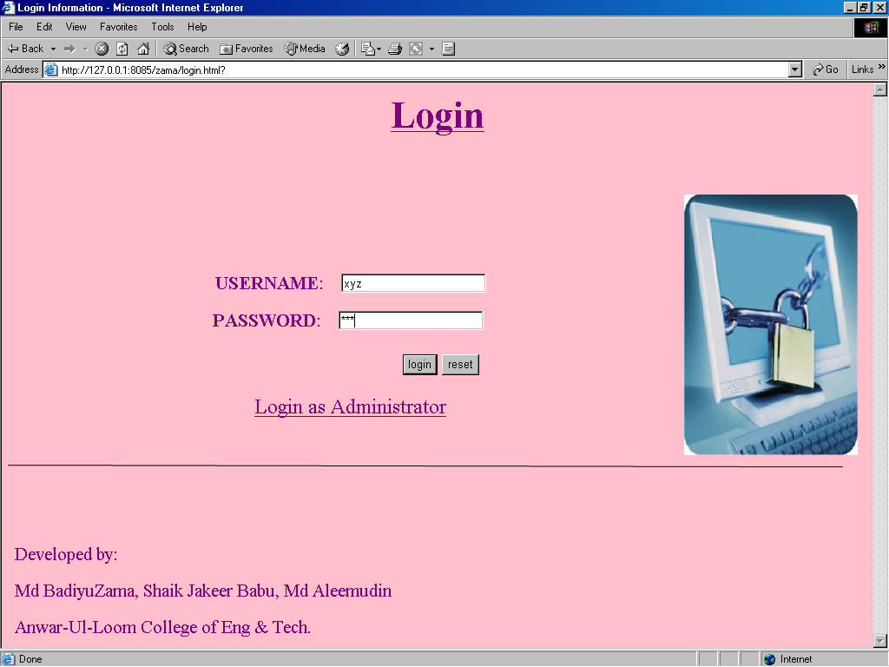

User selects Read option.

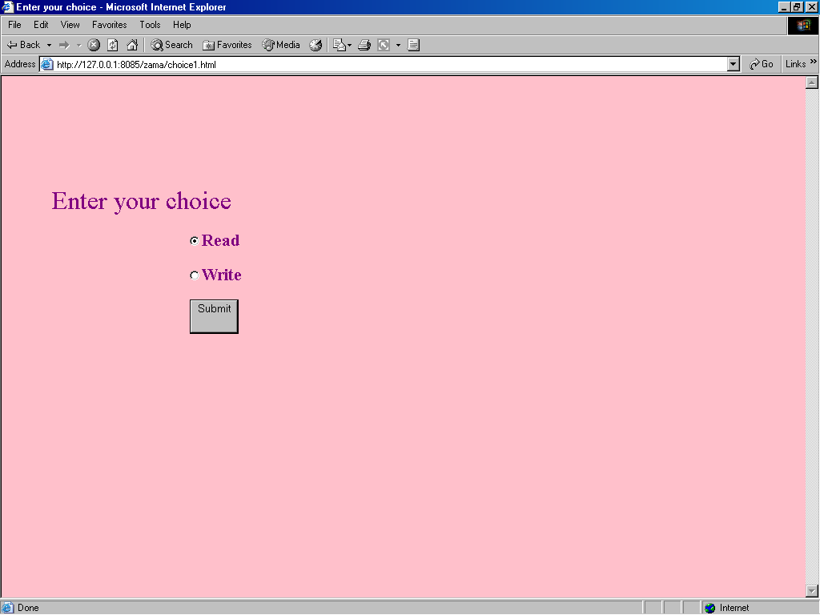

If there are no Messages.

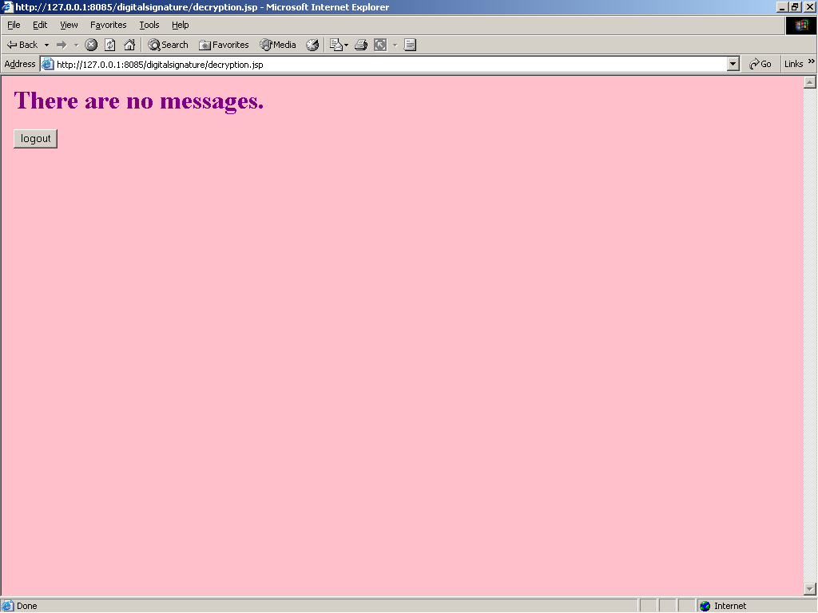

Press Decrypt to decrypt the received message.

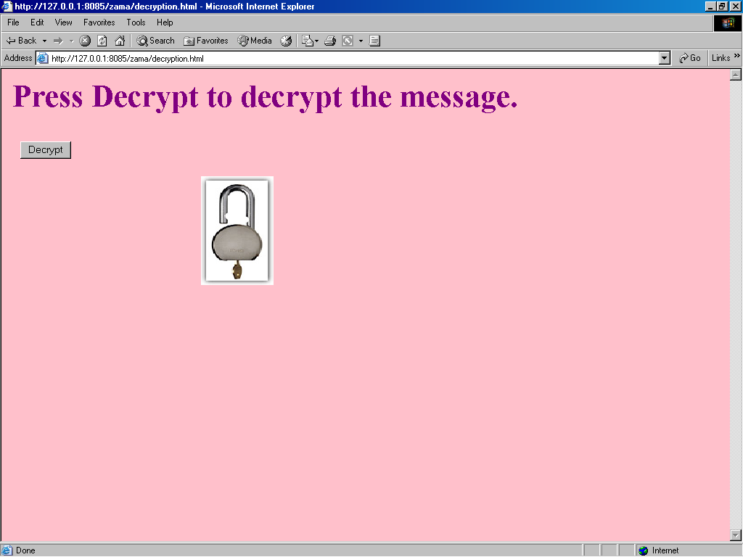

The message is decrypted using secret key.

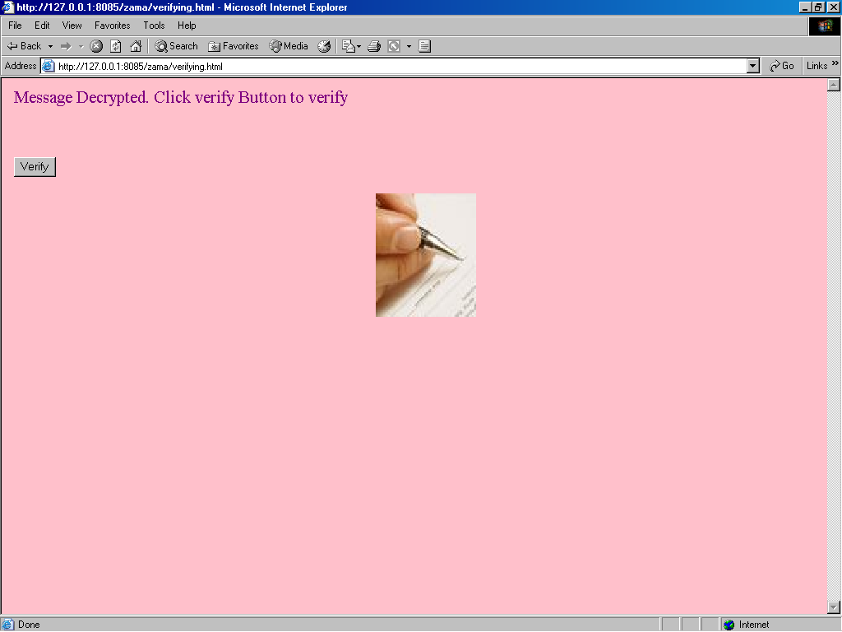

The signature is verified using public key of the sender; if it is valid then the message is display.

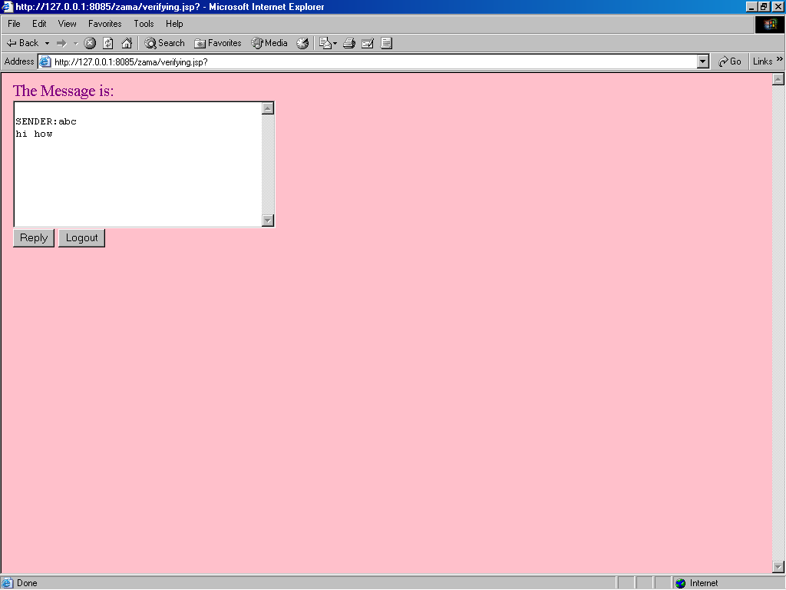

Login as administrator

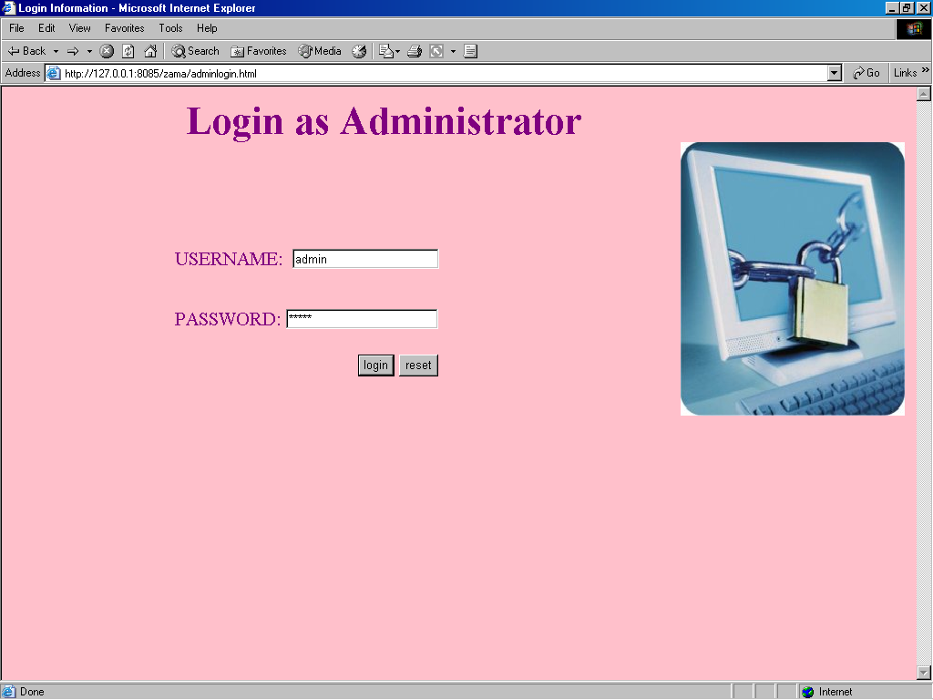

Administrator selects his choice.

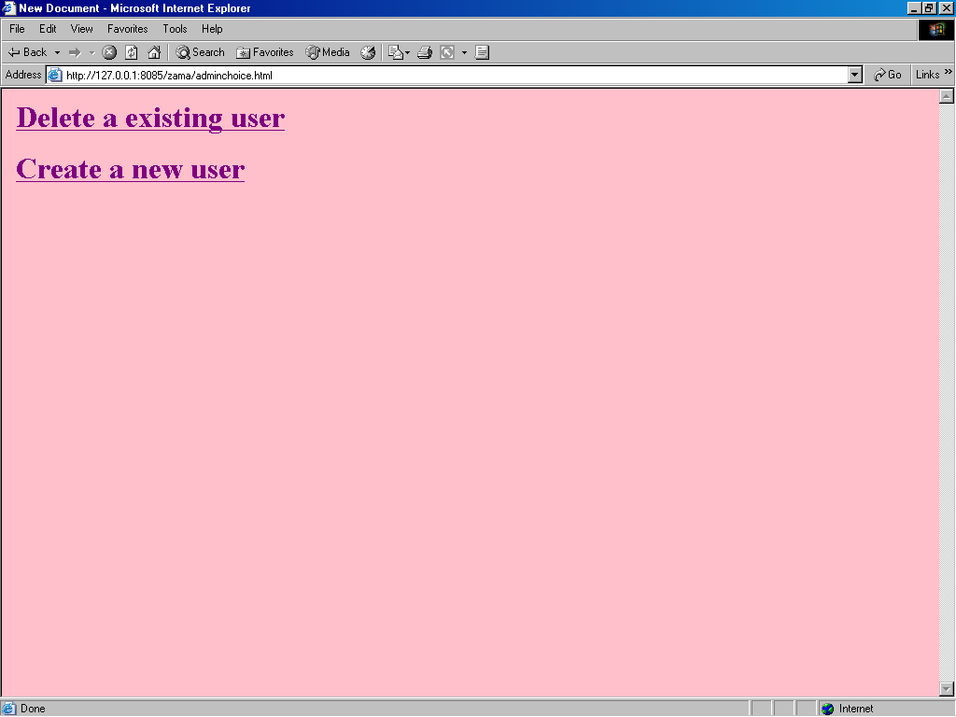

Delete existing user.

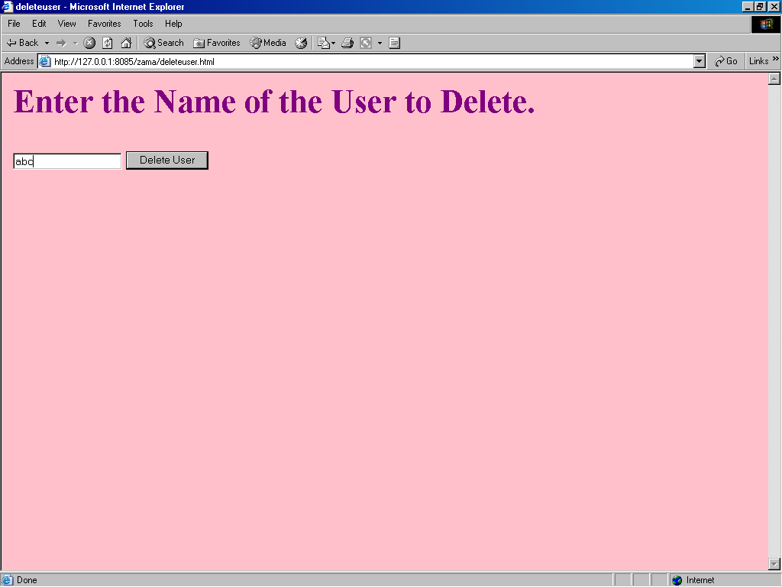

User abc is deleted.

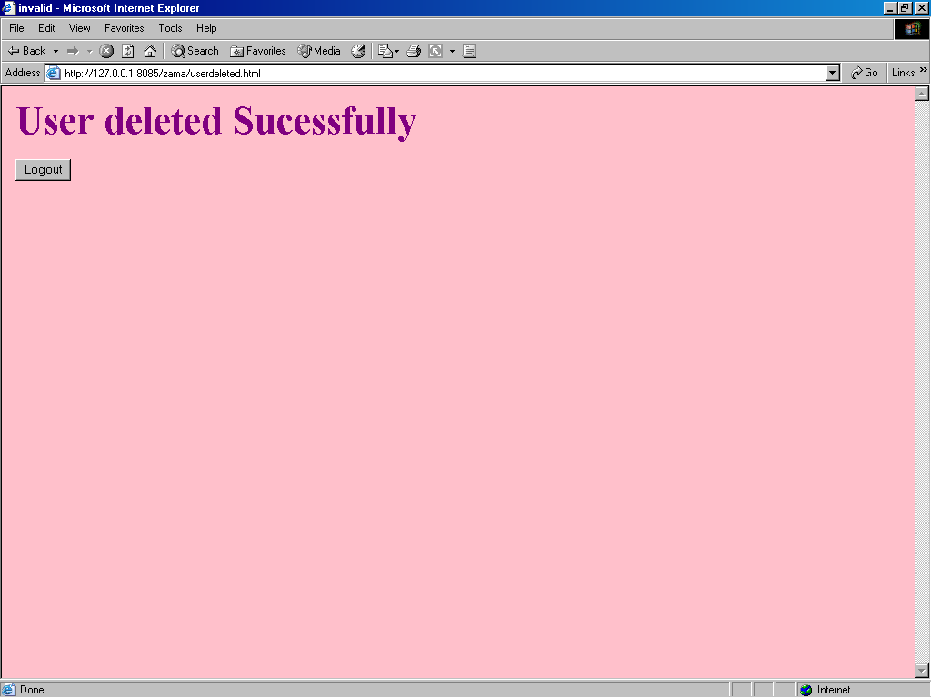

Adds a new user

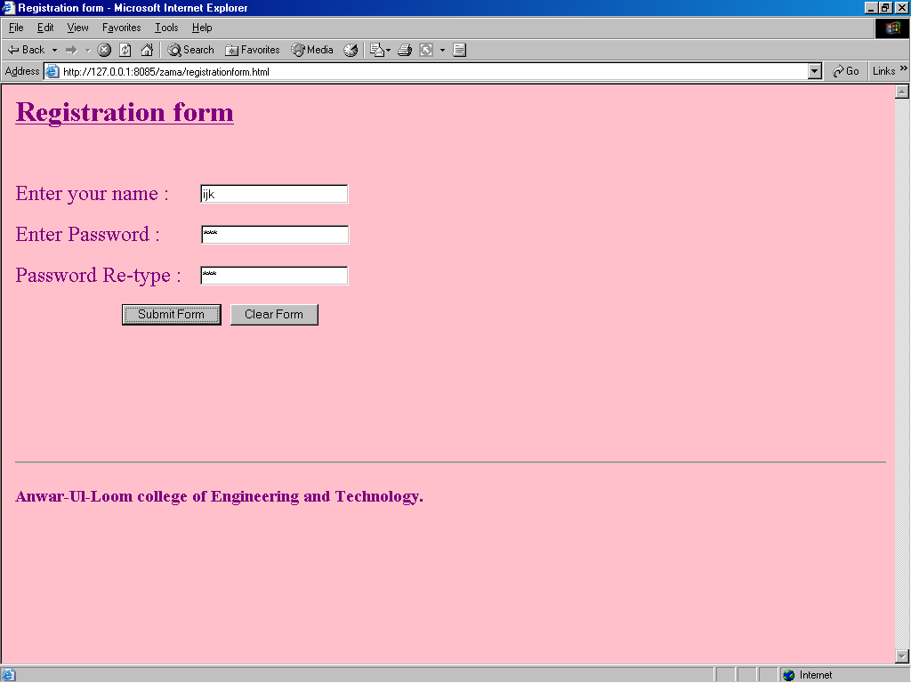

8.0 FUTURE ENHANCEMENTS

Improved security measures for authentication through SQL server for the administrator.

Digital Signatures can be used in the fields like:

- Banking

- Military

10.0. BIBILIOGRAPHY
1. CRYPTOGRAPHY AND NETWORK SECURITY
- William Stallings
2. SOFTWARE ENGINEERING
- Roger Pressman
3. JAVA COMPLETE REFERENCE
- Herbert Schmidt
4. WEB SOURCES
http://en.wikipedia.org/wiki

