**Steps to create ARFF file**

**And**

**Observations**

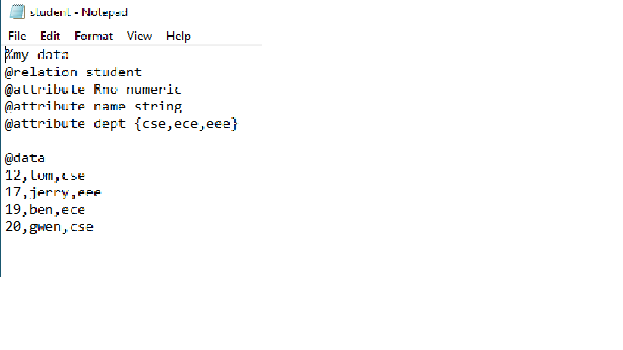

Fill the details in a notepad and save it with a .arff extension

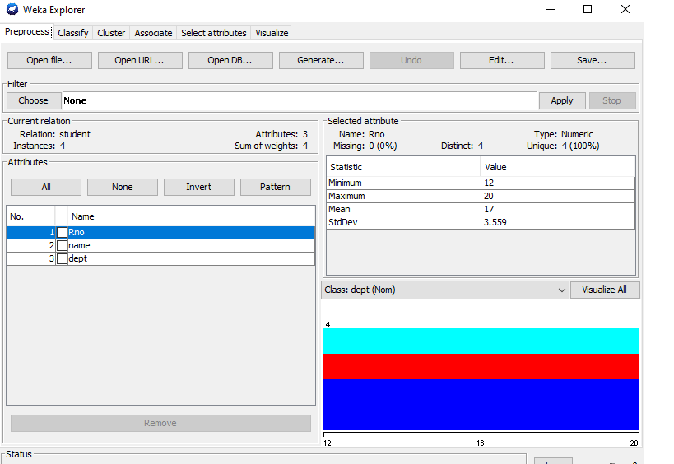

Open the weka file

It displays the attributed and type of each attribute

Visualize shoes an histogram related to the attribute

Visualize all displays histogram of all the attributes

If the datatype of an attribute is neither numeric nor nominal then there is no histogram representation for that attribute

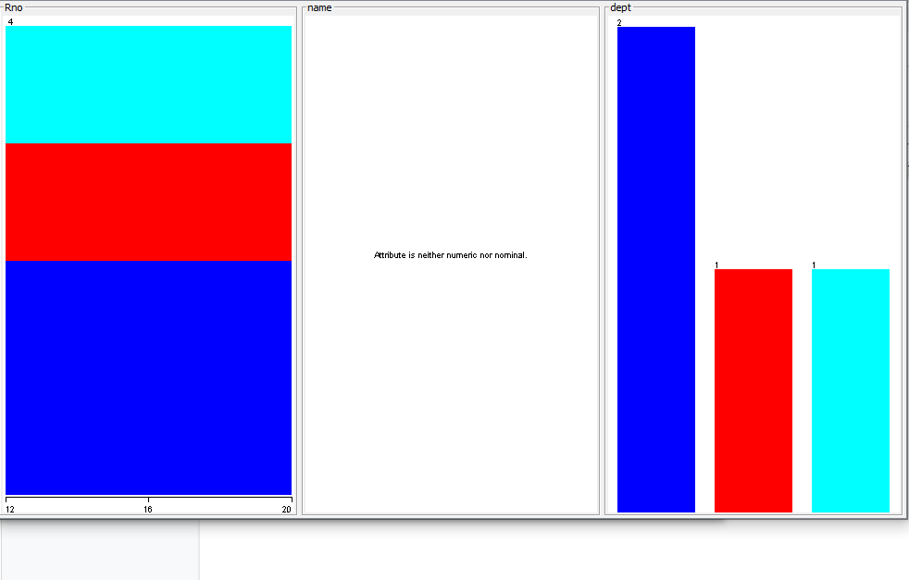

We can also edit the data in the attributes by clicking the edit button

