**Reshape**

1. **Prepare data in Table 1 and convert to Table 2 using melt.**

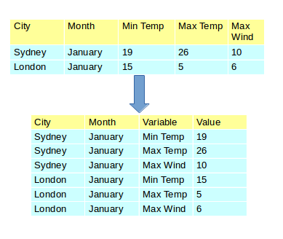

1. **Convert the data back to Table1 format using dcast.**
2. **Create 100 random numbers between 1 and 20. (hint:use sample with replace=TRUE ). Using table() function show the count of each number generated**
3. **Prepare the mpg Vs gear table from mtcars data using table() function**