**ASCRUM-PROJECT MANAGEMENT SYSTEM**

**INTRODUCTION:**

Ascrum is a project management system which deals with complete project info like adding new project, view the current projects, add backlog information of projects, adds and view the sprints.

**DESCRIPTION:**

* Ascrum has a login page from which authenticated admin and users login.
* Admin has the privilege to manage the projects and manage the users.
* Overview of complete projects can be viewed from My projects tab.
* Admin can add the new project from Manage projects.
* He has to supply required details like name, description, product owner, My role and user.
* Admin can view the users from manage users tab.
* Admin has the privilege to remove the users.
* He adds the new user, the new user gives details and gets registered.
* The registered user can have overview of the projects he/she has been involved.
* Sprints and product backlog information has to be added by admin.

**TECHNOLOGIES:**

* Node.js
* AngularJS
* MongoDB
* Express.js
* HTML5,CSS3
* Bootstrap

**CLASS DIAGRAM:**

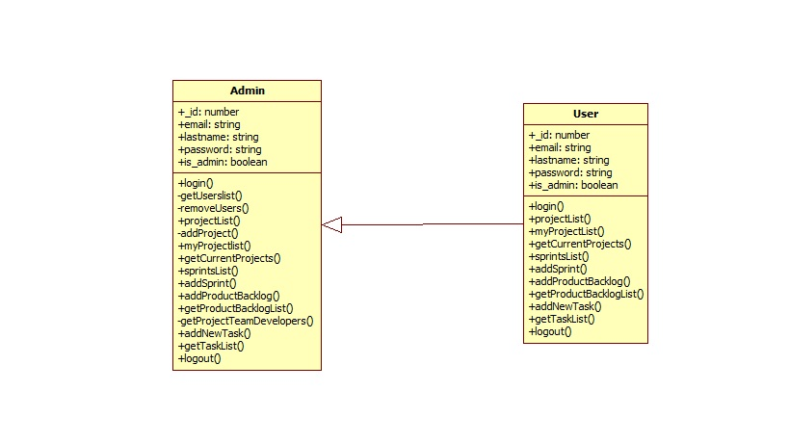

**ER-DIAGRAM:**

