A. KPI’s
PIZZA SALES SQL QUERIES

1. Total Revenue:
SELECT SUM(total_price) AS Total_Revenue FROM pizza_sales;
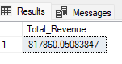
2. Average Order Value
SELECT (SUM(total_price) / COUNT(DISTINCT order_id)) AS Avg_Order_Value FROM pizza_sales;
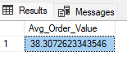
3. Total Pizzas Sold
SELECT SUM(quantity) AS Total_Pizza_Sold FROM pizza_sales;
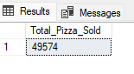
4. Total Orders
SELECT COUNT(DISTINCT order_id) AS Total_Orders FROM pizza_sales;
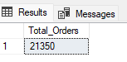
5. Average Pizzas Per Order
SELECT CAST(CAST(SUM(quantity) AS DECIMAL(10,2)) /
CAST(COUNT(DISTINCT order_id) AS DECIMAL(10,2)) AS DECIMAL(10,2))
AS Avg_Pizzas_Per_Orders
FROM pizza_sales;
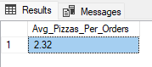
B. Daily Trend for Total Orders
SELECT DATENAME(DW,order_date) AS order_day, COUNT(DISTINCT order_id) AS
Total_Orders
FROM pizza_sales
GROUP BY DATENAME(DW,order_date);
Output:
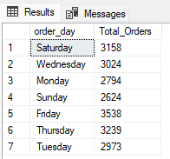
C. Monthly Trend for Orders
SELECT DATENAME(MONTH,order_date) AS Month_Name, COUNT(DISTINCT order_id) AS Total_Orders
FROM pizza_sales
GROUP BY DATENAME(MONTH,order_date);
Output:
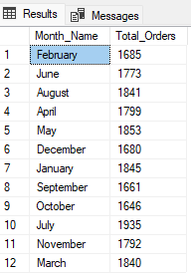

D. % of Sales by Pizza Category
SELECT pizza_category, CAST(SUM(total_price) AS DECIMAL(10,2)) as total_revenue,
CAST(SUM(total_price) * 100 / (SELECT SUM(total_price) FROM pizza_sales) AS DECIMAL(10,2)) AS PCT
FROM pizza_sales
GROUP BY pizza_category;
Output
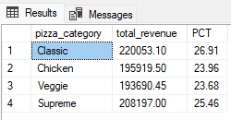
E. % of Sales by Pizza Size
SELECT pizza_size, CAST(SUM(total_price) AS DECIMAL(10,2)) as total_revenue,
CAST(SUM(total_price) * 100 / (SELECT SUM(total_price) from pizza_sales) AS DECIMAL(10,2)) AS PCT
FROM pizza_sales
GROUP BY pizza_size
ORDER BY pizza_size;
Output
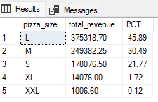
F. Total Pizzas Sold by Pizza Category
SELECT pizza_category, SUM(quantity) as Total_Quantity_Sold
FROM pizza_sales
GROUP BY pizza_category
ORDER BY Total_Quantity_Sold DESC
Output
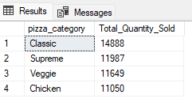

G. Top 5 Pizzas by Revenue
SELECT TOP 5 pizza_name, SUM(total_price) AS Total_Revenue FROM pizza_sales
GROUP BY pizza_name
ORDER BY Total_Revenue DESC;
Output

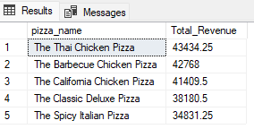
H. Bottom 5 Pizzas by Revenue
SELECT TOP 5 pizza_name, SUM(total_price) AS Total_Revenue FROM pizza_sales
GROUP BY pizza_name
ORDER BY Total_Revenue ASC;
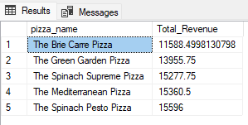
I. Top 5 Pizzas by Quantity
SELECT TOP 5 pizza_name, SUM(quantity) AS Total_Quantity FROM pizza_sales
GROUP BY pizza_name
ORDER BY Total_Quantity DESC
Output
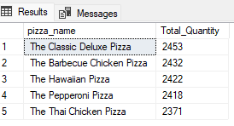
J. Bottom 5 Pizzas by Quantity
SELECT TOP 5 pizza_name, SUM(quantity) AS Total_Quantity FROM pizza_sales
GROUP BY pizza_name
ORDER BY Total_Quantity ASC;
Output
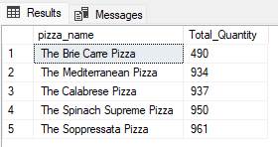

K. Top 5 Pizzas by Total Orders
SELECT TOP 5 pizza_name,COUNT(DISTINCT order_id) AS Total_Orders
FROM pizza_sales
GROUP BY pizza_name
ORDER BY Total_Orders DESC;
Output
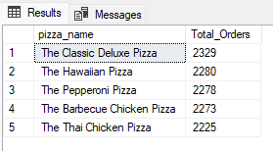
L. Borrom 5 Pizzas by Total Orders
SELECT TOP 5 pizza_name,COUNT(DISTINCT order_id) AS Total_Orders
FROM pizza_sales
GROUP BY pizza_name
ORDER BY Total_Orders ASC
Output

