

Main Axis

Cross Axis

Cross Axis

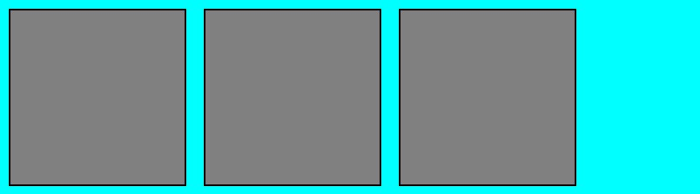

Main Axis