
Event Management System
Event Management Database System using MySQL
Student Name :- Prasanjit Bakawar
Branch: CSE (Data Science)

Academic Year 2026–27
Guide: Prof. Mr. Chinmay Munkim Sir

Introduction & Problem Statement
An Event Management System organizes event data — organizers, participants, registrations, payments, and certificates — in a structured

database. Manual record-keeping causes duplication, errors, and inconsistency.
1
Organizer
Creates and manages events
2
Event
Stored with date, category, fee
3
Participant
Registers for events
4
Registration
Links participant to event
5
Payment
Tracks fee transactions
6
Certificate
Issued on completion

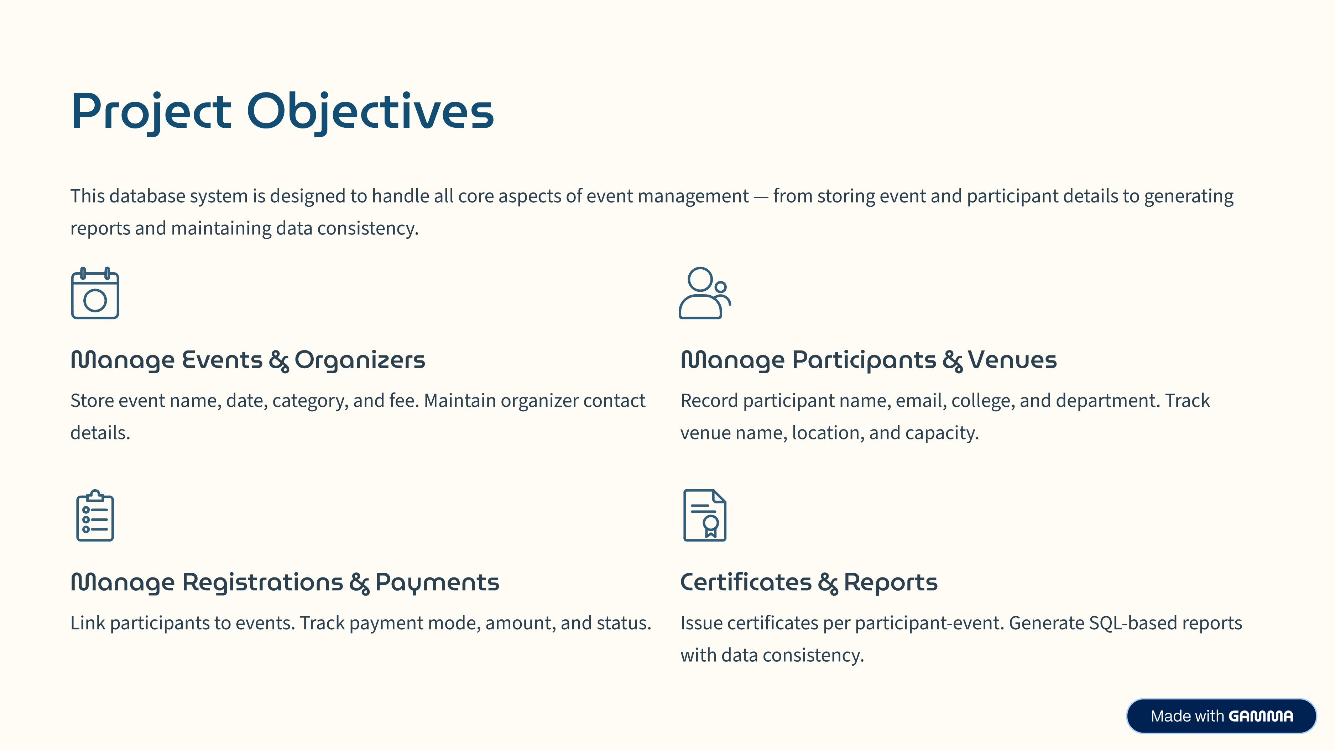

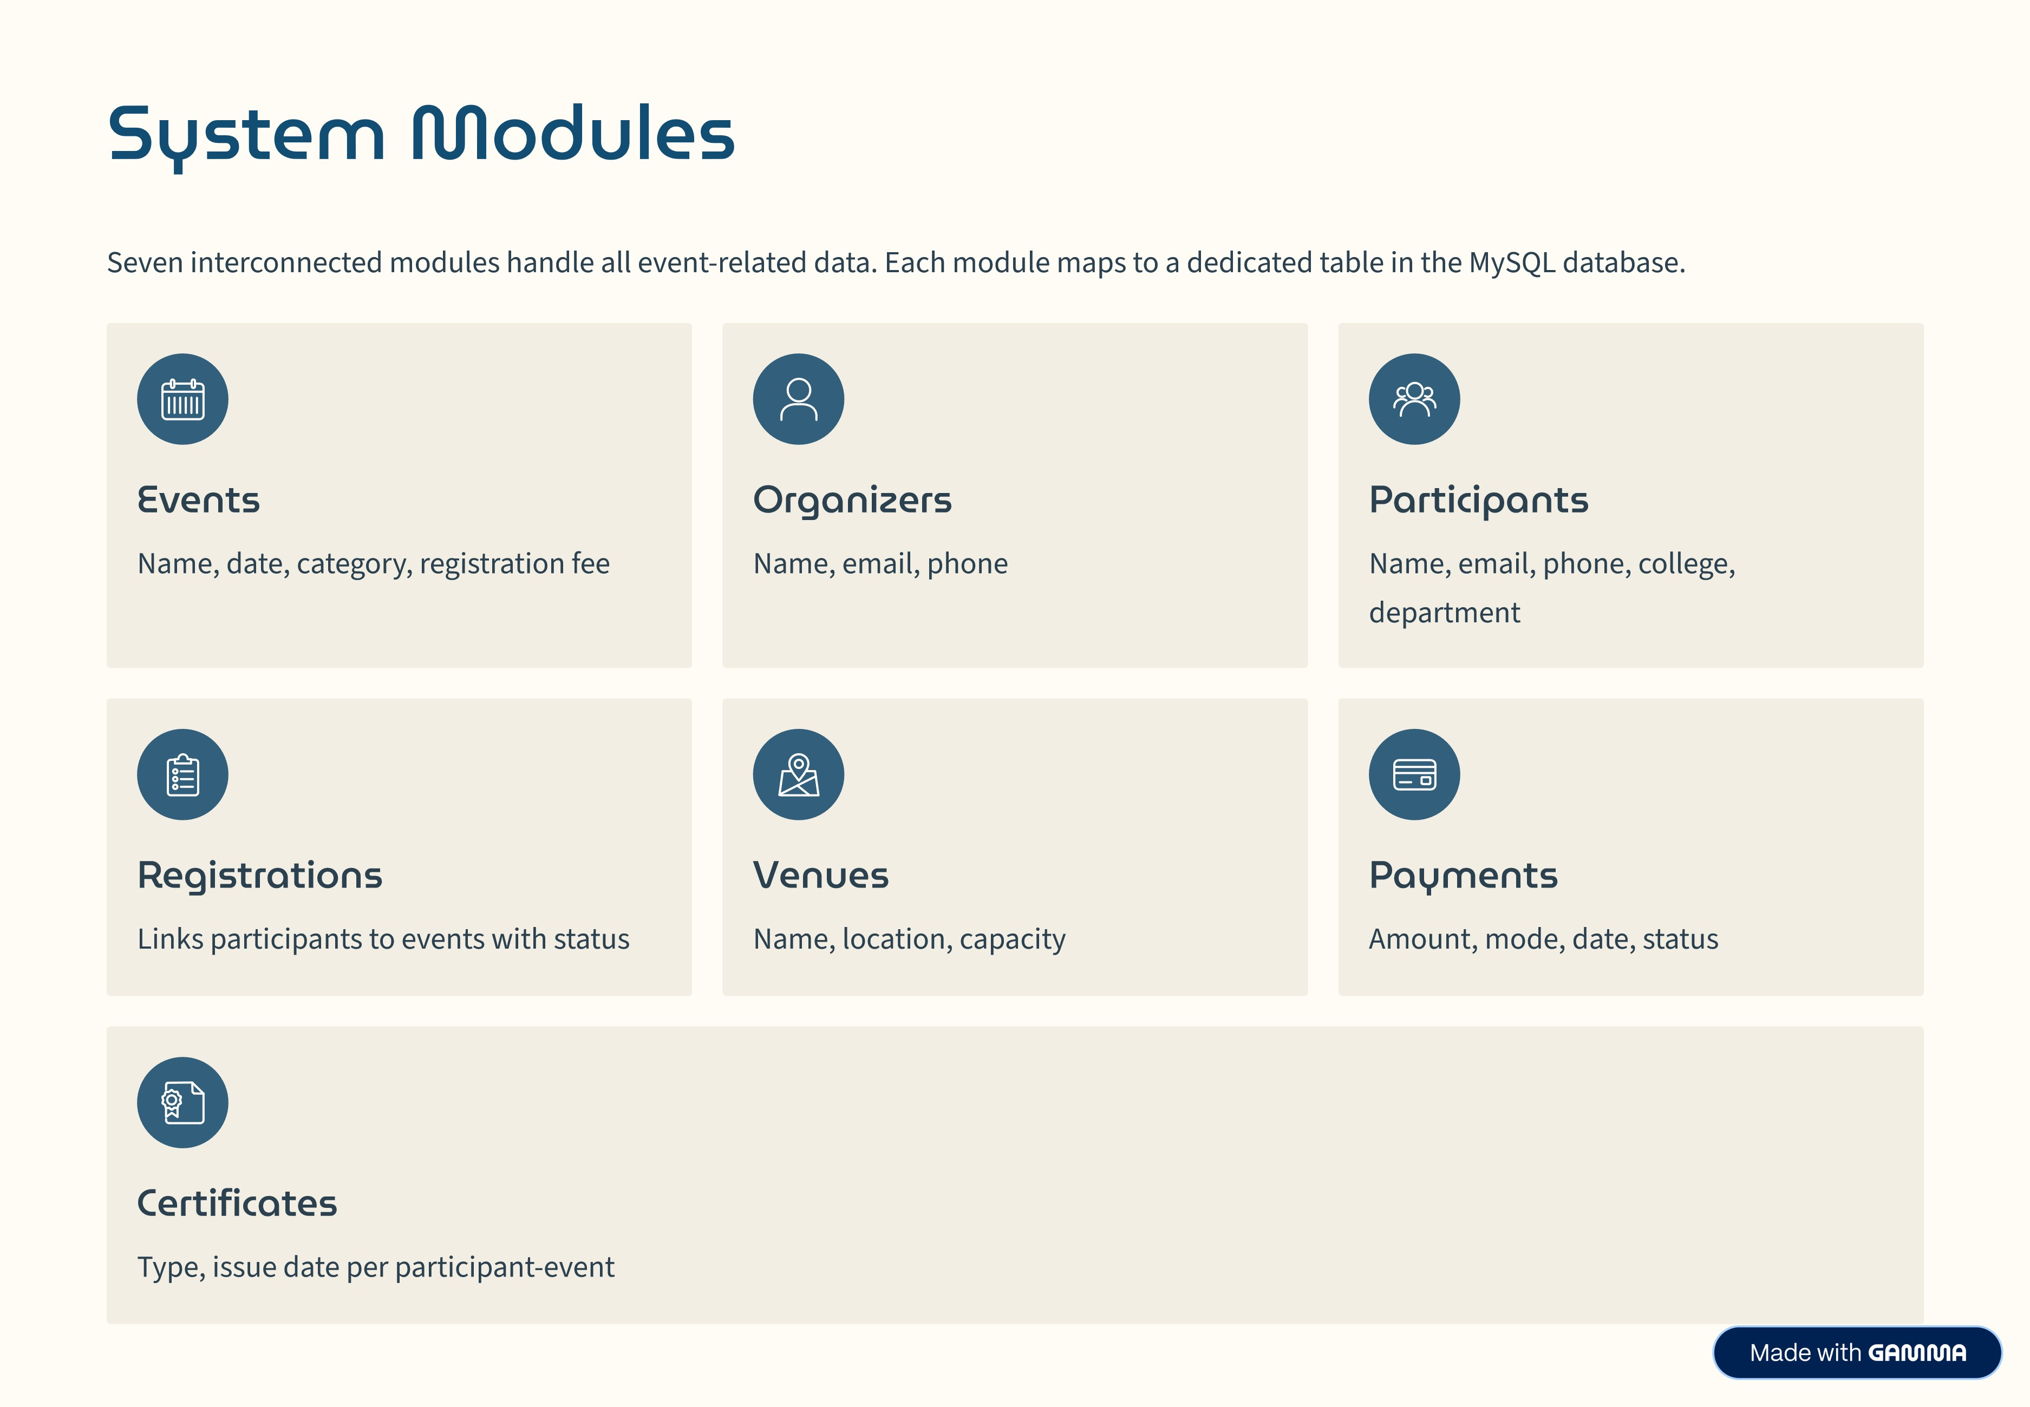

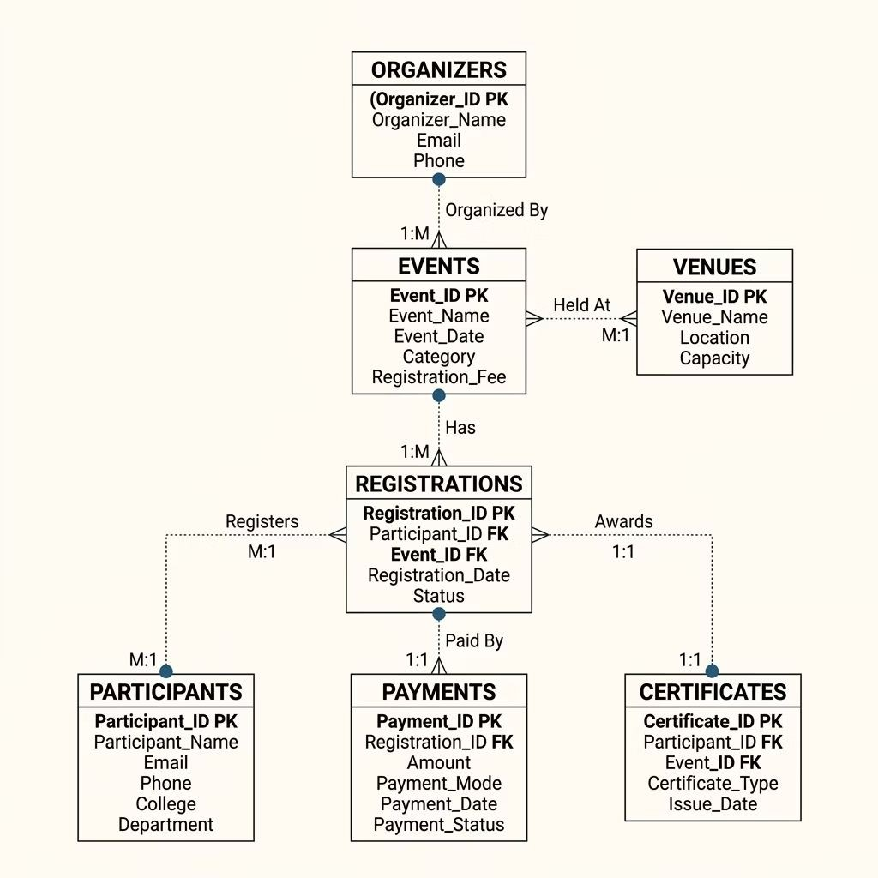
Database Design — ER Diagram
Seven entities connected through six relationships. Primary keys

(
PK) uniquely identify each record; foreign keys (FK) enforce

referential integrity across tables.
EVENTS
— PK: Event_ID
ORGANIZERS
— PK: Organizer_ID
PARTICIPANTS
— PK: Participant_ID
REGISTRATIONS
— PK: Registration_ID, FK: Participant_ID,

Event_ID
VENUES
— PK: Venue_ID
PAYMENTS
— PK: Payment_ID, FK: Registration_ID
CERTIFICATES
— PK: Certificate_ID, FK: Participant_ID, Event_ID

Technology & System Architecture
Tables & Reports
Event DB
MySQL Workbench
User
The system follows a straightforward architecture: users write SQL queries in MySQL Workbench, which communicates with the MySQL server

to store, retrieve, and manage all event-related data.
MySQL
Relational database engine for storing all event, participant, and

payment data
MySQL Workbench
Visual tool for designing schemas, writing queries, and viewing

results
SQL
Query language for data manipulation, joins, aggregations, and

reporting
Git & GitHub
Version control for tracking SQL scripts and project

documentation

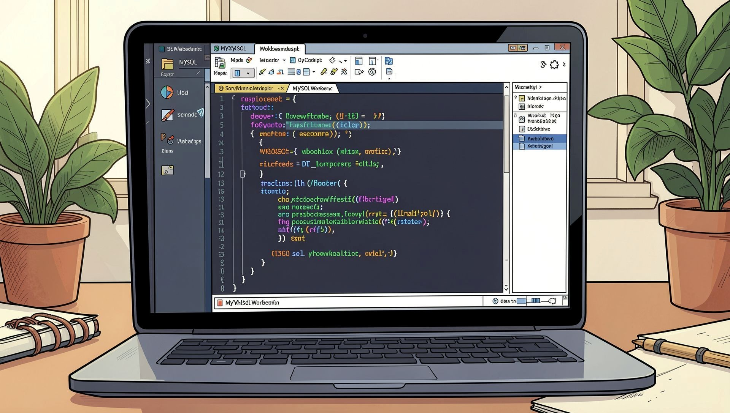
SQL Implementation
Core SQL Features Used
SELECT, INSERT, UPDATE, DELETE
INNER JOIN & LEFT JOIN
Aggregate Functions — COUNT, SUM, AVG
GROUP BY & HAVING
Subqueries
Views, Stored Procedures & Triggers
Sample Queries
SELECT
Event_Name, Category,

Registration_Fee
FROM
EVENTS;
SELECT

p
.Participant_Name
,

e
.Event_Name
FROM
PARTICIPANTS
p
JOIN REGISTRATIONS
r

ON
p
.Participant_ID
=
r
.Participant_ID
JOIN EVENTS e

ON
r
.Event_ID
= e
.Event_ID
;

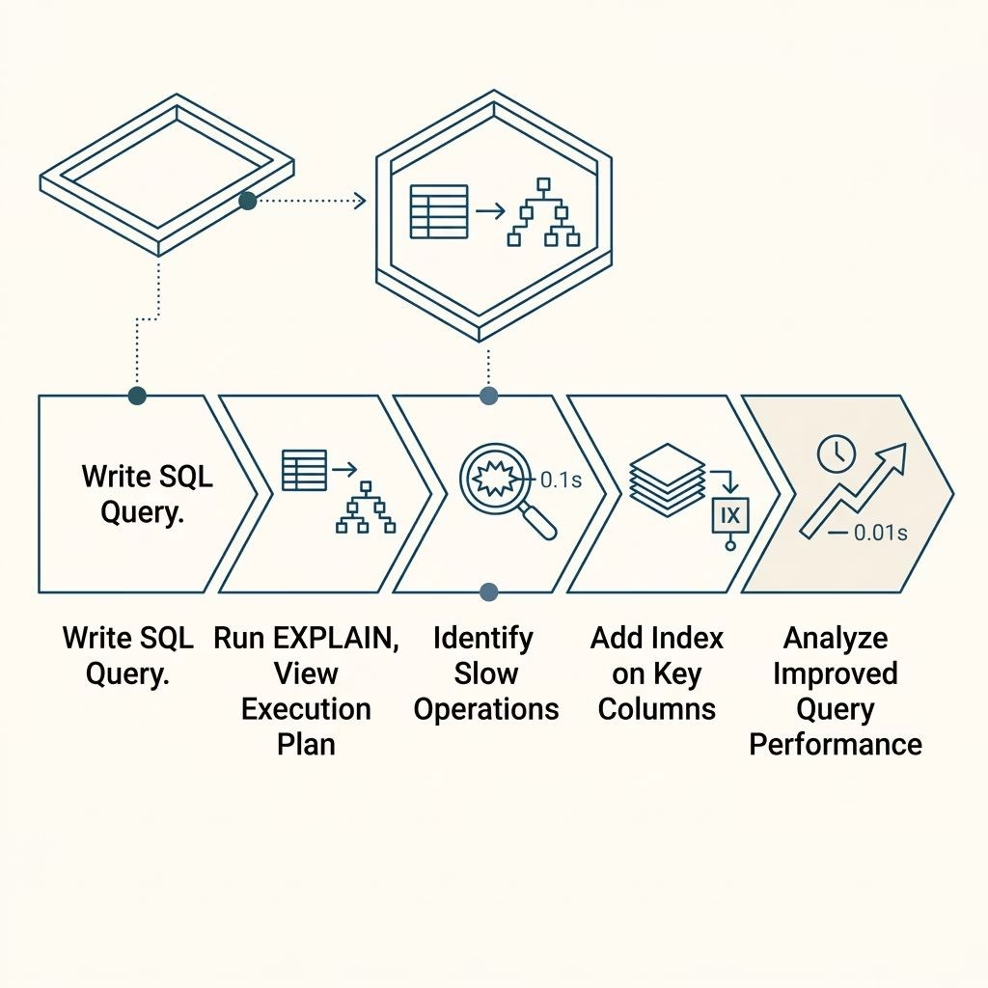
Database Relationships & Query Performance
Keys and integrity rules keep data accurate. Indexes and EXPLAIN

help optimize queries.
Primary Keys
Uniquely identify each row

e.g., Event_ID,
(

Participant_ID)
Foreign Keys
Link child tables to parent

tables (e.g.,

Registration_ID in

PAYMENTS)
Referential

Integrity
Prevents orphaned

records across related

tables
Cardinality
Defines relationship ratios

— 1:M, M:1, 1:1
Indexing &

EXPLAIN
Speeds up lookups;

EXPLAIN shows query

execution plans

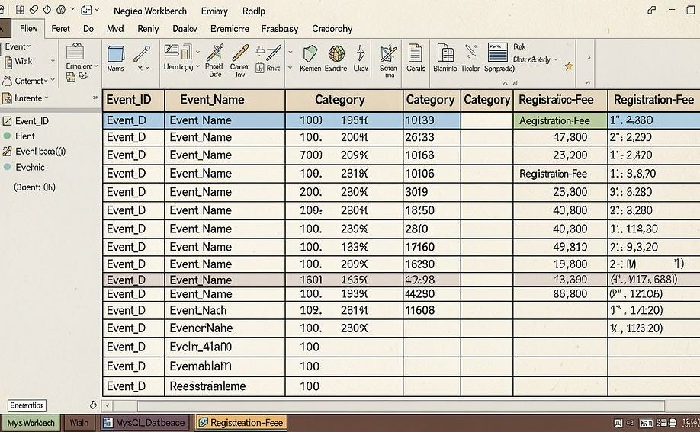
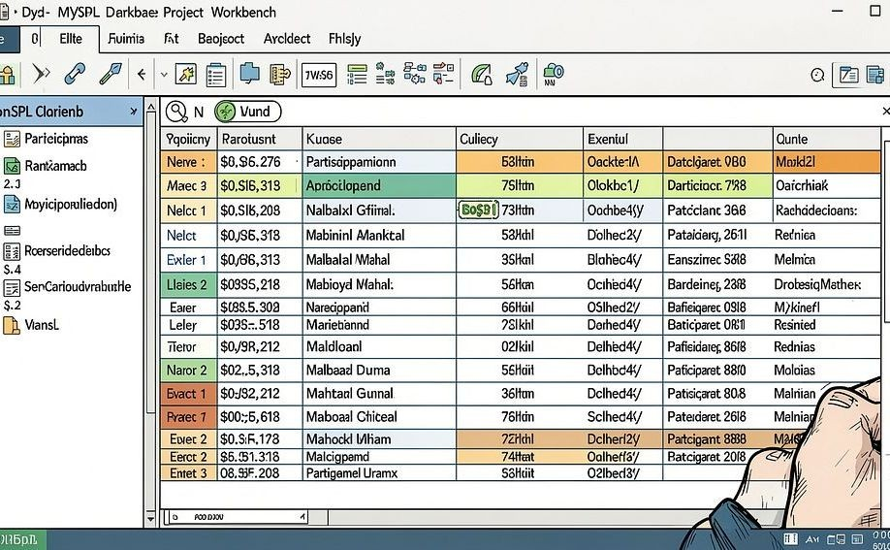
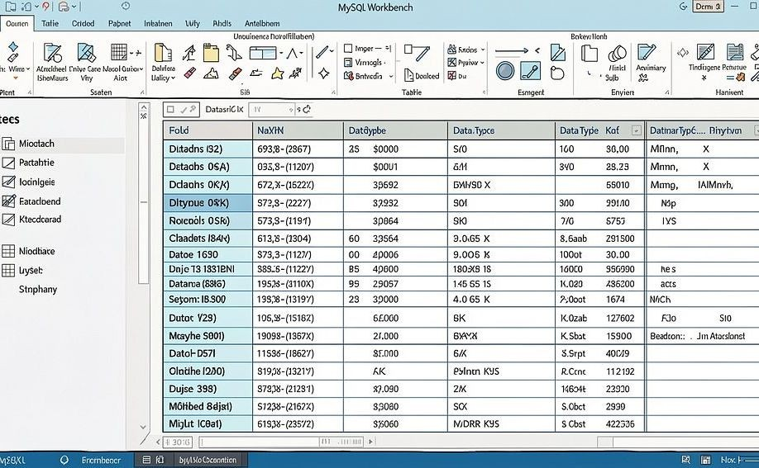
Results & Output
Sample outputs from MySQL Workbench. Insert your actual screenshots below.
Event Records
[
Insert MySQL Workbench Screenshot Here
]
Registration Report
[
Insert Query Output Screenshot Here
]
Database Tables
[
Insert Database Table Screenshot Here
]

Conclusion & Future Scope
Conclusion
Relational database designed for event management
Seven entities organized with clear relationships
ER model represents all entity connections
MySQL stores and manages event data
SQL queries retrieve and analyze records
Structured foundation for an event application
Future Scope
Web-based application with participant & organizer login
Online registration and payment integration
Email/SMS notifications for registrations
Digital certificates with search and filtering
Admin dashboard and mobile application
Thank You — Questions & Answers

