**Assignment 1**

1. **What is Multimedia? Explain multimedia system with examples.**

The word multi and media are combined to form the word multimedia. The word “multi” signifies “many.” Multimedia is a type of medium that allows information to be easily transferred from one location to another. Multimedia refers to the computer-assisted integration of text, drawings, still and moving images (videos) graphics, audio, animation, and any other media in which any type of information can be expressed, stored, communicated, and processed digitally.

Multimedia system is any system that supports more than a single kind of media​.Multimedia systems are systems that can store, retrieve, and process various types of media, such as text, graphics, image, full-motion video, audio, and animation. Multimedia system allow users to create, process, share, and display information in a broad variety of formats. Multimedia systems are used for security to keep intruders out of a system and for the protection of stored documents. Within organizations, multimedia systems are used in all forms of information systems from transaction processing systems to executive decision support systems. These systems also can be found across industries such as accounting, banking, communications, education, entertainment, insurance, manufacturing, medical, retailing, and real estate. Anywhere there is a need for combining text, pictures, sounds, and animation, multimedia systems are found. Canning devices are available to scan potential user's eyes (retina imaging) or thumb prints to gain access to a computer or site. Other systems can scan a person's signature or capture voice pattern recognition for the same purposes. Stored text, pictures, original document images, sound files, and video files can be protected through encryption methods, read/write protection, password management, and copyright protection that keep intruders from copying or accessing sensitive files.

Some of the examples of multimedia system are as follows:-

1. Education and Training:-Computer based training is a type of multimedia products used for education and training. The different media types of a multimedia product maintain the user interest and the interactivity allows the user to control their learning speed and subject. The Multimedia system are very cost-effective for education and training. E.g. [typing tournament](http://www.edalive.com/products/typing-tournament-v2).
2. Leisure and Entertainment:-**Computer Games** have a high level of interactivity as the response of the user can determine actions within the game. Games have complex animations and programming for a wide range of actions.
3. Virtual Reality:-Virtual Reality is the use of a computer modelling and simulation to enable a person to interact with an artificial environment. The environment is to simulate through interactive devices, goggles, head-up displays, gloves, body suits. Motion sensors pick up the user’s movement.
4. Simulation:-Simulation is the imitation of operation of real world process or system over time. Simulation is used in many contexts such as simulation of technology for performance optimization, safety engineering, training, testing, education and video games. It can also be used with scientific modelling of natural systems or human system to gain insight into their functioning.
5. Sound Processing:-Sound in multimedia applications enables a user to describe products, give instructions, enhance a presentation, or provide cues for some action by the viewer. Hardware for capturing and processing sounds includes a card attached to the main motherboard of the computer system.

**2. Explain data stream characteristics for continuous media.**

Data Stream is defined as any sequence of individual packets that is transmitted in a time-dependent fashion. Here, packets can carry information of either continuous or discrete media.

Hence the data stream characteristics can be discussed on the basic of three given factors or properties.

1. According to the time intervals between consecutive packets.
2. According to the variation of the amount between consecutive packets.
3. According to the continuity or connection between consecutive packets.

They are explained below in detail:-

**A. According to time intervals between consecutive packets:**

On the basic of this factor we find out three properties they are:

a) Strongly periodic data stream:-If time intervals are of the identical length between two consecutive t packets that's a continuing, then the stream is named strongly periodic and within the ideal case the jitter has the worth zero. For e.g.: PCM coded speech in traditional telephone switching.

b) Weakly periodic data stream:-If time intervals between two consecutive packets is not constant but are of periodic nature with finite period then the data stream is called weakly periodic.

c) A-periodic data stream:-If the sequence of time intervals is neither strongly nor weakly periodic, instead the time period or time gap various between packets to packets during transmission then such data stream is called A-periodic data stream.

**B. According to variation of consecutive packet amounts:**

On the basic of these factors there are three types of data stream:

a) Strongly regular data stream:-If the number of information stays constant during the life time of a knowledge stream, this feature is specially found in uncompressed digital data transmission, as an example audio stream of CD, video stream of camera in uncompressed form.

b) Weakly regular data stream:-If the amount of data stream varies periodically with time and not shows the behaviours of strongly regular data stream then it is called weakly regular data stream, For example compressed video stream.

c) Irregular data stream:-If the number of information is neither constant nor changes in keeping with a periodic function, then the information streams are called irregular data stream. Transmission and processing of this category data stream is complicated. Since data stream includes a variable (bit) rate after applying compression methods.

**C. According to continuity or connection between consecutive packets:**

On the basic of this factor there can be also 2 types or characters:

a) Continuous data stream:-If consecutive packets are directly transmitted one after another without any time gap then such data streams are called continuous data stream, For example audio data use for B channel of Isdn with transmission rate for 64 kbps.

b) Unconnected data stream:-A data stream with gaps between information units is named and unconnected data stream. The transmission of a connected data stream through a channel with the next capacity treads gaps between individual packets, as an example the information stream coded with JPEG method with 1.2 mbps on a FDDI network.

**3. What are required characteristics of multimedia system?**

A Multimedia systems has four basic characteristics:

* Multimedia systems must be computer controlled.
* Multimedia systems are integrated.
* The information they handle must be represented digitally.
* The interface to the final presentation of media is usually interactive.

4. Explain Global Structure of Multimedia.

Multimedia is defined as the presentation of text, pictures, audio, and video with links and tools that allow the user to navigate, engage, create, and communicate using a computer. For e.g. interactive presentation of huge amounts of information.

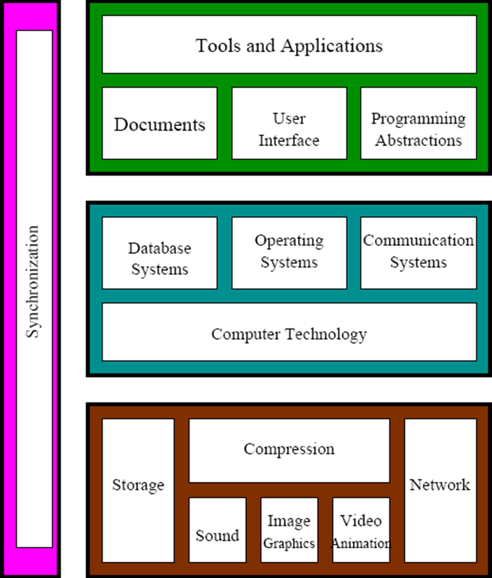

**Fig:-Global Structure Multimedia**

It encompasses of three main key elements and they are explained below in detail:-

I. Application Domain:-Application Domain issues functions to the user to develop and present multimedia projects. It usually comprises of software tools, multimedia projects development methodology.

ii. System Domain:-A system domain is a subdomain that every customer automatically receives with their order - regardless of whether they register a domain or not - that is generally used to test websites or applications. It comprises of all the supports essential for using the function of the device domain. Example: Operating System, Communication System and Database System.

iii. Device Domain:-It is a basic concepts and skill for processing various multimedia elements and for handling physical device.