**PURBANCHAL UNIVERSITY**



**DEPARTMENT OF COMPUTER ENGINEERING**

**KHWOPA ENGINEERING COLLEGE  
LIBALI-2, BHAKTAPUR**

**A FINAL PROJECT REPORT**

**ON**

**DODGE THE CAR**

Project work submitted in partial fulfilment of requirements for the award of the degree of Bachelor of Engineering in Computer Engineering (Third Semester)

**SUBMITTED BY**

Ashish Lawaju (750307)

Dina Manandha (750312)

Prashamsa Bakhrel (750323)

Rohan Kaju (750330)

**SUBMITTED TO**

Department of Computer Engineering

Khwopa Engineering College

**UNDER THE GUIDANCE OF**

Er. Bikash Chawal

7 November, 2020

**DEPARTMENT OF COMPUTER ENGINEERING**

**KHWOPA ENGINEERING COLLEGE  
LIBALI-2, BHAKTAPUR**

**CERTIFICATE**

This is to certify that the project entitled "**Dodge The Car**" submitted by Mr. Ashish Lawaju, Ms. Dina Manandhar, Ms. Prashamsa Bakhrel & Mr. Rohan Kaju in a partial fulfillment of the requirements for the award of the Degree of Bachelor of Engineering in Computer Engineering of Purbanchal University , is a bona fide work to the best of my/our knowledge and may be placed before the examination Board for their consideration.

**Panel of Examiners:**

|  |  |  |
| --- | --- | --- |
| **Name** | **Signature** | **Date** |
|  |  |  |
|  |  |  |
| **External Examiner** |  |  |
|  |  |  |
| Er. |  |  |
|  |  |  |
| **Project Supervisor** |  |  |
|  |  |  |
| Er. Bikash Chawal |  |  |
|  |  |  |
| **Head of Department** |  |  |
|  |  |  |
| Er. Reena Manandhar |  |  |

ACKNOWLEDGEMENT

This report is an outcome of inspiration and moral support of many people, especially our honourable teachers of Department of Computer Engineering, and we are always grateful to all of them. We also like to express to extend our sincere thanks to Head of Department, **Er. Reena Manandhar** for encouragement of this project. We take this opportunity to express our sincerest gratitude to all those who have inspired us to make this report.

We would also like to thank our supervisor **Er. Bikash Chawal** who helped us a lot in gathering different information, collecting data and guiding us from time to time and sharing us their valuable ideas in selecting project title as “**DODGE THE CAR**” despite of their busy schedules.

Finally, we are also grateful to our friends and our seniors for their supports and innovative ideas for this report.

Group members:

Ashish Lawaju (750307)

Dina Manandhar (750312)

Prashamsa Bakhrel (750323)

Rohan Kaju (750330)

ABSTRACT

In this project, we develop an arcade game that enhance concentration and helps us to pass our time. The player drives down a straight track dodging other car. The score of the player is recorded with relation to the number of the opponent cars dodged. This game ends when the car hits other car or the obstacles.

As the score of the player increases, the speed of the player car increases.

**TABLE OF CONTENTS**

CHAPTER 1 1

INTRODUCTION 1

1.1 Background 1

1.2 Motivation 1

1.3 Statement of Problems 1

1.4 Objectives 1

1.5 Scopes and Application 1

CHAPTER 2 2

LITERATURE REVIEW 2

CHAPTER 3 3

METHODOLOGY 3

3.1 Generic Model 3

3.2 Algorithm 3

3.3 Flowchart 4

3.4 Tools and Platforms 4

CHAPTER 4 5

PROJECT MANAGEMENT 5

4.1 Project members 5

4.2 Work breakdown structure 5

4.3 Activities table 5

CHAPTER 5 6

RESULTS AND DISCUSSION 6

5.1 Overview 6

5.2 Analysis of Result 6

CHAPTER 6 9

CONCLUSION AND RECOMMENDATION 9

6.1 Conclusion 9

6.2 Future Enhancement 9

REFERENCES 10

LIST OF FIGURES

3.1 Generic model 3

3.2 Flowchart 4

5.2.1 Main Menu 6

5.2.2 Game play 7

5.2.3 Car Crash 7

5.2.4 Game Tips 8

5.2.5 Score list 8

LIST OF TABLES

Table 1: Project member list 5

Table 2: Activities Table 5

# CHAPTER 1

# **INTRODUCTION**

* 1. Background

‘Dodge the car’ is a game where the player has to avoid the car with another car approaching from the opposite direction. Dodge Gamewas the first car dodging game developed by Carla Meninsky. There’s been over 2,000 [racing video game titles](https://thenewswheel.com/topics/video-game-cars/) released on console, arcade, portable, and digital platforms throughout the past 40 years. But it all started with one game. Way before the photo-realistic simulations we have today, Atari’s Gran Trak 10–the very first car racing video game ever–debuted, paving the way for the future of virtual racing.[1] Dodge game is also a game which has been conceptualized by the Gran Trak 10.

This game will demonstrate all the basic syntaxes, commands, functions, etc of C/C++ which will be an excellent example of game development. This project will be using the graphic features in C/C++ and we expect it to be user friendly and highly entertaining.

* 1. Motivation

This project is simple yet interesting and challenging. Games highly use graphics in C++ and we wanted to conduct a project using graphic feature in C++ which is dodge. It can also be said that it is also derived from the game two cars too.

* 1. Statement of Problems

In this project, we would develop a car dodging game using graphics in C/C++ and give the user controls to guide the movement of the car. We would make the game more challenging by increasing the speed of car as it moves ahead in scoreboard. Also, we are thinking of adding some ester eggs in-game, so that players would find in more

* 1. Objectives

The main objective of this game is to utilize the graphics and the other features of C++ in the game.

* 1. Scopes and Application

The main application of this game is to provide entertainment with challenges. It also helps the player to keep their mind concentrated. In the other hand, this game can be taken as reference to the present evolving arcade games with more complex and sophisticated concepts with great line of graphics.

# CHAPTER 2

# LITERATURE REVIEW

Reviewing, the literature on the topic area to help the researcher to make his/her work more advanced. It is the documentation of comprehensive review of the published and unpublished works form secondary sources data in the areas of specific interest to the researcher.

During the search of previously done projects similar to ours, we found a couple of them. So, we choose a project named ‘CAR GAME’[2] found in the internet as a reference to our project. This project was simple as it sounds, for the design of the car only a rectangle was used which did not even seemed like a car. It had a 3-lane system with strips to separate the lane. Those stripes were also animated so that the movement of the car seemed realistic. Storing the scores including their names was also among the primary features of this project. Now we are trying to develop something similar to this project considering some of their features and adding some new ones.

# CHAPTER 3

# METHODOLOGY

* 1. Generic Model**:**

Dodge the car

Exit

Main Menu

Play

Instruction

Gameplay

Scoreboard

3.1 Generic model

* 1. Algorithm**:**

Step 1: Research of the previous done similar project for reference.

Step 2: Design a friendly main menu section with start, high scores, instructions, exit and car and obstacles for the game.

Step 3: Check if the code runs properly and run the code.

Step 4: Select the option in the main menu.

Step 5: If start is selected, start the game and then go to step 9.

Step 6: If high scores is selected, show the high scores page.

Step 7: If help is selected, show the instructions page.

Step 8: If exit is selected, exit the game.

Step 9: If the player hits the obstacle, the game is ended.

Step 10: Then, enter the player name and save the score.

Step 11: End

* 1. Flowchart**:**

Main menu

Choose any one

T

F

T

Enter the name and show score

If Crash?

Game play

Start Game

High Scores

Exit

Help

Play again

F

3.2 Flowchart

2. 4. Tools and Platforms

During the development of the project, the tools and platforms that we used for coding and testing the project are:

1. Windows OS

2. Turbo C++

# CHAPTER 4

# PROJECT MANAGEMENT

4.1 Project members

For this project, we have group member of four group members:

|  |  |  |
| --- | --- | --- |
| **Name** | **Roll** | **Year/Sem** |
| Ashish Lawaju | 750307 | 2nd/3rd |
| Dina Manandhar | 750312 | 2nd/3rd |
| Prashamsa Bakhrel | 750323 | 2nd/3rd |
| Rohan Kaju | 750330 | 2nd/3rd |

Table 1: Project member list

4.2 Work breakdown structure

The entire project is divided into the graphical structure and the logical structure. The data or the coordinates from the graphics is used as the input for the logic of the game. Some team members were assigned to generate new ideas for the program and some were assigned to put the ideas into practice.

4.3 Activities table

The activities table for the proposed project is given below:

|  |  |  |  |  |  |  |  |  |  |  |  |  |  |
| --- | --- | --- | --- | --- | --- | --- | --- | --- | --- | --- | --- | --- | --- |
| Weeks  Work | 1st  12th Feb | 2nd  19th Feb | 3rd  26th Feb | 4th  4th Mar | 5th  11th Mar | 6th  18th Mar | 7th  25th Mar | 8th  1st April | 9th  8th April | 10th  15th April | 11th  22th April | 12th  Apr- Oct | 13th  Nov |
| Project Identification |  |  |  |  |  |  |  |  |  |  |  |  |  |
| Analysis |  |  |  |  |  |  |  |  |  |  |  |  |  |
| Design |  |  |  |  |  |  |  |  |  |  |  |  |  |
| Coding and Testing |  |  |  |  |  |  |  |  |  |  |  |  |  |
| Report making |  |  |  |  |  |  |  |  |  |  |  |  |  |
| Documentation |  |  |  |  |  |  |  |  |  |  |  |  |  |

Table 2: Activities Table

# CHAPTER 5

# RESULTS AND DISCUSSION

5.1 Overview

We have completed our game “Dodge the Car” using C. The obstacles come randomly and as per movement of the user car and we calculate the score and store it with user’s name. The game ends when the user car collide the obstacle approaching from opposite side.

While working in this project, we were actually able to implement the knowledge of C programming language. This project has helped us to enhance more knowledge about C languages and software development life cycle in a practical way.

5.2 Analysis of Result

We have worked the following components as below:

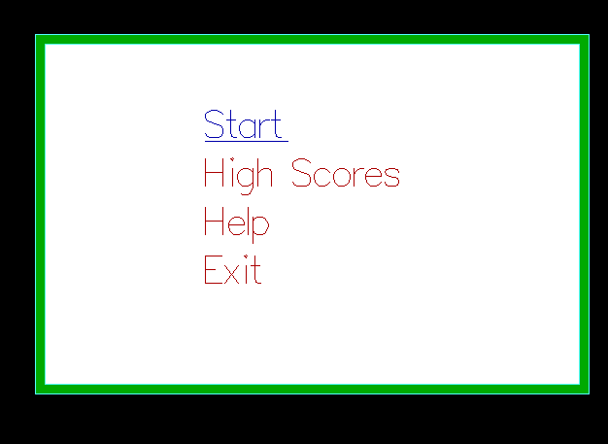

5.2.1 Main Menu

This is the menu page which includes start, high Scores, help and exit. We can select various options using keyboard.

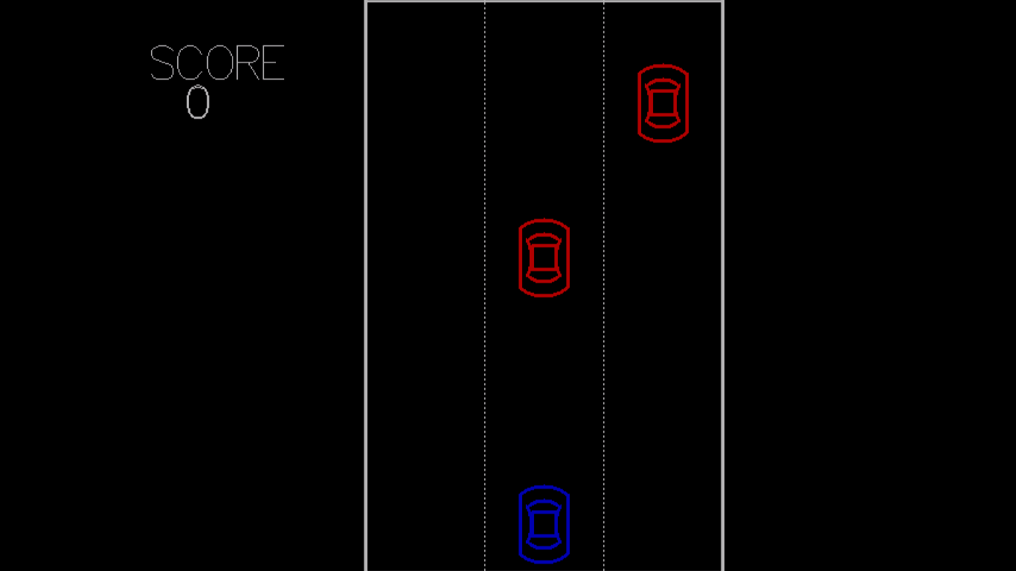

5.2.2 Game play

When the player clicks start option we can see obstacle car (red) at the top and user car (blue) as seen in the figure above.

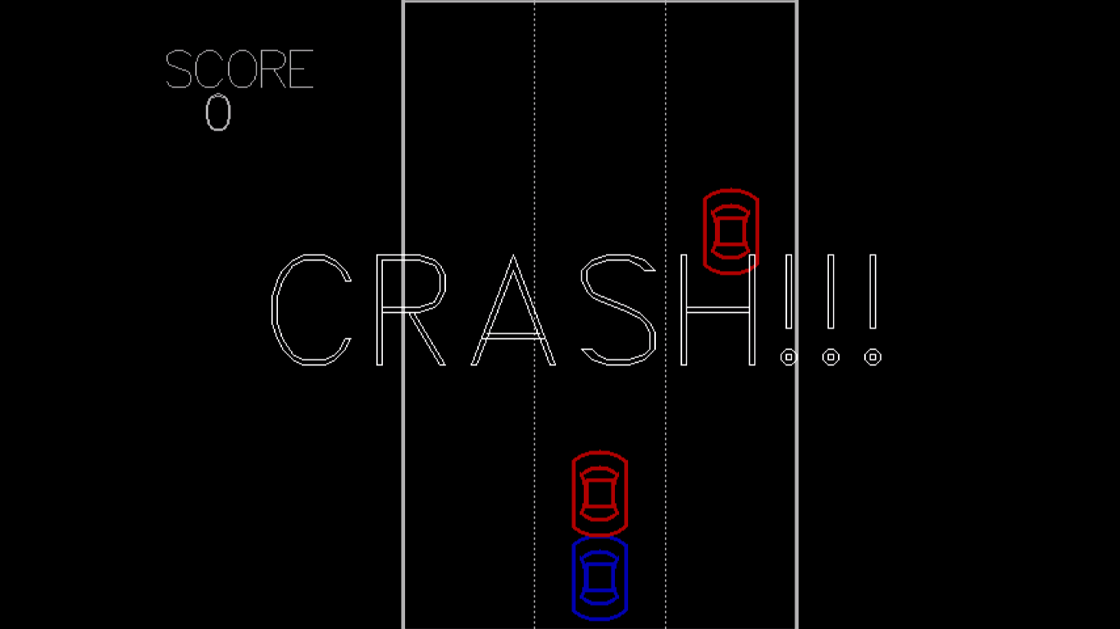

5.2.3 Car Crash

This is the figure when the car gets crashed.

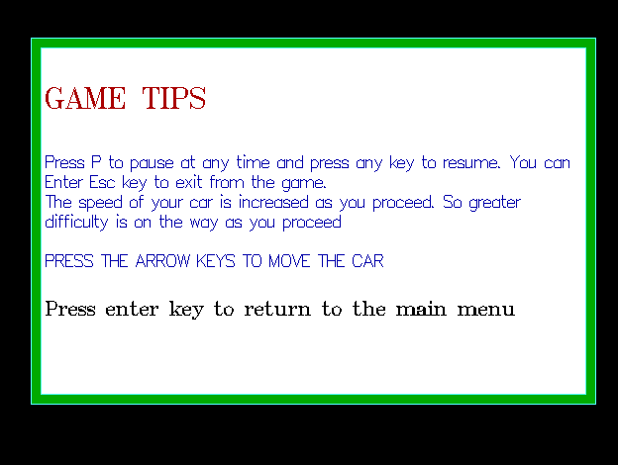

5.2.4 Game Tips

On selecting help option instructions is displayed.

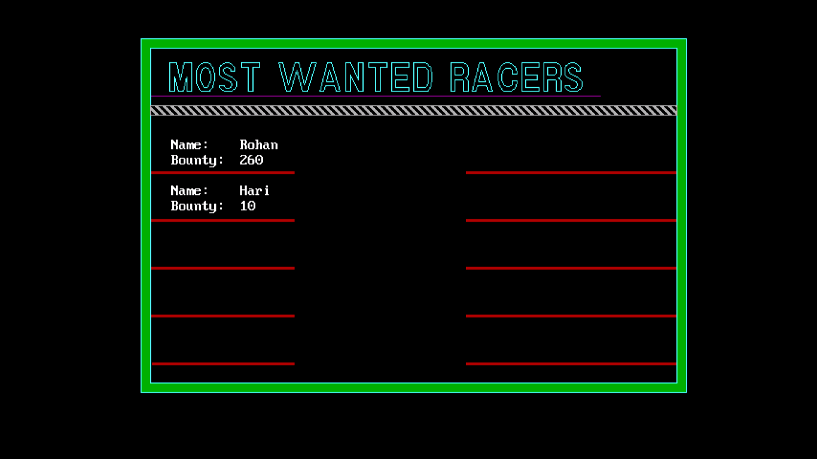

5.2.5 Score list

On selecting high sores, the scored scores are displayed.

# CHAPTER 6

# CONCLUSION AND RECOMMENDATION

6.1 Conclusion

Hence, after completion of the project we got familiar with the C programming and its features. As a whole, this project has been good experience for us. We have gained knowledge about the various aspects of C programming. At the same time we have developed a better understanding of graphics in C.

Since the project is completed but there are still lots of room for improvement.

6.2 Future Enhancement

A car dodging game can be developed with the knowledge about C programming language and its various features. This project is done with some basic knowledge and some research of C programming languages. Since we are beginner so there may be some flaws in the developed game. So, there are still improvements that can be done in our project.

1. The graphical interface can be improved.
2. The game can be made more attractive.
3. The game is not smooth as expected.
4. Mouse can be added to select with options.

# REFERENCES

1. <https://en.wikipedia.org/wiki/Gran_Trak_10> [visited March 15, 2020]
2. <http://yoineer.com/68Wx> [visited March 15, 2020]
3. <https://github.com/elshobokshy/ProjectCarRacing> [visited March 15, 2020]