Shimano Experience Platform
Multi-Repository Delivery Playbook & Architecture Guide
Target Audience: Development Teams, Tech Leads, Solution Architects, Security Engineers, & Leadership
Platform: Adobe Experience Manager as a Cloud Service (AEMaaCS), GitHub Actions, Git Subtree
Confluence Space: Engineering > Architecture & Delivery > Platform Playbook

1. Executive Snapshot: Why Multi-Repository?
Enterprise digital platforms must balance team independence with centralized deployment stability. Shimano achieves this by decoupling code into independent source repositories while automatically aggregating them for unified Adobe Cloud Platform deployments.
┌─────────────────────────────────────────────────────────────────────────────────────────────────┐
│ THE THREE VALUE PILLARS │
├───────────────────────────────┬─────────────────────────────────┬───────────────────────────────┤
│ ⚡ RAPID BUILD FEEDBACK │ 🛡️ ZERO-TOUCH AUTOMATION │ 🔒 EXTENSIBLE SECURITY │
│ Independent repositories │ GitHub Actions continuously │ Architecture readily supports│
│ enable fast, lightweight PR │ assembles, validates, and │ integrating SonarQube & │
│ validations per project. │ pushes code to Cloud Platform. │ Veracode security gates. │
└───────────────────────────────┴─────────────────────────────────┴───────────────────────────────┘

2. End-to-End Delivery Flow: From Developer to AEM Cloud

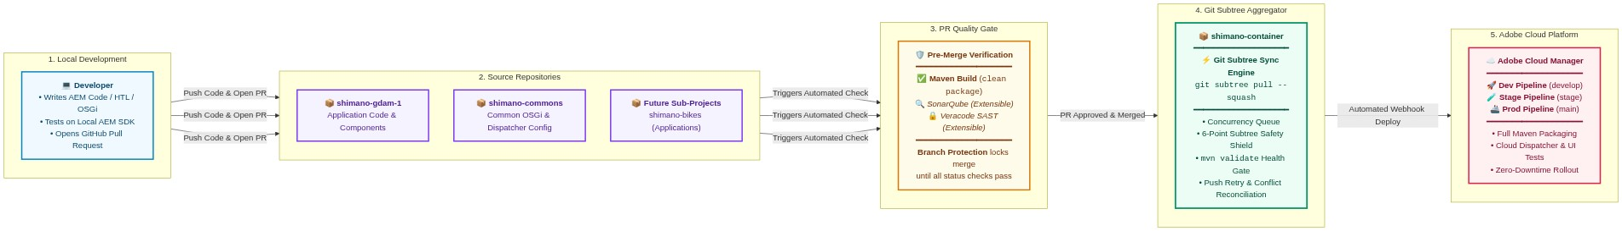

3. Pull Request Quality & Security Gates (Indicative Extensibility)
Each source repository enforces automated validation on pull requests. The architecture is designed to allow SonarQube code analysis and Veracode security scanning to be seamlessly introduced alongside the standard Maven build:
┌───────────────────────────────────────────────┐
│ PULL REQUEST OPENED │
└───────────────────────┬───────────────────────┘
│
┌───────────────────────┴───────────────────────┐
│ PARALLEL AUTOMATED GATES RUN CONCURRENTLY │
└───────────────────────┬───────────────────────┘
│
┌─────────────────────────────┼─────────────────────────────┐
▼ ▼ ▼
┌───────────────────┐ ┌───────────────────┐ ┌───────────────────┐
│ 1. Maven Build │ │ 2. SonarQube │ │ 3. Veracode SAST │
│ (Active) │ │ (Future / Option) │ │ (Future / Option) │
│ Fast compilation │ │ Code quality, │ │ Vulnerability & │
│ & package check │ │ coverage & smells│ │ security policies│
└─────────┬─────────┘ └─────────┬─────────┘ └─────────┬─────────┘
│ │ │
└─────────────────────────────┼─────────────────────────────┘
▼
┌───────────────────────────────────────┐
│ ALL REQUIRED CHECKS PASS (GREEN) │
└───────────────────┬───────────────────┘
▼
┌───────────────────────────────────────┐
│ 🔓 Merge Button Unlocked in GitHub │
└───────────────────────────────────────┘

How Branch Protection Rules Enforce These Checks:
In GitHub repository settings (Settings $\rightarrow$ Branches $\rightarrow$ Add branch protection rule for develop and main):
1. ✅ Require status checks to pass before merging:
- Validate PR Build (Active: runs `mvn -B clean package -DskipTests`)
- SonarQube Code Analysis (Can be enabled when SonarQube is onboarded)
- Veracode Security Scan (Can be enabled when Veracode scanning is onboarded)
2. ✅ Require branches to be up to date before merging (Prevents outdated code conflicts).
> Result: Whenever additional checks (like SonarQube or Veracode) are introduced, simply selecting their names under Branch Protection makes them mandatory prerequisites for merging.
Indicative PR Workflow Configuration (`pr-build.yml`)
📌 NOTE: Customizable Pre-Merge Checks & Toolchain Alignment: The workflow below is an indicative baseline. Development teams and project leads can modify, customize, or extend the pre-checks (such as adding unit tests, ESLint/Prettier code style checks, SonarQube quality gates, or Veracode SAST scans) as per project-specific quality and security requirements. The Java version in PR validation is aligned with Adobe Cloud Manager runtime requirements (Java 21).

name: Pull Request Verification & Security Gates
on:
pull_request:
branches: [ develop, main, stage, 'stage-*', 'release/**', 'hotfix/**' ]
jobs:
# Active Gate: Fast Maven Build Validation (Customizable)
maven-build:
name: Validate PR Build
runs-on: ubuntu-latest
steps:
- uses: actions/checkout@v4
- uses: actions/setup-java@v4
with: { java-version: '21', distribution: 'temurin', cache: maven }
- name: Build with Maven
run: mvn -B clean package -DskipTests
# Indicative Future Gate: SonarQube Code Quality Analysis
# sonarqube:
# name: SonarQube Code Analysis
# runs-on: ubuntu-latest
# steps:
# - uses: actions/checkout@v4
# with: { fetch-depth: 0 }
# - uses: actions/setup-java@v4
# with: { java-version: '21', distribution: 'temurin' }
# - name: SonarQube Scan
# env:
# SONAR_TOKEN: ${{ secrets.SONAR_TOKEN }}
# SONAR_HOST_URL: ${{ secrets.SONAR_HOST_URL }}
# run: mvn -B org.sonarsource.scanner.maven:sonar-maven-plugin:sonar
# Indicative Future Gate: Veracode Static Application Security Testing (SAST)
# veracode:
# name: Veracode Security Scan
# runs-on: ubuntu-latest
# steps:
# - uses: actions/checkout@v4
# - name: Veracode Pipeline Scan
# uses: veracode/veracode-pipeline-scan-action@v1
# with:
# vid: ${{ secrets.VERACODE_API_ID }}
# vkey: ${{ secrets.VERACODE_API_KEY }}
# file: "all/target/*.zip"
# fail_on_severity: "High, Very High"

4. Cross-Repository Dispatch Contract & Idempotency
When a pull request is merged in any source repository, trigger-container.yml sends a secure `repository_dispatch` event containing an immutable audit payload to shimano-container:
{
"event_type": "subtree_sync",
"client_payload": {
"source_repo": "shimano-gdam-1",
"source_branch": "develop",
"commit_sha": "46423dd6bf726ec1dc8d963d941015cb04c719e0",
"actor": "octocat-engineer",
"ref": "refs/heads/develop"
}
}

Payload Schema Definitions:
- `source_repo`: Name of the originating repository, determining the subtree folder prefix (e.g. shimano-gdam-1/).
- `source_branch`: Name of the target branch in the source repository.
- `commit_sha`: Exact Git commit SHA being synchronized for deterministic release tracking.
- `actor`: GitHub identity (github.actor) associated with the workflow execution, retained for audit and traceability.
- `ref`: Full Git ref path (refs/heads/develop).
🔁 Idempotency Guarantee
> Idempotency Contract: For the same source repository, source branch, source commit SHA, and target container branch, processing the same event multiple times must not create duplicate synchronization commits.
If GitHub Actions delivers a duplicate dispatch event or a workflow run is manually re-triggered for the same commit, the synchronization engine evaluates commit hashes after git subtree pull:
if [ "$LOCAL_SHA" = "$REMOTE_SHA" ]; then
echo "ℹ️ Container is already up-to-date with ${SOURCE_REPO}. No changes to push."
exit 0
fi

Repeated processing of the same source commit is designed to be idempotent and does not create another synchronization commit when that source commit is already represented in the target subtree.
5. Concurrency Architecture: Primary Queue & Defensive Retry
To handle simultaneous merges across multiple source repositories, the system utilizes a two-tier concurrency control model:
SIMULTANEOUS SYNC EVENTS
(GDAM & Commons Merged at t=0)
│
▼
┌───────────────────────────────────────────────┐
│ TIER 1: GitHub Concurrency Queue │
│ concurrency.group = subtree-sync-${branch} │
│ cancel-in-progress: false (Sequential Queue) │
└───────────────────────┬───────────────────────┘
│
▼
[ Job 1: Process GDAM ]
[ Job 2: Queued... ]
│
▼
┌───────────────────────────────────────────────┐
│ TIER 2: Defensive Conflict Retry │
│ Fetches, merges, and validates if a push │
│ collision occurs during container git push. │
└───────────────────────────────────────────────┘

1. Tier 1 — Concurrency Queue (Primary Gate): GitHub Actions groups runs by target branch (subtree-sync-develop). With cancel-in-progress: false, jobs are queued sequentially rather than executing in parallel on the same branch.
2. Tier 2 — Push Retry & Conflict Reconciliation (Safety Net): If a concurrent container update causes the push to be rejected (push collision), the synchronization engine fetches the latest container state, attempts a non-interactive merge (merge --no-edit), re-runs Maven validation, and retries the push automatically (up to 3 attempts). If Git cannot reconcile the histories automatically, the workflow fails safely for manual engineer resolution.
6. Real-World Practical Scenarios
Scenario 1: Developing and Deploying a New Feature
> Context: An engineer creates a new interactive Product Carousel component in shimano-gdam-1.
1. Fast PR Feedback: The engineer opens a PR. Maven quickly verifies compilation, dependencies, and packages without waiting on unrelated projects.
2. Review & Merge: The Tech Lead reviews and merges the PR into develop.
3. Automated Subtree Pull: GitHub Actions triggers git subtree pull --squash in shimano-container.
4. Cloud Deployment: The aggregated container update triggers the configured Adobe Cloud Manager deployment pipeline for the target environment.
Scenario 2: Simultaneous Merges (Conflict Reconciliation)
> Context: Two engineers merge PRs in GDAM and Commons at the exact same moment.

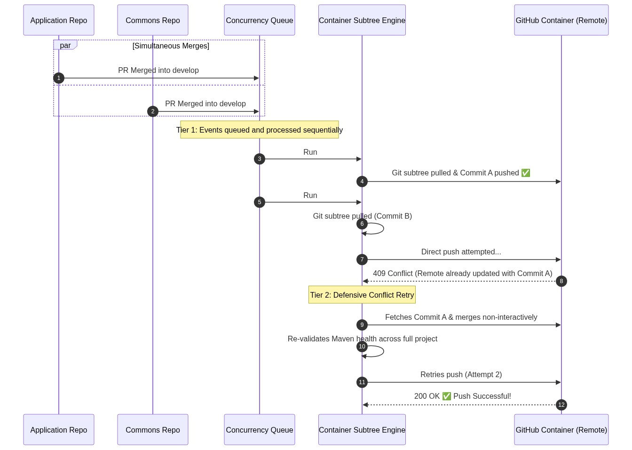

Scenario 3: Catching Issues Early (Quality & Security Guardrails)
> Context: A pull request inadvertently includes invalid XML, broken module syntax, or a flagged security dependency.
- Outcome: The PR check fails during pre-merge validation.
- Protection in Action: GitHub marks the check as failed (❌) and locks the Merge button.
- Result: The issue is caught immediately inside the source repository before ever reaching the container or disrupting Cloud Platform deployment pipelines.
Scenario 4: Adding an Additional Sub-Project (e.g., `shimano-bikes`)
> Context: A new team or brand agency is onboarded to build the Shimano Bikes application.
> Onboarding Paradigm: One-time container POM module configuration + zero-touch source synchronization thereafter.
1. Step 1 (Source Repo): Add the dispatch workflow [.github/workflows/trigger-container.yml](../shimano-gdam-1/.github/workflows/trigger-container.yml) to shimano-bikes.
2. Step 2 (Container POM): Add <module>shimano-bikes</module> to shimano-container/pom.xml.
3. Step 3 (Automatic Subtree Provisioning on First Sync): The container workflow automatically provisions the project on the very first PR merge!
- In scripts/update_subtree.sh, the engine automatically detects missing directories:
`bash
if [ ! -d "$SUBTREE_PREFIX" ]; then
# Subtree directory doesn't exist yet -> Automatically executes 'git subtree add'
git subtree add --prefix="$SUBTREE_PREFIX" "$SOURCE_REMOTE" "$SOURCE_BRANCH" --squash
else
# Subtree directory exists -> Executes 'git subtree pull'
git subtree pull --prefix="$SUBTREE_PREFIX" "$SOURCE_REMOTE" "$SOURCE_BRANCH" --squash
fi

4. Outcome: After the one-time container POM configuration, no manual Git CLI commands are required for normal synchronization. The first qualifying merge automatically provisions the subtree, validates the reactor, and—if validation succeeds—updates the container.
7. The 6-Point Subtree Synchronization Safety Shield
Before any code is pushed to the container repository, the sync script executes 6 automated safeguards:
Safeguard | Mechanism | Purpose
1. Whitelist Filter | Evaluates branch against ALLOWED_BRANCHES (main,develop,stage,stage-*,release/*,hotfix/*). | Feature branches (feature/*) are skipped, preserving CI runner minutes.
2. Branch Governance | Verifies that target branch already exists in shimano-container. | Prevents source repos from creating untracked branches in the container.
3. Zero Silent Fallback | Verifies source branch existence on remote. | Eliminates fallback pollution to main by failing fast (exit 1) on invalid branches.
4. Git Subtree Squash | Imports commits using git subtree pull --squash. | Keeps container Git history clean (1 concise commit per PR merge).
5. Reactor Health Gate | Executes mvn -B validate across all aggregated modules in seconds. | Validates Maven reactor hierarchy, POM XML schemas, and module linkages before push.
6. Conflict Reconciliation | Retries up to 3 times with fetch + merge + re-validate. | Defensive safety net against push collisions during rapid concurrent updates.

8. Branch Governance & Environment Mapping (1:1 Model)
Each whitelisted source branch maps strictly 1:1 to its corresponding container branch:
Source Repository Branch | Aggregator Container Branch | Adobe Cloud Platform Environment | Deployment Behavior
`develop` | `develop` | Dev / Non-Production | Automatic on PR merge (Continuous Delivery)
`stage` | `stage` | Stage / QA Environment | Automatic / Scheduled QA pipeline
`stage-*` (e.g. `stage-2`) | `stage-*` (e.g. `stage-2`) | Target QA Sandbox | Synchronizes only if container branch exists
`release/*` (e.g. `release/1.0`) | `release/*` (e.g. `release/1.0`) | Pre-Production Staging | Controlled Release Approval
`main` | `main` | Production Environment | Production Pipeline with Quality Gates
`feature/*`, `bugfix/*` | N/A (Skipped) | Local AEM SDK | Fast PR validation inside source repository

9. Operational Observability & Incident Runbook
Log Locations & Traceability
All synchronization runs are recorded in GitHub Actions under the Actions tab of shimano-container:
- Workflow Name: Synchronize Subtree in Container
- Logged Diagnostic Context:
- Source Repository: e.g. shimano-gdam-1
- Source Branch: e.g. develop
- Commit SHA: e.g. 46423dd6bf726ec1dc8d963d941015cb04c719e0
- Triggering Actor: GitHub username (github.actor)
- Attempt Number: Retry counter (1 of 3)
Failure Remediation Runbook
When a synchronization workflow fails, follow this 3-step triage and remediation procedure:
┌─────────────────────────────────────────────────────────────────────────────────────────────────┐
│ 3-STEP INCIDENT REMEDIATION │
├───────────────────────────────┬─────────────────────────────────┬───────────────────────────────┤
│ 1. IDENTIFY │ 2. INSPECT │ 3. RESOLVE │
│ GitHub alerts admins & actor │ Open runner logs in │ Apply targeted fix below │
│ on workflow failure (❌). │ shimano-container Actions tab. │ and re-sync. │
└───────────────────────────────┴─────────────────────────────────┴───────────────────────────────┘

Common Failure Scenarios & Resolution Actions:
Failure Cause | Log Error Indicator | Remediation Steps
1. Maven Reactor Failure | ERROR: Maven reactor validation failed! Aborting push. | Cause: A broken POM XML, syntax error, or unresolvable module dependency was merged in the source repo.  Action: Fix the POM / XML in the source repository, verify locally with mvn validate, merge the fix into the target branch, and the container will automatically re-sync.
2. Target Branch Not Initialized | Target branch '<branch>' does not exist in container. Skipping. | Cause: A new release/stage branch (e.g. stage-2 or release/v2.0) was created in the source repo before being created in shimano-container.  Action: Create the corresponding branch in shimano-container (git checkout -b <branch> origin/main && git push origin <branch>), then manually trigger the workflow via GitHub UI.
3. Source Branch Missing on Remote | ERROR: Source branch '<branch>' does not exist on remote repository! | Cause: Typo in branch name or deleted remote branch.  Action: Verify that the branch exists on the source repository remote.
4. Subtree Conflict | Automatic merge failed; fix conflicts and then commit the result. | Cause: Divergent changes made directly in the container directory for that prefix.  Action: Resolve the conflict locally in shimano-container and push to remote. (Rule: Always make code changes in source repos, never directly in container subtree folders).

Manual Re-Sync Procedure (Workflow Dispatch)
If an automated synchronization fails or needs to be manually triggered:
1. Navigate to `shimano-container` on GitHub $\rightarrow$ Click the Actions tab.
2. Select `Synchronize Subtree in Container` from the left-hand workflow list.
3. Click Run workflow (top right dropdown):
- Source Repository: Select shimano-gdam-1 or shimano-commons.
- Source Branch: Enter target branch name (e.g. develop or stage).
4. Click Run workflow.
10. Centralized Organization-Level Governance
In production enterprise deployments, tokens and variables are managed centrally at the GitHub Organization Level (Settings > Secrets and variables > Actions):
GITHUB ORGANIZATION LEVEL
(Settings > Secrets and variables > Actions)
│
┌───────────────────────────┴───────────────────────────┐
▼ ▼
ORGANIZATION SECRET: ORGANIZATION VARIABLE:
CONTAINER_DISPATCH_TOKEN ALLOWED_BRANCHES
(Shared across all Shimano repos) (Central branch policy)
│ │
├───────────────────────────┬───────────────────────────┤
▼ ▼ ▼
[ shimano-gdam-1 ] [ shimano-commons ] [ shimano-container ]

Centralized Management Benefits:
- Zero Token Duplication: Managed once at the Organization level (Settings > Secrets > Actions > Organization secrets) and inherited by all project repositories (shimano-gdam-1, shimano-commons, shimano-bikes, shimano-container).
- Granular Repository Access: Organization administrators control exactly which repositories can access the dispatch token.
- Enterprise Policy Ownership: ALLOWED_BRANCHES and security tokens are governed centrally without requiring per-repository configuration changes.
11. Configuration Secrets & Variables Reference
Parameter | Scope | Where Configured | Purpose
CONTAINER_DISPATCH_TOKEN | Secret | GitHub Organization Secrets (or repo level) | Authentication token with repo scope to authenticate cross-repo dispatch and subtree operations.
SONAR_TOKEN | Secret (Optional) | Organization / Source Repos | Authentication token when SonarQube / SonarCloud scanning is configured.
VERACODE_API_ID / KEY | Secret (Optional) | Organization / Source Repos | API credentials when Veracode SAST static security scanning is configured.
ALLOWED_BRANCHES | Variable | GitHub Organization Variables (or repo level) | Centralized list of whitelisted branch patterns (Default: main,develop,stage,stage-*,release/*,hotfix/*).

12. Developer Golden Rules, Architecture Boundary & Layout
📌 The 3 Developer Golden Rules
📌 IMPORTANT: 1. Work Exclusively in Source Repositories: Developers clone and push code only within their designated source codebases (shimano-gdam-1, shimano-commons, shimano-bikes). The container repository is a deployment aggregation layer and is not an authoritative source for application code. Direct code changes or commits inside shimano-container are strictly prohibited.
2. Enforce Clean PRs with Passing Checks: Merges into develop, stage, or main require an approved Pull Request with all status checks (Maven, SonarQube, Veracode) passing green.
3. Autonomous Local Development: Local feature development and testing run completely inside the source repository using the local AEM SDK, without requiring access or synchronization to shimano-container.

🛡️ Deployment Aggregator Boundary & Disaster Recovery
- Deployment Boundary: shimano-container is the deployment aggregation boundary for the platform. It combines independently owned source repositories into a buildable Maven reactor for Adobe Cloud Manager. Source repositories remain the authoritative systems of record for application code.
- Disaster Recovery & Rebuildability: Because shimano-container is non-authoritative and its application source content is derived from the source repositories, the container deployment repository can be reconstructed at any time by re-initializing the container POM, configuring subtree remotes, and triggering subtree synchronization.
📂 Container Aggregator Repository Structure
When shimano-container builds for Adobe Cloud Manager, it aggregates the source repositories into the following unified reactor layout:
shimano-container/ <-- Central Deployment Aggregator Repository (Non-Authoritative)
├── .cloudmanager/
│ └── java-version <-- Specifies JDK version for Cloud Manager (Java 21)
├── .github/
│ └── workflows/
│ └── update-subtree.yml <-- Subtree Sync Engine & Health Gate
├── scripts/
│ └── update_subtree.sh <-- Sync Script (6-Point Safety Shield)
├── all/ <-- Combined All-Package for Cloud Manager
├── dispatcher/ <-- Cloud Manager Dispatcher Configuration
├── shimano-commons/ <-- Subtree: Common OSGi & Dispatcher Config
├── shimano-gdam-1/ <-- Subtree: GDAM Application Code & Components
├── shimano-bikes/ <-- Subtree: Shimano Bikes Application Code
└── pom.xml <-- Parent Reactor POM (Aggregates all modules)

