

Prashanth A R

x16137591

**Salesforce Implementation of Automobile Service Center**

**INTRODUCTION**

Customer Relationship Management (*also known as CRM*) is a core aspect of any organization to improve their business relationships and attract new customers, With the introduction of cloud applications it has become easier for the companies to be continuously connected to customers on the go by developing mobile and web applications. CRM plays an important part to understand the user interactions and develop a relationship to retain the customers for a longer period. There are many CRM applications like Zoho, Microsoft Dynamics, Apptivo and so on. The most popular cloud application among these group is Salesforce.



Salesforce is a cloud computing enterprise situated with its headquarters in San Francisco, California. It was developed to serve as Software as a Service (SaaS) and later extended its functionality to Sales Cloud, Data Cloud, Community Cloud, App Cloud etc.,

Using this platform, it is easy to build applications, leverage in built functionalities to integrate customers and improve the interaction. The most striking feature of this platform is that it is possible to build an application from scratch with just mouse clicks, enabling non-programmers to utilize this platform to create their custom applications.

In this project, I have built an application for an Automobile Service Center to store the details of customers, products, service history, invoices and so on. The motive is to leverage cloud platform to build customer relationship attract more customers and automate few processes to eventually increase the profits of the service center.

**Proposed Product**

A Salesforce application to record the operations of an automobile service center and the details of customers in an organized way to generate reports and dashboards. The application helps as a source to improve customer satisfaction and draw new customers. The present system is more of a manual approach and is disoriented. The purpose is to reduce the manual work in generating and maintaining the data and automate few processes to reduce human involvement in the process. It is a better practice to have all the data in a single place so that maintaining it becomes easy and analysis can be performed on them to develop insights of what customers expect from the company.

**Current Scenario**

Majority of the small to medium service centers use software like excel to store the data related to customers and service related data. They do not possess centralized database to access the required data at once. They have paper based transactions and make minimum use of technology for their transactions. Every time the customers must be called once the service on the vehicle is finished, this is a time-consuming process which can be automated.

Providing certain additional features is an effective way to attract customers and be a better performer in a competitive market. To achieve this, it is necessary to understand what customers want and provide benefits accordingly. The proposed application tries to integrate the customers into the process.

**Benefits of the Proposed System**

* Easier to access any data as all the related information will be available in a single application in the form of objects.
* Reports can be generated on service history, customer feedback, spares consumption and can be analyzed to improve quality of service and customer satisfaction.
* Recognizing the regular customers and providing more offers to them will not only attract new customers but also helps in retaining them for a longer period.
* Productivity of the employees can be measured by the reports generated of services.
* Ability to forecast the future date of service for the vehicle by utilizing the past records.
* It becomes possible to focus on particular aspect of performance by analyzing the report and improve it.
* Data stored in objects acts as a source for generating reports and dashboards for analysis.

**Entity Relationship Model**

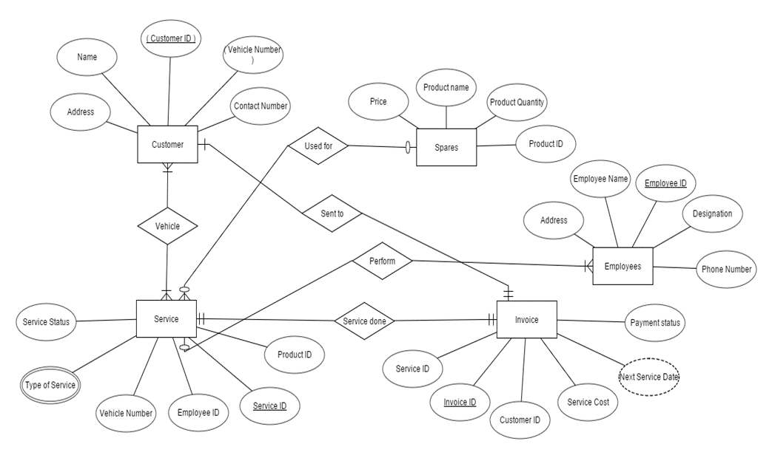

Figure 1: E-R Model for Automobile Service Center

Above diagram represents the Entity Relationship model of the proposed system. Here, the entities represent the objects and the attributes represent the fields of the objects in the application. The relationship between different entities is defined by lookup and master-detail relationships in the application.

Next section describes the process flow of an automobile service center.

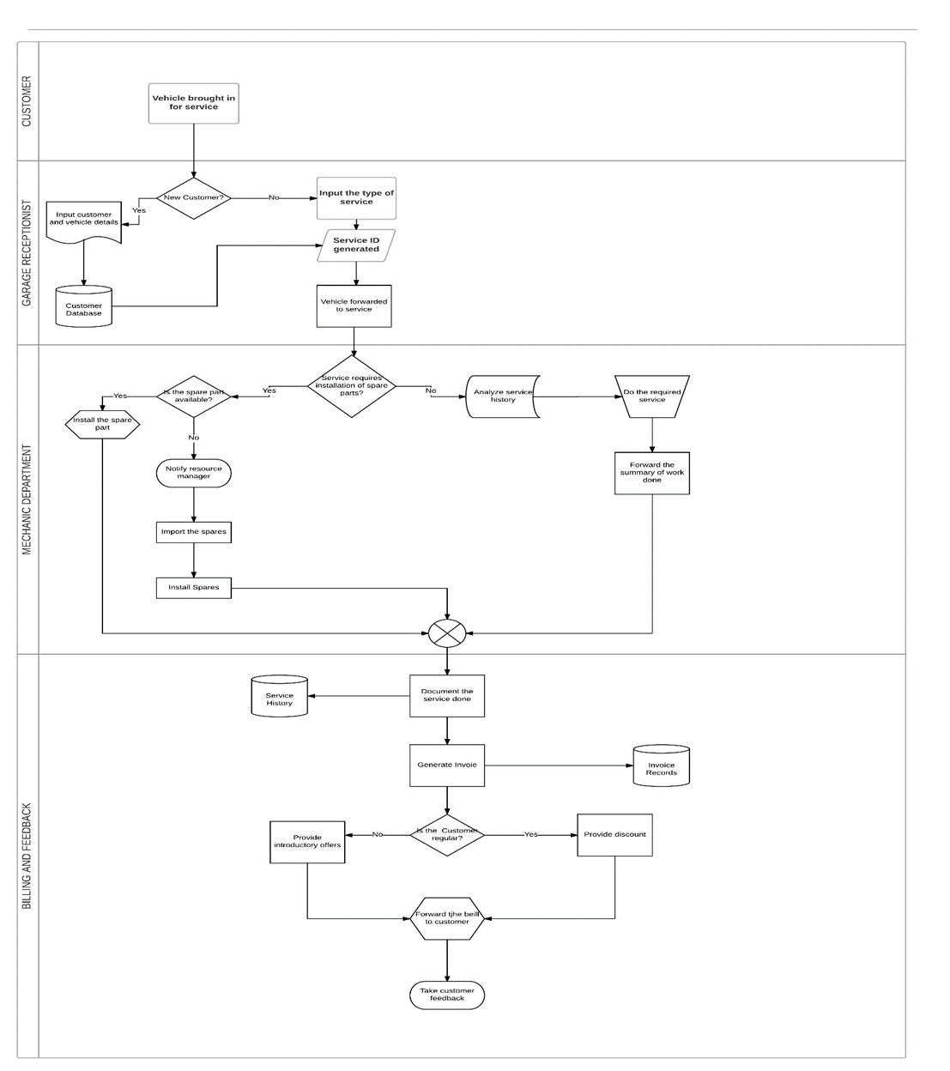

Figure 2: Process Flow Diagram

**Schema Design**

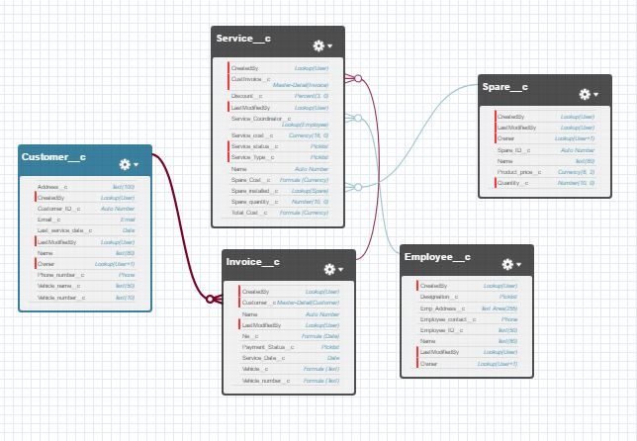

Figure 3: Schema Design

A schema is on overall structure of a database, it captures the key objects and their participation in the database.

The above diagram represents the schema design of the proposed system. It also shows the relationship between the objects.

The description of objects and the custom field for each object is explained in the next section.

**Objects**

Below is the list of the objects used, their description and their fields:

**Customer**

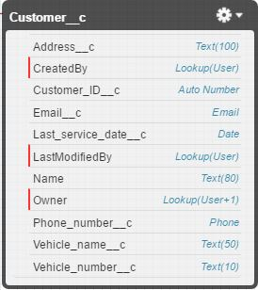

This object stores the details of a customer such as their name, address, phone number, vehicle name, vehicle number etc.,

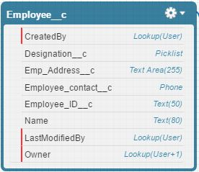**Employee**

This object stores the details of the employees of the service center such as their name, employee ID, phone number, designation and so on.

**Spares**

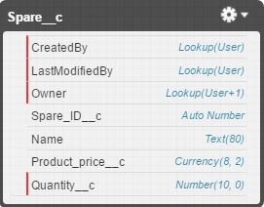

This object stores the details of list of available spares, their cost and their quantity.

**Invoice**

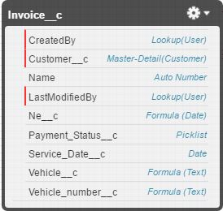

This object stores the invoice ID, payment status, customer information, service date and so on.

**Service**

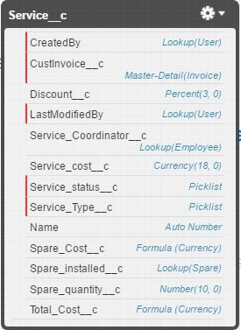

This object has all the details of the service performed on the vehicle such as service id, type of service performed, spares installed (if any), discounts offered, total cost of the service. It uses lookup relationships to connect to customer and invoice object to derive some of their fields.

The following actions takes place when a vehicle is bought in for service

1. If the customer is new, his/her details are first fed into the customer object. If it is an existing customer, an invoice ID is generated as a reference for service.
2. A Service ID is generated and the details required for the service such as service type, spares required and their quantity, employee coordinating the service is populated.
3. Once the service is completed, an email is triggered to notify the user.
4. An email is triggered the day after the service to take the customer feedback on the service performed on the vehicle.
5. A reminder email is triggered the day before the service date of a particular customer to notify them about the upcoming service

**Customer**

**Fields and Relationships**

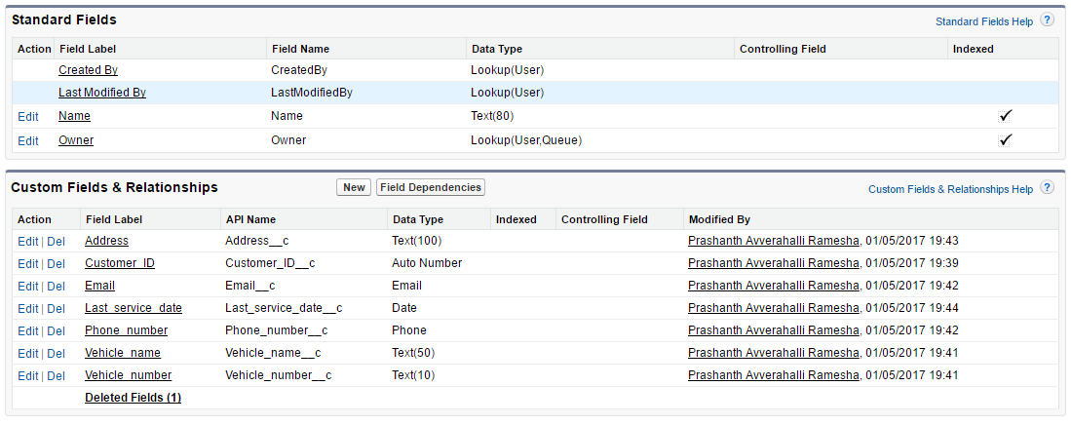

**Customer Layout**

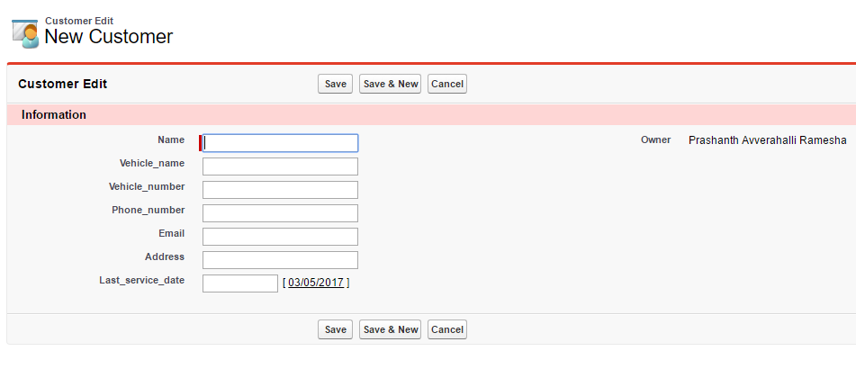

**Customer Values**

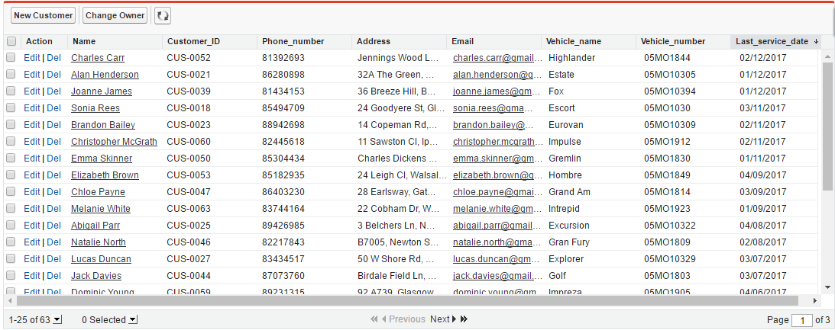

The data for the customers was created using a website which generates fictitious data. The generated data was exported to excel and brought into Salesforce app using import wizard.

**Choosing the custom object to populate the data**

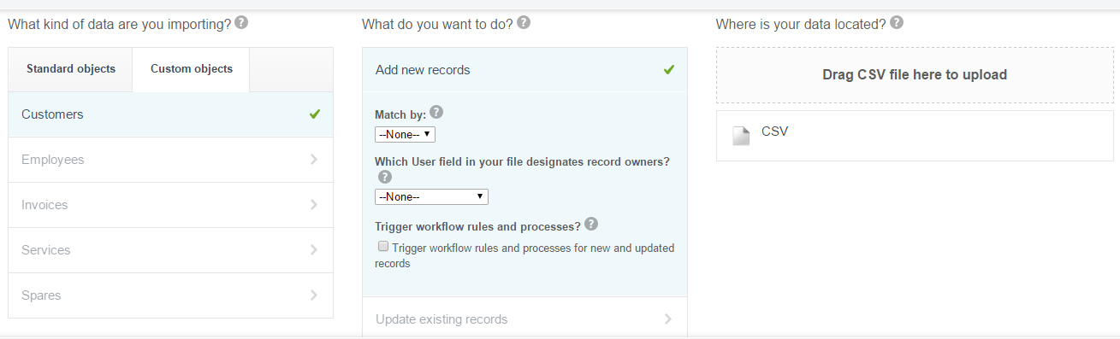

**Mapping the fields from excel source**

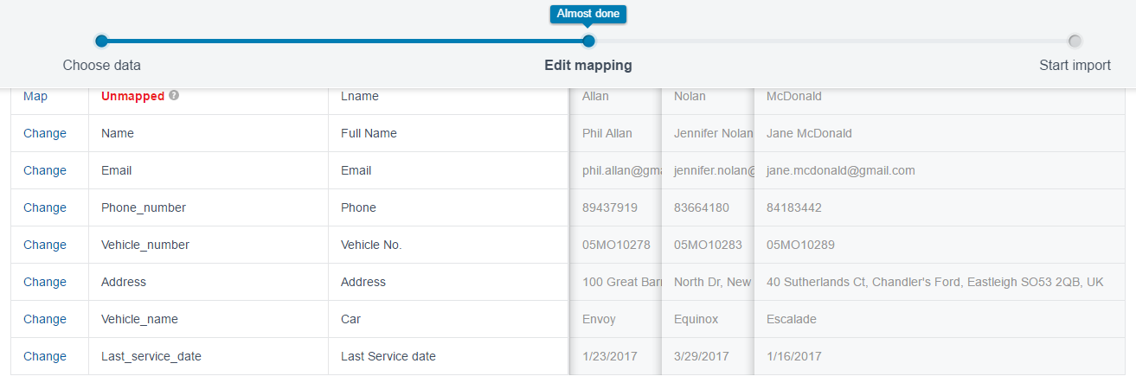

**Excel file data generated by website**

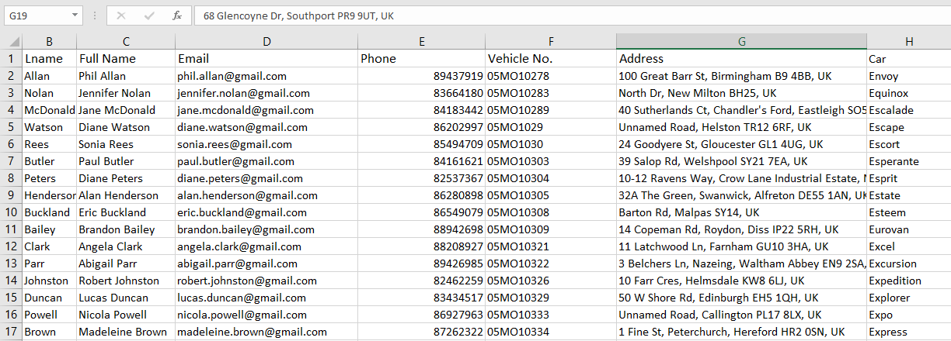

**After Import**

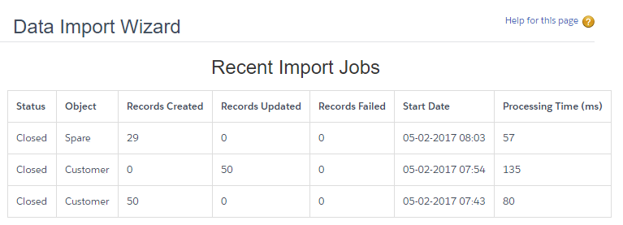

**Employee**

**Fields and Relationships**

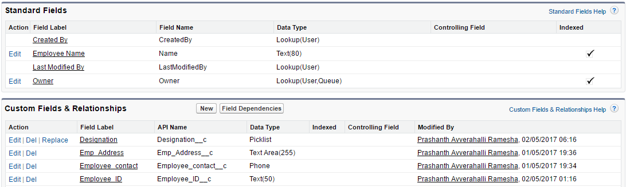

**Employee Layout**

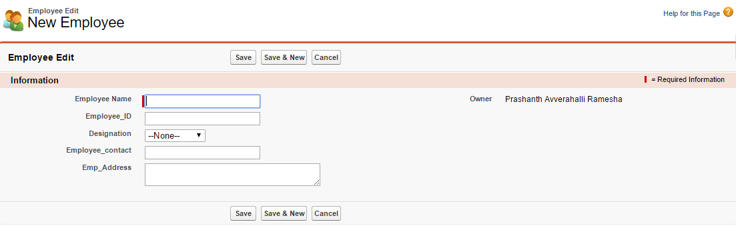

**Employee Values**

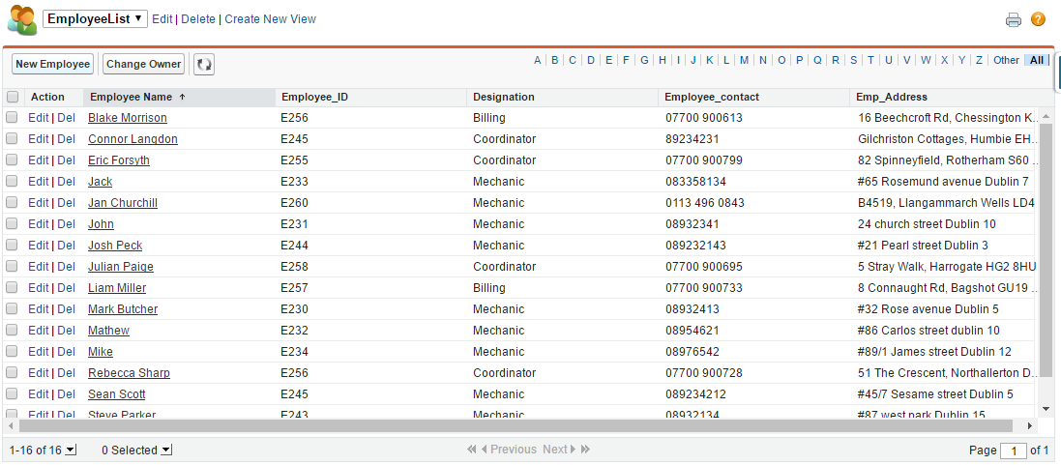

**Spares**

**Fields and Relationships**

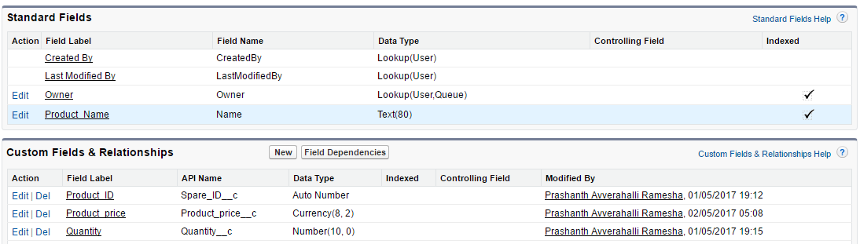

**Spares Layout**

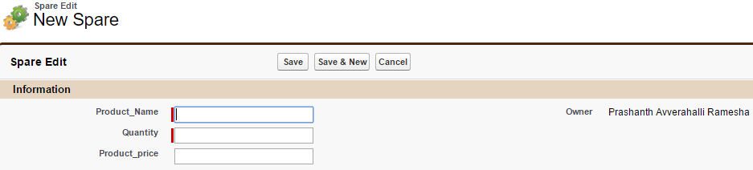

**Spares Values**

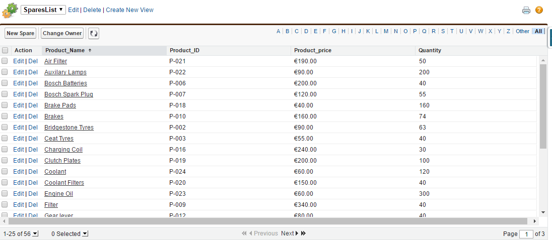

**Service**

**Fields and Relationships**

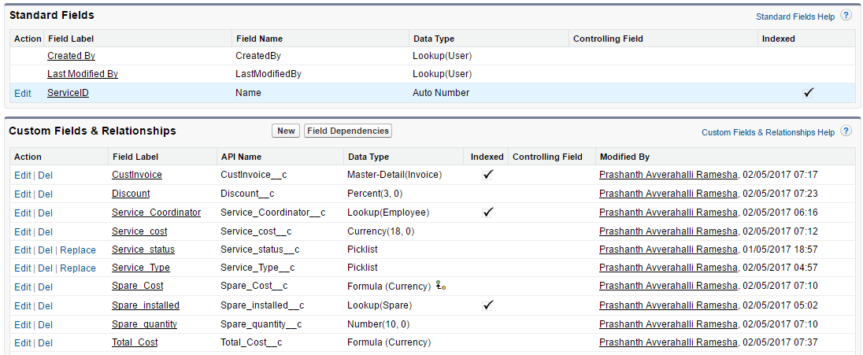

**Master – Detail Relationship between Service and Invoice**

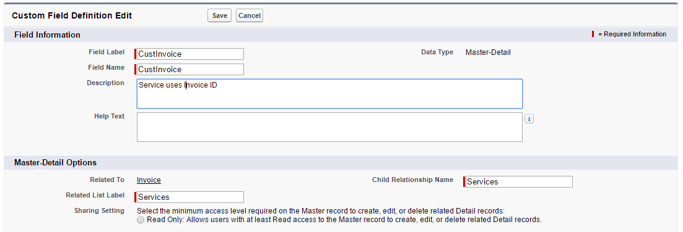**Calculating the spares cost**

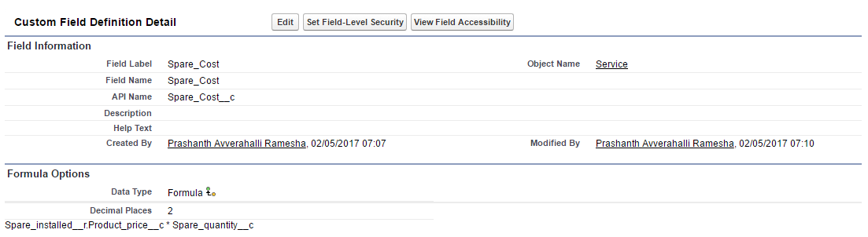

**Calculating total service cost**

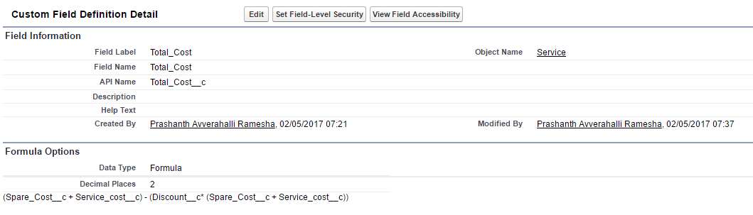

**Picklist values for type of service**

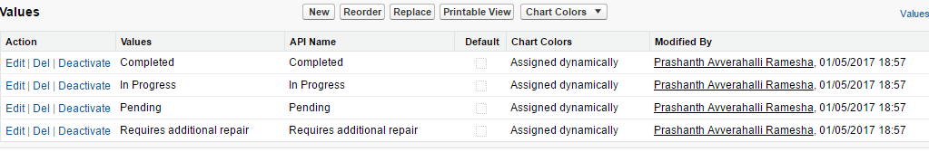

**Picklist values for status of service**

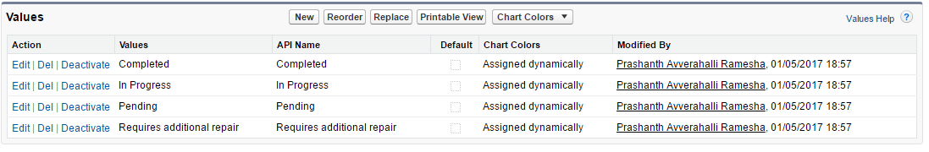

**Spares Layout**

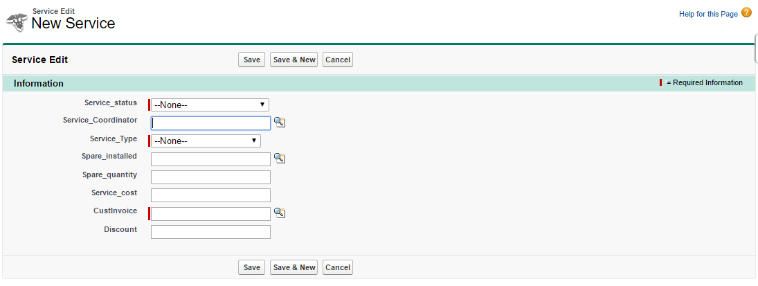

**Spares Values**

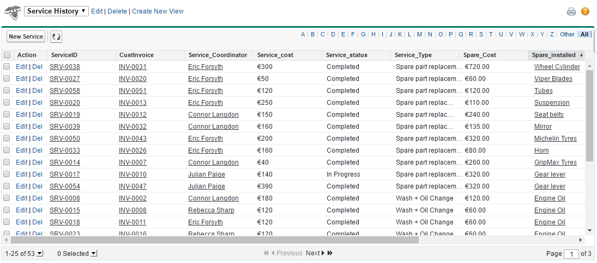

**Invoice**

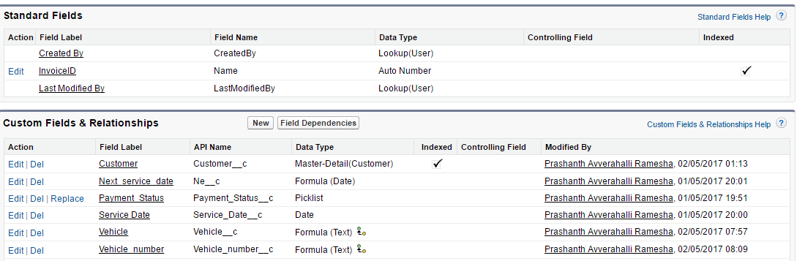**Fields and Relationships**

**Master-Detail Relationship between Customer and Invoice**

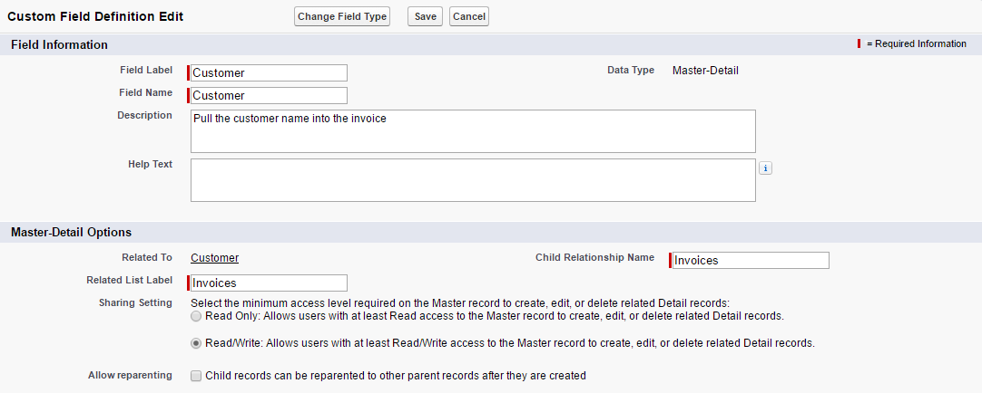

**Calculating the next service date**

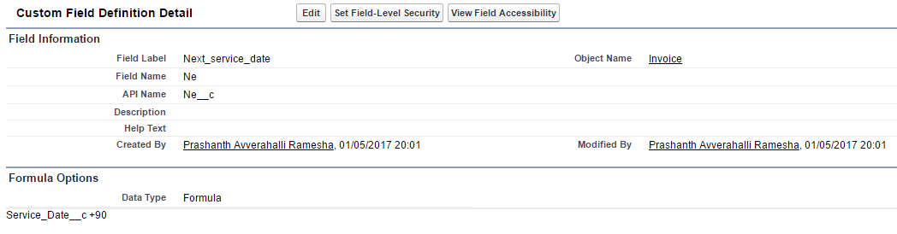

**Pulling the vehicle name and number from the customer object using formula**

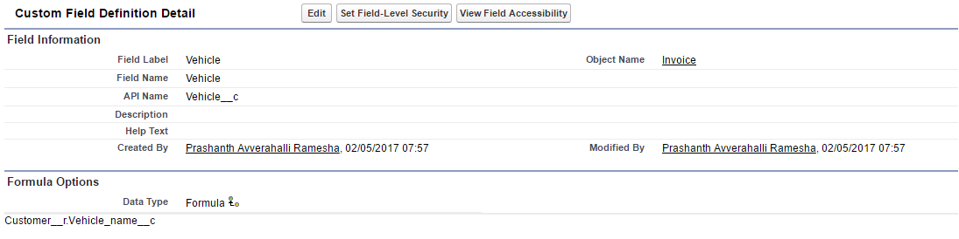

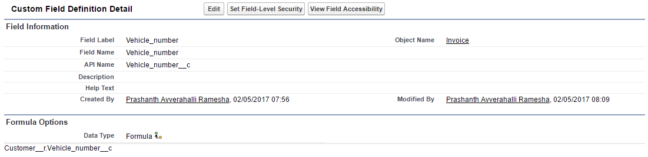

**Invoice Layout**

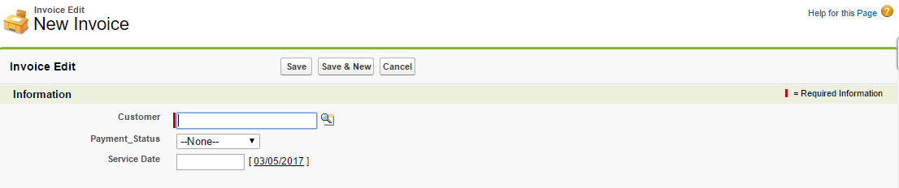

**Invoice Values**

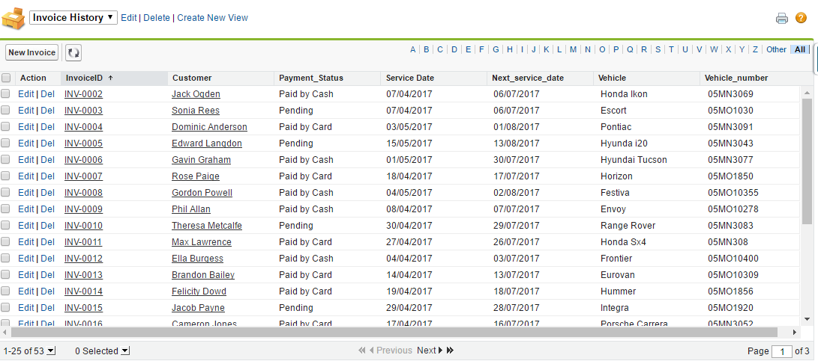

Once the objects have been created and populated, the app home window will look like below:

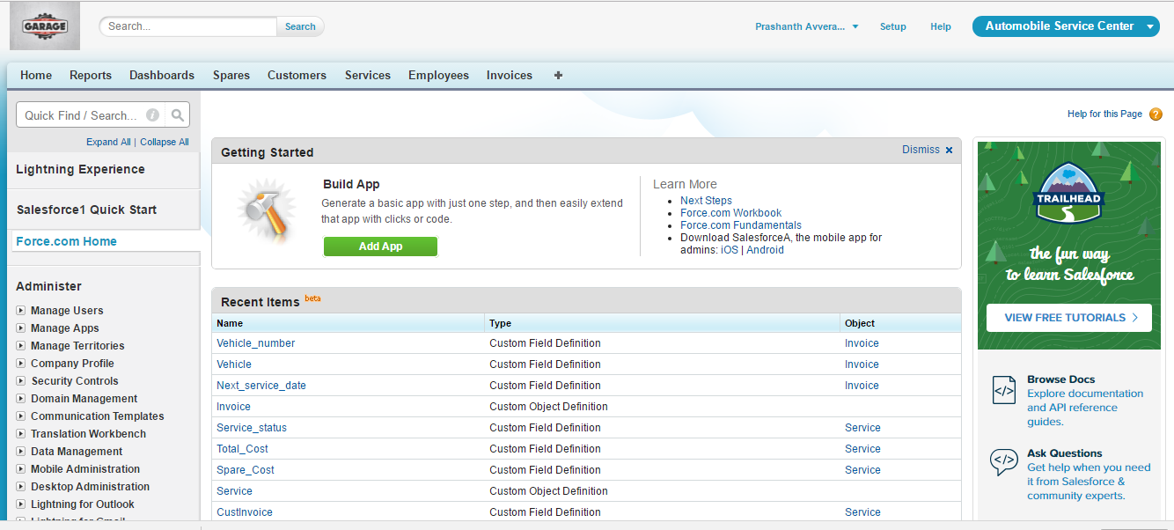

**Workflow Actions**

I have defined 3 workflow actions which triggers automatic emails to customers at 3 different phases-

1. Once the service status is set to completed, an email is triggered notifying the user that his/her vehicle has been serviced.

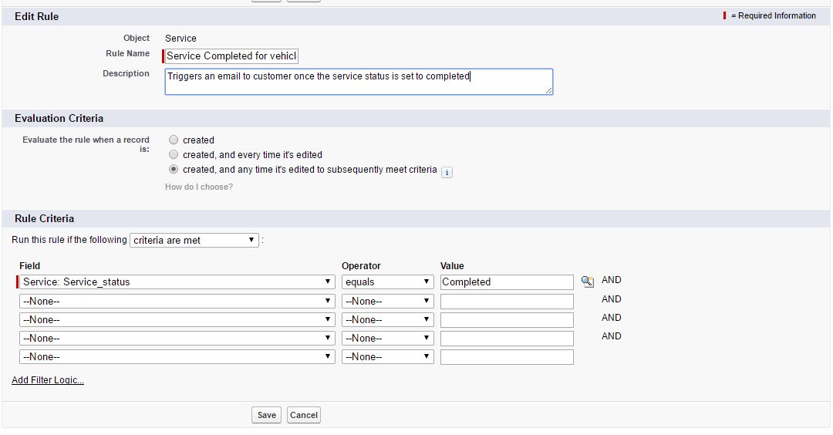

**Email Template**

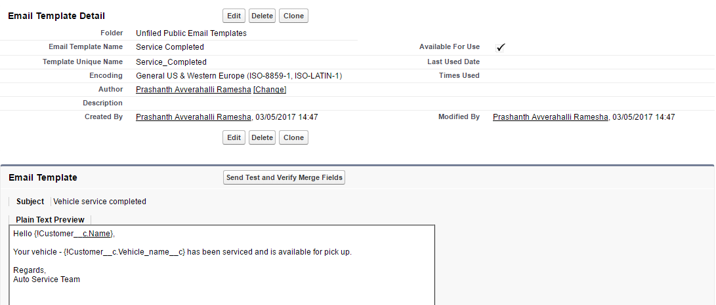

1. Another Email is triggered the day after the service to take the customer feedback.

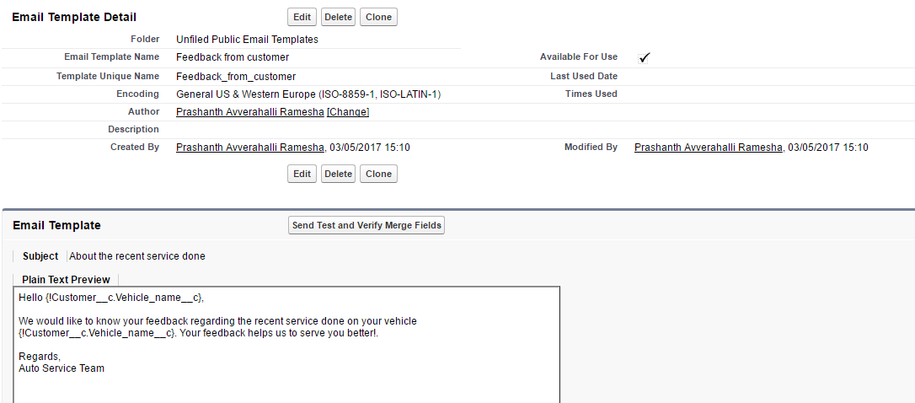

**Workflow action**

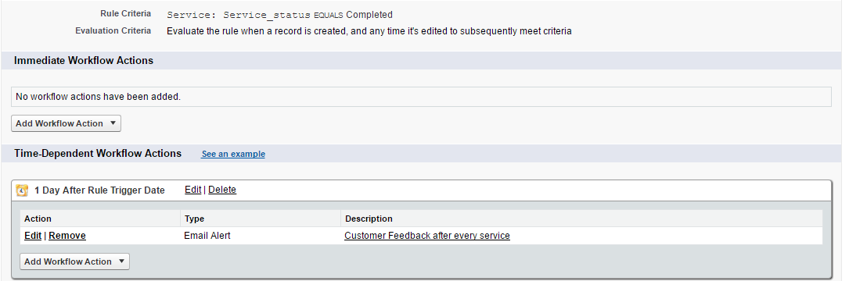

**Sample Email**

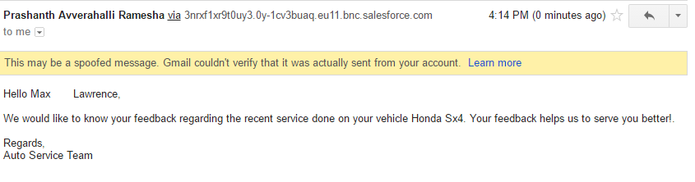

1. An Email is triggered when the next service day approaches, the email is triggered on the previous day of actual next service date as a reminder.

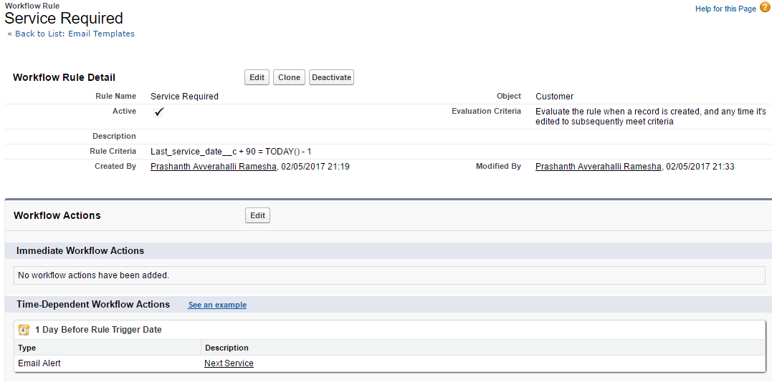 **Workflow Action**

**Email Template**

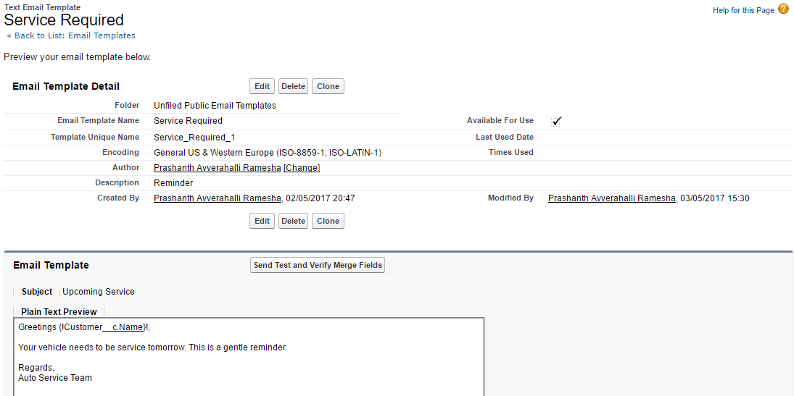

**Reports and Dashboards**

The following report summary shows the history of services done along with their details

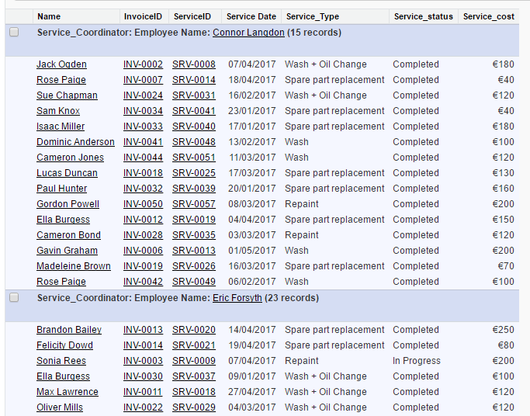

**Dashboard**

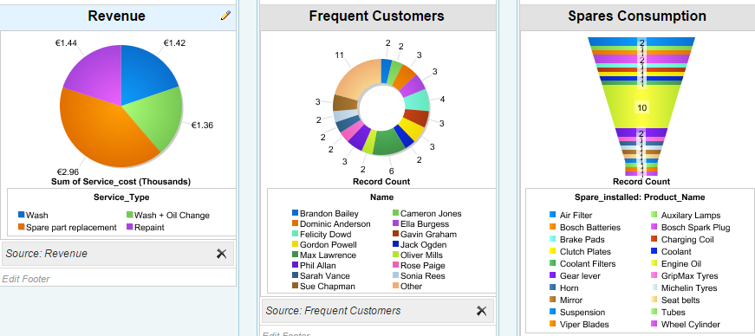

The description of individual graphs is discussed in the form of business case reports

**Business Case Reports**

**Distribution of revenue based on service type**

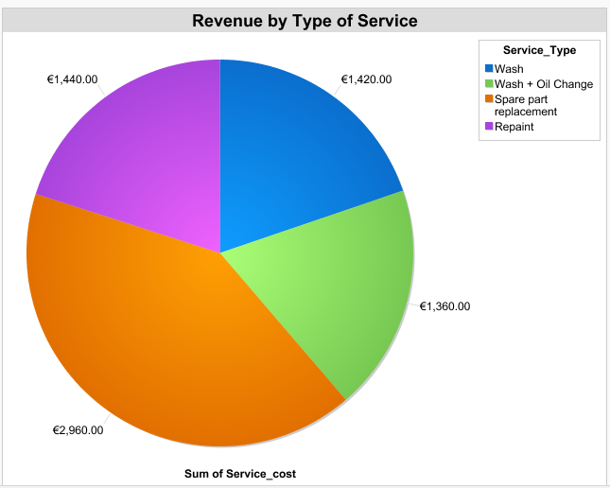

Above pie chart indicates the revenue made by different service types, by looking at the chart we can make out that spare parts replacement type service has bought in more revenue to the service center, by using this chart, the service center can focus more on the import of spares.

**Employee Performance**

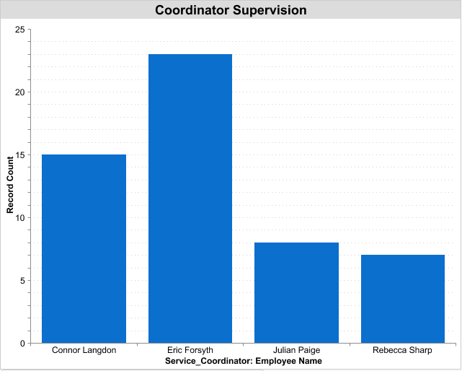

The above bar graph shows the no. of services supervised by the employees. It is evident that Eric Forsyth has supervised most services. By using this metric, companies can monitor the employee performance and provide incentives to best performing employees.

**Spare Parts Consumption**

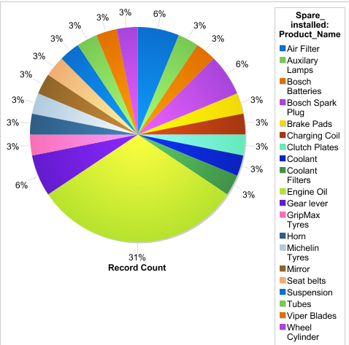

Above chart shows the utilization of spares for the service with Engine oil as the most frequently used spare. It becomes easier to keep track of the available parts in the warehouse by analyzing the spare consumption and import the spares only if there is a shortage to avoid unnecessary piling up of spare parts.

**Frequent Customers**

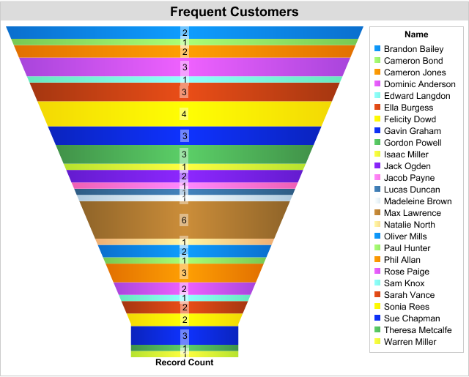

Above chart shows the customers and number of times they have serviced their vehicles. Identifying such customers and providing them additional benefits will not only attract new customers but also retain the existing customers for longer period.

**Conclusion**

The prime purpose of this application is to increase the business value of an automobile service center by integrating the customers into the process. Customer satisfaction is a primary aspect of a business organization. The workflow rules created in this application saves the burden of the service center by sending automated emails to the customers after the completion of a service, takes feedback from them, reminds them of impending service. The application also evaluates the performance of the employees based on their frequency of involvement in the service, additional functionalities can be added to define performance metrics to monitor them.

Management of spares also becomes easier by having all the required details in the form of records and a report can be fetched anytime to show their usage.

All these factors enable efficient operation of the service center and eventually increases their profit.