**ITMD 455/555**

**Intelligent Device Applications**

**Final Project - Phase 1**

**Team Members -**

Aditya Chebiyyam - A20385547

Prashanth Boovaragavan - A20382888

Kapilan Kumanan - A20375833

Michael McCartney - A20389663

**USE CASE DIAGRAM**

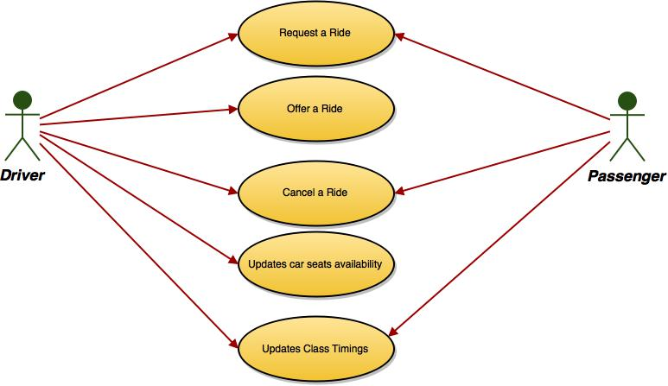

**PROTOTYPE SCREENSHOTS**

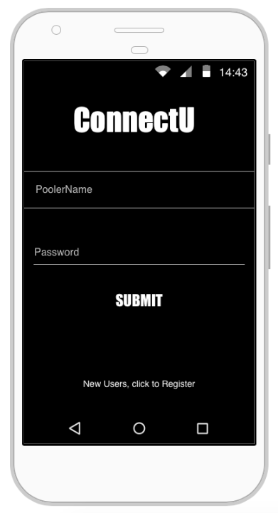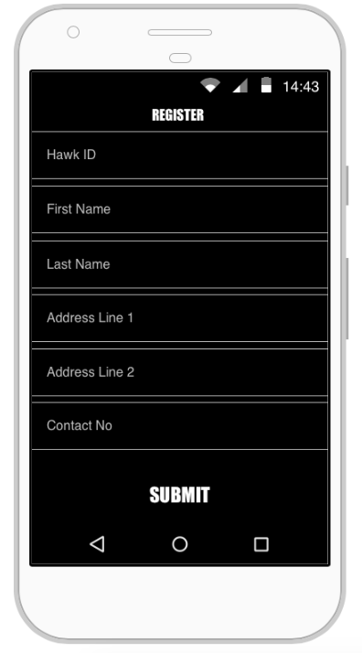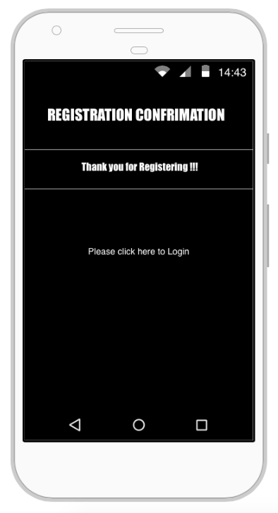

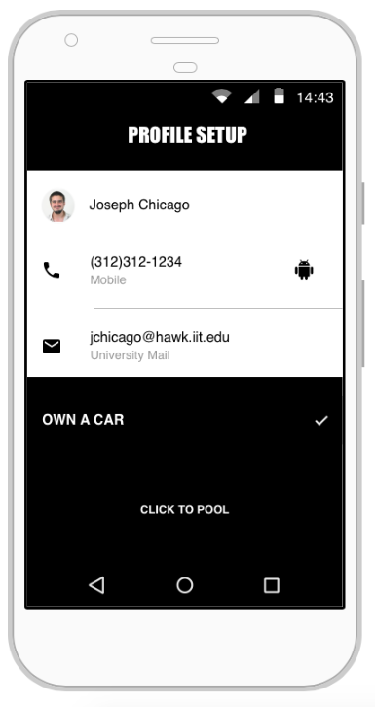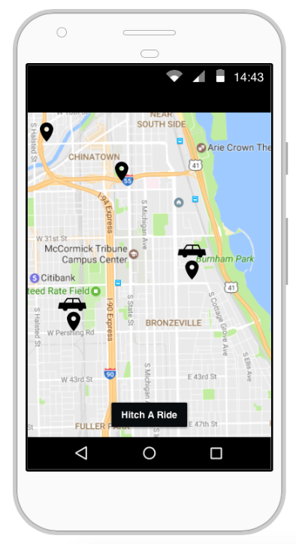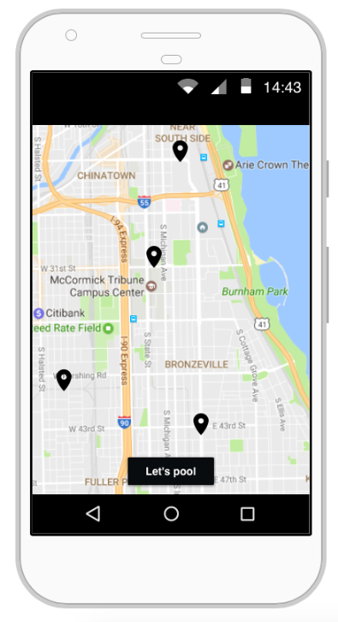

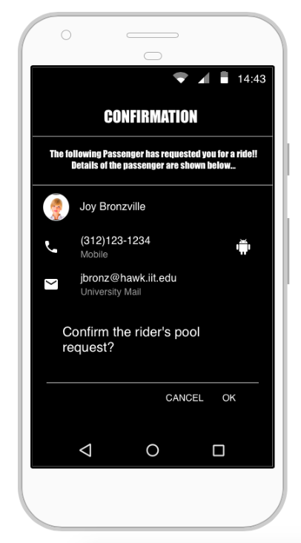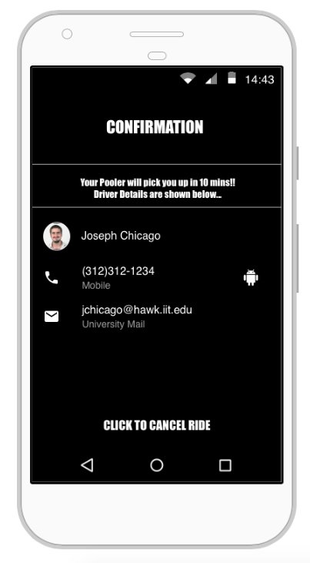

**UML DIAGRAMS**

