KUBERNETES
Core Concepts, Components, and Application Architecture
Technical Documentation

1. What is Kubernetes?
Kubernetes is a container orchestration platform used to manage containerized applications across multiple servers or virtual machines. It commonly works with container images such as Docker images and provides capabilities for deployment, scaling, networking, and self-healing.
Kubernetes can automatically restart failed workloads or create replacement Pods when required. It can also scale applications based on workload and configured metrics or thresholds.

2. Kubernetes Cluster Components
A Kubernetes cluster consists of a control plane and worker nodes. The control plane manages the desired state of the cluster, while worker nodes run application workloads.
Control Plane | Worker Node
kube-apiserver | kubelet
kube-scheduler | kube-proxy
kube-controller-manager | Container runtime
etcd

3. Control Plane Components
kube-apiserver: The kube-apiserver acts as the front end of the Kubernetes control plane. It receives requests to the Kubernetes API and communicates the requested state to the cluster components.
kube-scheduler: The kube-scheduler is responsible for selecting an appropriate worker node for newly created Pods, based on scheduling requirements and available resources.
kube-controller-manager: The kube-controller-manager runs controller processes that continuously monitor the cluster and work to move the actual cluster state toward the desired state.
etcd: etcd is the distributed key-value store used by Kubernetes to persist cluster state and configuration.

4. Types of Kubernetes Controllers
Node Controller: Responsible for noticing and responding when nodes become unavailable or go down.
Job Controller: Watches Job objects that represent one-off tasks and creates Pods to run those tasks to completion.
EndpointSlice Controller: Populates EndpointSlice objects, which provide the link between Services and the Pods that serve them.
ServiceAccount Controller: Creates default ServiceAccounts for new namespaces.

5. Worker Node Components
kubelet: The kubelet is an agent that runs on each worker node in the Kubernetes cluster. It makes sure that containers described in Pod specifications are running and healthy.
kube-proxy: kube-proxy is a network proxy that runs on each node. It maintains network rules on the node so that network communication can reach the appropriate Pods and Services.
Container Runtime: The container runtime enables Kubernetes to run containers. It is responsible for managing the execution and lifecycle of containers within the Kubernetes environment.

6. Pods
A Pod is the smallest deployable unit in Kubernetes. A Pod runs one or more containers that share the same network and storage context.
A Pod receives an IP address, but the address is normally temporary. If the Pod is deleted and a replacement Pod is created, the replacement can receive a different IP address.

7. Deployments
A Deployment manages Pods for an application. Instead of manually creating individual Pods, you normally create a Deployment and specify how many replicas should run.
- Maintains the desired number of Pod replicas.
- Creates replacement Pods when managed Pods fail or are deleted.
- Supports controlled application updates and replacements.

8. Services
A Service provides a stable network endpoint for accessing Pods. Because Pods can be recreated and their IP addresses can change, applications should normally communicate through a Service rather than depending directly on an individual Pod IP.

9. Namespaces
A Namespace provides logical separation inside a Kubernetes cluster. Namespaces are useful for separating environments, teams, applications, or other groups of Kubernetes resources.

10. How Kubernetes Resources Work Together
The core resources described in this document work together as follows:
Namespace → Deployment → Pods → Service → Traffic
Namespace: Organizes and separates Kubernetes resources.
Deployment: Manages the desired number of Pods and handles updates and replacements.
Pods: Run the application containers.
Service: Provides a stable way for clients and other workloads to communicate with the Pods.

11. Simple Kubernetes Architecture
A simplified view of the architecture is shown below:
KUBERNETES CLUSTER
Control Plane → API Server | Scheduler | Controller Manager | etcd
Worker Nodes → kubelet | kube-proxy | Container Runtime
Application Layer → Deployment → Pods
Networking → Service → Application Traffic

12. Summary
Kubernetes provides a structured way to run and manage containerized applications. The control plane manages the desired state of the cluster, worker nodes run workloads, Pods provide the execution unit, Deployments manage application replicas, Services provide stable network access, and Namespaces provide logical separation of resources.

End of Document

13. Kubernetes Cluster Architecture Diagram
Kubernetes Cluster – Control Plane and Worker Node Architecture
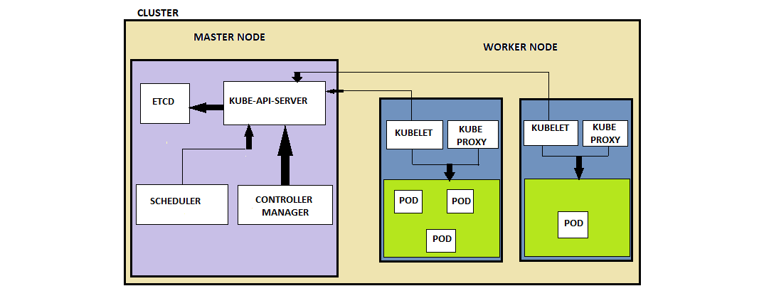
Figure 1: Kubernetes cluster architecture

