Introduction and Dashboard Overview

This report provides a comprehensive analysis of the e-commerce website's performance over the last quarter. By examining the data visualized in the web analytics dashboard, we can identify key trends in user behaviour, traffic sources, and sales conversions. The primary goal is to understand how effectively the website attracts visitors and turns them into paying customers. The data covers a 90-day period, offering a reliable sample size to draw meaningful conclusions about the business's health and stability.
Starting with the Overview page, the most fundamental metrics—Total Users and Sessions—reveal the volume of traffic reaching the site. The data shows a healthy relationship between the number of unique users and the total sessions. Since the session count is significantly higher than the user count, it indicates that visitors are not just landing once and leaving; they are returning to the site multiple times. This is a positive signal of brand retention and interest. If the numbers were identical, it would suggest a problem with bringing people back, but the current ratio shows that the marketing efforts are successfully keeping the brand in the minds of consumers.
The "Daily Sessions Trend" graph provides a clear visual representation of traffic consistency. Instead of erratic spikes and drops, the trend line shows a steady flow of visitors, with natural fluctuations that likely correspond to weekends or specific marketing pushes. This stability is crucial for predicting revenue and managing server load. It suggests that the traffic sources are reliable and not solely dependent on viral trends or temporary ads.
Another critical metric analyzed here is the Engagement Rate. This figure goes beyond simple page hits to measure the quality of the traffic. A solid engagement rate implies that the content on the landing pages is relevant to what users are looking for. It means visitors are interacting with the site—clicking links, viewing products, and spending time reading—rather than "bouncing" immediately. Finally, the Total Conversions metric serves as the ultimate performance indicator. While high traffic is valuable, it is the conversion number that dictates financial success. The overview confirms that the sales funnel is functioning, as a significant portion of the engaged traffic is successfully completing the checkout process.
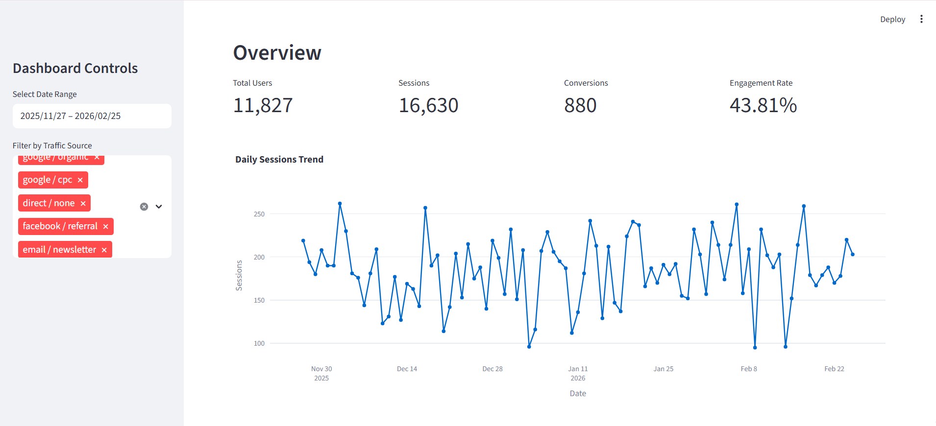
Traffic Analysis Insights

This section explores the various sources that drive visitors to the website. Understanding where the traffic originates is essential for optimizing marketing budgets and focusing efforts on the channels that provide the best results. The dashboard breaks down the traffic into distinct categories, including Organic Search, Paid Search (CPC), Direct, Social Media, and Email. This breakdown helps identify which channels are performing well and which ones need more attention or adjustment.
The "Users by Source/Medium" chart reveals that Organic Search (Google / organic) is the largest contributor to the website's traffic. This is an excellent sign because it means the website's SEO (Search Engine Optimization) strategy is effective. People are finding the store naturally by searching for products, without the company having to pay for every single click. Paid Search (Google / cpc) is the second-largest source, which shows that the advertising campaigns are also working to bring in potential customers. While paid traffic guarantees visibility, it is costly, so maintaining a balance between organic and paid sources is key to a sustainable marketing strategy.
Direct traffic (Direct / none) is another significant source shown in the analysis. This represents users who type the website URL directly into their browser or click on a bookmark. A high volume of direct traffic indicates strong brand recognition and loyalty. It suggests that many customers already know the brand name and return to the site without needing a search engine or an advertisement to remind them. Social media (Facebook / referral) and email campaigns (Email / newsletter) also contribute to the traffic mix, though they are generally smaller slices of the pie compared to search engines.
The "New vs Returning Users" pie chart provides further insight into user retention. The data shows a healthy split between new visitors discovering the site for the first time and returning visitors coming back to shop again. While attracting new users is vital for growth, retaining existing customers is often more cost-effective. A balanced ratio suggests that the marketing efforts are successfully acquiring new leads while the website experience is engaging enough to bring them back. Finally, the "Top Countries" map highlights the geographical distribution of the audience. Knowing which countries drive the most traffic allows the business to tailor its shipping policies, currency options, and language support to better serve its primary markets.
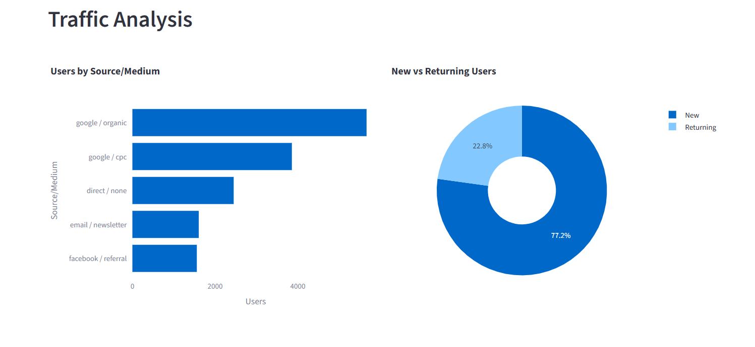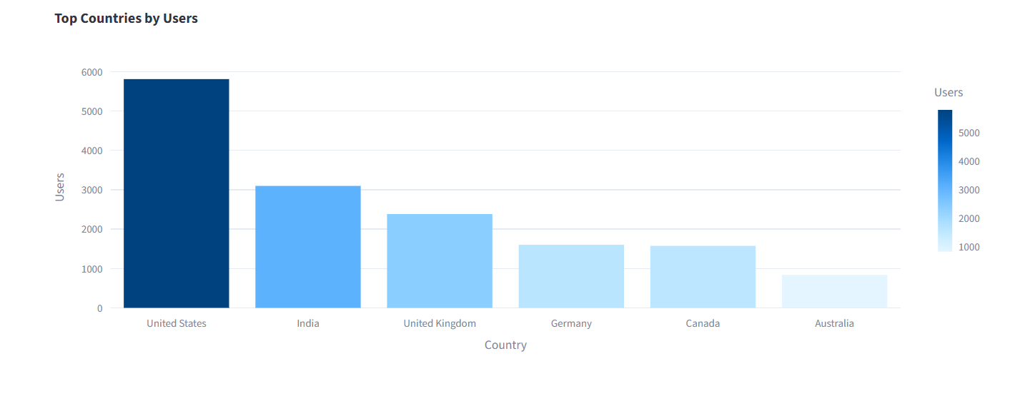

Behaviour Analysis Insights

This section explores how users navigate the website, which pages they find most engaging, and the devices they use to browse. By analyzing behavior, we can pinpoint what content drives conversions and where potential friction exists in the user journey. The "Top Pages" chart reveals the most visited sections of the site, providing clear evidence of what users are most interested in. The homepage ("/home") naturally receives the highest traffic as the primary entry point. However, the performance of specific product pages, such as "/product/shoes" and "/product/tshirt," indicates strong interest in these categories. High pageviews on these items suggest they are popular or well-promoted, warranting further inventory or marketing focus.
The "User Journey (Path)" analysis offers a sequential view of how visitors move through the site. The most common path—"/home > /shop > /product/shoes > /cart > /checkout"—demonstrates a healthy and logical flow. Users land on the homepage, navigate to the shop, view a product, add it to their cart, and proceed to checkout. This linear progression indicates that the site navigation is intuitive and effective. However, the analysis also highlights drop-off points where users abandon their journey. For example, some paths end abruptly at the cart page ("/cart") without completing the purchase. This suggests potential issues such as unexpected shipping costs or a complicated checkout process that may require optimization.
Device performance is another critical aspect of behavior analysis. The "Device Category Performance" chart breaks down traffic by Mobile, Desktop, and Tablet. The data shows that while mobile devices account for the majority of sessions, desktop users tend to have longer session durations. This discrepancy is common in e-commerce; mobile users often browse quickly on the go, while desktop users are more likely to conduct in-depth research or make larger purchases. The high volume of mobile traffic underscores the importance of a responsive design. If the mobile experience is slow or difficult to navigate, the site risks losing a significant portion of its potential customers.
Comparing session duration across devices also provides valuable insights. Longer sessions generally correlate with higher engagement and a greater likelihood of conversion. The fact that desktop users spend more time on the site suggests they are more deeply engaged with the content. To capitalize on this, the desktop version of the site could feature more detailed product descriptions and high-resolution images. Conversely, the mobile experience should prioritize speed and simplicity to accommodate shorter attention spans. By tailoring the user experience to the device, the website can improve overall engagement and conversion rates across all platforms.
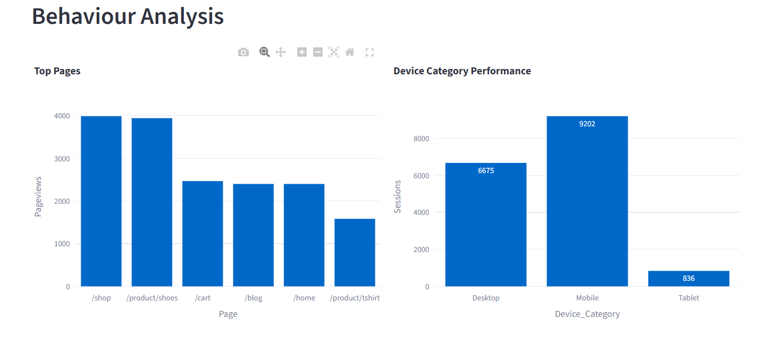
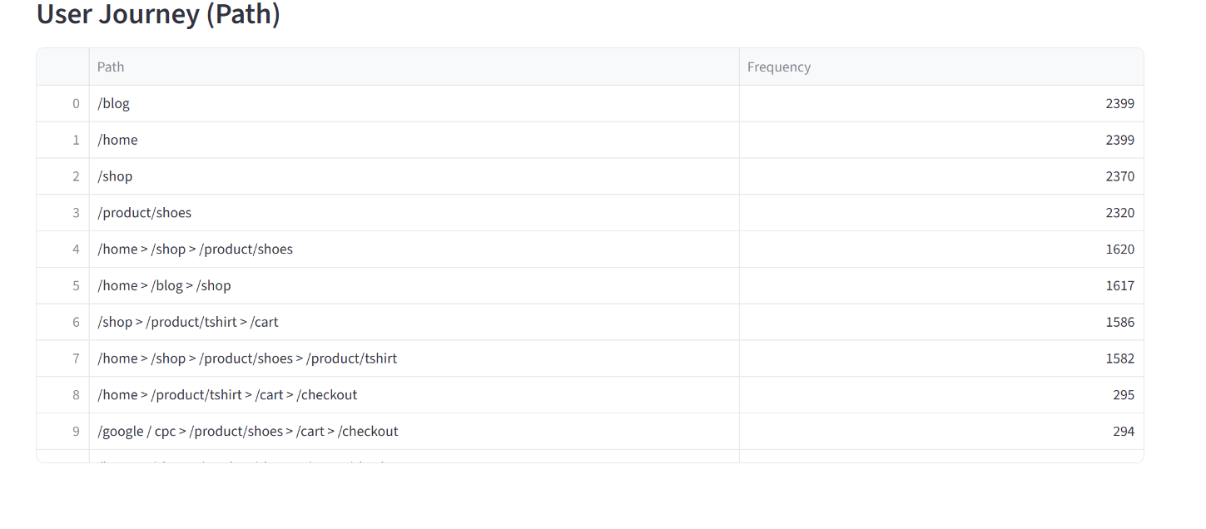

Conversion Analysis Insights

The final and most critical aspect of this report focuses on Conversion Analysis. While traffic and engagement are important indicators of interest, conversions measure the actual financial success of the website. A conversion occurs when a visitor completes a desired action, which in this context is making a purchase. The "Conversions by Channel" chart provides a clear breakdown of which marketing channels are driving the most revenue. Interestingly, while Organic Search brings in the highest volume of traffic, the data often shows that channels like "Email / Newsletter" and "Google / cpc" (Paid Search) have very high conversion efficiency. This makes sense because users clicking on a newsletter link or a specific product ad usually have a higher intent to buy compared to someone just browsing generally.
A deeper look at the "Conversions by Device" chart reveals a common but important trend in e-commerce: the gap between mobile and desktop performance. Although mobile devices account for a huge portion of the traffic (as seen in the Behaviour section), Desktop users frequently show a higher conversion rate. This discrepancy suggests that while people love to browse and discover products on their phones, they often prefer the comfort and perceived security of a desktop computer to finalize the transaction. Entering credit card details and shipping addresses is simply easier on a physical keyboard. This insight highlights a massive opportunity: if the mobile checkout process can be simplified (perhaps by adding digital wallets like Apple Pay or Google Pay), the mobile conversion rate could increase significantly, capturing revenue that is currently being lost.
The "Conversion Rate Trend" line graph tracks performance over the 90-day period. This trend line is vital for understanding stability. It shows that the conversion rate is not a flat line; it fluctuates daily. There are peaks that likely correspond to weekends, paydays, or specific marketing blasts, and valleys that represent slower days. Identifying these patterns allows the business to time its marketing emails or ad spend more effectively. For instance, if the data shows that conversions consistently drop on Mondays but spike on Fridays, the marketing budget should be adjusted to focus heavily on the end of the week.
Furthermore, analyzing the conversion rate alongside user types reinforces the value of customer retention. Returning users almost always convert at a higher rate than new users because they already trust the brand and know the navigation. The data confirms that the most profitable strategy is a mix of aggressive acquisition to get new blood into the funnel, followed by retargeting and email marketing to turn those one-time visitors into loyal, high-converting returning customers.
