# Assignment –

1. Create a “daemon supervisor”. This tool should check that the process is running and at all times and starts it in the case it is down.

It should take these as a parameter:

- Seconds to wait between attempts to restart service

- Number of attempts before giving up

- Name of the process to supervise

- Check interval in seconds

- Generate logs in case of events.

Provide the source code

and

output of supervisor runs for the following examples:

bash -c "sleep 1 && exit 0"

bash -c "sleep 5 && exit 0"

bash -c "sleep 1 && exit 1"

sh -c "sleep 10 && exit 1"

bash -c "if [ -f lock ]; then exit 1; fi; sleep 10 && touch lock && exit 1"

bash -c "if [ -f lock ]; then exit 1; fi; sleep 10 && touch lock && exit 1" (with 1 attempt only)

To solve this Assignment – I have used Supervisor: A Process Control System.

For demonstration, I have created simple bash application which is printing current date on console.

To configure supervisor, I have created config file which is satisfying our problem statement.

Please find conf file below –

[program:supervisor_demo]

command=/home/ub/supervisor_demo/supervisor_demo.sh

process_name=%(program_name)s 🡪 **Name of the process to supervise**

directory=/home/ub/supervisor_demo

autostart=true

startretries=3 🡪 - **Number of attempts before giving up**

startsecs=10 🡪- **Check interval in seconds**

stopwaitsecs=10 🡪 **Seconds to wait between attempts to restart service**

stdout_logfile=/home/ub/supervisor_demo/supervisor_demo_stdout.log **🡪 Generate logs in case of events.**

stderr_logfile=/home/ub/supervisor_demo/supervisor_demo_stderr.log

# How to install and validate my code –

1. sudo apt-get update
2. sudo apt-get install -y supervisor
3. sudo service supervisor start
4. copy supervisor_demo.conf to supervisor_demo.conf
5. sudo supervisorctl reread
6. sudo supervisorctl update
7. sudo supervisorctl start all

Please find below output of my code:

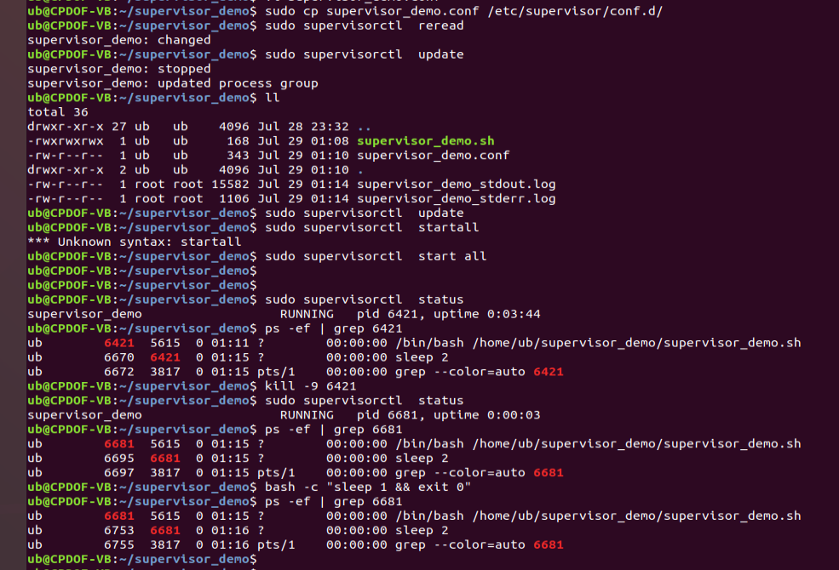

output of supervisor runs for the following examples:

bash -c "sleep 1 && exit 0"

bash -c "sleep 5 && exit 0"

bash -c "sleep 1 && exit 1"

sh -c "sleep 10 && exit 1"

bash -c "if [ -f lock ]; then exit 1; fi; sleep 10 && touch lock && exit 1"

bash -c "if [ -f lock ]; then exit 1; fi; sleep 10 && touch lock && exit 1" (with 1 attempt only)

* Because of these exit code in above commands, supervisor demon continuously starting supervisor_demo.sh

