A peer in a P2P network needs to be able to communicate with the other peers in the network. In order to do so, it must first be able to find the other peers in the network. To find the other peers in the network, each peer has a routing table. The routing table contains references to a number of peers in the network.

In a P2P network with millions of peers, each peer cannot hold a complete table of all other peers in the network. Such a table would take up a lot of resources on each peer, and would also be almost impossible to keep up to date, as peers join and leave the network.

In order to get the peers in the P2P network to communicate correctly, we therefore have to solve two problems:

1. Peer Identification (GUID)
2. Peers create a GUID themselves – create a smart algorithm
3. Peers are assigned a GUID when they join an existing network – one peer already in the network generate a GUID.
4. Peer Location

­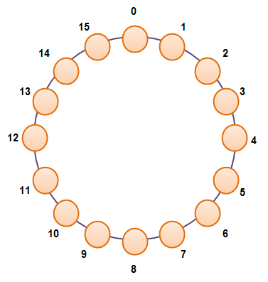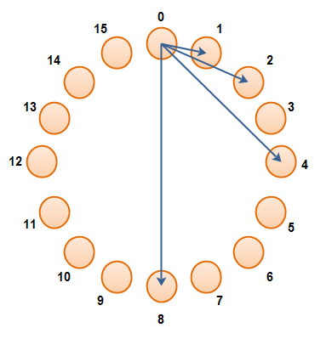

|  |  |  |
| --- | --- | --- |
| Cell Index | Referenced GUID | GUID Distance |
| 0 | 1 | 1  (20) |
| 1 | 2 | 2  (21) |
| 2 | 4 | 4  (22) |
| 3 | 8 | 8  (23) |

1. Finding peers

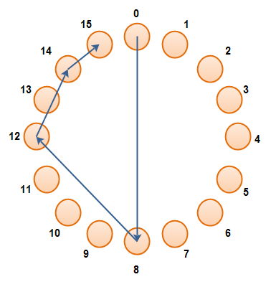

Peer 0 trying to find peer 15. It only takes log(n) steps

1. Booting and joining a P2P network

The first peer to join the network apart from the boot peer, will connect to the boot peer and send a "join" message. The boot peer responds with a new GUID to the joining peer.

|  |
| --- |
| A peer contacting the boot peer to join the network. |

When a peer no longer wants to be part of a P2P network, it will send a "leave" request to all peers in its routing table. Thus, each of these peers can remove the leaving peer from their routing table.

|  |
| --- |
| A leaving peer sends leave messages to all peers in its routing table. |

Once a "leave" message has been send to all peers in the leaving peers routing table, the peer can safely close down all network connections, and shut down.