# #Ubuntu

**“The Belief that we are define by our Kindness and compassion towards others”**

*The spirit of ‘ubuntu’ is what we need to fight COVID-19*

*Ubuntu literally means humanity towards others - it’s an African philosophy that permeates this country where all of us live.*

No-one has a choice but to fight and get involved because every one of us personally knows someone who is hungry. There’s nothing more sobering than a close-up view of people suffering in our country. We really need to pay attention because millions of people are on the brink of food insecurity. Ubuntu is an initiative by Inali Foundation to create a platform where people can connect with each other and share the right information which may save some lives.

*The spirit of ‘ubuntu’ is what we need to fight COVID-19*

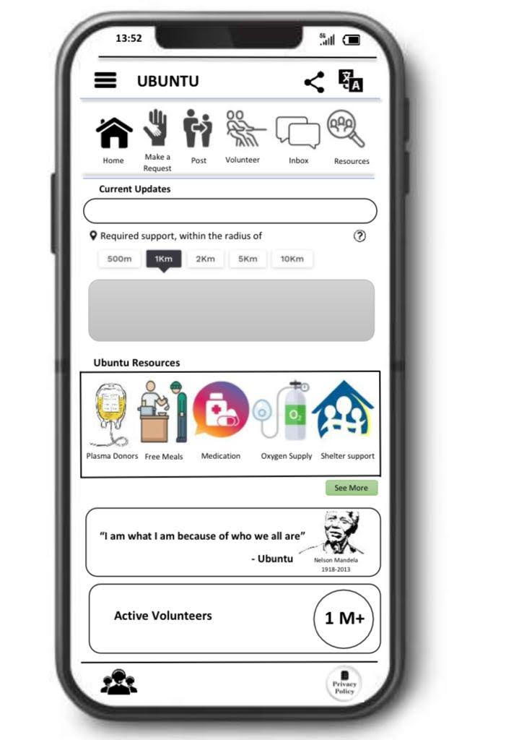

***Our Goal***

Share the message of Ubuntu and make sure nobody is left alone

***Information Ubuntu share:***

1. Kids Lost Parents due to Covid-19
2. Support for Differently abled
3. Elderly who lost kids and are left alone
4. Support to Pregnant women’s
5. People looking for meals
6. Connect Plasma Donors
7. Medication
8. People who need shelter
9. Oxygen Suppliers
10. Bed Suppliers
11. Last Ritual supports

**We need you:**

Ubuntu is calling change-makers, developers from across the globe and help us to make a difference. If you are a maker, developer and want to get involved, jump-in #Ubuntuchallenge #Ubuntusaves #Ubuntufightcorona