Aim :-
To design a basic HTML web page using structural tags like header, main, section, and footer for structured content display.
Code :-
<!Doctype = html>

<html>

<head>

<title>MyPage</title>

</head>

<body >

<header bgcolor="red">
<bold><pre>prashant<sup>mishra</sup></pre><bold>
</header>

<main>
<section bgcolor="green">
<bold>sec 1</bold>
<pre> Name :- <sup>prashant</sup>kumar<sub>mishra</sub></pre>
</section>
<section bgcolor="orange">
<bold>sec 2</bold>
<pre> Roll :- <sup>24</sup>470<sub>21</sub></pre>
</section>
<section bgcolor="pink">
<bold>sec 3</bold>
<pre> Program :- <sup>MCA</sup>(Ai And Iot)<sub>3rdsem</sub></pre>
</section>

</main>

<footer bgcolor="purple">
<bold>i am prashant</bold>
</footer>

</body>

</html>

Output :-
prashant^{mishra}
sec 1
Name :- ^{prashant}kumar_{mishra}
sec 2
Roll :- ²⁴470₂₁
sec 3
Program :- ^{MCA}(Ai And Iot)_{3rdsem}
i am prashant

Learning Outcome :-
- In this lab, I understand the basic structure of an HTML document.
- Also, I understand how to use semantic tags like <header>, <main>, <section> and <footer> in HTML.
- Additionally, I learned how to use <sup>, <sub> and <pre> tags for formatting.

Aim :-
To design and develop a basic personal resume webpage using HTML text formatting in a web page.
Code :-
<!DOCTYPE html>
<html lang="en">
<head>
<meta charset="UTF-8">
<meta name="viewport" content="width=device-width, initial-scale=1.0">
<title>my first resume</title>
<style>
img{
width: 125px;
height: 150px;
margin: 10px;
border: 2px solid black;
}
</style>
</head>
<body>
<header>
</header>

<main>
<hr>
<div>
<h1><b><u>Presonal Statement</u></b></h1>
<p>I am just a chill Guy, i like to talk about food and sweets. </p>
<ul>
<li><pre> this is me ↓ this is my hobby ↓</pre></li>
<li><img src="IMG_9877.jpeg"> <img src="i2.jpg "></li>
</ul>
</div>
<hr>

<div>
<h1><b><u>Educational Details</u></b></h1>

<ul>
<li>
<b>Basic Academic Credentials</b>
</li>
</ul>

<ul>
<li><pre>Qualification Board/University Year Percentage/CGPA</pre></li>

<li><pre>MCA NITP 2027 9.47</pre></li>
<li><pre>BSC DU 2024 8.02</pre></li>
<li><pre>12<sup>th</sup> CBSE 2021 92.2</pre></li>
<li><pre>10<sup>th</sup> CBSE 2019 89.6</pre></li>
</ul>

</div>
<hr>
<div>
<h1><b><u>Technical Skills</u></b></h1>

<ul>
<li><pre>Programming Language Efficiency</pre></li>

<li><pre>python expert</pre></li>
</ul>

</div>
<hr>
<div>
<h1><b><u>certifications</u></b></h1>
<ul>
<li><pre>NLP with Deep Learning 24th June-1st July 2025</pre></li>
<li><pre>Smart Healthcare with DL 9th June-13th June 2025</pre></li>
</ul>
</div>
<hr>
</main>
<footer>
</footer>
</body>
</html>

Output :-
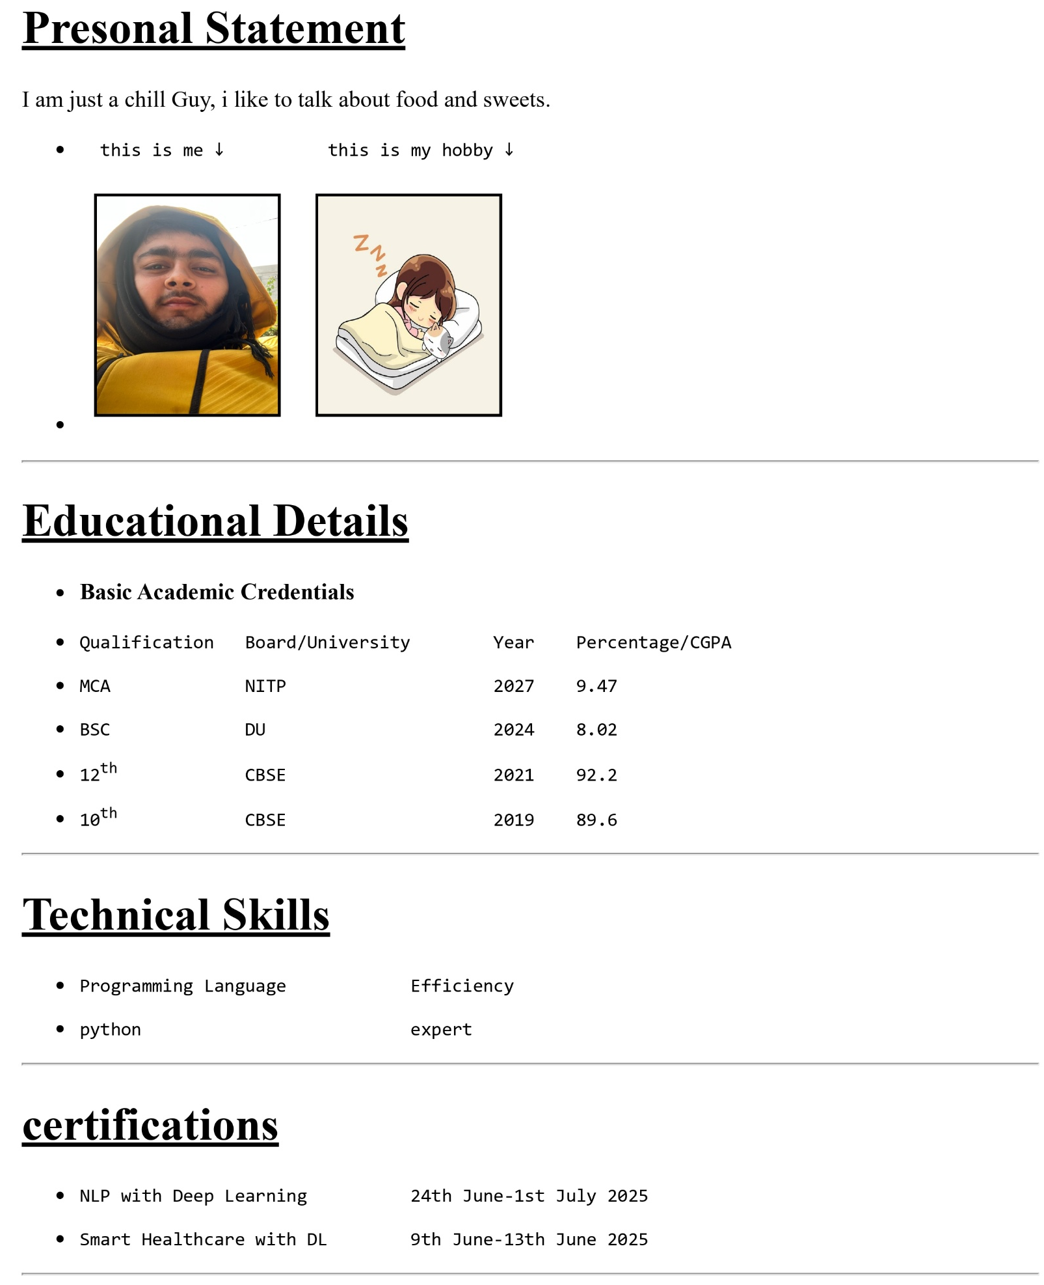

Learning Outcome :-
- In this lab, I understand the basic structure of an HTML document using <html>, <head> and <body> tags.
- Also, I understand how to use images in HTML using <img src=”” alt=””> tag.
- As well used semantic tags like <header>, <main>, <section> and <footer> to structure content in HTML.
- Additionally, I learned how to use text formatting tags such as <b>, <u > and <pre>.
- Overall, I designed a simple static resume showcasing personal, educational and technical details.

