Aim :-
To create a structured HTML table representing a monthly budget using semantic table elements as following: -
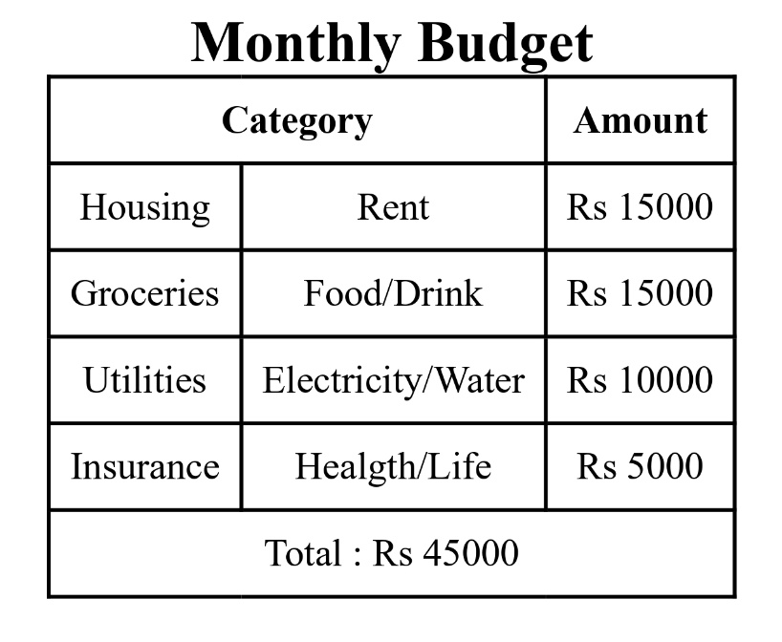
Code :-
<!DOCTYPE html>
<html lang="en">
<head>
<meta charset="UTF-8">
<meta name="viewport" content="width=device-width, initial-scale=1.0">
<title>my first table</title>
<style>
footer{
font-size: 30px;
}
table,th,td
{
border: 2px solid black;
border-collapse: collapse;
padding:10px;
margin: 10px;
font-size: 20px;
text-align: center;
}
b{
font-size: 30px;
}
</style>
</head>
<body>
<header>
</header>
<main>
<div>
<table>
<caption>
<b>Monthly Budget</b>
</caption>
<thead>
<tr>
<th colspan="2">Category</th>
<th>Amount</th>
</tr>
</thead>
<tbody>
<tr>
<td>Housing</td>
<td>Rent</td>
<td>Rs 15000</td>
</tr>
<tr>
<td>Groceries</td>
<td>Food/Drink</td>
<td>Rs 15000</td>
</tr>
<tr>
<td>Utilities</td>
<td>Electricity/Water</td>
<td>Rs 10000</td>
</tr>
<tr>
<td>Insurance</td>
<td>Healgth/Life</td>
<td>Rs 5000</td>
</tr>
</tbody>
<tfoot>
<tr>
<td colspan="3">
Total : Rs 45000
</td>
</tr>
</tfoot>
</table>
</div>
</main>
<footer>
</footer>
</body>
</html>

Output :-
Learning Outcome :-
- In this lab, I understand the basic use of <table>, <thead>, <tbody> and <tfoot> tags in HTML document.
- Also, I understand how to use create tabular data with rows, columns, captions and spanned cells using colspan.
- Additionally, I learned how to use borders and spacing in tables for better formatting.

Aim :-
To update and display the previous academic credentials in the following format: -
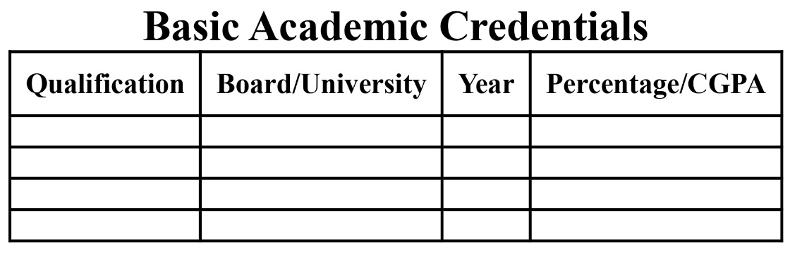
Code :-
<!DOCTYPE html>
<html lang="en">
<head>
<meta charset="UTF-8">
<meta name="viewport" content="width=device-width, initial-scale=1.0">
<title>my first resume</title>
<style>

table,th,td
{
border: 2px solid black;
border-collapse: collapse;
padding:10px;
margin: 10px;
font-size: 20px;
text-align: center;
}
b{
font-size: 30px;
}
p{
font-size: 20px;
}
img{
width: 150px;
}

</style>
</head>
<body>
<header>
</header>

<main>

<div>
<table>
<caption>

<b>Basic Academic Credentials</b>

</caption>
<thead>
<tr>
<th>Qualification</th>
<th>Board/University</th>
<th>Year</th>
<th>Percentage/CGPA</th>
</tr>
</thead>
<tbody>
<tr>
<td>MCA</td>
<td>NITP</td>
<td>2027</td>
<td>9.47</td>
</tr>
<tr>
<td>BSC</td>
<td>DU</td>
<td>2024</td>
<td>8.02</td>
</tr>
<tr>
<td>12<sup>th</sup></td>
<td>KVS PATNA</td>
<td>2021</td>
<td>92.2%</td>
</tr>
<tr>
<td>10<sup>th</sup></td>
<td>KVS PATNA</td>
<td>2019</td>
<td>89.6%</td>
</tr>
<tfoot>
</tfoot>
</table>
</div>

</main>
<footer>
</footer>
</body>
</html>

Output :-
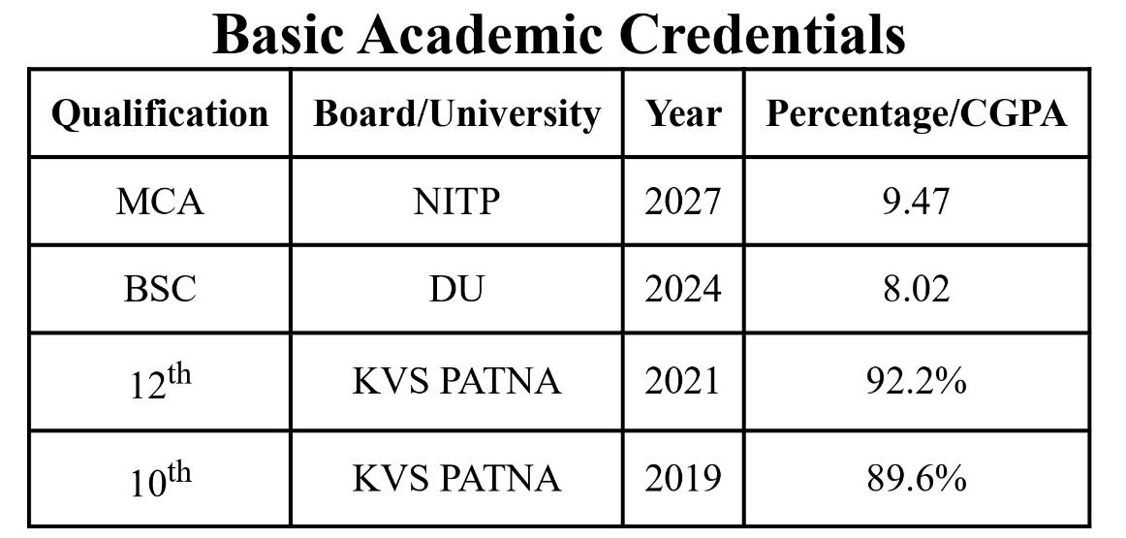

Learning Outcome: -
- In this lab, I understand the basic structure of an HTML document using <html>, <head> and <body> tags.
- Also, I used <table>, <thead>, <caption>, <tr>, <td>, and <tfoot> tags for creating table.
- Additionally, I learned how to add borders to table cells.
- Also, I learned how to highlight specific captions in table.

