Angular Module name: twitter-feeds

Dependency Used: ngSanitize, Strap.directive

Providers Used: $locationProvider, $routeProvider

Features of Angular Used: Factory, Directives, Controllers

Other Features: JavaScript helper Functions.

Factory is used to maintain various columns in this application,

Each Column is consist of Name, Type and Settings

"columns" : [

{

"name" : "home",

"type" : "friendTweets" ,

"settings" : false

}

]

This factory avoids the multiple calling in the application for various columns used.

About Directives,

Directives are usually used to maintain the code and reusable. Here in this application we have used for various purposed such as getting tweet body and profile links etc.

Tweet Body:

app.directive("tweetbody", function($compile){

return {

---------------------------,

---------------------------

}

};

In this directive we are maintaining the body for tweets.

Profile Links:

app.directive("profilelink", function($compile){

return {

---------------------------,

---------------------------

}

};

As the Modal for Angular Strap doesn't want to seem to work with the way i've set it up.

Load tweets:

Main feature of the application is to get the tweets and load them when the window starts.

app.directive("loadtweets",function(){

return {

restrict:"E",

template:"<p>Load More Tweets</p>",

link: function( scope , element, attrs ) {

element.addClass("loadmoretweets");

element.bind("click", function(){

scope.$apply("addMorePages()");

})

}

}

});

There are directives such as maintain size, resize, edit column, search setting and keep them up to the mark with current application.

Here in this application we have features such as maintain the profile of the users and get details of their tweets and follows.

Full information such as time and client name we have used directives.

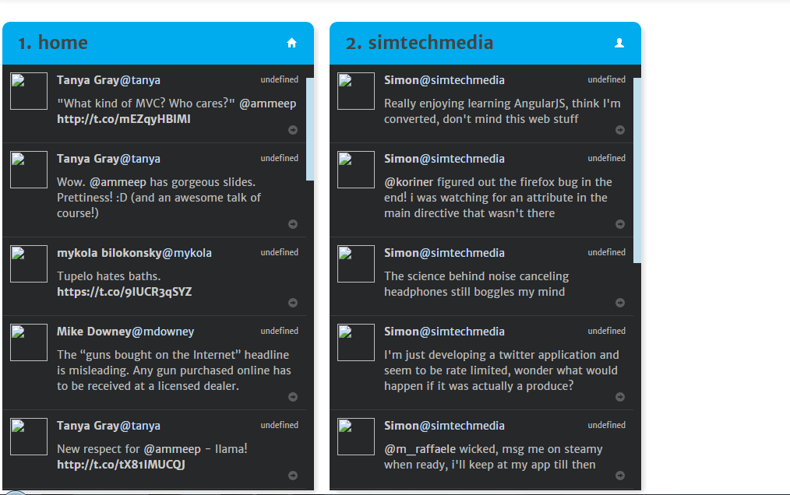

Tweeter app Landing page

As you can see here we have added various columns to maintain various feeds for the users.

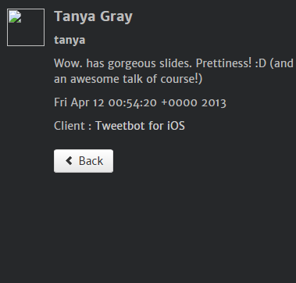

As you click on the right side icon of the tweet you get the brief about the tweet and client information and date time as well.

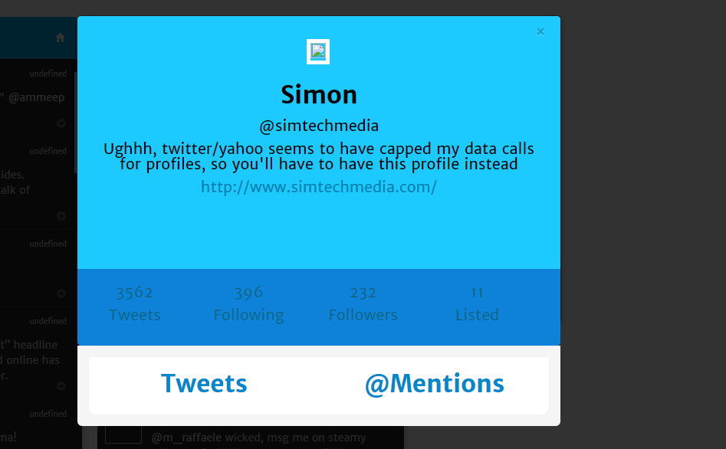

To see counters for the tweet please click on to the name of the user you will get a modal drawing from the top of the screen showing above screen.