**Detectron2 findings**

*By: Prashant Sharma*

**Detectron2:**

Detectron2 is a ground-up rewrite of Detectron that started with maskrcnn-benchmark. The platform is now implemented in PyTorch. With a new, more modular design, Detectron2 is flexible and extensible, and able to provide fast training on single or multiple GPU servers. Detectron2 includes high-quality implementations of state-of-the-art object detection algorithms, including DensePose, panoptic feature pyramid networks, and numerous variants of the pioneering Mask R-CNNmodel family also developed by FAIR. Its extensible design makes it easy to implement cutting-edge research projects without having to fork the entire codebase.

**Findings:**

1. Faster to train.
2. Greater accuracy in detecting object.
3. Multiple pretrained models available for object detection, image segmentation, panoptic segmentation.

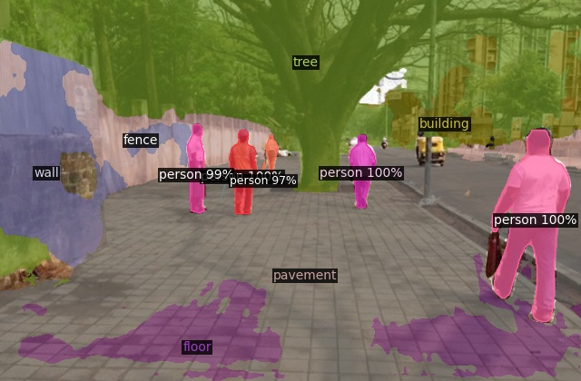

4. Gives better result on smaller dataset.

5. Bigger model than yolo v5.

6. Takes more resources when training in comparison to Yolo v5.

7. Takes more time for inference.