## Deep Learning / Data

### Structured Data

* Well defined dataframe.

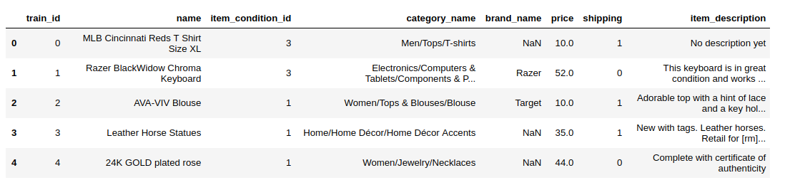

### Unstructured Data

* Audio, Image, Texts are the Unstructured Data.

#### Audio is 1 dimensional Time Series.

### Data and Performance

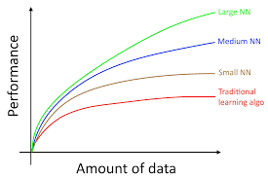

The amount of data and the size of neural network both are dependent on the performance of the model.

* The choice of algorithm is one of the most important things for data computation. For example choosing ReLU in place of a Sigmoidal function can make computation faster.