Problem Title: "Optimizing Cancer Treatment with Multi-Armed Bandits"

Problem Environment
In the given problem, cancer treatment data set is given. This data set contains prior data which captures information as given below :
- Characteristics which are related to a Cancer disease.
- For given characteristics, what type of Cancer Treatment was taken.
- If selected treatment resulted in SUCCESS of FAILURE and cost (money and time) incurred.
For given problem description and dataset, we have to identify personalized and effective treatment strategy.
To solve this problem, we will apply the concept of Multi-Armed Bandit.

Elaborate on how the cancer treatment clinical trial problem is related to the Multi-Armed Bandit (MAB) problem

Exploration-Exploitation Trade-off | In cancer treatment trials, diverse approaches (Hormone Therapy, Radiation, Chemotherapy, Surgery) are tested in different arms. Identifying the most effective strategy amid uncertainties mirrors the exploration-exploitation trade-off in Multi-Armed Bandit problems  Exploration: Trying out different treatment arms to gather information on their efficacies.  Exploitation: Allocating more patients to the arms that seem most effective based on the current knowledge
Dynamic Resource Allocation | The allocation of resources (research time and funding) across diverse treatment arms is crucial in optimizing the clinical trial. The Multi-Armed Bandit framework aligns with this need for dynamic resource allocation
Personalized Treatment Strategies | The goal of identifying the most efficacious and personalized treatment strategies corresponds to the MAB concept of learning the optimal action for each patient or context. MAB algorithms naturally adapt to individual patient responses over time, allowing for personalized treatment assignments
Minimizing Resource Expenditure | Efficiently allocating resources is essential in both scenarios. The MAB framework addresses the challenge of minimizing resource expenditure while maximizing the information gained
Budget and Treatment Duration | MAB algorithms can be adapted to include budget constraints, ensuring that resource allocations stay within predefined limits. Both domains require strategies that efficiently utilize time and resources to achieve the objectives within specified durations

To sum up, the challenge in cancer treatment trials resembles the Multi-Armed Bandit problem. This likeness arises from the demand for adapting resources dynamically, tailoring treatments individually, managing the balance between exploration and exploitation, and factoring in limitations of budget and time. Utilizing Multi-Armed Bandit algorithms offers a practical approach to streamline clinical trials and accelerate the progress in developing successful cancer treatments.

Strategy to solve the problem.

To tackle the issue in cancer treatment clinical trials using the Multi-Armed Bandit (MAB) framework, we recommend following a strategy that involves exploration, exploitation, and dynamic resource allocation. Here are the steps:

S.No | Steps | Description
1 | Formulate the Problem | Arms: Treatment arms represent different interventions (Hormone Therapy, Radiation Therapy, Chemotherapy, Surgery).  Reward: Treatment efficacy (Success/Failure).  Objective: Maximize cumulative reward (identify the most efficacious treatments) while minimizing resource expenditure
2 | Design the MAB Environment | States: Represent patient characteristics, cancer features, and budget constraints.  Actions (Arms): Correspond to the different treatment arms.  Rewards: Reflect the success or failure of each treatment.
3 | Choose a MAB Algorithm | Epsilon-Greedy: Balances exploration and exploitation by randomly selecting arms with probability epsilon and selecting the best-known arm with probability 1-epsilon.  UCB (Upper Confidence Bound): Uses uncertainty estimates to guide arm selection, favoring arms with higher potential efficacy.
4 | Define Resource Allocation Rules | Allocate more resources to arms showing promise: Based on the observed successes and failures, allocate more patients to treatment arms with higher expected rewards.  Balance exploration and exploitation: Initially explore different arms to gather information, then exploit the most promising arms as evidence accumulates.
5 | Include Constraints | Budget Constraints: Set rules to ensure that resource allocations stay within predefined budget constraints.  Ethical Considerations: Implement ethical guidelines to protect patient safety and well-being.  Statistical Significance: Ensure that results are statistically significant by defining criteria for the number of patients needed in each arm.
6 | Implement and Simulate | Implement the MAB environment.
7 | Evaluate Performance | Metrics: Measure metrics such as identification of the most effective treatment arm, time-to-discovery, patient safety, and overall cost-effectiveness.
8 | Iterate and Optimize | Fine-tune parameters: Adjust parameters of the MAB algorithm to optimize performance.

Multi-Armed Bandit
This is a concept in Reinforcement Learning, where at each step agent or decision maker selects an action out of multiple actions. At beginning of process, properties or actual reward associated with an action is unknown or partially know. As time passes, real-value of an action becomes clearer and gradually an action converged to it real value. Main objective is to maximize the reward.
In this, an action is equivalent to an ARM.
Value associated with an action is REWARD that selecting an ARM would yield.
There could be multiple actions(arm) available, hence termed as Multi-Armed Bandit.

Contextual Multi-Armed Bandit (Contextual Bandit)
This is more specific case of MAB. In this, contextual information associated with a sample is used to identify an action (ARM).
Each ARM might have different effectiveness for different user. So, if some contextual information or characteristics of user known in prior, then selection of ARM would be based on that information.
MAB has no personalization (same policy applied to all situation), whereas CB are more personalized based on context and hence better results.
Exploration and Exploitation trade-off is important to achieve good policy.
Reward Generation
Action
State (Context)

Problem Formulation: Cancer Treatment as Contextual Bandit
Given problem can be formulated as Contextual Bandit problem.
Each cancer treatment is formalized as an ARM in this problem.
ARMS : Treatment Type : Chemotherapy, Surgery, Radiation Therapy, Harmone Therapy
So, we see that there are 4 available ARMs.
Contextual Information: Characteristic information like radius, texture, smoothness, compactness etc are the context that describes
Reward : No reward if selected ARM had failed treatment.
Given data set gives samples where for certain characteristics, a treatment arm was selected. Its status of treatment is also recorded as 0 or 1.
Additionally, cost incurred in the treatment is recorded.
Hence, given problem aptly falls in category of Contextual Bandit problem, in which using context an optimal action would be determined based on the reward generated.

Problem Solution
Contextual Bandit problem can be solved using various algorithms. In this case, we are using Liner UCB to solve and arrive at stable policy which guarantees good results.
Linear UCB : Linear Upper Confidence Bound (LinUCB)
Step1 : Select a sample from given data set.
Step2 : For this sample, fetch out the context
Step 3 : For this context, calculate UCB for each ARM
Step 4 : Add to the action list if newly calculated UCB is higher than already available one
Step5 : Out of available action list, make a selection.
Following image shows the mathematics behind this : 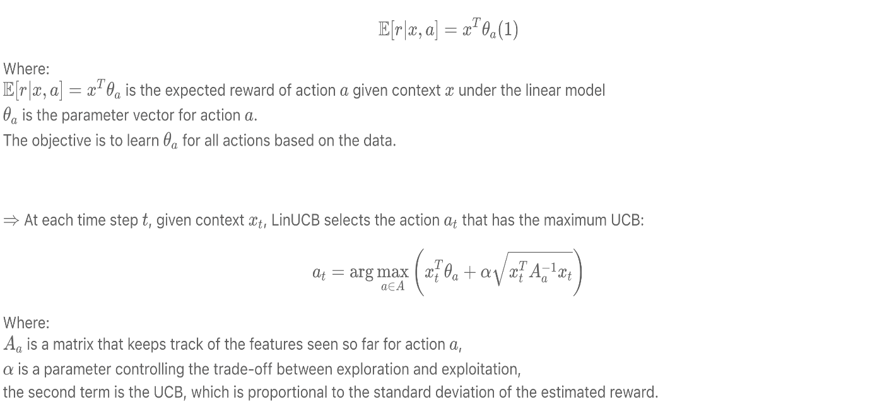
Using above formula, python code was developed.
Class linucb_dis_canc_treatment : UCB Calculation and Reward update function.
Class linucb_policy : arm selection using linucb_dis_canc_treatment
Function canc_tr_simul : main controller function to read data samples and process.
Reward Generation Function : Following policy was taken while generating rewards :
- 0 when selecte arm yielded “FAILURE”
- 1/(money+time)*10pow3 when arm yielded “SUCCESS”. So, if a treatment arm yielded SUCCESS, give higher priority to the case where lesser cost was incurred.

Result:
Based on above formulation, python code was generated. Various ALPHA (1.5, 1, 0.5) were used to control the trade-off of exploration and exploitation.

Statistical Significance of Treatment Arm:

##Most effective arm = Chemotherapy
##Number of time it was exploited = 485
##Number of time it was explored = 84
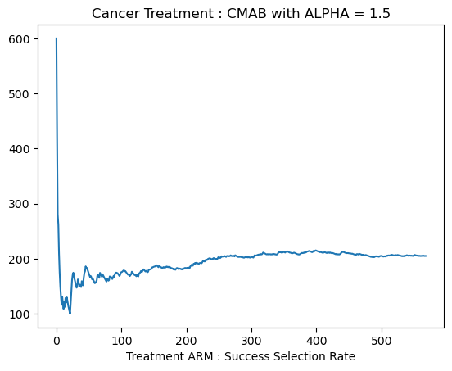

In the above plot, it was observed that initially there was lesser success rate. But then online learning ticked in, and overall success status increased.
This ensured better reward generation.

