Assignment: ML Systems Optimizations

Assignment Objective:
As part of assignment objective, we are expected to develop in-depth understanding of a domain of Machine Learning and hence deep dive in a specific algorithm of Machine Learning.
In this case, criterion for choosing ML Algorithm was usability and vast applicability of algorithm. For this purpose, we have chosen “Support Vector Machine” (SVM) as case study.

A1: Research and Summarization
As stated, after going through lots of brain-storming sessions among our group, we decided to select SVM as case study. We first studied texts around SVM to get in-depth understanding of algorithm, is mathematical basis, and finally its applicability and challenges.
In this section, we will present basic understanding of SVM which will lay foundation for trying to optimize it later.

A1.1: Introduction to SVM
Support Vector Machine is an algorithm that is used both in linear or non-linear regression and classification domains. SVMs are also used for another important task like “outlier detection”. SVM are many times applied during pre-processing phase of any problem formulation when trying to detect and remove outliers.
Although, SVMs are used in regression and classification, but they are more suited towards classification domain.
Main intention in SVM is to identify an optimal hyperplane in a N-dimensional space that can separate data points of different classes in feature space. Its like an optimization problem where width of hyper-plane between closest point is tried to be maximized.
Some important terms that would be used continuously in this write-up are explained below :
Support Vector: Closest data points to the hyper-plane. These points play important role in determining hyperplane and margin.
Hyperplane: Decision boundary which is used to separate data points of different classes. Basically, provides decision boundary for classification.
Margin: Distance between support vectors and hyperplane. Main intention of this algorithm is to maximize the margin.
Kernel: This is defined as a mathematical function whose role is to map original input data to higher dimension feature space. It helps in arriving to a hyperplane even though data points are not linearly separable.
Hinge Loss: This is loss function in SVM classification which penalizes in-correct classifications or margin violations.

A1.2: How SVM Works
Below given diagram, shows a typical example of data points and possible hyperplane boundary.
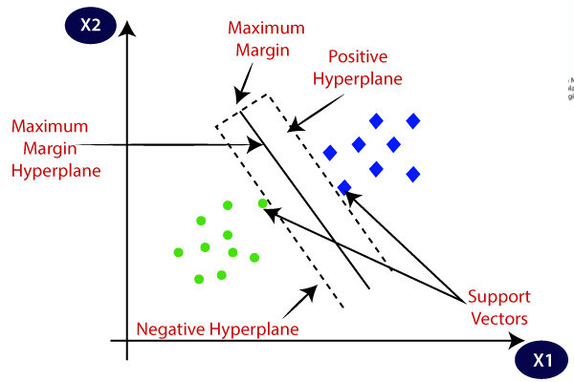

In above diagram, GREEN and BLUE colour data points are represented on 2-D space and Maximum margin hyperplane is shown which classifies 2 different type of data. Blue or green points which are closest to hyperplane are support vectors.

The best hyperplane is that plane that has the maximum distance from both the classes, and this is the main aim of SVM. This is done by finding different hyperplanes which classify the labels in the best way then it will choose the one which is farthest from the data points or the one which has a maximum margin.

A1.3: Mathematical Intuition behind SVM

Mathematically, SVM is a dual optimization problem. Few areas of SVM which are represented as mathematically:

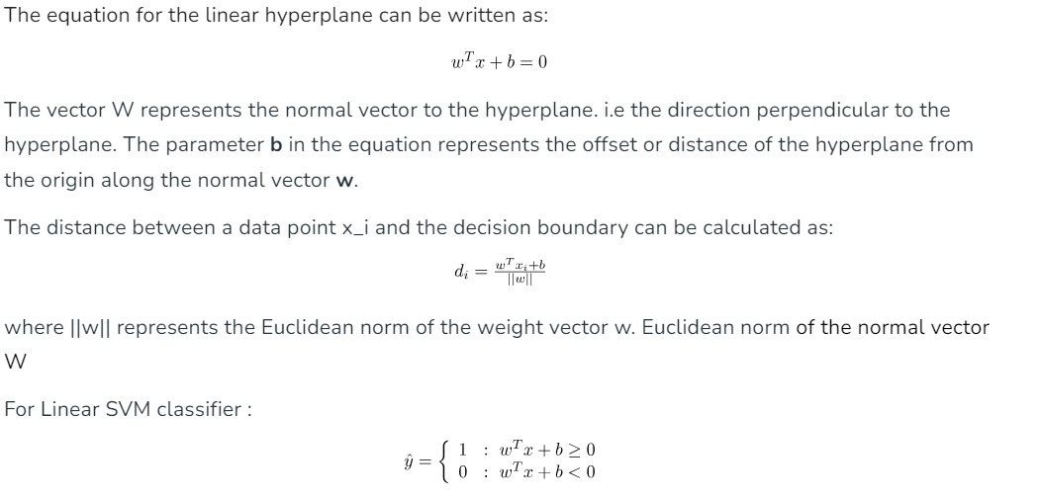
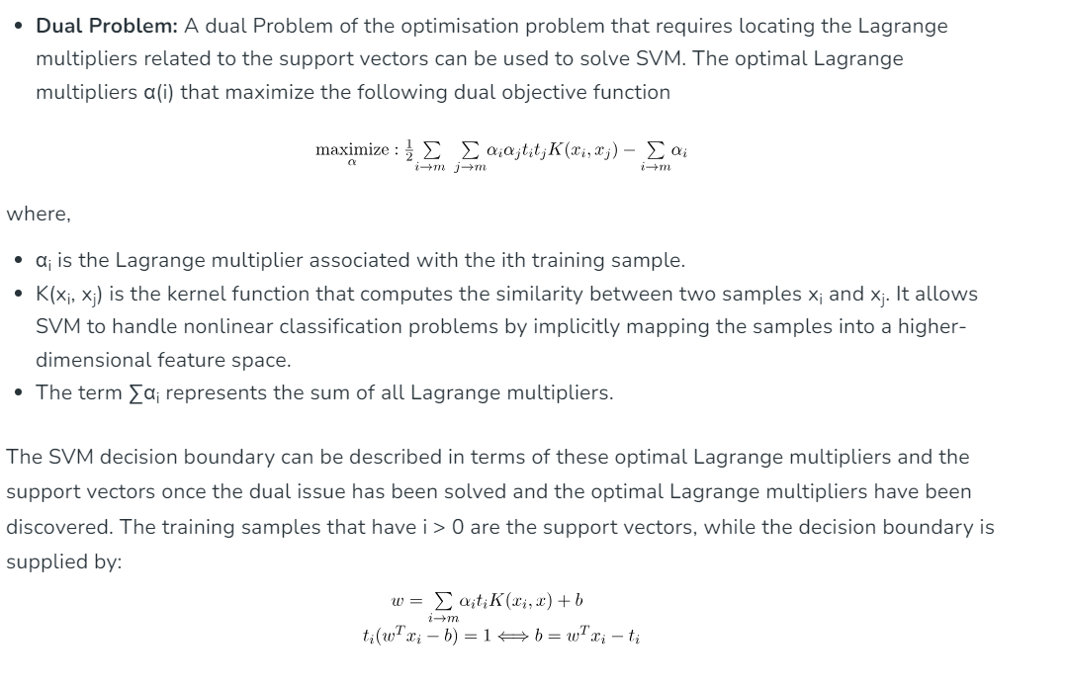

A1.4: Types of SVM
Linear SVM : When data is of nature which can be very precisely separated in 2 distinct classes, then linear SVM are used.
Non-Linear SVM : It is used when data is of the form that cannot be separate in 2 classes by a straight line in 2D. By using kernel functions, non-linear nature is handled to make it separable. Some popular Kernel function are :
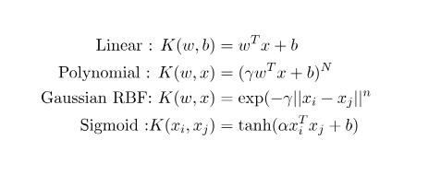

A1.5: Application of SVM
Text classification : Very commonly used in Natural language processing for sentiment analysis, spam detection , topic modelling etc.
Image Classification: SVMs are applied in image classification tasks such as object detection and image retrieval. It can also be useful in security domains, classifying an image as one that has been tampered with.
Bioinformatics and GIS (Geographical information Systems) are another areas where SVM finds its usefulness.

A1.6: Challenges in SVM
Most common use-cases of SVM lies type of problem involving non-linear data set.
When a kernel function is used, the time complexity of training an SVM becomes O(n^3) depending on the specific kernel function. The additional complexity arises because the kernel trick involves computing the pairwise similarity between all samples in the dataset, leading to quadratic or cubic time complexity.
So, from above we observe that training time of SVM increases exponentially.
Since Kernel based SVM needs computation of pairwise similarity between all samples in dataset, its quite obvious that huge datasets having samples in ranges of 10pow10 would greatly degenerate leading to very huge training time.
This is one of the biggest challenges faced when applying Kernel based SVM for practical or commercial products.

A2: ML Algorithm Parallelization
In this section, we will deal with challenge mentioned above in section A1.6
In general, ML algorithm faces problem like :
- Huge Training time
- Huge time in determining best classifier (ensemble Ness)
- Huge time in performing kFold cross validation
- Very high response time
So, as part of this assignment we went through possible approaches to tackle above mentioned problems. These could be:
- Parallelization of ML Algorithm : Identification of sub-part of an algo which could be run in parallel rather than sequential
- Deploying data parallelization to speed up
- Ensemble learning on different CPU cores
- kFold cross validation on different CPU cores to speed up
Using above mentioned approaches, certain advantages are expected :
- Speedup of overall algorithm
- Better resource utilization
A2.1: Example Scenario: Consider a Model X which trains sequentially over million of data points on a single core machine. If we have N cores available, and with parallelization, this can come down to 1/N. Hence, its quite important to come up with parallel and distributed algorithms.
A2.2: Type of parallelism:
- Data parallel approach : In this case, training data would be split in various parts and algorithm would work on separate part of data.
- Model Parallel approach : Find out part of algorithm and run in parallel environment. Parallel tasks could be computed on different cores, different machines in distributed environment.

A2.3: Problem Formulation for Speedup
When targeting speedup, we will breakdown overall process in following sub-steps :
- Algorithm Identification: Deep study of ML Algo (SVM in this case)
- Challenge Identification: Areas that need speedup
- Task Parallel identification:
  - Core logic of algorithm which can be parallelized
  - Finding best model using ensemble
  - kFold cross validation
So, above 3 points would be considered for achieving speedup.
- Data Parallel identification: Identify if there is possibility of achieving data parallelism.
So, SVM would be analysed based on above points in section A2.3 in order to achieve training time speedup.
A3: Speedup in SVM
To achieve speedup in SVM, we analysed and referred few research papers. After some brain storming within our group, we came up with conclusion that CASCADED SVM is a good approach to achieve speed up over traditional SVM approach.

A3.1: Introduction: Cascaded SVM
Cascade support vector machines have been introduced as extension of classic support vector machines that allow a fast training on large data sets. In this work, we combine cascade support vector machines with dimensionality reduction-based preprocessing. The cascade principle allows fast learning based on the division of the training set into subsets and the union of cascade learning
results based on support vectors in each cascade level.
Cascade machines are machine learning methods that divide the training set into subsets to reduce
the computational complexity and employ the principle of dividing a large problem into smaller subproblems that can be solved more efficiently.
The cascade principle is outstandingly successful for SVMs.
This is pretty much like data parallelism, where large data set would be broken down to sub-sets and employing principle of dividing large problem to smaller problems and solving more efficiently.

A3.2: How Cascaded SVM Works
1) The main idea of Cascade SVM is to split the data into manageable subsets, so that local models can be fitted.
Once we have the local models, we would like to combine them in a way that guarantees optimality after a few iterations.
This approach is common to other distributed versions of Machine Learning algorithms.
Steps in cascaded SVM training :
- Let N be the size of the data and M be the number machines used.
- We first assign approximately N/M data points to each machine
- we fit a kernel SVM locally in each of them
- After doing so, we have a set of support vectors at each machine together with their weights.
- Note that these support vectors are not necessarily support vectors of the whole dataset, but only support vectors with respect to the local subset of data that was assigned to their machine
Note : Our hope is to discard as many points as possible among those not lying on the margin —or, say, at least close to the boundary in the projected high-dimensional space
- In the next step, the sets of support vectors found in pairs of adjacent nodes (processors) are merged together and ‘passed’ to the next layer. In the consequent layer, each node takes as inputs the union of the support vectors from two parent nodes from the previous layer. At this point, each node fits a kernel SVM locally again.
- We repeat this train-then-merge process until we reach a layer with a single node
- We solve a last kernel SVM on this final node using the union of the support vector sets from the previous layer as inputs.
- The result of this final training step is a complete model (the support vectors and the weight vector found) for the entire dataset.
We refer to the entire process described above as one complete outer iteration (or one cascade).
Following diagram illustrates the phenomenon:
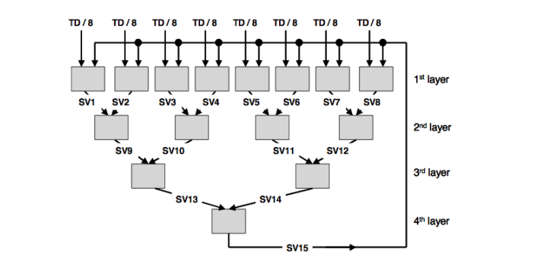
Cascaded SVM Training

A3.3: SVM Cascaded SVM with Dimensionality Reduction
Going ahead, we will perform following steps:
- Select huge classification data set
- Calculate/depict the training time
- Apply CSVM with DR
- Calculate the speedup and make performance metric of the results obtained in #1 and #3 above.

A3.4: Expected speedup using CSVM
- When we referred the paper [1] in detail, its expected that each level time complexity comes down to O(n2) from cubic complexity. So, for very large data sets, it will be big boost in training.
- Ensemble generation on multi-core (4 cores)
- kFold (using k = 4) on 4 cores.

So, A3.3 and A3.4 will give speed up in training SVM over large data set. During implementation Metric will cover these points and speedup comparison.
Data Set source for experimentation and PoC
We intend to pick a dataset relate to “The Faces data set is called Labeled Faces in the Wild”. Dataset source is http://vis-www.cs.umass.edu/lfw/.

References:
[1] Cascade Support Vector Machines with Dimensionality Reduction (hindawi.com)
[2] Parallel Support Vector Machines: The Cascade SVM (nips.cc)
[3] cascading_vector_machines_report.pdf (stanford.edu)
[4] Support Vector Machine (SVM) Algorithm - GeeksforGeeks

