Name: Prashant Yadav Batch-11 Generative AI

Using Tips Dataset as I am having limited tokens for analysis in GPTS and Tips dataset is small in size. Used ChatGPT and Gemini.

**TASK A – Data Analysis**

1. **Load Data into ChatGPT:**

**Prompt:** You are a Data Analyst expert with experience of more than 20 years. I need you to help me out with data cleaning, data preparation, data analysis and visualization tasks. I am a beginner so give complete explanations and relevant insights. So, we will start step by step.

**Output:**

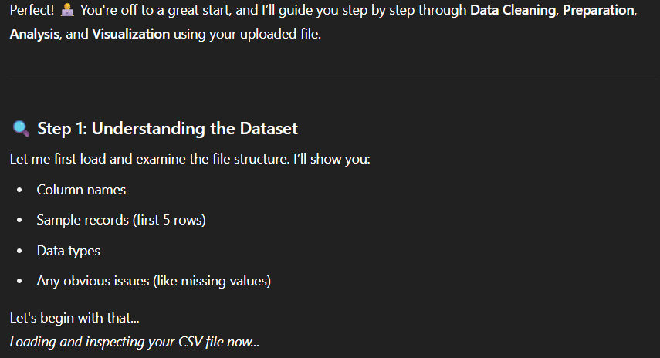

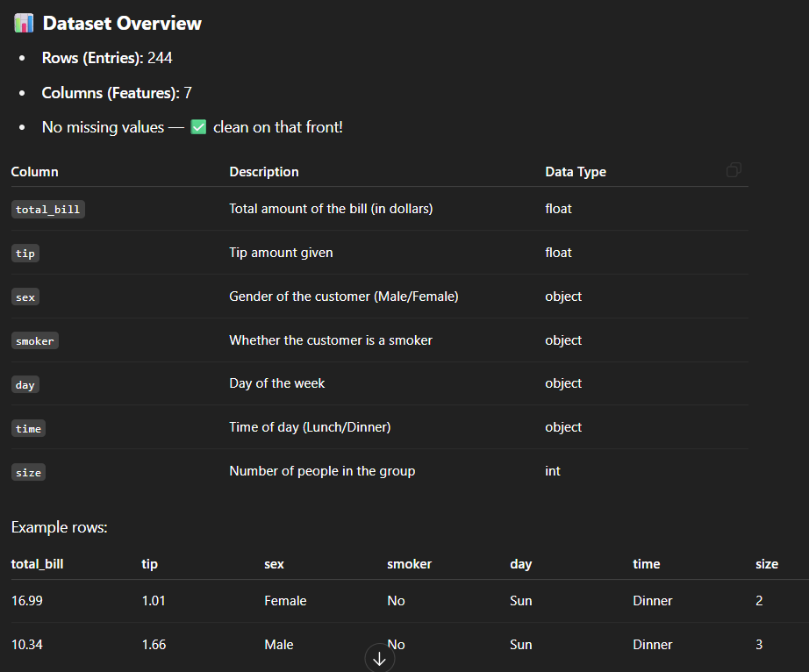

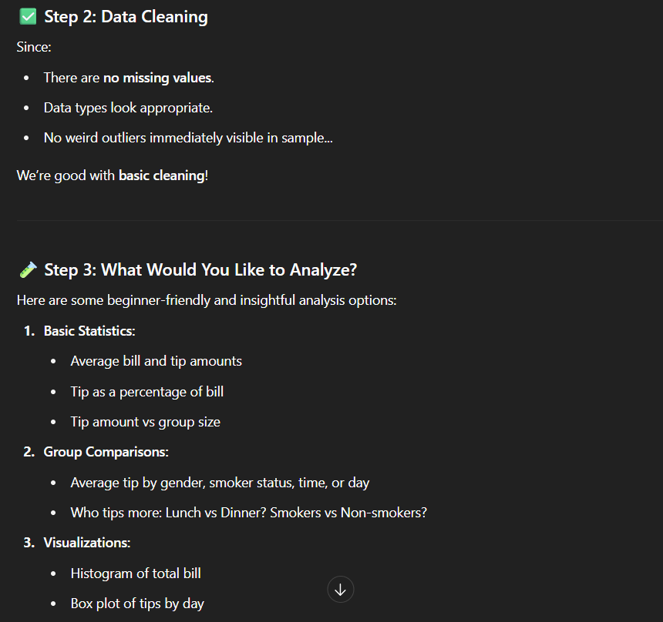

1. **Basic statistics of 5 important columns (Mean, Median, Mode, Std Dev, Min, Max)**

**Prompt:** Now I want mean, median, mode, standard deviation, min and max of the data in one table of 5 most important columns.

**Output:**

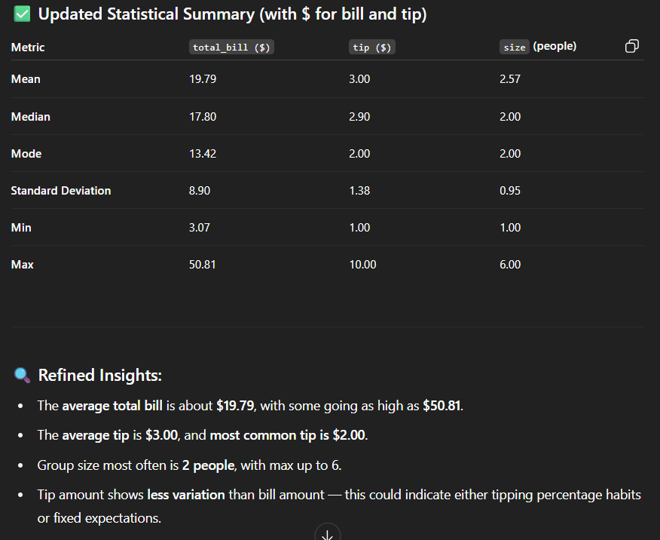

1. **Check for missing values and outliers:**

**Prompt:** Check if there is any missing values in the dataset, then check for the outliers present in this dataset

**Output:**

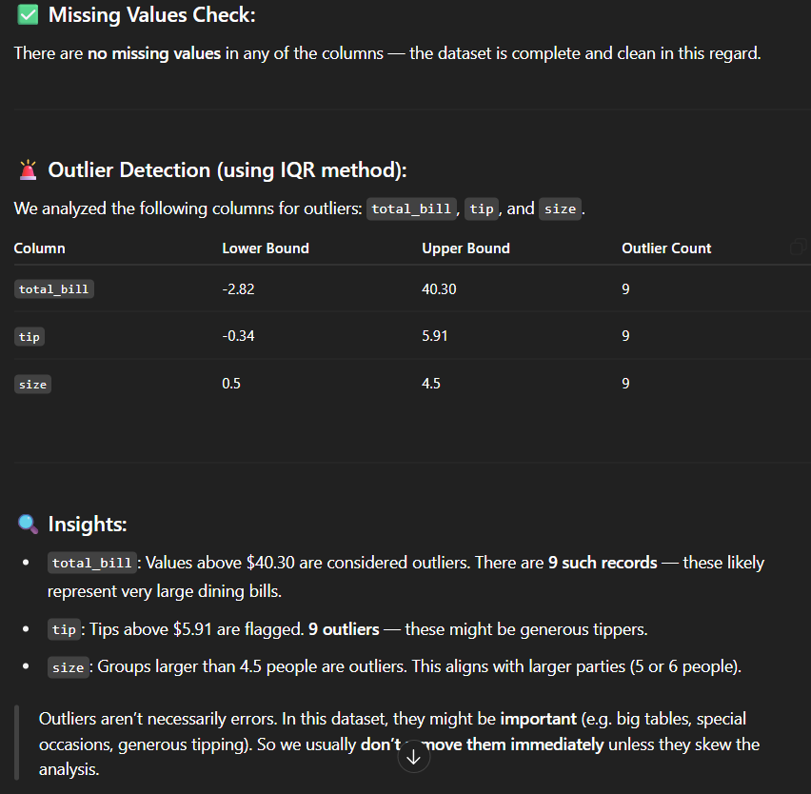

1. **Univariate Analysis:**

**Prompt:** Do the univariate analysis with visualization

**Output:**

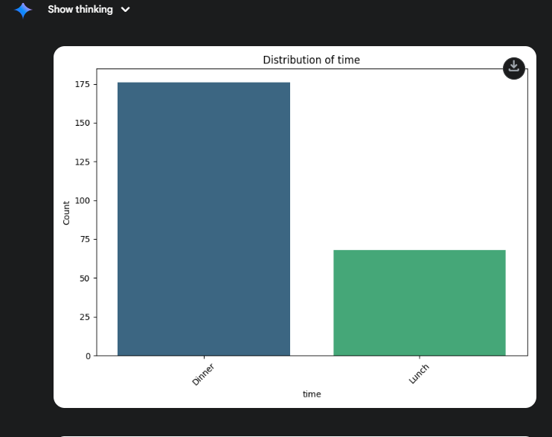

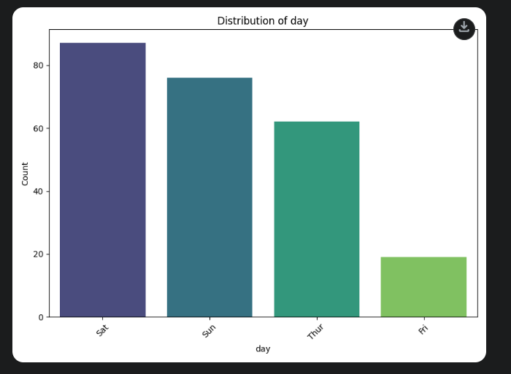

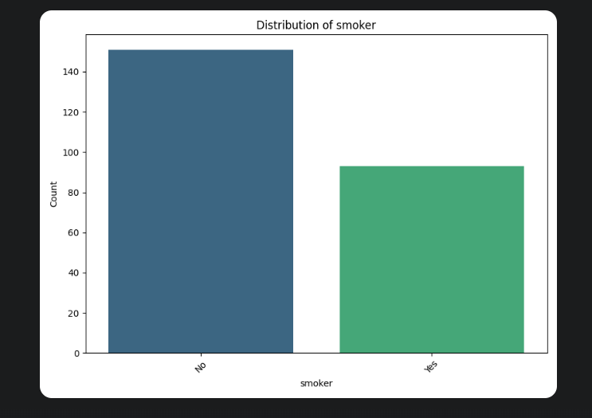

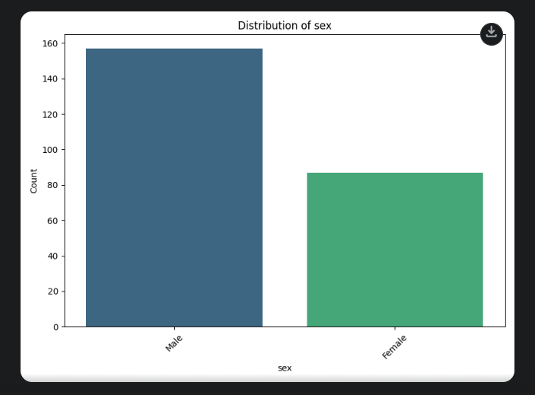

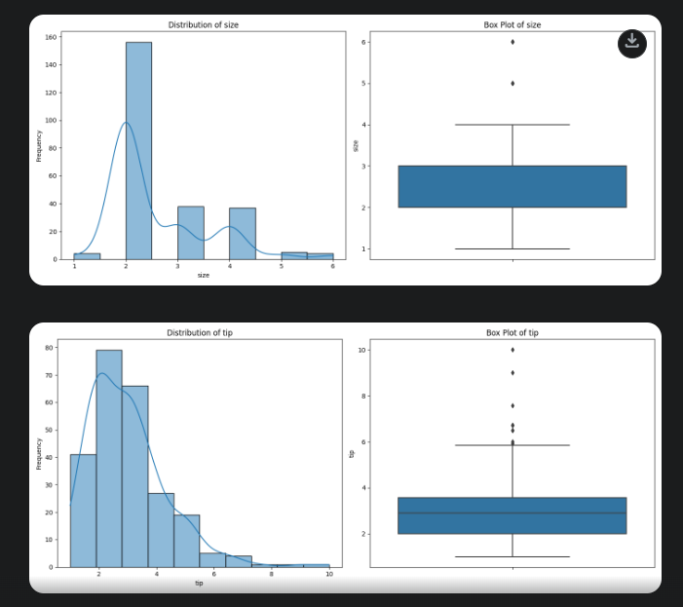

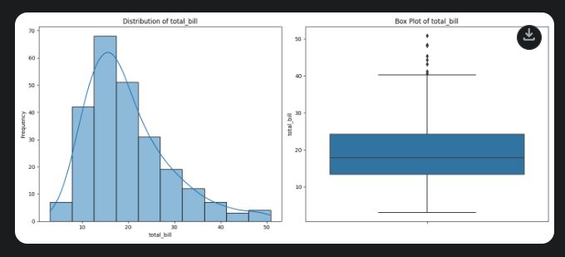

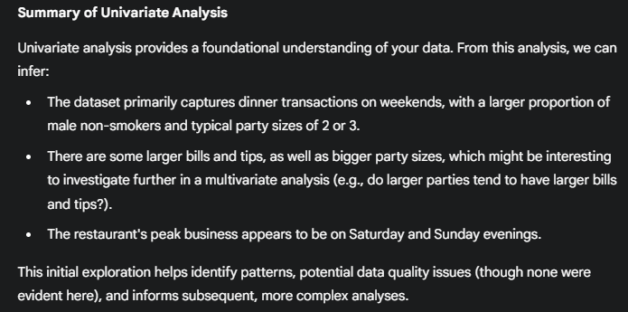

1. **Bi-Variate Analysis**

**Prompt:** Do Bi-variate analysis with visualization

**Output:**

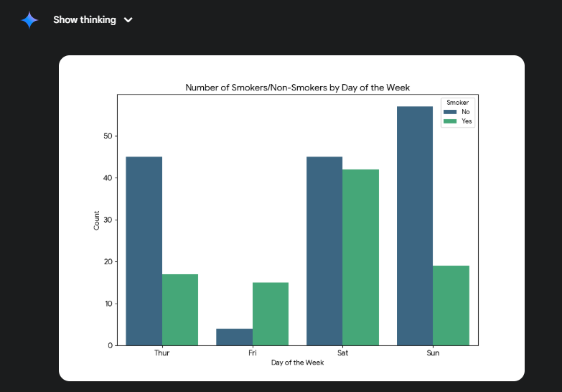

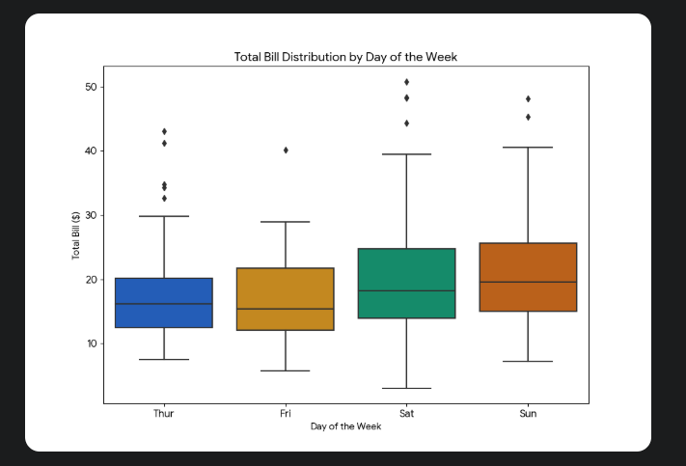

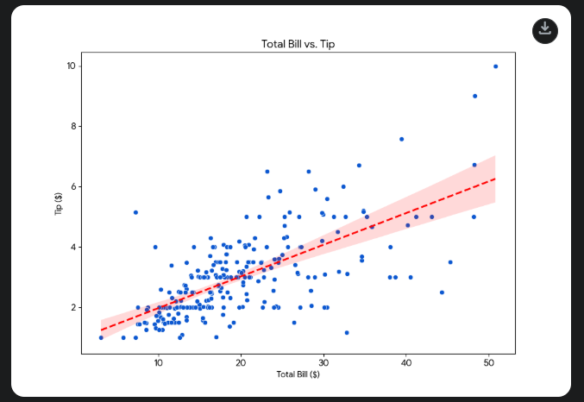

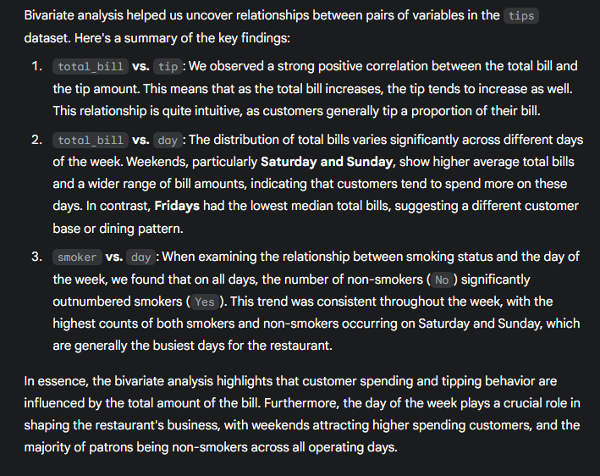

**TASK B – Data Science Expert Python Codes**

1. **Load Data into ChatGPT:**

**Prompt:** You are a Data Science expert with 20 years of experience. I am giving you a dataset and I need you to provide me python code that can run on Google Colab for each task that I will give.

**Output:**

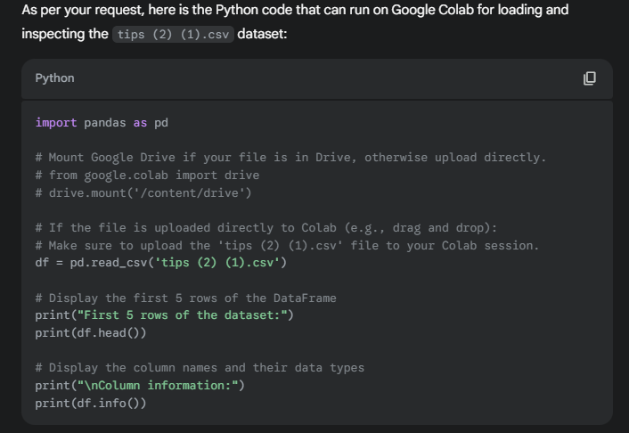

1. **Basic statistics of 5 important columns (Mean, Median, Mode, Std Dev, Min, Max)**

**Prompt:** N Now give me python code for mean, median, mode, standard deviation, min and max of the data in one table. but the code must not repeat previous steps of loading the data

**Output:**

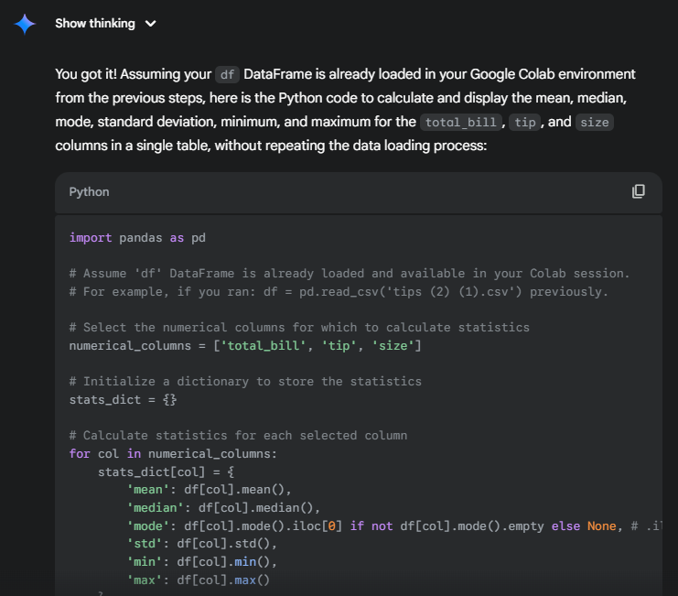

1. **Check for missing values and outliers:**

**Prompt:** code for check if there is any missing values in the dataset, then check for the outliers present in this dataset

**Output:**

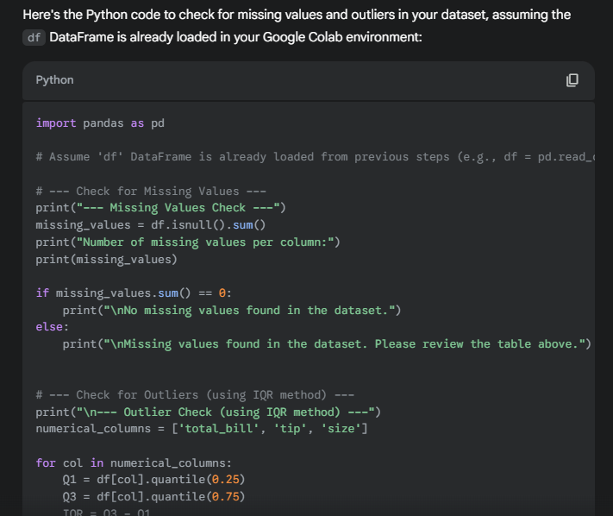

1. **Univariate Analysis:**

**Prompt:** give code for doing univariate analysis and visualization

**Output:**

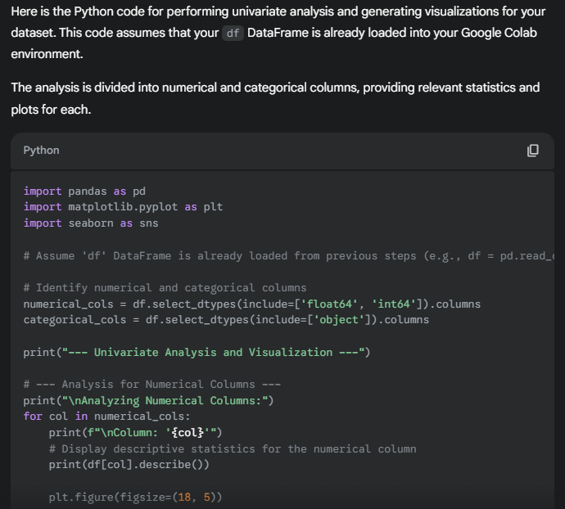

1. **Bi-Variate Analysis**

**Prompt:** give code for doing bi-variate analysis and visualization

**Output:**

