PENETRATION TESTING REPORT
FOOTPRINTING & NETWORK SCANNING PHASES
W2-PM-FINAL | CYBERSECURITY | NETWORKWALKS

Pentester Name  (Cybersecurity Professional) | Prashant Dubey
Program/Batch | Cybersecurity Week 2
Date | 11 November 2026
Modules completed | W2-PM1 (Kali Footprinting Tools)  W2-PM2 (GHDB Footprinting)  W2-PM3 (Maltego Footprinting)  W2-PM4 (theHarvester Footprinting)  W2-PM5 (Zenmap Scanning)  W2-PM5 (Zenmap Scanning)
Client/Target | 1. networkwalks.com (footprinting exercises)  2. Local Kali VM (127.0.0.1)  2. My own local LAN Network
Permission secured from client? | Not confirmed in the supplied project notes. Confirm and document written permission before any third-party assessment.
Phases covered | Phase 1: Reconnaissance & Footprinting  Phase 2: Local Host Scanning  Phase 3-5: In Progress

1. Liability Disclaimer
I performed these activities for education and research purposes. Testing must be limited to systems and devices that I own or for which I have secured explicit written permission. The footprinting exercises used publicly observable information about networkwalks.com as part of the assigned practical. The Zenmap exercise was directed at the local Kali virtual machine (127.0.0.1). Permission for any third-party active testing has not been confirmed in the supplied notes and must be documented before such testing. The author is responsible for complying with applicable laws, institutional requirements and the agreed scope.

2. Introduction
This report covers the Week 2 cybersecurity practicals involving footprinting, reconnaissance and network scanning. The work includes Kali Linux footprinting tools (PM1), GHDB-based searches (PM2), Maltego-based domain mapping (PM3), theHarvester public-source lookups (PM4), and Zenmap scanning (PM5). The practicals demonstrate how domain information can be collected, correlated and documented before any further authorised security assessment.
The activities were performed in Kali Linux running in VMware. The report records the commands, outputs and observations that were shared during the practical work. Where an exact tool output was not available for review, the report identifies the item as requiring verification rather than inventing results. Screenshots and logs should be attached in the evidence section.

3. Tools Used
The table below lists each tool used in this report and its purpose.
Tool | Purpose
Kali Linux & VMware | Operating system and virtualised environment used for the practical activities.
WHOIS | Find public domain registration details, registrar, dates and name servers.
WhatWeb | Fingerprint website technologies; exact result to be verified from saved output.
NSLOOKUP | Query DNS records such as NS, MX and TXT.
cURL -I | Read HTTP response headers returned by the website.
WAFW00F | Detect a Web Application Firewall signature.
DNSRecon | Enumerate DNS records including NS, MX, TXT and SRV.
GHDB / Google Search | Explore Google search operators and publicly indexed information.
Maltego | Visualise relationships between domain and DNS entities.
theHarvester | Query supported public sources for domain-related information.
Zenmap (Nmap GUI) | Perform a controlled scan of the local Kali VM and review scan output.

4. Activities Performed

4.1 Footprinting & Reconnaissance

I performed domain footprinting against networkwalks.com using six Kali Linux tools: WHOIS, WhatWeb, NSLOOKUP, cURL, WAFW00F and DNSRecon. I also completed the GHDB, Maltego and theHarvester practicals to explore publicly indexed information and domain-related infrastructure.
First, WHOIS identified GoDaddy.com LLC as the registrar. The returned creation date was 6 November 2019, updated date was 12 November 2025 and expiry date was 6 November 2027. The name servers were ns6135.hostgator.com and ns6136.hostgator.com. The result indicated that DNSSEC was unsigned and displayed client-side domain status protections.
NSLOOKUP used resolver 8.8.8.8 and returned NS records for ns6135.hostgator.com and ns6136.hostgator.com, an MX record with priority 0 for mail.networkwalks.com, and TXT data including an SPF policy. A Google site-verification record was also returned; its token is intentionally omitted.
The cURL command `curl -I https://networkwalks.com/` returned HTTP/2 200. The response included an Apache server header, WordPress-related cache information, a text/html content type, a referrer-policy header and Link headers referencing WordPress REST API paths including /wp-json/. A cookie was present; its value is intentionally not reproduced.
WAFW00F reported that https://networkwalks.com/ was behind ModSecurity (SpiderLabs) WAF. The tool reported two requests. This is a detection result and does not prove the WAF's complete configuration or effectiveness.
DNSRecon reported eight records, including SOA, NS, MX, A, TXT and SRV information. The output also displayed DNS software version strings for name-server IP addresses. Version disclosure alone does not establish a vulnerability. The DNSSEC query returned no answer, consistent with the unsigned status observed in WHOIS.
WhatWeb identified the page title as “Networkwalks Academy” and resolved the domain to 192.232.216.135 in the United States. Its technology summary identified Apache, Bootstrap 7.1.4, jQuery 3.7.1, WordPress 7.1.4 and WordPress Download Manager 3.3.76, along with HTML5, Google Tag Manager and cookie-related attributes. These are fingerprinting observations and do not establish that any component is vulnerable.

4.2 GHDB, Maltego & theHarvester Footprinting
For PM2, I explored the Google Hacking Database (GHDB) and reviewed its listed dorks and categories, including Files Containing Passwords, Various Online Devices, Vulnerable Servers, Files Containing Juicy Info and Files Containing Usernames. I examined the GHDB example `intitle:index of /etc/ssh` and used the domain-restricted Google query `site:networkwalks.com filetype:pdf` to review indexed PDF documents.
The GHDB practical included reviewing the database's listed categories and examining the example dork `intitle:index of /etc/ssh`. A separate Google query, `site:networkwalks.com filetype:pdf`, returned indexed PDF results including an ARP cheat sheet, an IT Diploma Training Course Schedule and an SNMP summary cheat sheet. These are publicly indexed search results; their presence alone does not establish a security vulnerability.
For PM3, I created a Maltego graph and added networkwalks.com as a Domain entity. DNS-related transforms returned mail.networkwalks.com and webmail.networkwalks.com as DNS Name entities, mail.networkwalks.com as an MX entity, and ns6135.hostgator.com and ns6136.hostgator.com as name-server entities.
- For PM4, theHarvester was run against the CRT.sh source using `theHarvester -d networkwalks.com -b crtsh`.
- The CRT.sh output reported no IPs found, no emails found, no people found and no hosts found. This is a source-specific no-results response and does not establish that such information is unavailable from all other sources.
- A second theHarvester lookup used the DuckDuckGo source. The displayed output reported no IPs, emails, people or hosts found. This is a source-specific result and does not prove that such information is unavailable from other sources.
- These footprinting activities demonstrate that different tools and data sources return different types of information. A search result, DNS record, server banner or WAF identification is an observation and is not, by itself, proof of a vulnerability.
4.3 Network Scanning with Zenmap
Zenmap/Nmap version 7.98 was used for a Quick Scan of 127.0.0.1, the local Kali VM. The host was up, and the scan reported TCP port 5432 open with the service identified as postgresql. The output also reported 99 closed TCP ports (reset). The scan completed against one IP address and one host.
The Zenmap screenshot records the Nmap output and confirms the local host's scan result. Port 5432 should be reviewed on the local VM to determine whether the PostgreSQL service is required and appropriately restricted.

5. Risk Analysis / Impact
Based on the information collected during the footprinting and scanning activities, I identified the following potential information-disclosure and reconnaissance risks. These are observations, not confirmed vulnerabilities.
# | Risk / Finding | Evidence / Observation | Potential Impact | Risk Level
1 | Domain registration information exposed | WHOIS returned registrar, dates, name servers and status data. | May assist an observer in profiling domain administration and hosting relationships. | ● Low
2 | DNS infrastructure identifiable | NS, MX, TXT, A and SRV records were returned by DNS tools. | May help build an infrastructure profile and identify externally visible services. | ● Low–Medium
3 | HTTP technical information exposed | cURL returned HTTP/2 200, Apache/WordPress-related headers and /wp-json/ references. | May assist technology fingerprinting and further authorised review. | ● Low
4 | WAF technology identifiable | WAFW00F detected ModSecurity (SpiderLabs). | Reveals a component of the web application's defensive architecture. | ● Low
5 | DNS software banner information | DNSRecon displayed DNS software version strings. | May provide information for further review; a banner alone does not prove a vulnerability. | ● Low
6 | Public search and source results | GHDB searches performed; one query returned no matching documents. CRT.sh returned no items in its reported categories. | Public indexing and source-specific results may support reconnaissance; impact depends on returned content. | ● Informational
7 | Local host scan | Zenmap Quick Scan of 127.0.0.1 was reported complete; detailed port output not reviewed. | Local listening services may require review; exact exposure depends on the saved scan result. | ● Pending

Risk level key: ● Critical ● Medium ● Low ● Informational ● Pending
The risks above are observations from the footprinting and scanning exercises, not confirmed vulnerabilities.
The practical exercises primarily involved information gathering and local host discovery. No exploitation or vulnerability validation was reported as part of these activities.
Therefore, the presence of a software version, IP address, DNS record, WAF signature or indexed search result does not by itself mean that a system is vulnerable. Further authorised security testing would be required to validate any actual vulnerability.

6. Recommendations
Based on the observations from these activities, I recommend the following security improvements:
- Review publicly exposed technology information
Organisations should regularly review what information about their web technologies, CMS and plugins is publicly visible.
- Keep software updated
CMS platforms, plugins and other web technologies should be regularly updated and reviewed against current security advisories.
- Review HTTP headers
HTTP response headers and cookie attributes should be reviewed in the context of the application to determine whether unnecessary technical information is exposed.
- Review DNS records regularly
DNS records should be checked periodically to ensure that only required information and services are publicly exposed.
- Properly configure and monitor the WAF
Keep the WAF enabled, updated and monitored. Detection of a WAF does not prove that all attacks are blocked.
- Review DNS service configuration
DNS services should be patched and securely configured. Unnecessary version disclosure should be reduced where practical.
- Perform regular internal network discovery
Organisations should periodically scan their own networks to identify active devices and services.
- Investigate unknown devices and services
Unexpected devices or listening services should be investigated and verified against an approved asset inventory.
- Perform security testing with authorization
Reconnaissance and scanning should only be performed against systems and networks where appropriate authorization has been provided.

7. Conclusion
During Week 2, I completed practical activities covering footprinting, reconnaissance and network scanning using Kali Linux tools and specialist applications.
In PM1, WHOIS, NSLOOKUP, cURL, WAFW00F and DNSRecon provided domain registration, DNS, HTTP response and WAF observations. WhatWeb was also run, but its exact findings must be verified from the saved output. PM2 introduced GHDB categories and Google search operators. PM3 used Maltego to visualise DNS-related entities. PM4 used theHarvester with CRT.sh and DuckDuckGo sources; CRT.sh returned no IPs, emails, people or hosts.
In PM5, Zenmap 7.98 was used for a Quick Scan of the local Kali VM at 127.0.0.1. The scan identified TCP port 5432 as open (PostgreSQL) and reported 99 closed TCP ports (reset).
The exercises showed that information gathering is an important part of cybersecurity. Before any further assessment, a security professional can learn about a domain and its infrastructure by carefully analysing publicly available information and network responses.
I also learned that technical findings should be documented clearly. A good cybersecurity report should explain what was performed, what was discovered, why the finding matters, what risk it may create and what can be done to reduce that risk.
Finally, reconnaissance and scanning must always be performed within an authorised scope. Observations should not be described as vulnerabilities unless they have been independently validated through permitted testing.

8. Evidences Collected

The following screenshots document the practical work performed for PM1–PM5. Each figure is labelled with the tool or activity shown.

Figure 1. WHOIS Enumeration
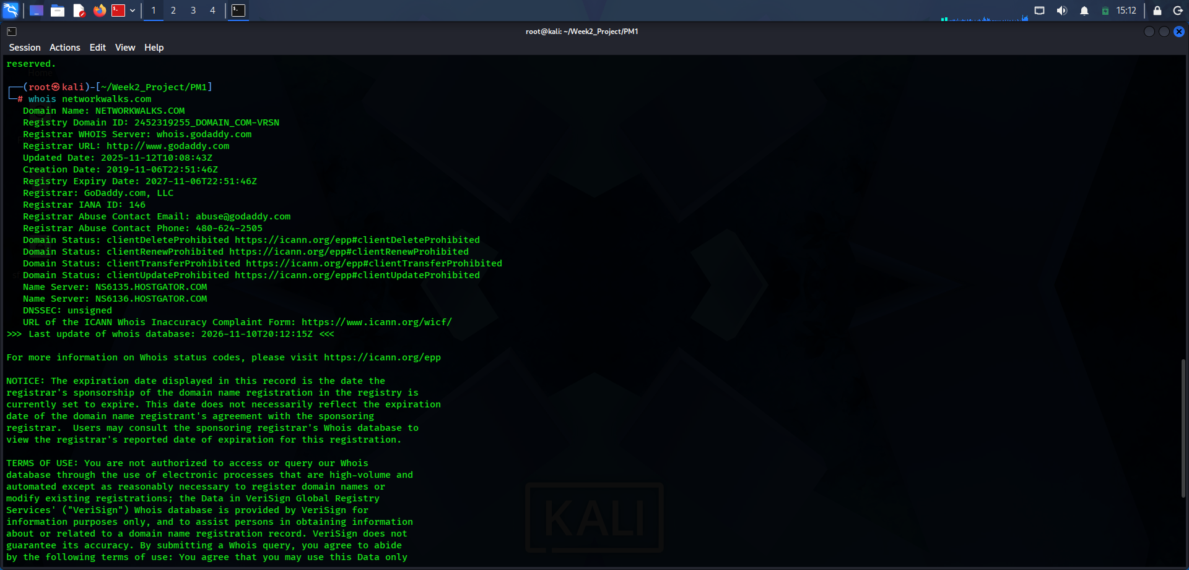

WHOIS output showing the domain registrar, registration dates, name servers, domain status codes and DNSSEC status.

Figure 2. WhatWeb Technology Fingerprinting
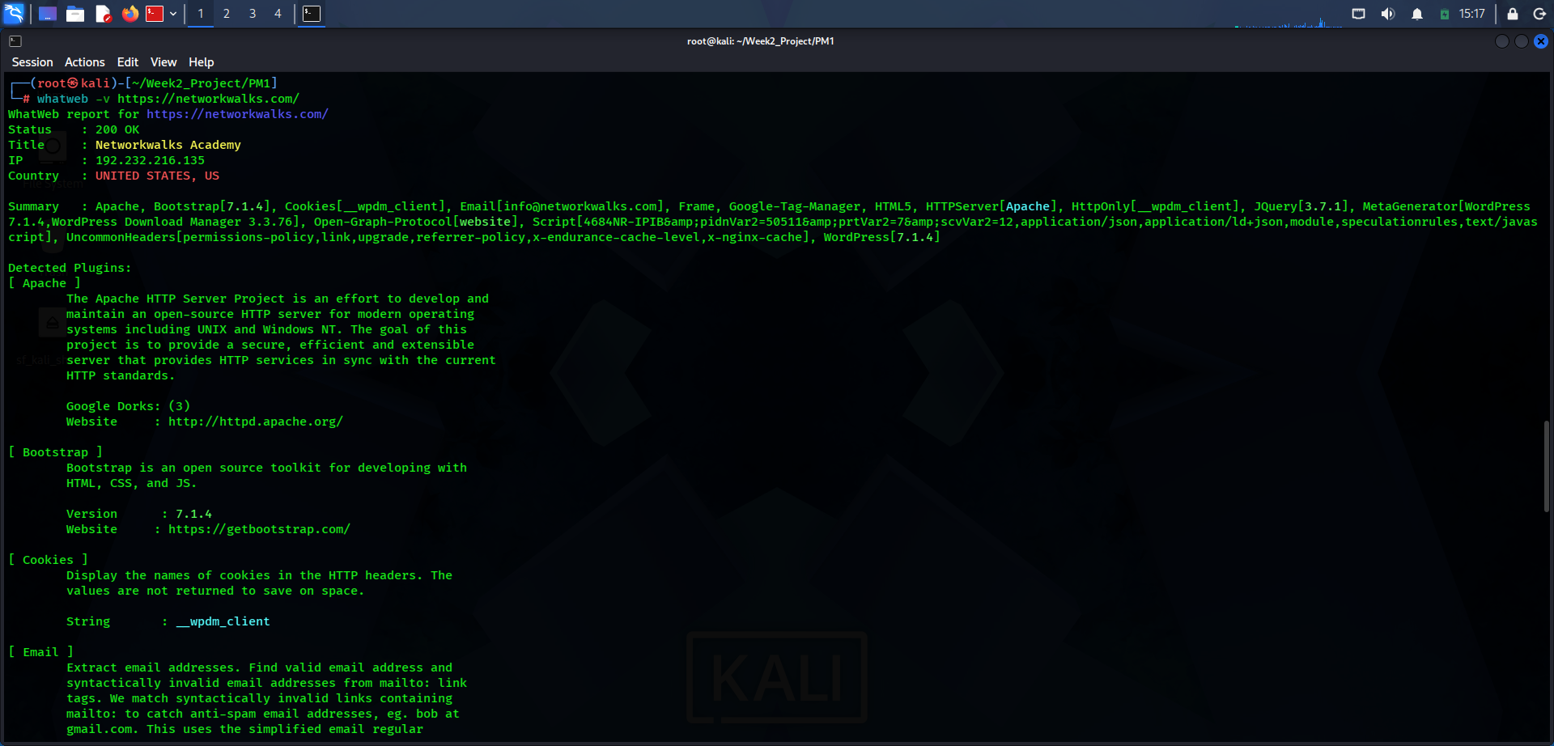

WhatWeb identified the site title, IP address and technologies including Apache, Bootstrap 7.1.4, jQuery 3.7.1, WordPress 7.1.4 and WordPress Download Manager 3.3.76.

Figure 3. NSLOOKUP DNS Record Queries
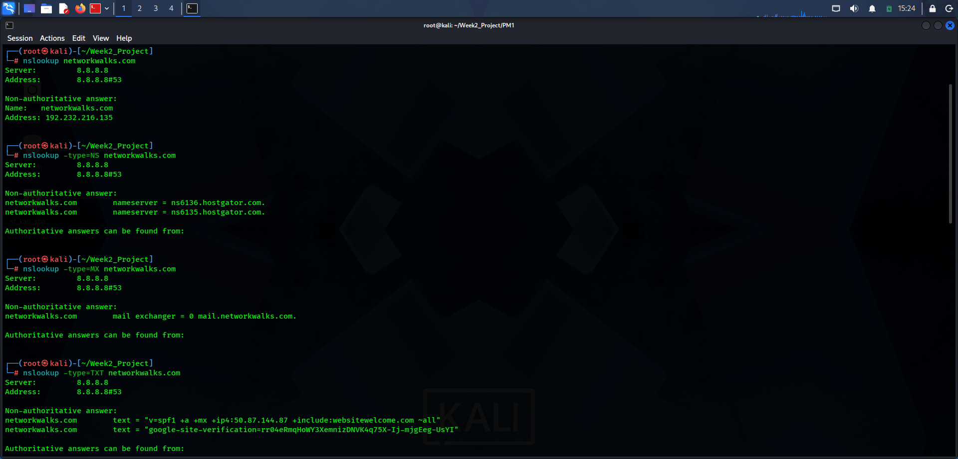

DNS queries using Google Public DNS (8.8.8.8) returned the domain A record, name servers, MX record and TXT records.

Figure 4. WAFW00F Detection
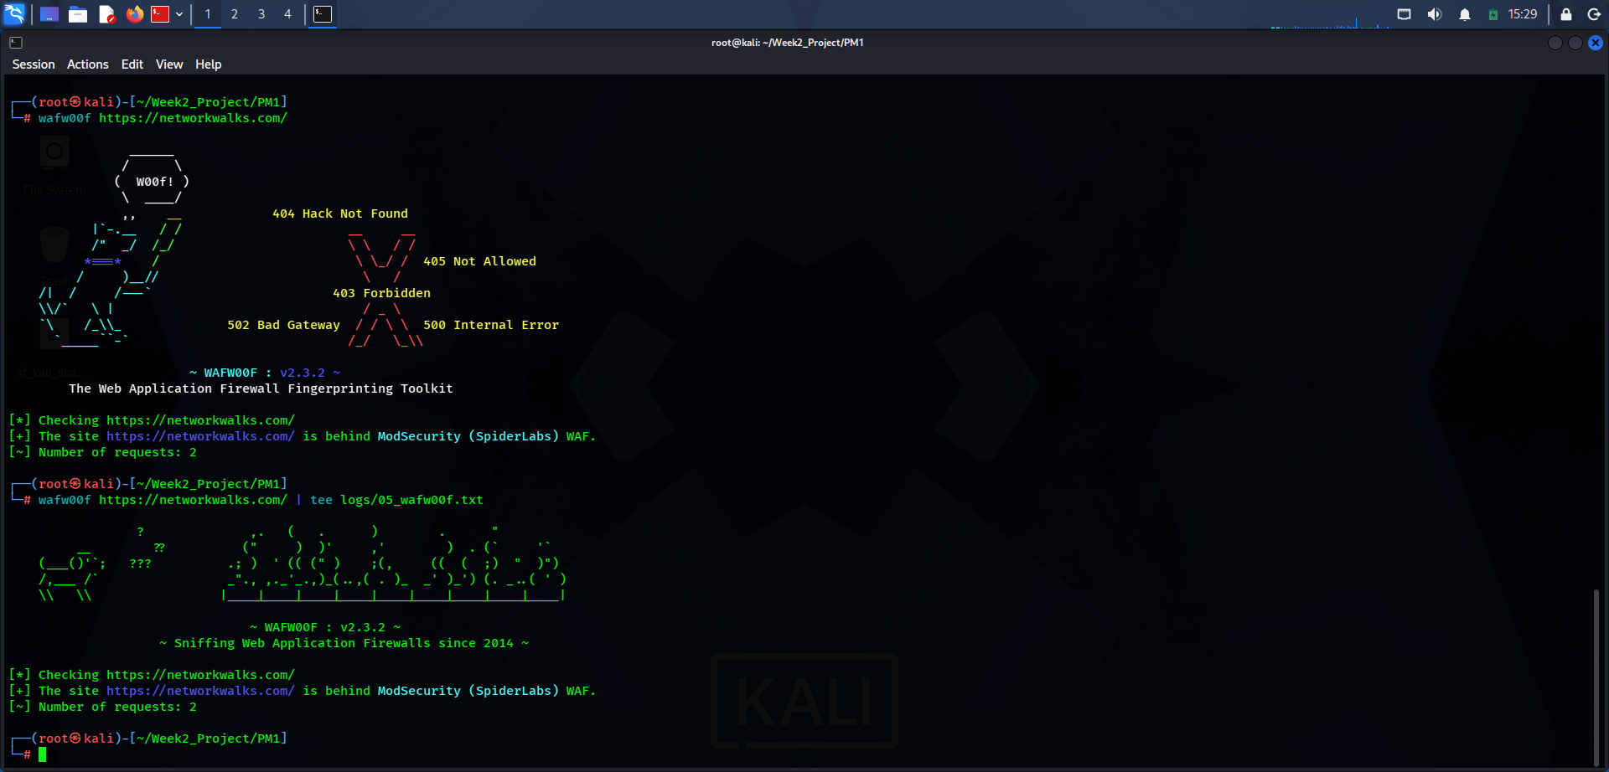

WAFW00F detected ModSecurity (SpiderLabs) WAF and reported two requests.

Figure 5. cURL HTTP Response Headers
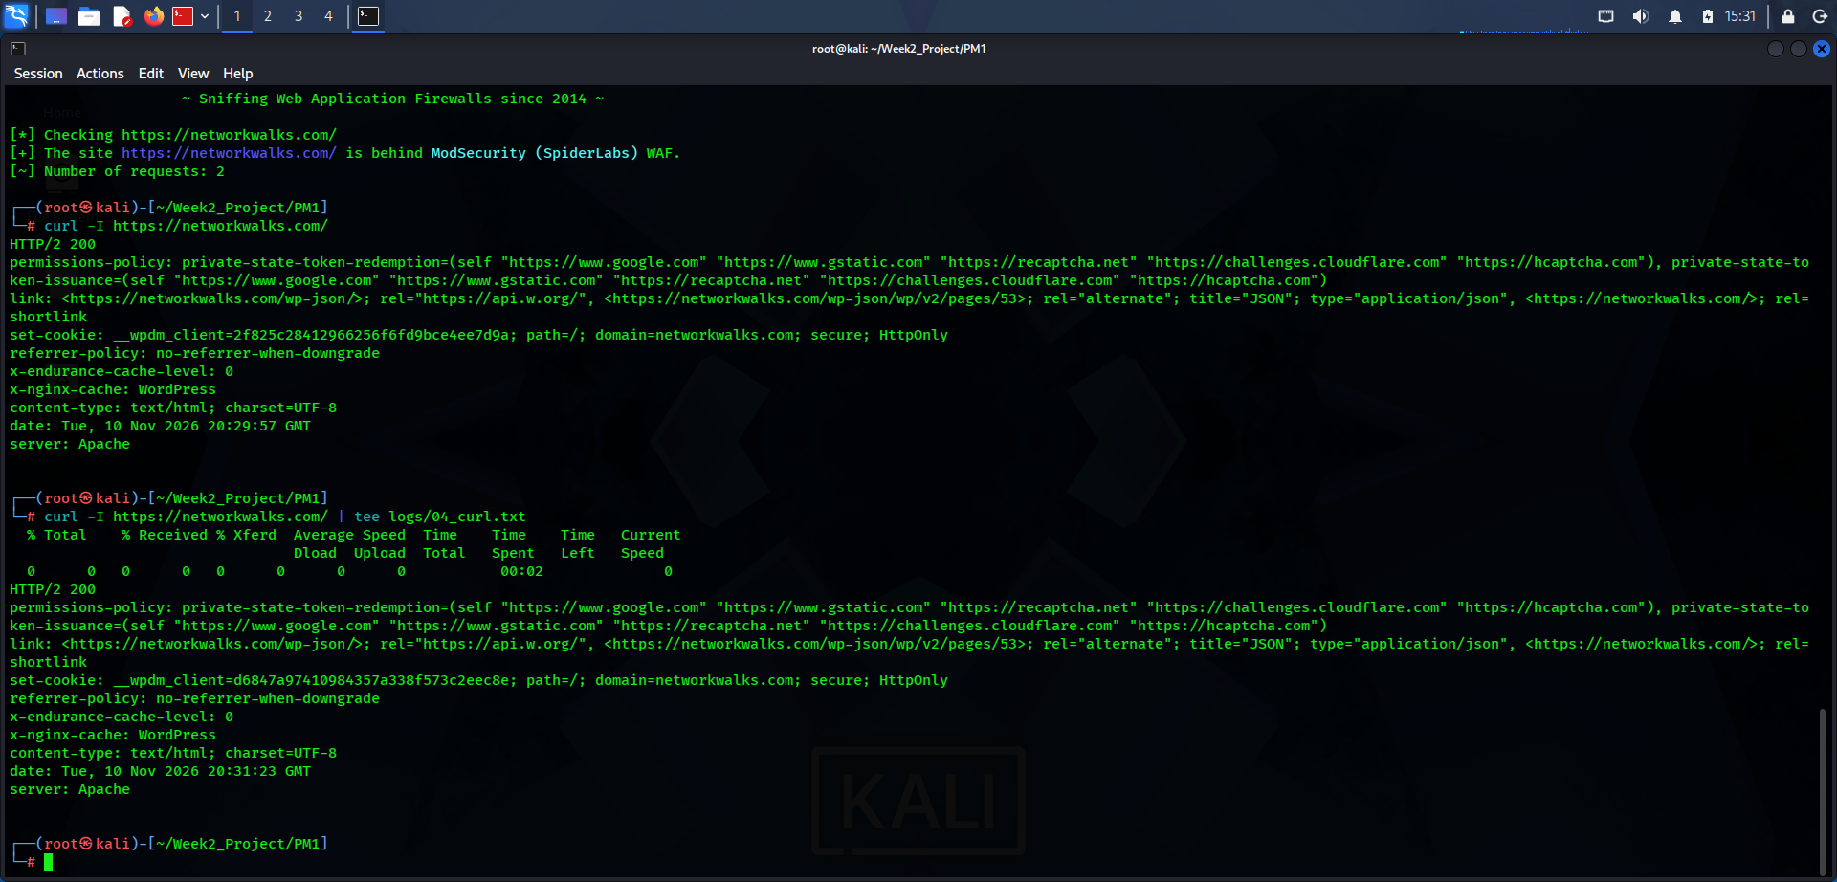

The HTTP HEAD request returned HTTP/2 200 and displayed Apache, WordPress-related headers and response metadata. Cookie value is not reproduced in the report text.

Figure 6. DNSRecon Enumeration
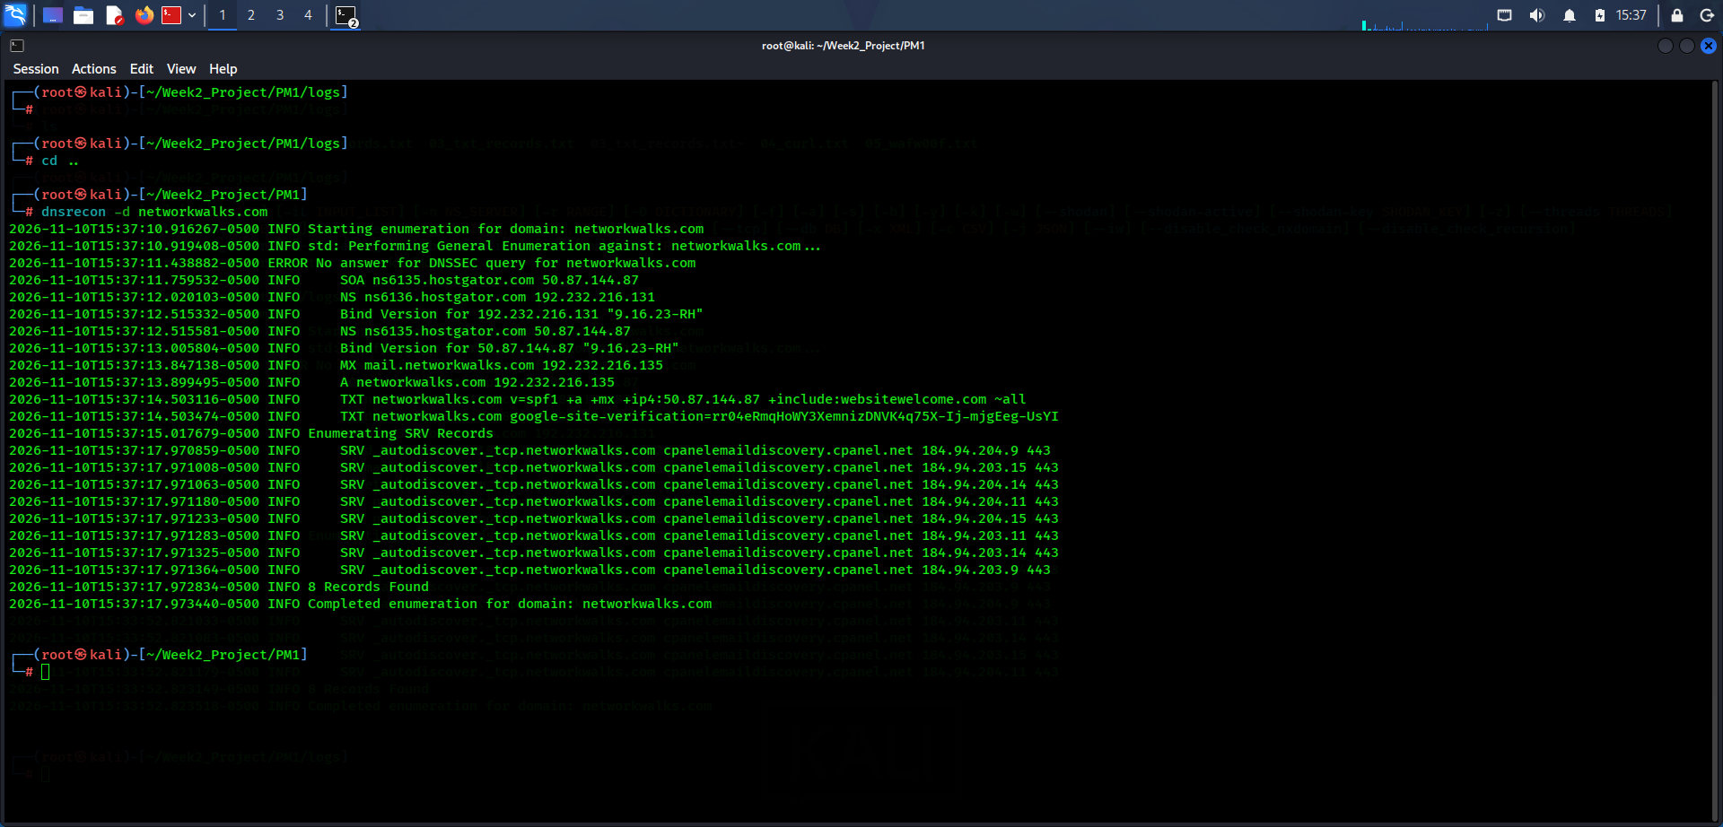

DNSRecon completed general enumeration and reported eight records, including SOA, NS, MX, A, TXT and SRV information.

Figure 7. Maltego Startup and Environment
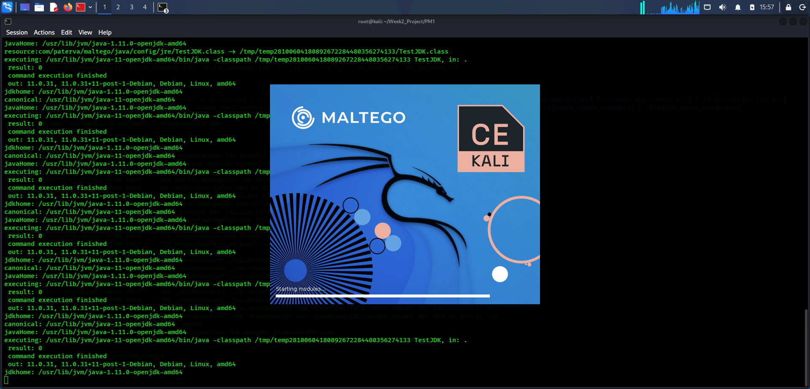

Maltego startup and Java environment output in the Kali Linux environment.

Figure 8. Maltego Community Edition Launch
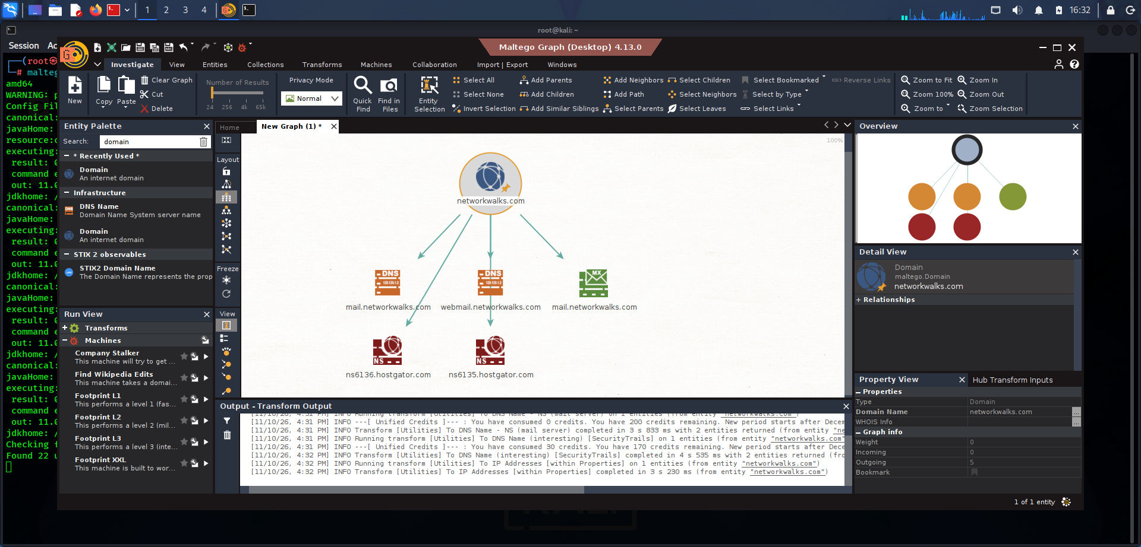

Maltego Community Edition launched successfully in Kali Linux.

Figure 9. Maltego Domain Graph
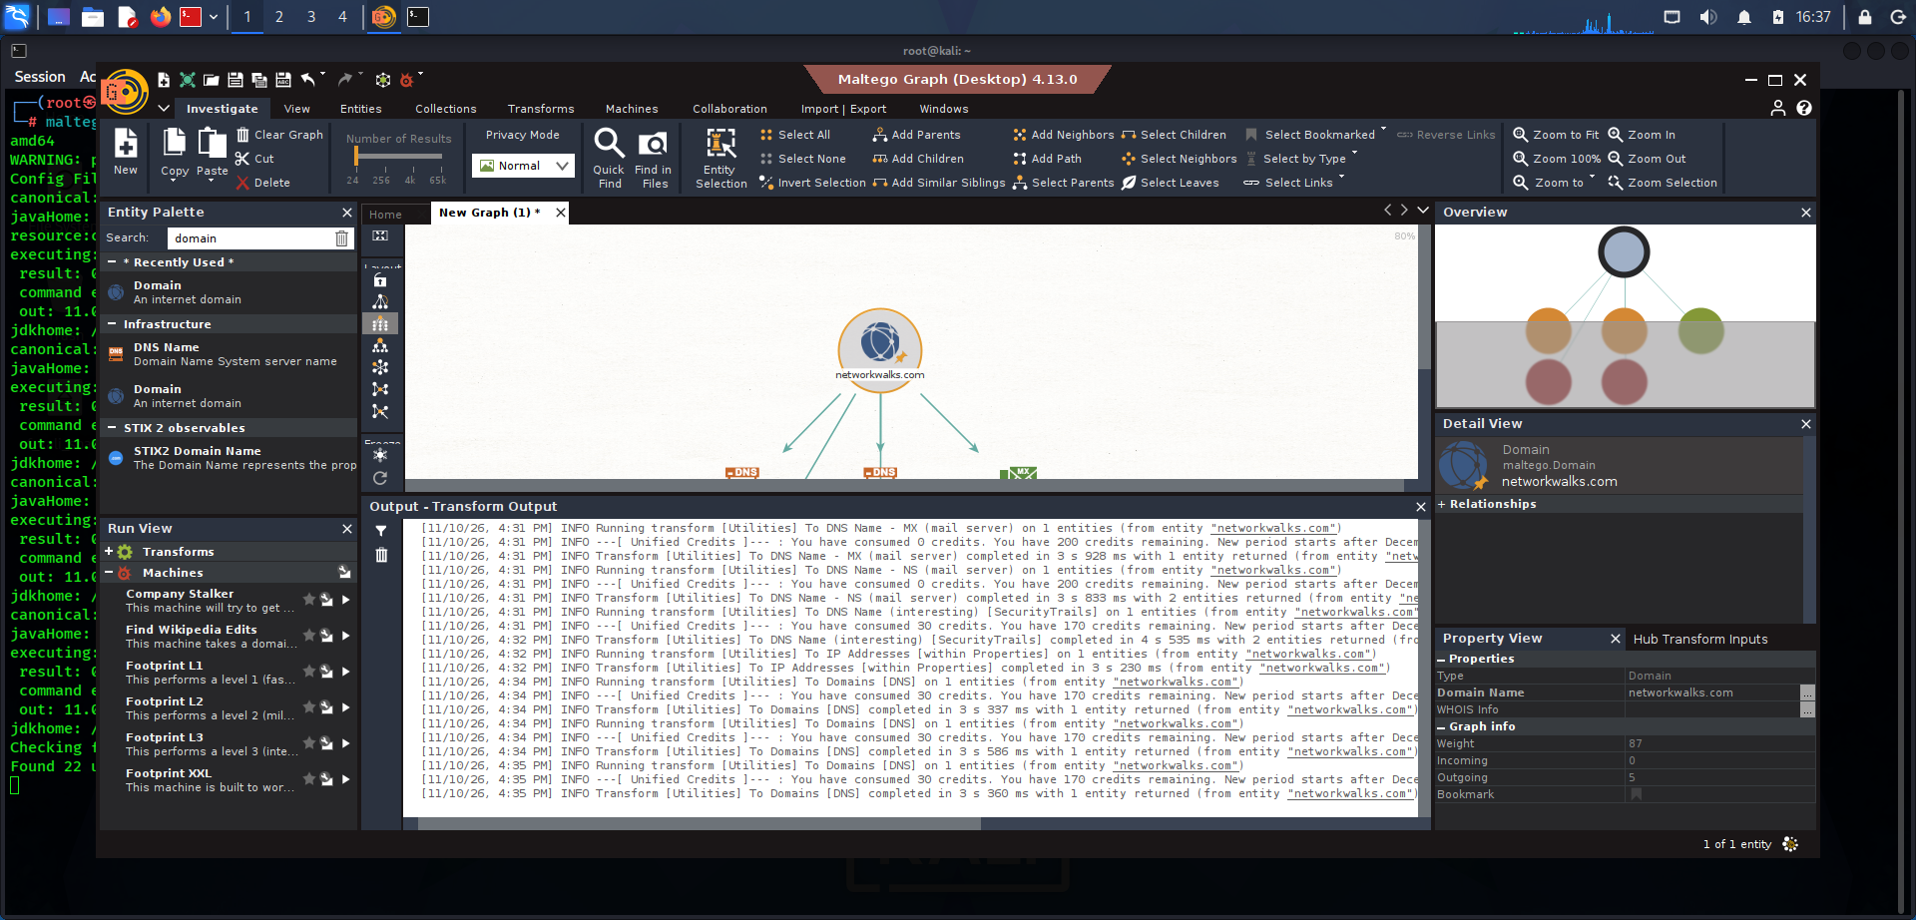

A Domain entity for networkwalks.com was added to the graph and related DNS Name and MX entities were visualised.

Figure 10. Maltego Transform Results
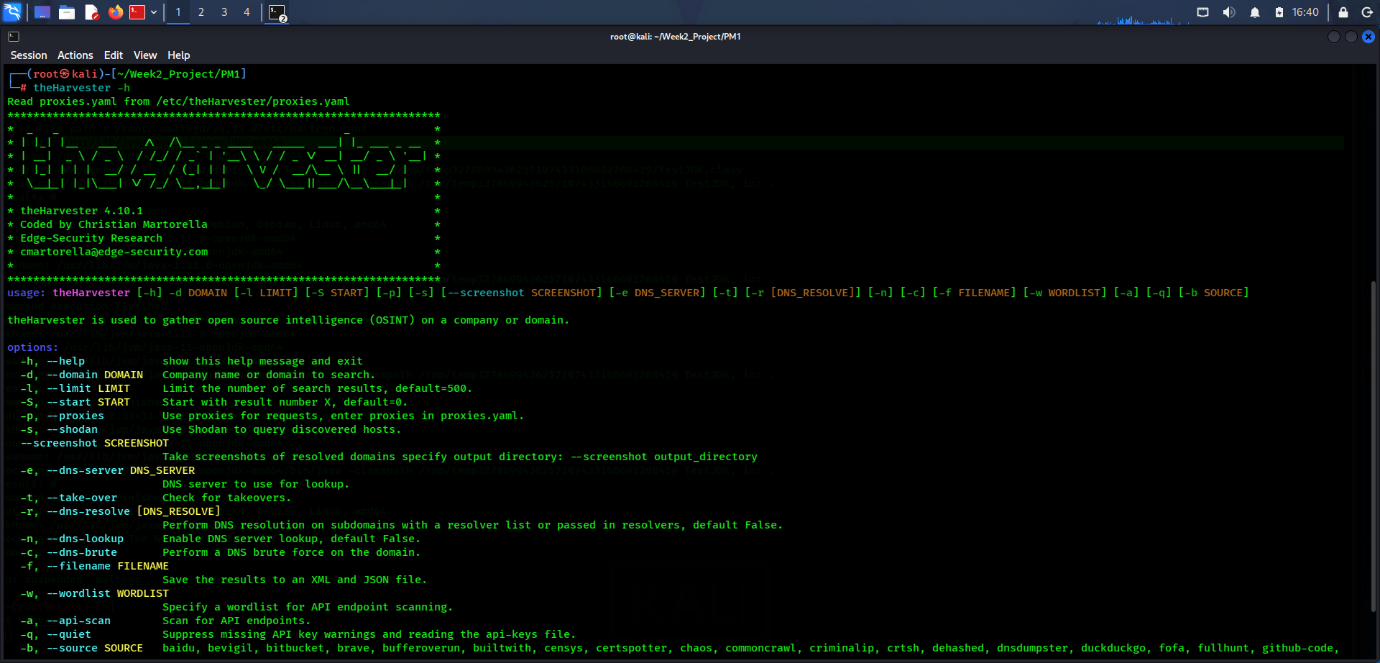

Maltego transform output shows DNS-related entity discovery and relationships for the selected domain.

Figure 11. theHarvester Help and Options
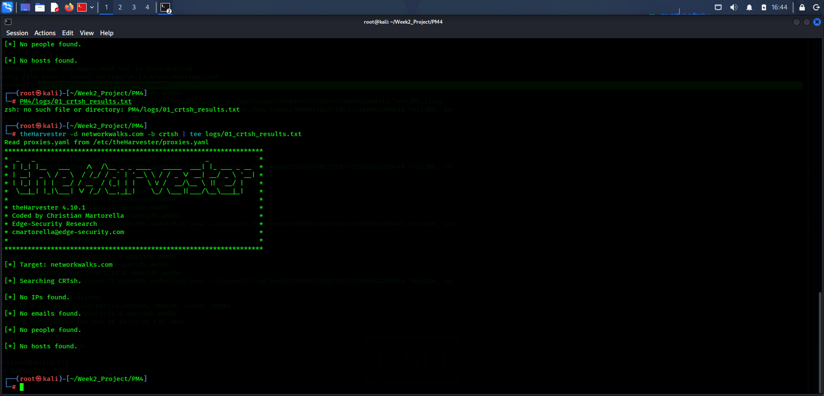

The theHarvester help screen shows the available command options and supported data-source parameters.

Figure 12. theHarvester CRT.sh Results
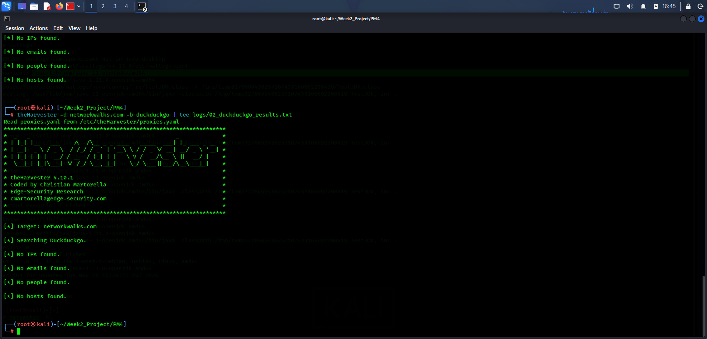

The CRT.sh source returned no IPs, emails, people or hosts for the domain during this lookup.

Figure 13. theHarvester DuckDuckGo Results
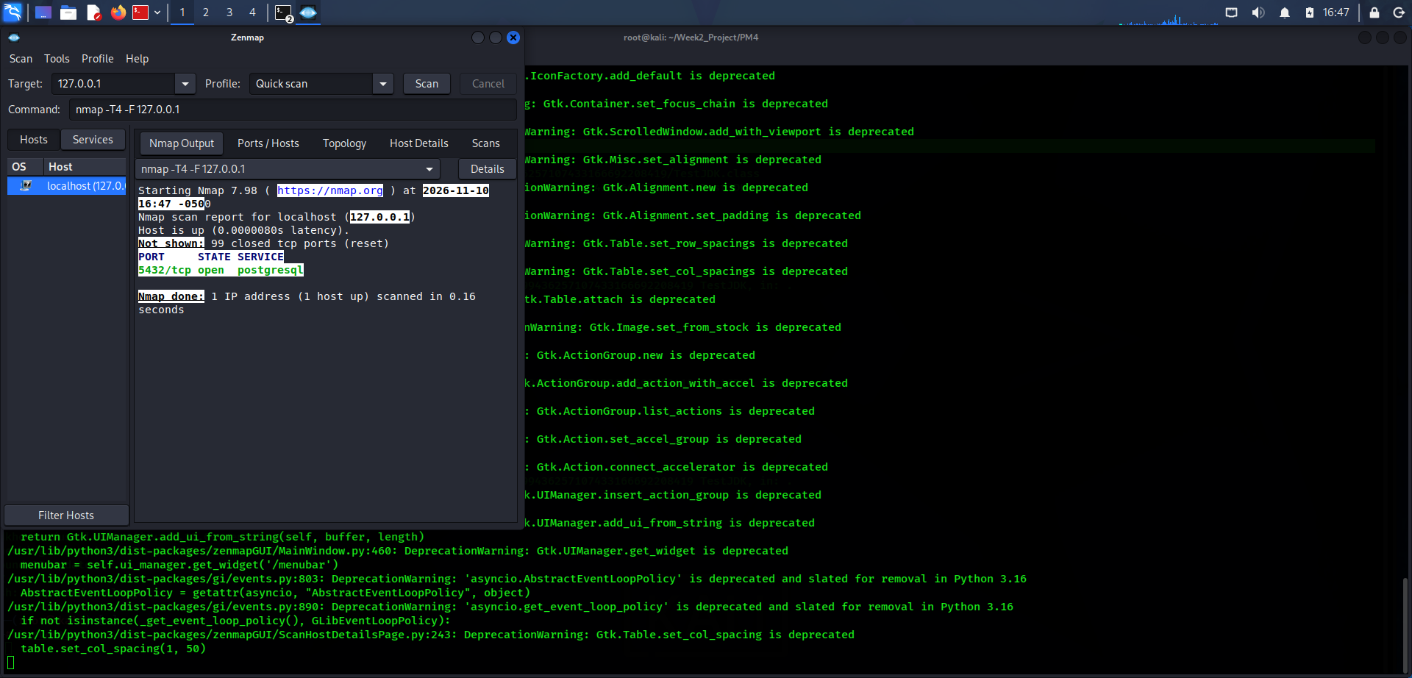

The DuckDuckGo source lookup returned no IPs, emails, people or hosts in the displayed output.

Figure 14. Zenmap Quick Scan of Localhost
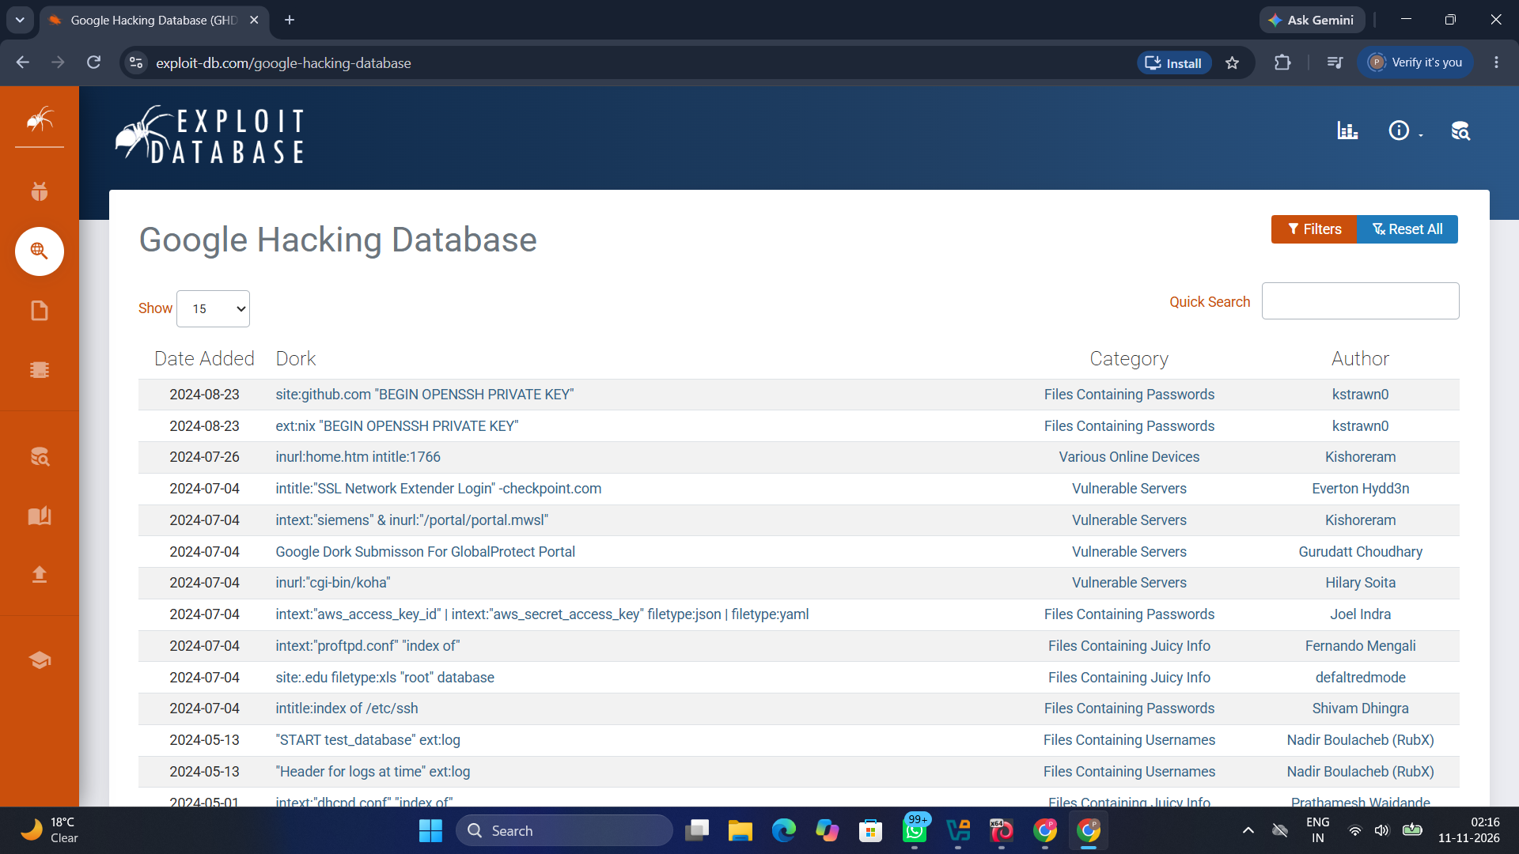

Zenmap 7.98 performed a Quick Scan of 127.0.0.1. The host was up; TCP port 5432 was reported open with service identified as postgresql, while 99 TCP ports were closed (reset).

Figure 15. Google Hacking Database (GHDB) Main Page
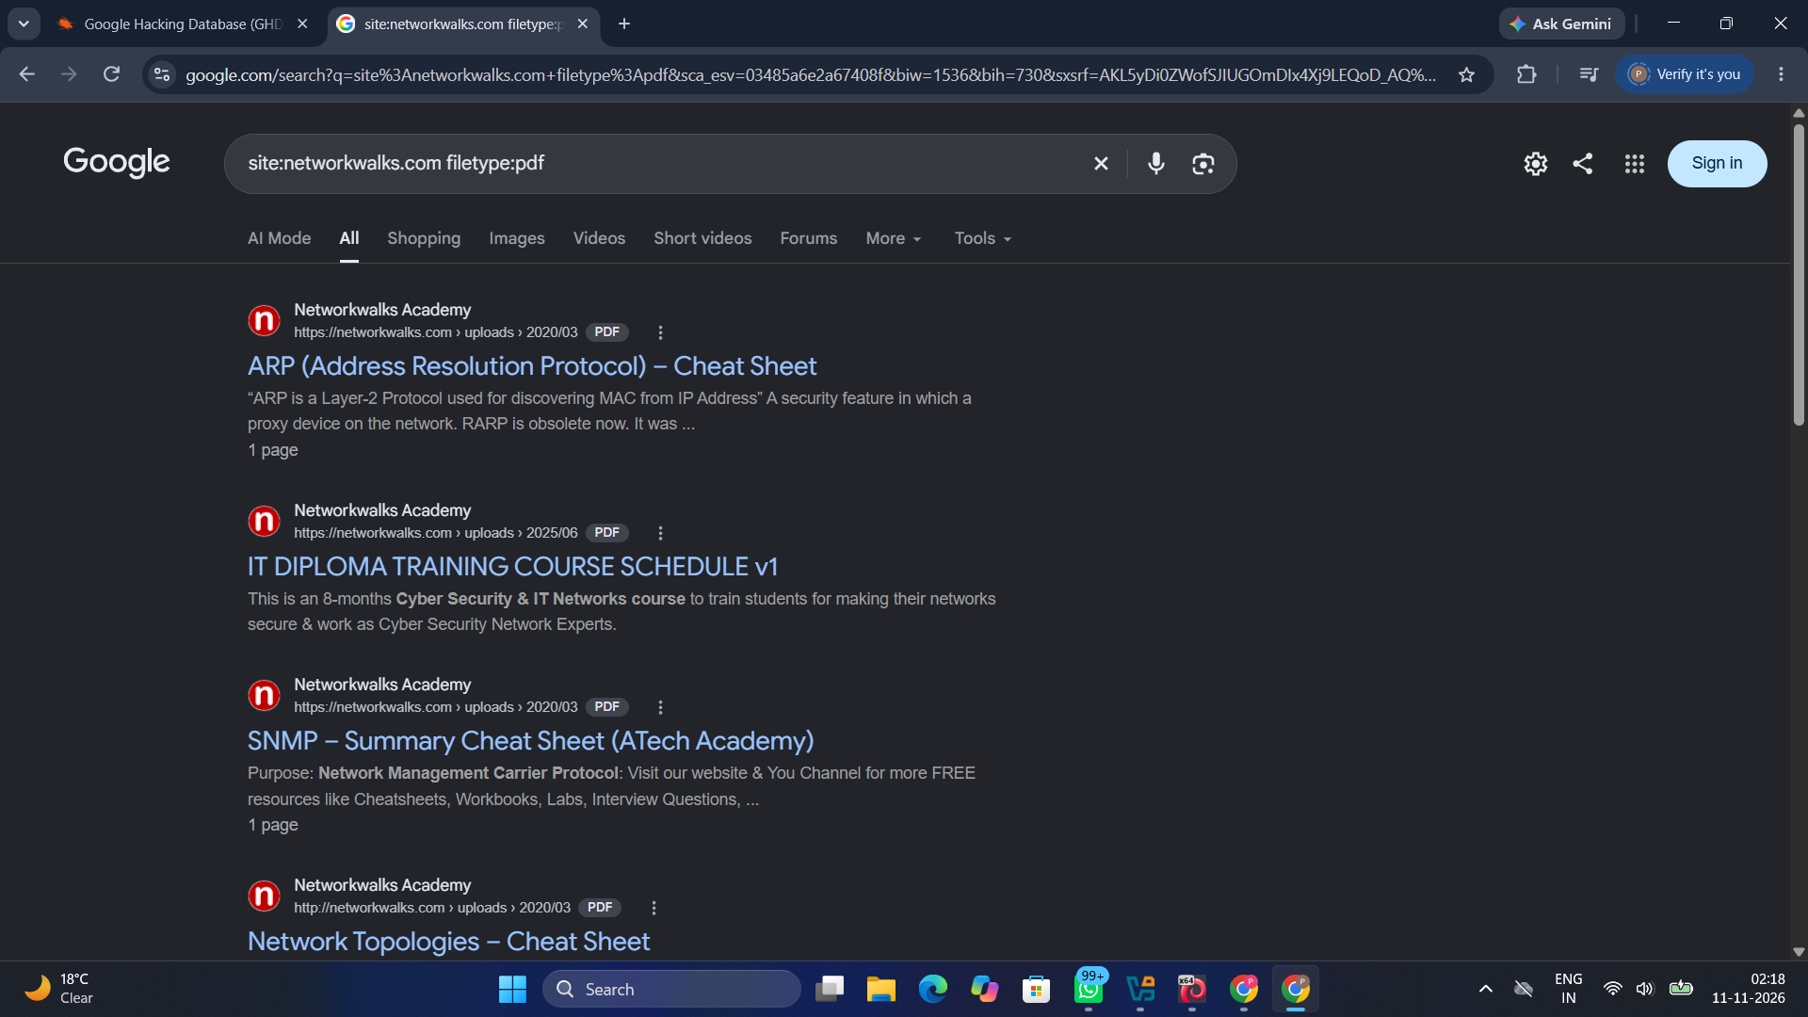

The GHDB page displays Google dorks, categories, authors and publication dates. Visible categories include Files Containing Passwords, Various Online Devices, Vulnerable Servers, Files Containing Juicy Info and Files Containing Usernames.

Figure 16. Google Dork Search Results
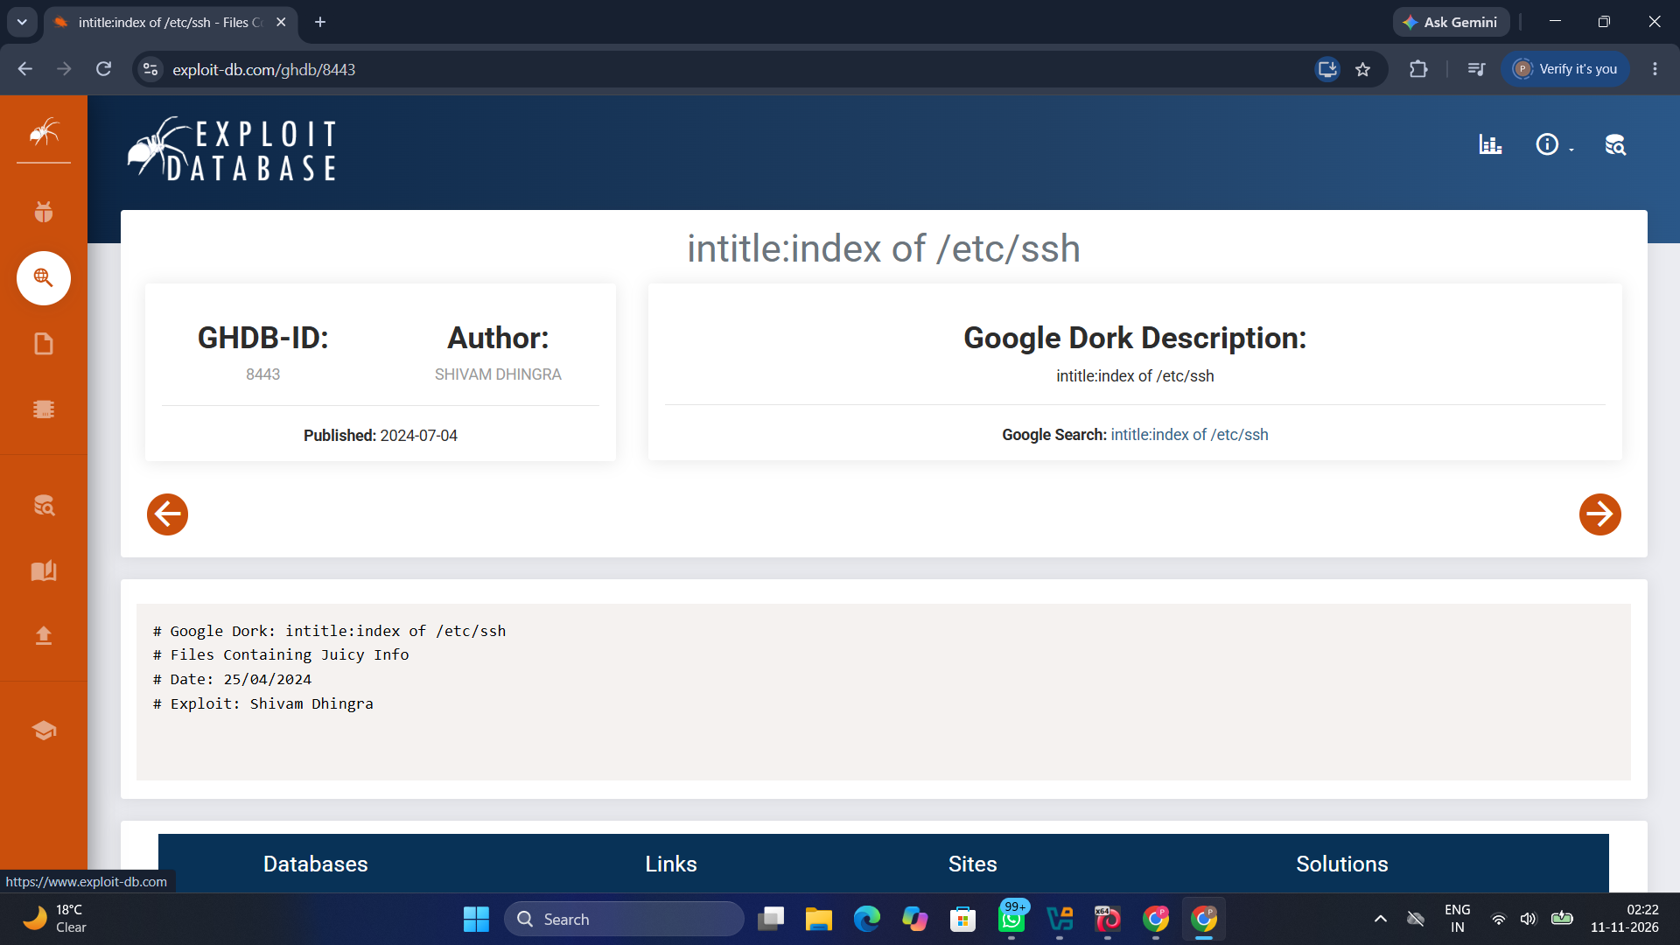

The domain-restricted query site:networkwalks.com filetype:pdf returned indexed PDF results, including ARP and SNMP cheat sheets and a training course schedule.

Figure 17. GHDB Dork Entry Example
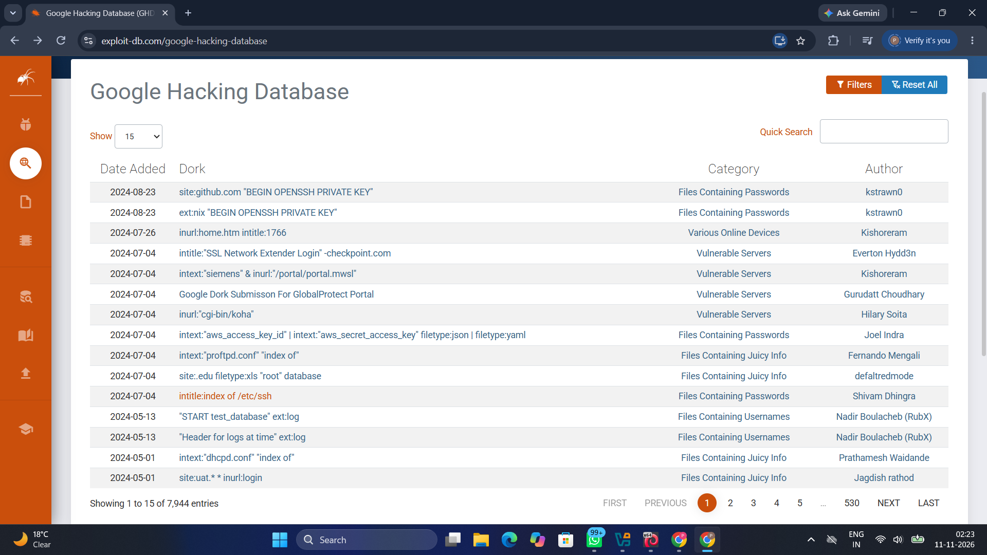

The GHDB entry displays the example query intitle:index of /etc/ssh, its category, author and publication date. This is documented as a GHDB example, not evidence that the target exposed such a directory.

-End-

👤 Author
Prashant Dubey
Cybersecurity Week 2 Project
GitHub: https://github.com/prashant041204/NETWORKWALKS-B084-WK2-PM-PENETRATION-TESTING-REPORT

📌 Project Information
Program Name: Cybersecurity Week 2 Project | Week: 02 | Repository: GitHub https://github.com/prashant041204

