**CSI PROJECT REPORT**

**TEAM MEMBER**: Prashant Nigam

**MENTOR**: Siddharth Tiwari

**PROJECT AIM**:

A messenger bot that aims to be as simple as possible to serve humans with their basic queries.

**INTRODUCTION:**Machine learning chatbots works using artificial intelligence. User need not to be more specific while talking with a bot because it can understand the natural language, not only commands. This kind of bots get continuously better or smarter as it learns from past conversations it had with people

**MOTIVATION FOR THE PROJECT :**

* Users want to chat with a bot about anything and get an answer to each question immediately.The AI chatbot is a great way to satisfy such information craving.
* A lot of companies are trying to develop the ideal chatbot, that can have a conversation that is as natural as possible and that it is indistinguishable from a normal one between humans.
* Why Messenger?Because Messenger is now used by 1.2 billion people every month

**DESCRIPTION:**

I have implemented a Facebook Messenger Bot to get an overview of how chatbot is build. During this implementation, I understood the flow of control for a chatbot service with other services which is explained below.

­

**Flask Application**

**Facebook Messenger (Chat Client)**

**Wit.ai (Natural Language Processing)**

1. 2

4 3

**The architecture flow is explained below.**

1. User sends message to Chatbot from Facebook Messenger (a Chat Client)   
2. Chatbot sends message to Wit.ai (a Machine Learning Natural Language Processing Engine)

3. Wit.ai extracts user’s intent and entities from message and sends back to Chatbot

4. Chatbot builds data into a proper response and sends to Facebook Messenger for display

In order to create a Facebook Messenger Bot, a developer needs to be authenticated and approved by Facebook to converse with the public and the web server for security reasons. For a Facebook Messenger Bot.

I ran the application locally. I also downloaded and installed ngrok. This launched a Forwarding URL to the local running server, that means any requests to Forwarding URL will hit the locally running server. This url is used as a Callback URL in Facebook App which will be explained further.

To set up the Facebook App, I have created a Facebook Page and Facebook App using my Facebook account. While setting up a Webhook in the app settings, I have given the Forwarding URL as Callback URL and added code for verification.The access token in page settings is stored as environment variable as it will be used in integration.

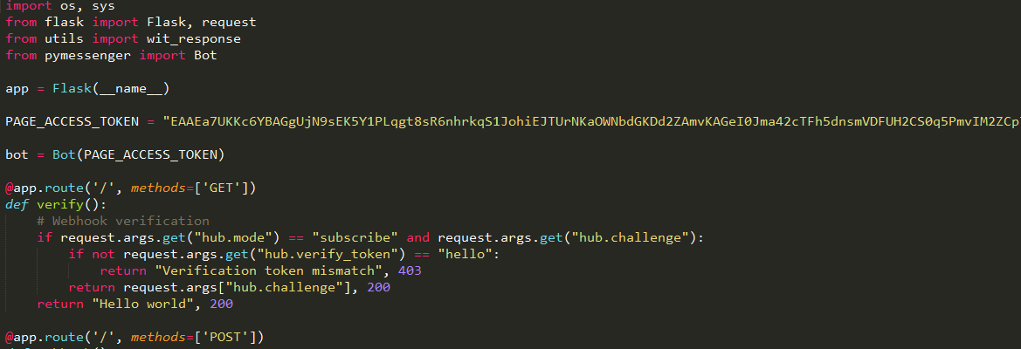

In order to make webhook to receive messages from this page, the app is subscribed to the page created. To set up the bot to handle the POST calls at webhook, I have created a webhook endpoint in the sample application. also defined constant variables Page_Access_Token and Verification_Token in the application. They are used to verify that the callback is coming from Facebook page. So far I have connected web application to Facebook Messenger using a webhook and have gained access to a facebook page using an access token.

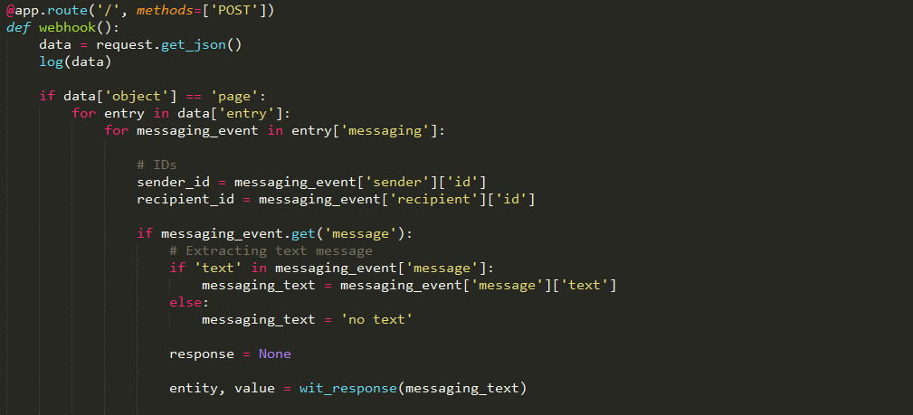

Next is to add artificial intelligence to the application using Wit.ai To set up the Wit.ai, I have created a new app in Wit.ai console which enhances the ability of the bot. The token from app setting is used as WIT_TOKEN in Flask application. Whenever the user sends a message to the bot in Facebook Messenger, Facebook sends the message to the webhook endpoint, which is nothing but a Flask application. Then the message is sent to Wit.ai for Natural Language Processing which extracts user’s intent and entities and sends this back to application.

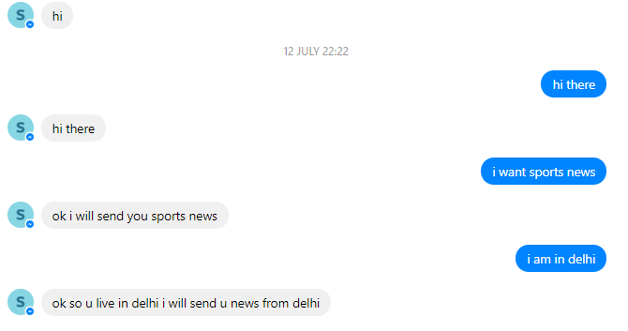Chat with Guide-Bot

**FUTURE PROSPECTS:**

As we have seen, to model a chatbot we need to provide the logic and the linguistic resources, mainly the input and output phrases and the entities. This is particularly true for Api.ai and Wit.ai. For small chatbots this should not be a problem, but if you are planning to deal with a big terminology and a lot of variants for phrases, you should consider using NLP and ML. That’s why I am working on Retrieval-Based Bot. Retrieval-based models have a repository of pre-defined responses they can use, which is unlike generative models that can generate responses they’ve never seen before. This will also help to improve accuracy of response.