Before Starting the project we need to set up the vertual enviroment and before that we need to activate the conda enviroment

some time conda is not added to the system path to verify that open the terminal and write

`conda --version` if it give error conda is not recognized then add the five path in the system path.

**Steps to add the conda path in the system path.**

1. Go to the search bar of the window.
2. write environment and open "Edit the system environment variables.”

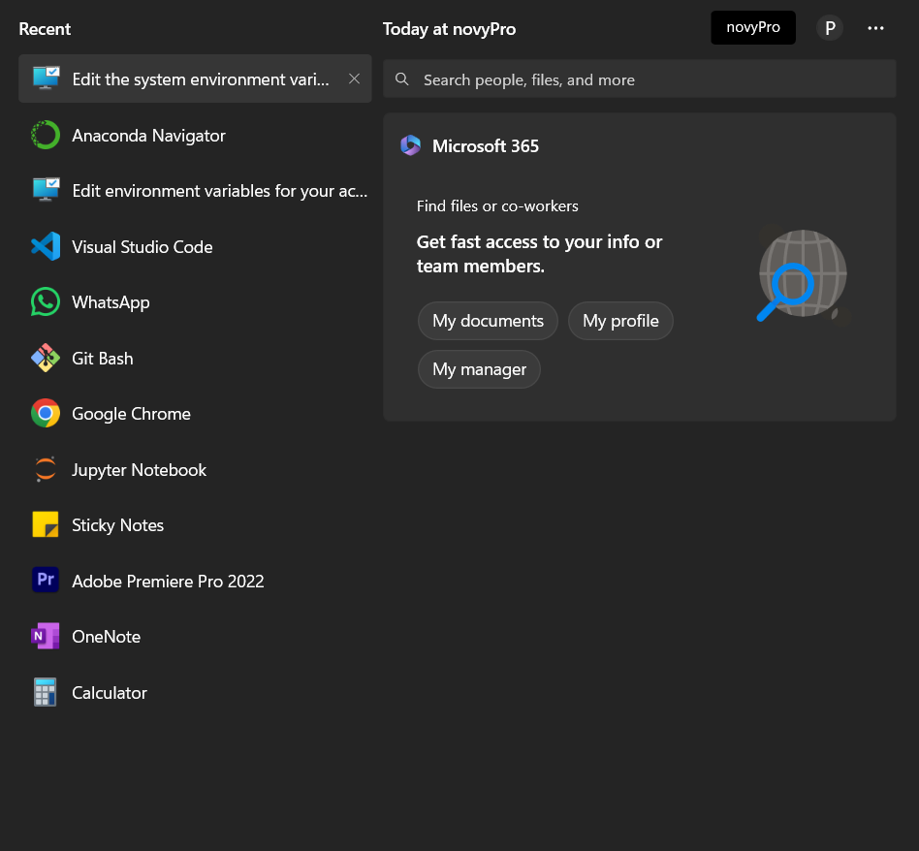



1. Click on the Environment Variables then click on the path either user variables for prash or System variables.



1. Check if anaconda path are available in the path or not, if not available then add manually

1. To add the conda path manually, Search in the window search bar anaconda Navigator.
2. This anaconda Navigator will show in the system only when it is installed in your system.
3. If It is not installed first installed it, If you are using jupyter notebbok , it must be installed in your system.
4. Once anaconda navigator reflects after search click on the open file location



1. Once file location opened right click on Anaconda Navigator and click on the open file location.

1. Copy the path of all five and add to the environment path.

Path .1: - C:\ProgramData\anaconda3

Path .2: - C:\ProgramData\anaconda3\Library\mingw-w64\bin

Path .3: - C:\ProgramData\anaconda3\Library\usr\bin

Path .4: - C:\ProgramData\anaconda3\Library\bin

Path .5: - C:\ProgramData\anaconda3\Scripts

1. Restart the vscode.